Travis Moore

GAT212—Spring 2015

Instructor: Chris Champagne

Subterfuge RPG

Mission Module

Table of Contents

Mission Module 3 – 21

Mission Briefing 3 – 8

Overview 3 – 4

Objectives 4

Mission Documents 4 – 6

Authorized Provisions 7 – 8

Game Master Information: The Briefing 9

Structure & Setting 9

NPCs 9

Mission Events 9

Game Master Information: The Charity Event 9 – 14

Structure & Setting 9 – 10

NPCs 10 – 11

Mission Events 11 – 12

Optional Events 12 – 14

Game Master Information: The Blackjack Game 14 – 17

Structure & Setting 14 – 15

NPCs 16

Mission Events 16 – 17

Optional Events 17

Game Master Information: The Finale 17 – 23

Structure & Setting 17 – 20

NPCs 21

Mission Events 22 – 23

Optional Ending 23

Mission Module

Mission Briefing

The following subsections (Overview, Objectives, and Authorized Provisions) are meant to be used by the Game Master to relay information that the players will need in order for the mission to start. The players can read these sections and view the provisions that they can choose from before heading out on the mission, but only these sections and nothing more.

Overview

Good afternoon, agents. Your mission, should you choose to accept it, is to go on reconnaissance to confirm or deny information that our agency has received from an operative who has recently gone M.I.A. during his last mission. We have reason to believe that one of the top US Defense Companies are obtaining profit margins that do not add up to their current contracts with the US Department of Defense. The US Government has reason to believe that one of these companies might be selling US Military weapons to foreign nations. In the interest of national security, our agency has been given approval to proceed with further investigation to see if this information is not only true, but which US Defense Companies are involved and if this is indicative of a more sinister plot.

We have some background information on two US Defensive Companies that our intelligence believes might warrant further investigation. Remember, this matter is of upmost secrecy and these companies must not be given reason to believe that they are being investigated so as to prevent them from destroying any incriminating evidence that there might be.

You and your fellow agents will be attending an exclusive US Weapons Manufactures’ annual charity event posing as officials for Northrop Grumann, a US Defense company. Our agency will provide you with a briefcase with the money needed to buy into the charity event, specifically to get closer to the CEOs of whom we believe to be possibly selling weapons to foreign nations. Your mission is to infiltrate the event and find out as much as possible about Ragnor Blackridge and Salvador Sharpe. As the highly aggressive CEO types that they are, we believe you’ll find them both engaged in the Blackjack game that will be taking place at this event. However, their spouses or other employees may also have information, so be vigilant but do not draw too much attention to yourself.

You and your team have been authorized certain provisions to help you complete your mission. While we do not suspect any immediate danger it is always in your best interest to be prepared for anything that may happen. Just remember that this mission requires you and your team to not give away who you are what your mission is. Anything traced back to the agency will result in an immediate termination of your employment and we will disavow any and all involvement with you, your team, and the mission. Good luck.

Objectives

**Main Objective:** Discover which company(ies) are involved in a potential arms deal with a foreign nation and obtain evidence proving so.  
**Sub Objective 1:** Prevent any further weapons deals with foreign nations.

**Sub Objective 2:** Find our missing field agent, Niccolo Kristov.

Mission Documents

**ManTech**:  
 Arms sales: 2.5 billion  
 Annual Profit: 125 million

Employees: 10,100  
 ManTech serves the United States government in the area of advanced technological military surveillance systems and are the leading provider of the C41SR technology. Not the largest department of defense contract, but this company once was the sole company responsible for arming the US Navy’s war gaming models and naval weapons.

**Motive**: A once powerful company that has since fallen from its leadership position as a top military provider. The CEO of ManTech, Ragnor Blackridge, has recently vowed to bring the company back from obscurity with aggressive business tactics like underpricing in order to win contracts from larger corporations. Ragnor Blackridge is no stranger to change and has restructured ManTech by laying off 60% of the workforce and has cut employee benefits and pensions in order to stay competitive. There’s no doubt that ManTech feels sore over their competitor, General Dynamics, winning over an 800 million dollar contract for work on what was once their staple of producing weapons for the US Navy. Is Ragnor Blackridge trying to make profits anywhere he can in order to better ManTech’s position for future business opportunities?

**General Dynamics**

Arms Sales: 24 billion

Annual Profit: 2.6 billion

Employees: 90,000

General Dynamics produces military vehicles, ships, munitions, and recently military grade communications systems. They have also recently been awarded an 800 million dollar contract for work on US Navy nuclear-powered submarines program.

**Motive**: A consistently top performing military weapons provider, General Dynamics rose from obscurity over the last 5 years and has become one of the nation’s most reliable weapons manufacturers. General Dynamics is run by Salvador Sharpe. An egotistic man who seems to have his fingers in every financial market, Salvador Sharpe is a controversial figure who does not shy away from the media and has gotten himself in several public embarrassments that threaten his position with the board of directors. Perhaps he is selling surplus weapons to appease the board in order to stay on top of it all?

**Charity Event Map**

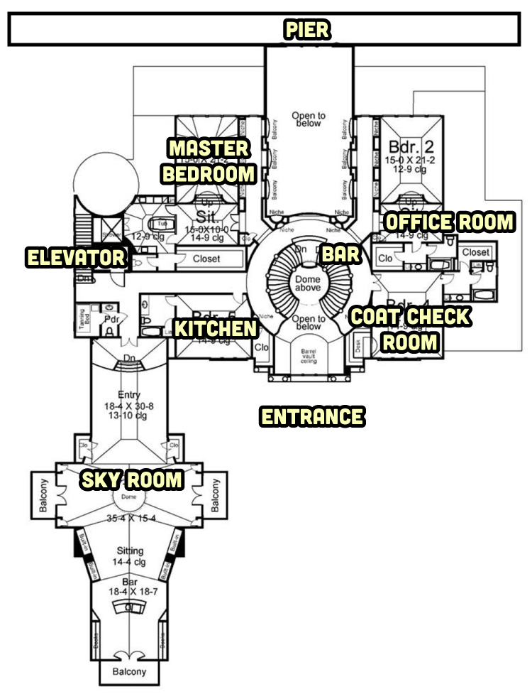

Authorized Provisions

The following provisions are available for this mission. Please note that you are only able to provision one melee weapon, one ranged weapon, one apparel, and three miscellaneous items each. Do note that there is one required mission item that one member of the spy team must carry.

**Melee Weapons**

|  |  |  |  |  |
| --- | --- | --- | --- | --- |
| Weapon NAME | Weapon TYPE | Description |  | Damage |
| MPK Knife | Knife | Standard issue knife. | | 6 damage |
| Expandable baton | Baton | Easily concealed baton that expands to a larger size. It does non-lethal damage. | | 4 damage |
| Garrote Wire | Wire | A silent weapon that can either do lethal or non-lethal damage depending on the user’s application of the weapon. | | 6 damage (strangling) |

**Ranged Weapons**

|  |  |  |  |
| --- | --- | --- | --- |
| Weapon NAME | Weapon TYPE | Description | DAMAGE / CAPACITY |
| P226 Tactical | Pistol | Standard pistol that can be equipped with a silencer. Comes with one standard magazine that is equipped. Concealable. | 6 damage / 10 rounds |
| mP5 N | SMG | Standard sub machine gun that can be outfitted with a Beta C-Mag to increase the number of round available. Comes with one standard magazine that is equipped. Not Concealable. | 5 damage / 30 rounds |
| M4 Carbine | Carbine Rifle | Standard carbine rifle that can be outfitted with a M203 Grenade launcher. Comes with one standard magazine that is equipped. Not Concealable. | 8 damage / 20 rounds |

**Items**

|  |  |  |  |
| --- | --- | --- | --- |
| Item NAME | Item TYPE | Description | Extra |
| BRIEFCAse with CHARITY Money | Mission Critical Item. | *This item must be taken on the mission in order to buy into the party’s gambling event.* | Not Concealable. $250,000 cash. |
| Additional Magazines | Ammo | More ammo for your ranged weapon of choice. | Concealable. Only one additional magazine per item slot. |
| flash bang | Stun Grenade | Used to temporarily disorient an enemy’s senses by producing a blinding flash of light and intensely loud noise. | Concealable. Each Flash bang takes up 1 item slot |
| Communications ear 4 piece set | Communication | Concealable ear piece set that will allow the agents on the field to hear/talk to each other within 200 yards. | Concealable. |
| Cord + GrappLE | Climbing Gear | Used to scale buildings or create trip-lines. Cord length is 30 feet. | Not concealable.  1 grapple hook and 30 ft. cord. |
| Lock picking kit | Kit | Standard tools used to pick most types of locks. | Concealable |
| arc welder | Tool | Used to cut through metal. It is slow, but effective. | Not concealable. |
| Silencer | Pistol Extra | Used to suppress noise and muzzle flash on the pistol. | Not concealable once attached to the pistol |
| Beta C-mag | SMG Extra | Used to expand the capacity of the SMG from 30 rounds to 100 rounds. | Not concealable, |
| M203 Grenade Launcher | M4 Carbine Extra | Used to | Not concealable. |
| SAT PHONE | Mobile Tech | Used to access headquarters for relaying/accessing information on the field. | Concealable. |
| Mobile defibrillator | Medical Tech | Used to revive an agent who has died. | Not concealable. |

Game Master Information: The Briefing

The briefing is your chance to set the stage for the game. Make sure to really play up the fact that the US government knows something is up but does not want to make an official move until they’ve uncovered who exactly is behind this plot. Sell the mission as a fact finding mission and one where it is imperative that the agents do not get caught trying to dig up dirt by either arms manufacturer. The assassin player types will not be thrilled with this kind of mission, but little do they know that there will be plenty of action in it for them later.

Structure & Settings

The briefing takes place in the headquarters of the spy agency. Make sure not to really reveal the location of the spy agency other than to say it exists somewhere in the United States. The location of the spy agency is not important and in fact it might be beneficial in future mission scenarios for the players to wonder just where and what this spy agency is really up to. Play up the fact that it is a spy agency and that the exact location is top secret and the mission is all that really matters.

NPCs

There are no NPCs for this part of the game, other than that of the headquarters spy master giving the briefing to the players.

Mission Events

It is critical that players understand their mission and have at least one member carrying the briefcase with the charity money. You may consider making a copy of the map to give to the players, or you can make up or simply adjust the provided map as you see fit.

Game Master Information: The Charity Event

The charity event is meant to be a fact finding mission for the players, but there is the potential for things to get heated depending on how the players decide to play out this first part of the game. As the Game Master try to keep the players focused on not drawing a lot of attention to themselves and keep them on task about trying to find out what has been going on lately with the CEOs and their companies.

Structure & Settings

If you are using the provided map you then the information below should provide you with the exact locations for where things will occur in this part of the game. Of course, if you decide to make your own map then use the general idea of the information below and fit it to the changes you have made. Remember, that the broad ideas of this chapter is more important to get across than the specific details of where exactly it takes place.

**Charity Event Location**

Players enter the charity event location from the south. To get to the poker tournament they take a left and head down a hallway until they make another left through double doors and into the Sky Room. The poker tournament takes place in the Sky Room. It is a very separate area to the rest of the house, and while not private, it is exclusively meant for those that are playing in the poker tournament. The people in this area are either watching very intently in on the game or are servicemen and servicewomen providing drinks to the players. The rest of the rooms in the estate of note are the Coat Check Room, the Master Bedroom, the Office Room, the Elevator, the Kitchen, the Bar, and the Pier.

NPCs

Other than the other party guests and security, there are a few NPCs worth mentioning that the players will possibly interact further with.

**Ragnor Blackridge**

The CEO of ManTech, Ragnor Blackridge has the personality type of a leader. He is a powerhouse of personality and appears larger than life and very positive about the future of ManTech, despite recently losing a large contract to General Dynamics. Ragnor Blackridge is always confident and energetic, perhaps too much so. Ragnor Blackridge is stubborn, dominant, and impatient. He should come off as not good at hiding his emotions.

**Salvador Sharpe**

The CEO of General Dynamics, Salvador Sharpe has the personality type of a mysterious entrepreneur. Salvador is direct and perceptive with a bold stance on living life to the fullest. A seeker of knowledge, Salvador is insensitive to others because he cares more about the facts than people’s feelings. Salvador Sharpe hates to be boxed in, and is defiant against those who stand in his way. Play Salvador Sharpe off as a mysterious character who is smart and knows it.

**Jocelyn Sharpe**

The much younger wife of Salvador Sharpe, Jocelyn is charming, sensitive to others, and basically quite the opposite of Salvador Sharpe. She is very friendly and highly passionate. Like a moth drawn to a flame, Jocelyn is drawn towards those she perceives as strong personalities. She is unpredictable and her self-esteem fluctuates easily, making it easy for her to be manipulated by others.

**Gabriel Stone**

Gabriel Stone is the personal assistant to Salvador Sharpe and his most trusted confidant. He has an accountant-like personality and seems obviously distressed, which is why he is found by the bar nursing a drink. He is very easily stressed and highly emotional, but observant. If anyone at the party is going to notice that something is not right, it will be Gabriel Stone, or at least it would be if he did not seem preoccupied with something on his mind.

**Enemies / Guards**

Feel free to sprinkle the difficulty of the guards around the charity event based on the skill and challenge you feel your players are up to facing. The standard charity event guards have the following attributes and gear. For enemy health, use your best judgement, but try to make it so that players defeat enemies pretty easily.

|  |  |  |  |  |
| --- | --- | --- | --- | --- |
| GUARD TYPE | MELEE WEAPON | MELEE SKILL | RANGED WEAPON | RANGED SKILL |
| Easy DIFFICULTY | Unarmed  (extra damage: 0) | 5 | Pistol (extra damage: 5) | 5 |
| MEDIUM DIFFICULTY | Baton (extra damage: 3) | 6 | SMG  (extra damage: 6) | 6 |
| HARD DIFFICULTY | Knife (extra damage: 4) | 7 | Rifle (extra damage: 7) | 7 |

Mission Events

The following events should take place during the Charity Event part of this mission:

**Entering the Estate**

Once the players arrive the location should be described as being an extravagant estate full of guests enjoying the charity party. The estate overlooks the ocean and even has its own gigantic pier that stretches out along the coastline. Even with such a large number of guests, the estate is so big that it seems it would be easy to get lost in there. This event is definitely a high-society party, with men in their best suits and gorgeous women in fine dresses.

The entrance to the building is full of servants who offer to check coats and other valuables that guests might have brought. Beyond this room there is a small security team who is there to pat down guests and check purses and other belongings for anything suspicious. It is possible for the players to try and find a way around this if they are careful enough, but for the most part not a lot of items will be allowed through and will have to be checked in the coatroom if they all want to go inside the building.

**Inside the Estate**

The players will be greeted right away by the owner of the estate, Salvador Sharpe and his wife Jocelyn. His greeting quickly turns from kind into a small investigation, as he prides himself on being on top of knowing all the big players in the weapons manufacturing business and does not immediately recognize the players. Players will have to use deception to get past him or distract him by getting friendly with his wife, either way he will seem unhappy with the players and grudgingly let them in.

Immediately after Salvador Sharpe leaves (with or without his wife in tow), the players will next be greeted by Ragnor Blackridge. Ragnor should brag about being able to make it here because of how busy he has been and delight in how Salvador Sharpe does not seem to like the players. For the most part, Ragnor seems delightful, despite being full of himself. If any players are female, he will pay special attention to them and compare them to the beauty of Salvador’s wife, Jocelyn. Ragnor will end the conversation by insisting on joining him in the Sky Room where the big blackjack game will be taking place. He seems sure that he’ll win the game.

**Players Make a Plan**

This will be the first part in the game where the players can choose where they’d like to go from here. It should be made clear that this party seems massive and it would be easy to slip in and out of the crowd, if not for the security detail which seems to be everywhere. There is an elevator which seems to be more heavily guarded than anything else. From here players can split up with only some of them going to the big poker game and others exploring. At least one player needs to go to the poker game, and if they all do not immediately go, make Ragnor very insistent that they have to go, if not to play, then at least to see Ragnor win.

Optional Events

**Seducing Jocelyn**

A player can attempt to seduce Jocelyn in order to find out more about both Salvador Sharpe and Ragnor Blackridge. As the Game Master use your best judgement to determine if players should be using their skills to do checks or if they are simply playing their part well and in-character.

Jocelyn should reveal without much prying that she has been spending money given to her from her husband and Ragnor, of whom she is having an affair with. She should be very fond of Ragnor and not care too much about how she is potentially hurting Salvador because Ragnor promised her that he would buy her the world and would take over all of General Dynamic’s accounts within the year, but she does not know how. If the players are very careful they can steal or convince Jocelyn’s security badge to get into any room in the estate. If the player asks for Jocelyn’s security badge make her reluctant to do so because she has lost it once before, but luckily Ragnor found it gave it back to her.

**The Master Bedroom**

If the players manage to get Jocelyn to bring one of them to the master bedroom or have her security badge then they can explore this room for more clues. The master bedroom will have a safe which will be revealed as previously broken into with some important contract papers missing.

**The Kitchen**

If the players decide to infiltrate the party staff they can talk to the head chef of the place who is very unhappy with what has been happening at the estate lately. As a loyal servant to Salvador Blackridge, he is concerned about Ragnor Blackridge paying Jocelyn a lot of attention and wandering through the estate with Jocelyn when Salvador is not around. He suspects that they are sleeping together but is afraid to bring this to Salvador’s attention for fear of his wrath.

**The Bar**

At the bar the players can find Gabriel Stone, the personal assistant of Salvador Sharpe. He seems to be conflicted over something and should be brought to the player’s attention as a man struggling to relax. He is in charge of the party as a whole, but is neglecting his duties and drinking at the bar. Players can attempt to figure out what is wrong with him but he should be a very difficult nut to crack. Persistent skill checks or very precise questions should open him up, but only slightly. He will only reveal that he feels guilty about something involving Salvador and that he was only trying to help him out. Too much pestering Gabriel will make him suspicious as to why the players are there and what they are doing.

**Office Room**

A locked room that is unguarded is the Office Room. In this room the players will find an assistant to Gabriel Stone trying desperately to find the right documents amongst a pile of paperwork and will become alarmed if players enter this room. Players will have to subdue this player in one way or another. If the assistant is kept alive and conscious, he will divulge that he works for Gabriel Stone and is trying to find missing documents involving the new 800 million dollar contact that General Dynamics recently made that were supposed to be locked up in the master bedroom.

**The Pier**

The Pier is off limits for the player. The security in this area is air tight and all party guests have been asked to refrain from going to the Pier during this event. The guards in this area are heavily armed and not concealing this fact at all.

Game Master Information: The Blackjack Game

While there might be some players exploring the estate, there should at least be one player playing blackjack with Salvador Sharpe and Ragnor Blackridge.

Structure & Settings

The blackjack game takes place in the Sky Room of the estate. The atmosphere in the room is like that of a sporting event. There are lots of people circled around the large blackjack table ready to watch Salvador Sharpe, Ragnor Blackridge, and only one of the players playing blackjack. Other players who join this player in the room can attempt to look at the NPCs’ cards or attempt to distract them, but they cannot play the game (there is only enough money for one player). For the purposes of keeping the game short, make every hand a 50,000 dollar hand. The last player with money wins (or you can simply say the first person to win 5 hands if you want it shorter than that).

**How to play Blackjack:**

**Components:** You’ll at least 1 standard 52-card deck of playing cards, but you can play with several decks.

**Rules**: Play begins when you place a bet by stacking a chip or chips in the betting square on the table directly in front of you. After all bets have been placed, each player and the dealer are given two cards. In a shoe game, all player cards are dealt face-up, and the players are not permitted to touch their cards. In a single- or double-deck game dealt from the hand, cards are dealt facedown and players may pick them up with one hand. Either way, one of the dealer's cards is turned face-up so the players can see it.

Once the cards have been dealt, players decide in turn how to play out their hands. After all players have finished, the dealer plays according to set rules: The dealer must draw more cards to any total of 16 or less and must stand on any total of 17 or more. In some casinos, the dealer will also draw to "soft" 17—a 17 including an ace or aces that could also be counted as a 7. The most common soft 17 is ace-6, but several other totals, such as ace-3-3 or ace-4-2, on up to ace-ace-ace-ace-ace-ace-ace in a multiple deck game, are soft 17s.

**Terminology:**

* **Hit**: If you hit, you take another card or cards in hopes of getting closer to 21. If the player's total exceeds 21 after hitting, the player is said to "bust" and loses the bet. In shoe games, the player signals a hit by pointing to his cards or scratching or waving toward himself. In facedown games, the player signals a hit by scratching the table with the cards. Verbal calls to hit are not accepted. Signals are used for the benefit of the security cameras above the table, so a taped record is on hand to settle any potential disputes.  
  Stand: If you stand, you elect to draw no more cards in hopes that the current total will beat the dealer. Signal a stand by holding a flattened palm over your cards in a face-up game or by sliding your cards under your bet in a facedown game.
* **Double** **down**: You may elect to double your original bet and receive only one more card regardless of its denomination. Some casinos restrict doubling down to hands in which your first two cards total 10 or 11. Others allow you to double on any two cards. Double down by taking a chip or chips equal to the amount of your original bet and placing them next to your bet. In a facedown game, at this point you also need to turn your original two cards face-up.
* **Split**: If your first two cards are of the same denomination, you may elect to make a second bet equal to your first and split the pair, using each card as the first card in a separate hand. For example, if you are dealt two 8s, you may slide a second bet equal to the first to your betting box. The dealer will separate the 8s, then put a second card on the first 8. You play that hand out in normal fashion until you either stand or bust; then the dealer puts a second card on the second 8, and you play that hand out.
* **Insurance**: If the dealer's face-up card is an ace, you may take "insurance," which essentially is a bet that the dealer has a 10-value card down to complete a blackjack. Insurance, which may be taken for half the original bet, pays 2-1 if the dealer has blackjack. The net effect is that if you win the insurance bet and lose the hand, you come out even. For example, the player has 18 with a $10 bet down. The dealer has an ace up. The player takes a $5 insurance bet. If the dealer has blackjack, the player loses the $10 bet on the hand but wins $10 with the 2-1 payoff on the $5 insurance bet.

NPCs

Salvador Sharpe and Ragnor Blackridge will be playing Blackjack with the player. Salvador Sharpe will play conservatively, only playing on good hands, while Ragnor Blackridge will always play his hand and is a risk-taker. Other NPCs include the guests watching the game and the servants providing drinks to the guests. If security needs to be brought in for any reason, use the following table below:

**Enemies / Guards**

Feel free to sprinkle the difficulty of the guards around the charity event based on the skill and challenge you feel your players are up to facing. The standard charity event guards have the following attributes and gear. For enemy health, use your best judgement, but try to make it so that players defeat enemies pretty easily.

|  |  |  |  |  |
| --- | --- | --- | --- | --- |
| GUARD TYPE | MELEE WEAPON | MELEE SKILL | RANGED WEAPON | RANGED SKILL |
| Easy DIFFICULTY | Unarmed  (extra damage: 0) | 5 | Pistol (extra damage: 5) | 5 |
| MEDIUM DIFFICULTY | Baton (extra damage: 3) | 6 | SMG  (extra damage: 6) | 6 |
| HARD DIFFICULTY | Knife (extra damage: 4) | 7 | Rifle (extra damage: 7) | 7 |

Mission Events

**If the Player Wins**:

If the player wins the game Ragnor Blackridge will act like a sore loser and insist that the player cheated in some way. Salvador Sharpe should mention something cold and witty about how Ragnor should be used to not winning. Ragnor will be visibly upset about the comment, but quickly compose himself and say under his breath that he’ll soon change that. Ragnor will then congratulate the player and leave without saying anything more to Salvador.

Salvador Sharpe will not make much of this comment, but will instead commend the player for a game well played. He will offer the player and his friends an opportunity to celebrate with him after retrieving a very expensive bottle of wine down in the wine cellar with him.

**If Salvador Sharpe Wins**:

If Salvador wins he will not be ecstatic about winning but will very confidently say that it was what he expected. Ragnor Blackridge will be very upset that Salvador Sharpe won and insist that the player let Salvador win. Salvador will mention that Ragnor should be used to losing by now which will cause Ragnor to turn red. Ragnor will take a moment to calm down and then excuse himself from the table and leave the Sky Room after looking directly at Salvador and saying, “Oh, did I?”

Salvador Sharpe will not make much of this comment, but will instead commend the player for a game well played. He will offer the player and his friends an opportunity to celebrate with him after retrieving a very expensive wine down in the wine cellar with him.

**If Ragnor Blackridge Wins**:

If Ragnor Blackridge wins he will very ecstatically celebrate by boasting loudly for all to hear. Salvador Sharpe will roll his eyes and sarcastically say something along the lines of “at least you won something”. This comment will take the wind out of Ragnor’s sails causing him to turn red. Before storming out of the Sky Room, Ragnor will take a moment to gather himself before proclaiming for all to hear that this will be just one of many wins to come.

Salvador Sharpe will not make much of this comment, but will instead commend the player for a game well played. He will apologize for the conduct of Ragnor and offer to cap the night off with some of his own special reserve wine down in the wine cellar.

Optional Events

Players that are in the room and not playing blackjack can attempt to distract Ragnor if they are female by acting interested in him. This will cause Ragnor to not keep very good track of his cards and sometimes flash his hand without noticing it to the player talking to him. Players attempting to distract Salvador will be met with a glare. Repeated attempts to view Salvador’s cards will result in Salvador temporarily stopping the game and confronting this player. This should feel like a scary moment where the player could potentially be caught by Salvador as an intruder. Use your judgement for how the player deals with the situation. You can either have security escort the player out of the Sky Room, or have Salvador threaten to do so if the player does whatever they did again.

Game Master Information: The Finale

Whether the players have been informed from exploring the estate or by accepting Salvador Sharpe’s invitation to celebrate in the wine cellar, this part of the game should focus combat.

Structure & Settings

Unknowingly, Jocelyn Sharpe has been tricked into allowing Ragnor to set up Salvador Sharpe by making it appear as if Salvador is privately selling US Military equipment in his own estate. With the Jocelyn’s badge he has stolen the documents of the $800 million dollar contract to alter them in order to blackmail General Dynamics. On top of this, the new design for US military nuclear submarines is submerged underwater at the pier. In the wine cellar Ragnor is completing a deal with North Korean spies to sell the submarine along with its missile payload while making it look like it is an official General Dynamic’s weapons sell.

Use the map below to portray the rather large wine cellar of Salvador Sharpe’s estate. Be sure to populate it with North Korean guards and henchmen from ManTech, as well. This part of the game is meant to be more combat heavy for the assassin class, as well as full of traps and locked doors for the saboteur class. Use this part of the mission to really bring the strengths of the whole team.  
 As far as mission essentials it is important to have an interrogation room where the missing agent, Niccolo Kristov has been beaten nearly to death. And also have a final, most heavily guarded room that Niccolo reveals as where the deal is going down between Ragnor and the Korean spies. Lastly, the game will have a mad dash to the pier where the agents must stop the submarine from escaping by any means possible. If you’d like to really play up an epic ending then a map has been provided of the submarine interior where the players must stop the sub by battling the Korean crew inside of it.

**Wine Cellar Layout**

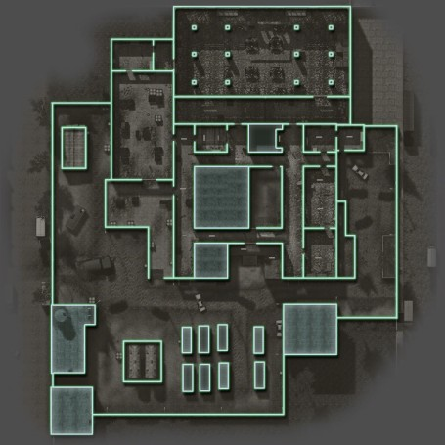

**Submarine Layout**

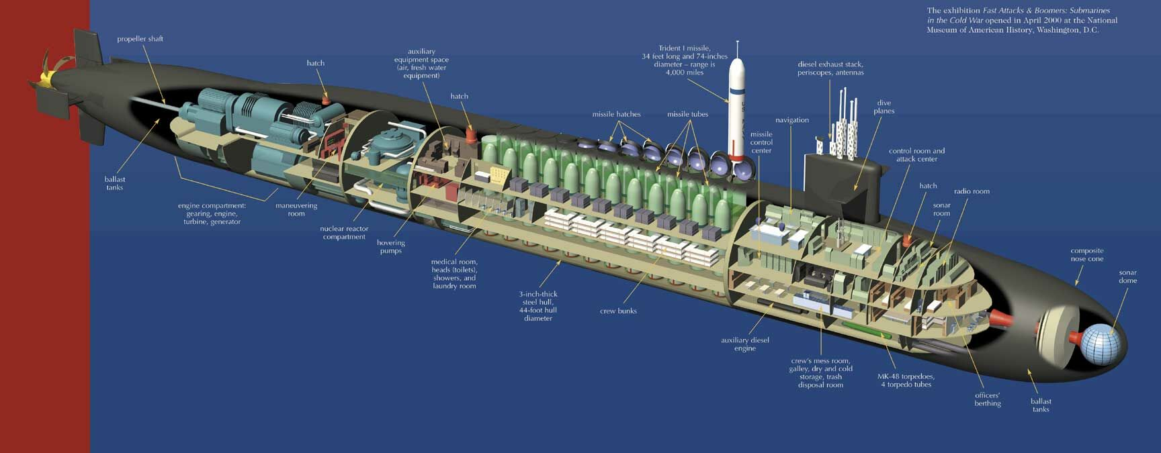

NPCs

**Niccolo Kristof**

There’s not much to say about Niccolo Kristof. He is an undercover agent who made the mistake of getting caught by Ragnor Blackridge. He has been beaten severely, but still breathes and can let the players know that they must stop Ragnor from forging documents that would incriminate General Dynamics and make it look like their 800 million dollar deal involved a deal with North Korea. He will not be able to help the players in their battle due to his condition.

**Korean Spies**

The Korean spies are armed with pistols and are crack shots. Make these enemies the hardest enemies in the game. They have no attachment to Ragnor Blackridge and when they are discovered by the players they believe Ragnor has set them up and will execute Ragnor as he pleads for his life. Make the Korean Spies have more health than normal, like a two or three shot kill instead of just one like normal enemies.

|  |  |  |  |  |
| --- | --- | --- | --- | --- |
| Korean Spy | MELEE WEAPON | MELEE SKILL | RANGED WEAPON | RANGED SKILL |
| SPY 1 | Unarmed  (extra damage: 0) | 8 | SMG (extra damage: 7) | 9 |
| Spy 2 (fleeing spy) | Knife (extra damage: 4) | 9 | Pistol  (extra damage: 6) | 8 |

**Enemies / Guards**

Feel free to sprinkle the difficulty of the guards around the wine cellar based on the skill and challenge you feel your players are up to facing. However, remember that this part of the game is meant to be challenging and more combat focused than earlier in the game. The standard wine cellar guards have the following attributes and gear. For enemy health, use your best judgement, but try to make it so that players defeat enemies pretty easily.

|  |  |  |  |  |
| --- | --- | --- | --- | --- |
| GUARD TYPE | MELEE WEAPON | MELEE SKILL | RANGED WEAPON | RANGED SKILL |
| Easy DIFFICULTY | Unarmed  (extra damage: 0) | 5 | Pistol (extra damage: 5) | 5 |
| MEDIUM DIFFICULTY | Baton (extra damage: 3) | 6 | SMG  (extra damage: 6) | 6 |
| HARD DIFFICULTY | Knife (extra damage: 4) | 7 | Rifle (extra damage: 7) | 7 |

Mission Events

**Getting to the Elevator**

Salvador Sharpe will lead the players to the elevator to go down to the wine cellar. Upon arriving at the elevator the guards tell the players they cannot enter the elevator. Salvador should assure the guards that the players are with him. However, these guards are not under the hire of Salvador. They forcefully tell Salvador that no one may enter the cellar at this time. When Salvador presses the issue further by shouting at the guards he is pistol whipped by the guards and knocked out. This will be a melee combat that will cause the guests at the party to start to freak out and draw more guards into the area. The players must quickly dispatch of these rouge guards and take the elevator before they are overwhelmed by the event security.

**Into the Wine Cellar**

The wine cellar is massive and labyrinth in nature. Use this part of the game to play to the strengths of the saboteur class by giving opportunities to fool guards and unlock doors. Use the analyst’s abilities to solve logic puzzles if you are feeling up to it, as well. Just make sure there are plenty of close combat and ranged combat battles to give the captain a chance to lead his team and the assassin a chance to do what he does best.

**Finding Niccolo Kristov**

One of the rooms the players will stumble upon contains the missing operative that was mentioned in the briefing. The players need to find him in order to discover the true plot that is going on (mentioned in the Overview above). Niccolo will also point the players in the right direction for the final showdown with Ragnor and the Korean spies. He will be unable to help the players beyond giving them this information.

**Showdown**

The final showdown with Ragnor and the Korean Spies involves breaking into the locked room and disrupting the weapons deal. The Korean Spies will immediately pull out weapons and start to yell at Ragnor, claiming that he set them up and that they knew this was a trap. From here, as the Game Master you can play the situation out in a few ways. You can have the Korean spies hold Ragnor at gunpoint and create a hostage scenario or you can have Ragnor plead for his life and be shot by the spies. Do whatever you feel matches the feel of the game and would please the players.

The battle between the Korean spies can end with both of them being shot down by the players, or if you are feeling adventurous and would like to make an epic chase ending you can have one of them escape out of the wine cellar through a secret entrance that leads to the back of estate pier. The left behind, and presumably shot and dying other Korean spy can say to the players that they are too late and they already have the submarine in their possession. If you decide to go this route, use the Optional Ending below:

Optional Ending

**The Pier**

The players give chase to the fleeing Korean spy down the secret passage that leads to behind the estate right before the pier. From here it is an open area like environment where there are guards shooting at the players. The players will have to cover each other and take out guards that are guarding the pier while the fleeing Korean spy runs towards the submarine that is rising out of the ocean next to the pier. The firefight with the guards should occupy the players so that the Korean spy can enter the submarine. The players will have to quickly run to the pier and board the submarine to stop it from getting away.

**The Submarine**

The players will have to navigate the submarine, carefully taking out guards, unlocking doors, and finally get to the fleeing Korean Spy who has his hands on the button for the missile launch. This should be a tense moment where one wrong move can force the Korean spy to launch the missiles. The should have had time between getting to the Korean Spy to either formulate a plan on how to stop him or sabotage the submarine on their own. Let the players be creative with this ending and how they want to solve it. Give them plenty of options inside the submarine but make it clear that they must stop the submarine at any cost!