Travis Moore

GAT212—Spring 2015

Instructor: Chris Champagne

Subterfuge RPG

Player Guide

Table of Contents

Subterfuge RPG Player Guide 3 – 22

Welcome to *Subterfuge RPG* 3

What is a Roleplaying Game (RPG)? 3 – 4

Game Theme and Genre 4

Components 4 – 5

Attributes 5 – 6

Skills 6

Character Generation 7 – 11

Creating your Character 7

Determining Attributes, Skills, and Health 8 – 9

Determining Class Type and Abilities 9 – 10

Provisioning and Types of Gear 10 – 11

Level Progression 11

How to Play 12 – 13

Taking Your Turn 12

Movement/Terrain 12

Non-combat Actions 12

Combat Actions 12 –13

Combat 13 – 18

Melee Combat 14 – 15

Ranged Combat 15 – 17

Life/Death Checks 17 – 18

Character Sheets 18 – 22

Pre-made Captain 19

Pre-made Assassin 20

Pre-made Saboteur 21

Pre-made Analyst 22

Subterfuge RPG Player Guide

Welcome to *Subterfuge RPG*

Have you ever wished for a life of danger and excitement? Have you ever dreamed what it would be like to be a highly-trained spy with access to the latest tools of espionage and weapons? Have you ever wanted to participate in a top secret mission alongside a team of other highly trained spies and save the world from threats they never even knew existed?

In *Subterfuge RPG* you can live out this fantasy and take on the role of one of the world’s finest spies. Become highly specialized and lead the team to victory as a spy captain, be a deadly force of reckoning as a spy assassin, learn the tools of the trade as a spy saboteur, or be a master of skills as an intelligence agent.

All you need for *Subterfuge RPG* is a group of willing friends with some imagination and together you can take on daring missions full of danger and mystery where you must work together to save the world from destruction. In this guidebook you’ll find everything you need to create a dangerous spy and take on top secret missions of your own.

What is a Roleplaying Game (RPG)?

Perhaps you have never really played a formal RPG, but there is a pretty good chance that at one point in time while you were growing up you played games of make-believe. A roleplaying game (RPG), is just like a game of make-believe but with an emphasis on storytelling and a little bit of structure.

*Subterfuge RPG* is a spy-fiction game where you create a character and team up with your friends on top secret missions that only highly-trained spies could handle. *Subterfuge RPG* uses dice and written rules, but the majority of the game is played in your imagination with the help of a Game Master who helps to tell the story of what is going on. Since the game takes place in your imagination the possibilities are limitless and you can truly play the game in any way you can think of.

*Subterfuge RPG* uses a Game Master (GM) to help keep the game’s story and rules in check, sort of like a storytelling referee. It is the GM’s responsibility to narrate the adventure of the spies’ mission to the players and react to the actions that the players take in a manner that fits the theme of the game. The GM is what makes *Subterfuge RPG* as infinitely flexible as it needs to be in order to allow the players to play the game in any way they would like to play it.

The mission in *Subterfuge RPG* is the core of the game and is where the game takes on a feeling of playing a spy movie or novel. The GM will set the scene for the players but where the story goes from there is up to the actions taken by the players, so anything can happen. Of course, the GM can reign the players in if the players get too off track and need to be reminded that time is of the essence if they are to complete their mission in time to save the world.

As a cooperative game, *Subterfuge RPG* requires a group of friends to work together and leverage each other’s character skills to complete the mission and have fun. As a storytelling game think of how your character fits best in the story. Is your character a take charge type of leader? Is your character more of a behind-the-scenes operator? Do your best to stay in character and help your team in any way you are able to. This will make the game more fun for everyone and ensure everyone is having a good time.

Your character continues to get better even when the game is over. By completing the mission everyone wins and gains new abilities to use in the next mission. Occasionally your character might die, whether overwhelmed by an enemy or sacrificing themselves for the good of the team. However, even if your character is defeated you do not really lose. A fellow teammate might be able to revive your character or you could create a new and different character altogether. Maybe your character might fail to complete the mission, but if you had a fun time with your friends then the whole group wins in the end.

Game Theme and Genre

*Subterfuge RPG* is a spy-fiction game set in the year 2015. This era is in an unstable state sitting at the brink of what could be a truly devastating world war. Governments take secret actions in order to stay safe not to implicate themselves in events that might be seen as acts of war. Getting caught is not an option, this is why your government has called on your team of highly-trained spies to carry out this mission. As spies you have access to the best gear your government can offer you. For the good of your country and the world you must carry out this mission successfully, good luck!

Components

While the bulk of *Subterfuge* RPG takes place in your imagination, there are a few components that are required in order to play the game:

* Player Guide: This very book should be used as reference during the game for all the players.
* Game Master Guide: The Game Master will need this book to use as a reference before and during the game.
* Character Sheet: All players should create a character and track of their player’s information, abilities, skills, and gear using a filled out *Subterfuge RPG Character Sheet*.
* Dice: *Subterfuge RPG* uses common D6 dice. Everyone (players and Game Master) should have at least one D6.

Attributes

After imagining the personal details of your spy, the next thing your character needs is concrete statistics that mathematically define your character. These 4 attributes are important for creating a quick description of your character’s physical and mental characteristics and are used to create their Skills, as well.

The higher the value of an attribute the stronger this attribute is for your character. Is your character physically tough but mentally weak? Perhaps your character is incredibly intelligent, but not very creative. Your attribute values will help to define these qualities, creating your character’s strengths and weaknesses:

Strength

The *Strength* attribute measures your character’s physical power. This attribute is important for characters that are capable fighters and leaders as this attribute affects the *Ranged Combat*, *Melee Combat*, and *Leadership* skills. Characters with a high *Strength* attribute tend to make good *Captain* or *Assassin* spy classes.

Intelligence

The *Intelligence* attribute measures your character’s mental capabilities. This attribute is important for characters that are great problem solvers and observant of their surroundings. This attribute affects the *Ranged Combat*, *Reasoning*, and *Awareness* skills. Characters with a high *Intelligence* attribute tend to make good *Assassins* or *Analyst* spy classes.

Willpower

The *Willpower* attribute measures your character’s fortitude and persuasiveness. This attribute is important for characters that need to inspire or deceive or otherwise be self-capable. This attribute affects the *Leadership*, *Deception*, and *Awareness* skills. Characters with a high *Willpower* attribute tend to make good *Captain* or *Saboteur* spy classes.

Ingenuity

The *Ingenuity* attribute measures your character’s physical power. This attribute is important for characters that are capable fighters and leaders as this attribute affects the *Melee Combat*, *Deception*, and *Reasoning* skills. Characters with a high *Ingenuity* attribute tend to make good *Analyst* or *Saboteur* spy classes.

Skills

Once your character has their attribute values determined, their skills can be derived from these values. Skills are important in helping you decide what kind of class your character would be best suited towards and are used when certain *Skill Checks* need to be made.

Do not despair of your character is not particularly skilled in a few areas as your teammates will more than likely make up for areas that you lack, while you provide in areas that they lack.

Ranged Combat

The *Ranged Combat* skill is used to determine how effective your character is using weapons like tasers, pistols, sub-machine guns, and sniper rifles.

Melee Combat

The *Melee Combat* skill is used to determine how effective your character is in close quarters combat, whether unarmed or using weapons like a blackjack, knife, baton, or garrote wire.

Leadership

The *Leadership* skill is used to determine how effective your character is at intimidation, keeping morale, and supporting others. A high value in *Leadership* *Skill Checks* can trump *Reasoning Skill Checks*.

Deception

The *Deception* skill is used to determine how effective your character is at stealth, bluffing, and tricking others. *Deception Skill Checks* can undercut the effectiveness of *Leadership Skill Checks*.

Reasoning

The *Reasoning* skill is used to determine how effective your character is at solving problems and can possibly see through *Deception Skill Checks*.

Awareness

The *Awareness* skill is used to determine how effective your character is at understanding their surroundings and observing details.

Character Generation

The first step in playing *Subterfuge RPG* is to imagine the type of character you’d like your spy to be. Your character will be the combination of what you come up with in your imagination along with the rules for character generation. You’ll use your imagination for personal things like your character’s name, physical appearance, and backstory. Dice will be used to determine other things like your character’s skills and personality traits. After the dice rolls determine your stats, you may then choose your character’s spy’s class and an ability to go along with it. Lastly, you’ll buy gear for your spy before setting out on the mission at hand.

Creating your Character

The first decisions you should make when creating your character come straight from your imagination. On the *Subterfuge RPG Character Sheet* under the “Personal” section you should write down the details of what makes your spy unique. Remember, you can have your character be anyone you would like them to be. Use this opportunity to live out your own spy fantasy or simply explore what it would be like to be something you are not. Be as creative as you like when determining the following personal details with your spy:

* *Name*: The real name of your character as they exist in this fictional spy world. This does not have to be your name, but it can be if you want to pretend that you are playing as yourself in this fictional spy world.
* *Alias*: The code name that your character goes by, for example: “Agent Laz0r”
* *Gender*: How does your character identify? Whether male, female, trans-gender, or otherwise, use this space to identify your character.
* *Eye Color*/*Hair Color*: Use these to further personalize your character.
* *Physical Description*: How does your character look? Are there any unique physical characteristics like piercings or tattoos? Use this space to help the other players “see” your character in their imagination.
* *Backstory*: This part of character creation is where you can really let your imagination shine. Use this section to let the players and Game Master really understand who your character is. Feel free to give your character motivations, fears, desires, etc…

Determining Your Attributes, Skills, and Health

Using D6 dice, the next step in creating your character involves determining what your character’s primary attributes of strength, intelligence, willpower, and ingenuity are. These attributes will be used in determining your character’s skills, as well.

Step 1: Determining Attributes

Determining your character’s *Strength*, *Intelligence*, *Willpower*, and *Ingenuity* attributes involves rolling a for each attribute one at a time using a D6 and adding up the value until you either reach 10 or bust by going over 10. If you roll and the result adds up to 10 then you receive a perfect 10 in that attribute. If you go over 10, then the last value from your roll(s) is used as the value for this attribute.

*For Example:*

*Auston is rolling for his Strength Attribute. His first roll is a 6. Auston’s next die roll is a 4. Auston adds 6 + 4 to get a perfect 10 for his Strength attribute.*

*For Auston’s Intelligence attribute he first rolls a 3. His next roll is a 4, making his new total so far at 7. His next roll is a 6. Since 7 + 6 = 13, Auston has busted by going over 10. Therefore, Auston’s Intelligence attribute will be his last combination of rolls, which is 7.*

Step 2: Determining Skills

Determining your character’s skills uses the attribute values that were previously determined in the last step. Beneath the attributes on the *Subterfuge RPG Character Sheet* are the skills listed for each character. Each of these skills are determined by adding up the appropriately listed attributes and dividing this total in half (rounding down) to get the value for each skill.

*For Example:*

*Auston Strength attribute is 10 and his Intelligence attribute is a 7. The Ranged Skill is determined by adding the Strength and Intelligence (10 + 7 = 17) attributes together and then dividing this total in half (17 / 2 = 8.5). Lastly, round the total down to a whole number (math.floor(8.5) = 8). Therefore, Auston’s Ranged Skill is 8*

Step 3: Determining Health

Determining your character’s health involves adding up the *Strength*, *Intelligence*, *Willpower*, and *Ingenuity* attributes, dividing four and rounding up.

*For Example:*

*Auston “Strength” attribute is 10, “Intelligence” is 7, “Willpower” is 9, and “Ingenuity” is 7. Auston adds these attributes together to get 32 (10 + 7 + 9 + 7 = 33). Next Auston divides this total by 4 giving him 8.25 (33 / 4 = 8.25). Lastly, Auston rounds up the total giving him 9 health (math.ceil(8.25) = 9).*

Determining Class Type and Abilities

Now that your character has all their attributes and skills determined it is time to figure out what role your character will play in his team of spies. There are four types of spy classes, each of these classes leverage an area of attributes and skills more than the others and provide abilities that other class types do not have.

Having a well-rounded team of spies is a good idea in order to have a little bit of everything on your team. A character can have one ability per level of their class. Be sure to choose wisely!

Captain

The *Captain* class uses their *Willpower* attribute to the fullest, especially because this attribute combines to create the *Leadership* and *Awareness* skills. As a *Captain* you are the team’s leader and inspire others to perform to their greatest abilities:

* *Inspire*: Once per mission you can allow a teammate to reroll any type of *Skill Check*.
* *Intimidate:* Once per mission you can force the Game Master to undo an action taken by an enemy and force a different outcome.
* *Sacrifice:* Once per mission you can take a failed *Deathblow* from an ally, saving them, and attempt to take the damage instead (roll to pass a *Deathblow Check* if applicable).

Assassin

The *Assassin* class uses their *Strength* attribute to the fullest, especially when this attribute is combined into the *Ranged Combat* and *Melee Combat* skills. As an *Assassin* you are the team’s primary damage dealer and are equally capable in both weapons and close range combat:

* *Assassinate*: Once per mission you can instantly kill any enemy that is not the main villain.
* *Deadly:* Once per mission you can reroll a failed *Ranged Combat* and also a failed *Melee Combat* roll.
* *Quick:* Once per mission you can perform both *Melee Combat* and *Ranged Combat* in the same turn against multiple enemies.

Saboteur

The *Saboteur* class uses their *Ingenuity* attributes to the fullest, especially as this attribute is combined into the *Deception* and *Awareness* skills. As a *Saboteur* you are the team’s means of stealth and dealing with contraptions:

* *Creative*: Once per mission you suggest an alternate means of solving a non-combat problem that would utilize a *Skill Check* of your choice.
* *Stealth:* Once per mission you guarantee not getting caught/tripping an alarm/being seen for any situation.
* *Trickery:* Once per mission you can fool an enemy, except the main villain, into thinking you are on their team and have them do something for you.

Analyst

The *Analyst* class uses their *Intelligence* attribute to the fullest, especially as this attribute is combined to make the *Reasoning* and *Awareness* skill. As an *Analyst* operative you are the team’s means of problem solving and keeping the team alive:

* *Medicine*: Twice per mission you can roll a D6 and heal any member of your team (including yourself).
* *Surveillance:* Once per mission you can privately talk to the Game Master to find out what major event/problem is coming up next.
* *Unbelievable Science:* Once per mission you can make a compelling, but most likely fake, scientific argument against a current situation to completely disregard and change the outcome (including the death of an ally).

Provisioning and Types of Gear

Gear is essential in helping your character tackle non-combat and combat situations. The specific gear available changes from mission to mission and can be provisioned from the list available in a *Mission Guide*.

Gear is divided into three types in *Subterfuge RPG*: *Apparel*, *Weapons*, and *Items*. Each of these types can contain a multitude of different gear, but the type it falls under controls the purpose of the gear and where your character stores this in your character’s equipment section of the character sheet.

Apparel

All gear under the *Apparel* category can be worn by the player’s character. *Apparel* is worn in the “Apparel” slot of the equipment section on your character sheet. *Apparel* serves the purpose of providing your character some protection for ranged attacks or it can act as a disguise to help fool enemies.

Weapons

All gear under the *Weapons* category can be used in *Melee Combat* or *Ranged Combat*. *Weaons* are carried in the “Melee Weapon” or “Ranged Weapon” slots of the equipment section on your character sheet. *Weapons* serve the purpose of providing your character *Ranged Combat* capability or adding to your melee damage in *Melee Combat*.

Items

All gear under the *Items* category can be used by your character in non-combat or combat situations. *Items* are carried in the “Item” slots of the equipment section on your character sheet. *Items* can be used for a variety of purposes, from solving puzzles, fixing equipment, or as a makeshift weapon in a dicey situation.

Level Progression

Upon creation of your character you start off at level 1. Successfully completing missions without dying grants your character (and those still alive in your spy team) an additional level. Gaining a level is one of the biggest awards you can receive for completing a mission because it allows your character to gain a new ability within your class:

Gaining a New Class Ability

*For Example:*

*Auston successfully completed a mission with his level 1 character, “Agent Laz0r”. Auston’s character is an Analyst spy class with the “Medicine” ability. Auston’s character is now level 2 and he can choose another ability (“Surveillance” or “Unbelievable Science”) from the Analyst spy class that he did not previously have.*

Gaining a new level also allows the player the chance to increase their lowest attribute by rerolling using the same process that was used upon creation of this character.

Rolling for an Increased Attribute

*For Example:*

*Auston’s character’s attributes are: Strength: 10, Intelligence: 7, Willpower: 9, and Ingenuity: 7. Auston can choose to reroll for either Intelligence or Ingenuity, but not for both. Using the process listed on the Subterfuge RPG Character Sheet Auston rerolls for his Intelligence attribute and gets a new value of 9, replacing this value (if a lower value is rolled, then no new value is taken and the old value is used instead).*

How to Play

The spy you created during the character generation process is your “character” for the rest of the game. Through your character you will interact with the game world in any way you can imagine. Each player will play the game by informing the Game Master and each other with what they would like to do on their turn.

Taking Your Turn

The Game Master will control the pace of the game and let players know which player is taking their turn. When it is you will say out loud for all the other players and the Game Master to hear what actions you would like to take with your character. Do not worry yourself about what you can and cannot do, the Game Master will let you know if your actions are outside the boundaries of the game.

Movement/Terrain

*Subterfuge RPG* does not require the use maps or character avatars to display where your character is in the game world. For this reason movement is carefully controlled by the Game Master who might wish to draw out rough maps if or when they feel it is needed. For the most part, the Game Master will describe the environment the players are in to the best of their ability and let you know how easily passible terrain may or may not be for your characters.

Non-Combat Actions

Any kind of action that does not actively involve combat is a non-combat action. You can make decisions about all sorts of things like moving across the room to look out the window, climbing a ladder, or talking to another character in the game. All you have to do to take a non-combat action is tell the Game Master what you would like to do. The Game Master will then tell you what happens when your character does it.

*For Example:*

*Auston wants his character, Agent Laz0r to climb down the sewer ladder. The Game Master explains to Auston that his character carefully climbed down the ladder into a dark, gloomy tunnel that spans to the east and west. From here, Auston can decide what else to do or the Game Master can let Auston know that his turn is now over.*

Combat Actions

Combat actions take place when your character is performing offensive or defensive actions against an enemy. Combat performed in a turn-based manner, with the Game Master acting as the referee for who goes first and determining the outcomes of combat events. See more in the *Combat* section of this guide.

Combat

Whether you are performing a stealthy melee kill or in a shootout with multiple enemies, combat is of important consequence in *Subterfuge RPG*. Combat usually occurs when you enter an area of enemies and have been spotted or are attempting to attack an enemy unseen. Either way, combat is played out in a turn-based style using weapons armor and combat skills to determine damage dished out and received for our spies and the enemies.

Combat is organized by *Rounds* and *Turns*, with *Rounds* comprised of each participant getting one *Turn* to perform 1 *Move Action*, 1 *Non-Combat Action*, and 1 *Combat Action*. Once every participant has had 1 *Turn* a new *Round* starts unless combat is deemed over by the Game Master. *Turn Order* is based off every character and enemies’ *Awareness* attribute, with the highest *Awareness* attribute value going first. If there is a tie for the highest *Awareness* attribute value, then the Game Master may elect to have every character involved roll a D6 with the highest value going first, or they may simply assign *Turn Order* to their choosing.

Your Turn—Step 1: Move Action

You may choose to move your character equal to the *Move Speed (Move Speed* is the current value of your character’s *Health*). This move may put you in or out of *Melee Combat* unless the Game Master declares that you are “Pinned Down”.

Your Turn—Step 2: Non-Combat Action

You may choose to take a *Non-Combat Action* with your character during your turn. This type of action does not involve directly harming an enemy and involves only the space or the spaces around your character.

*Examples:*

* Reloading
* Switching Weapons
* Closing a Door
* Pulling out a Grenade
* Yelling to a Teammate
* Ducking into Cover

Your Turn—Step 3: Combat Action

If possible you may choose to take a combat action involving either your *Melee Combat* or *Ranged Combat* skills. You may only perform a *Melee Combat* if there is an enemy within one space of you, otherwise if you have ammo for a ranged weapon, you may use it for *Ranged Combat*.

Melee Combat

*Melee Combat* is a *Combat Action* that occurs when your character and an enemy are within one space of each other. Melee weapons are only used in this type of combat, and if your character does not have a melee weapon, then they will fight unarmed, without the aid of a weapon.

The character performing *Melee Combat* is the attacker, with the other character being the defender. Damage is dealt to the defender based on the attacker’s melee weapon plus their *Melee Combat Roll* against the defender’s *Melee Combat Roll*. Note that armor does not factor in *Melee Combat*, making *Melee Combat* potentially very dangerous, but also very effective. Damage is dealt using the following formula:

Melee Attacker Damage Melee Defender Protection

Damage = (Melee Weapon + *Melee Combat Roll*) – (*Melee Combat*)

Damage dealt to the health of the defender is the positive difference between the attacker’s total against the defender’s total. If the difference is not positive, then no damage is dealt. If the damage is not enough to kill the defender then the two characters are still engaged in melee combat.

Step 1: Melee Attacker’s Damage

Determining the attacker’s damage involves adding the value of their melee weapon and a D6 die roll using the attacker’s *Melee Combat* skill. The *Melee Combat Roll* allows the attacker to test the limits of their abilities to get the most damage possible or get unlucky and bust by going over their *Melee Combat* skill value. The attacker will roll their D6 as many times as they would like, adding the values together until they reach their *Melee Combat* skill value. If the attacker rolls exactly up to their *Melee Combat* skill value, then the damage they add for this is double! If the attacker goes over their *Melee Combat* skill value, then they get no extra damage from this roll.

*For Example:*

*Auston character has a knife with a damage value of 3, so he adds this as his Melee Weapon. Auston’s character has a Melee Combat skill value of 8, so he can potentially roll his D6 up to a maximum value of 8 (adding 16 damage if he gets to exactly 8). Auston’s first roll is a 3. Auston elects to roll again, rolling a 4. Auston’s total damage so far is 7. Rather than risk going over his Melee Combat skill, he accepts this value and has a total amount of damage of 10 (3 + 7 = 10).*

Step 2: Melee Defender’s Protection

Determining the defender’s protection involves adding their *Melee Combat* skill as their Melee Protection.

*For Example:*

*Auston character is under attack. Auston’s Melee Combat skill value is 8, so the amount of protection he has is 8.*

Step 3: Determining Damage to the Defender

Determining the damage done to the defender is the positive difference when you subtract the defender’s protection from the attacker’s damage. If the difference is positive, then that value is subtracted from the defender’s health. If the defender is still alive, then these two characters are still in melee combat. If the defender is a player’s character and this character is now out of health, then they must roll a *Deathblow Check* to see if they are still alive (see Life/Death section below).

*For Example:*

*Auston’s character is under attack from an enemy! Auston’s attacker has a damage total of 13, while Auston’s protection is 8, dealing 5 damage to Auston’s character (13 – 8 = 5). Unfortunately, Auston only had 4 health, so now he must roll a Deathblow Check to remain in the game.*

Ranged Combat

*Ranged Combat* is a *Combat Action* that occurs when your character is more than one space away from an enemy, within their ranged weapon’s range, and have ammo for their ranged weapon. Ranged weapons are only used in this type of combat, and if your character does not have a ranged weapon, then they are unable to perform *Ranged Combat* at all.

The character performing *Ranged Combat* is the attacker, with the other character being the defender. Damage is dealt to the defender based on the attacker’s melee weapon plus their *Ranged Combat Roll* against the defender’s armor plus their *Ranged Combat Roll*. While not as effective as *Melee Combat*, *Ranged Combat* is safer for the attacker.

Ranged Attacker Damage Ranged Defender Protection

Damage = (Ranged Weapon + *Ranged Combat Roll*) – (Armor + *Ranged Combat Roll*)

Damage dealt to the health of the defender is the positive difference between the attacker’s total against the defender’s total. If the difference is not positive, then no damage is dealt. If the damage is not enough to kill the defender then nothing extra happens.

Step 1: Ranged Attacker’s Damage

Determining the attacker’s damage involves adding the value of their ranged weapon and a D6 die roll using the attacker’s *Ranged Combat* skill. The *Ranged Combat Roll* allows the attacker to test the limits of their abilities to get the most damage possible or get unlucky and bust by going over their *Ranged Combat* skill value. The attacker will roll their D6 as many times as they would like, adding the values together until they reach their *Ranged Combat* skill value. If the attacker rolls exactly up to their *Ranged Combat* skill value, then the damage they add for this is double! If the attacker goes over their *Ranged Combat* skill value, then they get no extra damage from this roll.

*For Example:*

*Auston character has a pistol with a damage value of 5, so he adds this as his Ranged Weapon. Auston’s character has a Ranged Combat skill value of 8, so he can potentially roll his D6 up to a maximum value of 8 (adding 16 damage if he gets to exactly 8). Auston’s first roll is a 3. Auston elects to roll again, rolling a 6. Too bad! Auston’s total damage is 9, putting him over his Ranged Combat skill. Auston only adds the damage from his pistol to do 5 damage total (5 + 0 = 5).*

Step 2: Defender’s Protection

Determining the defender’s protection involves adding a character’s armor along with their *Ranged Combat* skill for their Ranged Protection.

*For Example:*

*Auston character is under attack. Auston’s character has armor with a Kevlar Vest worth 5 protection and his Ranged Combat skill value is 8, so the amount of protection he has is 12 (5 + 8 = 13).*

Step 3: Determining Damage to the Defender

Determining the damage done to the defender is the positive difference when you subtract the defender’s protection from the attacker’s damage. If the difference is positive, then that value is subtracted from the defender’s health. If the defender is still alive, then nothing else happens. If the defender is a player’s character and this character is now out of health, then they must roll a *Deathblow Check* to see if they are still alive (see Life/Death section below).

*For Example:*

*Auston’s character is under attack from an enemy! Auston’s attacker has a damage total of 11, while Auston’s protection is 13. Since the difference between the damage and protection is -2, no damage is dealt (the damage is not positive).*

Life/Death

When a character’s health reaches 0 (having no more hearts left on their character sheet they have reached the tipping point of life and death. Thankfully, our highly trained spies are extremely lucky and difficult to kill. This player must now roll a *Deathblow* *Check* for their character based on their character’s *Willpower* attribute.

The player subtracts the value of their *Willpower* attribute from 11 to get the *Deathblow Number*. The player must roll their D6 higher than this number to continue to live. If the player beats this number with their D6 roll, then their character lives and their health is raised to the difference that was greater than the *Deathblow Number*. If the player fails then their character dies and is no longer usable in any mission.

Step 1: Get the Deathblow Check number

Take your character’s *Willpower* attribute value and subtract this from 11 to get the *Deathblow Check* number.

*For Example:*

*Auston character, Agent Laz0r*, *has run out of health! Auston’s character has a Willpower of 9. Auston subtracts his Willpower attribute of 9 from 11 to get 2 (11 – 9 = 2).*

Step 2: D6 Roll against the Deathblow Check number

Try to roll higher than the *Deathblow Check number* using your D6. Rolling higher than the *Deathblow Check* number means your character lives and now has health equal to the difference between the *Deathblow Check* number and your D6 roll. If your D6 roll is equal to or less than the *Deathblow Check* number then sadly your character’s luck has run out and has died.

*For Example:*

*Auston must roll higher than a 2 on his D6 roll. Auston beats the Deathblow Number with a D6 roll of 5! Auston’s character is still alive with 3 health left (5 – 2 = 3).*

Character Sheet

Use the blank character sheets at the back of this player guide to create and maintain your character. You will use this form to track their progress in the game as far as their equipment and health goes. After completion of a mission you will go up in level and gain new abilities based on your class.

*Subterfuge RPG Character Sheet*

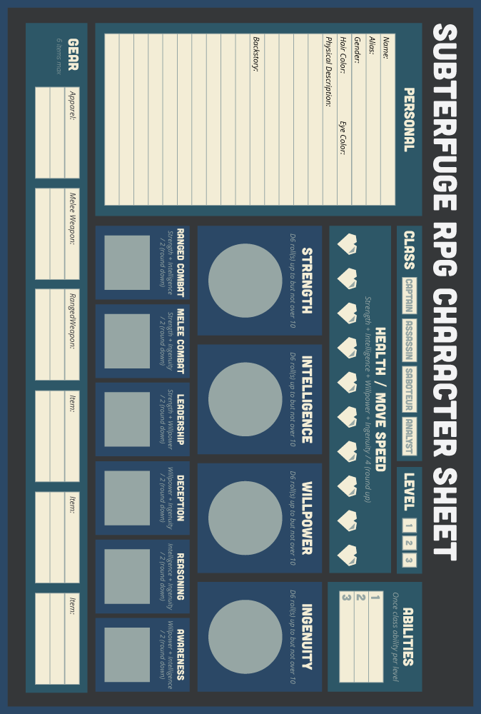

*Subterfuge RPG Pre-made Captain*

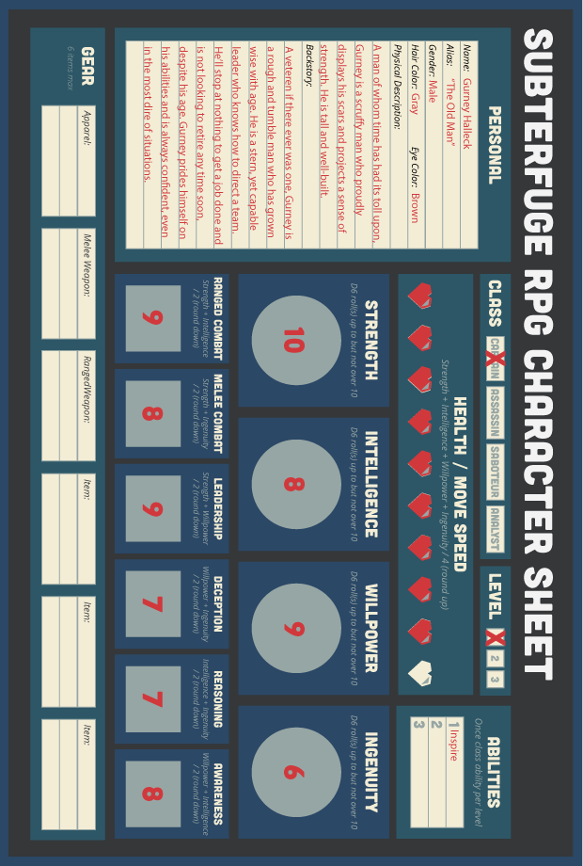

Pre-made Captain

Here’s an example of a pre-made character whose attributes and skills would make a great Captain class.

*Subterfuge RPG Pre-made Assassin*

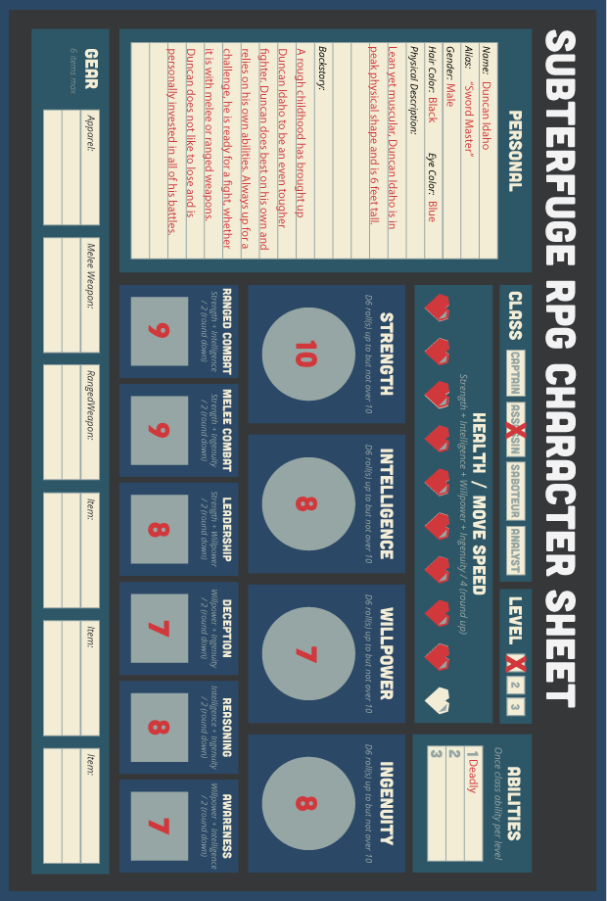

Pre-made Assassin

Here’s an example of a pre-made character whose attributes and skills would make a great Assassin class.

*Subterfuge RPG Pre-made Saboteur*

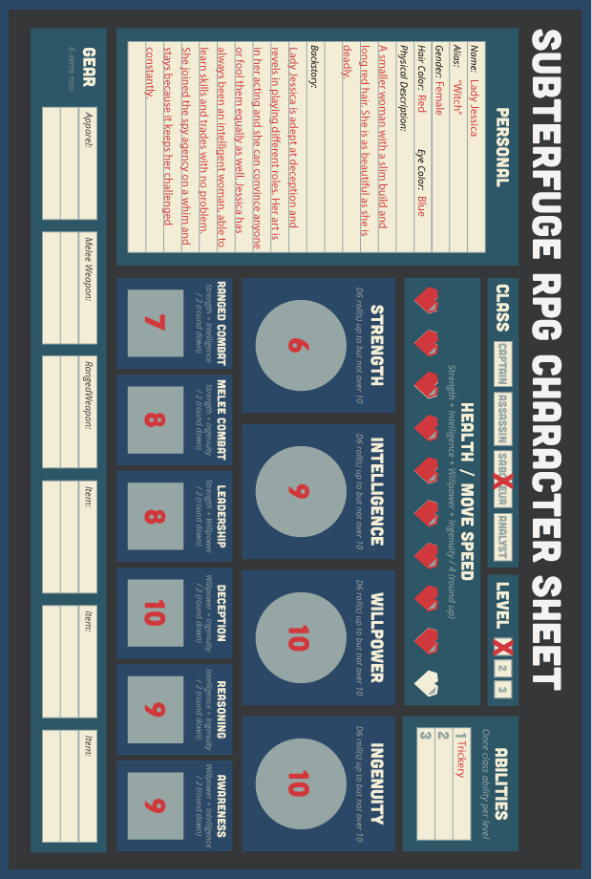

Pre-made Saboteur

Here’s an example of a pre-made character whose attributes and skills would make a great Saboteur class.

*Subterfuge RPG Pre-made Analyst*

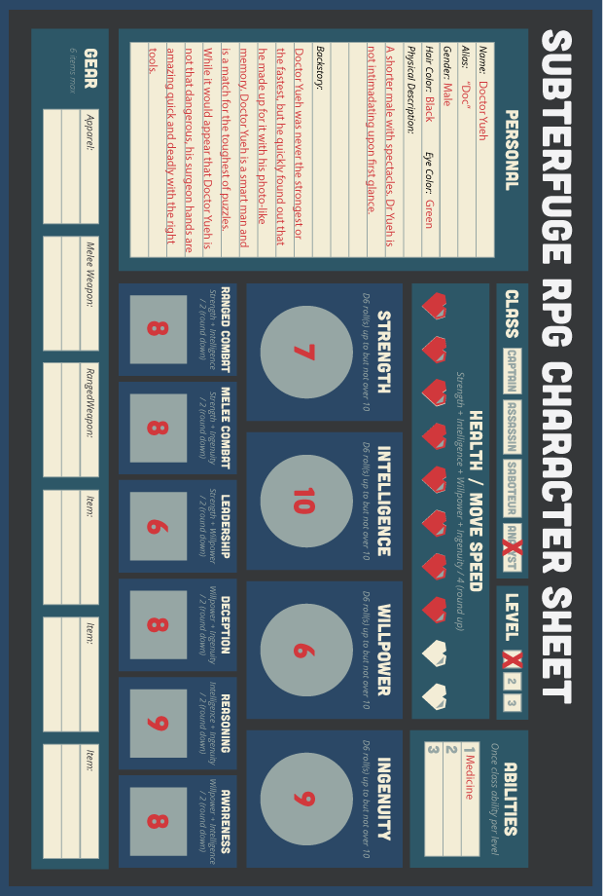

Pre-made Analyst

Here’s an example of a pre-made character whose attributes and skills would make a great Analyst class.

