Travis Moore

GAT212—Spring 2015

Instructor: Chris Champagne

Subterfuge RPG Playtest

Table of Contents

Subterfuge RPG Character Generation

Character Sheet 3

Subterfuge RPG Combat System

Overview 4 – 5

Playtesting

Character Created 5 – 6

Problems / Successes 6 – 7

Subterfuge RPG Character Generation

Character Sheet

This is the basic character sheet for keeping track of their character’s information, stats, abilities, and equipment. The character sheet has a Personal section for name, alias, gender, weight, eye color, hair color, physical description and a character backstory. The sheet also allows the player to write down their class, current level, abilities, and track health. Stats are primarily centered on the sheet to give full attention to their importance. Strength, intelligence, willpower, and ingenuity are all stats used in the game and together they combine to create secondary stats like ranged skill, melee skill, leadership, deception, sciences, awareness, and health. Lastly, the player can track their equipment in the slot system used on the character sheet.

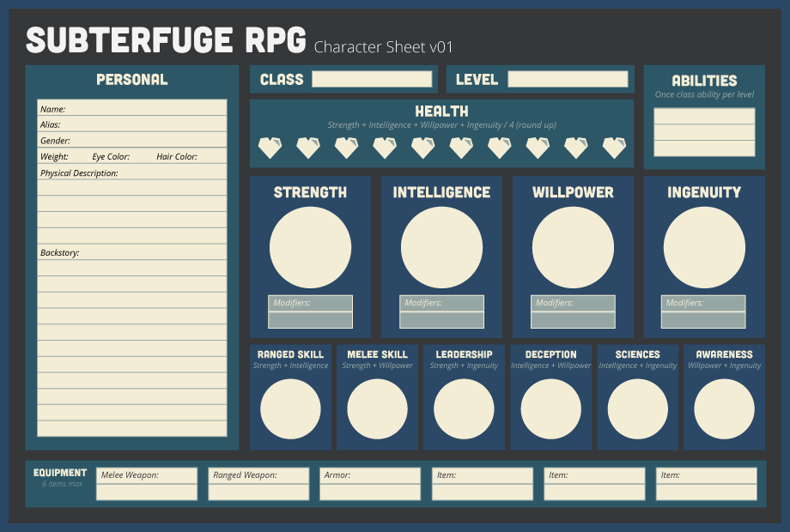  
*Subterfuge RPG Character Sheet v01 with combat system*

Subterfuge RPG Combat System

Overview

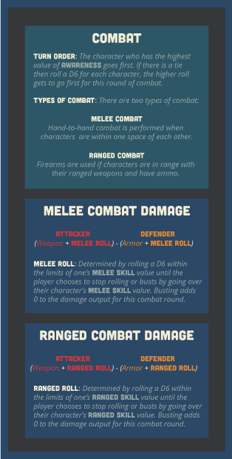  
*Subterfuge RPG combat system*

The character sheet also has a brief side section with a rundown of the combat system used through the game, as seen above. Basically the combat system is meant to be simple so that combat can be resolved quickly, but acknowledge character skill and a bit of pushing your luck involving character skill and dice rolling. Essentially, an attacker adds their weapon value to either a melee roll or a ranged roll against a defender’s armor value and either a melee roll or a defense roll. These skill rolls give the combat a bit of variability within the confines of one’s abilities.

The way these skill rolls work is based on pushing your luck through a mechanic a lot like the card game *Blackjack*. Let’s say a player has a character with a melee skill of 8 and wants to attack another character. The attacking player will roll a D6 to see how much extra damage they can add to their attack. If the player rolls a 4 they can simply add a 4 to their damage or let it ride and roll the D6 again to try to add this roll to their 4 and try get up to a maximum damage equal to the 8 of their melee skill. The player can keep rolling the D6 until they bust by going over 8. If this happens, then the player does not add anything to this round of melee combat. The same process happens for the defender.

It is my hope that this system adds a bet of gambling luck and weight to the player’s dice rolls in my combat system. I believe this system fits well within the theme of spies and espionage because in movies spies are portrayed as lucky and risk takers. With this combat system in place, the players can push the limits of their spies and try to take maximum advantage of their spy’s skills.

Playtest

Character Created

For my playtest I had Shaheene, a non-DigiPen student, try out my character generation and combat system to see if it made sense. Her character sheet can be found on the page below:

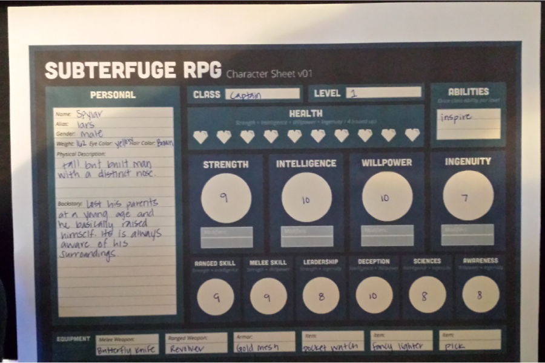  
*Spylar “Lars” has some great stats but questionable choice in armor*

Problems / Successes

The greatest strength in my playtest for the character generation has to be the ease of use for the character sheet. Shaheene said she thought the sheet looked great, but was not a big fan of how dark the black of the sheet was. She thought there was enough room for her to flesh out a backstory, and enjoyed how everything was compartmentalized out.  
 Perhaps also a success is the character generation mechanic itself, as well. Character generation for the stats of strength, intelligence, willpower, and ingenuity all involve rolling a D6 until busting at over ten. Shaheene was lucky enough to roll the dice several times and not go over ten, but actually get 10 twice. My idea behind this system was to let people get high numbers because they are meant to be highly trained spies, and having a high number will allow a greater spread for rolling for skill checks using the pushing luck mechanic I’ve decided to implement with the game. Shaheene never complained about getting high numbers, and if the rest of my playtests play out this way, it won’t be a big problem.

High numbers are great, but they can be a problem if it means there is too much similarity to the other spies playing the game. More playtests will need to be done to see if this system does not allow for enough variety between characters in the game. There is also a problem with the layout in my character sheet. There is not enough room for things like hair color and eye color, and equipment could use a little bit more space. Other than this, I believe character generation was easy to do and simple enough considering how complex it could have very well become.

The combat system seems to work well in its current form. The push your luck mechanic of rolling the dice until you bust seemed to appear fun because it gave Shaheene a way to control her fate in multiple rolls versus just one roll. Explaining the pushing your luck aspect could use a better example of the combat system sheet and is something I will definitely have to do for next time. At the time my weapons and armor do not really exist, and this is something I’ll have to tackle in future versions of my combat system. My playtest for combat systems is definitely not complete and needs these to move forward. More playtests will also need to be done to see if the push your luck mechanic is fun for most people and to see if it takes up too much time.