Travis Moore

GAT212—Spring 2015

Instructor: Chris Champagne

RPG Research Paper

Table of Contents

RPG1: Basic Dungeons & Dragons

Overview 3 – 4

RPG2: Top Secret RPG

Overview 4 – 5

RPG Comparison

Grid Comparison 5 – 6

Similarities 6 – 7

Differences 7 – 9

Lessons Learned

Observations 9 – 10

Appendix A

Dungeon & Dragons Character Sheet 10 – 11

Appendix B

Top Secret RPG Character Sheet 12 – 13

RPG1: Basic Dungeons & Dragons

Overview

*Basic Dungeons & Dragons* is a fantasy tabletop role-playing game originally designed by Gary Gygax and Dave Arneson and published by Tactical Studies Rules, Inc. in 1974. The game is well-known and widely regarded as being the most well-known modern role playing game. Utilizing a Dungeon Master to control the design of playing a game, participants play this open-ended RPG together as a group of adventurers set out on quests.

Before the game begins the dungeon master must determine a premade dungeon to explore or create a suitably designed dungeon of their own for the rest of the players to play through. Next, the players must create their player character to use in the game and record a variety of details about their characters using a character sheet (See Appendix A). Players roll dice to determine their player character’s abilities which will in turn determine some of their player character’s secondary attributes, as well. These statistics are important as the game uses basic arithmetic based upon these stats and dice rolls to determine the outcome of important events throughout the game.

After these attributes have been determined, the players can choose their player character’s race, such as Human, Dwarf, or Elf, and then choose their class, like Fighter, Magic User, or Thief. The combination of these things will help the players to also choose the moral alignment of their player characters. Lastly, players are encouraged to determine a backstory or other personal information for their player character to help further flesh out a believable character for that player to assume. Establishing the non-numerical information of their character is especially important in helping not only the player who is assuming their player character’s identity, but it is also important for the group as a whole so that the actions of the players will make sense within the fantasy realm in which the game will take place.

As the game begins the players will, with the help of their dungeon master, embark on a dangerous journey where their teamwork and individual player characters’ abilities will be essential in successfully enjoying their adventure. *Basic Dungeons & Dragons* relies highly upon both the imagination of the dungeon master as well as the players playing the game in order to create a fantastical game for all to enjoy.

RPG2: Top Secret RPG

Overview

*Top Secret RPG* is a spy-fiction tabletop role-playing game created by one designer, Merle M. Rasmussen and published by Tactical Studies Rules, Inc. in 1980. Much like *Basic Dungeons & Dragons*, *Top Secret RPG* is an example of a modern role playing game but instead of the traditional medieval fantasy-like setting, this game takes players on a journey through a more modern era of fantasy spy missions.

Before the game can begin, an administrator must be chosen to act as the person in charge of the game’s rules and story. The administrator can choose to play a premade mission or create an exciting mission of their own devising. By placing on person in charge of the rules and design of the mission the rest of the players do not have to bother themselves with these aspects of the game and get immerse themselves fully into the game. After the mission type has been selected, the rest of the players must create a player character of whom they will be role playing as.

Character creation is done through percentile dice rolling to determine characteristics of a player character’s attributes like strength, charisma, and courage. These attributes are stored by the players by keeping track of them on the game’s character sheets (See Appendix B). The outcomes of these dice rolls also help determine the player characters secondary traits, like offense, deception, and evasion. There is not a lot of room in *Top Secret RPG* for characteristics that are not determined through dice rolls, but more attributes like areas of knowledge, languages known, and even height and age are rolled for, too. Characters do get to freely choose which bureau their player character will work under, which will level them up in either the area of Investigation, Confiscation, or Assassination. While there is not a lot of freedom in personal choice for character creation, this system is set up to create very unique player characters for the players.

When the game begins the administrator and players will take on a clandestine operation full of espionage and danger that relies on all participants to make full use of their imagination in order to play the game.

RPG Comparison

Comparison Grid

|  |  |  |
| --- | --- | --- |
|  | Basic Dungeons & Dragons | Top Secret RPG |
| Designers | Gary Gygax and Dave Arneson | Merle M. Rasmussen |
| Publisher | TSR | TSR |
| Date of Publication | 1974 | 1980 |
| Genre | Fantasy | Spy-Fiction |
| System | Dice System | Custom (exclusively D10) |
| Players | At least 2 players and 1 Dungeon Master | At least 2 players and 1 Admin (but 3 – 6 can play with an additional Admin acting as a competing spy agency Administrator) |
| Additional Components | Pencils, Paper, Maps, Miniatures | Pencils, Paper, Maps |
| Random Chance | Dice Rolling | Dice Rolling |
| Skills Required | Role-Playing, Improvisation, Tactics, Arithmetic | Role-Playing, Improvisation, Tactics, Arithmetic |
| Character Creation | 3D6 roll for abilities which in turn determine attributes for the character. Players have some room for imagination in determining some of the characteristics of their character (example: appearance) | Percentile dice roll for the primary personal traits which in turn determine secondary personal traits. |
| Adjust Character Creation Abilities? | Yes, you can trade points from one ability to increase a more desired ability. | No, but there are modifiers attached to the percentile die roll to ensure undesirable characters are not created. |
| Classes? | Yes, 4 types: Fighting Man, Magic User, Cleric, and Thieves. The class chosen by a player is usually determined by the character creation die roll to maximize advantages for this class type. | Yes, 3 types: Investigation, Confiscation, and Assassination. Players can freely choose the class of their choice. |
| Alignment | Yes, determined in part by the class chosen by the player. | No, all players play for the good of their spy agency. |
| Customization | Players can freely determine the appearance of their characters, but race infers some advantages in particular classes. | Die rolls are used to determine height, age, and if they wear glasses. Players can freely choose any other statistics, like weight, sex, or national origin. |
| Levels/Experience | Experience levels up a player to a higher rank within their class and rewards the player with improved abilities and skills. | Experience levels up a player to a higher rank within their class and rewards the player with a higher base mission pay. |
| Gear | Yes, randomly rolled amount of gold to buy gear at the start of the game. Gear can be purchased during the game. | Yes, each player starts with $400 and can only buy gear before the start of a mission. |
| Encumbrance | Yes. | Yes. |

Similarities

Both games being made around the same era and of the same genre of game, role-playing, *Basic Dungeons & Dragons* and *Top Secret RPG* are very similar games. As per the comparison chart above, it is clear to see that mechanically both games are almost identical. Both games require a few amount of people to participate as players and at least one person to act as the referee and storyteller for the group. The person who acts in this position for both games must already be well-versed in the game in order to create an immersive experience for the players. This role is the most vital position of the game that I’ve experience thus far with RPGs. Without a good referee the game does not flow well and allow players to lose themselves in the story of either game.

Character creation is almost identical in *Basic Dungeons & Dragons* and also *Top Secret RPG*. Both games have the players rolling dice for determining player character attributes, with the only real differences between these basic statistics being the wordage being used to fit each game better. For example, in *Basic Dungeons & Dragons* the game players roll for their player character’s charisma, while in *Top Secret RPG* the similar attribute is charm. These attributes both mean the same thing mechanically, but charm makes more sense in the world of spy-fiction where you might need to seduce another agent. Outside of attributes, the players in both games pick classes for their player characters which their experience earned in both games will go towards leveling up in order to progress their player characters. This is a formula found in modern RPGs which helps define the genre and also allows for players to easily transition from one RPG to another with at least some basic knowledge for how the mechanics of the game will work out.

While both games have different looking components they essentially exist to serve the same purpose, whether it is as the player’s in-game avatar, map, and so on. Primarily, both games exist in the world of the mind for all the players and the game’s referee. It is essential to both games to keep within the theme of the game, whether by acting within their player character’s persona or committing actions that are in theme with the game.

Differences

While it would be wrong to not discount the syntactical difference between both games, the biggest difference between *Basic Dungeons & Dragons* and *Top Secret RPG* lies within the theme of both games. Sure both the games have slightly different wordage like “dungeon master” versus “administrator”, but the real difference is not in the petty details like these. The theme is where the biggest difference between both *Basic Dungeons & Dragons* and *Top Secret RPG* can really be found.

*Basic Dungeons & Dragons* is a fantasy RPG that is set in a medieval world of knights, wizards, and monsters. As such, the game employs language and objects that would fit this type of world. Your player is not just a class, he is employed as a fighting man, or a magic user. You do not have an objective, but a quest or an adventure. This kind of flavor is rampant in *Basic Dungeons & Dragons* and helps set it apart from what would be mechanically almost the same game as *Top Secret RPG*. Likewise, *Top Secret RPG* sends the players on a secret mission where they have to employ their spy training to infiltrate or assassinate. Instead of swords and battleaxes, *Top Secret RPG* borrows from the world of spy-fiction where players can buy spy cars, laser watches, or pistols with silencers attached.

Because theme is so important, once again the most important aspect for developing a difference from one RPG to the next comes down to the referee, or the person in charge of the rules and storytelling of the game. To truly get a different experience, this person must embrace the world in which these games inhabit and wring the most out of the theme to immerse the players. Truly the difference between both these games is in the hands of the “dungeon master” or “administrator”.

Aside from the general difference between the theme of these games and the variety that can be provided with a good Dungeon Master, these games differ in that *Basic Dungeons & Dragons* is played with the players all on the same team and *Top Secret RPG* has the possibility of having competing spy agencies play against each other with the addition of more players and a second Administrator. While I did not play the game in this way, it seems like it would create more competition and pressure on the Administrators to play combat situations more carefully. As far as combat goes, both games have ranged and melee weapons, but due to the different dice system, the results of combat are different. *Top Secret* uses the percentile dice to allocate damage to certain body parts, while *Basic Dungeons & Dragons* requires rolling dice and adding modifiers to overcome a monster’s armor rating and then adding damage based on weapon and modifiers. I particularly like combat system of *Top Secret RPG* because of its simplicity and because having an unarmed combat skill of 35 means that only a maximum of 3 points of damage could be done, placing an emphasis on the type of combat skill more so than weapons and modifiers.

Leveling in both RPGs is quite different as well. Leveling up in *Basic Dungeons & Dragons* and *Top Secret RPG* is used as a sort of reward for completing missions, but they carry more weight in future games of *Basic* *Dungeon & Dragons* because they open up improvement of a character’s class. In *Basic Dungeon & Dragons* you can gain more spells or improve combat effectiveness with leveling up. In *Top Secret RPG*, however, the experience gain will change your title, but really it seems like experience nets you a bigger cash payout to afford better equipment more than anything else.

Lessons Learned

Observations

I began this class never having played a modern pen and paper RPG. While I’ve heard of *Basic Dungeons & Dragons* I never had any friends who ever offered to play the game and I never seriously looked into trying to play the game. After playing the in-class RPG, and also a few hours of *Call of Cthulhu*, I can safely say I wish I had played these games earlier in life. I can remember making up pen and paper type games with my friends before, specifically one where I would draw out the map of caves and bat monsters. I never even knew I was doing something very similar to a modern RPG.

My experiences with modern RPGs so far have left me with the big impression of just how much the “Dungeon Master” brings to the game. While the game itself provides the initial story and rules, the majority of the game must exist in the mind of the person who is leading the game. For this reason, I do not believe I am completely there yet to do such a thing, but thankfully I’ve had good experiences thus far. I am interested in playing more RPGs to hopefully fish out some bigger differences in mechanics, because the two games I played for this paper were so mechanically similar.

Appendix A

Basic Dungeons & Dragons Character Sheet

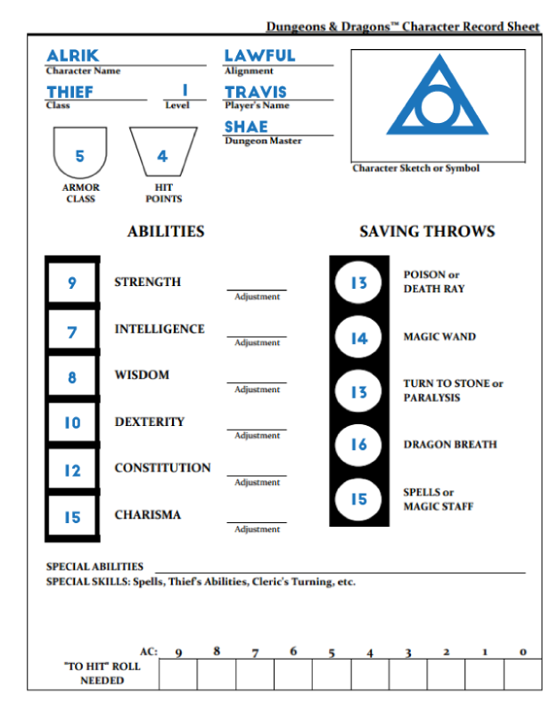

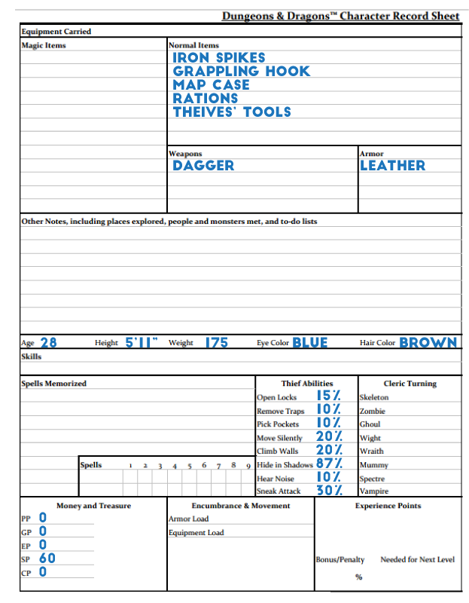

Appendix B

Top Secret RPG Character Sheet

