**Course Syllabus**

**DIGIPEN INSTITUTE OF TECHNOLOGY**

**ART 125**

***TONE, COLOR AND COMPOSITION***

Instructor: Doug Parry

**Course Syllabus**

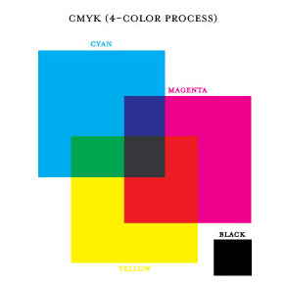

**SEMESTER-LONG PROJECT:**

**WATCH THESE THREE VIDEOS EVERY DAY UNTIL YOU’VE MEMORIZED THEM LIKE A SONG:**

[http://www.youtube.com/watch?v=5Z417hM-RAA&feature=fvwp&NR=1](http://www.youtube.com/watch?v=5z417hm-raa&feature=fvwp&nr=1)

[http://www.youtube.com/watch?v=MmhSXTMTtJM](http://www.youtube.com/watch?v=mmhsxtmttjm)

**AND**

[http://www.youtube.com/watch?v=jQqxN8LpGzw](http://www.youtube.com/watch?v=jqqxn8lpgzw)

**Course Title: Tone, Color and Composition**

**Code**: ART125/6SU16

**Pre-Requisites**: none

**Term:** SUMMER 2016

**CLASS LOCATION, DAY AND TIME: Rembrandt; Tuesday; 9:00AM to 12:10PM**

**OFFICE HOURS: Tuesday, 12:30PM to 2:30PM**

Name: **DOUG PARRY**

Phone #: (425) 895-4416

Email: [dparry@digipen.edu](mailto:dparry@digipen.edu)

**HOLIDAYS AND IMPORTANT DATES:**

April 1, 2016 Summer 16 Tuition Balance Due

May 2, 2016 Summer 16 Classes Begin

May 8, 2016 Last Date to add classes for Summer 16

Last Date to receive 100% Summer 16 tuition refund

May 15, 2016 Final Date to drop classes without academic penalty

May 30, 2016 Memorial Day – No Classes

May 31, 2016 Last Date to receive 50% Summer 16 tuition refund

June 26, 2016 Final day to receive a ‘W’ on transcript for Summer 16 semester

withdrawals. Withdraw from institute after this date will receive

‘F’ grades on transcript. Final day to drop a class.

July 4, 2016 Independence Day – No Classes

July 18-22, 2016 Summer Session Final Exams

July 22, 2016 Summer Session Ends

August 1, 2016 Fall 16 Tuition Balance Due

September 6, 2016 Fall 16 Classes Begin

September 12, 2016 Last Date to add classes for Fall 16

Last Date to receive 100% Fall 16 tuition refund

**COURSE DESCRIPTION**

This course introduces various methods for activating the picture plane, manipulating the viewer’s visual experience, and for visually communicating complex ideas and moods. These methods are reinforced through study and application of light, darkness and value, color harmony systems and compositional strategies.

**RATIONALE**

This course begins with the study of light, darkness (shadow) and value, followed by studies in color alteration, examining values of color, color temperature, and color desaturation.

The recognition, identification and understanding of the effects of different color and lighting circumstances as they apply to and alter the colors of objects, figures and environments are practiced both theoretically (via lecture and visual examples) and in actuality (via painting still life and landscape from observation), where both subtractive (paint) and additive (light) color mixing systems are addressed with regards to their individual influence on the art of painting.

Various methods for activating the picture plane, for manipulating the viewer’s visual experience, and for visually communicating complex ideas and moods are emphasized through the study of color harmony systems and compositional strategies in picture making.

Utilize class time with maximum quiet and serious effort. Turn off cell phones and IPods during class. Please do not wear ear buds in class.

**STUDENT PURCHASES**

Students are expected to supply the specific materials listed in the course materials list (see **SUPPLIES** below)

**STUDENT LAB RESPONSIBILITIES**

Students are responsible for keeping the studio and work areas clean. All tools and materials should be put away before the end of the class period or open studio session.

**SAFETY**

Safety is a crucial issue in studio use. Every attempt has been made to minimize danger and toxicity in the work areas. Students will be briefed on safety protocols for materials and equipment before use. Students violating these protocols will be denied access to materials and equipment.

**COURSE ACCESSIBILITY AND ACCOMMODATIONS**

If you need special accommodations, have emergency medical information, or need special arrangements in case of emergency, please provide the instructor and the Disability Support Services office with the relative details.

**DISABLED STUDENT SERVICES**

Students with physical, psychological, or learning disabilities that affect their ability to perform major life activities associated with this class may be eligible for reasonable accommodations under the Americans with Disabilities Act. If you have a documented disability please contact the college administration/ Disability Support Services office to arrange for accommodations for this class.

**TEACHING MATERIALS**

Students may be provided with hand outs during class time. If so, students are expected to retain their handouts for the duration of the course on order to refer to them. Many of the class topics are taught visually and orally, students are responsible for taking their own notes in order to keep current with class topics. If a student is absent for any reason, it is the student’s responsibility to ‘catch-up’ or become current with the class topics that they missed, it is not the responsibility of the instructor to provide extra instruction for students as a result of a student’s absence.

**ACADEMIC INTEGRITY**

Each student in this course is expected to abide by DigiPen’s Student Enrollment Agreement. Any work submitted by a student in this course for academic credit will be a product of the student’s own work, except for those assignments where co-operation is specifically allowed or master copy is required. Also, the work may not have been previously submitted for a grade in any other class.

**Grading, Attendance and General BFA Class Policies:**

The grading system in BFA classes may be different that you are familiar with. We do not simply assign grades to assignments, then add them up at the end of the semester and divide by the number of assignments to determine your grade. We expect you to demonstrate quality, competence and professionalism.

The point of this practice is that you will be entering a highly competitive profession and you need to be fully prepared to generate artistic solutions to a wide number of aesthetic problems in a changing industry. The profession you are entering also runs on critical deadlines where team members are expecting their fellow teammates to submit work on time and to the project specifications. Your teammates will also value those that can take minimal supervision and create art quality that exceeds everyone’s expectations. One more thing you need to be prepared for is, without warning, the piece you’re working on may appear on a top-level manager’s desk as an example of the project’s process. The presentation quality of your work therefore should ***always*** be impeccable.

While your portfolio of work will be the primary way you communicate your capabilities in seeking employment, in order to pass a class in the BFA program, you must demonstrate basic competency in the principles/techniques/concepts required by the class as well as quality work, professionalism and clean presentation. The entire program is designed to help you achieve this.

Therefore, in order to “pass” a class you must meet certain requirements. If you meet those requirements, then we revert to more traditional calculations to produce a grade that goes in your transcript. To “pass” you must do all the following:

* Attend classes, for the entire duration of the class meetings.
* Turn in all assignments.
* Pass all homework and project assignments.
* Generate calculated grades on your passing assignments that create a C- or better.
* Receive a grade of C- or better for the quality of your in-class participation, professionalism and performance.
* Pass any exit competency test or assignment required for that class.

**Attendance**:

In any profession, this is not an issue. People that don’t show up, don’t work there any more. In the BFA:

* You must sign the class sign-in sheet for each class meeting.
* If you miss more than **2** classes in a typical 15-week semester with a single class meeting, or more than **4** where classes meet more than once a week, you **fail** the class.
* The instructor may excuse an absence for a **documented** medical, family, extraordinary personal emergency or common sense circumstances such as weather etc. You will be expected to contact the instructor as soon as you determine you will be late or absent.
* If you are more than 15 minutes late for a class, or leave early, that is an unexcused absence.

**Submitting Assignments**:

Professional artists don’t have to think twice about submitting work on time, to the project specifications. In the BFA:

* Every assignment must be turned in and completed to the specifications of the assignment.
* Every assignment must be turned in on time: Individual instructors will assess stringent penalties for late work (see “**ART 125 GRADING**” below).
* If an assignment will be late, contact the instructor as soon as you know you can’t meet the deadline. The instructor will help you understand the penalties and explain the resubmission deadlines(see “**ART 125 GRADING**” below).
* In some cases, where the late assignment is required to assess your progress in order to determine if you are prepared for more advanced work, there may be a final cut-off date where you simply fail the class before it ends for the semester.
* Even if the late penalties lower the grade to below a C-, you must still complete the assignment.

##### ART 125 GRADING AND LATE HOMEWORK SUBMISSION POLICY

Each individual assignment must be turned in and passed, in order, to successfully pass the class. Each assignment in this class is designed to relate to and teach each of the competencies of the class so no assignment can be omitted. Failing a single assignment means failing the class. Every assignment must receive a passing grade of 70% or C- to successfully pass the class. Any assignment grade of 69% or D is considered a failing grade.

Students may resubmit any assignment that they failed over the course of the semester for a higher grade. Students may resubmit homework assignments within a maximum of two weeks of receiving their initial grade for that particular assignment. It is at the instructor’s discretion to allow a student more time to resubmit.

A student may resubmit assignments as long as that assignment was initially submitted on time and received a D/50% or better for it’s initial grade.

Additional resubmits may be allowed at the discretion of the instructor.

Any assignment turned in late within a week receives a 10% grade reduction.

It will be up to the discretion of the individual instructor as to whether or not the student can do any make-up work to avoid failing the course.

Grades for this class are determined as follows:

**Grading scale**:

95–100% = A+

90-94% = A

85-89% = B+

80-84% = B

75-79% = C+

70-74% = C

65-69% = C-

60-64% = D

Below 59% = F

**A**: The work meets a professional level of performance in *all* facets of the assignment.

**B**: The work approaches a professional level of performance in all facets of the assignment, and meets that level in at least one area.

**C+:** Above average student level work

**C**: Average student level work

**C-:** Below average student level work

**D**: Substandard work that demonstrates an understanding of basic principles. Usually, this is an indication of omitted specifications or weak drawing skills.

**F**: Unacceptable work.

**Competencies of ART 125:**

Students will learn essential drawing and painting skills through the execution of carefully designed in-class guided practice exercises and homework exercises and/or projects.

In order to pass this class, students must show at least the minimum artistic competency in each of these drawing and painting skill areas in all their in-class guided practice exercises, homework exercises and/or projects and on the **Exit Competency Test** at the end of the semester. Each student must demonstrate the ability to:

1. compose a picture, using several different techniques, to control the eye of the viewer and to give the image special meaning
2. accurately render subject matter (in both drawing and in painting) in proper perspective from both observation and from imagination.
3. accurately render subject matter monochromatically (several values of one hue) lit by a single or several light sources and in several different mediums (charcoal, graphite, pastel/chalk, gouache paint) from observation and from imagination
4. accurately render subject matter in full color lit by a single or several light sources in gouache paint from observation and imagination.
5. apply a practical knowledge of color theory and color harmony to traditional drawing and painting

In the BFA, the faculty will help you succeed. In addition to the design of the course and the instruction they will:

* Clearly communicate with you what you need to do to create excellent art through critical analysis of your work. Because art can be a complex set of interrelationships, several instructors may add comments to your work.
* Give clear expectations, then honestly, carefully and fairly assess your work.
* Get you feedback on your submissions in a timely manner so you can apply the ideas to your next assignment.
* Work with you on assignments that do not pass so that you have the information and resources to improve them.
* Point you towards additional resources that you can use to improve.
* Help you take charge of your own learning.

**EXIT COMPETENCY TESTS AND FINAL EXAMS**

The BFA faculty is committed to your success. It would be cruel to pass a student on to the next class where, because they were missing a key concept/skill/technique, they were doomed to failure. Besides the above, In the BFA:

* The timing, content and means of evaluation of the exit competency test will be clear throughout the semester. **No surprises!**
* You can pass the competency test, but still fail the class based on your poor coursework.
* Your coursework may meet minimum requirements, but failure of the competency test, even after a second attempt, means you fail the class.

The **Art 125 Final Color Exam/Competency Test** is no longer pass/fail. Since it is a test of the student’s ability to show that they understand the drawing and painting skills taught in the Art 125 course, the test will be graded on the same grading scale as the homework assignments (ranging for an A to an F specified by percentage points based on a predetermined grading rubric). ONE resubmission will be offered to students scoring less than a C-/70% on the test. Therefore, since the test will weigh the same as any individual homework assignment grade, if the student receives an F on the test, it will effect their final grade similarly, resulting in the student receiving an F for the course.

**LABELING ARTWORK**

Keep all artwork for the duration of the semester. All artwork must include the following information ON THE BACK OF EACH PIECE:

Student Name

Art 125SU16

Section A

Month/Date/Year

**DAMAGE OR LOSS**

Care will be taken to limit damage to a minimum, but 100% success cannot be guaranteed. As part of class process student artwork may be publicly displayed. In the unlikely event of loss or damage DigiPen is unable to insure artwork.

**Uploading Your Artwork to the “N’ Drive:**

1. Make sure the image is cropped. Show only art in the image. No backgrounds!
2. Make sure the image is square before cropping. If not: re-shoot the photo!

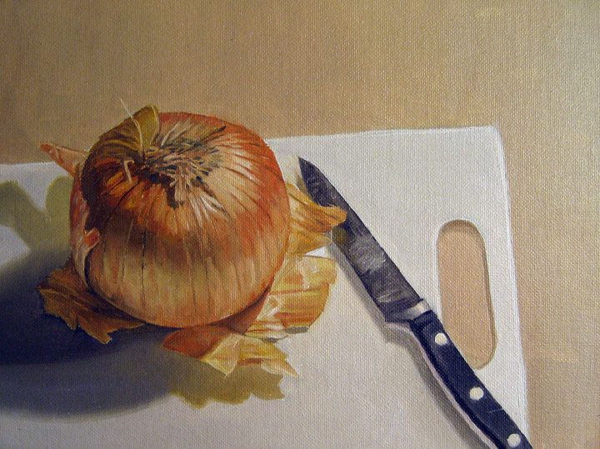 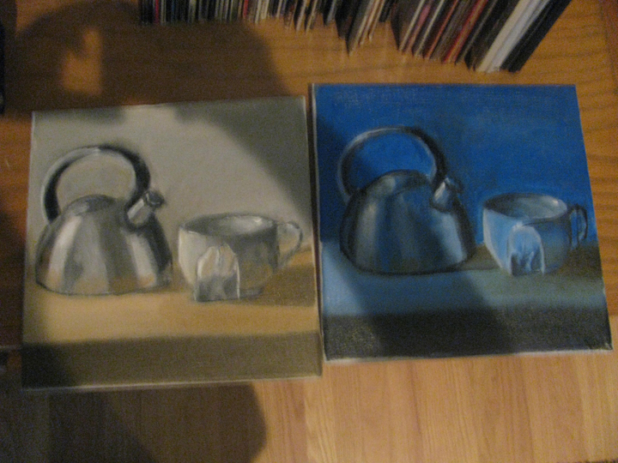

They way your images should look Example of incorrectly

uploaded image.

1. Once you have everything shot, please change the image size in a photo program (like Photoshop) according to the specs below:
   * DPI: 300 but no bigger
   * Height: 3,000 pix/inch max
   * Width: 2,400 pix/inch max

(Note: A 300 dpi image that is 8” x 10” is 2400 pixels wide by 3000 pixels high)

1. Save each image using this naming convention:

FA**16_ART125A_DParry_BRoss_I01.jpg**

Here's the order of the above example:

Semester (FA15)

underscore

Class and section (all caps, no spaces)

underscore

DParry

underscore

Name (First initial; full last name)

underscore

image number ("IO1"...that's an "I" at the beginning, not a 1...it's I01 for "image 01")

,jpg

1. Lastly, you will upload your photos individually to the "N" Drive in the appropriate section folder. Once you locate your section folder, create a folder with your name like this:

**SMITH, SAM**

Here is where the folder lives on the “N” drive:

Courses(\\data.digipen.edu)(N:)

Current Courses//2015 Fall//Art 101//your file name

I will keep you informed if there are any changes to this location.

1. You will also have the opportunity to take photography and uploading workshop at the beginning of the semester…so stay tuned!!!

**SUPPLIES**

1 @ Canson Spiral Field Sketch Book, 65lb, 9 in x 12 in, 160 Sheets (black, hardcover, spiral)

1 @ Canson XL Mix Media Pad, 98lb (160gsm), 14" x 17", 60 Sheets

2 @ Sanford Ebony Graphite Pencil Soft

1 @ DANIEL SMITH Platinum Series 23 Synthetic Multi-Media Brush, Flat 1 inch (or the closest thing you can find to it)

1 @ DANIEL SMITH Long Handled White Taklon Multi-Media Brush Set, 7pc. (or the closest thing you can find to it)

2 @ Holbein Designer Gouache Primary Mixing SET of 5 (it is advisable to buy an extra tube of yellow--available at the DigiPen Student Bookstore)

1 @ Permanent White, 37ml Tube, Winsor & Newton Designers' Gouache

1 @ Plastic Oval Palette 11.75 in x 8.5 inches

1 @ Winsor & Newton Artists Vine Charcoal Sticks, Soft , 12-pack

1 @ Chalk or “white charcoal” pencil.  Conte Crayons, HB White, 2-pack