Travis Moore

ECN100: Section A — Summer 2016

Instructor: Liliana Halim Lawrence

**­**

Homework Week 3  
Market Controls, Costs, and MP-MC

1. A price ceiling is implemented in the market for housing in Meth City, where we assume all housing units are identical. Demand is given by the equation P = 1,000 – 0.1 Qd, and the supply is given by the equation P = 200 + 0.3 Qs.

a) Fill in the blank for the following demand and supply schedules given the above equations:

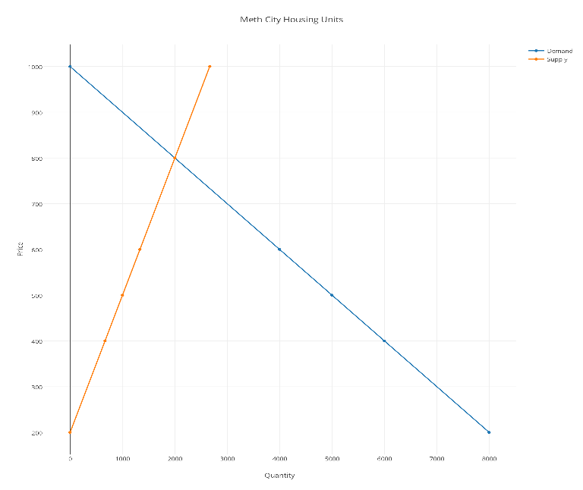

Price Qd Qs

$200 8,000 0

$400 6,000 667

$500 5,000 1,000

$600 4,000 1,333

$800 2,000 2,000

$1,000 0 2,667

b) What is the equilibrium price and quantity?

The equilibrium price is $800 with a quantity of 2,000.

c) What are the consumer surplus and producer surplus?

The consumer surplus is: The producer surplus is:  
½($1,000-$800)(2,000-0) ½($800-0)(2,000-0)  
½($200)(2,000) ½($800)(2,000)  
200,000 800,000

d) When the price ceiling is implemented, a housing shortage develops to 4,000 units (shortage is the difference between Qd and Qs). What is the price ceiling in the market?

$500

e) Who benefits from this price ceiling? Who is hurt?

Price ceilings are beneficial for most consumers to maintain a standard of living, however, price ceilings discourage suppliers from producing more of an item when they cannot set their own prices.

f) Calculate the Deadweight Loss (Welfare Loss to Society) Note: It always help to sketch a graph to show the effect of price/quantity changes due to the price ceiling.

Deadweight loss:  
½($800 – $500)(2,000 – 1,000)  
½($300)(1,000)  
$150,000

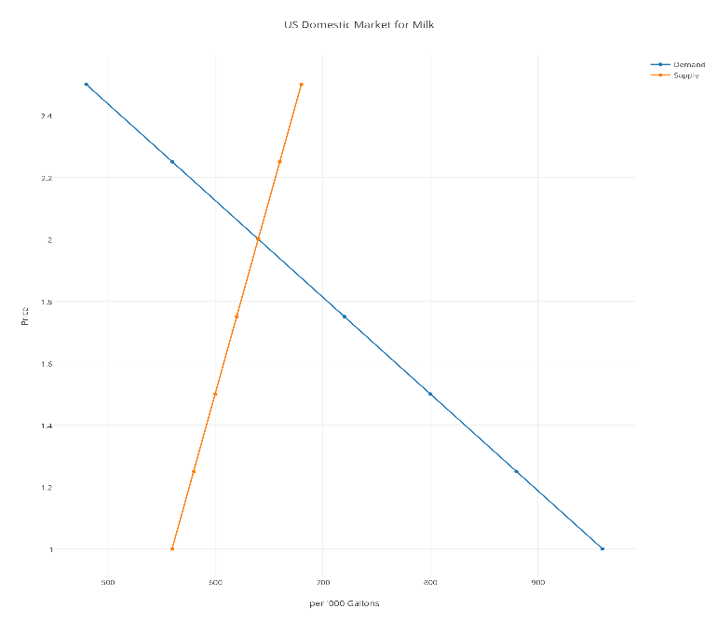2. Price Floor: The table below depicts the US domestic market for milk.

Price Qs (‘000 gals) Qd (‘000 gals)

$1.00 560 960

$1.25 580 880

$1.50 600 800

$1.75 620 720

$2.00 640 640

$2.25 660 560

$2.50 680 480

a) What is the equilibrium market price and quantity?

The equilibrium price is $2.00 with a quantity of 640,000

b) When government imposed price floor of $2.25, what are the quantity supplied and quantity demanded, a shortage or surplus?

The new quantity supplied is 660,000 and the quantity demanded is 560,000. There is a surplus of 100,000

c) Sketch a graph to clarify your thoughts; then calculate the Deadweight Loss

Deadweight loss:  
½($2.25 – $2.00)(660,000 – 640,00)  
½($0.25)(20,000)  
$2,500

3. In the following table, labor input is your only variable cost, and the price of labor is $20 per hour, and the fixed cost is $50.

a) Fill-in the table;

b) Notice the MP and MC that you calculated, how are the MP and MC related to each other?

There is a sweet spot for both MP and MC in how much things costs in terms of labor versus how much product you make. There are good returns to a point but after this point more labor results in only diminishing returns.

c) What is the relationship between MC and the average costs (ATC and AVC)?

Marginal Costs and Average Total Costs and Average Variable Costs relate to how much things cost overall to get the product you are trying to create. A high marginal costs tends to be the result of a high average variable costs and average variable costs.

Q. Labor(hour) Q.Output(units) MP TC MC AVC ATC

0 0 0 $50 cannot divide by zero $0 $0

1 2 2 $70 $10 $10 $35

2 6 4 $90 $3.33 $6.67 $15

3 15 9 $110 $2.22 $4 $7.33

4 20 5 $130 $4 $4 $6.5

5 23 3 $150 $6.67 $4.35 $6.52

6 24 1 $170 $20 $5 $7.08