Travis Moore

ECN100: Section A — Summer 2016

Instructor: Liliana Halim Lawrence

**­**

Homework Week 4  
Economic Decisions in Competitive Market

1) The following table shows total cost for a product of a competitive firm:

Q 0 1 2 3 4 5 6 7 8 9 10

TC 30 55 75 85 100 120 145 185 240 310 395

MC — 25 10 10 15 20 25 40 55 70 85

VC — 25 45 55 70 90 115 155 210 280 365

AVC — 25 22.5 18.3 17.5 18 19.2 22.1 26.3 31.1 36.5

ATC — 55 37.5 28.3 25 24 24.2 26.4 30.1 24.4 39.5

a) First calculate the other costs: MC, VC, AVC, ATC

MC = Δ Total Costs / Δ Quantity VC = (assuming FC is 30) = TC – FC

AVC = VC / Quantity ATC = TC / Quantity

b) What is the output level for a profit-maximizing firm if the market price is $20 per unit? Calculate the profit.  
Output 0 1 2 3 4 5 6 7 8 9 10  
MR 0 20 20 20 20 20 20 20 20 20 20  
Profit(MR–MC)0 -5 10 10 5 0 -5 -20 -35 -50 -65  
The output level for a profit maximizing firm is 3.

c) How does your answer change if price rises to $25? Calculate the profit.  
Output 0 1 2 3 4 5 6 7 8 9 10  
MR 0 25 25 25 25 25 25 25 25 25 25  
Profit(MR–MC)0 0 15 15 10 5 0 -15 -30 -45 -60  
The output level for a profit maximizing firm is still 3.

d) How does your answer change if price rises to $15? Calculate the profit.  
Output 0 1 2 3 4 5 6 7 8 9 10  
MR 0 15 15 15 15 15 15 15 15 15 15  
Profit(MR–MC)0 -10 5 5 0 -5 -10 -25 -40 -55 -70  
The output level for a profit maximizing firm is still 3.

e) Should the firm stay in business at price $20? At price $25? At price $15?  
The firm can stay in business at all price levels for an output at 3, but the profit will be smaller at $15 and largest at $25.

2) Draw a U-shaped ATC, AVC, and a “swoosh”-shaped MC curve. On it, indicate the range of output and the range of price for which the following actions are optimal.

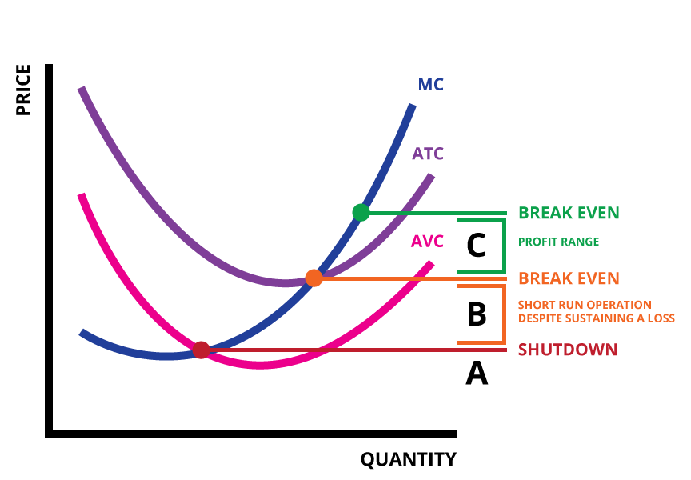

a) The firm shuts down immediately

b) The firm operates in the short run despite sustaining a loss

c) The firm operates while making a profit.

3) Which of the following events will induce firms to enter an industry? Which will induce firms to exit? When will entry or exit cease?

a) A technological advance lowers the fixed cost of production of every firm in the industry.  
This event will induce firms to enter an industry due to lowered production costs and more room for profit. Entry will cease when the industry becomes less profitable.

b) The wages paid to workers in the industry go up for an extended period of time.  
This event will induce firms to exit the industry. Exit will cease when the industry becomes more profitable.

c) A permanent change in consumer tastes increases demand for the good.  
A rightward shift in demand will induce firms to enter the industry. Entry will cease when the industry becomes less profitable.

d) The price of a key input rises due to a long term shortage of that input.  
If the price of a key input rises due to a long term shortage of an input this will induce firms to exit an industry. Exit will cease when the industry becomes more profitable.

4) The following table represents the market for Corning Fiberglass, and Corning is the sole producer of fiberglass, so Corning can set the price as it wishes.

Q 0 1 2 3 4 5 6

Price - 46 42 38 34 30 24

TC 60 65 81 111 145 189 249

TR 0 46 84 114 136 150 144

MR 0 46 38 30 22 14 -6

MC 60 5 16 30 34 44 60

VC 0 5 21 51 85 129 189

AVC 0 5 10.5 17 21.3 25.8 31.5

a) First calculate: TR, MR, MC, AVC   
TR = Price * Quantity  
MR = Δ Total Revenue / Δ Quantity  
MC = Δ Total Costs / Δ Quantity  
AVC = (assume FC is 60) = VC / Quantity

b) Determine the profit-maximizing price and output of the firm.  
Profit Maximizing Price = MR = MC, so at a Quantity of 3 and a Price of 38 we meet the profit maximizing price.

c) What is the monopolist’s profit?  
The monopolist’s profit is equal to TR – TC, so the largest return is $3.

d) Suppose the consumer of fiberglass has high price elasticity of demand, so Corning now acts like a competitive firm, what is its output and price now? Remember that a competitive firm is a price-taker, so the optimizing rule is P=MC. Would this company stay in business (look at AVC)?  
At an output of 4 and a price of 34 the company will optimize at this level, however the total revenue is less than the total costs at this level.

5. Regarding the article I assigned you to read, here are some questions for you to response: a) What happened to that “Invisible Hand”, that according to Adam Smith should occur in a free market?  
The invisible hand appears to be idle due to the American economy being too cozy for incumbents. It is difficult for newer companies to break in and compete with large companies due to concentration and consolidation of major companies throughout the American economy.

b) List three mergers-acquisitions (M&As) that are mentioned in this article.  
Applied Materials and Tokyo Electron, Charter Communications, DOW Chemical and DuPont, and Heinz and Kraft Foods.

c) Give two positive reasons for the case of market concentration, and two negative impacts of the market concentration.  
Two negative impacts of market concentration hinders the rate of small company creation in the United States of America and also the rising of prices due to lack of competition which can negatively affect consumers. Two positive reasons for market concentration include the potential benefit of lowered average costs which can decrease prices in economies of scale. Profits from market concentration can also be funneled easier into areas of research and development, resulting in long term benefits like better technology.

d) With regard to market concentration, what would be the position of Warren Buffett?  
As a businessman known for his investment power, I am sure Warren Buffett would regard market concentration as a viable strategy for businesses as this fits his ideals of building consolidation, or a moat, that offers a business a barrier of stability and pricing power.

e) According to this article, about two-thirds of some 900 business sectors are becoming more concentrated since 1997 until now. What are the major three sectors that become highly concentrated?  
IT, telecoms and media; manufacturing; and transport and logistics are the three sectors that have become highly concentrated.

f) “Concentration is contagious”. What does the article mean?  
“Concentration is contagious” refers to the nature of business as companies grow in power. On one end, to protect your power you need to dominate your industry which means bulking up your business. As a business trying to compete against a dominating competitor, the answer is also to concentrate or consolidate power with others to stay viable and try to out-power the dominating company. Concentration seems to be a natural part of surviving in an industry.