Travis Moore

ECN100: Section A — Summer 2016

Instructor: Liliana Halim Lawrence

**­**

Homework Week 7  
GDP and Economic Growth

1) Calculate the following about the economy in 1985, 1995, and 2000:

*1985 1995 2000*

*Nominal GDP (in $billions) 4,213 7400.5 9,824.6*

*GDP Deflator (index, 1996=100) 73.7 98.1 106.9*

*Real GDP (in 1996 billion dollars) 5716.4 7,543.8 9,191.4*

*Population (in millions) 238 265 280*

a) Nominal GDP in 1995:

Nominal GDP = (Deflator * Real GDP) / 100  
Nominal GDP = (98.1 * 7543.8) / 100  
Nominal GDP = 7400.5

b) Real GDP in 1985:

Real GDP = (Nominal GDP / GDP Deflator) * 100  
Real GDP = (4213 / 73.7) * 100  
Real GDP = 5716.4

c) Rise in the price level (inflation) from 1985 to 2000:

Inflation = (GDP Inflator 2000 – GDP Inflator 1985) / GDP Inflator 1985  
Inflation = (106.9 – 73.7) / 73.7  
Inflation = 45%

d) Growth in real GDP from 1985 to 2000:

Growth in Real GDP = (Real GDP 2000 – Real GDP 1985) / Real GDP 1985  
Growth in Real GDP = (9191.4 – 5716.4) / 5716.4  
Growth in Real GDP = 60.1%

e) Per capita real GDP in 1985, 1995, 2000:

Per Capita Real GDP 1985 = Real GDP 1985 / Population 1985  
Per Capita Real GDP 1985 = 5716.4 / 238  
Per Capita Real GDP 1985 = 24  
  
Per Capita Real GDP 1995 = Real GDP 1995 / Population 1995  
Per Capita Real GDP 1995 = 7543.8 / 265  
Per Capita Real GDP 1995 = 28.5

Per Capita Real GDP 2000 = Real GDP 2000 / Population 2000  
Per Capita Real GDP 2000 = 9191.4 / 280  
Per Capita Real GDP 2000 = 32.8

f) The growth in per capita real GDP from 1985 to 2000:

Growth Real GDP = (Growth Real GDP 2000 – Growth Real GDP 1985) / Growth Real GDP 1985  
Growth Real GDP = (32.8 – 24) / 24  
Growth Real GDP = 37%

2) A small economy has the following data:

*Quantities in 2003 Quantities in 2004 Prices 2003 Prices 2004*

*12 packs of Pepsi 14 packs $2.50/pck $2.00/pck*

*12 fan T-shirts 15 t-shirts $15/shirt $20/shirt*

*16 football tickets 18 tickets $25/ticket $30/ticket*

a) Calculate the nominal GDP for each year 2003 and 2004.

Nominal GDP 2003 Nominal GDP 2004  
(12 * 2.5) + (12 * 15) + (16 * 25) (14 * 2) + (15 * 20) + (18 * 30)  
30 + 180 + 400 28 + 300 + 540  
610 868

b) Calculate the real GDP for each year, using 2003 as the base year.

2003 is base year, nothing changes 2004 using 2003 prices  
Real GDP 2003 Real GDP 2004  
(12 * 2.5) + (12 * 15) + (16 * 25) (14 * **2.5**) + (15 * **15**) + (18 * **25**)  
30 + 180 + 400 35 + 225 + 450  
610 710

c) Calculate the growth (% change) of the real GDP from 2003 to 2004.

Growth in Real GDP = (Real GDP 2004 – Real GDP 2003) / Real GDP 2003  
Growth in Real GDP = (710 – 610) / 610  
Growth in Real GDP = 16.4%

3) GDP and Happiness:

a) How would you relate Happiness with a higher income (GDP) in the framework of a whole society? And for you, personally?

According to the graph below, money is not everything when it comes to relating higher income to happiness. This can be seen in how Israel has roughly the same level of happiness, if not than more, compared to the Netherlands, despite having nearly half of the GDP that the Netherlands. This being said, a higher income ensures less poverty related income problems and I would personally feel at least some comfort knowing that I do not owe money or have money problems with a higher income.

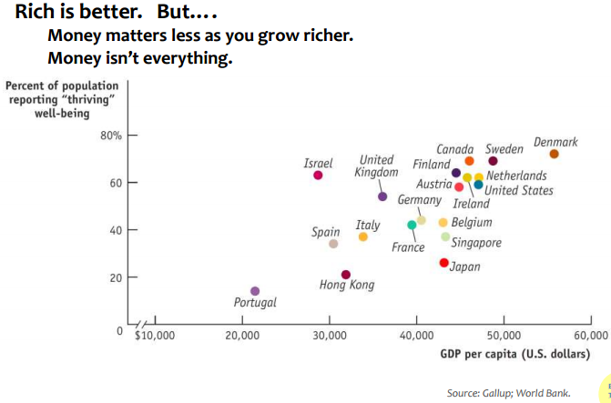

b) Happiness Index (searched Google) has some indicators, what are they?

The Gross National Happiness indicators are: sustainable development, preservation and promotion of cultural values, conservation of the natural environment, and establishment of good governance.

c) If you were to add two more (new) indicators to the Happiness Index, what would they be?

In light of recent tragedies in the United States, and warfare throughout the world, I would add world and national level safety related indicators to the Happiness Index. Such indicators could be comparative national security and local safety and security indicators.