6) b) Time Plot of Attendance in thousands over years:

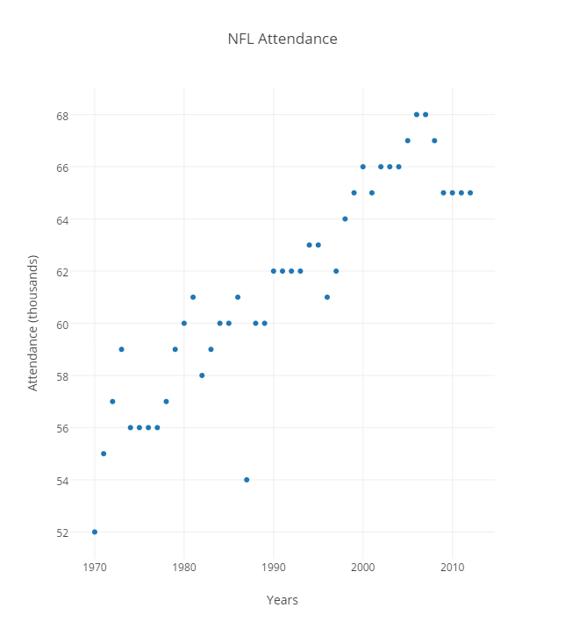  
c) histogram of nfl attendance over years

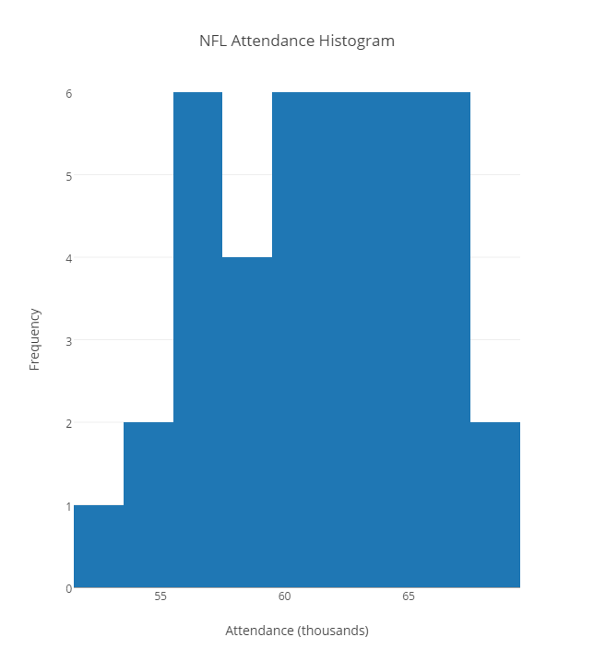

d) stem and leaf of nfl attendance over years

6|5 5 5 5 7 8 8 7 6 6 6 5 6 5 4 2 1 3 3 2 2 2 2 0 0 1 0 0 1 0

5| 4 9 8 9 7 6 6 6 6 9 7 5 2

7) mean: 61.42, median: 62, mode: 65

8) a) Scatterplot of Decline of the Arctic Sea Ice over years

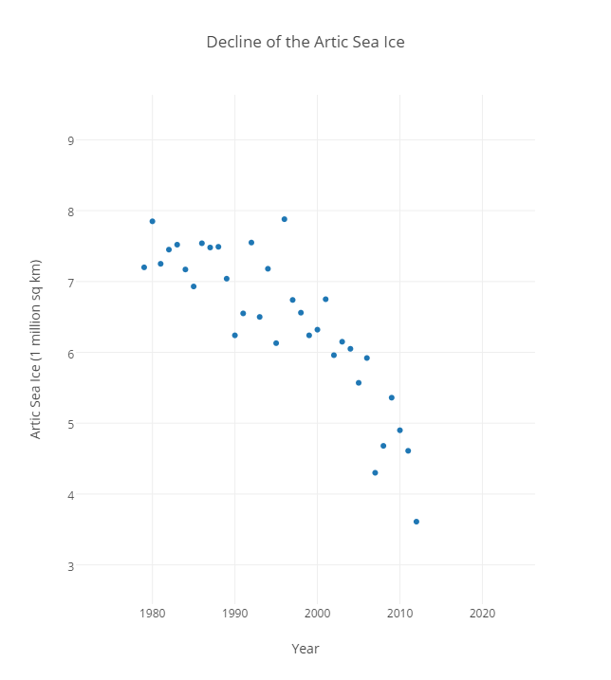

8) b) Histogram of Decline of the Arctic Sea Ice over years

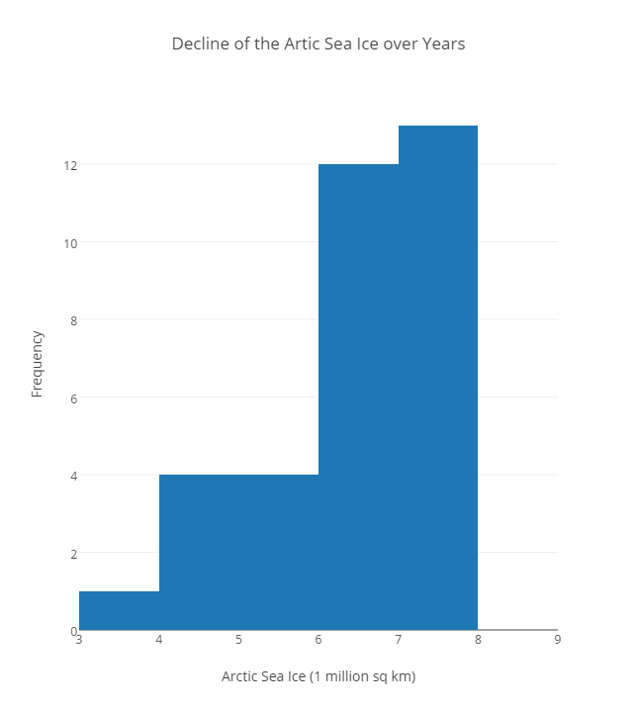

8) c) stem and leaf of the decline of the artic sea ice over the years

7| .2 .85 .25 .45 .52 .17 .54 .48 .49 .04 .55 .18 .88

6| .93 .24 .55 .5 .13 .74 .56 .24 .32 .75 .15 .05

5| .96 .57 .92 .36

4| .3 .68 .9 .61

3| .61

9) mean: 6.43, median: 6.56, mode: 6.24

10) a) range: 737

10) b) mean: 566.86

10) c) variance: 71202.14

10) d) standard deviation: 266.84

10) e) Chebyshev’s Theorem: 1 – (1/266.842) = 1 – (1/71202.14) = 0.99998595547