Example #1: Knife in the Water.

The following paper answered these questions in 380 words.

First, do your research on the New Revolutionaries discussed in class and become familiar with the the cultural environment. Then answer the following questions:
1. Using examples from the film, comment on the Mood achieved by Roman Polanski and how he accomplished it.
2. How did Polanski use the Camera to tell his story? What obstacles did he have to overcome?
3. What techniques did he borrow from François Truffaut and Jean Luc Godard and how effectively did he use them?
Document your examples from the film with a time stamp (how many minutes from the start) or a thumbnail (screen capture.jpg) and cite your resources either as footnotes or at the end of your paper as 'works cited.'

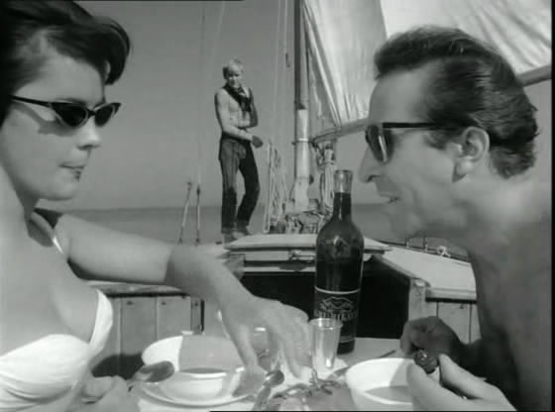
Knife in the water, Roman Polanski
- Knife in the water, by Roman Polanski, is a film that shows a constant mood of tension and isolation, which is a usual topic in the director’s films since his beginnings. There are only three characters in the story but they are usually framed together in the same shot, creating a claustrophobic mood.
It also helps to the isolation and solitude feeling the vast landscape where the story takes place, a small boat in the middle of an immense lake. Regarding this topic, Polanski said once in an interview: “What I like is a realistic situation where things don’t quite fit in. I like to begin with a mood, an atmosphere. I begin to people the atmosphere with characters. When I thought of Knife in the Water, I thought, first of the north of Poland where I used to sail and of a theme that wouldn’t involve large numbers of characters.”1
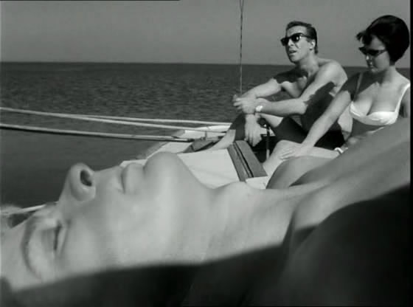
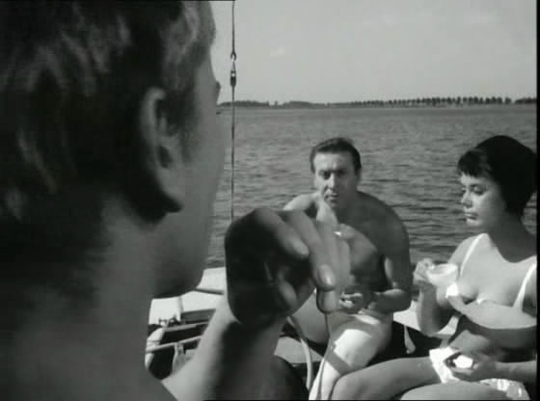
- Polanski shoots the three characters together in most of the scene, depicting two in the foreground and one in the background or vice versa. To achieve this he uses deep-focus, for example in the scenes at minute 18, 28 and 32. This kind of shot isolates (once again one of the topics of the film) one of the characters (usually the young boy) while the other two remain in other plane. He also uses some point of view shots for the young boy.
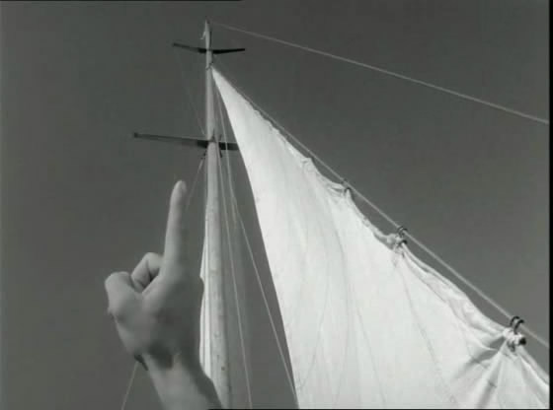 | 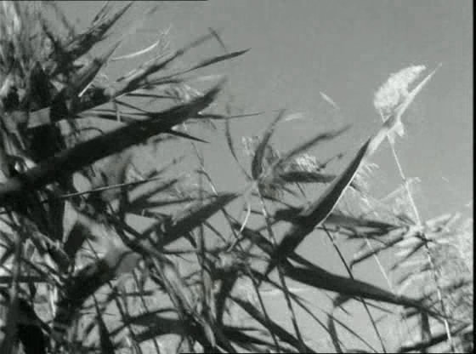
Minute 24 | Minute 20
Polanski’s biggest problem while recording this film was the little space available for the crew. In fact, the film is actually recorded in a boat in the lake district of Poland. They had to film from the masts and even dropped a camera to the lake.
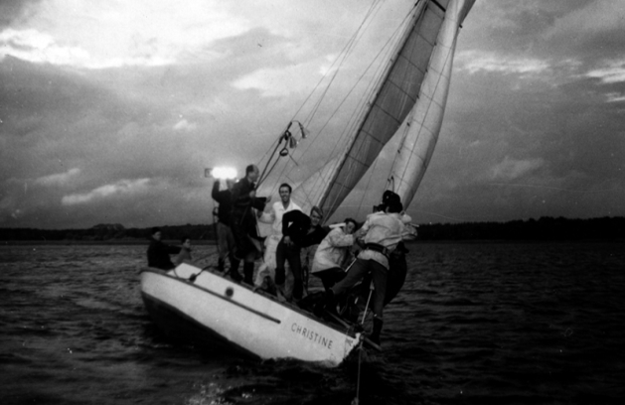
Polanski's crew
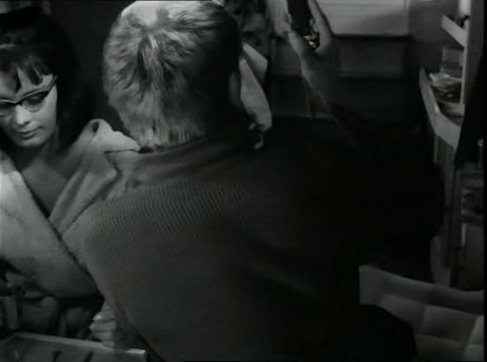
- French new wave’s influence in Polanski’s films is noticeable . The director uses jump cuts, probably an influence from Jean Luc Goddard’s film. An example of this technique is the scene were the youth throws a knife.
Other resemblances to Goddard and Truffaut’s films are the use of real location and natural lighting, the use of hand held cameras (very noticeable in minute 21 when the youth and Andrzej are guiding the boat with a rope). These techniques give a more realistic feeling to the overall mood of the film. Polanski achieves to create and entertaining and filled of tension story with very little resources.

Example #2: Wild Strawberries.

The following paper answered these questions in 360 words.

1. How is symbolism used in Wild Strawberries? Give examples. Which film(s) have you seen for this class that also use symbolism? Compare to Wild Strawberries.
2. Film scholar John C. Stubbs has written that "much of Bergman's strength comes from his ability to dramatize his scenes in visual compositions that are striking and often shocking.... [For example,] high contrasts between dark shadows and brightly lit areas." Give an example of a shot, sequence, or scene that was lit in such a particularly effective way? What effect did the lighting have on the viewer?
3. Wild Strawberries, like most of Bergman's films, abounds with religious imagery. What do these scenes say about Bergman's own religion? Use an example to support your statement.

Wild Strawberries, Ingmar Bergman

1. Symbolism is used throughout the movie Wild Strawberries, starting with the title. The Swedish title, Smultronstället, translates literally to Wild Strawberries, but it's meaning in the Swedish culture is that of a fond childhood memory or place. Summers are short in Sweden and the idea of "wild strawberries" represents youth and its brevity. A reoccurring element, the handless clocks, appearing in the first dream sequence where Isak encounters himself in a broken coffin (3:58) and then later when his mother shows him his father's handless watch (49:58). Isak's first dream has a strong suggestion of his death, and when he's visiting his mother there is a strong undertone of death (she says that all of her children are dead except Isak (47:25) and that one of her faults is that she doesn't die (48:04)).

2. Isak's first dream was very harshly lit with the lit parts being very brightly lit and all of the shadows have sharp edges (no fading in). This gives the scene a feeling of unease, as if there was something wrong about this world despite it being completely visible. Usually the darkness is what people associate with the unknown and unsettling but it was quite the opposite in this case. This is evident by the fact that Isak is the only living person in his dream (he meets a weird doll-man who falls down, "popping" his head open (5:36)) and the riderless horsedrawn cart that's carrying a coffin with his body inside of it.

3. Bergman grew up with a Lutheran father but lost his faith when he was 9, and this indifference towards religion is clearly seen in the scene where Isak, Marianne, Anders, Viktor, and Sara are all eating lunch (44:04). Anders and Viktor start debating over the existence of God and how "practical" it is to believe in God, with Anders, who aspires to become a priest, siding with believing and Viktor siding with believing in God being akin to believing in Santa Claus (44:09). When asked his opinion, Isak decides to keep his thoughts to himself, stating that nothing but more debate would come of it.

Works Cited:
• http://en.wikipedia.org/wiki/Wild_Strawberries_(film)
• http://oldschoolreviews.com/rev_50/wild_strawberries.htm
• http://www.decentfilms.com/reviews/wildstrawberries.html
• http://bernardwelt.blogspot.com/2007/04/wild-strawberries.html
• http://www.cosmoetica.com/B408-DES343.htm

http://www.criterion.com/current/posts/298-knife-in-the-water
For example, minute 32, the scene at the image in the right.
http://www.imdb.com/title/tt0056291/
http://movienite.blogspot.com/
Minute 53

