Shot Selection
The framing of a shot is usually discussed in terms of a human subject. The purpose of framing shots is to allow you to direct the audience’s attention in order to tell a story with moving pictures by how close the camera is to the subject.
While the cut-off points are somewhat arbitrary, the general rule is put your frame lines on a “natural” break point such as the waist, or shoulders.
Since film frames are generally projected on a huge wall-sized screen while the video frame is generally projected on a small TV screen, video tends to frame tighter than film.

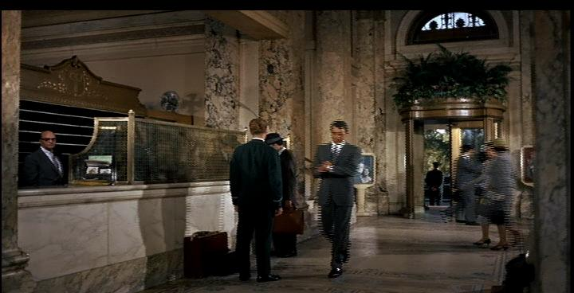 | ELS  Extreme Long Shot  The Extreme Long Shot generally frames the entire human subject as a small part of the frame.  The ELS is generally used to establish location or show a large sweep of action such as a battle. When The ELS is used to establish location it is called an ESTABLISHING SHOT.
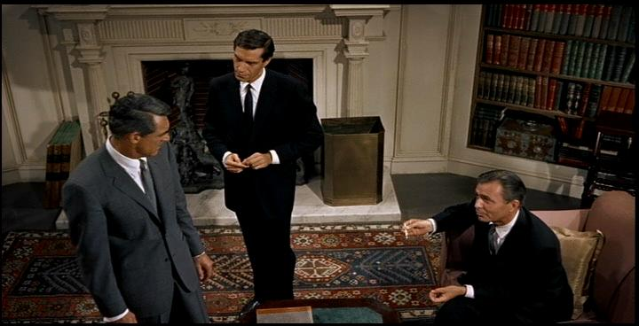 | LS  Long Shot  The Long Shot generally frames the entire human subject from head to foot.  The LS is generally used to establish the subject, location or action. It allows the audience to understand where the characters are in relation to each other and the environment of the scene.
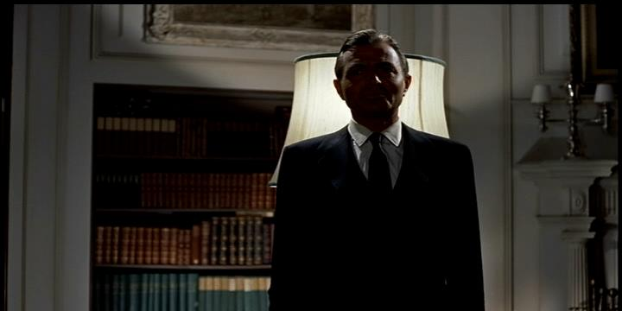 | MS  Medium Shot  The Medium Shot generally frames the human subject from just below the waist to the top of the head. A real “workhorse” shot because it frames close enough to see faces but far enough away for action.  The Medium shot is generally used to follow the unfolding action in the scene or allow two actors to talk to each other. The Medium Shot is sometimes called a WAIST SHOT.

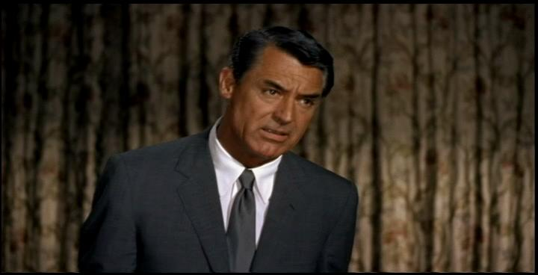 | CMS  Close Medium Shot  The CMS is generally framed from the mid chest to the top of the head. Sometimes called Tight Medium Shot TMS.  American filmmakers have traditionally favored the MS while Europeans favor the CMS. Video generally uses the CMS. If you need to add titles to an interview shot, frame for a TMS or wider.
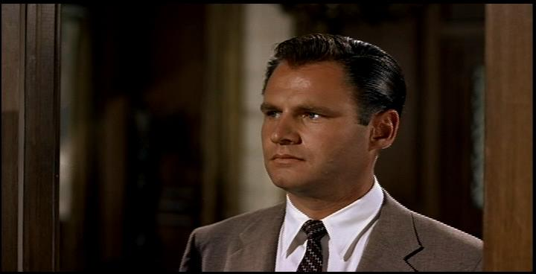 | CU  Close Up  The Close Up is generally framed from the top of the shoulders to the top of the head.  The close up is used to show detail. With human subjects this shot carries emotional content because we can carefully observe the subject’s facial expressions. This shot is sometimes called a HEAD SHOT, or in an interview, a TALKING HEAD. Like the MS, Europeans tend to frame tighter.
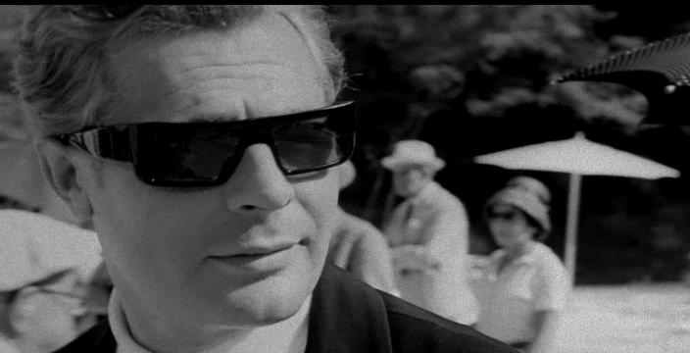 | TCU  Tight Close Up  A TCU or Tight Close Up frames the neck and cuts the very top of the head off. (European close up)
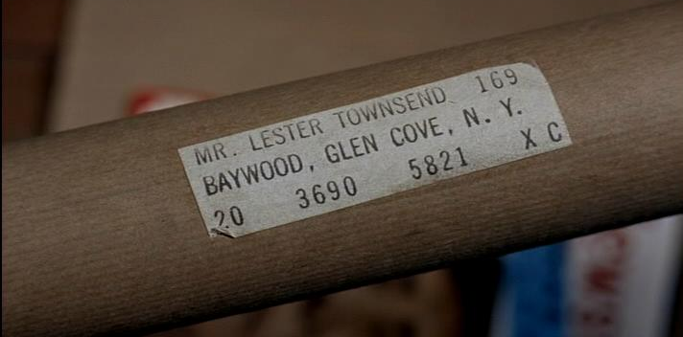 | ECU  Extreme Close Up  An Extreme Close Up frames a fraction of a person’s head (or other body part) or a small object (or part of a large object).  The ECU is generally used to place special emphasis on a detail that the audience needs to know. It usually needs to be “placed” with a longer shot either before or after.

Other Shots
There is a film/video (cinematic) shorthand for a number of other common shots. Foreground refers to objects close to the camera, between the subject and the camera. Background generally means objects behind the subject, further from the camera. Tightening a shot means geting closer, loosening a shot means getting further away.

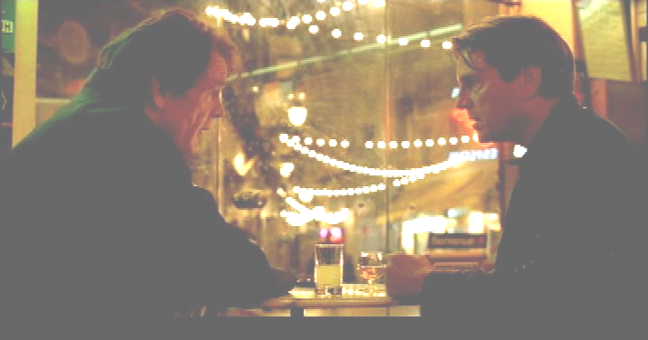 | Two Shot (2S)  This is generally a CMS (or CU) that frames two people in the same shot.  This is extremely common in exchanging dialogue.
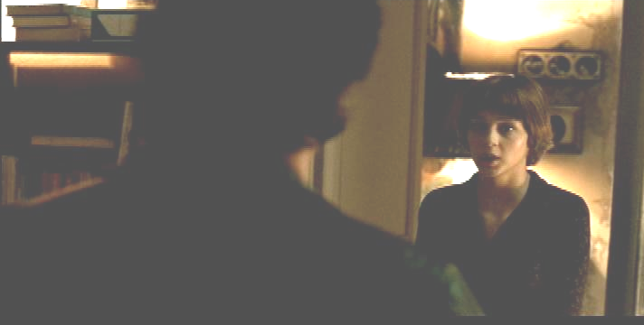 | Over The Shoulder (OS)  This is generally a CMS that frames two people, but makes one of them more important by framing their entire face and the back of the other person’s head or just a bit of their shoulder.  This is extremely common in both dialogue exchanges and interviews.
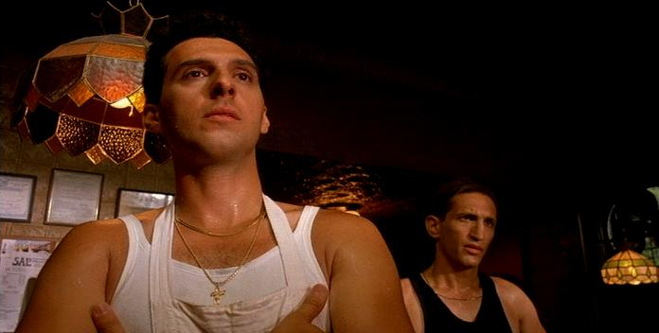 | Low Angle (LA)  This is when the camera is below the subject, shooting up.  When shooting a low angle, the subject often appears more powerful and dominating.
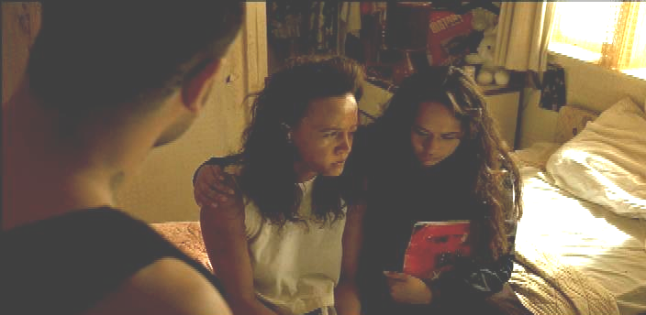 | High Angle (HA)  This is when the camera is above the subject, shooting down.  When shooting a high angle, the subject often appears less important or submissive.

Camera Movement
In early films the camera moved simply to follow action. Moving the camera, however, allows us to make “comments” on what the audience sees on the screen. We may pan to reveal new information, such as the monster creeping up in the background; or we can dolly in on the actor to intensify their reaction to bad news. There are a number of other camera movements that are generally named for the method that moves the camera such as a hand-held, steadycam or aerial shot.
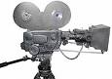 | P r/l  Pan Right or Pan Left  The camera rotates left or right on the tripod head.  The movement is generally used to follow action or reveal detail.

T u/d

Tilt Up or Tilt Down
The camera inclines up or declines down on the tripod head.
The movement is generally used to follow action or reveal detail.

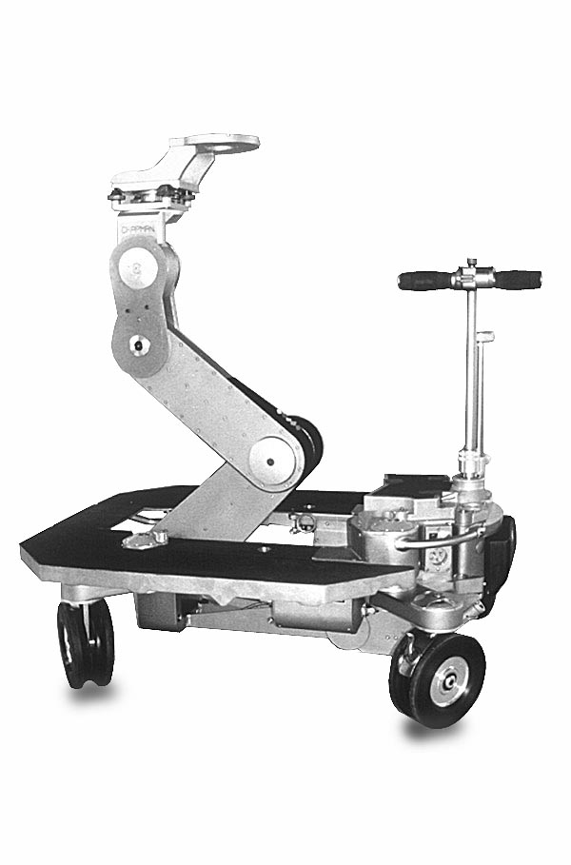 | Din/out  Dolly In or Dolly Out  The camera moves towards (in) the subject or away (out) from it.  The movement in is used to focus the audience’s attention or increase the drama/tension in a shot. The movement out reveals more detail or releases drama/tension.  In Television you can also dolly left or right.  A dolly is also a wheeled device for mounting and moving the camera.
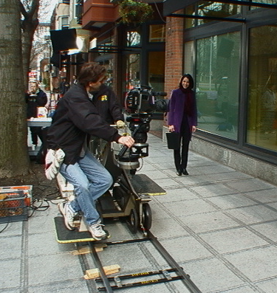 | T r/l  Track Left or Track Right  The camera moves parallel to the subject.  This shot is used to follow action or a conversation as the subjects walk. The camera is often literally on tracks to make the movement smooth.

Ped u/d

Pedestal Up or Pedestal Down
The camera remains a fixed distance from the subject, but lifts a short distance straight up or down.
The movement is generally used to follow action or reveal detail.
A hydraulic device on the camera dolly moves the camera higher or lower.

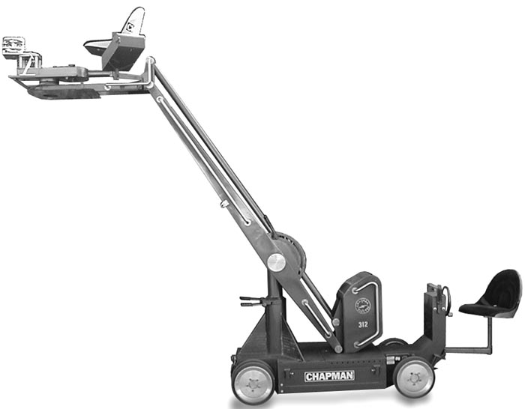 | CR up/down  Crane Up or Crane Down  The camera sweeps up or down a large distance.  The camera is usually attached to a long arm that can not only lift it, but also move it left or right in an arc.

