Travis Moore
GAT 211A—Fall 2014
Instructor: Jeremy Holcomb

Lab Report 3
Combat Systems III

Table of Contents

Lab Report 3 – 9
Less Drunken, More Boxing _{(version 03)} 3 – 8
Intentions 3 – 4
Rules 4 – 6
Playtesters 6
Playtesting 6 – 7
Mechanics 8
Dynamics 8
Experience 8
Intensity Curve 9

Less Drunken, More Boxing _{(version 03)}
Intentions
The previous playtest of “Drunken Boxing” was not as successful as I had hoped it would be. I think the biggest problem that currently exists in the game is that I am attempting to do a little bit of everything without fully nailing down the core of the game. For this reason, the latest version of “Drunken Boxing” has been stripped of the before round coach actions. This newer version of the game will no longer have “Boozing” or “Sobering” coach actions. These coach actions may return, but for now I do not want to deal with them getting in the way of players understanding my game. By eliminating the before round coach actions I can focus more on the actual round of fighting rather than complicating it with compounding effects.
Due to the removal of the coaching actions, the latest version of the game is now called “Less Drunken, More Boxing”. There is no longer an upgrade or downgrade dice mechanic to the game. Replacing the upgrade and downgrade dice mechanic is the option to throw whichever one die you still have simultaneously against your opponent each round. This change is purely in response to how the players never really used all the dice, would not secretly select dice, and would throw a die only after their opponent threw theirs. This should preserve the hidden knowledge mechanic of the game and force players to try and outwit each other in a way that works better than it has previously. I also decided to make the game shorter, from 5 rounds to just 3 rounds for a shorter, sweeter experience.
With a focus on the core fighting mechanic of the game, I definitely need to address the biggest concern from my last playtest. In the previous version of the game my playtesters were hung up on the concept behind the maximum damage limit. The purpose behind the implementation of this mechanic is to make choosing and rolling a die against your opponent not just a “pick my best die against yours” battle. The maximum damage limit was intended to give some power behind choosing to battle with a lower value die.
Unfortunately, the way it has been communicated in previous rules made it confusing by requiring players to make a calculation between the differences in dice values. For this reason the maximum damage limit is now set to the value of the die you choose to use. For example, if a player chooses to roll a d4 then their opponent can only beat their die roll by a maximum of 4, regardless of what die they choose to roll. Hopefully this change will clear up some confusion and require less effort accurately calculate during the game.
The only real addition to the game is the critical hit system in the game which involves what to do if the players tie when rolling dice. If players tie then they choose a new dice to throw against each other with the knowledge that whoever wins this next dice throw will get have their damage doubled. I figure this is both a convenient way to resolved ties as well as add a spike in intensity in the game.

Rules
The rules for “Less Drunken, More Boxing” are based off the previous version of the game “Drunken Boxing”. Changes are highlighted to properly reflect if things were added, removed, or changed from the previous rules.
Less Drunken, More Boxing (version 03)
Components
- 2 pens and 2 pieces of paper to track damage
- 1 set of Green Dice (d4, d6, d8, d10, d12, d20)
- 1 set of Black Dice (d4, d6, d8, d10, d12, d20)
Players
“Less Drunken, More Boxing” is played with 2 players.
Objective
The objective of the game is to score more damage than your opponent after the end of 3 rounds.
Setup
You are the boxing coach for your star boxer and you must help him win the biggest bout of his lifetime. Each round you must determine whether to slip your boxer some booze or slap him to sober him up, as well as determine which moves he will perform each round.
Before you start playing, decide who will play as Black coach and who will play as Green coach. To decide who goes first players roll both their d8, and the highest roll goes first (in the event of a tie, both players reroll the dice). Before the game begins, each player will start with their d8 as their boxer.
Rules
Turn Sequence
Before each round is played each player must secretly decide to either booze up or sober up their boxer. The rules for this are as follows:
- Booze Up: upgrade your boxer by swapping out your current die for a larger die (example: d8 is now a d10).

- Sober Up: downgrade your boxer by swapping out your current die for a smaller die (example: d8 is now a d6).
Each coach must choose which moves their boxer will perform. The goal of the boxing round is to defeat your opponent's die roll by rolling higher than them as long as you are under the max limit.

Max Limit: When you choose a die to throw you also are setting the max limit an opponent can beat you by. If you choose to throw a d4, then your opponent can only beat your die roll by a maximum of 4, if you were to choose a d8, then your opponent can only beat your die roll by a maximum of 8, etc…

Rolling: Each coach secretly chooses a die to roll, and on the count of 3 both coaches roll their die simultaneously. As long as your die roll beats your opponent's die roll and is under the max limit, you score damage that round. However, if you overthrow and go over this limit, then your opponent does damage to you. The damage done is the difference between the die roll, but never higher than a maximum of 5 per die roll.

Ties: If both players tie, then each coach selects another die to throw. If the next throw is another tie, then choose yet another die to throw and continue until the tie is resolved or if players run out of dice. If the players run out of dice then the round is over and there is no damage done. However, if one player wins then the damage done is critical hit and is times by the number of dice involved in the tiebreaker! This is the only time in the game where the damage done can go above the limit of 5.

Scoring Damage: When a player scores damage on their opponent they record the damage done on their piece of paper.

Victory
After 3 rounds are played both players add up their damage they have done and the player with the higher damage done wins!

Playtesters
Classmates from the GAT211 participated as first-time players for the combat system that I brought to lab.
Name: Email:
- Jason Guelbert j.guelbert@digipen.edu
- Berne Capone charlesberne.capone @digipen.edu

Playtesting
Once again I decided to use Jason Guelbert and Berne Capone as the playtesters for the latest version of my game, “Less Drunken, More Boxing”. While both of them have played the game before, I decided that it would be a good idea to have them play again because the last version left them confused and kind of just going through the motions. My hope is that by eliminating extras and focusing on the core of the game I can get them to be much more engaged in this version of the game.
Both Jason and Berne started out by reading the rules. It was my hope that both of them would be able to start playing without any help this time, so I did not comment at all during the reading of the rules and setup. Unlike the last playtest, this time Jason and Berne did not ask any questions and were able to start playing after reading the rules for a little over 2 minutes. This is great news, especially considering that I figure this is my game at its bare minimum. If it cannot be understood at this state, then I do not know what I would do.
Jason and Berne are definitely much more engaged in this version of the game so far. With this playtest they actually stare at each other and quickly asses what kind of die they will pick before throwing dice against each other. Luckily for me their first throw of the game results in a tie. There is a brief moment of “what do we do now” before Jason starts to read through the rules. It appears that they have skimmed over this part before, so it took them a little bit of time to figure out that they would pick new dice to throw again. Berne wins the tiebreaker by throwing an 11 to Jason’s 8. Berne is very excited about scoring so much damage right from the start of the game.
The next hiccup in the game comes about when the last dice thrown in the round is a d4 against a d20. Jason had been saving this d20 and was excited to blow away Berne’s d4. Unfortunately, there is still confusion regarding the maximum damage limit. I have to explain the intentions behind the mechanic, which is not a good sign. Jason is visibly not happy that he would take so much damage from a d4 when a d20 is clearly a better die. After the rule is clarified this mistake is not made again, but when one of them does manage to roll extremely better than the other it is a moment of annoyed letdown in the game.
Berne ended up winning the game due to several good decisions of throwing smaller dice when Jason threw bigger dice, in addition to winning more tiebreakers. While the game works well, the confusion behind the maximum damage limit still does not work in a satisfying way for both players. Jason suggested a change to the mechanic to have the die you throw determine how much maximum damage you can possibly receive, eliminating the static 5 damage cap. We all agree that taking damage from a d4 under throwing a d20 is not a good idea. I think in the next version of the game I’ll say that if you overthrow a die you don’t hit the lower die, but the lower die does not do any damage either. This should help fix the feeling of losing big to a small die.
Mechanics
“Less Drunken, More Boxing” utilizes dice, and as such has the following mechanics:
- Dice Rolling (combat mechanic of the game)
- Hidden Information (not knowing which die will be thrown)
- Dice Pool Decisions (choosing which die to throw)
- Memorization (keeping track of which dice were thrown)
- Critical Hits (tie breaking dice rolls)
- Score Tracking (writing down damage done)

Dynamics
The dynamics in "Less Drunken, More Boxing" involve pitting two players against one another so there is definitely a strategy part of the game where players must make decisions based on what will help them best win. In order for a player to win the game, the game becomes a "what do I think my opponent will think I'll do" kind of game. This is apparent in the secrecy of dice selection before a round begins. Due to this there is a strategy dynamic created by the need to outwit your opponent. The ability to bluff and make dice pool decisions plays into the strategy dynamic of the game.

Experience
The strategy dynamic helps create a challenge aesthetic for "Less Drunken, More Boxing". This is the type of experience that is often associated with competitive games and is reinforced by the dynamics and mechanics available in "Drunken Boxing". The game should feel like you are a coach involved in a boxing match, but currently this feeling is not quite there. The addition of mechanics that make the game feel like you are the coach and not the boxer still needs to be added to the game. As it stands, it definitely feels like a “me versus you” type of game with not much of a boxer feel to it. This is something I’ll have to address in a future version of the game.

Intensity Curve
The intensity curve I was hoping for when designing "Less Drunken, More Boxing" and the intensity curve that I think actually occurred during the playtest are different than I had wanted.

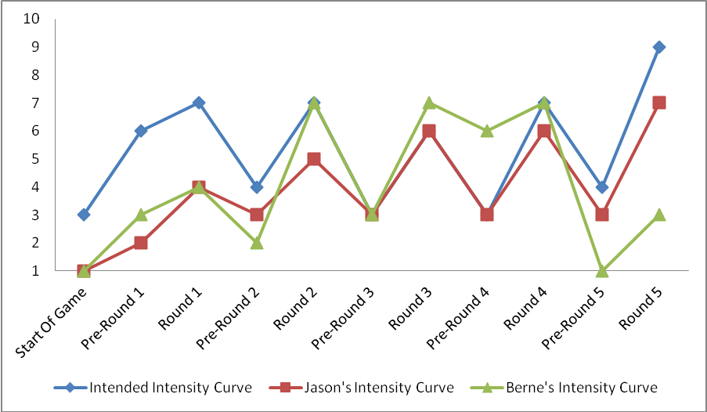
I was hoping that each round would show a spike in intensity as players eagerly awaited the die throw to see the results of their pre-round strategy. While I am glad that the intensity curves for both Jason and Berne show some indication of spiking during the rounds and dipping during the planning, the level of intensity is not quite there.
The beginning of the game saw Jason and Berne having a hard time getting into the game due to confusion about the rules and so they did not seem to be fully in that moment. Also, Berne seemed to checkout near the end, when it became increasingly clear that his crazy train strategy would not work out. Jason kept a pretty consistent intensity throughout the game as his strategy was sound and kept him increasingly in the lead.
I think the biggest problems with "Drunken Boxing", as is evident with the intensity curve, is that the game is difficult to understand right away and does not allow a player who has gotten too far behind a way to catch up.

