Course Syllabus

DIGIPEN INSTITUTE OF TECHNOLOGY
ART 101
THE LANGUAGE OF DRAWING
Course Syllabus

Instructor: Doug Parry

Course Title: The Language of Drawing
Code: ART102FA13
Type: Art, Theory, Compulsory
Pre-Requisites: None
Description: This course explores the nature of drawing as a language skill and the use of drawing by production artists and animators. Applied drawing goals and critical thinking skills are given special consideration. Students are introduced to basic professional habits in drawing practice, drill, and play. Design principles, basic research, and the design process are introduced and applied to a series of practical problems. This course also explores basic drawing materials, drawing strategy, drawing sequence, linear drawing methodology, practice and theory.

Term: Fall 2013
Email/Phone: dparry@digipen.edu; 425-895-4416

DOUG PARRY ART 101F13

COURSE ROOM AND TIME OFFICE HOURS

ART101F13-A REMBRANDT: M 12:00pm-2:50pm 10:00AM TO 12:00PM

ART101F13-B REMBRANDT: W 9:00am-11:50am 1:00PM TO 3:00PM

ART101F13-C BERNINI: Th 11:00am-1:50pm 2:00PM TO 4:00PM

ART101F13-D BERNINI: T 9:00am-11:50am 1:00PM TO 3:00PM

ART101F13-E BERNINI: F 11:00am-1:50pm 2:00PM TO 4:00PM

GROUP LECTURE LAB; PLATO: T 4:00pm-5:50pm (NO OFFICE HOURS)

Recommended Reading:

Curtis, Brian, Drawing from Observation. New York: McGraw-Hill Higher Education, 2002

Mornin, David R., Perspective Made Easy,

Edwards, Betty. The New Drawing on the Right Side of the Brain, New York: Simon and Schuster, Inc. 1999

Edwards, Betty. The New Drawing on the Right Side of the Brain Workbook, New York: Simon and Schuster, Inc. 2002

Robert Henri, The Art Spirit, Boulder Colorado, Westview Press (Icon Editions) 1984

Holiday and Important Date Schedule:

September 2, 2013 (Monday) Labor Day No Classes (WEEK #1)

September 3, 2013 Classes Begin—Fall Semester

September 9, 2013 Last day to drop Fall 2013 Semester courses for 100% refund. Last day to add classes for Fall 2013 Semester

September 16, 2013 Final day to drop classes without academic penalty

October 2, 2013 Withdrawal deadline for 50% refund

October 28, 2013 Final day to receive a “W” on transcript for Fall 2013 Semester withdrawals. Withdrawals from the Institute after this date will receive “F” grades on transcript

October 28, 2013 Final day to drop a class

November 1, 2013 Tuition deposit due for Spring 2014 Semester

November 11, 2013 (Monday) Veterans' Day No Classes (WEEK #12)

November 28-29, 2013 (Thursday and Friday) Thanksgiving No Classes (WEEK #13)

November 25, 2013 Last day to submit Request for Change of Major for Spring 2014 Semester Last day to submit Application for Readmission for Spring 2014 Semester

December 1, 2013 Tuition balance due for Spring 2014

December 9-13, 2013 Fall Semester Final Exams

December 13, 2013 Fall Semester Ends

Grading, Attendance and General BFA Class Policies:

The grading system in BFA classes may be different that you are familiar with. We do not simply assign grades to assignments, then add them up at the end of the semester and divide by the number of assignments to determine your grade. No. We expect you to demonstrate quality, competence and professionalism.
The point of this practice is that you will be entering a highly competitive profession and you need to be fully prepared to generate artistic solutions to a wide number of aesthetic problems in a changing industry. The profession you are entering also runs on critical deadlines where team members are expecting their fellow teammates to submit work on time and to the project specifications. Your teammates will also value those that can take minimal supervision and create art quality that exceeds everyone’s expectations. One more thing you need to be prepared for is, without warning, the piece you’re working on may appear on a top-level manager’s desk as an example of the project’s process. The presentation quality of your work therefore should always be impeccable.
While your portfolio of work will be the primary way you communicate your capabilities in seeking employment, in order to pass a class in the BFA program, you must demonstrate basic competency in the principles/techniques/concepts required by the class as well as quality work, professionalism and clean presentation. The entire program is designed to help you achieve this.

Therefore, in order to “pass” a class you must meet certain requirements. If you meet those requirements, then we revert to more traditional calculations to produce a grade that goes in your transcript. To “pass” you must do all the following:

- Attend classes, for the entire duration of the class meetings.
- Turn in all assignments.
- Pass all project assignments.
- Generate calculated grades on your passing assignments that create a C- or better.
- Pass any pass/fail exit competency test or assignment required for that class.

Attendance:
In any profession, this is not an issue. People that don’t show up, don’t work there any more. In the BFA:

- You must sign the class sign-in sheet for each class meeting.
- If you miss more than 2 classes in a typical 15-week semester with a single class meeting, or more than 4 where classes meet more than once a week, you fail the class.
- The instructor may excuse an absence for a documented medical, family, extraordinary personal emergency or common sense circumstances such as weather etc. You will be expected to contact the instructor as soon as you determine you will be late or absent.
- If you are more than 15 minutes late for a class, or leave early, that is an unexcused absence.
Submitting Assignments:
Professional artists don’t have to think twice about submitting work on time, to the project specifications. In the BFA:

- Every assignment must be turned in and completed to the specifications of the assignment.
- Every assignment must be turned in on time: Individual instructors will assess stringent penalties for late work (see “ART 101 GRADING” below).
- If an assignment will be late, contact the instructor as soon as you know you can’t meet the deadline. The instructor will help you understand the penalties and explain the resubmission deadlines(see “ART 101 GRADING” below).
- In some cases, where the late assignment is required to assess your progress in order to determine if you are prepared for more advanced work, there may be a final cut-off date where you simply fail the class.
- Even if the late penalties lower the grade to below a C-, you must still complete the assignment.

ART 101 GRADING AND LATE HOMEWORK SUBMISSION POLICY

- Every assignment must be turned in and passed, in order, to successfully pass the class. All assignments are important to successfully understanding and meeting the competencies of the class so no assignment can be omitted. You must pass all the assignments to pass the class. Failing a single assignment means failing the class.

- Every assignment must receive a passing grade of 70% or C- to successfully pass the class.

- Any assignment grade of 69% or D is considered a failing grade.

- Students can make up any assignment that they failed over the course of the semester for a higher grade. Student has one week to refine the failed assignment.

- Students can make up a failed assignment only if the original assignment was turned in on time…OR…

- Any assignment turned in late within a week receives a 10% grade reduction and the opportunity to resubmit if the grade, before late penalty, is a failing grade.

- Any assignment turned in over 1 week late receives a 40% grade reduction and no opportunity to resubmit. It will be up to the discretion of the individual instructor as to whether or not the student can do any make-up work to avoid failing the course. Any make-up work can be equivalent to the failed assignment BUT not a re-do of said assignment.

Grades for this class are determined as follows:

Grading scale:

95–100% = A+
90-94% = A
85-89% = B+
80-84% = B
75-79% = C+
70-74% = C
65-69% = C-
60-64% = D
Below 59% = F

A: The work meets a professional level of performance in all facets of the assignment.
B: The work approaches a professional level of performance in all facets of the assignment, and meets that level in at least one area.
C+: Above average student level work
C: Average student level work
C-: Below average student level work
D: Substandard work that demonstrates an understanding of basic principles. Usually, this is an indication of omitted specifications or weak drawing skills.
F: Unacceptable work.

Exit Competency Tests:
The BFA faculty is committed to your success. It would be cruel to pass a student on to the next class where, because they were missing a key concept/skill/technique, they were doomed to failure. Besides the above, In the BFA:

- There will be pass/fail competency test(s) in a class.
- The timing, content and means of evaluation of the pass/fail exit competency test(s) will be clear throughout the semester. No surprises!
- You can pass the competency test, but still fail the class based on your poor coursework.
- Your coursework may meet minimum requirements, but failure of the competency test means you fail the class.

6 Competencies of ART 101:

Students will learn essential drawing skills through the execution of carefully designed in-class guided practice exercises and homework exercises and/or projects.
In order to pass this class, students must show complete artistic competency in each of these drawing skill area in all their in-class guided practice exercises, homework exercises and/or projects and on the Exit Competency Test at the end of the semester:

- ABILITY TO DRAW SIMPLE GEOMETRIC FORMS FROM IMAGINATION/CONSTRUCTION METHOD USING PERSPECTIVE GRIDS
- ABILITY TO DRAW A SIMPLE ENVIRONMENT IN PERSPECTIVE
- ABILITY TO DRAW SIMPLE OBJECTS IN PERSPECTIVE
- ABILITY TO PLOT AND DRAW SHADOWS IN PERSPECTIVE
- ABILITY TO DRAW FROM OBSERVATION: LANDSCAPE; INTERIOR; AND STILL-LIFE
- ABILITY TO DRAW FROM IMAGINATION: LANDSCAPE; INTERIOR; STILL-LIFE

In the BFA, the faculty will help you succeed. In addition to the design of the course and the instruction they will:

- Clearly communicate with you what you need to do to create excellent art through critical analysis of your work. Because art can be a complex set of interrelationships, several instructors may add comments to your work.
- Give clear expectations, then honestly, carefully and fairly assess your work.
- Get you feedback on your submissions in a timely manner so you can apply the ideas to your next assignment.
- Work with you on assignments that do not pass so that you have the information and resources to improve them.
- Point you towards additional resources that you can use to improve.
- Help you take charge of your own learning.

Uploading Your Artwork to the “N’ Drive:

- Make sure the image is cropped. Show only art in the image. No backgrounds!

- Make sure the image is square before cropping. If not: re-shoot the photo!

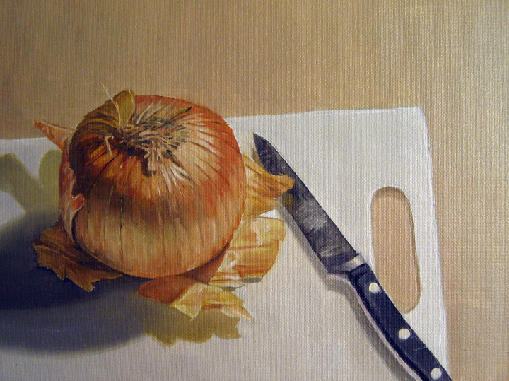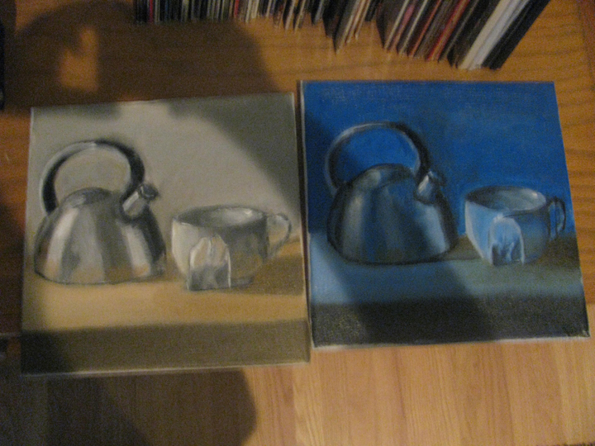

They way your images should look Example of incorrectly
uploaded image.

- Once you have everything shot, please change the image size in a photo program (like Photoshop) according to the specs below:

  - DPI: 300 but no bigger
  - Height: 3,000 pix/inch max
  - Width: 2,400 pix/inch max

(Note: A 300 dpi image that is 8” x 10” is 2400 pixels wide by 3000 pixels high)

- Save each image using this naming convention:

FA13_ART101_DParry_BRoss_I01.jpg

Here's the order of the above example:

Semester (FA13)
underscore
Class and section (all caps, no spaces)
underscore
DParry
underscore
Name (First initial; full last name)
underscore
image number ("IO1"...that's an "I" at the beginning, not a 1...it's I01 for "image 01")
,jpg

- Lastly, you will upload your photos individually to the "N" Drive in the appropriate section folder. Once you locate your section folder, create a folder with your name like this:
SMITH, SAM

Here is where the folder lives on the “N” drive:

Courses(\\data.digipen.edu)(N:)

Current Courses//2013 Fall//Art 101//your file name

I will keep you informed if there are any changes to this location.

- You will also have the opportunity to take photography and uploading workshop at the beginning of the semester…so stay tuned!!!

Required Art Supplies:

ALL SUPPLIES ARE AVAILABLE AT DANIEL SMITH ART SUPPLIES (THE NUMBER AT THE END OF EACH LINE IS THE ORDER NUMBER FOR DANIEL SMITH UNLESS OTHERWISE NOTED) OR BY PURCHASING “STUDENT PACKETS” OR INDIVIDUALLY PURCHASING THEM IN THE DIGIPEN STUDENT BOOKSTORE. PLEASE NOTE THE “ADDITIONAL ITEMS TO PURCHASE” AT THE END OF THIS LIST. SEE INSTRUCTOR WITH ANY QUESTIONS.

(Additional supplies may be required later in the course)

- Portfolio: Approximately 30” x 24”. Large enough for your biggest pad of paper.
Prestige Student Series Soft Sided Portfolio, 23 in x 31 in 479 025 009 $15.48

- Paper: Minimum 2 bound sketchbooks. 8/12” x 11” 50 to 100 pages. Sketching paper or drawing paper quality. Not newsprint. These may be hard bound (preferred) or spiral bound on the long side. (Portrait aspect). These must have your name and class section clearly labeled on the outside front cover.

Canson Spiral Field Sketch Book, 65lb, 9 in x 12 in, 160 Sheets Item No: 355 020 003 $15.41

Minimum 2 large drawing newsprint pad (18” x 24”).

Richeson Newsprint Pad, Rough, 18" x 24", 50 Sheets 027 081 007 $5.63

2 Canson XL Mix Media Pad, 98lb (160gsm), 14" x 17", 60 Sheets, Item No: 159 125 010 (at Daniel Smith or DigiPen Student Store)

- Drawing Media:

One each Graphite pencils: B, 2B, 4B, 8B or softer.
Tombow Mono Professional Drawing Pencil 243 100 004 $1.10

2 BOXES OF VINE CHARCOAL; soft or medium
Winsor & Newton Artists Vine Charcoal Sticks, Soft #2 , 3-pack 261 530 001 $2.53

Compressed Charcoal sticks. I recommend General Jumbo Charcoal, #960 APB Extra smooth assorted. They come in packs of three.
General's Jumbo Charcoal Set 098 015 002 $3.15

Chalk or “white charcoal” pencil
Conte Crayons, HB White, 2-pack Item No: 119 040 010 $3.80

4 Sanford Ebony Graphite Pencil Soft 14420, Item No: 028 060 019 (at Daniel Smith or DigiPen Student Store)

3 kneaded erasers
Small Kneaded Eraser, 1-1/4in x 3/4in Item No: 028 060 006 $0.69

2 Magic Rub erasers
Mars Plastic Eraser Small-20 Pk Item No: 224 100 003 $14.40 ($0.72 each)

1 straight edge
Staedler Double Ink Edge 30-60 Drafting Triangle, 8in
Item No: 224 070 003 $3.99

Clip Light:
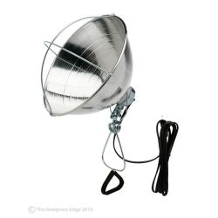
Designers Edge 10.5 in. Brooder Clamp Light Model # E-240-4PK
Internet #100664505 $12.99. AVAILABLE AT HOME DEPOT.

ALSO:
- 1 ROLL OF 1” MASKING TAPE (NOT blue tape!)
- RULER (clear plastic; inches and centimeter)
- FLEXI-CURVE OR FRENCH CURVE
- BOX TO CARRY SUPPLIES
- POCKET PENCIL SHARPENER
- SMALL OR MEDIUM SIZED XACTO KNIFE

NEW ADDITIONS!
PLEASE ADD THESE ITEMS TO YOUR SUPPLY KIT IMMEDIATELY!!! THE NUMBER BEFORE THE ITEM IS THE ITEM NUMBER AT DICK BLICK ART MATERIALS (http://www.dickblick.com/) IN SEATTLE.

- 55682-2424 Standard T-Square 24"

- 12981-0000 Dry Cleaning Pad

- 10609-3119 Tracing Paper Pad, 100 Sheets 19" × 24" 25 lb (41 gms)

- 55777-1006 Student Compass and Protractor Set

- 55703-1008 Professional Triangle, 45°/90°, 8"

- 10629-1017 #116 Vellum, 40-Sheet Pad 14" × 17"

