|  |
| --- |
| Tragedy Search Corporation |
| Beatrix Lycanthorn: Curse of the Werewolf |
|  |
| GAM100-H Game Design Document  © 2013 Digipen Institute of Technology. |
| **Preston Lowery, Travis Moore, and Kellie Pelton** |
|  |

|  |
| --- |
| October 1, 2013 |

1. **High Concept –**

Beatrix Lycanthorn is a 2D platform adventure set in a stylized, melancholy medieval Europe. Beatrix hungers like the wolf…for vegetables.

1. **Summary –**

Beatrix Lycanthorn is a bearer for the curse of lycanthropy, a curse that has run rampant in her genealogy for decades, skipping a generation from time to time. Most bearers of the curse in her bloodline are outcasts to society, while some never undergo the transmogrification process. In the case of Beatrix Lycanthorn, the beast is alive and active and it hungers every night for succulent vegetables!

Beatrix Lycanthorn’s life was fragmented by the social implications of turning into a ravenous, veggie munching monster. In order to piece together her life, Beatrix must travel the country side searching for clues that could help remedy her affliction. Players must take control of the ill-fated heroine as they navigate the morose environment solving puzzles, interacting with villagers and gaining access to new environments yet to be explored.

Medieval Europe is an enigmatic and perilous place, wrought with trials and tribulations at every corner. Luckily for Beatrix, her greatest burden is also her strongest asset. By unleashing the beast within, Beatrix becomes a dexterous, meaty tank capable of unparalleled maneuverability and withstanding multiple blows to her person. Players beware, by activating her primal form Beatrix’s nearly insatiable hunger can only be stifled by consuming an usual amount of vegetables. Failure to do so could result in dire consequences for our heroine, ending her tragic quest prematurely. You wouldn’t want that, would you?

1. **Game Mechanics –**

- Beatrix Lycanthorn is capable of movement in all four integral directions: up, down, right and left.

- Beatrix can actively enter her beast state. Upon doing so, she must consume vegetables to satisfy her hunger. Beast state does not last forever and once deactivated there is a cool-down timer before she can become a werewolf again.

- Beatrix is a pacifist and will not inflict damage on lesser beings. However, she is capable of taking heavy damage while a werewolf. In addition to this, Beatrix can regenerate her health by consuming veggies

- Beatrix must solve puzzles in order to freely navigate throughout her environment. Solving puzzles allows her to gain access to resources that will bring her one step closer to solving her curse.

1. **Characters**

Beatrix Lycanthorn – This is the human female protagonist in the game. Players will follow Beatrix as she travels the European world in search of answers to her lycanthropy curse. By solving the curse, Beatrix hopes to revert to her past life and return to the family she once had. Beatrix is of a common appearance and garb akin to medieval century women from England.

**Human State:**

- Does not provoke guards or villagers 

- Petite size allows her access through tight spots to reach objects

- Basic movement and low health

- Can use items

- Can advance to new stages

**Beast State:**

- Provokes guards and villagers into attacking her if seen

- Large frame does not allow Beatrix to move while crouched or enter tight spaces

- Advanced movement allows for wall jumps and swift run speeds

- Must maintain a hunger meter to stay alive

Villagers/Guards - Villagers and guards are NPC characters that react to Beatrix’s presence in different ways depending on her current state. If she is a human they will ignore her and go about their way, however, if she is in her beast state they will chase her relentlessly until Beatrix manages to get away.

1. **Environment -**

Beatrix Lycanthorn’s adventures will take place in a somber and melancholic medieval Europe. This location is set as the initial hub world and will span out to multiple stages that take on their own inherent theme and mood. For instance, a drizzly and dimly lit cave section will feel dark and ominous to the player. Torches will emit flickering yellow light against an environment that is highlighted by a bluish tint. Other stages will follow this same formula where the mood and tone of the stage will be emphasized by a lightly tinted color such as red or green.

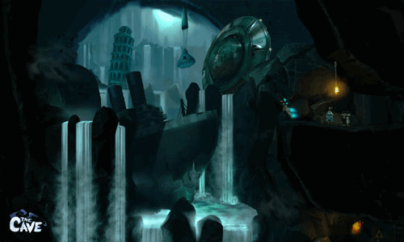

The initial hub world itself will be larger than the supporting stages and play host to a myriad of different structures, and terrains. Beatrix will wander through villages, trek up steep cliff sides and stand at awe in front of towering castles and forts. Beatrix’s world is richly stylized, with the purpose of enhancing the players experience by communicating a clear and decisive mood and tone.

1. **Citations –**

<http://www.pearsonsrenaissanceshoppe.com/ameline-peasant-overdress.html>

Medieval woman picture

<http://www.game.co.uk/en/the-cave-202753>

The Cave™ © Doublefine, Valve

The Cave™ picture