Travis Moore

GAT-110 F13

Week 3—Digital Game Analysis: Super Meat Boy

*Super Meat Boy* is an independently made two-dimensional platformer that is designed by Edmund McMillen and Tommy Refenes of Team Meat. It is a wonderfully quirky game that has received numerous awards since its release on October 2010. Noted for its tight game controls, pixel style artwork, and rocking soundtrack, it is as awesome as it is difficult. The difficultly of *Super Meat Boy* is a very unique aspect of the game, as most games try to tone down the difficultly of games to appease a wider audience and not frustrate players playing the game. So how does *Super Meat Boy* get away with being an incredibly difficult game and still be popular? *Super Meat Boy* perfectly executes a smooth learning curve and tight controls make the game fun, despite it being a tough game to play.



*Super Meat Boy, the star of the game.*

Like many games, *Super Meat Boy* does not just plop the player into the most difficult levels of the game without giving the player a chance to learn how to play. *Super Meat Boy* slowly introduces the player to the controls through the first few levels. As the player masters these controls, advanced movement, like wall-jumping, are introduced next to boost learning further. This gives the player a chance to master the concept before escalating the difficulty. Even level obstacles are introduced slowly, so the player can learn how to deal with them. For example, stationary saw blades in early levels teach the player that they most maneuver around them to survive before saw blades become more difficult by allowing them to follow along a track. By slowly teaching the player advanced controls and difficult obstacles, players do not get discouraged quickly by the time they get to very difficult puzzles.

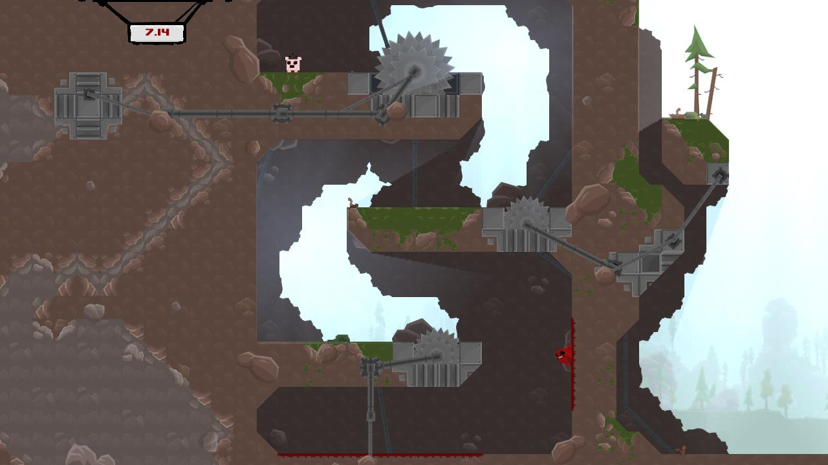

*A screenshot of Super Meat Boy showing wall-jumping and stationary saw blades.*

Too often the controls while playing two-dimensional platformer games feel imprecise, like a guessing game as to where the character you play will end up when you are directing movement. This is not the case in *Super Meat Boy*. The controls for *Super Meat Boy* feel very in sync with the movement of each of the characters. Not once playing *Super Meat Boy* do you feel cheated because your character slid a little farther than you thought, or jumped just a half second too late. The controls feel solidly mapped to their buttons and happen instantaneously when a button is pressed. When you jump or fall to your demise in *Super Meat Boy* it is purely because your timing or judgment was wrong. Although failing is not fun, the frustration of feeling like the controls are sloppy are not to blame in dying in *Super Meat Boy.*