Travis Moore

GAT-110 F13

Week 4—Original Game Design: Beatrix Lycanthrope—Curse of the Werewolf

For the last couple of Halloweens I have always dressed up as a werewolf who also dresses up for Halloween. Some years I have been a doctor werewolf or a werewolf on a tropical vacation. As Halloween approaches this year, dressing up as a themed werewolf has me thinking about how I can make a werewolf video game while I am studying at Digipen. While I am only a freshman at Digipen, I think that it is within my reach to try and make a werewolf themed game with the help of others.

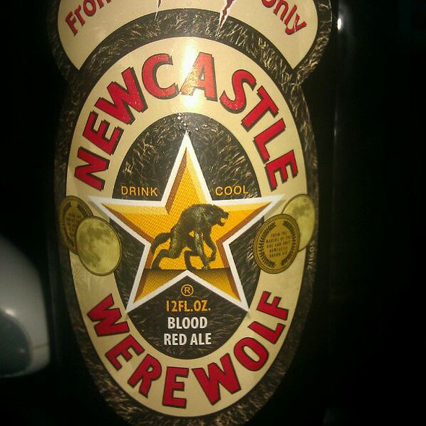

*Beer label that was a source of inspiration for character*

*design. The beer probably played a part, as well.*

*Beatrix Lycanthrope—Curse of the Werewolf* is the working title for a two-dimensional side-scrolling platformer that is set in the English countryside during the 16th Century. The game is single player and features a human female protagonist, Beatrix Lycanthrope. Cursed to be a werewolf, the goal of the game is to help Beatrix break her curse before it is too late. During the course of the game, the player can transform from Beatrix to a werewolf to help solve puzzles or access areas of a level that Beatrix normally wouldn’t be able to reach.

In her human form, Beatrix is an intelligent and pacifist person. A firm believer in non-violence, Beatrix would never hurt anyone or anything, which is why she is a vegan (rare for her place in time, I know). Beatrix is delicate and would rather find ways around fights by using the tools at her disposal. Everyone in England finds Beatrix to be a pleasant person to be around, but Beatrix is not always her human self.

As a werewolf, Beatrix frightens her fellow humans into attacking her when she comes near. Steadfast in her pacifist beliefs, Beatrix does not attack anyone as a werewolf, so she is unable to fight back and must run and hide when confronted. Being a werewolf is not completely full of drawbacks, however. As a werewolf Beatrix is much tougher, able to absorb damage that she could not as a human and break obstacles. Beatrix’s werewolf form is also able to perform advanced movement, such as jumping off of walls and running quick. As fun as this might seem, when transformed into a werewolf, Beatrix is unable to use tools and is slave to hunger to the point where she must constantly eat to stay alive.

I believe Beatrix’s duality of form could potentially be a lot of fun for the player to solve puzzles with. The juxtaposition of advantages and disadvantages in being a human versus being a werewolf should allow for interesting level designs and a variety of challenges that can be presented to the player. While the game is still an idea floating in my mind, I think it has enough depth to be a really exciting game.