**Travis Moore**

**GAT 110—Fall 2013**

**Instructor: Rich Rowan**

**Assignment: Paper #1—Race Games**

**Game Analysis**

*Sorry!* is a board game for two to four players that is heavily influenced by the cross and circle game, *Pachisi*. Falling under the category of a racing game, the goal of *Sorry!* is to be the first player to move all of their color pawns from start to home. The components that make up *Sorry!* are the game board, pawns, and a deck of 45 cards (figure 1-1). The game board is square, with fifteen spaces per side that a player must travel in a clockwise direction on in order to get their pawns to their home (table 1-2). Each player is represented in *Sorry!* by four pawns of the same color and may move by drawing a card on their turn (table 1-3).

Winning a game of *Sorry!* is highly based on chance more than skill. There are 11 different types of cards with unique rules and the probability of drawing any card is 8.89%, with the only exception to that being the 1 card, which is 11.11% (table 1-4). However, because drawing a card removes it from the deck, the probability of drawing any one card changes as the game progresses. Entering a pawn into play requires a 1 or a 2 which has a 20% chance of occurrence, unless another player has a pawn in play. If this is the case, a player can use the *Sorry!* card to enter a pawn, which gives a 28.89% chance of entering a pawn. Once a pawn is in play, a player can perform pawn captures by landing on an opponent’s pawn with their pawn or switch places with an opponent if they draw the right card.

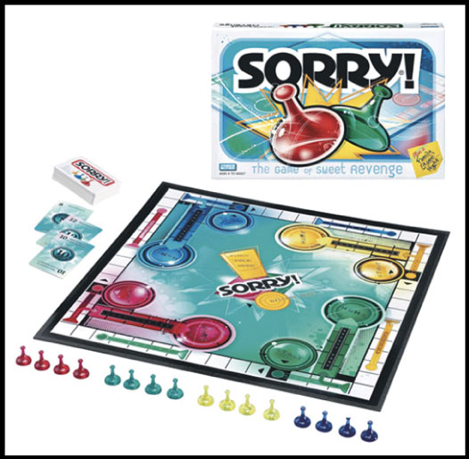

*Figure 1-1 Sorry! Game Board, Pawns, and Deck of Cards*

*Table 1-2 Sorry!—Game Board Attributes*

|  |  |
| --- | --- |
| Game Board | Description |
| Size: | Square, 15 spaces x 15 spaces. |
| Movement Direction: | Clockwise (unless otherwise directed by a card). |
| Safe Zone, Start, Home | 1 for each color (red, green, blue, and yellow) located in the corners of the game board, 4 in total. |
| Slides | 2 for each color (red, green, blue, and yellow). Slides are grouped by color, 1 group of 2 slides per side of the board. Slides allow a pawn that lands on the beginning of a slide to move forward to the end of the slide (unless the pawn is the same color as the slide). |
|  |  |

*Table 1-3 Sorry!—Player Token Attributes*

|  |  |
| --- | --- |
| Pawn | Description |
| Per Player: | 4 pawns of the same color group. |
| Colors: | Red, green, blue, and yellow. |
| Ownership: | Each player only controls their color group of pawns. |
| Design Purpose: | Player representatives that can move around the game board, capture opposing pawns, and switch place with opposing pawns. |

*Figure 1-2 Sorry!—Card Values, Rules, and Probability*

|  |  |  |
| --- | --- | --- |
| Value | Rules for the Card | Probability* |
| 1 | Move pawn from Start or move a pawn 1 space forward. | 11.11% |
| 2 | Move pawn from Start or move pawn 2 spaces forward. Drawing a 2 entitles the player to draw again at the end of his or her turn. If you cannot use 2, you can still draw again. | 08.89% |
| 3 | Move pawn 3 spaces forward. | 08.89% |
| 4 | Move pawn 4 spaces backwards. | 08.89% |
| 5 | Move pawn 5 spaces forward. | 08.89% |
| 7 | Move one pawn 7 spaces forward or split the 7 spaces between two pawns (such as four spaces for one pawn and three for another). This makes it possible for two pawns to enter Home on the same turn, for example. The 7 cannot be split into a 6 and 1 or a 5 and 2 for the purposes of moving out of Start. The entire seven spaces must be used one way or the other or the turn is lost. | 08.89% |
| 8 | Move pawn 8 spaces forward. | 08.89% |
| 10 | Move pawn 10 spaces forward or 1 space backward. If a player cannot go forward the full ten spaces, then one pawn must go backward one space. | 08.89% |
| 11 | Move pawn 11 spaces forward or switch places with one opposing pawn. A player that cannot move 11 spaces is not forced to switch and instead can forfeit the turn. | 08.89% |
| 12 | Move pawn 12 spaces forward. | 08.89% |
| *Sorry!* card | Move any one pawn from Start to a square occupied by any opponent, sending that pawn back to its own Start. If there are no pawns on the player's Start, or no opponent's pawns on any squares, the turn is lost. | 08.89% |
| *Probability assumes a full deck of 45 cards that has had no cards drawn from it yet. The probability of the next card drawn after a card has been pulled is dependent on the previously drawn card and the new number of cards left in the deck. | | |

*Senet* is a board game for two players that symbolizes the transition of the human spirit toward a new life beyond death. A racing game, the goal of *Senet* is to be the first player to move all of their tokens off the board. *Senet* has a game board, tokens, and four two-sided dice (figure 2-1). The game board is a rectangle that is three rows of ten spaces each and has specially marked spaces near the end of the board (see table 2-2). Each player controls five tokens of a similar color and may move any token if it is possible to do so according based on their dice throw (table 2-3).

*Senet* has a stable probability of movement because dice throws are independent of each other. There are five different types of outcomes for a dice throw with different probabilities (table 2-4). The average move is two spaces, with a 37.5% chance of occurrence, followed equally by either a one or a three, both with a 25% chance of occurrence. Like *Sorry!*, *Senet* allows players to capture pieces and also for strategy by allowing adjacent tokens of the same color to block an opponent from capturing a token. This is furthered by allowing 3 adjacent tokens of the same color to block all movement beyond them, adding more depth to the strategy in playing Senet.

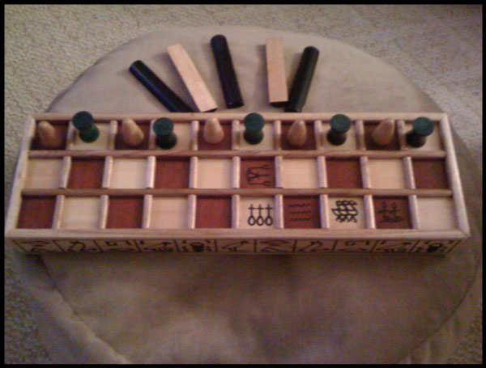

*Figure 2-1 Senet Game Board, Tokens, and Dice*

*Table 2-2 Senet—Game Board Attributes*

|  |  |
| --- | --- |
| Game Board | Description |
| Size: | Rectangle, 3 rows of 10 spaces each |
| Movement Direction: | The game tokens advance according to the numbers on the spaces in the first row, whereby they enter the second row where they move laterally until they reach the end where they enter into the third row and continue until they are on the final space. Once on the final space, the piece is then removed from the board. The movement shape is like that of an “S”. |
| Free Houses | Space 26, 28, 29, and 30 are safe spaces on the board where pieces cannot be attacked. |
| House 27 | If a player lands their token on the 27th space on the board they most return this token to the first space on the board. |
|  |  |

*Table 2-3 Senet—Player Token Attributes*

|  |  |
| --- | --- |
| Token | Description |
| Per Player: | There are 5 tokens per player. |
| Colors: | Black and white. |
| Ownership: | Each player only controls their color group of tokens. |
| Design Purpose: | Player representatives that can move on the game board, capture opposing tokens, and form 2 and 3 token blocks. |

*Table 2-4 Senet—Dice Values, Rules, and Probability*

|  |  |  |
| --- | --- | --- |
| Dice Outcome | Rules for the Dice Outcome | Probability |
| 1 flat side up | Move pawn 1 space forward. | 25% |
| 2 flat side up | Move pawn 2 spaces forward. | 37.5% |
| 3 flat side up | Move pawn 3 spaces forward. | 25% |
| 4 flat side up | Move pawn 4 spaces backwards. | 06.25% |
| 4 flat side down | Move pawn 6 spaces forward. | 06.25% |

*Super Mario Kart Racing Tournament* is a digital game for one player that is based off the *Super Mario Brothers* series of games. Unlike the last two racing games, a player competes against computer controlled players to finish first in each level. Every level is a two-dimensional race against three computer racers with various obstacles and power-ups along the way (table 3-1). Before racing a player must select a racer to use in the game from one of the eight available *Super Mario Brothers* characters, but this selection does not affect the how well a player races in the game (table 3-2).

Like the racing games before it, *Super Mario Kart Racing Tournament* requires the player to use movement to get from start to finish, but movement is not controlled by a randomizer. Instead, racing in *Super Mario Kart Racing Tournament* requires skill in avoiding obstacles and power-ups to help the player come in first place. The power-ups provide the player with useful items that aid in movement, aid the player to stop opposing players, or provide money to use in the shop (table 3-3). Assuming that the game has an even chance of receiving a power-up from a chance block, there is a 50% chance that the power-up will aid movement in the form of a red mushroom, star, or feather.

*Table 3-1 Super Mario Kart Racing Tournament—Level Attributes*

|  |  |  |
| --- | --- | --- |
| mario-diagram.jpg | | 1—Item Slots  2—Boost Indicator  3—Current Place  4—Current Gold  5—Opposing Player  6—Power-Up (Red Mushroom)  7—Obstacles  8—Player  9—Chance Block (contains a power-up) |
| Size: | Each level is roughly a minute long to complete (assuming little to no obstacle collisions). | |
| Movement Direction: | Start from the left of the level and proceed to the finish at the right of the level. | |
| Levels Menu: | There are 8 standard levels and 1 locked level. | |

*Table 3-2 Super Mario Kart Racing Tournament—Player Token Attributes*

|  |  |
| --- | --- |
| Available Racers: | Mario, Luigi, Princess Peach, Yoshi, Bowser, Goomba, Koopa, and Pokey.  Racers do not perform differently from one another. |
| Ownership: | Each player only controls their selected token. |
| Design Purpose: | Player representatives that can collect gold, collect items, use items, use a boost, move forward, backwards, and jump. |

*Table 3-3 Super Mario Kart Racing Tournament—Power Ups, Descriptions, and Probability*

|  |  |  |
| --- | --- | --- |
| Power-Up | Descriptions | Probability |
| Coin | Gives the player 1 gold coin. | 16.67% |
| Green Mushroom | Gives the player 25 gold coins. | 16.67% |
| Red Mushroom | Gives the player a temporary speed boost. | 16.67% |
| Star | Gives the player temporary invulnerability. Any other racer that the player runs into while invulnerable is stunned for a short time. | 16.67% |
| Feather | Gives the player temporary ability to fly. | 16.67% |
| Flower | Gives the player 1 projectile that shoots from the front of the player and will pass through objects until it hits another racer. A racer hit by this projectile will be stunned for a short time. | 16.67% |

*Sorry!*, *Senet*, and *Super Mario Kart Racing Tournament* are all similar in that they are racing games where the goal is to be the first one to finish, whether it be in a home, off the board, or crossing a finish line. All three games use representatives for players in the form of a player representative, a racetrack in the form of a game board or level, and a randomizer to add an element of chance to the game. Where the games differ is their methods of achieving movement. *Sorry!* and *Senet* both rely on a randomizer in the form of cards or dice to achieve movement, and as such, chance is a big factor in how well a player does in the game. This works well for these types of games because unpredictability makes the games fun, even with some control provided by elements of strategy. While power-ups utilize a randomizer in *Super Mario Kart Racing Tournament*, this game does not rely on a randomizer for movement, so the player’s skill in navigating a level successfully is important for winning. This choice fits well with the single player nature of this game, since winning with skill over computer opponents seems more fitting than winning by chance.

**Dynamics**

The experience of playing *Sorry!* hinges mostly on the chance of drawing the right card needed to help one win. Using cards as the primary means of movement means the probability of drawing the right card changes with every card drawn, so *Sorry!* really does feel like a game of luck more than anything else. On top of this, the movement range of the cards varies wildly from backwards four spaces to forwards 12 spaces making the game feel unpredictable and fast pace. Due to this, it is easy for anyone to play and do relatively well, even if they do not properly utilize the few chances where some strategy could be applied. Because there are eight different cards, each with different rules, drawing the right card had a big impact on the progress of the game, making for fun surprises throughout playing. However, relying heavily on chance can cause the pacing of the game to suffer, such as waiting to get a pawn out of start so that a player can actually play the game.

*Senet* did not rely on chance quite as heavily as *Sorry!* due to movement being independent dice throws. While there still is chance involved with a dice throw, the limited range of movement and average probability of moving two spaces a dice throw made the game’s pacing more predictable, especially in comparison to *Sorry!* However, the additional strategy elements and the two player format in *Senet* made the game challenging and competitive. It is very satisfying to set up a strategic block on an opponent, allowing one to move their pieces further ahead. However, the limited movement and blocking strategies did make the game feel very slow. It was also very frustrating to be forced to move on to House 27 and be moved all the way back to the start. Despite this, *Senet* is rewarding in that when one wins a game, it feels like a triumph against a specific opponent.

*Super Mario Kart Racing Tournament* is a different kind of experience, especially after playing *Sorry!* and *Senet*. Movement is not randomly decided in the game, so the pacing of the game is steady. While the levels had different obstacles, the game did feel repetitive. Thankfully, having the randomizer in the form of power-ups made the fun of playing the game increase when several good power-ups were collected and used to help the player take the lead from behind. If the game ever did feel too difficult, buying upgrades from the shop helped the player tip the balance more in their favor, making the game more enjoyable to those players with less skill. However, buying too many upgrades would make the game too easy, which would make the game boring. Having the player race against three computer opponents helped add a competitive element to the game, but it is not as enjoyable as playing against other people. Ultimately the game felt more like a challenge for one’s self.

Even though all the games played were racing games, the experience of playing each game was very different, depending on the game being played*. Sorry!* relies greatly on chance making it a great game to play with other people of all skill levels . Being a two player game, *Senet* felt much more competitive than both *Sorry!* and *Super Mario Kart Racing Tournament* because it was one player versus another player. *Super Mario Kart Racing Tournament* felt different from both of the board games, not just because it was a video game, but because of the lack of other human players and how it relied more on skillfully controlling your player. *Sorry!* and *Senet* allow you to make decisions on which pawn or token you could move, but do not give full movement control like *Super Mario Kart Racing Tournament* does. Being playable in real time also makes *Super Mario Kart Racing Tournament* feel quicker than taking turns in both of the board games. Despite all being racing games with similar goals, the experience of all three games were unique due to the design decisions involved in the components and mechanics of each game.

**Modification**

While *Sorry!* is enjoyable with its original rules, I decided to make a modification for it in an attempt to make it even more fun to play by enhancing the revenge aspect of the game. When playing *Sorry!* with the original rules, I found myself wishing there was more strategy involved, especially when the game was nearing its conclusion and I did not have any pawns in the home position of the board. The “Home Invasion” modification is an attempt to interject more strategy to *Sorry!* so it will be more fun to play, as well as give players who are behind in the game a chance to make a comeback. “Home Invasion” essentially removes the “safety” aspect of both the home and save zones and allows any player to travel in this area to “steal” pawns away from the home of opposing players. For example, in figure 4-1 the blue player has a pawn in their home and red has elected to attempt to steal the pawn from home by drawing a 7 card, moving into the blue home, and moving the remaining spaces out with the blue pawn. Due to this strategy, the blue player must now retry to move their blue pawn back into home, effectively prolonging their ability to win the game. This strategy can pay off even better, such as in figure 4-2, where the red player has drawn a 12, dragging the blue pawn all the way back to the outside section of the board, where the blue player must now traverse the outside of the board in order to get back to home. The expected trade off of the “Home Invasion” modification is that a player must choose whether to delay their own pawn from traveling to home for the chance at further delaying another opponent who already has a pawn in their home.

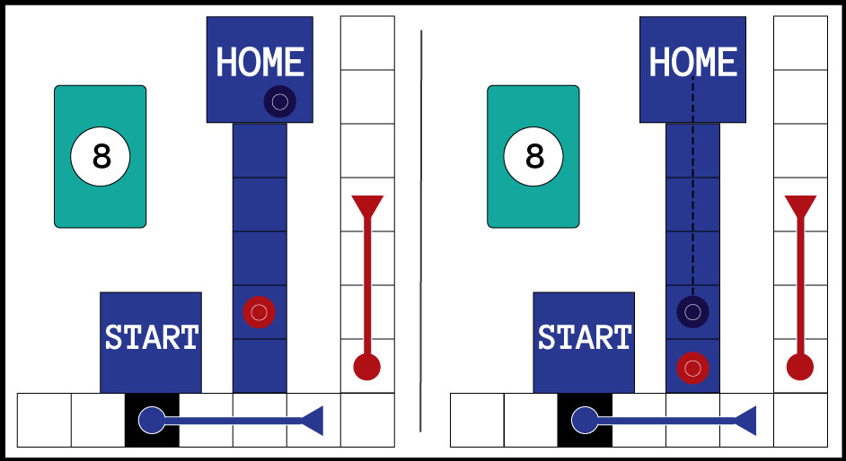

*Figure 4-1—Sorry! “Home Invasion” scenario where the red player draws an 8 and steals a blue pawn from its home. The blue player will need to retry to get the stolen pawn back into home.*

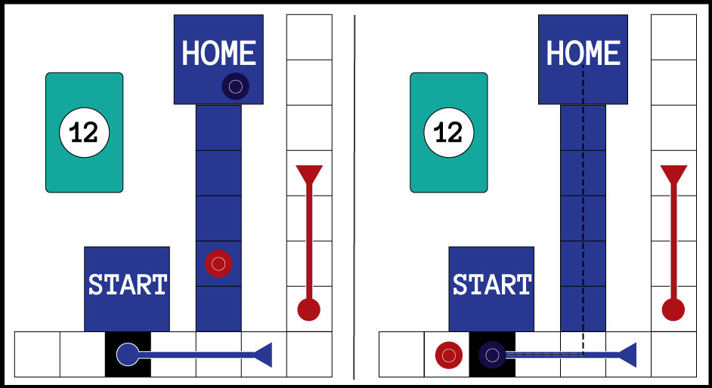

*Figure 4-2—Sorry! “Home Invasion” scenario where the red player draws a 12, steals a blue pawn far enough outside of its home that the blue pawn will have to travel around the board again to get back to home.*

**Testing Report**

Open conceiving of “Home Invasion” I wanted to make *Sorry!* more fun by improving upon the revenge aspect of the game, but was unsure if players would actually make use of the addition of a new strategy. My initial games of playing *Sorry!* using the regular rules did not result in many situations where I was close to an enemy safety zone. Because of this, I did not expect this rule to see a lot of use. In fact, I had expected that only one player, who was so far behind, would possibly make use of the new rules. I imagined that only this player would see the reward of stopping a player who is ahead worth the risk of putting their pawn in danger in order to pull of this move. Moreover, I expected that situations where a losing player would be close enough to enter the safety zone of an opposing winning player would not happen frequently. For these reasons, I saw the “Home Invasion” rules as a great way to tip the balance of the game, but I was worried that it would only see a little use. Thankfully, however, I was wrong.

While the “Home Invasion” rules did not much apply during the beginning of a game of *Sorry!*, the rules immediately took over the game as soon as the first player managed to land a pawn in their home. Unexpectedly, several mechanics were affected by the “Home Invasion” rules in ways I had not originally intended. Firstly, the slides in front of the safety zone area went from being a positive experience for a player where they got to move more, to a negative experience where the player missed an opportunity to steal from an opposing player. Essentially, the slides become a sort of home defense mechanic. Even with the slides acting as a deterrent, players still managed to get into opposing players safe zones, and even leave a pawn lingering there, waiting to draw a high number card so that they could steal a pawn further away from home. I originally imagined that this would be considered too risky a move to make, but it proved not to be. Also, sometimes attempting to steal from a player by lingering in their safe zone would allow for a player to switch places with the would-be invader and be just a few spaces from home, which happened a lot during the first test. However, this did not detract from the modification from being fun, as player comments, such as “really enjoyed the mod” and “hilarious and morally twisted version of *Sorry!*” were made after both tests (table 5-1).

Most of the unexpected effects of “Home Invasion” were fun, but the new rules did have an awful, unintended effect in that games went longer than normal. Unexpectedly, the “Home Invasion” rules quickly became a way for any player to exact revenge on not just the player in the lead, but anyone who had pawn in their home. Because “Home Invasion” affected the mechanics of the original safe zone and home, nowhere on the board was safe and landing a pawn at home was not permanent. Due to this, games played with the “Home Invasion” rules lasted longer than a standard game of *Sorry!* ever did. The game lasting longer than normal was evident to the players in their comments made after the test and hurt the modification (table 5-1). There were many times when a player had three pawns in home only to have the losing players gang up and remove all pawns that player. Sure stealing pawns from opposing players tipped the balance of the game, something I had wanted with the new rules, but it was also impeding anyone from winning without playing a longer version of the game.

*Table 5-1 Sorry! “Home Invasion” Mod—Test, Players, Game Length, and Player Comments*

|  |  |  |  |
| --- | --- | --- | --- |
| Test | Players | Game Length | Player Comments |
| 1 | Travis, Preston, Auston, Shae | 1.25 hours | “The addition of in-home kidnapping makes for a crazy, hilarious, and morally twisted version of Sorry!. This makes the game the ultimate game of vengeance. Be careful, the rule could potentially leave the game without an end in sight.” - Preston |
| 2 | Travis, Brittney, Michael, Maddy | 1.5 hours | “Made me laugh. Really enjoyed the mod. Made it really interesting, but also annoying. One downfall is that it increased the time it takes to play the game and have a winner. But on the other hand; it allowed people to come from behind to win.” -Brittney |

**Further Modification**

My modification of *Sorry!* with the “Home Invasion” rules were successful in enhancing the revenge aspect of the game to make it more fun, but it was not without its downsides. The biggest problem with the modification in its current state is that games of *Sorry!* play longer than they previously did because of the ability to steal pawns from opposing players’ homes. While stealing pawns from the opposing players is a crucial change that allowed the game to go on longer, I do not believe that the solution is to get rid of this mechanic entirely. Testing showed that players would use the stealing pawns tactic anytime they could, even lingering in another player’s safe zone waiting to steal an enemy pawn from home. This shows me that the risk of the maneuver is not high enough to deter players enough from performing it all the time.

There are several different changes available that could fix the “Home Invasion” modification to *Sorry!* that could possibly improve it for the future. One such solution could be to make it much more difficult to successfully steal a pawn from an opposing player by making it harder to land on an opposing player’s home space. Simply making it so that a player needs the perfect card number in order to get in an opposing player’s home in order to steal a pawn would perhaps make it more risky to a player to sit and linger in an enemy safe zone. If this solution was not successful and players still lingered in a safe zone too frequently, then perhaps affecting a player’s future moves could fix the problem. If a player were going to attempt to steal a pawn from an opposing player, instead of needing a perfect number to get into an opposing player’s home, they would have to dedicate their next turn to this tactic for as long as their pawn remains in an enemy’s safe zone. This would solve the problem of lingering because a player attempting to steal a pawn wouldn’t be allowed to move any other pawns not already in an enemy safe zone. Both of these possible further modifications might reduce the amount of stealing and thereby make the game play quicker than it previously had.