Travis Moore

GAT120—F13

Paper #3—Mario 1-1

As with any new game, a player who has not yet played *Super Mario Brothers* will not be familiar with how the game works and may potentially not like the game if they are not introduced to core concepts of the game early. *World* 1-1 does a great job of utilizing the discovery aesthetic to introduce the core mechanics of *Super Mario Brothers* to the player. Firstly, the player is placed in a flat setting so that a player can discover the controls, such as running and jumping. Immediately afterwards the player is shown bricks, chance boxes, coins, a power-up, and an enemy (figure1). This helps to establish what is good, like how to get coins and power-ups, while also introducing what is bad, like an enemy. The intensity at this part of the game spikes slightly because everything is so new to the player.

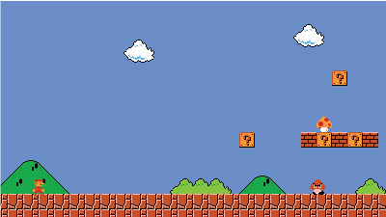

Figure 1—the player is introduced to moving, an enemy, coins, and a   
power-up.

Moving on through the level *Super Mario Brothers* continues to use the discovery aesthetic, while sprinkling in small doses of the challenge aesthetic to help keep the level from being purely a tutorial. Because jumping is such a core mechanic of *Super Mario Brothers*, the next section of world 1-1 involves jumping over pipes of varying heights (figure 2). The player quickly learns that how long they hold on to the jump button affects the height of their jump. If the player has not done yet before, there is a good chance that jumping over a pipe might have Mario land on an enemy. This helps the player learn how to defeat bad guys. This is also an opportunity to provide a greater challenge to the player in the form of multiple enemies. If the player had gotten the first power-up, they would learn at this point that touching an enemy will cause them to lose their power-up or die if they failed to do so.

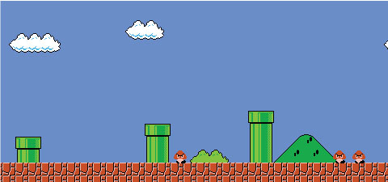

Figure 2—the player is introduced to different jump heights and multiple enemies.

Upon jumping over the last pipe in the section, the player has gotten a taste of the linear nature of *Super Mario Brothers*, so the designers of world 1-1 take this opportunity to provide the player with more elements to the game. Pitfalls are introduced as an obstacle, further emphasizing the need to jump properly in the game (figure 3). If the player is lucky, they also learn about secret blocks by accidentally jumping in the air below one and receive an extra life. This reinforces the discovery aesthetic by rewarding players for trying to find hidden goodies in the game. Complexity is also discovered at this point because the player is given the option to jump upon bricks to explore alternate paths through a level that could help the player avoid obstacles, like another pitfall (figure 4).

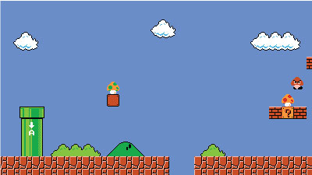

Figure 3—the player is introduced to secret blocks, a pitfall, and the possibility of entering certain pipes.

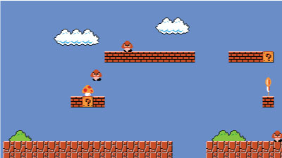

Figure 4—the player is introduced to the possibilities of different paths, such as moving along the bricks above.

At this point through world 1-1, the designers have shown a lot of concepts and elements of the game, so the challenge aesthetic is increased even more, perhaps to put the player through the first big test. The proceeding area can be done in many ways, such as traveling above and over the obstacles, getting the star and plowing through enemies, or slowly collecting every coin and power-up (figure 5). This area challenges the player by allowing them to solve it in their own way, whether it is speed, brute force, or methodically exploring every part of the area. The intensity of this part of the level is at its highest for world 1-1. Afterwards, the next section involves forcing the player to move vertically, an essential concept that the player cannot pass up if they had not done so before (figure 6). This part also acts as a cool down to the intensity of the section before it.

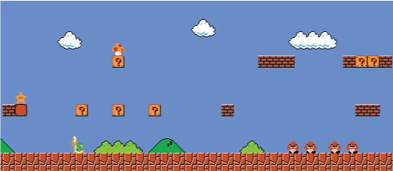

Figure 5—the player is introduced to new power-ups and must decide how to traverse a complex section with multiple paths, coins, and enemies.

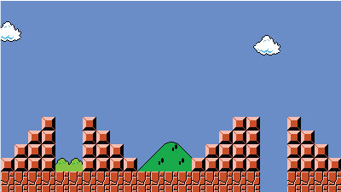

Figure 6—The player is introduced to forced verticality, if they had not taken an upper path before.

Nearing the end of world 1-1, *Super Mario Brothers* has a few more challenges to give the player before it concludes. The player is given an option of entering a confined space with multiple enemies to get a coin or an easier path of jumping over the area (figure 7). This is just a taste of some of the choices to come, but it is enough to allow the player to discover these options and accept a challenge or not. The end of world 1-1 gives the player one last part that introduces how a level will end and also gives the player one final challenge in order to earn extra points in the form of a flag jump (figure 8). Even at the end, *Super Mario Brothers* world 1-1 is engaging because it delivers the core aesthetics of discovery and competition to the player in a gradual way.

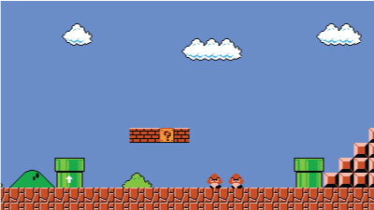

Figure 7—the player is introduced to a reward option of facing the enemies below to get a coin or jump over and past the challenge.

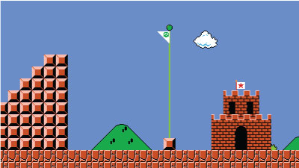

Figure 8—the player is introduced to how levels will end and the last challenge of jumping high over a long distance.