Travis Moore

GAT120—F13

Paper #6—Bioshock: How to Guide the Player

As the ability to create even more photo-realistic worlds in video games gets better with every passing year, it is absolutely essential to understand how to guide the player through a game. As a designer there are many methods available to help guide the player in even the most complex levels and situations. *Bioshock* is an example of a visually beautiful game that is equally beautiful in its ability to guide a player through the beginnings of the game. By properly utilizing straight-forward guiding, the environment, and lighting, *Bioshock* is successful at guiding even the newest of video game player navigate through Rapture with little frustration.

While not the most subtle of techniques, the designers for *Bioshock* are not shy about simply showing or telling the player how to get around in the game. By using a non-playable character, Atlas, the player is guided through audible and textual language in their adventure through Rapture. Atlas often guides the player in where they should go next, what they should be looking for, or even guides them in fighting techniques (see figure 1). Just in case Atlas is not heard, or to prevent the player from going crazy from constantly receiving instruction from Altas, the UI uses a navigation arrow to guide the player to their next goal (see figure 2). If this is not enough, *Bioshock* even guides the player in understanding what items they can interact with by highlighting it in gold (see figure 3). There is even a situation where the designers place the player directly in front of a locked door when they finally have a way to open it (see figure 4). By not being afraid to hold the player’s hand, this method of guiding ensures that the player understands important aspects of the game.

*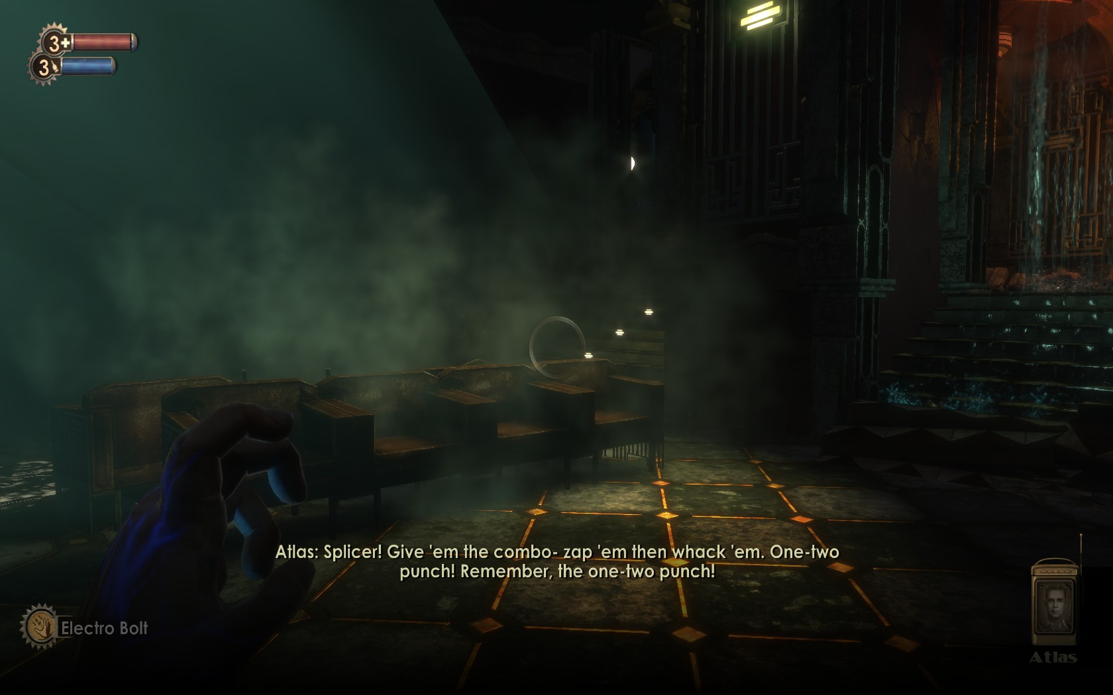*

*Figure 1—an example of how Bioshock uses non-playable characters to guide the player in fighting enemies.*

*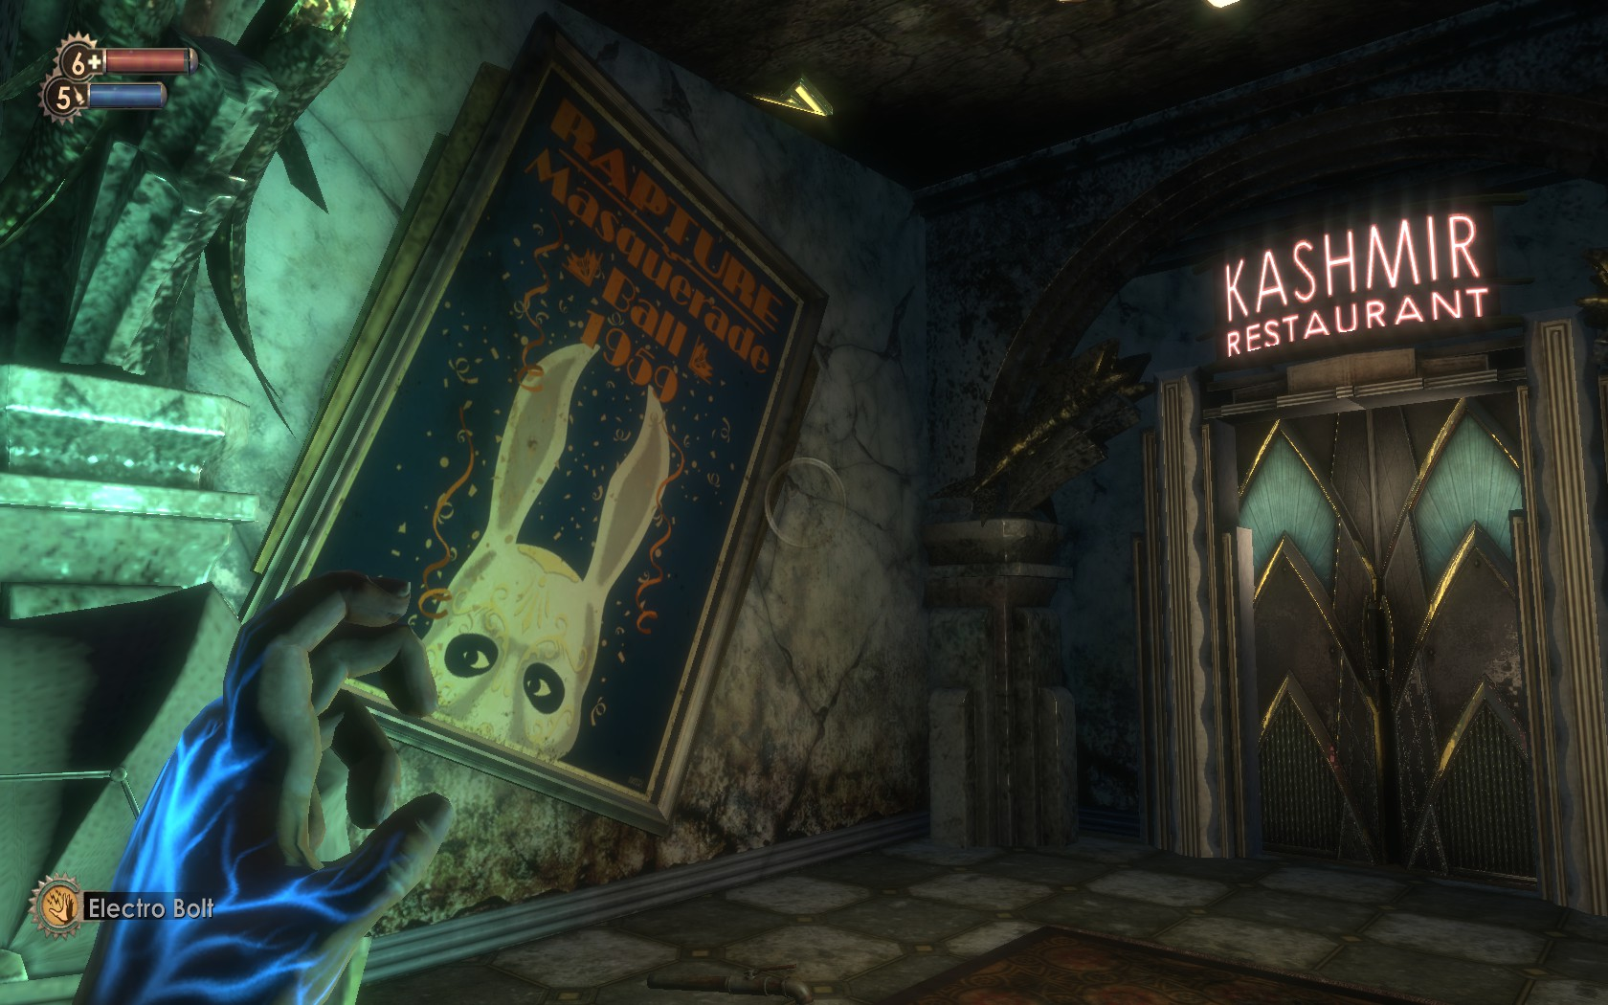*

*Figure 2—an example of how Bioshock uses the UI navigation arrow to help guide the player towards a goal. Notice how the environment uses artwork and statues to point the player forward to the door.*

*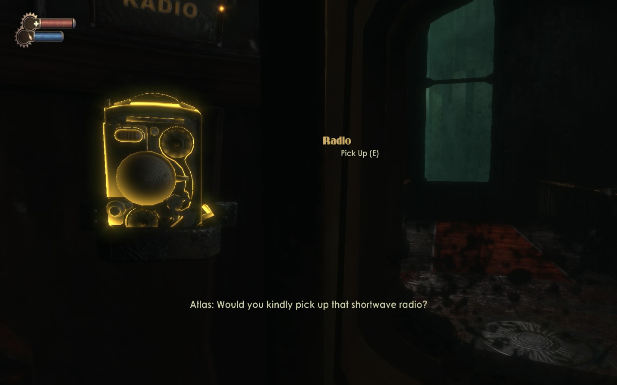*

*Figure 3—an example of how Bioshock highlights items and also tells the player to pick up items.*

*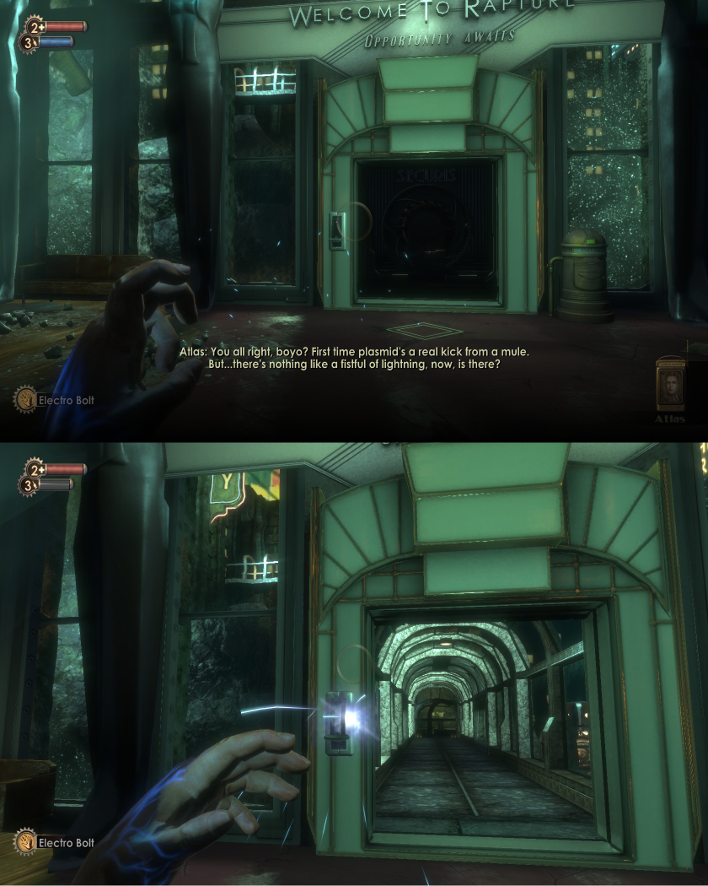Figure 6—an example of how Bioshock places the character in front of a locked door after gaining the ability to open it. This almost ensures that the player will open the door, even by accidentally trying the new power.*

*Bioshock* also uses the physical environment to help guide the player all throughout the game. From the very start of the game, the player is placed in a situation where they are surrounded by flames in the middle of the ocean and there is only a small gap that they player can go through (see figure 4). This effectively guides the character by funneling them in the correct direction. The game also uses artwork and statue to lead the eye of the player in the environment, acting as subtle visual guides for where to go and what t look at (see figure 2. More obvious environmental clues exist in the form of signs, such as when the player must find plasmids in order t unlock a door (see figure 5). ). While some are more hidden than others, these techniques all guide the player in going the right direction whether they are aware of it or not.

*Figure 4—an example of how Bioshock uses the environment to guide the player, in this case, flames encircle the player with only one gap open for the player to go through.*

*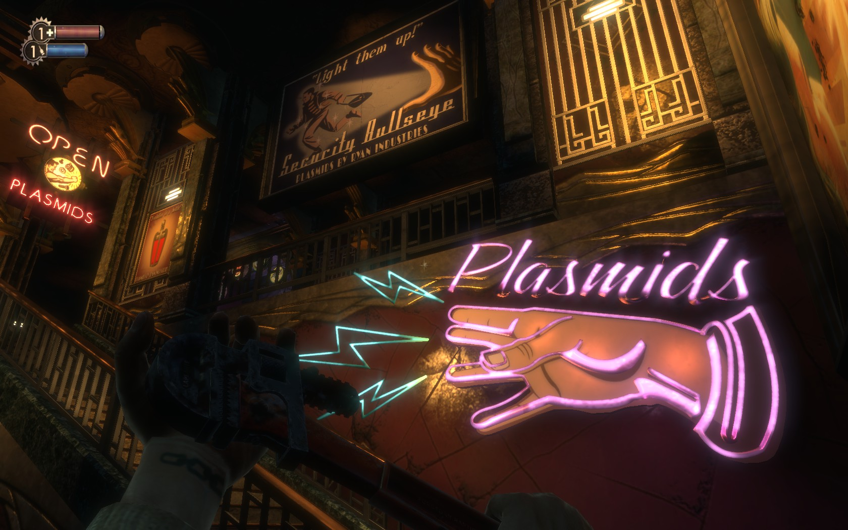Figure 5—an example of signage in the Bioshock environment and how it helps guide the player towards goals.*

One of my favorite ways that *Bioshock* guides the player is the very dramatic use of lighting throughout the city of Rapture. Spotlights are very commonly used by the designers of the game to help the player focus on important moments, such as the Little Sister and Big Daddy explanation (see figure 6). Lighting also is used in an environmental sense, lighting up a tower against a dark, starless night and providing a visual path in the form of lit lamps for the player (see figure 7). Even doorways and elevators have lighting in contrast to other pathways so that the player chooses to go the right way when there are multiple possible paths that are not meant to be usable (figure 8). This creative use of light is not only visually appealing, but also guides the player by contrasting against the general darkness of the environments and helps make *Bioshock* easily playable.

*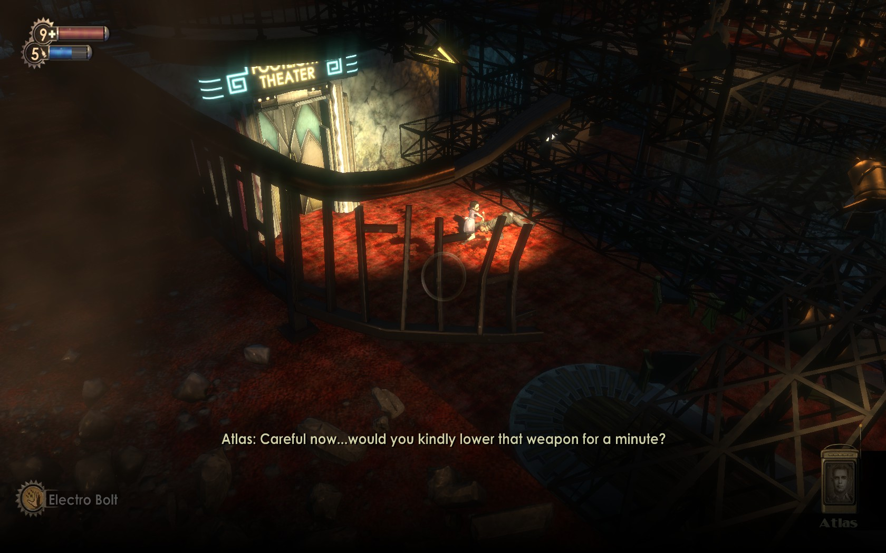*

*Figure 6—an example of how the Bioshock uses lighting to spotlight important events.*

*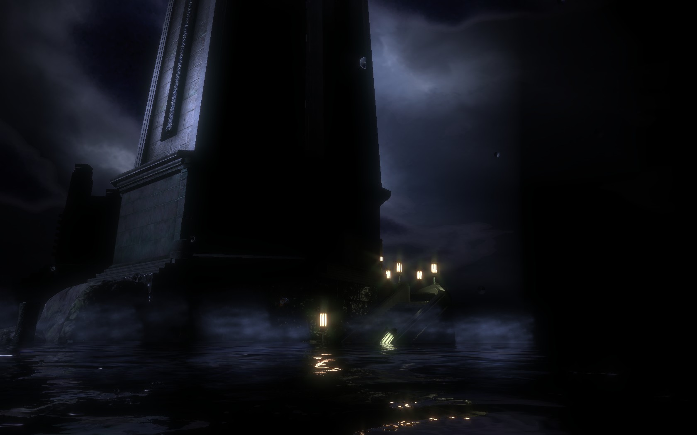*

*Figure 7—an example of how the Bioshock uses lighting to guide the player to the right paths, in this case up the stairs and into the tower (which is also lit up using the light reflected from the moon).*

*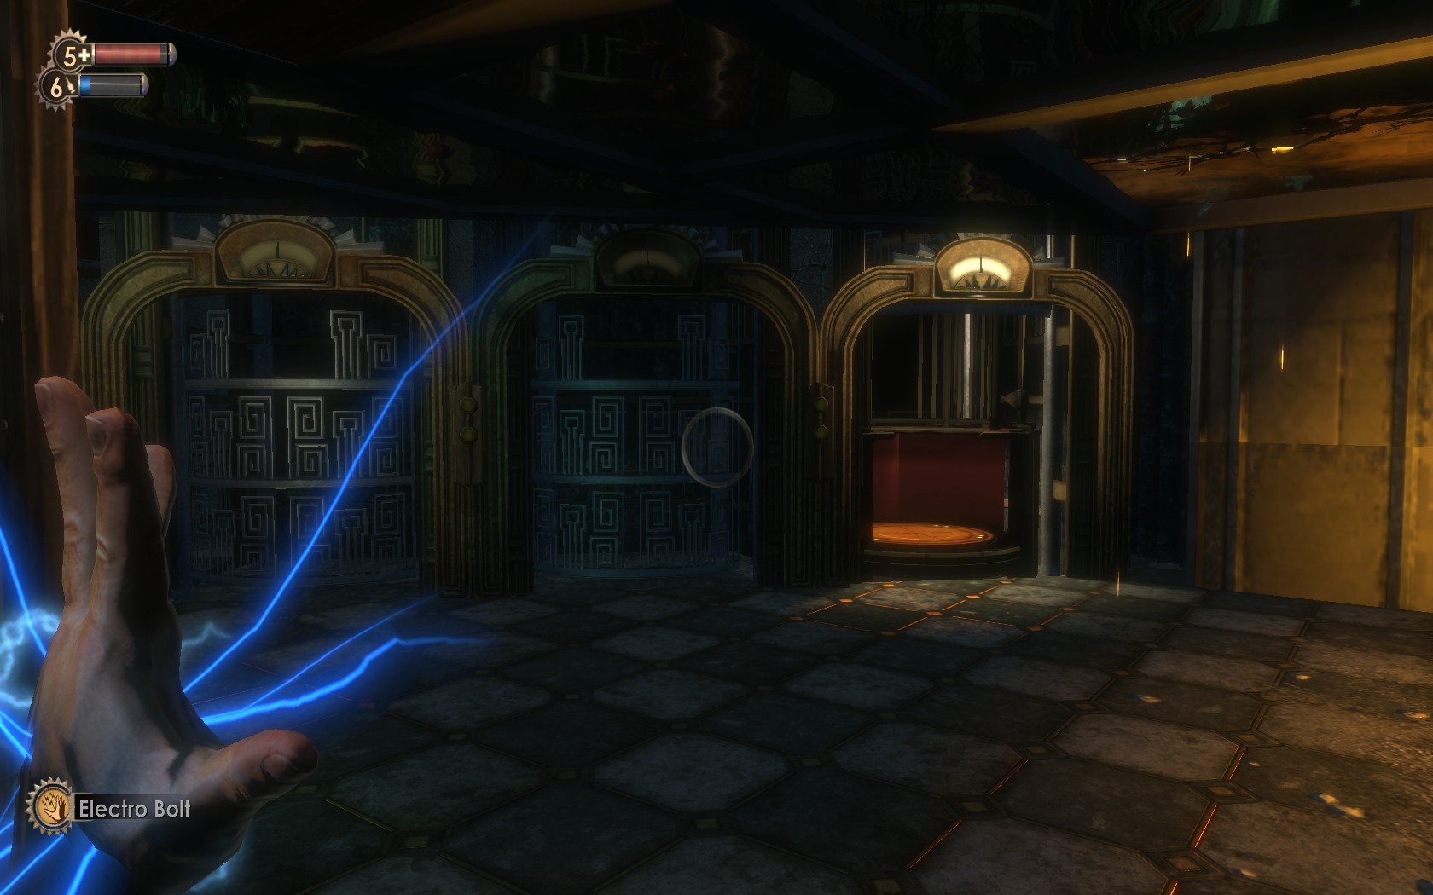*

*Figure 8—an example of how lighting is used to help guide the player to the correct door/elevator in a level.*