Travis Moore

Faction: Orcs

GAT 210A—Spring 2014

Instructor: Jeremy Holcomb

Lab Report 7

Table of Contents

**Lab Report 3 – 12**

Written Rules 3 – 4

Playtesters 5

Playtesting Results 5 – 7

Written Rules Rewrite 8 – 11

Observations 11

Characteristics of Games Exercises 11 – 12

**Written Rules**

Kings Crossing

Components

* 10 pawns (5 silver and 5 bronze)
* 2 kings (1 silver and 1 bronze)
* 2 elephant pieces (1 silver and 1 bronze)
* Hexagonal game board

Players

2 players

Objective

The objective of “Kings Crossing” is to keep your king alive and move him across the board before your opponent does.

Setup

Players decide who will play as West (silver pieces) and who will play as East (bronze pieces). The board is set up with each player’s pieces positioned on opposite ends of the game board according to the image below:

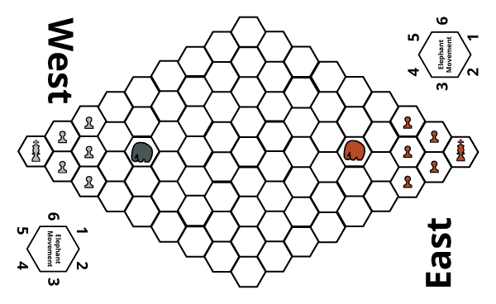

Rules

**Turn Sequence**

The game is played in **alternating turns**, starting with the East Player. **After each player has completed a turn, their elephant is moved**. Each player may move/capture using either one of their pawns or king once per turn.

* **Movement:** Each player may move any one of their pieces in any adjacent space unless it is occupied by the player’s own piece or the elephant.
* **Capturing:** A player may capture an opposing player’s piece by moving their piece onto a space occupied by the opposing player.

**Elephant Movement**

After a player has moved either one of their pawns or their king, they must move their elephant. The player rolls a d4 and a d6 to determine elephant movement. **The d4 is used to decide the amount of spaces the elephant moves as well as if the player has control of their elephant. If the d4 roll is a 1 or 2, then the player gets to decide which direction the elephant moves in. If the d4 roll is a 3 or 4, then the player must use a d6 roll to determine the direction that their elephant moves.** Using the number from the d6 die roll and matching it to the Elephant Movement diagram found on the board determines the elephant’s direction:

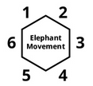

**While elephants cannot capture or move through another elephant, any other pieces that the elephant moves through are considered trampled, even if it is their own team’s pieces. Trampled pieces are removed from the game**. If the elephant cannot complete movement due to the boundaries of the board or running into another elephant, then the elephant moves as much as it can before reaching the edge of the board or the other elephant.

Victory

The game is over in one of three ways: The player who reaches the opposite side of the board with their king before their opponent wins the game. The player who is left with their king on the board if their opponent loses their king wins. If the elephant tramples both kings in one movement, then both players lose and must replay the game.

**Playtesters**

Classmates from the GAT210 Section A participated as first-time players for the rules that are written in the previous section of this lab report. Due to the limited number of students available in class this day our class TA, Alexandra Schecterson, participated as a playtester, as well.

**Name: Email:**

* Christopher Christensen c.christensen@digipen.edu
* Alexandra Schecterson [a.schecterson@digipen.edu](mailto:g.huxtable@digipen.edu)

**Playtesting Results**

For this week’s lab I decided to update last week’s game based upon the playtester feedback from last week’s lab. The previous version of this game was simply called “Elephant”, due to the independent elephant piece that acted as a source of chaos and randomness. While both Garrett and Ian expressed that they enjoyed the game they had suggestions to make it better. Both of them wanted to have their own elephant piece to wreck havoc on each other. They also both thought the game board was too big. The latest version of this game has been rewritten to test if the smaller board and elephants for both players increase the enjoyment of the game in ways that the previous game did not.

Christopher and Alexandra were first time playtesters for “Kings Crossing” in this week’s lab. The playtest proceeded with both players given the set of rules and a pen so that they can edit the rules as they see fit. I have never done this in pervious labs, and while this increased the time spent reading the rules to a total of twelve minutes, it proved beneficial in helping me understand how to better write rules for the future. Specific to “Kings Crossing” areas of confusion arose in the rules for the elephant. Christopher felt the wording used was too complex and Alexandra suggested that a table would help organize this information better.

After reading the rules Christopher and Alexandra spent a few minutes thinking out loud about the elephant. They both felt that the possible lack of control for their elephants was distressing and did not like this idea at all. Both of them felt that the lack of full control for the elephant would lead to disaster and ultimately not enjoy the game. Both players also felt that only being able to control the elephant for moves of one to two spaces also did not seem to make it different than pawns. Despite their worries, they participated in the playtest with Christopher as the East player and Alexandra as the West player.

Interestingly, Christopher and Alexandra set up the game board horizontally instead of playing on the opposite sides of the board. This is likely because of the words “East” and “West” printed on the board and also because of the diagram used in the rules. While this was not at all an intention of mine, both of them explained that this layout seemed different and interesting. The playtest was played in this orientation for the entire game and did not seem to cause any problems in their ability to play the game.

Three minutes into playing the game, Christopher and Alexandra brought up a critical area of confusion in how the turn sequence goes for both players. Both of them want to be able to move their elephants first instead of their pawns/king. Their concern is that making a move with these pieces before moving their elephant could lead to disaster if the elephant is out of control. This is a good point, and for the remainder of the game they played the game by moving their elephant first before their other pieces. This is a better way to play the game, because a better informed movement decision can be made after the random movement of the elephant.

Ten minutes into the game both players appear to be enjoying the game by using their elephants to trample each other. Because he had trampled his own piece at the start of the game, Christopher was upset about the randomness of the elephant. However it worked to his advantage when he was able to charge forward four spaces and trample two of Alexandra’s pawns. This lucky turn of events made him excited and opened him up to the positive possibilities the randomness of the elephant can have. Alexandra managed to use her elephant the most efficiently by using it to trample Christopher’s king and win the game after eighteen minutes of play.

Both Christopher and Alexandra were great playtesters and brought up a myriad of shortcomings with the current state of the game. While my initial goal was to test to see if the smaller board would start the action of the game sooner, it turns out the board may not be the problem. The one space at a time movement makes the beginning of the game too slow, despite the smaller board size. Changing the way other pieces move would greatly help the game and perhaps lessen the power of the elephant. Both Christopher and Alexandra were right in their worry for how powerful and broken the elephant is in the game. Tweaking the dice probabilities for control of the elephant is needed. Also, Alexandra pointed out that perhaps the Kings should be able to capture the elephants, a great idea that I will have to test.

**Written Rules Rewrite**

Changes to the original rules are shown in red, with ~~strikethroughs~~ showing a rule being taken out entirely.

Kings Crossing

Components

* 14 player pieces
* 10 pawns (5 silver and 5 bronze)
* 2 kings (1 silver and 1 bronze)
* 2 elephants (1 silver and 1 bronze)
  + 1 game board

Players

2 players

Objective

The objective of “Kings Crossing” is to keep your king alive and be the first player to place your king in the opposing king’s castle.

Setup

Players decide who will play as West (silver pieces) and who will play as East (bronze pieces). The board is set up horizontally with each player’s pieces positioned on opposite ends of the game board according to the image below:

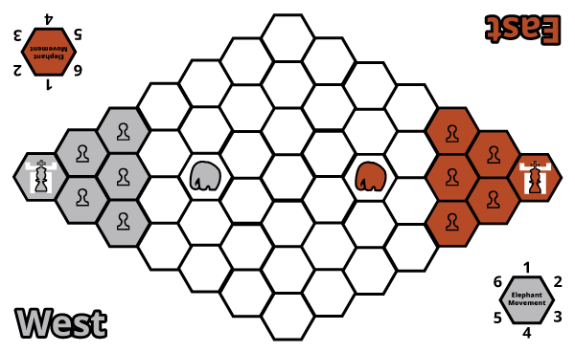

Rules

**Pieces**

Each player has an army consisting of 1 king, 5 pawns, and 1 elephant. Each piece has the following characteristics:

**King**

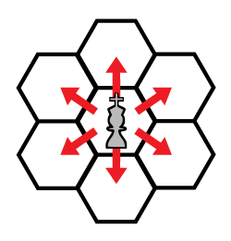**Movement**

The King can move into any adjacent space (see figure to the left).

**Capturing**

If the space is occupied by any of the opponent’s pieces then the king may capture it, removing it from the game.

**Special**

The king is the only piece that may capture an opponent’s elephant.

**Pawn**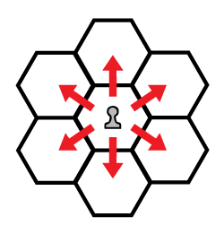

**Movement**

A pawn can move into any adjacent space (see figure to the left).

**Capturing**

If the space is occupied by either an opponent’s king or pawn the pawn may capture it, removing it from the game

**Elephant**

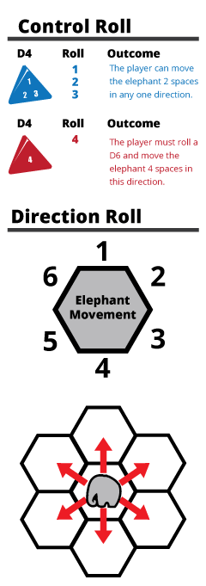**Control Roll**

Before the elephant can move the player must roll a d4 to see if they have control over their elephant. (see figure on the left). If a 1, 2, or 3 is rolled, the player may move their elephant 2 spaces in any one direction. If the player rolls a 4, they must perform a direction roll (described below).

**Direction Roll**

If the player rolled a 4 during the control roll, then a d6 must be rolled to determine the direction the elephant will move in (see figure on the left).

**Movement**

If the player has passed the control roll they may move their elephant up to 2 spaces in any one direction.

**Capturing**

If the space is occupied by any of the opponent’s pieces, except another elephant, then the elephant may capture it, removing it from the game.

**Special**

The elephant can capture its own army’s pieces, but may not capture or move through another elephant.

**Turn Sequence**

The game is played in **alternating turns**, starting with the East Player. **A player’s turn consists of moving their first elephant and then the rest of their pieces one at a time. After a player has moved all their pieces once, their turn is over.**

Victory

The game is over in one of three ways:

* A player wins by capturing their opponent’s castle with their king.
* A player wins by capturing their opponent’s king
* If both kings are captured by an out of control elephant in a single turn, then the game is a draw.

**Observations**

During this week’s lab I was a playtester for Christopher’s variation of the game poker. While he did not have a solid idea for this variation or a name for the game at the time, it was interesting to play the game because I had not played poker before. His variation involved using a d4 to control how many cards are dealt out to the player at the start of the game. This effectively affected how many betting/bluffing phases could exist in one hand of the game. While this did not make a change in the mechanics of the way poker is played, it did allow for more “gut check” moments, making the game interesting when only one card was dealt due to a die roll of one.

**Characteristics of Games Exercises**

**Exercise 5.14: In bridge, one player (the dummy) “plays” with an open hand. How does this elimination of hidden information affect the skill in the game? In other words, would bridge have more or less skill without the dummy rule, and why?**

Bridge would not have more skill without the dummy rule. As a hallmark of bridge, the dummy rule adds an element of skill to the game, forcing the declarer to play both their hand and the dummy hand, making the game more interesting and adding a layer of depth to the game. Playing the dummy hand can be used to benefit the declarer, but can also benefit the other player as well. Plus, there is plenty of hidden information with the other hidden hands in the game. This unique aspect of Bridge definitely adds to the skill of the game, instead of subtracting from it.

**Exercise 5.15: If all players in bridge played with open hands, how would it affect the skill in the game?**

If there were no hidden information it bridge it would definitely affect the skill of the game. Giving all players perfect knowledge of each other’s hand would make the game more predictable in play because good bridge players could figure out how the round would most likely be played out before it even really started.

**Exercise 5.16: If all players in poker played with open hands, how would it affect the skill in the game?**

If all players in Poker played with open hands it would effectively eliminate bluffing from the game, which is a vital aspect to Poker. The game would lose a lot of its magic and would become a game mostly of who gets the luckier draw.

**Exercise 5.17: Give examples in baseball of hidden information.**

The pitch that a team chooses to throw in a game is an example of hidden information. The pitcher and the catcher know what kind of a pitch will be thrown, but the batter does not know until the pitch is actually thrown. The batter also has hidden information because the way he chooses to hit the ball is known only by him, like whether he is going to bunt or try to position the ball somewhere further on the field.

**Exercise 5.14: Give examples in football of hidden information.**

The defensive and offensive play a team chooses to do on the field is unknown to the opposing team throughout the game of football. Only once the play is run does the other team finally learn what the opposing team is going to do for that down. For example, the offensive team can choose to pass, rush, or punt and the defense will not know until the play has started.