Travis Moore

Faction: Orcs

GAT 210A—Spring 2014

Instructor: Jeremy Holcomb

Lab Report 4

Table of Contents

Lab Report 2 - 6

Written Rules 3 – 4

Playtesters 5

Playtesting Results 5 – 6

Written Rules Rewrite 6 – 8

Observations 9

King’s Crossing

Components

* 10 pawns (5 silver and 5 bronze)
* 2 kings (1 silver and 1 bronze)
* 1 elephant piece
* Hexagonal game board

Players

2 players

Objective

The objective of “King’s Crossing” is to keep your king alive and move him across the board before your opponent does.

Setup

Players decide who will play as West (silver pieces) and who will play as East (bronze pieces). The board is set up with each player’s pieces positioned on opposite ends of the game board and the elephant piece in the middle of the game board according to the image below:

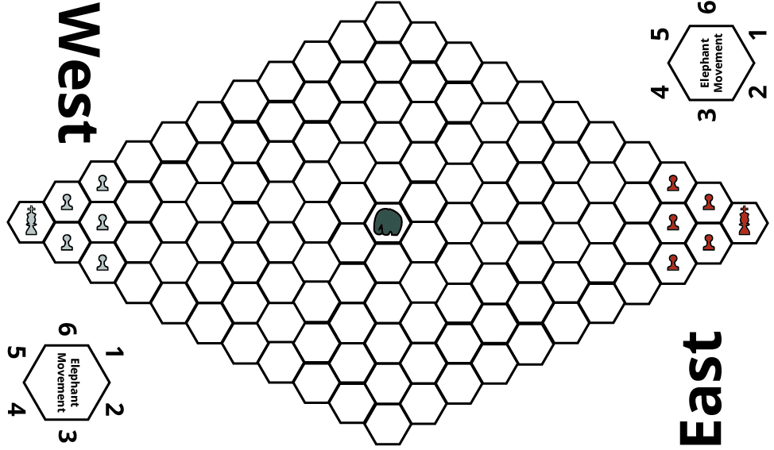

Rules

**Turn Sequence**

The game is played in **alternating turns**, starting with the East Player. **After each player has completed a turn, the elephant is moved**. Each player may move/capture using one piece per turn.

* **Movement:** Each player may move any one of their pieces in any adjacent space unless it is occupied by a the player’s own piece or the elephant.
* **Capturing:** A player may capture an opposing player’s piece by moving their piece onto a space occupied by the opposing player.

**Elephant Movement**

After both players have each completed a turn, the elephant is moved by rolling a d6 for direction and a d4 for spaces moved. Direction is determined by using the number from the die roll and matching it to the Elephant Movement diagram found on the board:

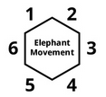

Any pieces that the elephant moves through are considered trampled, and removed from the game. If the elephant cannot complete movement due to the boundaries of the board, then the elephant moves as much as it can.

Victory

The game is over in one of three ways: The player who reaches the opposite side of the board with their king before their opponent wins the game. The player who is left with their king on the board if their opponent loses their king wins. If the elephant tramples both kings in one movement, then both players lose and must replay the game.

**Playtesters**

Classmates from the GAT210 Section A participated as first-time players for the rules that are written in the previous section of this lab report. There were only two students who playtested my game once for this lab.

**Name: Email:**

* Ian Aemmer i.aemmer@digipen.edu
* Garrett Huxtable [g.huxtable@digipen.edu](mailto:g.huxtable@digipen.edu)

**Playtesting Results**

During the lab my game was playtested by Ian Aemmer and Garrett Huxtable.

**Written Rules Rewrite**

Changes to the original rules are shown in red text, with ~~strikethroughs~~ showing a rule being taken out entirely.

King’s Crossing

Components

* 10 pawns (5 silver and 5 bronze)
* 2 kings (1 silver and 1 bronze)
* 1 elephant piece
* Hexagonal game board

Players

2 players

Objective

The objective of “King’s Crossing” is to keep your king alive and move him across the board before your opponent does.

Setup

Players decide who will play as West (silver pieces) and who will play as East (bronze pieces). The board is set up with each player’s pieces positioned on opposite ends of the game board and the elephant piece in the middle of the game board according to the image below:



Rules

**Turn Sequence**

The game is played in **alternating turns**, starting with the East Player. **After each player has completed a turn, the elephant is moved**. Each player may move/capture using one piece per turn.

* **Movement:** Each player may move any one of their pieces in any adjacent space unless it is occupied by a the player’s own piece or the elephant.
* **Capturing:** A player may capture an opposing player’s piece by moving their piece onto a space occupied by the opposing player.

**Elephant Movement**

After both players have each completed a turn, the elephant is moved by rolling a d6 for direction and a d4 for spaces moved. Direction is determined by using the number from the die roll and matching it to the Elephant Movement diagram found on the board:



Any pieces that the elephant moves through are considered trampled, and removed from the game. If the elephant cannot complete movement due to the boundaries of the board, then the elephant moves as much as it can.

Victory

The game is over in one of three ways: The player who reaches the opposite side of the board with their king before their opponent wins the game. The player who is left with their king on the board if their opponent loses their king wins. If the elephant tramples both kings in one movement, then both players lose and must replay the game.

**Observations**

During this week’s lab I was a playtester for both Chris and Garrett’s games. Garrett’s game “Faction Wars” is a game that I have played before, but this week he expanded upon it by adding different class types to the races in the game. While it added a layer of depth to the game, it also had issues with creating very noticeable imbalances in the game. For example, while Elves were impossible to defeat before, they no longer could stand up against any other race well. Also, some of the class benefits or detriments would never come into play if they went up a particular race’s class. I suppose if he wanted to add more weight to the decision of which race and class to play then he has accomplished this, but it does put an awful lot of weight there, and less in playing the game. After playing a few times we discussed the possibility of making the game be one player playing against an entire race, 3 classes versus 3 classes, and also whether or not the negative d4 for elves was necessary.

Chris’ game “Duel of the Stubborn” was also fun to play because it really did feel like you were playing against the opponent and not relying on luck so much, although luck is a big part of the game. Basically it became a battle of who would take a bet with a high number versus who wants the bet with the low numbers. After playing his game we all felt like the board needed to be incorporated more into the game, like having slow zones or betting limits to help someone from running away with the game.