Travis Moore

Faction: Orcs

GAT 210A—Spring 2014

Instructor: Jeremy Holcomb

Lab Report 6

Table of Contents

Lab Report 2 **–** 10

Written Rules 3 – 4

Playtesters 4

Playtesting Results 4 – 7

Written Rules Rewrite 7 – 9

Observations 9 – 10

Characteristics of Games Exercises 10

**Written Rules**

I had not originally brought written rules to class, so these rules are the basics for how I explained the game to both of the playtesters.

Elephant

The objective of “Elephant” is to keep your king alive and move him across the board before your opponent does.

Setup

Players decide who will play as West (silver pieces) and who will play as East (bronze pieces). The board is set up with each player’s pieces positioned on opposite ends of the game board and the elephant piece in the middle of the game board according to the image below:

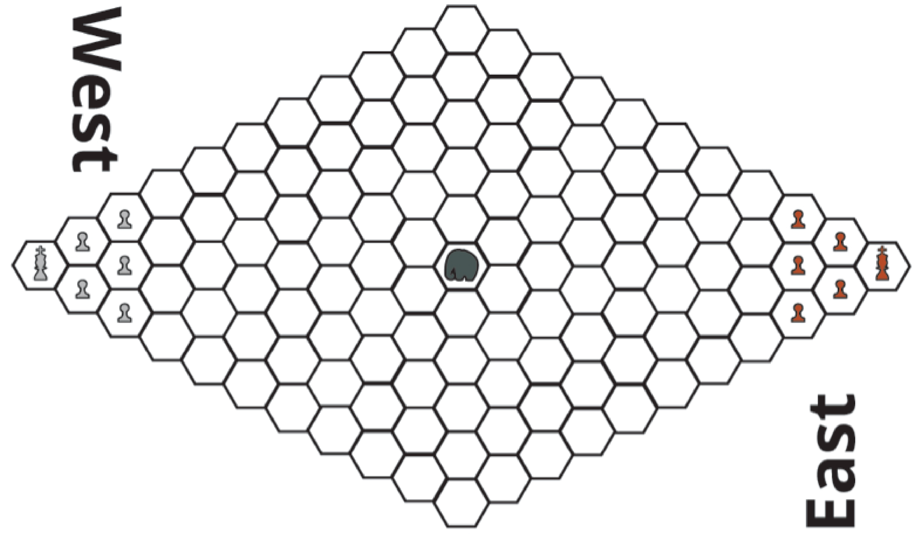

Rules

**Turn Sequence**

The game is played in **alternating turns**, starting with the East Player. **After each player has completed a turn, the elephant is moved**. Each player may move/capture using one piece per turn.

* **Movement:** Each player may move any one of their pieces in any adjacent space unless it is occupied by the player’s own piece or the elephant.
* **Capturing:** A player may capture an opposing player’s piece by moving their piece onto a space occupied by the opposing player.

**Elephant Movement**

After both players have each completed a turn, it is the elephant’s turn to move. **East rolls a d4, used to decide the amount of spaces the elephant moves, while West rolls a d6 to determine the direction of movement for the elephant.** The number from the d6 roll determines direction clockwise starting with 1 for forward right, 2 for right, 3 for backwards right, 4 for backwards left, 5 for left, and 6 for forward left.

**Any pieces that the elephant moves through are considered trampled, and removed from the game**. If the elephant cannot complete movement due to the boundaries of the board, then the elephant moves as much as it can before reaching the edge of the board.

Victory

The game is over in one of three ways: The player who reaches the opposite side of the board with their king before their opponent wins the game. The player who is left with their king on the board if their opponent loses their king wins.

**Playtesters**

Classmates from the GAT210 Section A participated as first-time players for the rules that are written in the previous section of this lab report. There were only two students who playtested my game once for this lab.

**Name: Email:**

* Ian Aemmer i.aemmer@digipen.edu
* Garrett Huxtable [g.huxtable@digipen.edu](mailto:g.huxtable@digipen.edu)

**Playtesting Results**

Ian Aemmer and Garrett Huxtable were both my playtesters for my game, “King’s Crossing”. I had neglected to bring proper printed rules to the lab, so I explained the rules and setup the board for both the players. Explaining the rules went over well, except for my rules for determining the direction of movement for the elephant. I did not have the elephant movement diagram nicely printed out and explaining the elephant movement through words alone made it difficult to understand. This was confusing to both players, until I drew a diagram for elephant movement. In future versions of the game the elephant movement diagram should be placed somewhere on the board at a size large enough for both players to see. Garrett chose to play as bronze, leaving Ian to play as silver for the duration of the playtest.

About two minutes later the players were both ready to start playing the game. During the first two turn sequences both players forgot about moving the elephant. However, on the third turn both players realized that the elephant had not moved yet and they remembered to move the elephant from there on out. Once the players got into the rhythm of alternating turns then moving the elephant, the game progressed well. This is important because it means that both the players understood how to play the game.

Although not my intention, the game appeared to have three distinct parts, a sort of beginning, mid, and end phase to the game. In the beginning, both players did not take much time to make a decision on which piece to move, resulting in a rapid pace for the game. This is most likely because during this part of the game both players are separated by many spaces, with little threat in making any kind of move. The beginning phase took five to six minutes, much longer than it should have. This is likely the fault of the game board, because there are 5 pieces for both players to move and the board is quite large, resulting in a long time before both players meet in the middle. The beginning phase of the game might be improved by adjusting the game board so that both players can meet in the middle much sooner.

The mid phase of the game seemed played different than the beginning phase of the game. Both players’ pieces met at the middle of the board making the decision on which piece to move difficult. There is a two minute time period where both players line up and wait to see who will make the first move. Up until this point the elephant has danced around bronze pieces throughout the whole game, and has yet to cause any casualties. However, eight minutes into the game the elephant trampled a silver piece, starting a capture contest between both players in the middle of the board. Both players seemed intensely engaged, with laughter and stare-down moments throughout this part of the game.

The final phase of the game dealt with Ian making a break with his king towards the opposite side and Garrett trying to chase him down with a pawn. There were more sliver pieces and one bronze piece trampled by the elephant in this phase of the game, as well. Ian ended up making it through to the end, winning the game at nearly the ten minutes into playing the game. Unlike the mid phase, the ending phase of the game involved a quick turn sequence between both players as less pawns and a clear course of action for both players existed at this point.

Talking to both Garrett and Ian about the game revealed some interesting insights into how they felt the game played. Considering that the elephant remained close to the Garrett the whole game he felt it greatly affected the way he moved his pieces. Both players agreed that the board is a little too long, because it took them quite awhile to reach the middle of the board. Overall, they said the game was enjoyable.

**Written Rules Rewrite**

Changes to the original rules are shown in red, with ~~strikethroughs~~ showing a rule being taken out entirely.

Kings Crossing

Components

* 10 pawns (5 silver and 5 bronze)
* 2 kings (1 silver and 1 bronze)
* 1 elephant piece
* Hexagonal game board

Players

2 players

Objective

The objective of “Kings Crossing” is to keep your king alive and move him across the board before your opponent does.

Setup

Players decide who will play as West (silver pieces) and who will play as East (bronze pieces). The board is set up with each player’s pieces positioned on opposite ends of the game board and the elephant piece in the middle of the game board according to the image below:

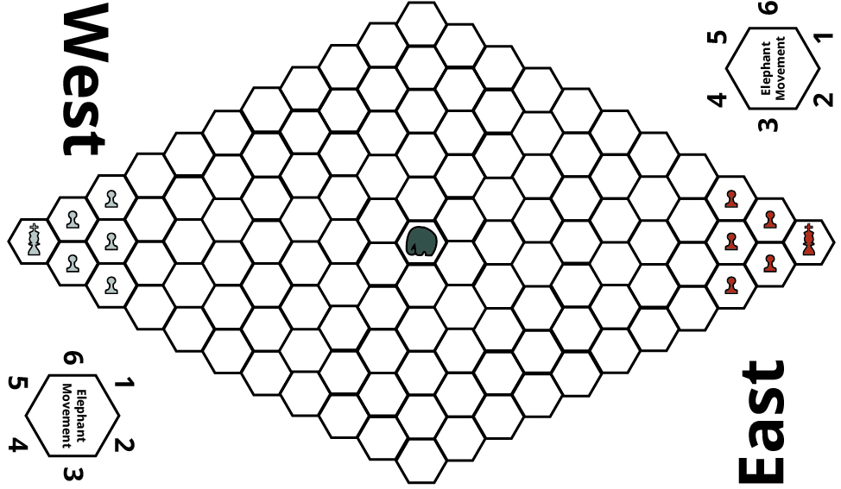

Rules

**Turn Sequence**

The game is played in **alternating turns**, starting with the East Player. **After each player has completed a turn, the elephant is moved**. Each player may move/capture using one piece per turn.

* **Movement:** Each player may move any one of their pieces in any adjacent space unless it is occupied by the player’s own piece or the elephant.
* **Capturing:** A player may capture an opposing player’s piece by moving their piece onto a space occupied by the opposing player.

**Elephant Movement**

After both players have each completed a turn, it is the elephant’s turn to move. **East rolls a d4, used to decide the amount of spaces the elephant moves, while West rolls a d6 to determine the direction of movement for the elephant.** Using the number from the d6 die roll and matching it to the Elephant Movement diagram found on the board determines the elephant’s direction:

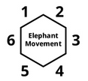

**Any pieces that the elephant moves through are considered trampled, and removed from the game**. If the elephant cannot complete movement due to the boundaries of the board, then the elephant moves as much as it can before reaching the edge of the board.

Victory

The game is over in one of three ways: The player who reaches the opposite side of the board with their king before their opponent wins the game. The player who is left with their king on the board if their opponent loses their king wins. If the elephant tramples both kings in one movement, then both players lose and must replay the game.

**Observations**

During this week’s lab I was a playtester for both of my playtesters, Garrett and Ian. Garrett’s game, “Thief”, is a hidden information game that has players playing as 3 policemen and 1 thief. The concept for this game is fun, and it certainly is fun playing as the thief. Playing as the policemen, however, was frustrating, despite the fact that the policemen won both playtests for the game. The game board was perhaps the area of biggest improvement for the game, as making it easier for the thief to get around might make the game work better for the thief. The abilities for the policemen also need to be reworked, as the teleport option in his game is difficult to use and the guard tower is very overpowered due to the lack of spaces in the game.

Ian’s game, “Crater”, was a lot of fun to play and worked very well. A sort of reverse territory control game, the objective of the game is to stay alive as pieces of the board become inaccessible due to explosions. A lot like the video game “Bomberman”, but in board game form, his game worked well. The biggest area for improvement in his game is how well the components are implemented in the game. I suggested to him that since the board is slowly taken away by explosions that maybe his game would work best if the board were made up of modular pieces, and then these pieces can be taken away. It would be a very fun and unique way to express inaccessible areas as they are blasted away.

**Characteristics of Games Exercises**

**Exercise 5.13: If the luck in poker decreases the return to skill, why do skilled people who wish to make money through gaming nevertheless play poker? Why don’t they play some game that has less luck?**

As stated previously in the chapter, ”The fact that poker has a lot of luck in no way decreases its skill”. The question makes the false assumption that skilled people should not play games that have luck in them because luck opposes skill. This would mean that because a player is skilled that luck can only hurt their ability to play poker. I believe that this is not the case at all, and luck is just as appealing to a skilled player who knows how to use lucky opportunities to their advantage. Luck can keep a game interesting, and skilled players can still outplay unskilled players even if there is luck in poker.