Travis Moore

Faction: Game Over?

GAT 210A—Spring 2014

Instructor: Jeremy Holcomb

Lab Report 8

Table of Contents

**Lab Report 3 – 14**

Written Rules 3 – 6

Playtesters 6

Playtesting Results 6 – 9

Written Rules Rewrite 9 – 13

Observations 13 – 14

**Written Rules**

Kings Crossing v2

Components

* 14 player pieces
* 10 pawns (5 silver and 5 bronze)
* 2 kings (1 silver and 1 bronze)
* 2 elephants (1 silver and 1 bronze)
  + 1 game board

Players

2 players

Objective

The objective of “Kings Crossing” is to keep your king alive and be the first player to place your king in the opposing king’s castle.

Setup

Players decide who will play as West (silver pieces) and who will play as East (bronze pieces). The board is set up horizontally with each player’s pieces positioned on opposite ends of the game board according to the image below:

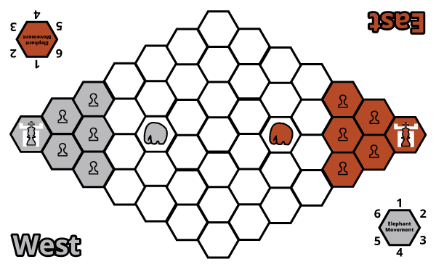

Rules

**Pieces**

Each player has an army consisting of 1 king, 5 pawns, and 1 elephant. Each piece has the following characteristics:

**King**

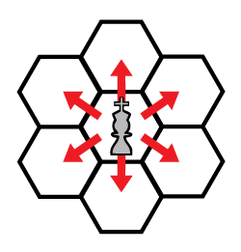**Movement**

The King can move into any adjacent space (see figure to the left).

**Capturing**

If the space is occupied by any of the opponent’s pieces then the king may capture it, removing it from the game.

**Special**

The king is the only piece that may capture an opponent’s elephant.

**Pawn**

**Movement**

A pawn can move into any adjacent space (see figure to the left).

**Capturing**

If the space is occupied by either an opponent’s king or pawn the pawn may capture it, removing it from the game

**Special**

Pawns may jump over friendly pawns.



**Elephant**

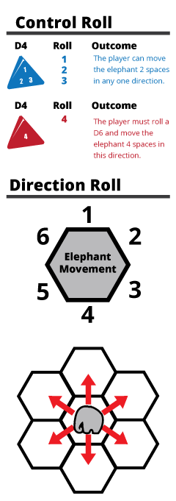**Control Roll**

Before the elephant can move the player must roll a d4 to see if they have control over their elephant (see figure on the left). If a 1, 2, or 3 is rolled, the player may move their elephant 2 spaces in any one direction. If the player rolls a 4, they must perform a direction roll (described below).

**Direction Roll**

If the player rolled a 4 during the control roll, then a d6 must be rolled to determine the direction the elephant will move in (see figure on the left).

**Movement**

If the player has passed the control roll they may move their elephant up to 2 spaces in any one direction.

**Capturing**

If the space is occupied by any of the opponent’s pieces, except another elephant, then the elephant may capture it, removing it from the game.

**Special**

The elephant can capture its own army’s pieces, but may not capture or move through another elephant.

**Turn Sequence**

The game is played in **alternating turns**, starting with the East Player. **A player’s turn consists of moving their first elephant and then the rest of their pieces one at a time. After a player has moved all their pieces once, their turn is over.**

Victory

The game is over in one of three ways:

* A player wins by capturing their opponent’s castle with their king.
* A player wins by capturing their opponent’s king
* If both kings are captured by an out of control elephant in a single turn, then the game is a draw.

**Playtesters**

Classmates from the GAT210 Section A participated as first-time players for the rules that are written in the written rules section of this lab report. One complete game was played during this playtest.

**Name: Email:**

* Jonathan Blunden j.blunden@aol.com
* Joseph Borber [j.borber@digipen.edu](mailto:g.huxtable@digipen.edu)

**Playtesting Results**

For this week’s lab I decided to continue developing my game “Kings Crossing” using rules that I have since modified from the previous playtest. In “Kings Crossing v2” I have modified the board to be a bit more intuitive for the initial setup of the game’s pieces and also smaller so that the pieces meet at the middle sooner. Further changes include a lowered probability of the elephant moving chaotically and special movement and capturing rules for the pawns and kings. I am going into this lab looking to see if the new board is aesthetically pleasing, functional, and shortens the time it takes for the main action of the game to take place. I am also looking to see if the pawns no longer feel slow and unimportant and that the elephant does not feel as overpowered as in the previous version of this game.

I felt it was important that my playtesters for this new version of “Kings Crossing” had never played any iteration of this game before, so for this playtest Jonathan and Joseph were the playtesters for this lab. The playtest began with both Jonathan and Joseph reading over the rules and marking up areas of the rules that were unclear to them. It took a total of eight minutes for them to go over the rules. Jonathan made a great suggestion that my movement diagrams shade the legal and illegal spaces for movement, as well as make sure to list my dice as components of the game. Joseph also pointed out that capturing the castle was unclear since what I really mean is move unto the other castle. All of their suggestions were great and will help clarify my rules for new players in the next iteration of this game.

Play began with Jonathan electing to play as the West and Joseph playing as the East. Jonathan managed to correctly setup the game with all the pieces in the right locations, and Joseph pointed out that while the diagram showed where the elephant should start at, it would perhaps be better to have it displayed on the board, too. This is a great point and can only further ensure that the game starts out correctly. A few minutes in there were questions regarding if they had to move every piece or could elect not to move pieces if they did not want to. This is an option that I had not considered, and further playtesting on this would be interesting. For the remainder of the game both of them played as if they had to move every piece in a turn.

Despite having more pieces to move in a turn, the average turn for either player is quick at roughly thirty seconds to a minute in length. Jonathan managed to use pawn jumping to breach the middle of the board with his pieces about four minutes into the game. This is much quicker than in the previous version of the game, which is the result of board topology changes and movement changes for the pawns. However, this movement may be way too powerful, as it allowed him to cover five spaces on the board in one turn between two pawns. While quicker movement was an initial goal for this version of the game, the movement of every piece means that pawn jumping can be exploited to gain a lot of territory in the game. This was not my intention and may have to be removed altogether if players abuse it in a way that it makes the game not fun to play.

Lowering the probability of the elephants losing control also seemed to be a success. While Joseph did get unlucky a few times, neither player complained not being able to use the elephant to their advantage. Joseph even felt brave enough to use the elephant to shield his king, despite the risk of that the elephant can trample his own king. The game ended with Jonathan winning after playing the game for twelve minutes. However, the invulnerable state of the elephant is still an area of debate for players, which was the biggest discussion after the game was over. This brings back the question of whether or not players feel the need to have their own elephant or go back to having the elephant be an independent player in the game.

There were a few successes for this version of the game, especially in that the game did not feel as slow to start and the players did not complain about the pawns being useless. However, the problem with the elephant still exists. At the end of the game the playtesters and I discussed using pawns as a way to capture and control one elephant that is used throughout the game. In the next version of the game I’ll explore players fighting over who will have current control of the elephant. Also, after playtesting Joseph’s game I decided that I need to focus more on the castle capture theme.

**Written Rules Rewrite**

Changes to the original rules are shown in red, with ~~strikethroughs~~ showing a rule being taken out entirely.

Castle Capture

Components

* 14 player pieces
* 10 pawns (5 silver and 5 bronze)
* 2 kings (1 silver and 1 bronze)
* 2 elephants (1 silver and 1 bronze)
  + 2 d6 (1 silver and 1 bronze)
  + 2 d4 (1 silver and 1 bronze)
  + 1 game board

Players

2 players

Objective

The objective of “Castle Capture” is to capture the opposing team’s castle with your king.

Setup

Players decide who will play as West (silver pieces) and who will play as East (bronze pieces). The board is set up horizontally with each player’s pieces positioned on opposite ends of the game board and the neutral elephant placed in the middle elephant space according to the image below:

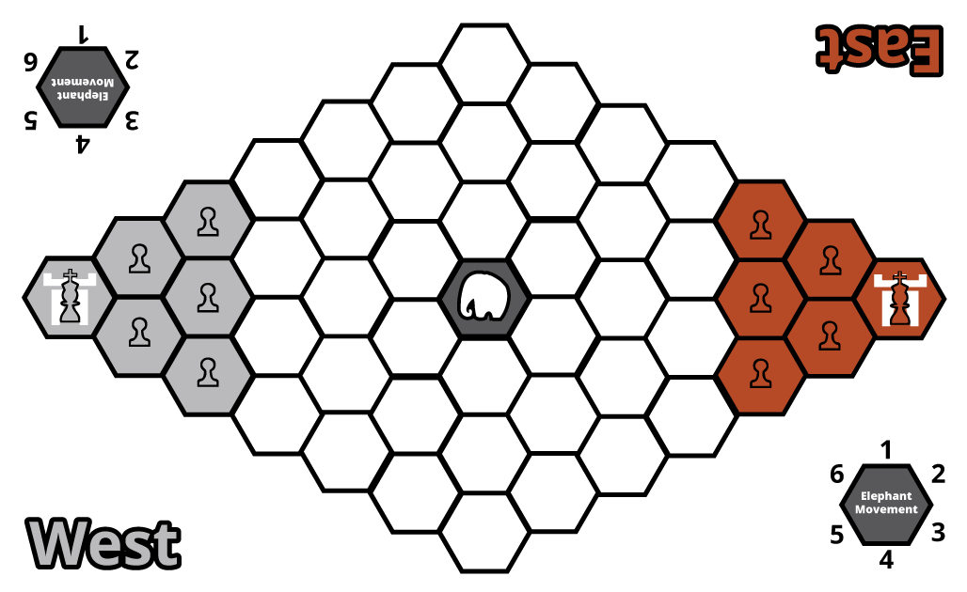

Rules

**Pieces**

Each player has an army consisting of 1 king and 5 pawns~~,~~ ~~and 1 elephant~~. Each piece has the following characteristics:



**King**

**Movement and Capturing**

The King can move into any adjacent space and capture any opposing piece it lands on (see figure to the left).

**Special**

The king is the only piece that may capture the opposing player’s castle and an elephant.

**Pawn**

**Movement and Capturing**

The Pawn can move into any adjacent space and capture any opposing piece it lands on, except for an elephant or the opposing player’s castle (see figure to the left).

**Special**

~~Pawns may jump over friendly pawns.~~

If a player’s pawn is adjacent to the elephant it may forfeit this pawn’s movement and capturing for one turn in order to attempt to control and move the elephant by performing a control roll.

As long as a player has a pawn near the elephant it can perform a control roll, meaning that the elephant can be moved multiple times in one player’s turn.

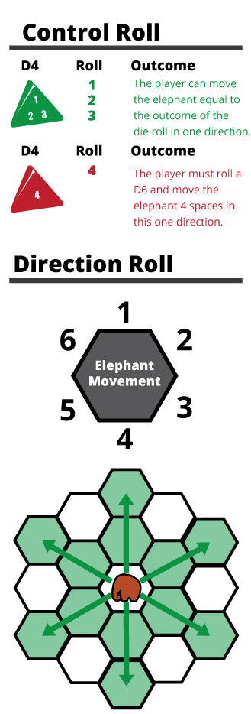

**Elephant**

**Free Elephant**

If the elephant is not under the control of any player than after every player’s turn the elephant freely moves by rolling a d4 for the amount of spaces moved and a d6 to determine its direction.

**Control Roll**

If a player is attempting to control the elephant they must have a pawn adjacent to the elephant. Then the player must roll a d4 to see if they have control over the elephant (see figure on the left). If a 1, 2, or 3 is rolled, the player may move the elephant equal to the number of the die roll in one direction. If the player rolls a 4, they must perform a direction roll (described below).

**Direction Roll**

If the player rolled a 4 during the control roll, then a d6 must be rolled to determine the direction the elephant will move in (see figure on the left).

**Movement**

If the player has passed the control roll they may move their elephant the spaces equal to the outcome of the d4 roll in any one direction. If it is not possible for an elephant to complete its move due to the boundaries of the board, then the elephant as much as possible in this direction before coming to a stop at the edge of the board.

**Capturing**

Any pieces that an elephant pass through or lands on at the end of its movement are considered captured.

**Turn Sequence**

The game is played in **alternating turns**, starting with the East Player. **A player’s turn consists of moving every one of their pieces (unless a pawn is used to control the elephant) in any order they choose to do so. Players may elect not to move a piece.**

**If a player’s king is eliminated from the game it is no longer possible for them to win the game. However, they can still try to eliminate the opposing player’s king before he captures the castle resulting in a draw game that must be replayed.**

Victory

The game is over if:

* A player wins by capturing their opponent’s castle with their king.
* Both players’ kings are eliminated from the game and the game must be replayed.

**Observations**

During this week’s lab I was a playtester for both Jonathan Blunden’s game “No Blind Mice” and also Joseph Borber’s game “Defense of the Squiggly Ones”. Jonathan’s game had a random board configuration for his game which was basically a race against your opponent to get the most cheese featuring a tug-of-war battle over control for a cat. The game was interesting, though flawed in a few ways. The risk of losing a mouse to a cat or to a mousetrap was non-existent because the only penalty was going back to the starting space for your mouse. Because you never lost the cheese you captured, this means that you can use getting caught by the mouse as a way to extend for far away pieces with a free means of teleporting back to cheese that was close to your starting position. I suggested that the risk of losing a mouse be steeper, perhaps by losing all cheese gained with this mouse unless the mouse banks the cheese back at its starting space. Overall, it was kind of fun, but could use some work fixing out the penalties in the game.

Joseph’s game was incredibly fun in concept and kind of a mess as far as how many different kinds of dice are needed to play his game. I think his game would work better as a video game, thereby freeing up the player from having to keep track of all the dice in play and which dice he is upgrading. I loved the cult/monster theme to his game and it inspired me to focus my game a little harder on the main goal of capturing the castle. For this reason, I enjoyed his game despite the difficultly of playing it because it opened my mind up to keeping my core theme at the forefront.