Travis Moore

GAT 210A—Spring 2014

Instructor: Jeremy Holcomb

Concept & Design

Table of Contents

Elephant (version 1) 2 – 5

Written Rules 2 – 4

Design Goals 4 – 5

Design Changes 5

Kings Crossing (version 2) 6 – 8

Written Rules 6 – 7

Design Goals 8

Design Changes 8 – 9

Kings Crossing (version 3) 10 – 14

Written Rules 10 – 13

Design Goals 13

Design Changes 13 – 14

Castle Capture (version 4) 15 – 19

Written Rules 15 – 18

Design Goals 18

Design Changes 18 – 19

Castle Capture (version 5) 20 – 23

Written Rules 20 – 23

Written Rules

Elephant (version 1)

Components

* 10 pawns (5 silver and 5 bronze)
* 2 kings (1 silver and 1 bronze)
* 1 elephant piece
* Hexagonal game board

Players

2 players

Objective

The objective of “Elephant” is to keep your king alive and move him across the board before your opponent does.

Setup

Players decide who will play as West (silver pieces) and who will play as East (bronze pieces). The board is set up with each player’s pieces positioned on opposite ends of the game board and the elephant piece in the middle of the game board according to the image below:

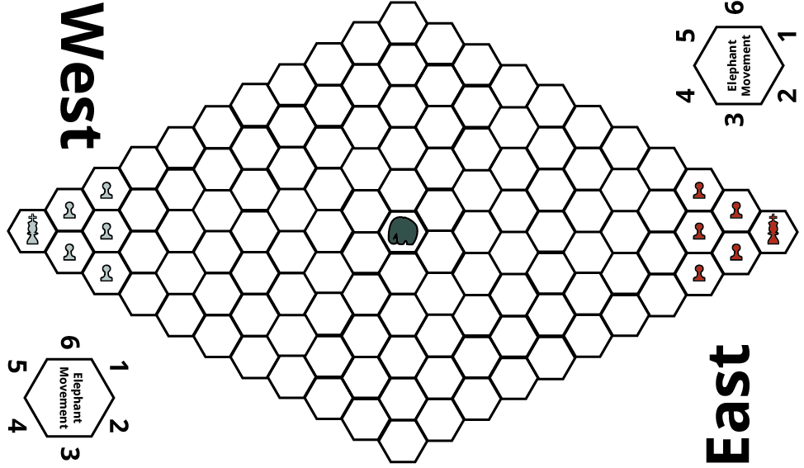

Rules

**Turn Sequence**

The game is played in **alternating turns**, starting with the East Player. **After each player has completed a turn, the elephant is moved**. Each player may move/capture using one piece per turn.

* **Movement:** Each player may move any one of their pieces in any adjacent space unless it is occupied by the player’s own piece or the elephant.
* **Capturing:** A player may capture an opposing player’s piece by moving their piece onto a space occupied by the opposing player.

**Elephant Movement**

After both players have each completed a turn, the elephant is moved by rolling a d6 for direction and a d4 for spaces moved. Direction is determined by using the number from the die roll and matching it to the Elephant Movement diagram found on the board:

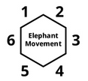

Any pieces that the elephant moves through are considered trampled, and removed from the game. If the elephant cannot complete movement due to the boundaries of the board, then the elephant moves as much as it can.

Victory

The game is over in one of three ways: The player who reaches the opposite side of the board with their king before their opponent wins the game. The player who is left with their king on the board if their opponent loses their king wins. If the elephant tramples both kings in one movement, then both players lose and must replay the game.

Design Goals

When I developed the initial version of “Elephant” I wanted to create a symmetrical game for two players that involved a third party piece that neither player could control. This uncontrollable piece would act as both the randomizer in the game, as well as a sort of “agent of chaos”. After digging through a Persian chess set, I came up with the idea of using an elephant, which is a bishop from the Persian chess set, as my “agent of chaos”. The elephant would be able to trample pieces from any player and would not be able to be captured throughout the game.

The idea was that the elephant would be an invulnerable piece that the players would have to watch out for in their simple goal of getting their king from one side of the board to the other. With this simple goal in place, I was mostly interested in seeing how a fairly symmetrical game, 5 pawns and 1 king per player on a symmetrical board layout, would play out with this random elephant piece. I went into playtesting not sure if one random elephant would be enough to change such a simple game, but curious to find out.

Design Changes

Considering that I really did not know ahead of time if the elephant piece would be enough to change the game much at all, I was incredibly surprised to find out that it influenced the course of the game greatly. The elephant as an “agent of chaos” was extremely effective; however it only mostly affected Garrett. The elephant managed to hover around Garrett for the first half of the game and forced him to move his king and pawns in a very defensive manner. Because of the luck, or unlucky, rolls of the dice, the elephant did not affect Ian much at all, allowing him to gain ground quickly. While this is an interesting mechanic, it seems an extreme case such as this is not fun for all players.

A completely independent “agent of chaos”, at least in this form, has its flaws. For this reason I am considering giving each player their own elephant as part of their army. Perhaps the randomness can be had in the d4 roll for control of the elephant. This would still allow for mishaps, such as trampling your own pieces, but would at least give the player a little bit of control over how the elephant works.

Another big design change is the board itself. Right now the board is too big, and moving each piece one at a time makes the game last way too long. Considering that the middle of the board is where all the action is, and the clustering of pieces in a corner makes the first ten moves on the board just trying to get out of a corner, the board must be made smaller in the next version. Aside from this, the name “Elephant” is not very good, so I’ll have to come up with a better name for the game.

Written Rules

Kings Crossing (version 2)

Components

* 10 pawns (5 silver and 5 bronze)
* 2 kings (1 silver and 1 bronze)
* 2 elephant pieces (1 silver and 1 bronze)
* Hexagonal game board

Players

2 players

Objective

The objective of “Kings Crossing” is to keep your king alive and move him across the board before your opponent does.

Setup

Players decide who will play as West (silver pieces) and who will play as East (bronze pieces). The board is set up with each player’s pieces positioned on opposite ends of the game board according to the image below:

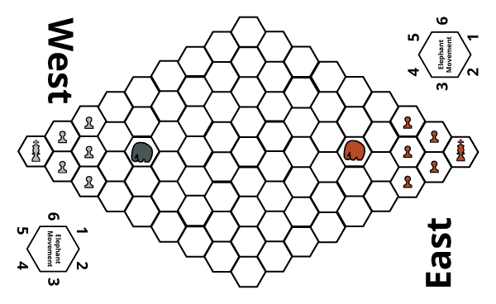

Rules

**Turn Sequence**

The game is played in **alternating turns**, starting with the East Player. **After each player has completed a turn, their elephant is moved**. Each player may move/capture using either one of their pawns or king once per turn.

* **Movement:** Each player may move any one of their pieces in any adjacent space unless it is occupied by the player’s own piece or the elephant.
* **Capturing:** A player may capture an opposing player’s piece by moving their piece onto a space occupied by the opposing player.

**Elephant Movement**

After a player has moved either one of their pawns or their king, they must move their elephant. The player rolls a d4 and a d6 to determine elephant movement. **The d4 is used to decide the amount of spaces the elephant moves as well as if the player has control of their elephant. If the d4 roll is a 1 or 2, then the player gets to decide which direction the elephant moves in. If the d4 roll is a 3 or 4, then the player must use a d6 roll to determine the direction that their elephant moves.** Using the number from the d6 die roll and matching it to the Elephant Movement diagram found on the board determines the elephant’s direction:



**While elephants cannot capture or move through another elephant, any other pieces that the elephant moves through are considered trampled, even if it is their own team’s pieces. Trampled pieces are removed from the game**. If the elephant cannot complete movement due to the boundaries of the board or running into another elephant, then the elephant moves as much as it can before reaching the edge of the board or the other elephant.

Victory

The game is over in one of three ways: The player who reaches the opposite side of the board with their king before their opponent wins the game. The player who is left with their king on the board if their opponent loses their king wins. If the elephant tramples both kings in one movement, then both players lose and must replay the game.

Design Goals

With the second version of the game, my main goal is to see if giving the players their own elephant helps the game feel more fair, while still retaining some of the random chaos that the elephant brings to the game. The elephant can only be controlled 50% of the time based on a d4 roll, but can only be used to capture pawns or the king. This should allow the players to use their elephant to charge at the enemy without fear of losing their elephant. My hope is that the elephant will strike a good balance between how useful it can be with its advanced movement and how risky it is to keep around your army. I also hope that the smaller board will allow for players to quickly get to the middle of the board.

Design Changes

While my noble intentions of giving the players an elephant was to help balance out the game it was anything but fair. This game is now more broken than ever, and should probably be named “Bowling with Elephants”. The elephants remained a powerful component of the game, but their power was completely unchecked. No other piece can capture the elephant, so it basically had free reign of the board and cleared the middle within 2 turns. Also, the 50% chance of controlling the elephant was not enjoyed by Alexandra or Christopher, who both managed to destroy a good share of their own armies. While both players liked having their own elephants, the pieces are just too strong. This is likely because of their ability to clear 1 to 4 spaces at a time, compared to the pawns and kings which only move 1 space. Also, because the elephants are moved every turn and only 1 pawn or king can be moved a turn, the elephants are just too good. Pawns are basically useless.

The next version of this game needs to somehow reign in more control of the elephant for the player and also make the other pieces more capable. Moving only one piece at a time is just too slow, so the players should probably be able to move every piece they have once per turn. Also, the 50% chance to control the elephant should probably be increased to 75%, so this way the elephant is not so destructive to its own team.

Alexandra also gave a good idea that the King should be able to capture an elephant. This is a great idea that basically will make it more difficult to keep the elephant around the king without consequence. This also helps separate the king from the pawns. I am also considering making the board a little bit smaller again and giving the pawns special jumping mechanics. Hopefully the next version of this game will see the elephants as still good pieces, but not overly powered as in this version because the other pieces have been given more mobility and special rules.

Written Rules

Kings Crossing (version 3)

Components

* 14 player pieces
* 10 pawns (5 silver and 5 bronze)
* 2 kings (1 silver and 1 bronze)
* 2 elephants (1 silver and 1 bronze)
  + 1 game board

Players

2 players

Objective

The objective of “Kings Crossing” is to keep your king alive and be the first player to place your king in the opposing king’s castle.

Setup

Players decide who will play as West (silver pieces) and who will play as East (bronze pieces). The board is set up horizontally with each player’s pieces positioned on opposite ends of the game board according to the image below:

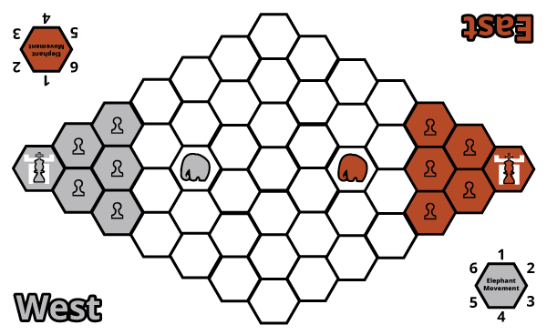

Rules

**Pieces**

Each player has an army consisting of 1 king, 5 pawns, and 1 elephant. Each piece has the following characteristics:

**King**

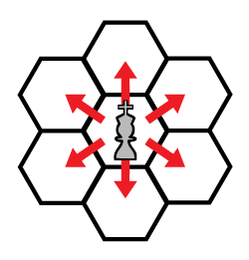**Movement**

The King can move into any adjacent space (see figure to the left).

**Capturing**

If the space is occupied by any of the opponent’s pieces then the king may capture it, removing it from the game.

**Special**

The king is the only piece that may capture an opponent’s elephant.

**Pawn**

**Movement**

A pawn can move into any adjacent space (see figure to the left).

**Capturing**

If the space is occupied by either an opponent’s king or pawn the pawn may capture it, removing it from the game

**Special**

Pawns may jump over friendly pawns.



**Elephant**

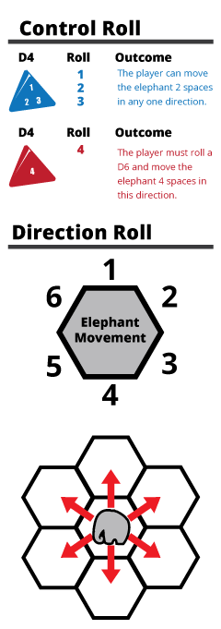**Control Roll**

Before the elephant can move the player must roll a d4 to see if they have control over their elephant (see figure on the left). If a 1, 2, or 3 is rolled, the player may move their elephant 2 spaces in any one direction. If the player rolls a 4, they must perform a direction roll (described below).

**Direction Roll**

If the player rolled a 4 during the control roll, then a d6 must be rolled to determine the direction the elephant will move in (see figure on the left).

**Movement**

If the player has passed the control roll they may move their elephant up to 2 spaces in any one direction.

**Capturing**

If the space is occupied by any of the opponent’s pieces, except another elephant, then the elephant may capture it, removing it from the game.

**Special**

The elephant can capture its own army’s pieces, but may not capture or move through another elephant.

**Turn Sequence**

The game is played in **alternating turns**, starting with the East Player. **A player’s turn consists of moving their first elephant and then the rest of their pieces one at a time. After a player has moved all their pieces once, their turn is over.**

Victory

The game is over in one of three ways:

* A player wins by capturing their opponent’s castle with their king.
* A player wins by capturing their opponent’s king
* If both kings are captured by an out of control elephant in a single turn, then the game is a draw.

Design Goals

The third version of “Kings Crossing” is an attempt to reign in the power of the elephant by giving the other pieces more mobility and rules that will help them stand out more in the game. Most importantly, all pieces may be moved once in a turn. This should help the game get rolling quickly and lessen the power of the elephant’s advanced movement. The pawns have been given the ability to jump over other friendly pawns. This should allow pawns to get across the board quicker and allow for more strategy involving the pawns. The king also may now capture an opposing elephant, making it more risky to simply charge straight in towards the king.

Aside from the rules for pieces, the board is now smaller and features colored spaces so the game is more organized. Also, a castle is placed on opposite sides of the board as a reminder of the objective of the game. Hopefully this visual reminder will give the players a focus on the goal, instead of on their elephants.

Design Changes

While the game appears to be getting better, the elephants still suffer from being incredibly overpowered. This is especially noticeable, considering that the player has an increased chance of controlling the direction that the elephant will move in. While players seem to like having control over the elephant, it is appearing to have more problems than it might be worth fixing. My original intentions of making the elephant an independent “agent of chaos” were more effective than giving an elephant to the players. The game has become all about the elephant and less about the objective of the game. For this reason, I am considering making the elephant an independent piece, yet again.

Also unfortunate is that while the board seems to be a good size now, it is still impossible for the king to clear much distance on the board before the elephants start to become a real threat. Unexpectedly, the advanced jumping of the pawns can also be exploited in a way that allows a player to clear a total of 4 spaces with 2 pawns. This put into question how powerful pawns were becoming, especially when this exploit was used to capture pieces. Reconsidering the special rules for pawns needs to be done.

Written Rules

Castle Capture (version 4)

Components

* 14 player pieces
* 10 pawns (5 silver and 5 bronze)
* 2 kings (1 silver and 1 bronze)
* 1 elephant
  + 2 d6 (1 silver and 1 bronze)
  + 2 d4 (1 silver and 1 bronze)
  + 1 game board

Players

2 players

Objective

The objective of “Castle Capture” is to capture the opposing team’s castle with your king.

Setup

Players decide who will play as West (silver pieces) and who will play as East (bronze pieces). The board is set up horizontally with each player’s pieces positioned on opposite ends of the game board and the neutral elephant placed in the middle elephant space according to the image below:

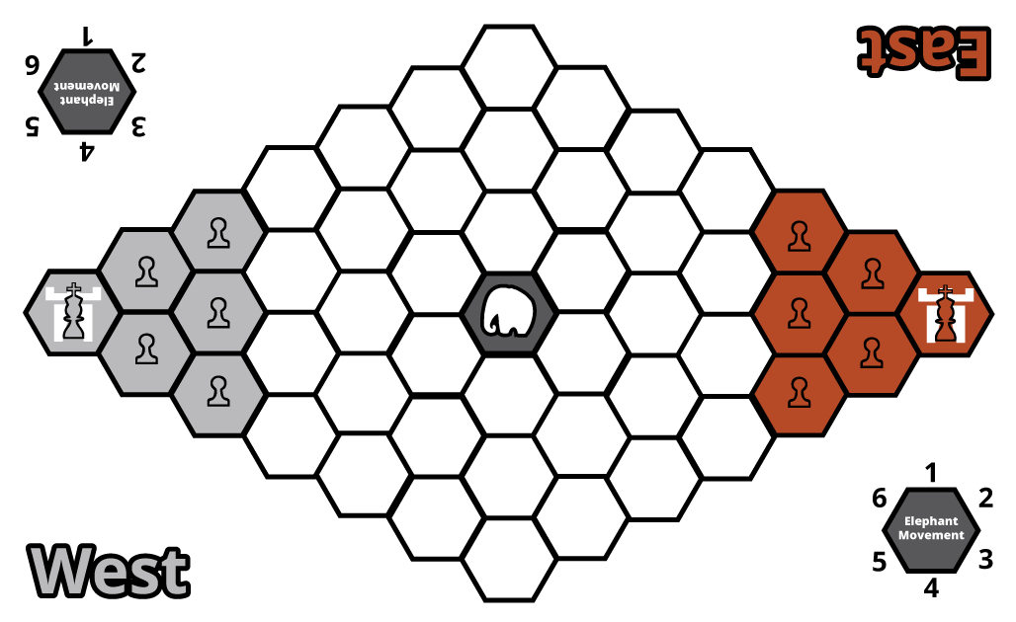

Rules

**Pieces**

Each player has an army consisting of 1 king and 5 pawns~~.~~ Each piece has the following characteristics:

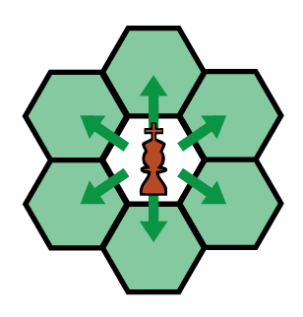

**King**

**Movement and Capturing**

The King can move into any adjacent space and capture any opposing piece it lands on (see figure to the left).

**Special**

The king is the only piece that may capture the opposing player’s castle and an elephant.



**Pawn**

**Movement and Capturing**

The Pawn can move into any adjacent space and capture any opposing piece it lands on, except for an elephant or the opposing player’s castle (see figure to the left).

**Special**

If a player’s pawn is adjacent to the elephant it may forfeit this pawn’s movement and capturing for one turn in order to attempt to control and move the elephant by performing a control roll.

As long as a player has a pawn near the elephant it can perform a control roll, meaning that the elephant can be moved multiple times in one player’s turn.

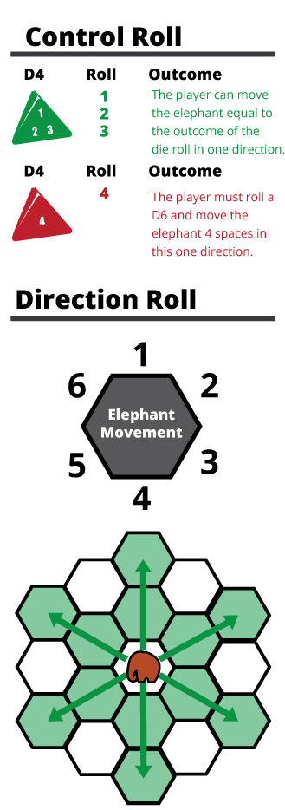**Elephant**

**Free Elephant**

If the elephant is not under the control of any player than after every player’s turn the elephant freely moves by rolling a d4 for the amount of spaces moved and a d6 to determine its direction.

**Control Roll**

If a player is attempting to control the elephant they must have a pawn adjacent to the elephant. Then the player must roll a d4 to see if they have control over the elephant (see figure on the left). If a 1, 2, or 3 is rolled, the player may move the elephant equal to the number of the die roll in one direction. If the player rolls a 4, they must perform a direction roll (described below).

**Direction Roll**

If the player rolled a 4 during the control roll, then a d6 must be rolled to determine the direction the elephant will move in (see figure on the left).

**Movement**

If the player has passed the control roll they may move their elephant the spaces equal to the outcome of the d4 roll in any one direction. If it is not possible for an elephant to complete its move due to the boundaries of the board, then the elephant as much as possible in this direction before coming to a stop at the edge of the board.

**Capturing**

Any pieces that an elephant pass through or lands on at the end of its movement are considered captured.

**Turn Sequence**

The game is played in **alternating turns**, starting with the East Player. **A player’s turn consists of moving every one of their pieces (unless a pawn is used to control the elephant) in any order they choose to do so. Players may elect not to move a piece.**

**If a player’s king is eliminated from the game it is no longer possible for them to win the game. However, they can still try to eliminate the opposing player’s king before he captures the castle resulting in a draw game that must be replayed.**

Victory

The game is over if:

* A player wins by capturing their opponent’s castle with their king.
* Both players’ kings are eliminated from the game and the game must be replayed.

Design Goals

With version four of the game I felt confident that this might just be the final version of the game. The elephant has returned to being an independent “agent of chaos” in the game, but now shares a special relationship with pawns. Pawns can now give up their movement if an elephant is adjacent to it in order to control and move the elephant for one roll. This means the game is down to having one elephant that has a “shared” aspect to it. I feel really confident that this mechanic can be fair but also result in chaotic moments of unlucky control rolls.

Other than the elephant and pawns being changed, the game remains mostly the same. The board seems to be a good size and having the players move all their pieces allows for a much quicker game than it ever has before. The only thing I’m not sure about is whether or not to force players to move all pieces or not. I have also added much more to the rules in terms of diagrams and explanations, so I really hope that I’ll be able to blind test this version of the game with players.

Design Changes

For the most part the blind test went well for this version of the game. It seems as if though the players understand the rules and the diagrams in the rules. There were a few errors and misspellings that will have to be ironed out, but other than this the rules were understood fairly quickly. I’m positive that the diagrams have helped tremendously in allowing a player to process all the new information quickly and clearly.

After this playtest it is clear to me that the game is almost ready to be complete. The players were almost able to capture the castles, a first for all my playtests, and neither player felt the elephant was too overwhelming. This is amazing, because all my playtests up until now had issues with the elephant. Moreover, I even caught moments of enjoyment from both players. The last changes to the game are to make sure I have a different colored elephant so that players do not confuse who has the elephant, and to make the castles further away from the corners. This should allow for an even quicker game.

Written Rules

Castle Capture (final version)

Components

* 13 pieces
* 10 pawns (5 silver and 5 bronze)
* 2 kings (1 silver and 1 bronze)
* 1 black elephant
  + 1 d6
  + 1 d4
  + 1 game board

Players

2 players

Objective

The objective of “Castle Capture” is to capture the opposing team’s castle with your king.

Setup

Players decide who will play as West (silver) and who will play as East (bronze). The board is set up horizontally with each player’s pieces positioned on opposite ends of the game board and the neutral elephant placed in the middle elephant space according to the image below:

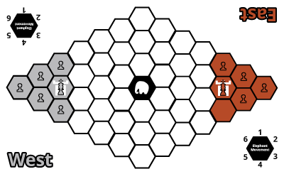

Rules

**Pieces**

Each player has an army consisting of 1 king and 5 pawns~~.~~ The elephant is a free agent piece that moves on its own unless captured during a player’s turn. Each piece has the following characteristics:



**King**

**Movement and Capturing**

The King can move into any adjacent space and capture any opposing piece it lands on (see figure to the left).

**Special**

The king is the only piece that may capture the opposing player’s castle and an elephant.



**Pawn**

**Movement and Capturing**

The Pawn can move into any adjacent space and capture any opposing piece it lands on, except for an elephant or the opposing player’s castle (see figure to the left).

**Special**

If a player’s pawn is adjacent to the elephant it may forfeit this pawn’s movement and capturing for one turn in order to attempt to control and move the elephant by performing a control roll.

As long as a player has a pawn near the elephant it can perform a control roll, meaning that the elephant can be moved multiple times in one player’s turn.

**Elephant**

**Free Elephant**

At the end of a player’s turn they must roll to move elephant by rolling a d4 for the amount of spaces moved and a d6 to determine its direction (see Direction Roll figure to the left).

**Control Roll**

If a player is attempting to control the elephant they must have a pawn adjacent to the elephant. Then the player must roll a d4 to see if they have control over the elephant (see Control Roll figure on the left).

If a 1, 2, or 3 is rolled, the player may move the elephant equal to the number of the die roll in one direction that they choose. If the player rolls a 4, they must perform a direction roll (described below).

**Direction Roll**

If the player rolled a 4 during the control roll, then a d6 must be rolled to determine the direction the elephant will move in (see Direction Roll figure on the left).

**Movement**

If the player has passed the control roll they may move their elephant the spaces equal to the outcome of the d4 roll in any one direction. If it is not possible for an elephant to complete its move due to the boundaries of the board, then the elephant is moved as much as possible in this direction before coming to a stop at the edge of the board.

**Capturing**

Any pieces that an elephant passes through or lands on at the end of its movement are considered captured.

**Turn Sequence**

The game is played in **alternating turns**, starting with the East Player. A player’s turn consists of moving every one of their pieces (unless a pawn is used to control the elephant) in any order they choose to do so.Players **must make a move with every one of their pieces**.

**Example Turn Sequence:**

* East begins turn by moving pawns
  + (this can include attempts to control elephant)
* East moves their king
* East cannot move any more pieces, rolls for Free Elephant movement
* East’s turn is over, passes dice to West

If a player’s king is eliminated from the game it is no longer possible for them to win the game. However, they can still try to eliminate the opposing player’s king before he captures the castle resulting in a draw game.

Victory

The game is over if:

* A player wins by capturing their opponent’s castle with their king.
* Both players lose their kings before they are able to capture the opponent’s castle.