Travis Moore

GAT 210A—Spring 2014

Instructor: Jeremy Holcomb

Castle Capture Rules

Castle Capture (final version)

Components

* 13 pieces
* 10 pawns (5 silver and 5 bronze)
* 2 kings (1 silver and 1 bronze)
* 1 black elephant
  + 1 d6
  + 1 d4
  + 1 game board

Players

2 players

Objective

The objective of “Castle Capture” is to capture the opposing team’s castle with your king.

Setup

Players decide who will play as West (silver) and who will play as East (bronze). The board is set up horizontally with each player’s pieces positioned on opposite ends of the game board and the neutral elephant placed in the middle elephant space according to the image below:

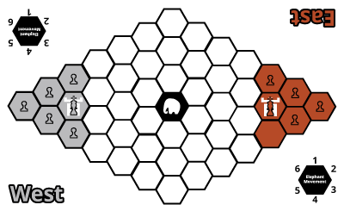

Rules

**Pieces**

Each player has an army consisting of 1 king and 5 pawns~~.~~ The elephant is a free agent piece that moves on its own unless captured during a player’s turn. Each piece has the following characteristics:



**King**

**Movement and Capturing**

The King can move into any adjacent space and capture any opposing piece it lands on (see figure to the left).

**Special**

The king is the only piece that may capture the opposing player’s castle and an elephant.



**Pawn**

**Movement and Capturing**

The Pawn can move into any adjacent space and capture any opposing piece it lands on, except for an elephant or the opposing player’s castle (see figure to the left).

**Special**

If a player’s pawn is adjacent to the elephant it may forfeit this pawn’s movement and capturing for one turn in order to attempt to control and move the elephant by performing a control roll.

As long as a player has a pawn near the elephant it can perform a control roll, meaning that the elephant can be moved multiple times in one player’s turn.

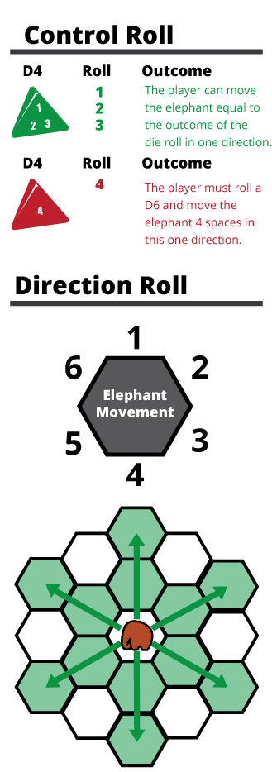**Elephant**

**Free Elephant**

At the end of a player’s turn they must roll to move elephant by rolling a d4 for the amount of spaces moved and a d6 to determine its direction (see Direction Roll figure to the left).

**Control Roll**

If a player is attempting to control the elephant they must have a pawn adjacent to the elephant. Then the player must roll a d4 to see if they have control over the elephant (see Control Roll figure on the left).

If a 1, 2, or 3 is rolled, the player may move the elephant equal to the number of the die roll in one direction that they choose. If the player rolls a 4, they must perform a direction roll (described below).

**Direction Roll**

If the player rolled a 4 during the control roll, then a d6 must be rolled to determine the direction the elephant will move in (see Direction Roll figure on the left).

**Movement**

If the player has passed the control roll they may move their elephant the spaces equal to the outcome of the d4 roll in any one direction. If it is not possible for an elephant to complete its move due to the boundaries of the board, then the elephant is moved as much as possible in this direction before coming to a stop at the edge of the board.

**Capturing**

Any pieces that an elephant passes through or lands on at the end of its movement are considered captured.

**Turn Sequence**

The game is played in **alternating turns**, starting with the East Player. A player’s turn consists of moving every one of their pieces (unless a pawn is used to control the elephant) in any order they choose to do so.Players **must make a move with every one of their pieces**.

**Example Turn Sequence:**

* East begins turn by moving pawns
  + (this can include attempts to control elephant)
* East moves their king
* East cannot move any more pieces, rolls for Free Elephant movement
* East’s turn is over, passes dice to West

If a player’s king is eliminated from the game it is no longer possible for them to win the game. However, they can still try to eliminate the opposing player’s king before he captures the castle resulting in a draw game.

Victory

The game is over if:

* A player wins by capturing their opponent’s castle with their king.
* Both players lose their kings before they are able to capture the opponent’s castle.