Travis Moore

GAT 210A—Spring 2014

Instructor: Jeremy Holcomb

Subterfuge Rules

Subterfuge (version 5: Final)

Components

* 2 Player Boards (1 blue, 1 green)
* 12 Crew Pieces (5 blue, 5 green, 2 black)
* 2D8 Dice (1 blue, 1 green)
* 2D4 Dice (1 blue, 1 green)
* 40 Event Cards
* 60 status tokens (15 flooding, 15 flooded, 15 damaged, 15 destroyed)
* 14 systems tokens (7 blue and 7 green, 1 Temple of The Squid God System)

Players

“Subterfuge” is played with 2 players.

Objective

The objective of “Subterfuge” is to either eliminate all systems aboard the enemy sub or all of its crew.

Setup

Players decide who will play as Blue and who will play as Green. Before the game starts both players need to setup the event cards and their sub:

* Event Cards are shuffled and place face down between both players.
* All lock and status tokens are placed between both players to be used throughout the game to keep track of area statuses and lock states
* Each player decides where to place their 7 System cards (1 space on each sub will be blank and without a system).
* Each player places 4 of their color crew in areas of their sub
* The box top is used as a divider to keep crew from looking at each other’s interior (unless sonar is used by a player that turn)
* Each player gets one Saboteur Event Card which can be played at any time.

**To decide who goes first players roll both their dice, and the highest roll goes first** (in the event of a tie, both players reroll the dice). Players sit across from each other as shown below:

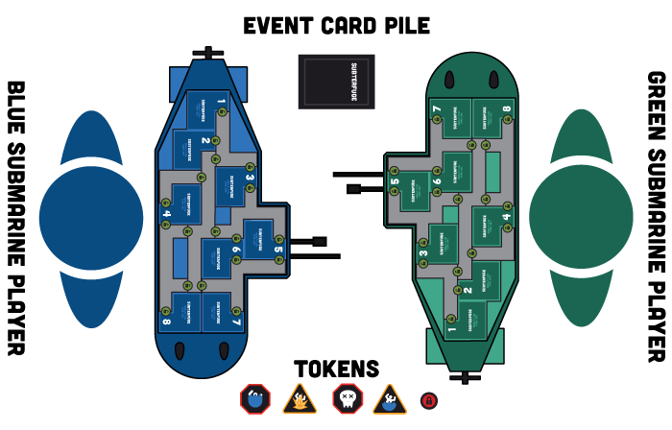

Rules

Turn Sequence

The game is played in **alternating turns**, starting with the player who won the dice roll. **The turn sequence is: Draw an Event Card then Perform Crew Actions**.

* **Draw an Event Card:** At the start of a player’s turn they must draw an Event Card and follow the instructions on the card if it can be applied. After the instructions have been followed the card is discarded (if all Event Cards have been used, the pile is reshuffled to be used again).
* **Perform Crew Actions:** Every crew piece can move once and perform **2 separate actions** per turn. Actions are the following:
* Open/ lock an area’s doors
* Attack and kill enemy saboteur
* Repair (crew piece can only repair one flooding, damaged, or destroyed status per turn. Destroyed status goes to Damaged, and then Damaged goes to normal. Note: if a room is destroyed or flooded while a crew piece is in it, then the crew piece is killed. Crew pieces cannot enter flooded areas or fix them without use of the pump.)
* Use a System Action (crew must be in area to use bonus)

After the Draw Event Card and Perform Crew Actions have been completed, this player’s turn is over and the next player’s turn begins.

Dice Actions

Dice are used for targeting randomly, squid attacks, evasion, and damage. See the diagram below:

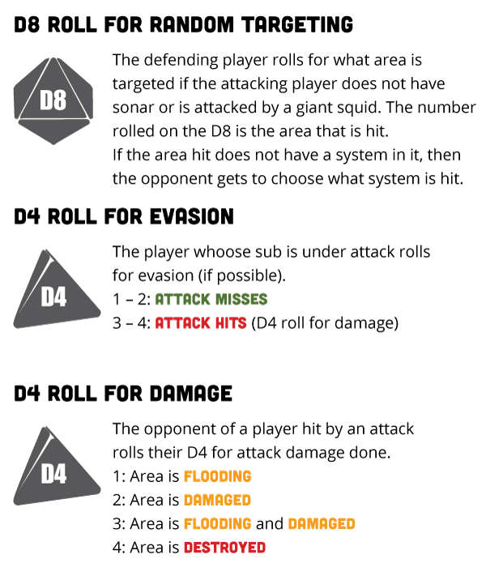

System Actions

Engines: Evasion

If a crew member is in the Engines System then a player may attempt to evade a torpedo or squid attack if their engines are not flooded or irradiated.

* Evasion: D4 Roll of 1 – 2 : Attack Misses and D4 Roll of 3 – 4: Attack Hits
* No Evasion: All attacks hit

Sonar: Targeting and Viewing Interior

If a crew member is in the Engines System then a player may use the actions of a crew piece in the Sonar room to specifically target an area of the enemy sub.

* Sonar: Player may choose which area is targeted for 1 or 2 torpedoes
* No Sonar: Player must roll D8 to determine location targeted by torpedoes

Doors: Free Unlocking and Locking of Sub Doors

If a crew member is in the Engines System and the Doors System is not destroyed or flooded then the player does not have to use any actions from their crew pieces at a door to lock and unlock doors this turn.

* Doors: May unlock and lock doors freely throughout the sub for this turn.
* No Doors: Crew piece must use 1 action and be at a door to lock and   
   unlock doors

Pump: Free Flooding/Flooded Repair

If a crew member is in the Engines System and **if the Pump area is not destroyed or flooded, then the player can drain completely once per turn**.

* Pump: Revert the Flooding/Flooded Status of any one room (Flooded and Flooding go to normal)
* No Pump: Crew must be in area to fix flooding (cannot fix flooded)

Firing a Torpedo

As long as a crew piece is in a weapons room and the weapons room is not destroyed or flooded, a torpedo can be fired at the enemy. If the sonar is working and a crew piece is in this room, then the area fired upon can be chosen by the player. If there is no crew piece in the sonar or the sonar is destroyed or flooded, then a torpedo may still be fired, but the player must roll to see what they are targeting. If a torpedo hits, the type of damage is dependent on a D4 roll.

* Torpedo: May fire a torpedo at the enemy (with or without the aid of the sonar). If the enemy does not evade then damage is assessed as follows:

D4 Roll of 1: Area is Flooding  
D4 Roll of 2: Area is Damaged  
D4 Roll of 3: Area is Flooding and Damaged  
D4 Roll of 4: Area is Destroyed

* No Torpedo: No torpedoes can be fired without a crew in the weapon room.

Special Rules

Oxygen System

No crew are required for the oxygen system to work, it must be not be destroyed or flooded for it to work.

* Oxygen: Crew can breathe
* No Oxygen: If not repaired within 4 alternating turns (starting with the player’s first turn with a destroyed or flooded oxygen room) then the crew on this sub all die and the game is over.

Saboteur

A saboteur card allows you to replace any crew aboard the enemy sub with a saboteur (use a black crew piece). You can only have 1 saboteur on the enemy sub at one time. The saboteur can move once and attack systems once per turn (roll a D4 like a torpedo hit this area). The saboteur may not attack or move onto spaces occupied by the enemy crew. The enemy can kill the saboteur by moving onto the same space as the saboteur and using an action to kill him.

Flooding/Flooded

Flooding is dangerous to the submarine, as well as the crew. Crew can spend 1 action to repair an area that is flooding back to operational (including hallways). Use flooding and flooded tokens to help keep track of hallways that are flooded. **Once an area is flooded it will spread “flooding” statuses to adjacent areas that are not locked on the next turn**.

Victory

The game is over when a player no longer has crew or operational systems left on their sub. The winner is the player who still has crew/systems.