Travis Moore

PHY 115—Spring 2014

01/29/2014

Assignment 2

**1. Moving in a straight path, Digipen Dee is running away (due west) from Pac-Man at an astounding, constant speed of 8 m/s for 1 minute. She then reaches a corner of the maze and hides for 3 minutes, until she sees Pac-Man passing by. From minutes 4 to 6, DigiPen Dee sneaks back towards where she came from (east) at 1 m/s, always moving in a straight line. What are her average velocities (reminder: velocities are vectors!) over the time intervals:**

**a. t=1 min to t=4 min?**

(8 meters / 1 seconds) * (60 seconds / 1 minutes) = (480 meters / 1 minutes)

Vav,x = (x2 – x1) / (t2 – t1) = (480 meters – 480 meters) / (4 minutes – 1 minutes)

Vav,x = 0 meters / 3 minutes = 0 meters / 1 minutes

Vav,x = 0 meters / 1 second

**b. t=0 min to t=4 min?**

Vav,x = (x2 – x1) / (t2 – t1) = (480 meters – 0 meters) / (4 minutes – 0 minutes)

Vav,x = 480 meters / 4 minutes = 120 meters / 1 minute

Vav,x = (120 meters / 1 minutes) * (1 minutes / 60 seconds)

Vav,x = 2 meters / 1 seconds

**c. t=0 min to t=6 min?**

(1 meters / 1 seconds) * (60 seconds / 1 minutes) * 2 minutes = (120 meters / 2 minutes)

480 meters – 120 meters = 360 meters

Vav,x = (x2 – x1) / (t2 – t1) = (360 meters – 0 meters) / (6 minutes – 0 minutes)

Vav,x = 360 meters / 6 minutes = 60 meters / 1 minute

Vav,x = (60 meters / 1 minutes) * (1 minutes / 60 seconds)

Vav,x = 1 meters / 1 seconds

**d. What is Dee's average speed over the time interval t = 0 to t = 6 min?**

Average speed = total distance traveled / total time = 600 meters / 6 minutes

Average speed = (100 meters / 1 minutes) * (1 minutes / 60 seconds)

Average speed= 1.67 meters / 1 seconds

**2. in a movie, a Pontiac GTO (car 1) and a highly-modified Chevrolet 150 (car 2) travel due east on U.S. Route 66 in straight paths, in parallel lanes. At instant t = 0.0 h, car 1 is located at position x = 100 mi (mi = miles) with respect to the origin, and maintains a constant speed of 130 mi/h. Car 2 is located at the origin (x = 0.0 mi) at instant t = 0.50 h, and travels at the unbelievable speed of 180 mi/h, which is kept constant. Note: please use miles and hours for your answers.**

**a. Graph the motion of cars 1 and 2 on the same position vs. time graph.**



**b. Based on your graph, at what position with respect to the origin do the cars meet? Briefly explain your answer.**

At the 4 hour mark car 1 is at 620 miles and car 2 is at 630 miles, so the cars will both meet at just before 4 hours at their current speed at around the 600 mile marker.

**c. At what time does car 2 pass car 1? Briefly explain your answer.**

Just before the 4 hour mark is when the cards pass each other with car 1 at 620 miles, and car 2 at 630 miles at the 4 hour mark.

**3. The speed of a mysterious object along a straight, horizontal line, and moving due east for the time interval of 5.0 s is represented on the graph below.**

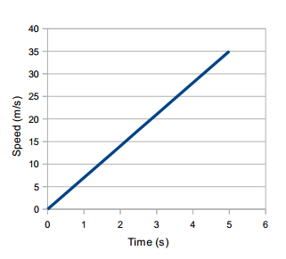

**a. What is the initial speed of the object?**

Initial speed = final velocity – (acceleration * time)  
Initial speed= 35 meters – (7 meters/second * 5 seconds)

0 meters / 1 seconds

**b. What is the magnitude of the acceleration of this object?**

Magnitude of acceleration = velocity / time = 35 meters / 5 seconds

7 meters / 1 seconds

**c. How far does the object travel in those 5.0 seconds?**

35 meters

**d. Based on the graph, is the acceleration of the object constant? Explain.**

Based on the graph the acceleration of the object is constant because it does not fluctuate (such as a curved line) and is a straight line.

**4. Sonic the Hedgehog's position, in a motion along a straight line, is described as a function of time as shown in the graph below:**

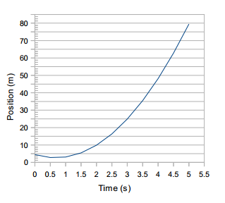

**a. Approximately at what time is Sonic's velocity equal to zero? Explain.**

At approximately 1.5 seconds, Sonic’s velocity is equal to zero. This is because Sonic travels from 5 meters to approximately 2.5 meters and back to 5 meters during this time span, effectively making his velocity equal to not having moved at all.

**b. What is the average velocity between t = 3.0 s and t = 4.0 s?**

Vav,x = (45 meters - 25 meters) / (4 seconds - 3 seconds)

Vav,x = (20 meters / 1 seconds)

**c. Are there negative velocities in this motion? At what times? Explain.**

Yes, from 0 to 0.5 seconds Sonic moves backwards from 5 meters to approximately 2.5 meters, making his velocity negative.

**d. What is the meaning of a negative velocity? Explain.**

A negative velocity means that the object in motion is moving in the opposite direction of its reference position, which is usually to the left or its origin on charts and graphs.

**EXTRA-CREDIT: Is it possible to have a zero velocity and a nonzero acceleration in a motion? Explain your answer and provide one example.**

Since zero velocity means that there is no change in velocity and nonzero acceleration refers to moving away from the reference point in a non-positive direction, it is possible to have both in a motion. Such an example is dropping a ball from a building. The ball starts with a nonzero acceleration and will eventually fall at a constant zero velocity.