How to make Pre-Commit Message hooks policy at Developer side

STEP-1 : Clone the Repository
STEP- 2.
At repository root level, Create a directory for holding the scripts (let's say that the name will be: git-hooks)
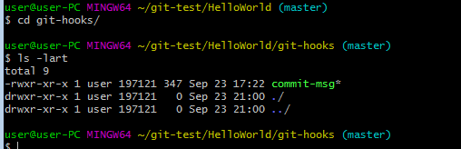
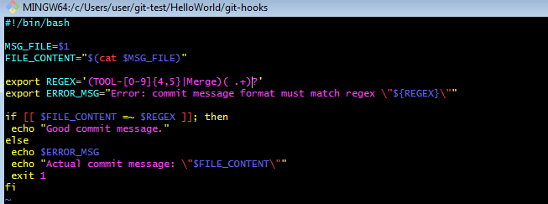

Code is below:
#!/bin/bash
MSG_FILE=$1
FILE_CONTENT="$(cat $MSG_FILE)"
export REGEX='(TOOL-[0-9]{4,5}|Merge)( .+)?'
export ERROR_MSG="Error: commit message format must match regex \"${REGEX}\""

if [[ $FILE_CONTENT =~ $REGEX ]]; then
echo "Good commit message."
else
echo $ERROR_MSG
echo "Actual commit message: \"$FILE_CONTENT\""
exit 1
fi

Add this file to master so that when developer create a feature branch he should have this folder and file in his feature branch.
commands :
git add .
git commit -m "TOOL-0000 Adjusting the hook"
git push origin master
git checkout feature-1

Command: This command should be executed from the root directory of your repository.
cd ../
git config core.hooksPath=./git-hooks
git config core.hooksPath ./git-hooks

Result:
This will help to apply the policy that no develope will allow to commit a message without TOOL-**** phrase in commit message.
This commands instructs (only for this single repository) git that the scripts acting as hooks are stored in the git-hooks directory.
From now on if you try to commit anything with the commit message not starting with TOOL-XXXX or TOOL-XXXXX (where X is a digit) the commit will fail with the proper message.

