The design & implementation of LGC
Thijs Haker

Table of Contents
Introduction: 2
Context – Diagram: 2
Context – Description: 3
Architecture – Diagram: 3
Architecture – Description: 3
Security & Testing: 3

Introduction:
LGC which stands for Little Green Cluster, is a portable and elegant orchestration system for small computer clusters. It lends its microservice design from Kubernetes, and is written in Go.

Context – Diagram:
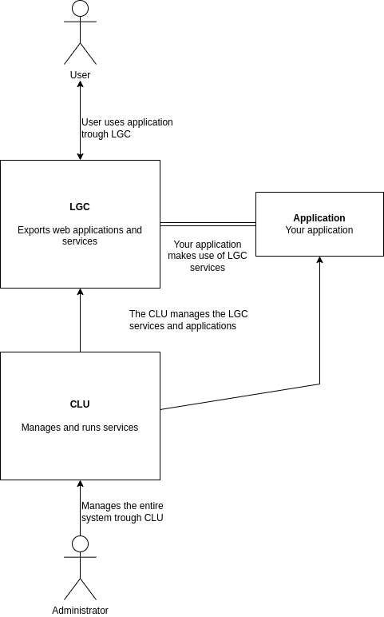

Context – Description:
Any LGC system contains three subsystems, the first is called CLU. With it’s possible to manage services running on different nodes. This is usally done by the systems administrator. The second subsystem is called LGC proper, it’s a collection of microservices, and they provide a small but usefull environment for your application to run on. Lastly we have the applications, these will be managed by CLU and make use of LGC services.

Architecture – Diagram:
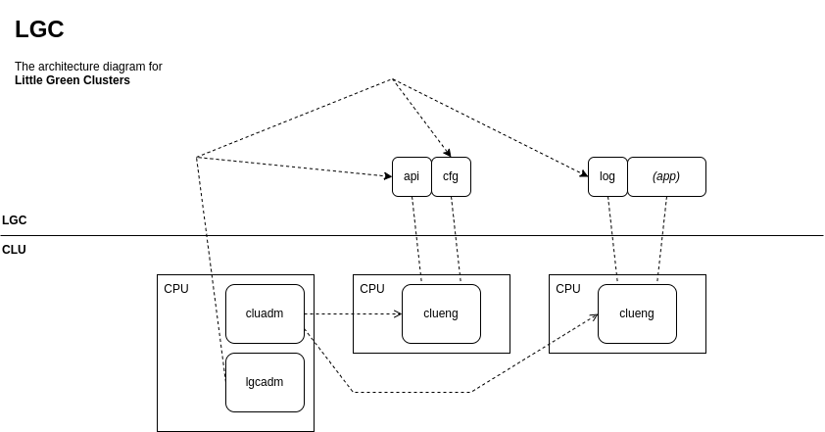

Architecture – Description:
As the diagram shows we’ve three compute nodes. These nodes all run an instance of the Cluster Engine (clueng). And these instances are managed by the Cluster Administator Program (cluadm). With these programs it’s possible manage the LGC services.
The core LGC services are: The API gateway (api), the configurator service (cfg), and the logger (log). These core services are managed by a single program called lgcadm.

Security & Testing:
Security is handled primarly by the API gateway, which runs on https and requires a valid certificate. The usage of microservices makes there be less attack surface, which also increases security. We will test verify by standard unit tests. The cluster engines however, communicate via an unencrypted TCP socket. This means that it’s not recommended to publish the ports to the internet.

