CCCS 310 - Web Development - Project

Sebastien Gascon - 260571356

*Alejandro Ulloa Cisneros – 260559418*

# Planning Analysis sheet

### What is the purpose of the site?

Our site will be a gaming community website. The purpose is to provide a place where gamers can find other gamers with similar interest and share information about the games they are playing. The site will also provide previews and reviews of the newest platforms and titles.

### Who is the intended audience?

While people of all ages and genders could be gamers, the intended audience will mostly be males between 12 and 30 years old.

### What are the objective of the site?

The objective will be to give the users a platform where they can post information about themselves, the games they play and the platforms available to gaming..

### What do you want the web site to accomplish?

We want the website to connect people together and help them find other games with the same interests as theirs. We also want the website to provide information about specific games and platforms.

### What information do you need?

We need the user’s personal information (in order to create a profile for the user) and we need information about games and platforms.

### What opportunity, problem or issue is your website addressing?

The gaming community is large and people sometimes get lonely while playing games. Our site will give them a chance to find other games with similar interests and give them a way to connect with each other.

### List of working title of each page on your web site

* Home
* News
* Forum
* Join our Community
* Games
* Gallery
* Members
* Online Store
* Videos
* About
* Contact
* Terms

### List where you will obtain the content for the web pages you listed above

#### Home

Content on the homepage will contain a description of what the site tries to achieve and will also have the latest news that are on the News page.

#### News

The news will come from various gaming websites about recent activities in the gaming world (such as IGN.com). It will also contain news about the site itself.

#### Forum

The forum will be user generated posts about various games and topics. The forum will be hosted on an external site.

#### Join our Community

This page will be a form for the users to fill to create an account on the website.

#### Games

The games page will list the games this community supports and the platforms.

#### Gallery

The gallery page will display picture of games.

#### Members

The members page will list all current members and link to their public profile.

#### Online Store

This page will display available merchandise for users to purchase.

#### Videos

This page will have videos (trailers) of supported games.

#### About

This page will display the goals of the site.

#### Contact

This page will display contact information for the website.

#### Terms

This page will display the terms of usage of the website.

# Flowchart of the siteCCCS310 - Project.png

# Tentative layout

## Browser Layout

### Homepage

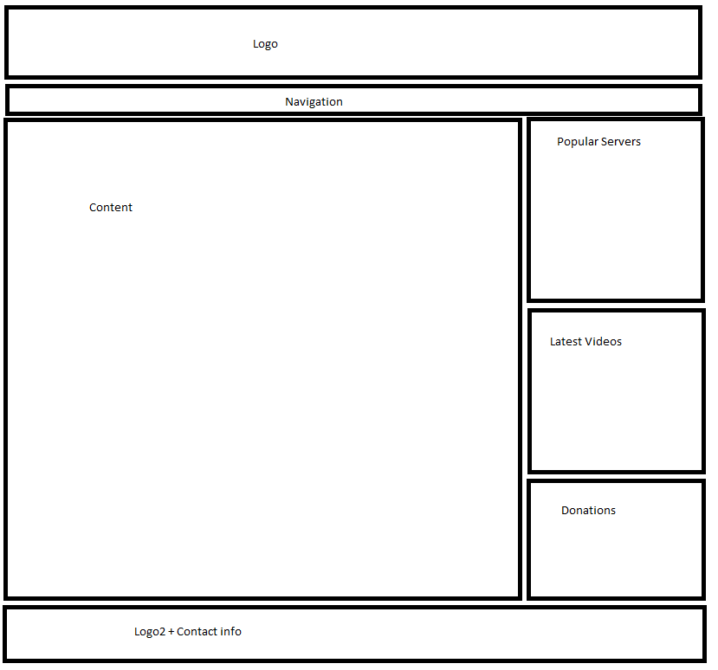

### Other Pages

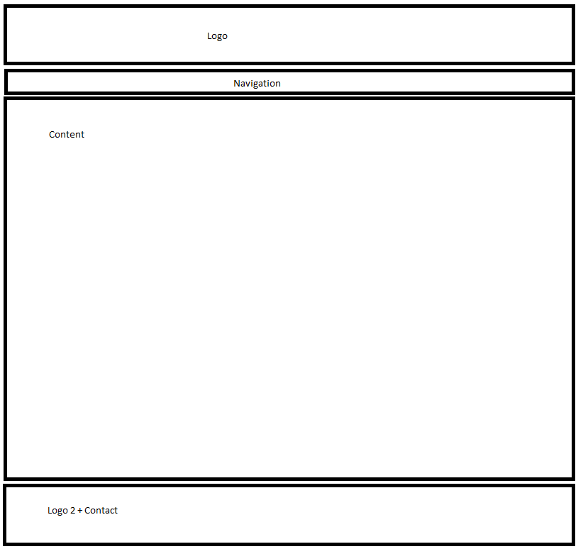

## Tablet Layout

### Homepage

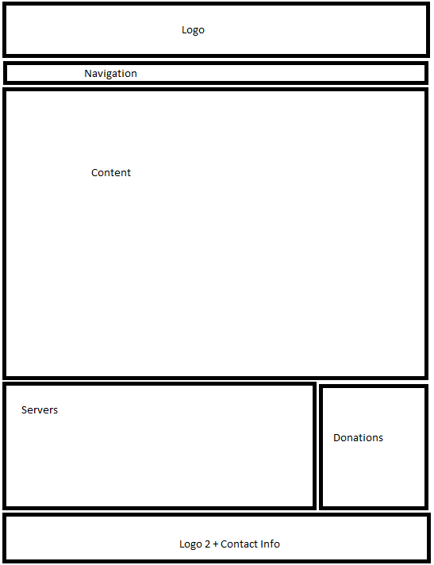

### Other Pages



## Mobile Layout

### Homepage

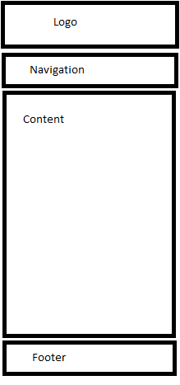

### Other Pages



## Similar Websites

<http://www.wydgaming.com>

On WYD Gaming the content is good and the site layout is well done. The website is well maintained and new information is added regularly. The pages are a bit overloaded with information and images.

<http://nrns-games.com/>

NRNS-Games is lacking in information and content. Information is only found in the forums and it can be hard to find the right information. The colors used on the site are bright and make reading easier.

## Tool used

### GitHub

We will use a collaborative tool known as GitHub to work together as a team to develop the website. The use of this tool will help in reducing duplicated work and keep files in sync.

### Microsoft Visual Studio