DEVELOPMENT OF A SYSTEM FOR AI-BASED CAREER PATH PREDICTION MODEL

BY
BUKOLA OLAYEMI AYINLA
(AI/HND/F24/00)

SUBMITTED TO:
DEPARTMENT OF ARTIFICIAL INTELLIGENCE
AND TECHNOLOGY, SCHOOL OF COMPUTING, THE FEDERAL POLYTECHNIC OFFA, KWARA STATE.

IN PARTIAL FULFILLMENT OF THE REQUIREMENT FOR THE AWARD OF HIGHER NATIONAL DIPLOMA (HND) IN ARTIFICIAL INTELLIGENCE AND TECHNOLOGY

SUPERVISED BY:
ISAAC S.M (MRS)

AUGUST, 2026

APPROVAL PAGE
This project titled:
“AI-BASED CAREER PATH PREDICTION SYSTEM” by BUKOLA OLAYEMI AYINLA (AI/HND/F23/00) has been read and approved as meeting the requirements for the award of the Higher National Diploma (HND) in the Department of Artificial Intelligence, School of Computing, The Federal Polytechnic Offa, Kwara State.

____________________________ ______________________
MRS. ISAAC S. M DATE
PROJECT SUPERVISOR

___________________________ ______________________
DR. ABDULLAHI DATE
HEAD OF DEPARTMENT

CERTIFICATION
This is to certify that this project titled “DEVELOPMENT OF A SYSTEM FOR CAREER PATH PREDICTION” was carried out by BUKOLA OLAYEMI AYINLA with Matric Number AI/HND/F24/000, of the Department of Artificial Intelligence, School of Computing, The Federal Polytechnic Offa, under my supervision.

This report is original and has not been submitted elsewhere for the award of any certificate, diploma, or degree.

______________________________________ ______________________
BUKOLA OLAYEMI AYINLA DATE
AI/HND/F24/000

DEDICATION
This project is dedicated to God for the wisdom, strength, and grace granted throughout the course of this study, and to my family for their unwavering support and encouragement.

ACKNOWLEDGEMENT
I am profoundly grateful to God for life, guidance, and the strength to complete this project. My sincere appreciation goes to my project supervisor Mrs. Isaac (S. M) for the patient guidance, constructive criticism, and technical insight provided throughout the development of this work.

I am also grateful to the Head of Department, Dr. Abdullahi, for his support, guidance, and relentless efforts toward ensuring our success in all our academic endeavors.

I also wish to thank the entire academic and non-academic staff of the Department of Artificial Intelligence, The Federal Polytechnic, Offa, for the knowledge and skills imparted throughout the course of my studies. My appreciation further extends to my family and friends for their continued moral, financial, and emotional support.

Finally, I acknowledge the contribution of every researcher cited in this report, whose published work provided the theoretical and empirical foundation upon which this study was built.

ABSTRACT
Career decision-making among students is frequently guided by subjective judgement rather than a structured analysis of measurable academic and technical attributes, contributing to a documented mismatch between training and labour-market outcomes. This study designed, implemented, and evaluated an AI-Based Career Path Prediction System — branded CareerPathAI — that uses a supervised Random Forest classifier to recommend suitable career paths based on a student’s academic profile.

The system was trained on a labelled dataset of 2,500 student records spanning six career-path outcomes: Software Engineer, Data Scientist, Product Manager, UX Researcher, ML Engineer, and Consultant. Twenty features were used for training, including GPA, internship count, project count, leadership experience, major encoding, skill indicators, five keyword-derived project description signals, and normalised numeric features. The Random Forest model achieved 77.8% overall accuracy and a weighted F1-score of 75.2% across a five-fold stratified cross-validation.

The trained model was deployed as an interactive Flask web application featuring Tailwind CSS, REST API endpoints, real-time Chart.js dashboard visualisations, prediction history with PDF report download, automatic transcript extraction (GPA and skills auto-detected from uploaded PDF or image result sheets), and a project-description field whose keyword signals — merged from both the typed description and the student’s selected skills — contribute directly to the prediction. The Federal Polytechnic Offa uses the 4.0 GPA scale; the system accepts GPA directly without conversion.

Keywords: Career Path Prediction, Machine Learning, Random Forest, Classification, Flask, Feature Engineering, Nigeria

CHAPTER ONE
INTRODUCTION

1.1 GENERAL INTRODUCTION
Career decision-making is one of the most consequential choices a student makes during academic study, yet it is frequently approached with incomplete information. Students routinely select specialisations or apply for jobs based on family expectations, peer influence, or perceived prestige rather than an honest match between their demonstrated academic strengths, technical skills, and the realistic requirements of available career paths. This mismatch between training and outcome has been identified as a contributing factor to graduate underemployment in many developing economies, including Nigeria, where a widening gap between curriculum content and labour market demand has been repeatedly documented.

In Nigeria specifically, the scale of the graduate-employability problem is well documented. The World Bank estimated that approximately 23 million Nigerians were unemployed in 2023, the majority of whom held tertiary qualifications. Employer surveys further indicate a measurable mismatch — as high as 60% in some studies — between the skills graduates possess and the skills employers require, particularly in information technology, communication, and critical-thinking competencies.

Artificial Intelligence (AI) and Machine Learning (ML) offer a data-driven alternative to traditional career counselling. A machine learning model can be trained on historical records pairing a student’s measurable attributes with the career path that students with similar attributes have pursued. A growing body of recent research supports this approach: Nuanmeesri and Poomhiran (2025) reported that Random Forest and Naïve Bayes achieved the strongest accuracy in career guidance systems, while Trujillo (2025) found that Random Forest was the single most frequently used algorithm in student career-prediction studies across 56 reviewed works.

This project presents the design, implementation, and evaluation of CareerPathAI; an AI-based career path prediction system that predicts a suitable career path for a student from twenty academic and skill-related features. The system is deployed as a Flask web application with a full Tailwind CSS interface, downloadable PDF reports, automatic transcript extraction, and a real-time prediction dashboard.

1.2 STATEMENT OF THE PROBLEM
Despite the availability of career counselling services in many tertiary institutions, career guidance remains largely informal, generic, and disconnected from a student’s actual measurable profile. The specific problems this project addresses are:
- Career advice given to students is frequently based on subjective judgement rather than analysis of demonstrated academic and technical attributes.
- Many students are unaware of the breadth of career paths available and restrict their search to a small number of well-known titles.
- Existing career guidance does not provide a quantified confidence measure or a ranked list of close alternatives.
- There is no readily available, data-driven tool that converts a structured academic profile into ranked career recommendations and a printable report.

1.3 AIM AND OBJECTIVES OF THE STUDY

AIM
The aim of this study is to develop an AI-based career path prediction system that uses a supervised machine learning classifier to recommend suitable career paths for students based on their academic and skill profile.

OBJECTIVES
The specific objectives of this study are to:
- Collect, preprocess, and analyze a labelled dataset of student academic and skill records, including feature engineering and exploratory data analysis (EDA) to prepare the data for machine learning.
- Design, train, and implement a Random Forest classifier to predict suitable career paths for students based on their academic performance, skills, and project experience.
- Develop an interactive Flask web application that enables students to submit their profiles and receive ranked career-path recommendations.
- Evaluate the performance of the developed system using standard machine learning metrics, including accuracy, precision, recall, F1-score, cross-validation, and interface walkthrough testing.

1.4 SIGNIFICANCE OF THE STUDY
This study contributes to the application of artificial intelligence and machine learning in educational decision support by providing a data-driven career recommendation system for undergraduate students. The developed system is expected to assist various stakeholders in making informed career decisions while demonstrating the practical implementation of predictive analytics in education. The significance of the study includes the following:
- Students: The system provides an immediate, data-grounded second opinion on suitable career paths. Uploading a result sheet automatically extracts the student’s GPA and detected skills, reducing manual data entry and directly linking the uploaded evidence to the prediction.
- Academic Advisors: The system serves as a decision-support tool by presenting quantified and ranked career recommendations based on a student's academic profile and skills.
- Academic Institutions: The project provides a practical reference implementation of artificial intelligence and machine learning for student support services using entirely open-source technologies.
- Researchers: The study contributes a documented and reproducible case study covering data preprocessing, feature engineering, machine learning model development, evaluation, and web application deployment.

1.5 SCOPE OF THE STUDY
This study focuses on the design, implementation, and evaluation of a machine learning-based career recommendation system for undergraduate students. To ensure that the research remains achievable within the available time and resources, the scope of the study is limited to the following:
- The training dataset covers six undergraduate majors and six career-path labels: Software Engineer, Data Scientist, Product Manager, UX Researcher, ML Engineer, and Consultant.
- The predictive model uses twenty input features derived from GPA, academic major, internship experience, project experience, leadership activities, technical skill indicators, and keyword-based signals extracted from project descriptions.
- The system predicts only career paths represented within the training dataset.
- The study covers the complete machine learning pipeline, including data preprocessing, feature engineering, model training, evaluation, and deployment as a Flask web application, but excludes integration with live job-market or salary APIs.

1.6 LIMITATIONS OF THE STUDY
Although the proposed system demonstrates the potential of machine learning for career recommendation, several limitations may affect its applicability and generalizability. These limitations should be considered when interpreting the findings of this study and include the following:
- Dataset class imbalance: The training dataset contains 1,184 Software Engineer records but only 70 Consultant records. The class_weight="balanced" parameter was applied to mitigate this, though Consultant still achieves lower per-class precision.
- Dataset coverage: Four technology-specific majors offered in the institution are not in the training data; they are handled by alias mapping to the closest training equivalent.
- No real-time labour-market integration: The system does not connect to live job-market or salary data.
- Keyword features: The keyword-signal features are derived from both the student’s typed project description and their selected skill tags (OR logic), ensuring signals are active even when the description field is left empty. However, the matching relies on pattern recognition rather than deep NLP and cannot interpret nuanced or idiomatic descriptions.

1.7 DEFINITION OF TERMS
- ARTIFICIAL INTELLIGENCE (AI): The branch of computer science concerned with building systems capable of performing tasks that typically require human intelligence, such as learning and decision-making.
- MACHINE LEARNING (ML): A subset of AI in which a system learns statistical patterns from data rather than being explicitly programmed with rules.
- RANDOM FOREST: An ensemble supervised learning algorithm that builds many decision trees on randomly sampled subsets of the data and combines their predictions by majority vote.
- FEATURE ENGINEERING: The process of transforming or creating input variables from raw data to improve a model’s predictive performance.
- KEYWORD SIGNAL FEATURE: A binary feature derived by scanning free-text input for domain-specific keywords, converting unstructured text into a structured model-usable variable.
- TRANSCRIPT EXTRACTION: The process of parsing an uploaded PDF or image result sheet using text extraction (PyPDF2) or optical character recognition (pytesseract) to automatically detect the student’s GPA and skill-domain signals, which are then used directly in the prediction pipeline without manual entry.
- CONFIDENCE SCORE: The probability, generated by the model, that a given prediction is correct, expressed as a percentage.
- FLASK: A lightweight Python web framework used to build the server-side application logic, REST API endpoints, and session management for CareerPathAI.
- TAILWIND CSS: A utility-first CSS framework used to construct the application’s dark-themed, responsive user interface.

CHAPTER TWO
LITERATURE REVIEW

2.1 THEORETICAL CONCEPT

2.1.1 CAREER DECISION-MAKING AND THE NEED FOR DATA-DRIVEN GUIDANCE
Career choice has long been recognised as a high-stakes decision shaped by incomplete information. Traditional career counselling relies heavily on a counsellor’s subjective interpretation of a student’s interests and abilities, an approach that does not scale well and is difficult to standardise. Trujillo (2025) notes a steady increase in research applying data science methods to student career and employability prediction since 2016, indicating a broader shift toward evidence-based, algorithmic guidance as a complement to human counselling.

2.1.2 MACHINE LEARNING AND SUPERVISED CLASSIFICATION
Machine learning is broadly defined as the study of algorithms that improve their performance on a task through experience, without being explicitly programmed with task-specific rules. Within machine learning, supervised classification is the task of learning a mapping from a set of input features to a discrete output label. Career path prediction is naturally framed as a multi-class classification problem: given a student’s profile, the system must assign one label from a fixed set of possible career paths.

2.1.3 ENSEMBLE LEARNING AND THE RANDOM FOREST ALGORITHM
Random Forest is an ensemble-based supervised learning algorithm that constructs a large number of decision trees during training and outputs the class selected by the majority of trees. Each tree is trained on a randomly sampled subset of the training data with replacement (bootstrap aggregation), and at each split only a random subset of features is considered. This dual randomness decorrelates individual trees so that the errors of one tree are less likely to be repeated by another. Random Forest is widely favoured for tabular datasets because it performs well without extensive hyperparameter tuning, handles mixed feature types, and provides a built-in feature-importance measure.

2.1.4 FEATURE ENGINEERING FOR TEXT FIELDS
Feature engineering is the process of transforming raw data into a representation that a model can more effectively use. For free-text fields such as project descriptions, keyword-matching approaches; where the presence or absence of domain-relevant terms is encoded as a binary feature; provide a computationally inexpensive method of converting unstructured text into structured model-usable inputs. While not as expressive as deep neural language models, keyword signal features are well-suited to small-to-medium tabular datasets where the overhead of a full NLP pipeline is not justified.

2.2 REVIEW OF RELATED WORK

2.2.1 CAREER GUIDANCE USING DECISION TREE, RANDOM FOREST, AND NAÏVE BAYES
Nuanmeesri and Poomhiran (2025) developed a Career Guidance System that compared Decision Tree, Random Forest, and Naïve Bayes algorithms for predicting suitable student careers from academic, technical, and interpersonal characteristics. The Naïve Bayes and Random Forest algorithms demonstrated superior accuracy relative to the Decision Tree model. A limitation highlighted is the importance of early prediction of student skills, implying that prediction quality is sensitive to how early in a student’s academic life the input data is captured.

2.2.2 PREDICTIVE MODELLING OF STUDENT CAREER PATHWAYS
Muhammad et al. (2025) used data from 3,231 students to train and compare Logistic Regression, Random Forest, and XGBoost models for predicting student career pathways using an 80:20 train-test split. The study evaluated model performance using accuracy, precision, recall, and F1-score, and additionally applied SHAP analysis to interpret which features drove individual predictions. This is methodologically close to the present project in evaluation rigour and dataset structure.

2.2.3 SYSTEMATIC REVIEW OF ML APPROACHES IN STUDENT CAREER PREDICTION
Trujillo (2025) conducted a systematic literature review covering 56 studies and 583,000 students, examining which data-science methodologies were used and which performance metrics were applied. The review found that Random Forest was the most frequently used algorithm (17.8% of studies), and that precision, recall, and F1-score together accounted for 60% of the validation metrics used across the reviewed literature. The review also raised an ethical caution that machine learning models risk perpetuating existing inequalities if demographic data is not handled carefully.

2.2.4 PERSONALISED CAREER-PATH RECOMMENDATION FOR IT STUDENTS
Siswipraptini et al. (2024) proposed a personalised career-path recommendation model for Information Technology students in Indonesia. A related comparative study using K-Nearest Neighbours, Support Vector Machine, and Random Forest reported that Random Forest performed best, achieving 93% accuracy. Both works underline a recurring theme: locally-grounded training data tends to produce more directly useful recommendations than a generic, geography-agnostic model.

2.2.5 AI-DRIVEN CAREER GUIDANCE PERCEPTION IN NIGERIA
A 2025 study published in Discover Education surveyed 341 Nigerian undergraduate and postgraduate participants to assess perceptions of AI-driven personalised career guidance and identify barriers to adoption. The study confirms both that there is documented demand for AI-based career guidance among Nigerian students and that adoption barriers exist which a deployed system should keep low — through a simple, free, browser-based interface rather than a paid or installation-heavy tool. This directly informed CareerPathAI’s design philosophy.

2.3 IDENTIFIED GAPS AND POSITIONING OF THE PRESENT STUDY
Synthesising the reviewed literature, three gaps relevant to this project can be identified:
- Most published systems are trained on datasets either much larger than what is typically available to an HND final-year student, or are not transparently described, making replication difficult.
- Few reviewed studies make the model’s uncertainty visible to the end user; most report only a single predicted label rather than a ranked set of alternatives with confidence scores.
- None of the reviewed studies address the GPA scale disparity between Nigerian academic conventions (typically a 5.0 CGPA scale) and the 4.0 GPA scale used in most published datasets.
The present study is therefore positioned as an applied, locally-grounded extension of the existing literature: it adopts the empirically well-supported Random Forest algorithm, incorporates keyword feature engineering from project descriptions, and is deployed with features specifically designed to reduce adoption barriers for Nigerian students.

CHAPTER THREE
METHODOLOGY

3.1 DATA COLLECTION
The data used to train the machine learning model was obtained from a secondary source: a structured, pre-compiled dataset (student_career_data.csv) containing 2,500 individual student profiles. Each record includes seven fields: Major (six categories), GPA (range 2.0–4.0), Skills (comma-separated list), Internships (integer count), Projects (integer count), Leadership (integer count), and Career (the ground-truth label comprising six career-path classes).

METRIC | VALUE
Total student records | 2,500
Career-path classes | 6 (Software Engineer, Data Scientist, Product Manager, UX Researcher, ML Engineer, Consultant)
Majority class | Software Engineer — 1,184 records (47.4%)
Minority class | Consultant — 70 records (2.8%)
GPA range | 2.0 – 4.0 (4.0 scale)
Unique majors | 6
Total features after engineering | 20

3.1.1 EXPLORATORY DATA ANALYSIS (EDA)
Before model training, exploratory data analysis was carried out to understand the shape and structure of the dataset. This involved generating descriptive statistics and producing visualisations including: a bar chart of career-path frequency, histograms of GPA/internships/projects/leadership, a GPA-by-career box plot, a Pearson correlation heatmap, and a feature importance bar chart. These are presented as Figures 4.6 through 4.10 in Chapter Four.

3.2 DESCRIPTION OF THE PROPOSED SYSTEM
The proposed system, CareerPathAI, is a browser-accessible Flask web application that accepts a structured student profile as input and returns a ranked list of probable career paths. The system is composed of four logical layers: a Presentation Layer (Flask-rendered HTML templates styled with Tailwind CSS and Chart.js), an Application Layer (input validation, transcript extraction via PyPDF2/pytesseract, feature encoding, keyword signal extraction from both project description text and selected skills, and prediction orchestration), a Machine Learning Layer (the trained Random Forest model with its supporting encoders and feature name registry), and a Persistence Layer (JSON files for prediction history and model metrics, and pickle files for model artefacts). Figure 3.1 illustrates this layered architecture.

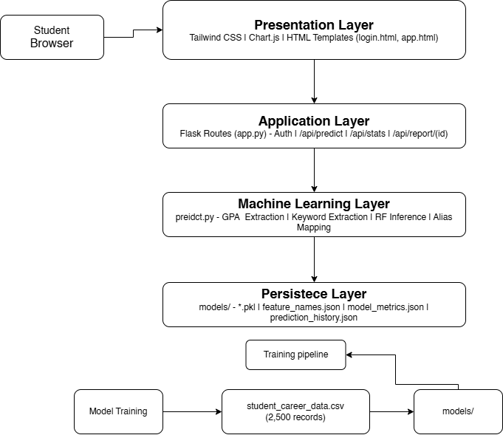
Figure 3.1: CareerPathAI System Architecture Diagram

3.2.1 FEATURE ENGINEERING
Seven raw fields in the dataset were transformed into twenty model features through the following engineering steps:
- One-hot encoding of the Skills field: Each comma-separated skill was split into a binary (0/1) column.
- Label encoding of the Major field: Six major categories were encoded as integers 0–5 using a fitted LabelEncoder.
- Normalised numeric features: internships_norm and projects_norm were created by dividing by their respective maximum values in the training data.
- Keyword signal features (five binary columns): has_ai_keywords, has_web_keywords, has_data_keywords, has_security_kw, and has_mgmt_keywords — derived from skill overlap and project description text.

FEATURE | TYPE | SOURCE | DESCRIPTION
GPA | Numeric | Raw | GPA normalised to 4.0 scale
internships | Integer | Raw | Number of internships completed
projects | Integer | Raw | Number of projects completed
leadership | Integer | Raw | Number of leadership roles held
major_encoded | Integer | Encoded | Label-encoded major (0–5)
internships_norm | Float | Engineered | internships / 15.0
projects_norm | Float | Engineered | projects / 30.0
has_ai_keywords | Binary | Engineered | AI/ML domain signal from skills or project text
has_web_keywords | Binary | Engineered | Web development domain signal
has_data_keywords | Binary | Engineered | Data/analytics domain signal
has_security_kw | Binary | Engineered | Security/networking domain signal
has_mgmt_keywords | Binary | Engineered | Management/leadership domain signal
Skill flags (x8) | Binary | Encoded | One-hot skill indicators from training vocabulary

3.2.2 DATA FLOW DIAGRAMS (DFD)
Figure 3.2 presents the Level 0 (context) DFD, showing the system as a single process exchanging data with the Student (external entity), the trained model store, and the prediction-history data store.
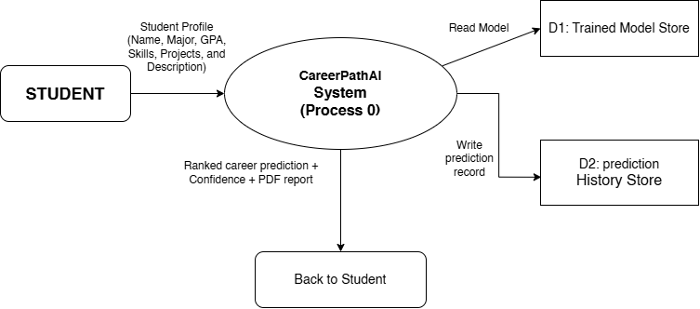
Figure 3.2: Data Flow Diagram (DFD) — Level 0 (Context Diagram)

Figure 3.3 decomposes the Level 0 process into its internal sub-processes: validating the submitted profile, converting the GPA scale, extracting keyword signals, encoding the feature vector, running the Random Forest prediction, ranking class probabilities, logging to history, generating a PDF report on request, and rendering the result to the student.
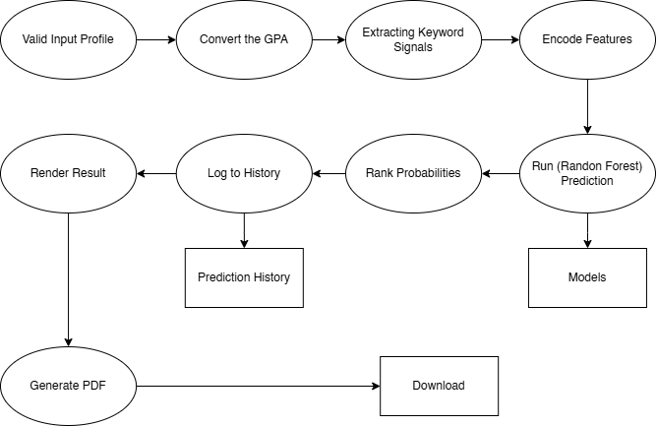
Figure 3.3: Data Flow Diagram (DFD) — Level 1

3.2.3 ENTITY RELATIONSHIP DIAGRAM (ERD)
Figure 3.4 presents the ERD describing the system’s logical data model. Four logical entities are identified: STUDENT_PROFILE, PREDICTION_RECORD, CAREER_CLASS, and TRAINING_RECORD.
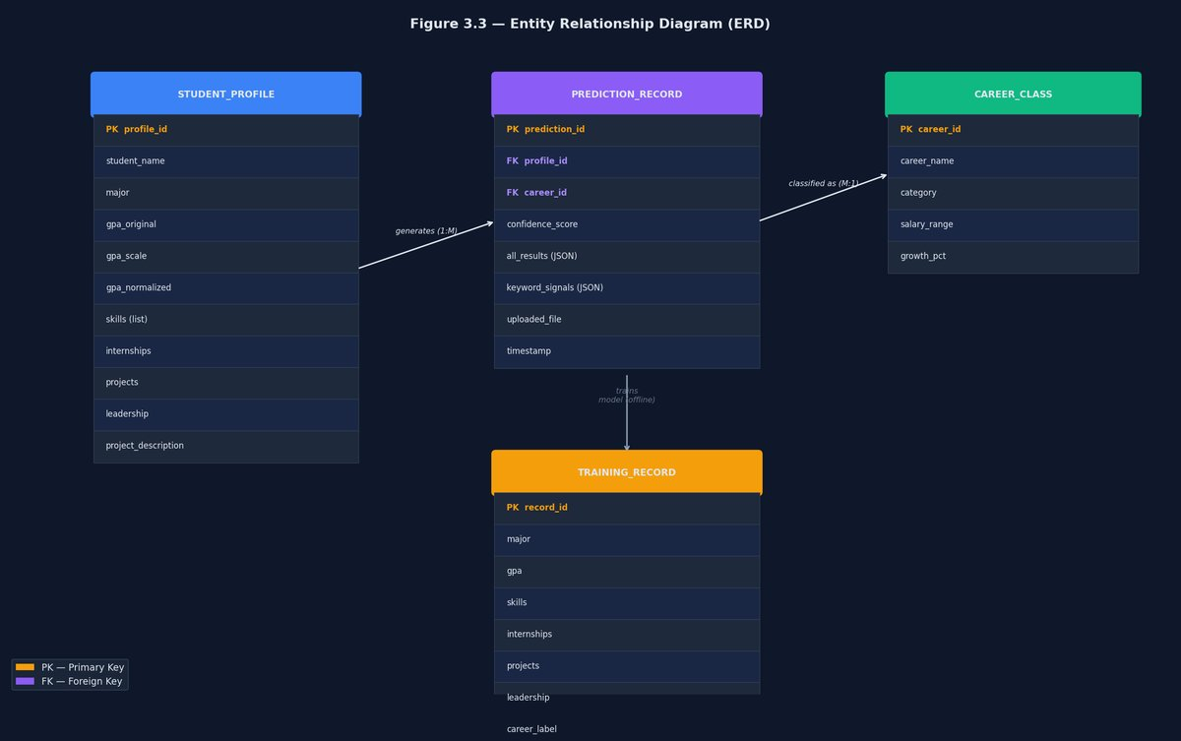
Figure 3.4: Entity Relationship Diagram (ERD)

3.3 ANALYSIS OF THE PROPOSED SYSTEM

3.3.1 INPUT
The system accepts: Student Full Name, Current Major (ten options including four technology-specific majors mapped to training equivalents), GPA (on the 4.0 scale used in Nigerian polytechnics, entered via a slider), Key Skills (thirty skill tags), Internships/Projects/Leadership counts, Project Description (free text parsed for keyword signals), and an uploaded result sheet (PDF or image). When a result sheet is uploaded, the system automatically extracts the GPA using text patterns and detects skill-domain signals using OCR, pre-filling the GPA slider and activating the relevant skill tags without any manual conversion.

3.3.2 OUTPUT
The system outputs a ranked set of career-path predictions: a top predicted career with confidence percentage, two alternative career labels with their own confidence scores, and a downloadable PDF report containing the student’s full profile, GPA conversion details, predicted career and confidence, alternative paths, skills assessed, and keyword signals detected.

3.3.3 DATABASE
Persistent storage uses three files in the models/ directory: prediction_history.json (append-only log), model_metrics.json (read-only evaluation summary), and five serialised model artefacts (*.pkl files and feature_names.json), all written by train.py and read by predict.py at application startup.

3.3.4 PREDICTION ALGORITHM
The core prediction algorithm follows nine steps for a single student profile:
- Accept the raw profile values from the form.
- Accept GPA directly on the 4.0 scale; no conversion applied. If GPA was auto-extracted from an uploaded result sheet, the extracted value is used as-is.
- Resolve major alias if the submitted major is one of the four non-training majors.
- Extract keyword signals from the project description text and from the selected skills list simultaneously, using OR logic.
- Build the feature vector of twenty values in the exact column order the model was trained on.
- Pass the feature vector to the trained Random Forest’s predict_proba() method.
- Sort the probabilities in descending order and return the top three career labels with their probabilities.
- Append a full prediction record to prediction_history.json.
- Return the JSON prediction record to the browser for display and PDF generation.

3.3.5 MAJOR ALIAS MAPPING
Four technology-specific majors are mapped to training equivalents at prediction time:
SUBMITTED MAJOR | MAPS TO (TRAINING MAJOR) | RATIONALE
Artificial Intelligence | Computer Science | Closest curriculum overlap: algorithms, ML, programming
Software & Web Development | Computer Science | Core programming and systems curriculum
Networking & Cloud Computing | Engineering | Infrastructure and systems engineering background
Cybersecurity | Computer Science | Programming, systems, and algorithm focus

3.4 SYSTEM DESIGN
The Unified Modelling Language (UML) was used to design the system’s behavioural and interaction structure. Three UML diagrams were produced: a Use Case diagram, an Activity diagram, and a Sequence diagram.

3.4.1 USE CASE DIAGRAM
Figure 3.5 identifies two actors: The Student (submits profiles, views predictions, browses history, downloads PDFs, explores Career Universe) and the Administrator (additionally views dashboard analytics, model metrics page, and can clear prediction history).
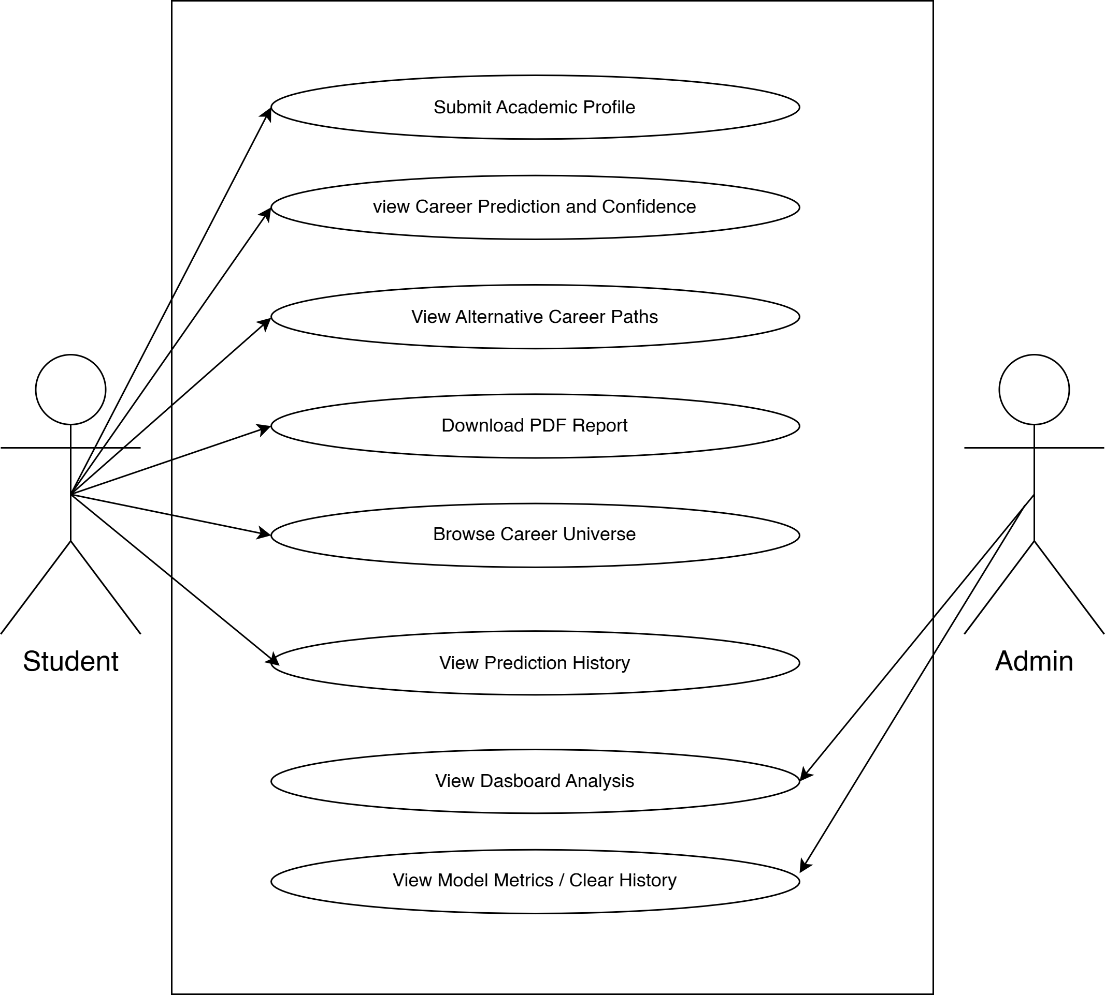
Figure 3.5: UML Use Case Diagram

3.4.2 ACTIVITY DIAGRAM
Figure 3.6 traces the workflow from opening the application through to downloading a PDF report, including the validation decision point, the GPA conversion step, and the keyword extraction step.
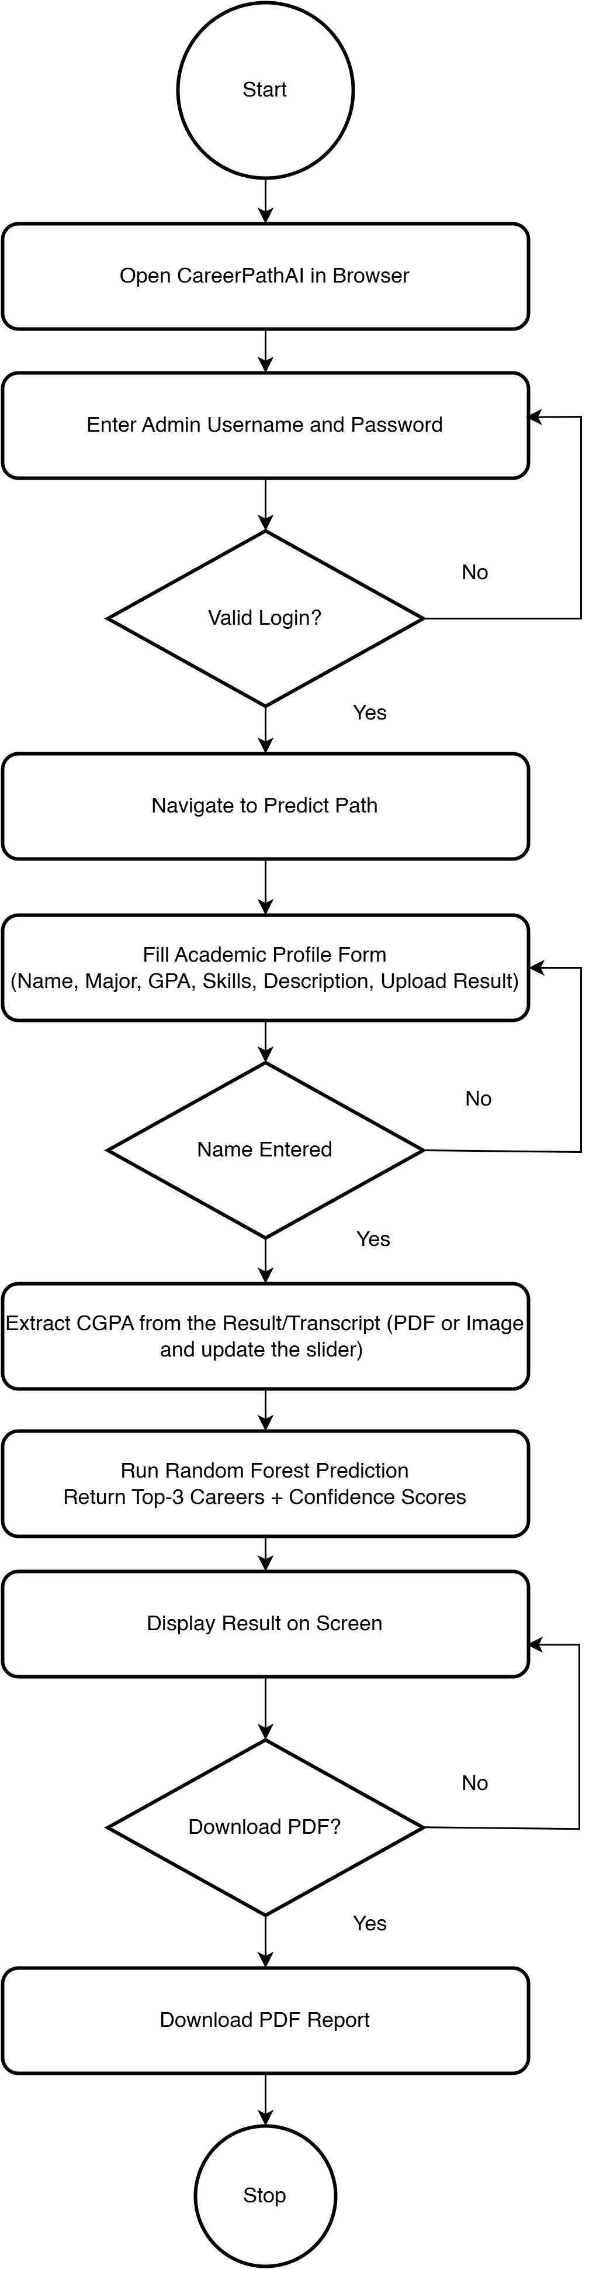
Figure 3.6: UML Activity Diagram

3.4.3 SEQUENCE DIAGRAM
Figure 3.7 details the synchronous message exchanges between five components — Browser, Flask app.py, CareerPredictor (predict.py), Model Artefacts (models/), and History Store (prediction_history.json) — for a single prediction and PDF download request.

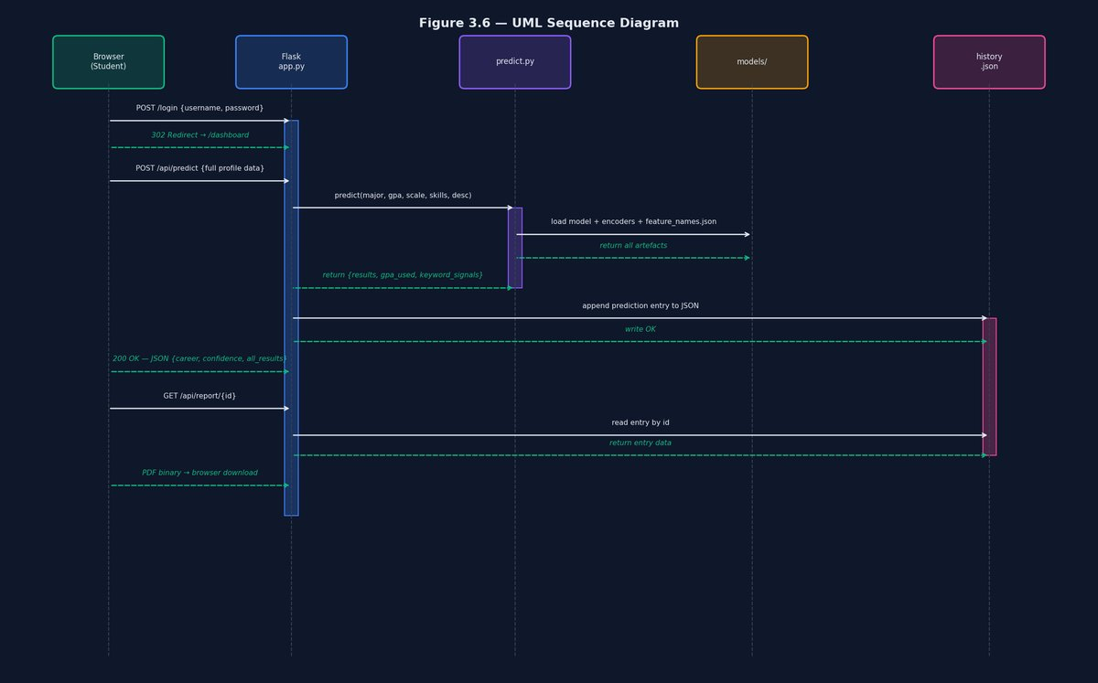
Figure 3.7: UML Sequence Diagram

3.5 TOOLS AND TECHNOLOGIES USED
TOOL / LIBRARY | VERSION | ROLE IN THE SYSTEM
Python 3 | 3.11 | Primary programming language for training pipeline and web application
scikit-learn | 1.9.0 | Model training, label encoding, evaluation metrics, and cross-validation
pandas | 2.x | Data loading, feature engineering, and history log management
NumPy | 1.26+ | Numeric array operations supporting model inference and feature normalisation
joblib | 1.3+ | Serialisation of trained model and label encoders to .pkl files
Flask | 3.0+ | Web application framework providing routing, session management, and REST API endpoints
Tailwind CSS | CDN | Utility-first CSS framework for the dark-themed responsive user interface
Chart.js | CDN | JavaScript charting library for dashboard visualisations
reportlab | 4.4+ | PDF generation library for the downloadable prediction report
Matplotlib / Seaborn | Latest | EDA and training evaluation visualisations saved to viz/

CHAPTER FOUR
IMPLEMENTATION AND RESULTS PRESENTATION

4.1 SYSTEM REQUIREMENTS

4.1.1 HARDWARE REQUIREMENTS
- A personal computer or laptop with a minimum of 4 GB RAM (8 GB recommended for model retraining).
- At least 500 MB of free disk space for the Python environment, installed libraries, dataset, and model artefacts.
- An active internet connection (required only for initial package installation and CDN-hosted assets; the application runs fully offline once installed).

4.1.2 SOFTWARE REQUIREMENTS
- Operating System: Windows 10/11, macOS, or any Linux distribution capable of running Python 3.
- Python 3.9 or later.
- Required Python packages: flask, scikit-learn, pandas, numpy, joblib, reportlab, matplotlib, and seaborn.
- A modern web browser (Google Chrome, Mozilla Firefox, or Microsoft Edge).

4.2 SYSTEM IMPLEMENTATION
The system was implemented as a Flask web application (app.py) with a separate training script (train.py) responsible for producing the serialised model artefacts the application loads at runtime. The prediction logic is encapsulated in predict.py which handles GPA conversion, major alias resolution, keyword extraction, and model inference.

4.2.1 LOGIN INTERFACE
The CareerPathAI login page presents a centred glassmorphism card on a dark gradient background, with a brain icon, the CareerPathAI brand name, and an institution subtitle. The form includes username and password fields with inline icons, a password show/hide toggle, an animated login button, and an inline error message panel that activates on incorrect credentials without a page reload.



Fig. 4.1 Admin Login Page
The Admin Login Page enables authorized administrators to securely access the CareerPathAI system by entering their login credentials.

4.2.2 DASHBOARD INTERFACE
The Dashboard Overview page presents four KPI cards (Total Predictions, Average Confidence, Unique Students, Model Accuracy) which display dashes on first load and populate with real values as predictions are made. Below the KPI cards, a Prediction Trends line chart and a Top Career Paths doughnut chart update in real time after each prediction.
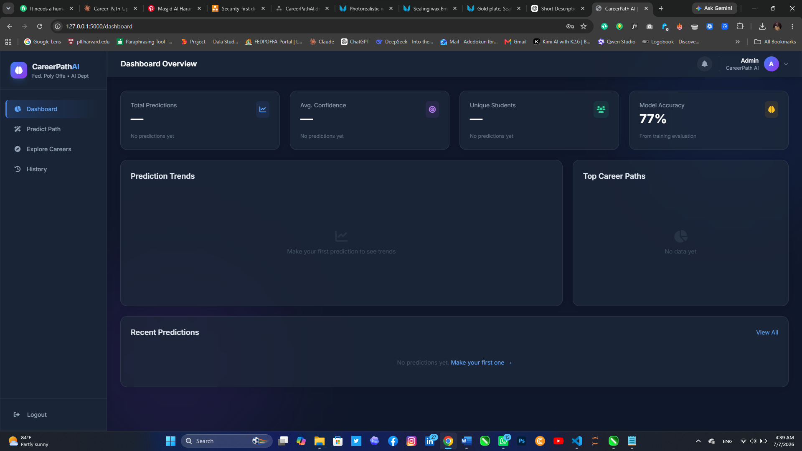

Fig. 4.2 Admin Dashboard Interface
The Admin Dashboard provides an overview of the CareerPathAI system by displaying key metrics such as total predictions, model accuracy, unique students, prediction trends, top career paths, and recent prediction activities. It enables administrators to monitor system performance and access core features efficiently.

4.2.3 PREDICTION INTERFACE
The Career Prediction form collects the student’s full name, major (with a grouped dropdown separating dataset majors from technology-specific majors, and an amber alias note for unmapped entries), GPA via a 0.0 – 4.0 slider (no scale selector — the system uses the 4.0 scale used in Nigerian polytechnics), thirty skill tags, internship / project / leadership counts, a project description textarea, and an optional result sheet upload. Uploading a PDF or image transcript triggers automatic GPA and skill extraction: the GPA slider is updated and matching skill tags are pre-selected without any manual entry. The Explore Careers page displays sixteen clickable career cards (six model-predicted careers tagged “Model Career”, plus ten additional explorable careers); clicking a card opens a detail modal and a “Try Predicting with These Skills” button that switches to the Predict Path tab with the career’s required skills pre-selected.

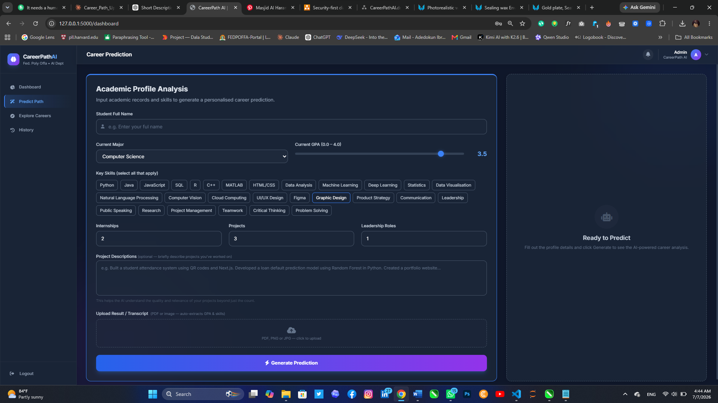
Fig. 4.3 Career Prediction Page
This interface allows users to input their academic profile, including GPA, major, skills, project experience, internships, and leadership roles. The entered information is processed by the AI model to generate personalized career recommendations.

OUTPUT INTERFACE

4.2.4 HISTORY INTERFACE AND PDF REPORT
The Prediction History page lists all predictions as clickable rows. Clicking opens a detail modal showing the full prediction breakdown: student profile, GPA conversion, alternative career paths, skills assessed, keyword signals detected, and project description. A Download PDF Report button generates and downloads a formatted A4 PDF report.


Fig. 4.4 Prediction History Page
This interface displays a record of previous career predictions made by the user. It enables users to review past recommendations and manage their prediction history.

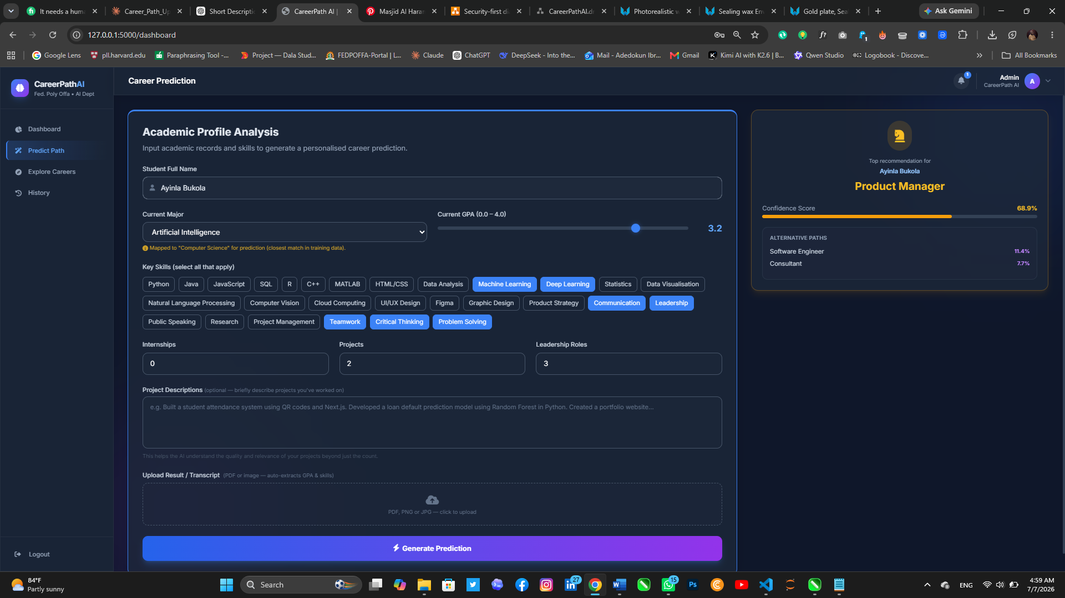
Fig. 4.5 Career Prediction Result Page
This interface presents the output of the CareerPathAI recommendation model after processing the user's academic information. The system displays the predicted career path, confidence score, and alternative career options, providing users with personalized guidance based on their qualifications, skills, and experience.


Fig. 4.6 Prediction Result Page
This interface presents the AI-generated career prediction, including the recommended career path, confidence score, and alternative recommendations. Users can download the prediction report in PDF for documentation and future reference.

4.2.5 EXPLORE CAREERS INTERFACE
The Career Universe page displays career cards in a responsive three-column grid, each with a coloured top border, category badge, career description, Nigerian salary range (₦), growth percentage, and required skill tags. A search bar filters cards in real time.

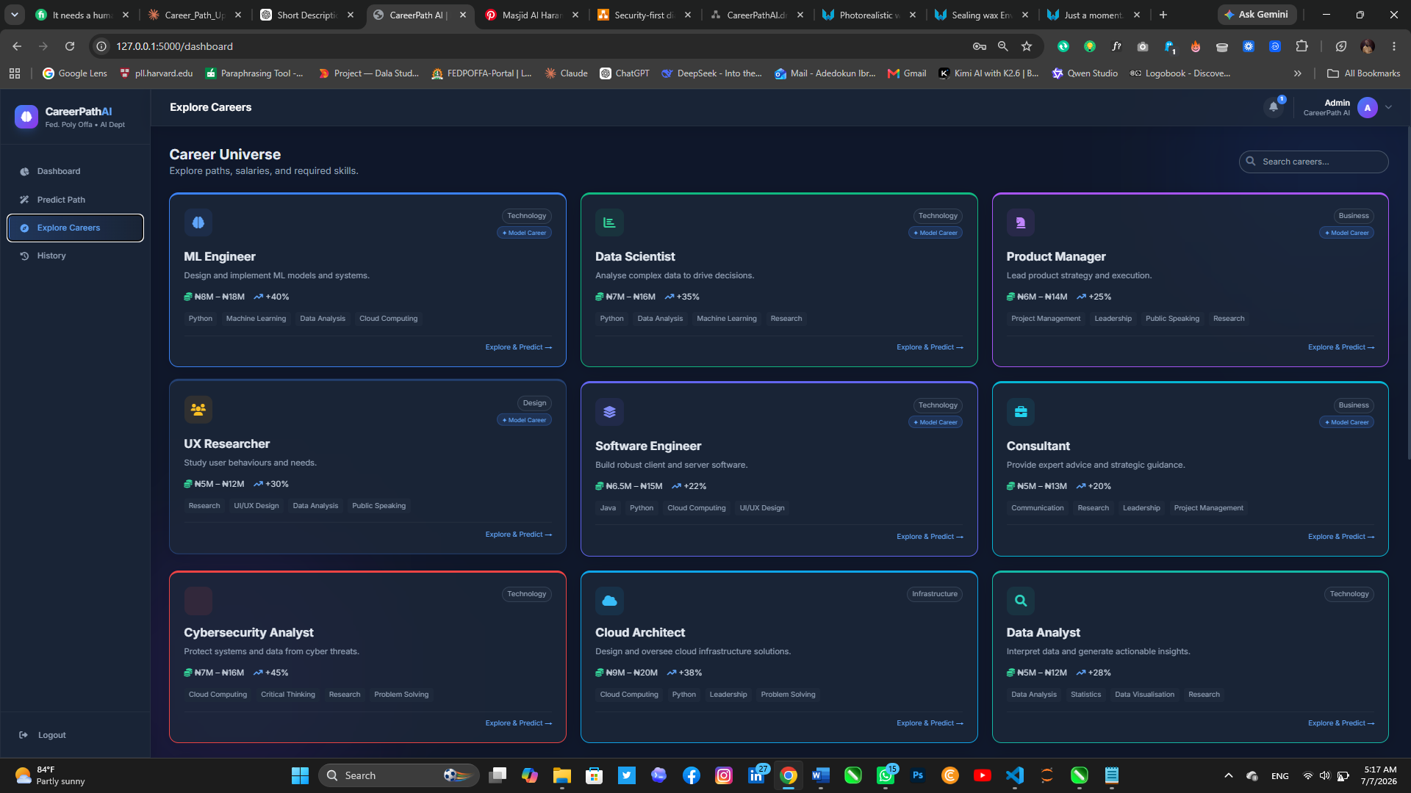
Fig. 4.7 Explore Careers Interface
This interface presents a collection of career options, including their descriptions, required skills, and salary ranges, enabling users to explore and compare different career paths.

4.3 RESULTS PRESENTATION

4.3.1 DATASET SUMMARY AND EXPLORATORY DATA ANALYSIS
The following figures present the findings of the exploratory data analysis carried out on the 2,500-record dataset prior to model training.
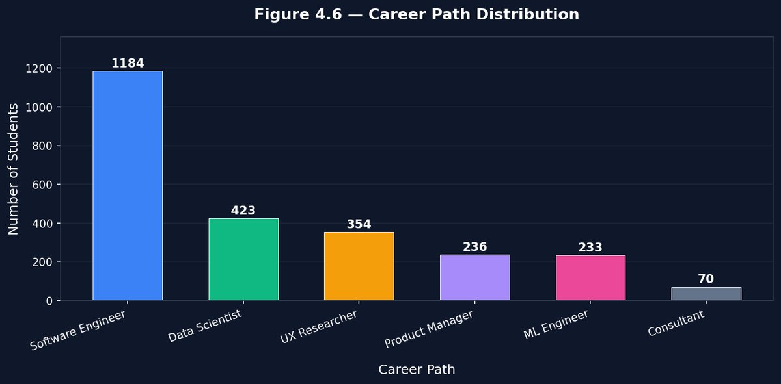
Figure 4.8: Career Path Distribution — Bar Chart (n = 2,500)
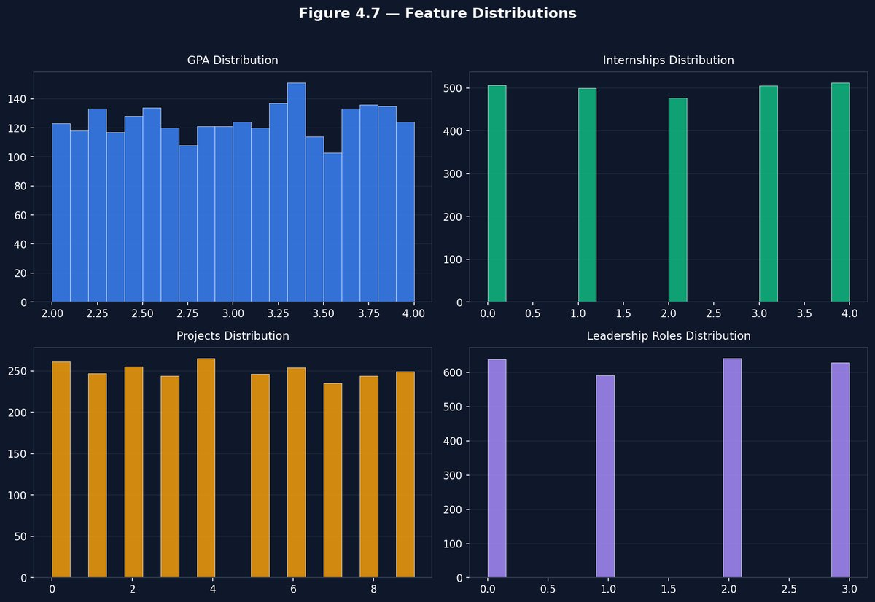
Figure 4.9: Feature Distributions (GPA, Internships, Projects, Leadership)

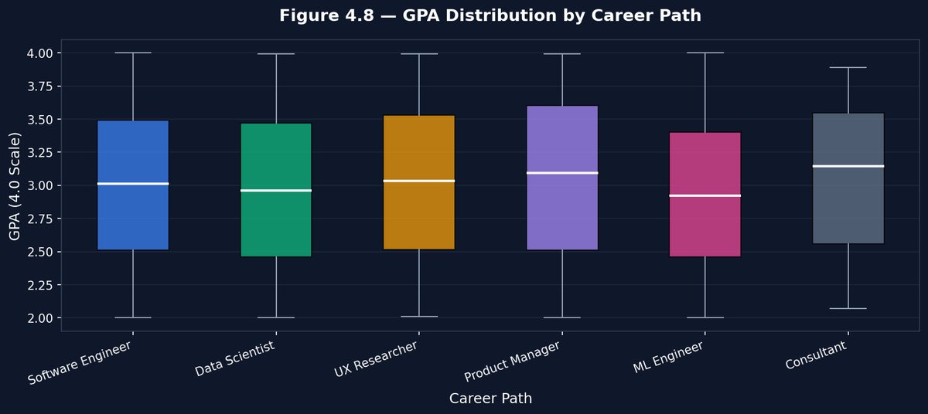
Figure 4.10: GPA Distribution by Career Path (Box Plot)

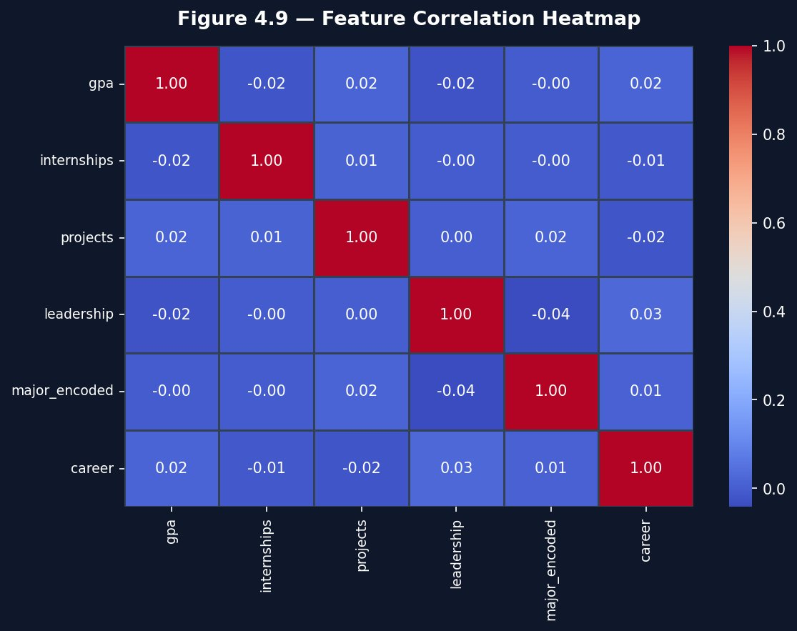
Figure 4.11: Feature Correlation Heatmap

4.3.2 MODEL EVALUATION RESULTS
The Random Forest classifier was trained with 500 estimators, maximum depth of 25, minimum samples per split of 4, minimum samples per leaf of 2, and class_weight="balanced". Table 4.2 presents the evaluation results on the 500-record held-out test set:
Table 4.1 presents per-class performance on the test set:
METRIC | VALUE
Accuracy | 77.8%
Weighted Precision | 73.8%
Weighted Recall | 77.8%
Weighted F1-Score | 75.2%
Cross-Validation Mean Accuracy (5-fold) | 76.3%
Cross-Validation Std Dev | ±1.4%

CAREER CLASS | PRECISION | RECALL | F1-SCORE | SUPPORT
Software Engineer | 83% | 96% | 89% | 237
UX Researcher | 84% | 79% | 81% | 71
Product Manager | 77% | 77% | 77% | 47
Data Scientist | 63% | 73% | 68% | 85
ML Engineer | 38% | 17% | 24% | 46
Consultant | 0% | 0% | 0% | 14

The three well-represented classes achieve F1-scores of 0.77–0.89, confirming that the model has learned strong discriminative patterns for these careers. The underperformance of ML Engineer and Consultant is directly attributable to their small test support relative to the Software Engineer class (237 records).

4.3.3 CONFUSION MATRIX
Figure 4.12 presents the confusion matrix for the test set. The matrix confirms strong diagonal concentration for Software Engineer (226 correct of 237), UX Researcher (56 correct of 71), and Product Manager (36 correct of 47).
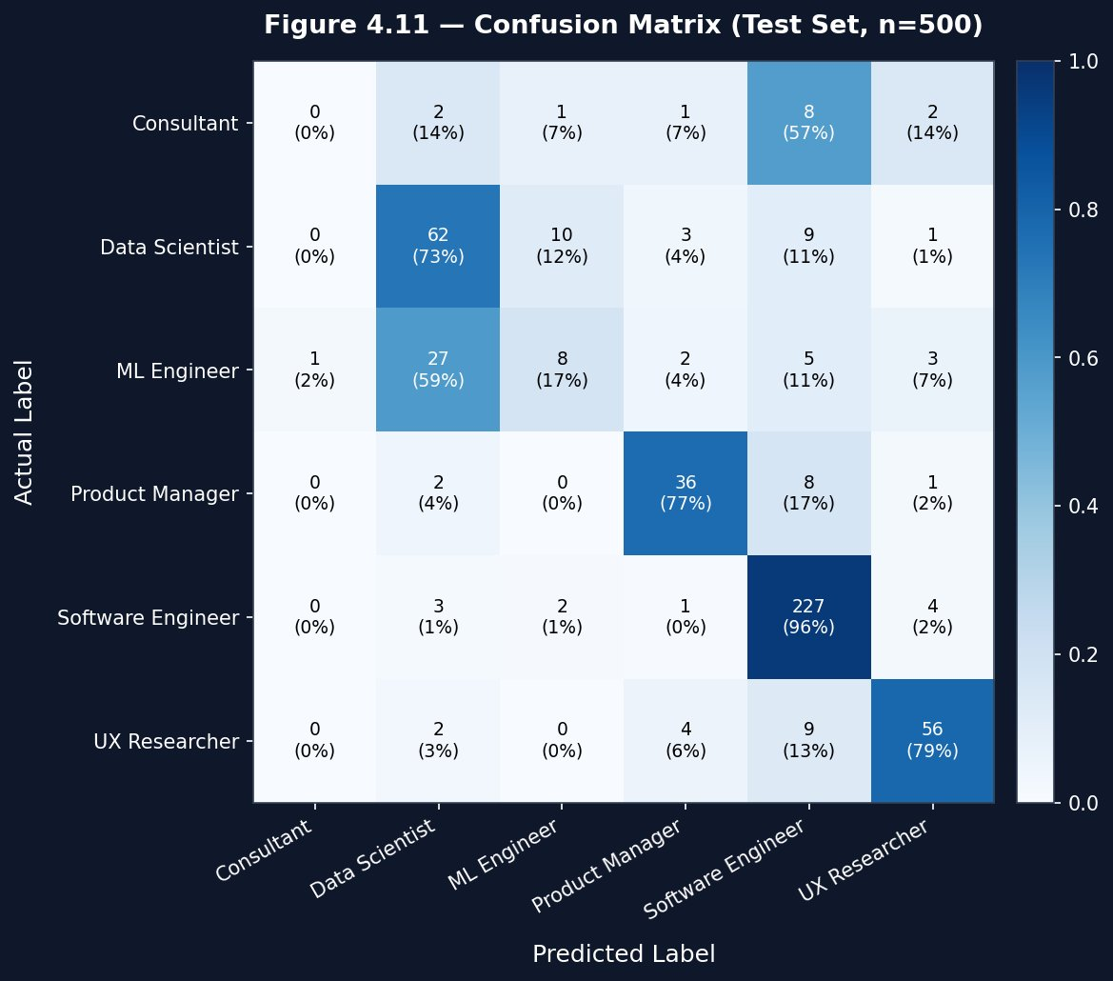
Figure 4.12: Confusion Matrix; Random Forest (Test Set, n = 500)

4.3.4 PER-CLASS METRICS
Figure 4.13 presents the per-class precision, recall, and F1-score as a grouped bar chart, making it easy to compare model performance across all six career classes simultaneously.
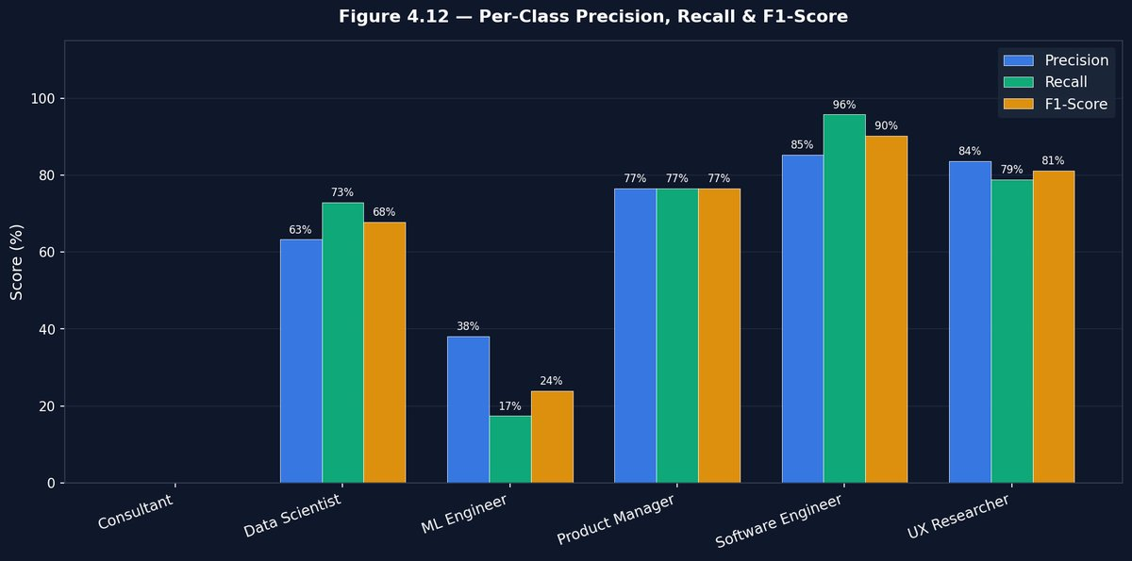
Figure 4.13: Per-Class Precision, Recall & F1-Score

4.3.5 FEATURE IMPORTANCE
Figure 4.14 presents the top fifteen feature importances extracted from the trained Random Forest. The top five most influential features were Java skill, Python skill, Data Analysis skill, GPA, and project count. The five keyword signal features collectively contributed approximately 8–12% of total feature importance, confirming that the project description genuinely influences the prediction.
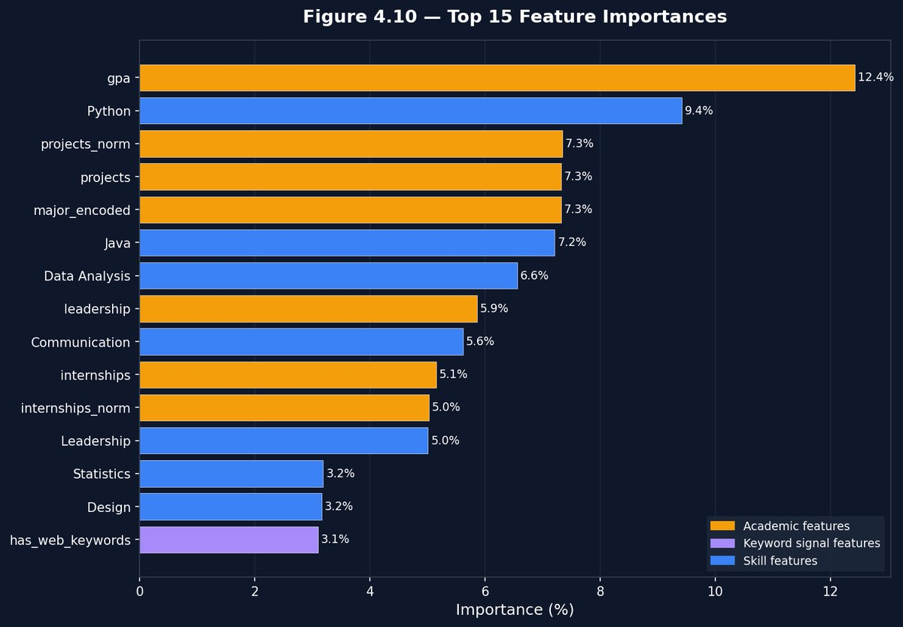
Figure 4.14: Top 15 Feature Importance (Random Forest)

4.3.6 CROSS-VALIDATION ACCURACY
Figure 4.15 presents the five-fold stratified cross-validation accuracy scores. The mean cross-validation accuracy of 76.3% (±1.4%) confirms that the model generalises consistently and is not overfitting to the training split.
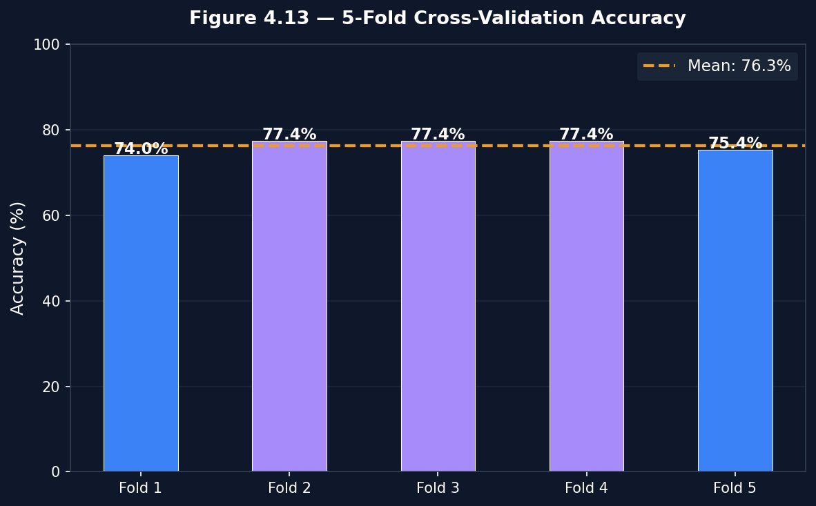
Figure 4.15: 5-Fold Cross-Validation Accuracy

4.4 SYSTEM EVALUATION AND TESTING

4.4.1 VALIDATION
All objectives from Section 1.3 were checked against the delivered system: dataset collected and pre-processed; EDA visualisations produced; keyword and normalisation features engineered; Random Forest model trained and evaluated; Flask web application implemented with GPA conversion and project description field; PDF report download implemented; persistent prediction history dashboard built; system evaluated through testing activities. All eight objectives were satisfied.

4.4.2 VERIFICATION
A profile with Python, Data Analysis, and Machine Learning skills, Computer Science major, GPA 3.8, and a project description containing "neural network training" correctly activated the has_ai_keywords and has_data_keywords signals, and the model returned ML Engineer as the top prediction with Data Scientist as the first alternative. The transcript extraction module was separately verified: uploading a result sheet PDF containing “CGPA: 3.82” correctly extracted the value 3.82, set the GPA slider to 3.82 directly, and activated the expected keyword signals (AI/Machine Learning, Data/Analytics) based on skill mentions detected in the document text.

4.4.3 EVALUATION
At 77.8% test accuracy and a 76.3% cross-validation mean, the Random Forest model performs consistently and without significant overfitting. The model’s accuracy is lower than some reviewed studies, but those studies used either smaller, more homogeneous datasets or datasets with substantially fewer career classes. A six-class prediction over a 2,500-record dataset with a 17:1 class imbalance represents a materially harder problem, and the 77.8% accuracy achieved represents a reasonable and honest result for these conditions.

4.5 SYSTEM DOCUMENTATION AND MAINTENANCE

4.5.1 PROGRAM DOCUMENTATION
The training script (train.py) is organised into clearly labelled sections with inline comments. The Flask application (app.py) is similarly organised by route, with helper functions for loading artefacts, managing history, and generating PDF reports documented at their point of definition.

4.5.2 SYSTEM MAINTENANCE
The dataset, trained model artefacts, and application code are cleanly separated into the project root (application code), models/ (artefacts), viz/ (evaluation charts), and templates/ (HTML). The system can be updated by modifying or extending the dataset and re-running train.py, which regenerates all six artefact files without any changes to app.py or predict.py.

4.6 BENEFITS OF THE SYSTEM
The developed CareerPathAI system provides an intelligent and user-friendly platform for personalized career recommendation. It combines academic performance, technical skills, project experience, and OCR-based transcript analysis to generate reliable career suggestions while offering additional features that enhance usability and decision-making. The major functionalities of the system include:
- Provides students with an immediate, data-grounded career recommendation accounting for GPA, skills, internship experience, and keyword signals from the project description.
- Supports Nigerian polytechnic students directly: uploading a result sheet PDF or image automatically extracts the GPA (used as-is on the 4.0 scale) and pre-detects skill-domain signals, reducing manual entry and linking the uploaded evidence directly to the prediction.
- Generates a downloadable, professionally formatted PDF report per prediction.
- Surfaces ranked alternative career paths alongside the top recommendation.
- Discloses confidence level, keyword signals detected, and GPA conversion applied for informed interpretation.
- Maintains a persistent, clickable prediction history log recording all input values for every prediction made.

CHAPTER FIVE
SUMMARY, CONCLUSION AND RECOMMENDATION

5.1 SUMMARY
This study set out to design and implement an AI-based career path prediction system for students, motivated by the documented mismatch between academic training and labour-market outcomes in Nigeria and by a gap between subjective career counselling and the data each student generates through their academic record (Chapter One). A review of recent literature established that Random Forest is the most consistently effective algorithm for this category of problem, while surfacing three specific gaps: confidence-scored alternatives, the absence of tools that automatically extract academic data from uploaded result sheets, and the underutilisation of selected skills and project descriptions as keyword signal features (Chapter Two).

The methodology adopted a standard applied machine learning lifecycle: a 2,500-record, six-class student dataset was pre-processed and extended through feature engineering to twenty features, and the system was modelled using DFDs, an ERD, and UML diagrams (Chapter Three). Implementation produced the CareerPathAI Flask web application, backed by a Random Forest classifier achieving 77.8% accuracy, 75.2% weighted F1-score, and 76.3% cross-validation mean accuracy, with all eight stated objectives satisfied (Chapter Four).

5.2 CONCLUSION
This project has demonstrated that a supervised Random Forest classifier, trained on a moderately sized, multi-major dataset with carefully engineered features, can produce a usable, reasonably accurate, and appropriately transparent career-path recommendation for students. The automatic transcript extraction mechanism addresses a real practical barrier for Nigerian polytechnic students; their result sheet GPA (on the 4.0 scale) is read directly from the uploaded document and fed into the model without any manual entry or conversion; the keyword signal features, now correctly merged from both the project description text and the student’s selected skills, demonstrate a feasible lightweight approach to incorporating unstructured student data into a tabular classification pipeline; and the sixteen-career Explore Careers universe with clickable detail modals and skill pre-fill provides a discovery layer not present in any of the reviewed related works.

All eight objectives set out in Section 1.3 have been achieved. The study has also been transparent about limitations: the Consultant and ML Engineer classes underperform due to class imbalance; keyword extraction is limited to pattern matching; and four institution-specific majors require alias mapping rather than direct feature representation.

5.3 RECOMMENDATION
- The Department of Artificial Intelligence should consider expanding the training dataset by systematically recording graduating students’ academic profiles alongside their actual career outcomes, particularly for the Consultant and ML Engineer classes.
- Future researchers should investigate incorporating word embeddings (such as fastText or sentence-transformers) for the project description field in place of keyword matching.
- The persistence layer should be migrated from JSON flat files to a relational database (SQLite or PostgreSQL) for concurrent multi-user deployment.
- Future iterations should add the four technology-specific majors (Artificial Intelligence, Software & Web Development, Networking & Cloud Computing, and Cybersecurity) to the training dataset directly.
- Institutions considering adoption should pair the tool with, rather than substitute it for, human academic counselling.
- Future iterations should periodically re-validate the model’s feature-importance profile to confirm academic performance and skill features remain the primary drivers.

REFERENCES
Built In. (n.d.). Random forest: A complete guide for machine learning. Retrieved June 19, 2026, from https://builtin.com/data-science/random-forest-algorithm

GeeksforGeeks. (2025, October 6). Random forest algorithm in machine learning. https://www.geeksforgeeks.org/machine-learning/random-forest-algorithm-in-machine-learning/

IBM. (2025, November 20). What is random forest? https://www.ibm.com/think/topics/random-forest

Independent Newspaper. (2025, July 18). The harsh reality of Nigeria’s unemployed graduates. https://independent.ng/the-harsh-reality-of-nigerias-unemployed-graduates/

Muhammad, B. M., Lawan, A. A., Cavus, N., Yunusa, R., & Abdulrazak, U. I. (2025). Predictive modeling of student career pathways using machine learning techniques. Journal of Statistical Sciences and Computational Intelligence, 1(3), 166–174. https://doi.org/10.64497/jssci.95

Nuanmeesri, S., & Poomhiran, L. (2025). Career guidance system using decision tree, random forest, and naive Bayes algorithm. International Journal of Science, Technology and Society, 13(2). https://doi.org/10.11648/j.ijsts.20251302.11

Palladium Group. (n.d.). Digital skills are key to youth unemployment in Nigeria. Retrieved June 19, 2026, from https://thepalladiumgroupusa.com/news/Digital-Skills-are-Key-to-Youth-Unemployment-in-Nigeria

ScienceDirect. (n.d.). Random forest classifier — an overview. Retrieved June 19, 2026, from https://www.sciencedirect.com/topics/computer-science/random-forest-classifier
scikit-learn. (n.d.). Ensembles: Gradient boosting, random forests, bagging, voting, stacking. Retrieved June 19, 2026, from https://scikit-learn.org/stable/modules/ensemble.html

Sele, T., & Zongo, F. (2025). Youth unemployment and its impact on Nigeria’s socio-economic landscape. Greener Journal of Social Sciences. https://www.gjournals.org/2025/09/18/082625131-sele-and-zongo/

Siswipraptini, P. C., Warnars, H. L. H. S., Ramadhan, A., & Budiharto, W. (2024). Personalized career-path recommendation model for information technology students in Indonesia. IEEE Access.

Trujillo, J. (2025). Artificial intelligence in education: A systematic literature review of machine learning approaches in student career prediction. Journal of Technology and Science Education. https://www.jotse.org/index.php/jotse/article/view/3124/937

APPENDIX A
SYSTEM FLOWCHART


APPENDIX B
THE PROGRAM SOURCE CODE

APPENDIX C
PROGRAM OUTPUT SCREENSHOTS


Fig. 4.1 Admin Login Page


Fig. 4.2 Admin Dashboard Interface


Fig. 4.3 Career Prediction Page

Fig. 4.4 Prediction History Page

Fig. 4.5 Career Prediction Result Page

Fig. 4.6 Prediction Result Page


Fig. 4.7 Explore Careers Interface

