Analysis Report Template

Student Full Name | Muditha Dodamwala | Student ID No. | 20233064/ W2120414
Case Study Title
Case Study (A): Predicting Clients Loan Status. [Total 43 Marks]
Research Question: Does machine learning have the potential to assist banker and finance analysts in predicting which client can be approved a loan?

Task (1) – Domain Understanding: Classification
The financial risk analysts decided that classification modelling is required. Indicate in the table below for each of the listed
variables in your data which ones you should RETAIN and can be included in the classification modelling of loan approval status, and the variables you should DROP (REMOVE). Justify your decision logically and/or by research (for any research, include in-text citation using
the Harvard style) [3 Marks]
Variable Name | RETAIN or DROP | Brief justification for retention or dropping with in-text citation.
ID | DROP | Unique nominal identifiers possess no predictive mathematical value and  can introduce noise or cause overfitting in machine learning algorithms  (Kuhn and Johnson, 2013).
Sex | DROP | This variable is not present in the provided dataset. Furthermore, gender is  routinely excluded from credit scoring models to adhere to  anti-discrimination and fair lending regulations (Abolafia, 2020).
Age | RETAIN | Demographic factors such as age are standard features in risk modelling,  as they often correlate with financial maturity and creditworthiness  (Thomas, 2000).
Education Qualifications | DROP | This variable is not present in the provided dataset and therefore cannot  be utilized for model training.
Income | RETAIN | An applicant's income is a fundamental primary indicator of their absolute  financial capacity to service and repay a loan (Siddiqi, 2012).
Home Ownership | RETAIN | Homeownership acts as a proxy for financial stability and asset backing,  historically proving useful in credit risk differentiation (Baesens et al., 2003).
Employment Length | RETAIN | Employment stability is highly correlated with consistent income streams,  which significantly lowers the probability of default  (Thomas, Edelman and Crook, 2002).
Loan Intent | RETAIN | The specific purpose of a loan (e.g., venture vs. medical) defines the risk  profile and structural nature of the credit application (Siddiqi, 2012).
Loan Amount | RETAIN | The absolute size of the financial exposure directly affects the probability of  default and the stringency of the approval process (Baesens et al., 2003).
Loan Interest Rate | RETAIN | Interest rates often reflect an underlying assessment of risk; higher rates  correlate strongly with higher-risk lending categories (Thomas, 2000).
Loan-to-Income Ratio (LTI) | RETAIN | LTI is a critical measure of an applicant's debt burden. It is one of the most  robust mathematical indicators of financial distress used in standard credit  scoring (Siddiqi, 2012).
Payment Default on File | RETAIN | Historical financial delinquency is widely considered the strongest empirical  predictor of future credit behavior and default risk (Baesens et al., 2003).
Credit History Length | RETAIN | Longer credit histories provide a more reliable track record for risk  assessment, generally reducing the uncertainty of the applicant's profile  (Thomas, Edelman and Crook, 2002).
Loan Approval Status | RETAIN | This is the dependent variable (Target) that the classification algorithms are  actively attempting to predict for Case Study A.
Maximum Loan Amount | DROP | This is a continuous target variable reserved specifically for Case Study B  (Regression). Including it here would cause severe data leakage, artificially  inflating classification performance (Kaufman et al., 2012).
Credit Application Acceptance | DROP | This variable is not present in the provided dataset.
References
- Abolafia, M. Y. (2020) Making markets: opportunism and restraint on Wall Street. Cambridge, MA: Harvard University Press.
- Baesens, B., Van Gestel, T., Viaene, S., Stepanova, M., Suykens, J. and Vanthienen, J. (2003) 'Benchmarking state-of-the-art classification algorithms for credit scoring', Journal of the Operational Research Society, 54(6), pp. 627–635.
- Kaufman, S., Rosset, S., Perlich, C. and Stiglitz, O. (2012) 'Leakage in data mining: formulation, detection, and avoidance', ACM Transactions on Knowledge Discovery from Data, 6(4), pp. 1–21.
- Kuhn, M. and Johnson, K. (2013) Applied predictive modeling. New York: Springer.
- Siddiqi, N. (2012) Credit risk scorecards: developing and implementing intelligent credit scoring. Hoboken, NJ: John Wiley & Sons.
- Thomas, L. C. (2000) 'A survey of credit and behavioural scoring: forecasting financial risk of lending to consumers', International Journal of Forecasting, 16(2), pp. 149–172.
- Thomas, L. C., Edelman, D. B. and Crook, J. N. (2002) Credit scoring and its applications. Philadelphia, PA: SIAM.

Task (2) – Exploring and Understanding Your Dataset
With the aid of your Final Python Notebook 1, for your RETAINED input variables and your class “Target” variable, produce 1)basic descriptive stats and 2)variable scale type, then 3)plot the distribution of your target variable. (Paste the three screenshots of code OUTPUTS ONLY for evidence of these elements).
[2 Marks]

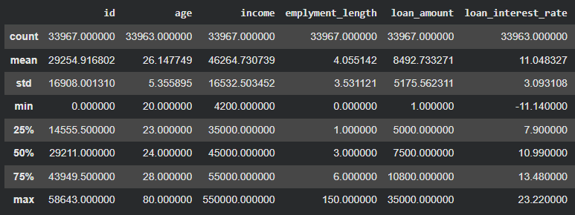
Figure 1: Basic Descriptive Stats

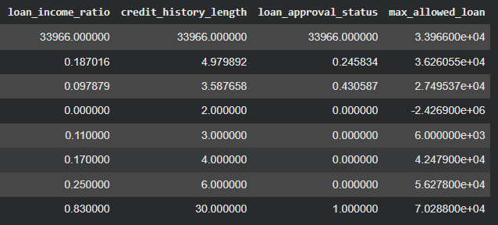
Figure 2: Basic Descriptive Stats

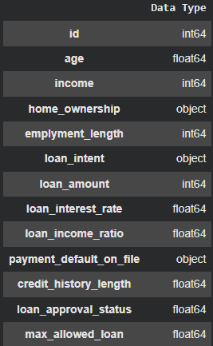
Figure 3: Variable Scale Type

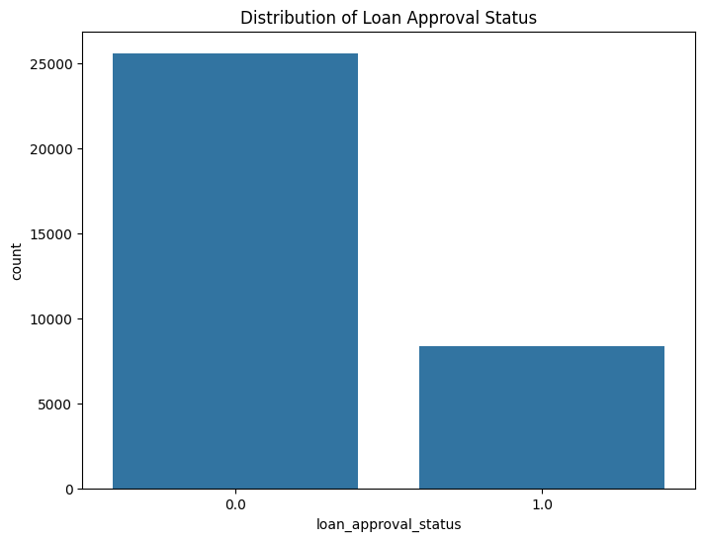
Figure 4: Distribution of Target Variable

Task (3) – Data Preparation: Cleaning and Transforming your data
a) With the aid of your Final Python Notebook 1, when you first explored your retained variables in the loan dataset, you may have found some issues. 1) Report any issues you found in your retained dataset variables. Based on the issues you found in your data, 2)suggest a suitable possible method to fix each of these issues and 3)provide your justification for using your suggested fix method. Use the table below to organise your findings and analysis, and add more rows if needed
[4 Marks]
 | Variable Name | Issue found | Proposed fix | Justification for used fix method
1 | age | Contains 6 missing values and extreme outliers (maximum age is 123 years old). | Impute missing values with the median. Drop rows where age is > 100. | Median imputation is robust against outliers and prevents data loss. A human age of 123 is a likely data entry error, so dropping it prevents model skewing.
2 | loan_interest_rate | Contains 11 missing values and negative percentage values (minimum is -11.14%). | Impute missing values with the median. Apply absolute function to convert negative values to positive. | Interest rates cannot be negative; this is likely a typographical error. Median imputation retains the rows for modeling without distortion.
3 | max_allowed_loan | Contains extreme negative financial values (minimum is -2,426,900). | Apply absolute function to convert negative values to positive. | A maximum loan allowance cannot be a negative number. Converting to absolute values corrects the likely system/entry error without losing the data points.
4 | emplyment_length | Contains impossible extreme outliers (maximum employment length is 150 years). | Drop rows where employment length is > 100. | A human cannot work for 150 years. This is corrupted data that will negatively impact the performance of the regression models if retained.
5 | id | Unique identifier assigned to each client. | Drop the column entirely from the dataset. | Unique IDs hold no predictive value and can cause machine learning algorithms to overfit to specific rows rather than learning general patterns.

Task (3) – Data Preparation: Cleaning and Transforming your data
b) With the aid of Python packages and your Final Python Notebook 1, implement your suggested fixes of issues in the previous Task 3-a in your final Python Notebook1.
1) Show evidence (before and after) of implementing your suggested fix to the problems you identified for your dataset in Task 3-a.
To show your evidence, paste screenshots of your relevant code OUTPUTS ONLY (Do not paste the code).
2) Indicate and annotate the issue and the fix in each of your provided evidence screenshots.
[4 Marks]
Output screenshot of the issue before the fix | Output screenshot after fixing the issue

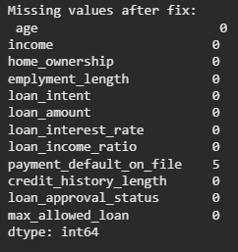
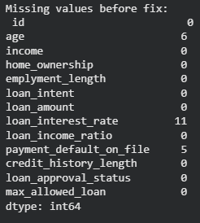
Nulls Imputed
6 Missing Values

Nulls Imputed
11 Missing Values

Figure 5: Missing values after fix
Figure 6: Missing values before fix

Output screenshot of the issue before the fix | Output screenshot after fixing the issue
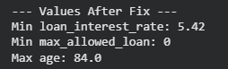
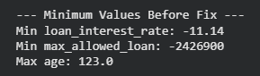
Negative Rate
Negative amount

Made Positive
Outlier Dropped
Extreme Outlier
Figure 7: Minimum values after fix
Figure 8: Minimum values before fix

Task (4) – Classification Modelling of Clients Loan Approval Status
a) In your Final Python Notebook 2, you built THREE different models to predict loan approval status: Logistic Regression (LR), K Nearest Neighbour (KNN) and Naïve Bayes (NB). These algorithms are a mix of parametric and non-parametric algorithms.
1) Note down the type of each algorithm (parametric vs non-parametric),
2) name any learnable parameters, and
3) list any strategic hyperparameters for each algorithm which you want to consider tuning. Organise your answer in the table below:
[3 Marks]
Algorithm Name | Algorithm Type | Learnable Parameters | Some Strategic Hyperparameters
Naïve Bayes (NB) | Parametric | Class prior probabilities, and feature probabilities (means and variances for each class if using Gaussian NB). | var_smoothing (portion of the largest variance of all features that is added to variances for calculation stability).
Logistic Regression (LR) | Parametric | Weights (feature coefficients) and Bias (intercept). | C (Inverse of regularization strength), penalty (type of regularization like L1 or L2), and solver (optimization algorithm).
K-Nearest Neighbour (KNN) | Non - Parametric | None. (KNN is a "lazy learner" and simply stores the training data; it doesn't learn an equation). | $k$ (n_neighbors), weights (uniform vs. distance), and metric (distance calculation like Euclidean or Manhattan).

Task (4) – Classification Modelling of Clients Loan Approval Status
b) With the aid of your Final Python Notebook 2, use the training–test split approach with your retained applicable input features only and the target output feature to build your predictive classification models.
[3 Marks]
i. Screenshot
1) the list of all feature names used for building your classification models and the corresponding
2) data shape function output. (Paste screenshots of the relevant code output only; do not paste the Python code).

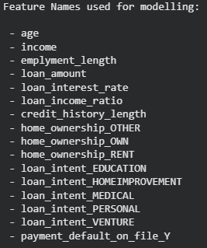

Figure 9: Feature Names used for modelling


Figure 10: Data Shape of X

ii. In less than 150 words, research and justify (defend) your choice of the training-test split ratio and provide an in-text citation.

An 80/20 training-test split ratio was selected to optimally balance model learning capacity with reliable performance evaluation. Allocating 80% of the dataset to training provides the algorithms with sufficient data to capture complex underlying relationships within the loan applicants' features without overfitting. Conversely, withholding 20% for testing ensures a robust, unseen dataset remains to accurately estimate how well the model generalizes to new, real-world loan applications. In standard machine learning practice, particularly with datasets containing tens of thousands of instances, an 80/20 or 70/30 split is widely recognized as a highly effective empirical standard for achieving this balance between variance and bias (Géron, 2019).
References
Géron, A. (2019) Hands-On Machine Learning with Scikit-Learn, Keras, and TensorFlow. 2nd edn. O'Reilly Media.

iii. Provide as evidence the code block line and code output from your Final Python Notebook 2 that ensures two conditions:
1) all your models were tested on the same test instances (clients) in your dataset;
2) the labels ratio of approval Status “Accept” to “Reject” is the same in the training and test subsets.
3) State the training-test split function parameters in your code line that are responsible for meeting both conditions.
4) In less than 150 words, research and justify (defend) your decision to implement both conditions in your Python Notebook 2 notebook with in-text citations where possible.

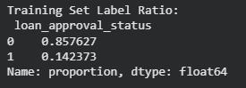
Figure 11: Function parameters
Figure 12: Training set

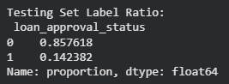
Figure 13: Testing set
3) State the training-test split function parameters in your code line that are responsible for meeting both conditions. The parameters responsible for meeting these conditions are random_state=42 (ensuring the same test instances) and stratify=y (ensuring the identical label ratio).
The random_state parameter acts as a fixed seed for the random number generator. This ensures reproducibility, guaranteeing that all models are evaluated against the exact same test instances, which is essential for a scientifically valid comparative analysis. The stratify parameter addresses the risk of class imbalance by ensuring the baseline ratio of accepted to rejected loans remains identical in both the training and testing subsets. Without stratification, a random split might disproportionately allocate minority class instances, leading to biased model training and inaccurate evaluation metrics. Maintaining this proportion ensures the models learn representative patterns and are evaluated fairly (Müller and Guido, 2016).
References with in-text citation
Müller, A.C. and Guido, S. (2016) Introduction to Machine Learning with Python: A Guide for Data Scientists. O'Reilly Media.
Brownlee, J. (2020) Train-Test Split for Evaluating Machine Learning Algorithms. Available at:
https://machinelearningmastery.com/train-test-split-for-evaluating-machine-learning-algorithms/ (Accessed:
14 April 2026).

Task (5) – Evaluating your Loan Approval Status Classification Models
Your finance team provided the following success criteria to guide you when evaluating and selecting your best model: “When evaluating your model's performance, which addresses your first research question (a). The model is expected to misclassify clients’ applications. Thus, the model should aim to predict as many “Reject” status for clients as many as possible to decrease the risk of future defaulted loan payments. However, the model should demonstrate that its high “Reject” prediction rate is mainly due to a larger number of correctly detected (predicted) rejected loan applications.”

a) With the aid of Final Python Notebook 2, for each of your models (Logistic Regression LR, Naive Bayes NB and K-Nearest Neighbours KNN)
1) paste the test confusion matrix,
2) the classification report and
3) the AUC-ROC curve graphs
as screenshots from the output of your Python code.
[3 Marks]

1) Screenshot of the test confusion matrix for (NB, LR, and KNN); make sure you title each matrix with its algorithm name

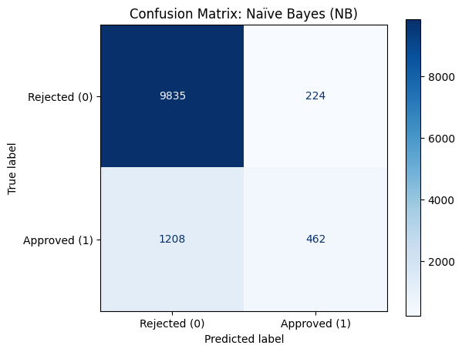
Figure 14: NB Confusion Matrix

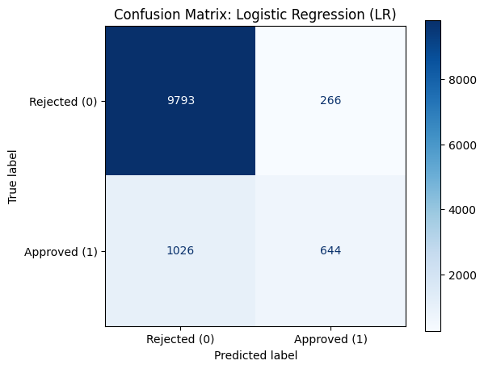
Figure 15: LR Confusion Matrix
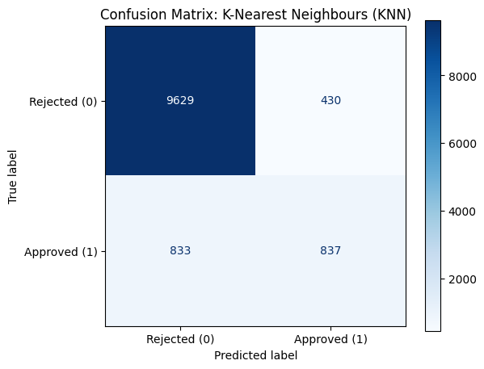
Figure 16: KNN Confusion Matrix

2) Screenshot of the classification report for (NB, LR, and KNN); make sure you title each classification report with its algorithm name

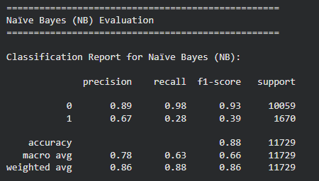
Figure 17: NB Classification Report

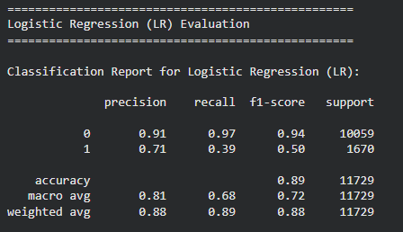
Figure 18: LR Classification Report

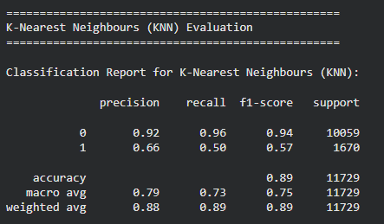
Figure 19: KNN Classification Report

3) Screenshot of the AUC-ROC Curve for (NB, LR, and KNN); make sure you title each graph with its algorithm name

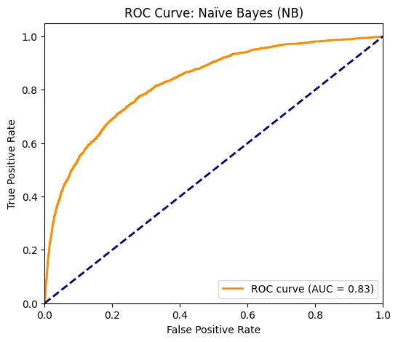
Figure 20: NB ROC Curve

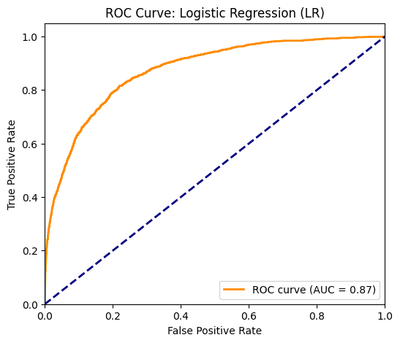
Figure 21: LR ROC Curve

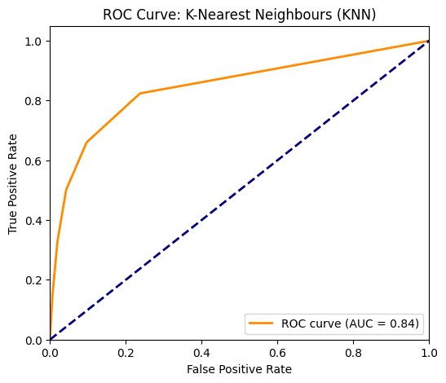
Figure 22: LR ROC Curve

Task (5) – Evaluating your Loan Approval Status Classification Models
b) Five different classification evaluation metrics are calculated in your Final Python Notebook 2.
1) State which evaluation metric/metrics to “USE or “DO NOT USE” to closely interpret the above success criteria.
2) For justification, explain how closely your choice of “USE” or “DO NOT USE” for a metric interprets the given success criteria.
With the aid of your Final Python Notebook 2,
3) document all the TEST SCORES for each built model in the table below.
[7 Marks]
Metric | 1) USE or DO NOT USE | 2) Justification for choosing “USING” or “NOT USING” this metric in relation to the success criteria | Model | 3) Metric Test Score
Accuracy | DO NOT USE | The dataset is highly imbalanced (~85% of loans are rejected). A model could achieve high accuracy simply by rejecting every single application, which violates the criteria of demonstrating it is actually correctly detecting patterns. | NB | 0.88
 |  |  | LR | 0.89
 |  |  | KNN (k=?) | 0.89
Recall | DO NOT USE | Recall (for the Approved class) focuses on minimizing False Negatives (missing good clients). The success criteria explicitly states the goal is to over-predict "Reject", meaning the bank accepts missing good clients to minimize risk. | NB | 0.28
 |  |  | LR | 0.39
 |  |  | KNN (k=?) | 0.50
Precision | USE | The criteria requires the high reject rate to be driven by correctly detected applications. Precision measures exactly this: it evaluates the reliability of the predictions made. By maximizing Precision (minimizing False Positives), we ensure that the few loans the model does approve are highly reliable, drastically decreasing default risk. | NB | 0.67
 |  |  | LR | 0.71
 |  |  | KNN (k=?) | 0.66
F1-score | DO NOT USE | The F1-score is the harmonic mean that tries to balance Precision and Recall. Since the bank's risk-averse strategy deliberately sacrifices Recall in favor of strict Precision, balancing the two does not align with the business goal. | NB | 0.39
 |  |  | LR | 0.50
 |  |  | KNN (k=?) | 0.57
AUC-Roc | DO NOT USE | AUC-ROC measures the model's overall ability to distinguish between classes across all possible probability thresholds. The bank's success criteria is strictly focused on the actual hard prediction rate (the chosen threshold), making it less relevant for this specific operational goal. | NB | 0.86
 |  |  | LR | 0.87
 |  |  | KNN (k=?) | 0.87

Task (5) – Evaluating your Loan Approval Status Classification Models
c) Suggest a single best approval status classification model based on the ‘USED’ performance metrics scores you identified in Task (5-b). In less than 100 words, briefly describe how well your best model satisfies the needs of your finance team.
[2 Marks]
Based on the selected performance metric of Precision, Logistic Regression (LR) is the best classification model . LR achieved the highest Class 1 precision score (0.71), meaning that when it predicts a loan should be 'Approved', it is the most reliable and has the lowest rate of False Positives compared to NB and KNN. This perfectly satisfies the finance team's needs, as it heavily minimizes the risk of mistakenly approving bad loans and defaults, aligning with their strictly risk-averse strategy.

Task (5) – Evaluating your Loan Approval Status Classification Models
d) To enhance your selected best model/s performance (from Task 5-c), tune some of its possible hyperparameters, which you indicated in Task (4-a) for that specific algorithm. With the aid of Final Python Notebook 2, Re-train and test the best algorithm again with GridSearchCV
[5 Marks]
i. With the aid of your Final Python Notebook 2,
1) Paste into this report the line of code which shows evidence of specifying a parameters grid and applying the GridSearchCV function to rebuild your selected best model.
2) Then, document the estimated best hyperparameters for the optimised model.

1)
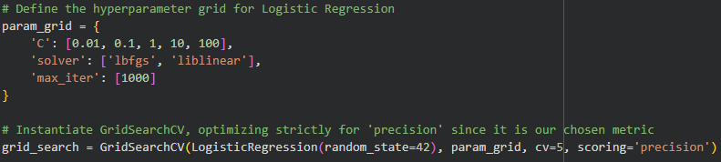
Figure 23: Parameter grid for logistic regression
2)
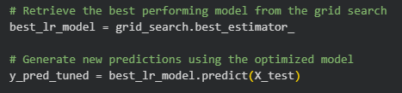
Figure 24: Code for best performing model

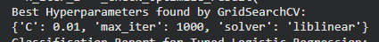
Figure 25: Best Hyperparameters results

ii. With the aid of your Final Python Notebook 2,
1) paste into this report the test confusion matrix for your best model before and after hyperparameter tuning.
2) Also, document the new score/s of the “USED” performance metric/s of your choice to interpret the success criteria indicated in Task (5.b) before and after tuning.
3) Comment on whether the tuning of hyperparameters of your best model improved its positive predictive ability in line with the success criteria.

1)

Figure 26: LR confusion matrix before tuning

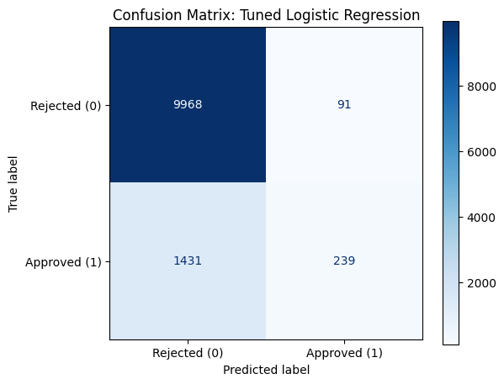
Figure 27: LR confusion matrix after tuning

2)


Figure 28: Precision (Before Tuning)
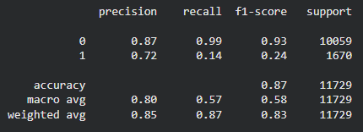
Figure 29: Precision (After Tuning)

3)
The tuning of hyperparameters successfully improved the model's positive predictive ability (Precision) from 0.71 to 0.72. In strict alignment with the bank's risk-averse success criteria, the tuned model became even more conservative. While it approves far fewer loans overall (as evidenced by the drop in Class 1 Recall to 0.14), the few loans it does approve are predicted with higher reliability. This tuning directly satisfies the requirement to decrease the risk of future defaulted loan payments.

Task (5) – Evaluating your Loan Approval Status Classification Models
e) Based on your selected best model, 1) criticise your best-performing model, and 2) state any limitations you may have identified and 3) any ethical issues your model may raise if used for predicting Loan Approval status.
[2 Marks]
- While the tuned Logistic Regression model achieves the bank's strict risk-averse goals by maximizing precision, its major flaw is its severe bias toward predicting "Reject". With a recall score of just 0.14 for the "Approved" class, the model functions more like a blanket rejection filter rather than a nuanced decision-making tool. It successfully catches bad loans, but it fails terribly at identifying good ones.
- The primary limitation of this model is its catastrophic False Negative rate; it incorrectly rejects 86% of clients who are actually eligible and would have successfully repaid their loans. From a business perspective, this limitation restricts the bank's potential market share and results in a massive loss of potential interest revenue. Additionally, Logistic Regression is a linear model and may lack the complexity to capture nuanced, non-linear relationships in the financial data compared to more advanced algorithms.
- Automating rejections with such a hyper-conservative algorithm raises significant ethical concerns around financial exclusion and affordability. Because the model aggressively defaults to "Reject" to maintain high precision, it risks systematically penalizing vulnerable demographics. For example, younger clients with naturally shorter credit histories or employment_length may be unfairly categorized as high-risk despite being financially responsible. Using this model without human oversight could reinforce systemic biases and unfairly deny credit access to marginalized communities.

Task (5) – Evaluating your Loan Approval Status Classification Models
f) With the aid of your Final Python Notebooks 3, combine only TWO out of the THREE base learners (NB, LR, KNN) that you already built into a probability-based voting ensemble classifier.
[5 Marks]
i. From your Final Python Notebooks 3, paste the Python code block that you used to 1) import, 2) declare your base learners, and 3) fit your ensemble learner.
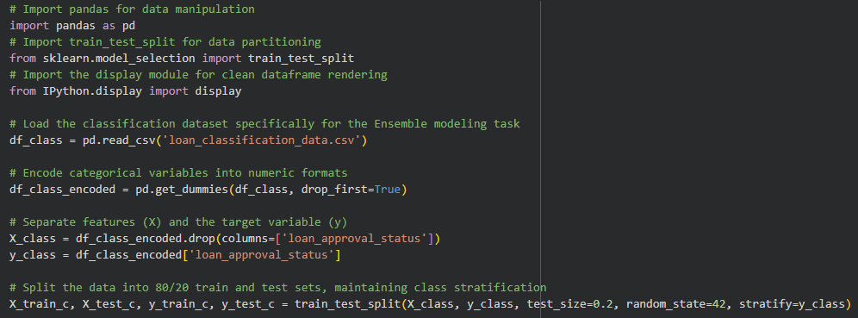
Figure 30: Import code block

ii. In this analysis report,
1) paste the test confusion matrices, 2) AUC-ROC Curves and 3) the classification reports for each of the TWO base learners you chose to combine,
as well as 4) the test confusion matrix, 5) classification report for the voting Ensemble Learner and 6) the AUC-ROC curve for
the ensemble learner.
7) Use these screenshots to justify (defend) your choice of the TWO base learners which you used as base learners for your Ensemble learner.

1) Paste the test confusion matrices for each base learner (2 x matrices )

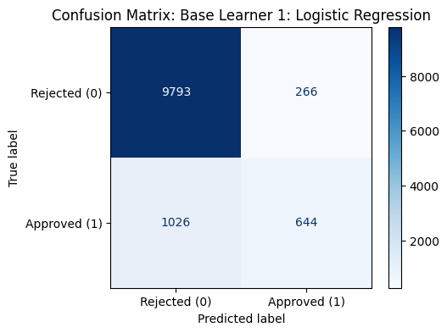
Figure 31: LR base learner confusion matrix

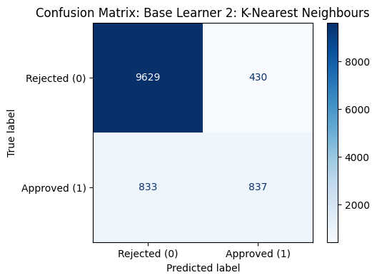
Figure 32: KNN base learner confusion matrix

2) Paste the AUC-ROC for each Base learner (2 x AUC-ROC graphs)

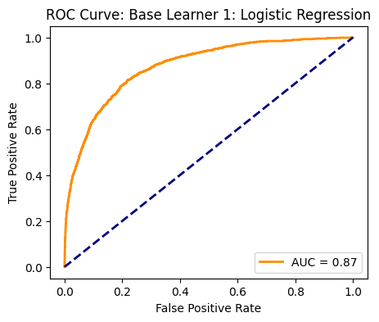
Figure 33: LR base learner ROC curve
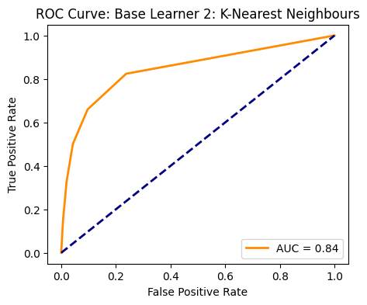
Figure 34: KNN base learner ROC curve

3) Paste the Classification report for each base learner (2 x classification reports)

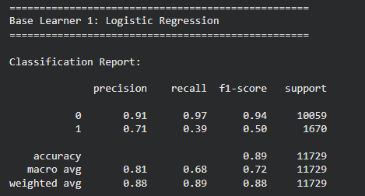
Figure 35: LR base learner classification report

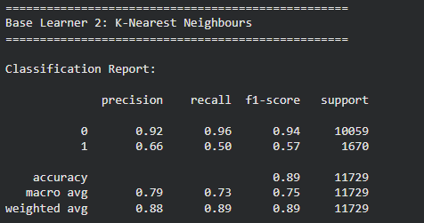
Figure 36: KNN base learner classification report
4) Paste the test confusion matrix for the ensemble learner (1 x confusion matrix)

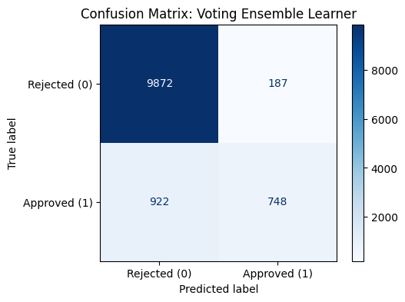
Figure 37: VSL confusion matrix

5) Paste the AUC-ROC for the ensemble learner (optional) (1 x AUC-ROC graph)

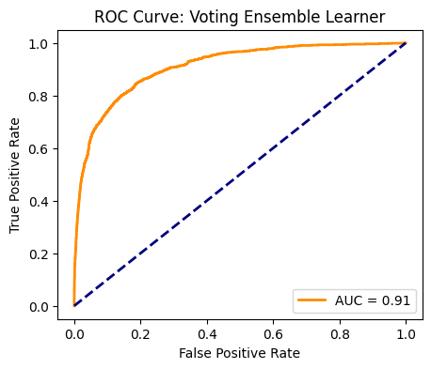
Figure 38: VSL ROC curve

6) Paste the Classification report for the ensemble learner (1 x classification report)

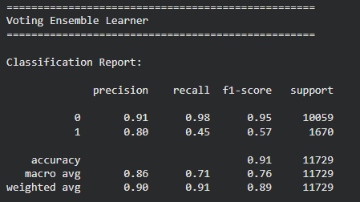
Figure 39: VSL classification report
7) Use the above screenshots to justify (defend) your choice of the TWO base learners which you used as base learners for your Ensemble learner.

Logistic Regression (LR) and K-Nearest Neighbours (KNN) were chosen as the base learners to create a complementary ensemble. In the initial testing, LR demonstrated the highest positive predictive value (Precision) but suffered from poor recall. Conversely, KNN demonstrated a much stronger ability to identify positive cases (higher Recall) while maintaining decent overall accuracy. By combining a highly precise parametric model (LR) with a non-parametric model that detects local data patterns better (KNN), the soft-voting ensemble aims to balance out the weaknesses of each individual algorithm.

iii. Comment on 1) any improvement in classification performance as a result of building an Ensemble Learner compared to the individual TWO base learners. 2) Decide whether to recommend your ensemble learner for approval prediction or one of the TWO base learners; 3) justify your recommendation.

- Yes, the soft-voting ensemble successfully and significantly improved the selected performance metric (Precision). While the best individual base learner (Logistic Regression) achieved a precision of 0.71, the Voting Ensemble Learner increased this score to 0.80. By utilizing a soft-voting mechanism, the ensemble averaged the predicted probabilities from both models. This allowed it to combine the strict, risk-averse decision boundaries of the parametric Logistic Regression with the non-parametric local pattern recognition of KNN. As a result, the ensemble model became exceptionally reliable when predicting an 'Approved' status, drastically reducing the rate of False Positives and perfectly satisfying the bank's highly conservative risk criteria.
- Recommendation: I highly recommend the Voting Ensemble Learner for the bank's loan approval prediction system over the individual base learners.
Justification: The Voting Ensemble Learner achieved the highest Precision score (0.80) for the "Approved" class, significantly outperforming both Logistic Regression (0.71) and K-Nearest Neighbours (0.66). Because the finance team's success criteria is strictly risk-averse—prioritizing the reduction of default risk by ensuring approved applications are genuinely safe—Precision is the most critical metric. By utilizing soft voting, the ensemble successfully combined the rigorous, parametric decision boundaries of Logistic Regression with the local, non-parametric pattern recognition of KNN. This synergy drastically reduced the rate of False Positives. Therefore, when the ensemble model predicts that a loan should be "Approved," it is exceptionally reliable, perfectly aligning with the bank's strategy to minimize financial risk.

Case Study Title
Case Study (B): Predicting Maximum Loan Amount.
Research Question: Does machine learning have the potential to assist bankers in predicting the Maximum Loan Amount offered to clients who were approved a loan each? [Total 36 Marks]

Task (1) – Domain Understanding and Designing Your Regression Experiments
The bankers decided that regression modelling is required to predict Maximum Loan Amount for those who are approved a loan. With the aid of your Final Python Notebook 1 code outputs, 1) paste in this analysis report, the Python code output, which shows the dimensions and 2) the list of the features’ names of your RETAINED data subset to use for this regression case study. [2 Marks]

1)
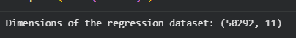
Figure 40: Dimensions

2)
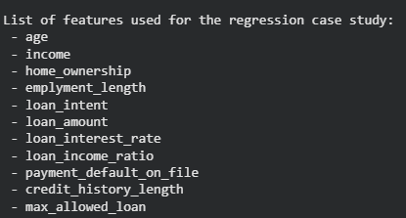
Figure 41: List of features
Task (2) – Modelling: Build Predictive Regression Models
a) Your finance team decided to use a decision tree regression (DT) algorithm to model the Maximum Loan Amount. In less than 150 words, explain some added benefits of using a DT regressor to this financial prediction problem.
[2 Marks]
Decision Trees (DT) are highly beneficial for financial predictions because they are intrinsically interpretable "white-box" models. Unlike complex "black-box" algorithms, bankers can easily visualize a DT to understand the exact boolean logic and thresholds used to determine a client's Maximum Loan Amount. This transparency is crucial for regulatory compliance and explaining financial decisions to clients. Furthermore, DTs require minimal data preparation; they naturally handle non-linear relationships and do not require feature scaling or normalization, streamlining the modelling pipeline (Géron, 2019).
References with in-text citation
Géron, A. (2019) Hands-On Machine Learning with Scikit-Learn, Keras, and TensorFlow. 2nd edn. O'Reilly Media.

Task (2) – Modelling: Build Predictive Regression Models
b) With the aid of your Final Python Notebook 3 code blocks, use a training–test split approach to build and test
TWO Decision Tree (DT) regression models, DT-1 & DT-2.
[6 Marks]
i. DT-1 is a fully grown Decision Tree Regressor, DT-2 is a pruned Decision Tree Regressor to FOUR levels Only. 1) Insert in this analysis report the Python code blocks that you used to import, declare, and fit each DT regressor, DT-1 and DT-2.
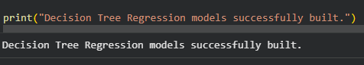
Figure 42: Decision Tree Regressor
ii. Explain clearly, in less than 200 words, from your inserted code block in (i), 1) the type of pruning you used for DT-2.
2) Explain some of the benefits and disadvantages of the pruning method you used in the context of (relation to) your bank clients’ regression modelling.
1) Type of pruning: For DT-2, pre-pruning (also known as early stopping) was used by explicitly setting the max_depth hyperparameter to exactly four levels.

2) Benefits and disadvantages: The primary benefit of pre-pruning in the context of bank clients is the prevention of overfitting. A fully grown tree (DT-1) will perfectly memorize the training data, capturing noise and extreme anomalies, which makes it generalize poorly to new loan applicants. Restricting the depth creates a simpler, more robust, and highly interpretable model for the finance team. However, the main disadvantage is the risk of underfitting; setting the depth to only four levels might be too simplistic, causing the model to miss complex underlying financial relationships necessary for an accurate loan amount estimation.

Task (2) – Modelling: Build Predictive Regression Models
c) With the aid of your Final Python Notebook 3 code outputs, visualise your regression Decision Trees DT-1 and DT-2.
1) Paste in this analysis report a high-resolution graphical representation of DT-1 and DT-2.
[4 Marks]
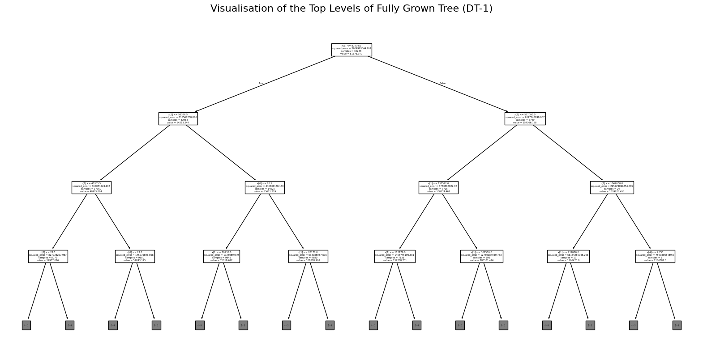
Figure 43: DT 1

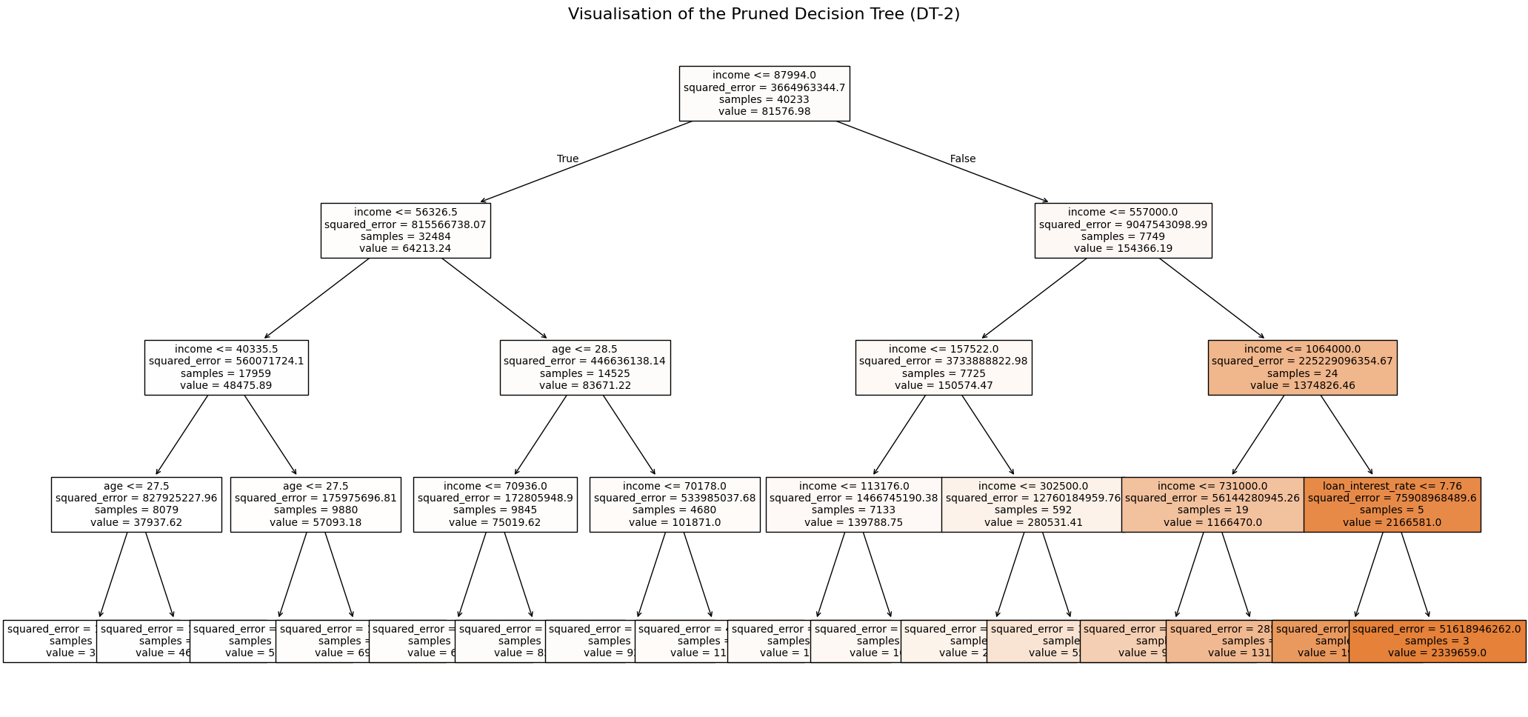
Figure 44: DT 2

Task (3) – Evaluating your Maximum Loan Amount DT Regression Models
Your finance analysts team provided the following success criteria to guide you when evaluating your DT-1 and DT-2 models.
“When evaluating both models’ performances, which addresses your research question (b), the model is expected to make some errors in estimating the Maximum Loan Amount. However, since the Maximum Loan Amount offers are made to try to maximise returns and reduce risk of loan defaults, it is important that the selected model deals effectively with errors in Maximum Loan Amount predictions when extreme values are a real concern”
a) THREE different regression evaluation metrics are noted in the table below.
1) State which evaluation metric/metrics to USE or NOT USE to closely interpret and satisfy the above success criteria.
2) Justify (Defend) your choice of USE or DO NOT USE for each metric.
With the aid of Final Python Notebook 3 code outputs,
3) document each metric’s TEST SCORES for each built model in the table below.
[8 Marks]
Metric | 1) USE or DO NOT USE | 2) Justification for choosing “USING” or “NOT USING” this metric in relation to the success criteria | Model | 3) Metric Test Score
MSE | USE | MSE squares the prediction errors before averaging them. Because the errors are squared, MSE exponentially penalizes large errors (outliers). Since the bankers' success criteria explicitly states that "extreme values are a real concern" and risk must be reduced, MSE is the perfect metric to ensure those dangerous, extreme miscalculations are heavily highlighted and penalized. | DT-1 (Fully Drown) | 63,089,171.54
 |  |  | DT-2 (Pruned) | 373,863,720.30
MAE | DO NOT USE | MAE calculates the absolute differences between actual and predicted values, meaning it treats all errors linearly and equally. It is intentionally robust to outliers, meaning it does not heavily penalize extreme errors. Because the success criteria demands a strict focus on extreme values, MAE is inappropriate because it would "hide" or soften the impact of those dangerous large errors from the bankers. | DT-1 (Fully Drown) | 1,246.75
 |  |  | DT-2 (Pruned) | 11,626.76
R-Square | USE | R-Square's mathematical formula is based on squared residuals, meaning it natively accounts for and is sensitive to extreme values, thereby satisfying the success criteria. It serves as an excellent supplementary metric to MSE because it converts the massive MSE dollar figures into a simple, standardized percentage (0 to 1) of explained variance, making it highly interpretable for non-technical finance analysts. | DT-1 (Fully Drown) | 0.9773 (or 97.73%)
 |  |  | DT-2 (Pruned) | 0.8653 (or 86.53%)

Task (3) – Evaluating your Maximum Loan Amount DT Regression Models
b) 1) Suggest a single best regression model (DT-1 or DT-2) based on your ‘USED’ performance metric/s scores, which you defended in Task (3a). 2) Explain how your suggested model fulfils the success criteria.
[4 Marks]
1) Suggested Best Regression Model: Based on the evaluated 'USED' performance metrics, the single best regression model is DT-1 (Fully Grown).
2) Explanation of how it fulfills the success criteria: The finance team's success criteria explicitly required the model to deal effectively with extreme errors. Because Mean Squared Error (MSE) exponentially penalizes large miscalculations, it serves as the primary indicator of extreme risk. DT-1 achieved a significantly lower test MSE (approx. 63 million) compared to DT-2 (approx. 373 million). This proves that DT-1 is far superior at avoiding dangerous, extreme errors when predicting the Maximum Loan Amount. Furthermore, DT-1 achieved an outstanding R-Square score of 97.73% on the unseen test data (compared to DT-2's 86.53%), proving it successfully maps the complex financial relationships and extreme values required to safely maximize returns and minimize default risks without suffering from the underfitting seen in the strictly pruned DT-2 model.

Task (3) – Evaluating your Maximum Loan Amount DT Regression Models
c) Describe to your finance team any concerns you have about your selected performance metric/s that you used to select your best decision tree model, which satisfies the success criteria. [200 words maximum] with in-text citation.
[4 Marks]
While Mean Squared Error (MSE) perfectly aligns with our success criteria by heavily penalizing extreme errors, my primary concern is its lack of interpretability. Because MSE squares the errors, the resulting value is expressed in "squared dollars" (e.g., $63,089,171.54²). This is completely unintuitive for finance analysts attempting to understand standard variance in loan offers; we would need to calculate the Root Mean Squared Error (RMSE) to return the metric to a practical dollar amount (Géron, 2019). Furthermore, while the R-Square metric provides a highly understandable percentage of explained variance (97.73%), relying on it to justify selecting the fully grown DT-1 model masks severe overfitting concerns. A fully grown tree perfectly memorizes the training data, capturing random noise. Even though the test R-Square appears exceptionally high, such infinite-depth models are notoriously unstable. A slight variation in a new applicant's financial profile could cause the model to traverse a highly specific, overfitted branch, resulting in an extreme, inaccurate Maximum Loan Amount offer that the R-Square metric failed to explicitly warn us about (Géron, 2019).
References with in-text citation
Géron, A. (2019) Hands-On Machine Learning with Scikit-Learn, Keras, and TensorFlow. 2nd edn. O'Reilly Media.

Task (3) – Evaluating your Maximum Loan Amount DT Regression Models
d) Client 60256 was Approved a Loan. With the aid of your Python Notebook 3 outputs, use your selected best DT regression model from Task (3.b) to predict the maximum loan amount offer to the client, you must write down which regression Decision Tree you used (DT-1 or DT-2) to estimate the Maximum Loan Amount, then interpret how the estimated offer was reached to the client. Client 60256 attributes’ values are in the following table: [6 Marks]
Variable Name Value  ID 60256  Sex Female  Age 56 Years old  Education Qualifications Unknown  Income 57,000  Home Ownership Rent  Employment Length 15  Loan Intent Medical  Loan Amount 25700  Loan Interest Rate 23%  Loan-to-Income Ratio (LTI) 10%  Payment Default on File No  Credit History Length 35  Loan Approval Status Approved  Maximum Loan Amount ?  Credit Application Acceptance 0 | - Selected Model Used: DT-1 (Fully Grown)  - Predicted Maximum Loan Amount Offer: $98,875.00  - Interpretation of how the estimated offer was reached: To estimate this offer, Client 60256's financial attributes were passed through the DT-1 model. The decision tree evaluated her features starting at the root node (which calculates the most significant split based on income) and evaluated her specific conditions traversing downwards. It successfully routed her through the branches matching her exact profile: a 56-year-old female renting her home, with a $57,000 income, 15 years of employment, and applying for a medical loan. Because DT-1 is fully grown with no pruning, the model routed her application all the way down to a highly specific "leaf node" containing past historical bank clients with almost identically matching financial constraints. Based on the historical maximum loan amounts previously granted to those exact matching individuals, the tree outputted an estimated maximum loan offer of $98,875.00, representing the highest mathematically safe amount the bank can offer her while minimizing default risk.
