SCMP

Software Engineering

Software Configuration Management Plan

TheDonorsChoice





Table of Contents

3.1 Introduction 1

3.1.1 Definitions 1

3.1.2 Acronyms 1

3.1.2 Referenced Documents 2

3.2 SCM management 2

3.2.1 Organization 2

3.2.2 SCM responsibilities 3

3.2.2.1 Configuration Leader tasks 3

3.2.2.2 Project Manager 3

3.2.2.3 Engineers 3

3.2.3 Applicable policies, directives & procedures 3

3.3 SCM activities 3

3.3.1 Configuration identification 3

3.3.1.1 Identifying configuration items 3

3.3.1.2 Naming configuration items 4

3.3.1.3 Acquiring configuration items 4

3.3.2 Change identification 4

3.3.2.1 Requesting changes 4

3.3.2.2 Evaluating changes 4

3.3.2.3 Approving or disapproving changes 4

3.3.2.4 Implementing changes 4

3.3.3 Configuration status accounting 5

3.3.4 Configuration evaluation & reviews 5

3.3.5 Interface control 5

3.3.6 Subcontractor / vendor control 5

3.4 SCM schedules 5

3.5 SCM resources 5

3.6 SCM plan maintenance 6

3.7 SCMP change history 6

# 3.1 Introduction

The Software Configuration Management Plan (SCMP) describes how the artifacts for the project TheDonorsChoice are to be managed.

## 3.1.1 Definitions

Approved Configuration Items (CI):

CIs are signed off by project management.

Artifact:

A final or interim product of the project (e.g., a document, source code, object code, test result).

CI:

Configuration Item - an item tracked by the configuration system

CM:

Configuration Management - the process of maintaining the relevant versions of the project

Git:

Distributed Version Control System (DVCS) tool for allowing multiple persons to collaborate.

GitHub:

Web platform for collaborating on Git based version control projects. Also provides access to an Issue Tracking system.

## 3.1.2 Acronyms

CI:

Configuration Item

CM:

Configuration Management

POC:

Point of Contact

QA:

Quality Assurance

SCMP:

Software Configuration Management Plan

SME:

Subject Matter Expert

## 3.1.2 Referenced Documents

[1] Ron Czik, (2014) Lecture notes, MET CS673 Software Engineering

[2] Braude, Eric J.,Bernstein, Michael E. (2010) Software Engineering: Modern Approaches Wiley; 2 edition, (p. 129 - 134)

# 3.2 SCM management

## 3.2.1 Organization

TheDonorsChoice project team is made up of nineteen (19) members; a high level depiction of the team structure is shown in the figure below. Additional information is included within this document articulating the various roles and responsibilities. Across the various teams we have allocated the following roles and responsibilities:

* Project Leader
* Team Leader(s)
* Configuration Leader
* QA leader
* Engineer/Developer/Tester
* QA Engineer/Code Reviewer

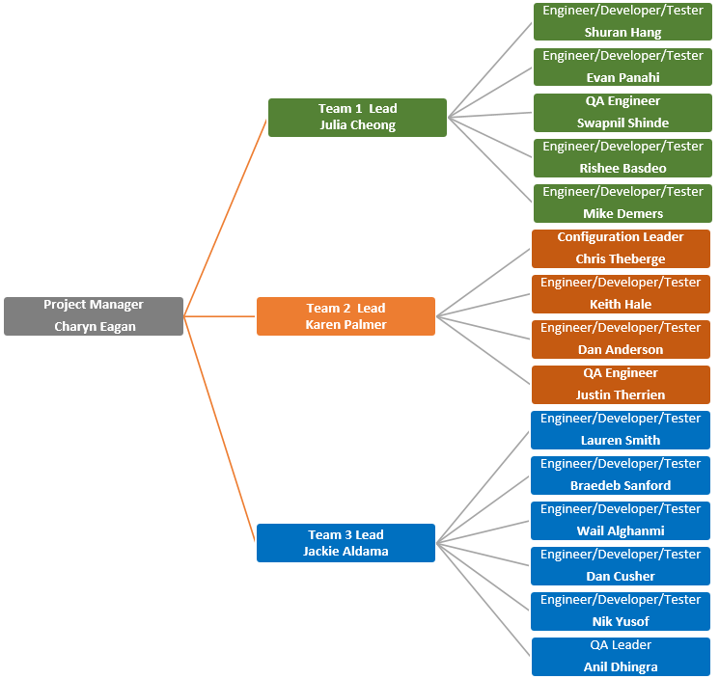

Figure 1: TheDonorsChoice Organizational Chart

The proper use of the configuration tool and adherence to the configuration standards and tasks will be the responsibility of all team members. TheDonorsChoice project has one specific role for the configuration portion of the project: that of the Configuration Leader. The Project Manager will be the backup for the Configuration Leader.

## 3.2.2 SCM responsibilities

### 3.2.2.1 Configuration Leader tasks

Include, for all iterations:

* Maintaining this document
* Organizing and managing configuration management (CM)
* Coordinating the installation and maintenance of the configuration management tool(s) specified in Section 3.2.3
* Archiving documents according to CM directives
* Presenting and discussing CM plans with the development team prior to implementation

### 3.2.2.2 Project Manager

The Project Manager will take over the Configuration Leader’s function only under exceptional circumstances. He or she is responsible for knowing all the relevant means of access to documents throughout the life of the project, as well as the archiving process.

### 3.2.2.3 Engineers

It is the responsibility of each engineer to abide by the CM rules that the Configuration Leader publishes. Additional responsibilities of the Engineers are outlined in the SCM Activities section.

## 3.2.3 Applicable policies, directives & procedures

Our team policies are listed below.

* All current and previously released versions of CIs will be retained.
* All users shall have their own username and password accounts.
* The Project Manager and Team Leads or designated POC shall have complete access to all documents under configuration management at all times.
* Configuration management tools must receive stakeholder approval prior to use
* Google Drive will be used for all configuration items related to Project documentation and GitHub will be used for all configuration items related to source code.

# 3.3 SCM activities

## 3.3.1 Configuration identification

### 3.3.1.1 Identifying configuration items

The Project Manager shall be responsible for identifying all the CIs. Engineers wishing to propose CIs shall secure his or her agreement, via e-mail or otherwise. If the Project Manager is unavailable for one business day following the Engineer's emailed proposal for inclusion, the Configuration Leader shall have the authority to accept the proposed item.

### 3.3.1.2 Naming configuration items

Because GitHub provides the versioning of configuration items, the naming standard will not reflect a version number. The configuration leader has the responsibility of labeling all CIs. The file naming conventions are as follows:

Documents

The nodes in the document will be separated by an underscore (_)

Node 1: Document Type, for example: SCMP, SQAP:

Node 2: Draft or Final

Code CIs will follow the naming standards as described in section 5.2.1 of the SQAP

### 3.3.1.3 Acquiring configuration items

Engineers requiring CIs for modification shall check them out using GitHub’s checkout procedure. Anyone requiring a CI that is currently checked out should negotiate with the current owner of the CI to transfer control through GitHub. A read-only version of the CI is available to all Engineers. Under no circumstances may an Engineer transfer a CI directly to anyone.

## 3.3.2 Change identification

Technical changes within the code do not require a change identification unless

* there is an increase in the scope or
* there is an architectural change

### 3.3.2.1 Requesting changes

Each Team Lead serves as the Inspector for his or her team. Engineers must route all change requests to his or her Inspector. The Inspector works with engineer to propose the incorporation of a changed CI into the baseline to the Team Leads and the Project Manager.

### 3.3.2.2 Evaluating changes

Each Inspector is responsible for evaluating all proposed changes from his or her team before the change is submitted to the other Team Leads and the Project Manager for approval.

### 3.3.2.3 Approving or disapproving changes

Approval for proposed changes must be granted by both the Project Manager and Team Leads with input from the Configuration Leader. Due to the compressed nature of the project timeline, if the Project Manager is unavailable for one business day following the submission of a proposed change, the Team Leads have the authority to approve changes.

### 3.3.2.4 Implementing changes

Once the change is approved, the Configuration Leader is responsible for coordinating the testing and integration of the changed CI. This should be performed in accordance with the Software Test Documentation. In particular, the Configuration Leader shall coordinate the building of a version for testing. Version releases must be cleared with the Project Manager or the Team Leads if the Project Manager is unavailable.

## 3.3.3 Configuration status accounting

Configuration status accounting does not apply to this project.

## 3.3.4 Configuration evaluation & reviews

The teams will conduct peer review of the documents and ensure master documents are maintained and managed appropriately.

## 3.3.5 Interface control

The CM system interfaces do not interface with the project web site. This interface shall be managed by the configuration leader.

## 3.3.6 Subcontractor / vendor control

The team responsible for tracking upgrades and bug reporting of configuration management tools, including the GitHub tool and IPower, the hosting provider for the website, will track the status of outages, notify the appropriate teams, and alert once issues have been resolved and the system is back online.

# 3.4 SCM schedules

The configuration management schedule of reporting/reviewing, archiving, and continuous improvement is shown in Figure 2.

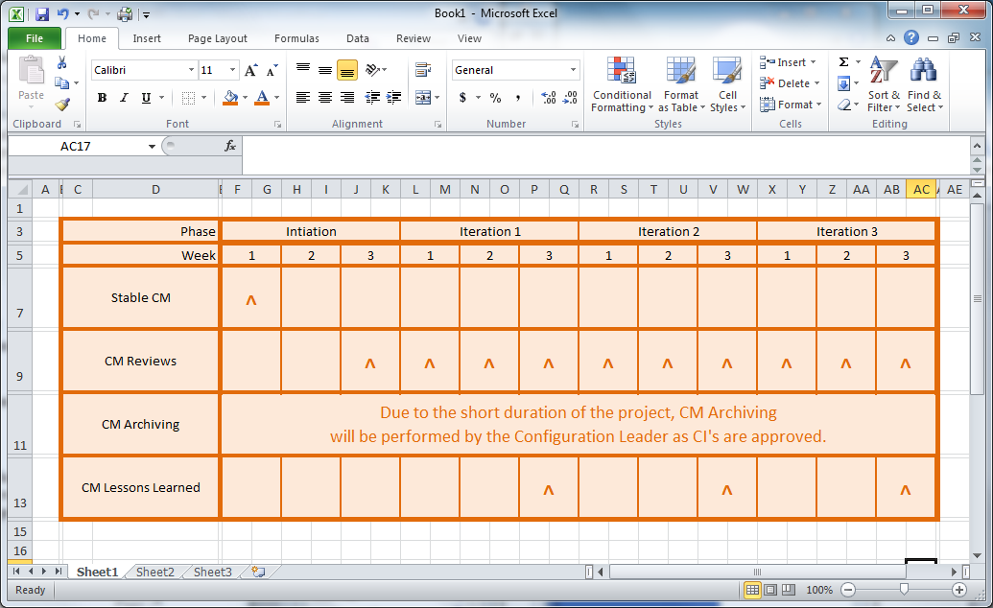

Figure 2: Configuration Management Schedule

# 3.5 SCM resources

The Configuration Leader may require additional hours a week to maintain the system configuration for their portion of each project. Team Leads will ensure that tasks associated with configuration management are completed appropriately.

# 3.6 SCM plan maintenance

All documents under CM undergo changes throughout the duration of the project. Due to the duration of the project, a maintenance plan does not apply.

# 3.7 SCMP change history

|  |  |  |
| --- | --- | --- |
| Date | Version | Author |
| February 5, 2014 | V 1.0 | Project Manager & Project Teams |
|  |  |  |
|  |  |  |
|  |  |  |