SQAP

Software Engineering

Software Quality Assurance Plan

TheDonorsChoice





Table of Contents

1 Purpose 1

2 Referenced Documents 1

3 Management 1

3.1 Organization 1

3.2 Tasks 1

3.2.1 QA Leader 1

3.2.2 QA Engineer 2

3.2.3 Developers 2

3.3 Responsibilities 2

3.3.1 QA Leader Responsibilities 2

3.3.2 QA Engineer Responsibilities 2

3.3.3 QA Developer Responsibilities 2

3.4 QA Estimated Resources 3

4 Documentation 3

4.1 Purpose 3

4.2 Minimum Documentation Requirements 3

5 Standards & Practices 3

5.1 Purpose 3

5.2 Content 3

5.2.1 Documentation Standards: 3

5.2.2 Product Standards 4

5.2.3 Process Standards 4

5.2.4 Quality Practices: 5

6 Reviews & Audits 5

6.1 Purpose 5

6.2 Minimum Requirements 5

6.2.1 Software Requirements Reviews 5

6.2.2 Architecture Design Reviews 5

6.2.3 Detailed Design Reviews 5

6.2.4 Test Plan Reviews 5

6.2.5 Functional Audits 5

6.2.6 Physical Audits 5

6.2.7 In-Process Audits 5

6.2.8 Managerial Review 6

6.2.9 SCMP Review 6

6.2.10 Post-Implementation Review 6

6.2.11 Verification and Validation Plan Review 6

7 Test 6

8 Problem Reporting & Corrective Action 6

9 Tools, techniques and methodologies 6

10 Media control 7

11 Supplier control 7

12 Records collection, maintenance and retention 7

13 Training 7

14 Risk Management 7

14.1 Risk Probability Definitions& Impact Matrix 7

15 Glossary 9

16 SQAP change procedure and history 9

Appendix A – Referenced Figures i

Figure 1: TheDonorsChoice Organizational Chart i

Figure 2: TheDonorsChoice QA Team i

Figure 3: Documentation Review Process ii

Appendix B – Referenced Documents iii

Appendix C – Risks Detail iv

Appendix D – Glossary vi

# 1 Purpose

The purpose of this Software Quality Assurance Plan (SQAP) is to define the techniques, procedures, and methodologies that will be used by TheDonorsChoice to assure timely delivery of the software that meets specified functional and nonfunctional requirements within project resources. (reference: http://acis.mit.edu/acis/sqap/sqap.r1.html[1])

This document describes the means by which the project will produce and maintain a high quality product. It is also intended to describe mechanisms for improving the quality assurance process itself. ‘‘Quality’’ is defined as the degree to which the application satisfies its requirements.[2]

# 2 Referenced Documents

Please see Appendix B

# 3 Management

## 3.1 Organization

TheDonorsChoice project team is made up of nineteen (19) members; a high level depiction of the team structure is shown in Appendix A, as Figure 1.

Quality of the product and all the related artifacts will be the responsibility of all team members and not just the QA team. All the team members participate in requirement analysis and design phase so that each member has a clear understanding of the system and their own role and responsibilities. All artifacts are peer-reviewed for correctness. All defects/discrepancies found during the review will be recorded and communicated to the person who made the change and all such defects must be removed.

TheDonorsChoice QA team is made up of three (3) members; a high level depiction of the team structure is shown in Appendix A, as Figure 2.

## 3.2 Tasks

### 3.2.1 QA Leader

Tasks include, for all iterations:

* Maintaining the SQAP document
* Documenting the outcome of QA tests
* Managing team QA review meetings
* Preparing for and attending all inspections
* Post-unit testing as per the Software Test Documentation
* Reporting QA progress through weekly status report
* Providing the development team with feedback from QA’s activities
* Logging the defects within the defect report

### 3.2.2 QA Engineer

Tasks include, for all iterations:

* Collecting and maintaining an issue spreadsheet
* Carrying out the reviews and inspections specified in Section 6 of this document

### 3.2.3 Developers

Tasks include, for all iterations:

* Each team member responsible for the quality of his or her work, as defined in this document
* Reporting issues to the team QA Engineer
* Unit testing

## 3.3 Responsibilities

The leaders designated in the SPMP are responsible for the quality of their respective areas (requirements, design, etc.). They shall ensure that the designated metrics are collected and that the quality standards and practices as outlined in Section 5.2 of this document are conducted. Each member of TheDonorsChoice development team is responsible for quality, including testing individual methods and combinations of methods in a class, also known as unit testing.

### 3.3.1 QA Leader Responsibilities

* Ensure the tasks in Section 3.2 are performed
* Ensure that the prescriptions in this document are followed
* Schedule the reviews specified
* Prepare and maintain test strategies
* Review test plans
* Report Defect status and product quality to project team and other stakeholders

### 3.3.2 QA Engineer Responsibilities

* Consolidate test cases for stories
* Consolidate team deficiencies into issue spreadsheet
* Ensure deficiencies are retested
* Ensure regression testing is conducted

### 3.3.3 QA Developer Responsibilities

* Prepare test cases for stories
* Test the stories and report all defects found (functional and non-functional testing)
* Retest defect fixes
* Regression testing
* Participate in grooming and provide testing estimates

## 3.4 QA Estimated Resources

Quality Assurance resources are integrated team members within each of the three (3) teams. This ensures that the QA standards are being followed and implemented as part of the day to day work.

# 4 Documentation

## 4.1 Purpose

The purpose of this section is to identify the documentation that will be used to ensure quality.

## 4.2 Minimum Documentation Requirements

This section lists all of the project documentation, since the documentation is a major factor ensuring the quality of the product.[3]

* Software Quality Assurance Plan (SQAP)
* Software Project Management Plan (SPMP)
* Software Requirements Specification (SRS)
* Software Detailed Design Document (SDD)
* Software Test Plan (STP)
* Software Configuration Management Plan (SCMP)

# 5 Standards & Practices

## 5.1 Purpose

This section describes the standards, practices, and conventions used for the project. Details the minimum documentation requirements for the project, identifies product standards and process standards.

## 5.2 Content

### 5.2.1 Documentation Standards:

* Table of Contents at the beginning of the document to ease navigation.
* Times New Roman font – size 12.
* Headers and sub headers as appropriate within an MS Word stylesheet, including bold and/or italic
* Footers with page numbers
* First line of each paragraph is indented.
* Leave empty space between the sections.
* The line spacing is single.

### 5.2.2 Product Standards

In general, the coding standards should be used to provide a guideline for Formatting and Style to keep a consistent look and feel across the entire project. Since this project is designed to span multiple coding languages, conventions are outlined below for the specific languages to be used.

These standards apply to code written for specifically for this project and not other libraries referenced by the project, such as use of jQuery, CSS Templates, etc.

1. Java - This project will utilize the standard Oracle conventions for code documentation and styling. Oracle’s coding standards are located online in various formats here: <http://www.oracle.com/technetwork/java/codeconv-138413.html>[4] This standard should be utilized for all aspects of the project, including (but not limited to) naming conventions, organizational structure, comments (se of JavaDocs is required) and code formatting
2. HTML, CSS, Javascript- This project will utilize Google’s code conventions for code documentation and styling. The Google Coding Standards can be found for HTML/CSS here: <http://google-styleguide.googlecode.com/svn/trunk/htmlcssguide.xml>[5] and JavaScript here: <http://google-styleguide.googlecode.com/svn/trunk/javascriptguide.xml>[6] The standards should be used to guide code formatting and naming conventions.

### 5.2.3 Process Standards

In this section, the process standards that must be followed by the project and the manner in which compliance is monitored and assured are presented.

Document Reviews

* Done on google docs
* Comments left by team members inline
* Reviewed by Author and addressed on following team meeting

Test Plans

* Write specific tests that point to a requirement
* Can stub testable content in feature specs (depending how detailed this gets)
* Write tests that specifically retire risks drawn from risk matrix

Documentation Review Process

The documentation review process is presented in Figure 3 in Appendix A. TheDonorsChoice project will use two levels of configuration management tools:

* Local CM Tool (Google Drive) which is a collaborative too used by all teams. Local copies of all documents are stored to include all archived documents; in Figure 3, Local CM tools are annotated in blue.
* Master CM Tool (GitHub) which is used solely to store all documents marked final; in Figure 3, the Master CM tool is annotated as green.

### 5.2.4 Quality Practices:

The engineers apply quality precepts while working, rather than as an afterthought. This is referred to on the project as ‘‘internal quality.’’ It includes all unit testing. Once the developers release their code the QA Engineers conduct quick review on code to ensure standards are being followed.

# 6 Reviews & Audits

## 6.1 Purpose

The purpose of reviews and audits is to continually focus engineers’ attention on the quality of the application as it develops. Reviews effect this in a scheduled and thorough manner. Audits do so on the basis of random sampling with short notice.

## 6.2 Minimum Requirements

### 6.2.1 Software Requirements Reviews

These are walk-throughs of all proposed requirements in the presence of the entire team. They will be led by the Team Leads, who will determine their frequency and scope.

### 6.2.2 Architecture Design Reviews

This is a review of alternative architectures with the entire team. The review will be led by the Project Manager allowing as many review cycles as needed. The team will provide feedback, which will be reflected in the final design.

### 6.2.3 Detailed Design Reviews

These are reviews of all proposed detailed designs in the presence of the entire development team. They will be led by the Project Manager, who will determine their frequency and scope, but at least one design review will be conducted per iteration.

### 6.2.4 Test Plan Reviews

These are reviews of all proposed test plans in the presence of the entire team. They will be led by the QA leader, who will determine their frequency and scope. The test plan will be decomposed into parts, and these will undergo separate reviews.

### 6.2.5 Functional Audits

The functional audits do not apply to this project.

### 6.2.6 Physical Audits

The physical audits do not apply to this project.

### 6.2.7 In-Process Audits

The in-process audits do not apply to this project.

### 6.2.8 Managerial Review

The managerial review does not apply to this project.

### 6.2.9 SCMP Review

The QA leader shall review the status of configuration management on an as needed basis independently.

### 6.2.10 Post-Implementation Review

This project will not conduct post-implementation reviews.

### 6.2.11 Verification and Validation Plan Review

Each QA Engineer will conduct verification to ensure that the product is being built in accordance with requirement specifications. The QA Engineer will also check to ensure the product satisfies the customer’s requirements. The following techniques will be used during this process:

* Code inspection & reviews
* Test unit inspection & reviews

# 7 Test

The responsibilities for testing are described in Section 3.3.

# 8 Problem Reporting & Corrective Action

When a problem, such as a lack of functionality or wrong functionality in the code or non-adherence to documentation standards, is detected, the person who detected the problem is responsible for reporting the problem to their team QA Engineer. The person who elevated the issue to the team QA Engineer, as well as the person who coded or created the document with the problem, is also responsible for supporting the effort to resolving and updating problem status.

# 9 Tools, techniques and methodologies

A Software Quality Assurance (SQA) tool is a program which helps the developer in identifying the errors and anomalies during the different phases of the software design lifecycle.

Software development tools:

* MySQL
* Google Docs
* Eclipse, IntelliJ, Junit (and other IDE’s used)
* Git and GitHub

Development Methodology

TheDonorsChoice project will be developed using the Iterative Methodology and will define the iterations in the associated SPMP.

# 10 Media control

For TheDonorsChoice project, the team utilizes vendor repositories as the primary repository and supplemental repositories as the alternate repositories. For this project, team leads will coordinate and develop a backup strategy to be stored locally on developers, team leaders and other local system laptops, computers or servers.

# 11 Supplier control

Supplier control does not apply to this project.

# 12 Records collection, maintenance and retention

The records collected and archived include, and are not limited to, the following:

* Task reports
* Issue reports
* Memos, including recommendations to responsible parties
* Minutes of inspections
* Draft Documents
* Final Documents

# 13 Training

Training materials will be provided to all members of TheDonorsChoice project. This section is subject to updates and changes throughout the life of the project as more training in different areas is required.

Currently, training materials are available for GitHub at <http://try.github.com> .

# 14 Risk Management

This section provides a summary of the risks associated with the project and includes a mitigation strategy for each risk. A detailed list of risks and the mitigation strategy is listed in the SPMP . Risks are generated at the individual team level and the Program management level. Risks are consolidated and reviewed weekly to be considered as a managed risk. Our ultimate goal is to deliver the product on time, on budget and within scope.

## 14.1 Risk Probability Definitions& Impact Matrix

This section includes the risk probability definitions which define the probability scale by which to classify risks. Each risk is additionally assessed for its impact to the project, especially timeline and budget, if the risk were to occur. The combination of probability and project impact was used to decide the relative priority of risks. Risks that fall into the red-shaded cells of the Impact Matrix are the highest priority, and should receive the majority of risk management resources during response planning and risk monitoring/control. Risks that fall into the yellow-shaded cells of the matrix are the next highest priority, followed by risks that fall into the green-shaded cells.

The following table shows risk probability definitions. During risk analysis, the potential likelihood that a given risk will occur is assessed, and an appropriate risk probability is selected from the chart below.

|  |  |  |
| --- | --- | --- |
| Probability Category | Probability | Description |
| Very High | 90% | Risk Event expected to occur |
| High | 70% | Risk Event more likely than not to occur |
| Probable | 50% | Risk Event may or may not occur |
| Low | 30% | Risk Event more likely not to occur than to occur |
| Very Low | 10% | Risk Event not expected to occur |

Table 1: Risk Probability Definitions

The following table shows the impact assessment definitions. During risk analysis, the potential impact that a given risk occurring will have on the project is assessed. This figure and the risk probability are combined to give an impact assessment value. This table defines the categories for this impact assessment.

|  |  |  |
| --- | --- | --- |
| Project Impact | Impact Assessment | Combination of Risk Probability and Impact |
| High | > 50% | High Likelihood of Project Impact |
| Probable | 25 - 50% | Moderate Likelihood of Project Impact |
| Low | < 25% | Low Likelihood of Project Impact |

Table 2: Project Impact Assessment Definitions

The following table shows the current Impact Matrix Assessments for each of the Risks detailed for TheDonorsChoice project. The detail for these risks can be found in Appendix C.

|  |  |  |  |  |
| --- | --- | --- | --- | --- |
| Risk Profile | Risk 1  Impact Assessment | Risk 2  Impact Assessment | Risk 3  Impact Assessment | Risk 4  Impact Assessment |
| This Report | 50% | 55% | 28% | 5% |
| Last Report | N/A | N/A | N/A | N/A |

Table 3: Risk Summary Report

# 15 Glossary

Please see Appendix D – Glossary.

# 16 SQAP change procedure and history

|  |  |  |
| --- | --- | --- |
| Date | Version | Author |
| February 5, 2014 | V 1.0 | Project Manager & Project Teams |
|  |  |  |
|  |  |  |
|  |  |  |

# Appendix A – Referenced Figures

## Figure 1: TheDonorsChoice Organizational Chart

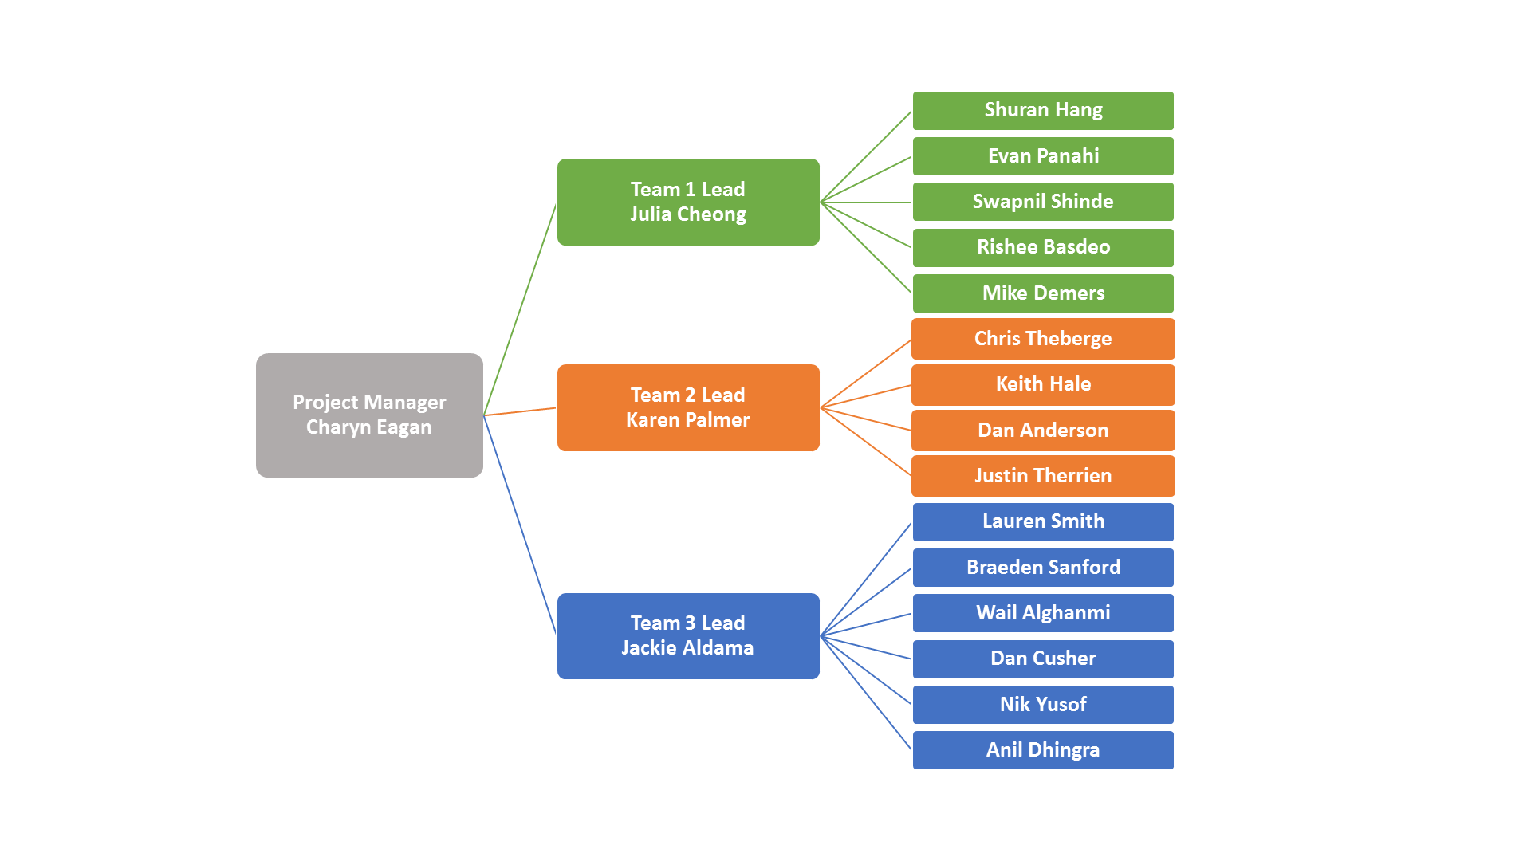

## Figure 2: TheDonorsChoice QA Team

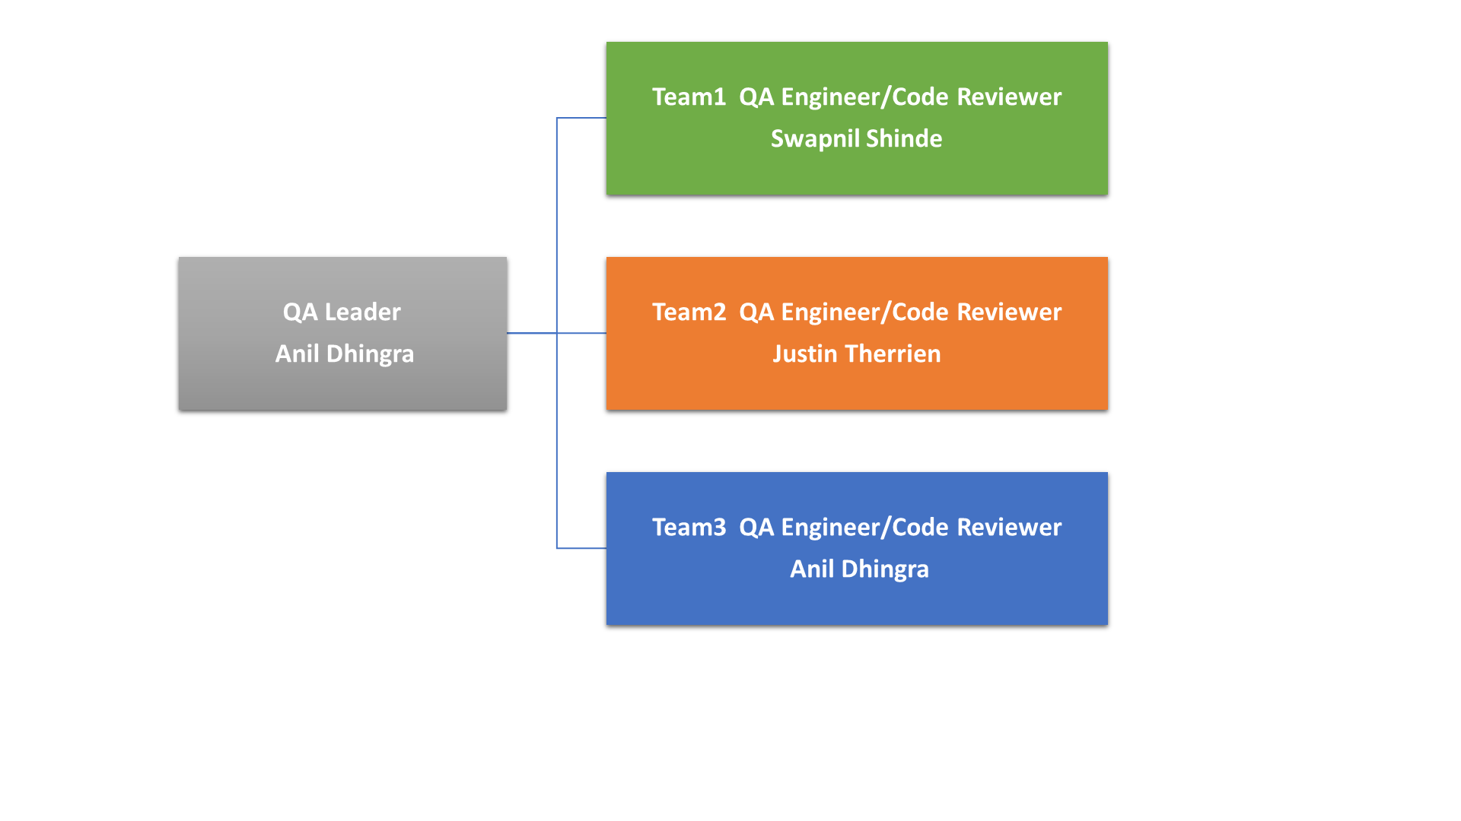

## Figure 3: Documentation Review Process

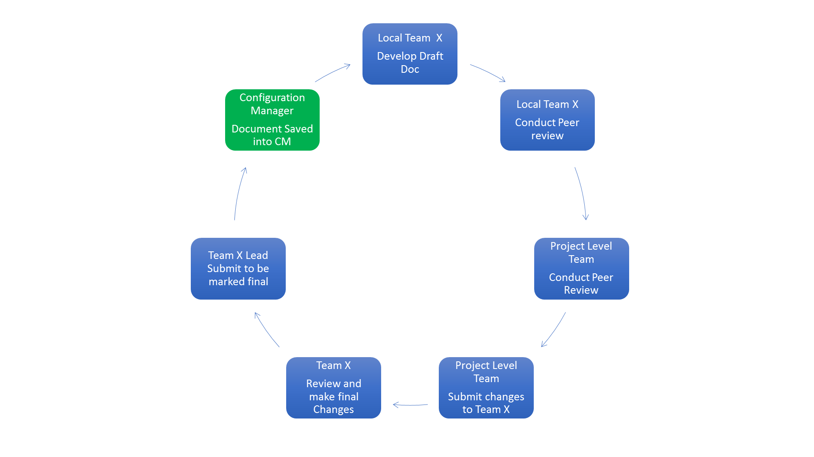

# Appendix B – Referenced Documents

[1] Ron Czik, (2014) Lecture notes, MET CS673 Software Engineering, Spring

[2] Braude, Eric J.,Bernstein, Michael E. (2010) Software Engineering: Modern Approaches Wiley; 2 edition, (p. 104 - 112)

[3] Software Quality Assurance Plan. ACIS. Jan. 2014 http://acis.mit.edu/acis/sqap/sqap.r1.html

[4] Code Conventions for the Java Programming Language. Code Conventions for the Java Programming Language. Jan. 2014 http://www.oracle.com/technetwork/java/codeconv-138413.html

[5] Google Coding Standards for HTML/CSS http://google-styleguide.googlecode.com/svn/trunk/htmlcssguide.xml

# Appendix C – Risks Detail

|  |  |  |  |  |  |  |  |
| --- | --- | --- | --- | --- | --- | --- | --- |
| Risk Description | Objective(s) Affected | Current Probability Category | Current Impact Category | Previous Probability Category | Previous Impact Category | Risk Owner | Mitigation Strategy |
| Risk 1 -  Time | Schedule | 20% | 80% | N/A | N/A | PM & Team Leads | **If** the schedule changes due to customer change in priorities **Then** there will be a schedule increase, additional resources will be needed to support the changes causing additional risks in other project areas **Mitigation Strategy:** Collaborate with the customer weekly, manage and handle any change requests appropriately. We will ensure changes are made only if absolutely necessary and with customer approval. |
| Risk 2 -  Scope | Project Scope | 40% | 90% | N/A | N/A | PM, Team Leads, & Technical Teams | **If** the project scope changes due to customer change in priorities **Then** there will be a change in the schedule resulting in an increase, additional resources will be needed to support the changes causing additional risks in other project areas **Mitigation Strategy:** Ensure the project scope is agreed upon by all stakeholders, collaborate with the customer weekly, manage and handle any change requests appropriately. We will also ensure scope changes are made only if absolutely necessary and with customer and specifically all of the stakeholders approval. |
| Risk 3 -  Time | Schedule | 35% | 70% | N/A | N/A | PM, Team Leads, & Technical Teams | **If** the schedule changes due to technical issues or delays **Then** there will be a schedule increase, additional resources will be need to support the changes causing additional risks in other project areas **Mitigation Strategy:** Collaborate with the technical team daily, manage and handle any change requests appropriately. Ensure that all technical issues are addressed by the most skilled person for the problem. |
| Risk 4 -  Cost | IT Equipment, Web Hosting Costs | 10% | 75% | N/A | N/A | PM, Team Leads, & Technical Teams | **If** the project team is unable to use all open source, free products for development and rollout **Then** there will be an increase in the total project cost **Mitigation Strategy:** Collaborate with the team leads and technical teams weekly or on request; manage and handle any requests/recommendations for products appropriately; ensure products used are carefully considered for use; research similar products and receive customer approval. |

# Appendix D – Glossary

Approved Configuration Items:

Configuration items that are signed off by project management

Artifact:

A final or interim product of the project (e.g., a document, source code, object code, test result)

Branch:

Parallel version of repository contained within the repository, but does not affect the primary or master branch allowing you to work freely without disrupting the "live" version

Configuration Item (CI):

An item tracked by the configuration system

Configuration Management (CM):

The process of maintaining the relevant versions of the project

Git:

Distributed Version Control System (DVCS) tool for allowing multiple persons to collaborate

GitHub:

Web platform for collaborating on Git based version control projects. Also provides access to an Issue Tracking system

GNU General Public License (GNU GPL, GPL):

A free software license, which guarantees end users the freedoms to use, study, share, copy, and modify the software

Google Drive:

Personal cloud storage service from Google that helps users store and synchronize digital content

Merge:

Take the changes from one branch (in the same repository), and apply them into another

MIT License:

Permissive free software license that permits reuse within proprietary software provided all copies of the licensed software include a copy of the MIT License terms

Open Source:

Software that can be freely used, modified, and shared (in both modified and unmodified form) by anyone

Public Domain:

Works whose intellectual property rights have expired, have been forfeited, or are inapplicable

Push:

Sending your committed changes to a remote repository

Repository:

Container for all project files on GitHub including documentation

Software Quality Assurance Plan (SQAP):

Specifies the overall quality plan, policies, and procedures that will be followed by the team

1. ACIS Software Quality Assurance Plan
2. p.104 (2010) Braude, Eric J.,Bernstein, Michael E.
3. p.106 (2010) Braude, Eric J.,Bernstein, Michael E.
4. Code Conventions for the Java Programming Language. Jan. 2014
5. Google Coding Standards for HTML/CSS
6. Google Coding Standards for JavaScript