**Approach to Scoliosis.**

I) **PA** Radiograph of the whole spine – standing , must include the C spine, whole sacrum and iliac crests.

i) Check covers whole spine

ii) Ennumerate all the vertebra: start at C2 and work down

**Lateral must also cover at least C7 to S1**

2) Count the number of curves present

3) Identify the apical curve and describe the location of each curve.

Apical is the most deviated from a central plumb line

4) Identify the end vertebrae of each curve and quantify the magnitude of each curve

i) Cephalad end is the first vertebra in a cephalad direction from the apex whose superior surface is tilted maximally toward the concavity of the curve. (ie the most tilted)

ii) Caudad end is the first vertebra in a caudad direction from the apex whose inferior surface is tilted maximally toward the concavity of the curve.

iii) Measure Cobb angle which is the angle between 2 parallel lines here.

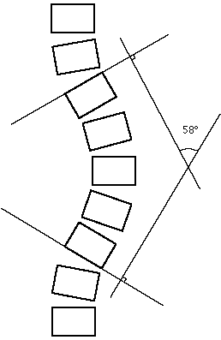

5) Determine which curve is the major curve (= one with the largest Cobb angle)

6) Assess for rotation. Look at the convex pedicle. (Nash –Moe Method)



7) Assess for Coronal Balance

i) Draw Central sacral vertical line (CSVL) – exactly perpendicular to line through iliac crests and runs superiorly through the sacrum

ii) Draw C7 plumb line: Down from middle part of C7 vertebral parallel to edge of film.

Should be less than 1cm between the 2. (Others look at shoulder asymmetry)

8) Assess skeletal maturity

Risser classification and also state if triradiate cartilage ossified. (Risser 5 is fusion of the apophysis)

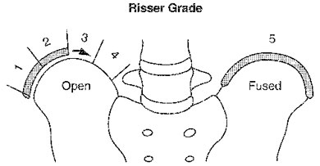

9) Lateral Bending Views - toward the side of the apex)

Assess if curve is structural (does not correct past zero degrees) or non-structural (corrects past 0)

10) Assess for Sagittal Balance on Sagittal view

i) Draw vertical plumb line from centre of C7 body and measure offset from posterosuperior aspect of body of S1

ii)Thoracic kyphosis = angle subtended between top endplate of T4 and bottom endplate of T12.(n=20-50)

iii) Lumbar lordosis = top endplate of L1 and bottom endplate of L5 (n=31-79)