ShapeMaker QuickStart Guide

Open the plugin from Effects > Advanced > DHShapeMaker
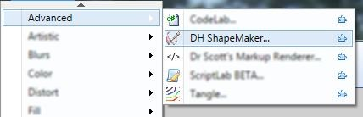

Select the option to Snap by ticking the checkbox. This forces all points (Start, End and Control nubs) onto the grid intersections.
Select the type of Line or Curve you wish to draw.
What does Closed do? It automatically closes a Path by drawing a straight Line from the End point back to the Start point. Check this if you wish to create a closed Shape.
Right click anywhere on the grid to place the Line/Curve Start point.
Click anywhere else on the grid to locate the End point of the Line/Curve.
Drag a Start/End point by clicking + holding the left mouse button while you drag the mouse around. The point will follow the mouse and the Line will be redrawn between the Start and End points. Release the mouse button to stop dragging the point.
If the type you're drawing with is a Curve, control points will be shown. These alter the curvature by changing the angle of the Curve and magnitude. Change the angle of the Curve by dragging the control point clockwise or anticlockwise. Change the magnitude of the Curve by dragging the control point further away from it's reference point(s). Cubic Béziers have two control points associated with the Start and End points. Quadratic Béziers have a single control point
Create another Line/Curve by clicking a new location on the grid. The new Line/Curve will automatically be joined to the End point of the first Line. Add as many new Line/Curve as you like.
Hold down the Shift key and drag any point in the series. The entire Path of Lines moves with the mouse.
The series of Lines is still being actively edited. To commit the Path (or any changes) to the Path List, click on the Apply Edit button. Once clicked the Path is entered into the Path List and editing ceases.
Add another Path using a different type of Curve or Line. See how this second Path automatically joined the terminus of the first Path? What if you don't want that? Click Clear Edit to disengage the automatic connection of a new Path to a previous one.
Commit the second Path to the Path List by clicking Apply Edit.

Quick Reference - Primitive Types
 | Primitive |  | Path (Series) |  | Closed Form
Straight Line | 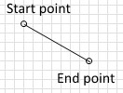 | 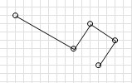 |  | 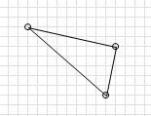
Ellipse | 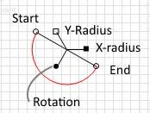 | No Series.  Individual Ellipses form their own complete Path. |  | 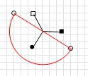
Cubic Bézier | 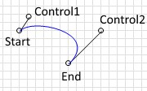 | 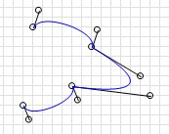 |  | 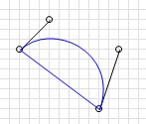
Quadratic  Bézier | 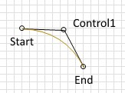 | 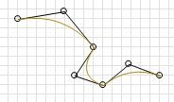 |  | 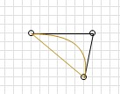

Quick Reference - Smooth Types
 | Smooth Type |  | Path (Series) |  | Closed Form
Smooth Cubic  Bézier | 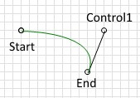 | 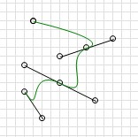 |  | 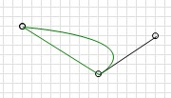
Smooth Quadratic  Bézier | 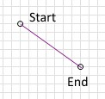 | 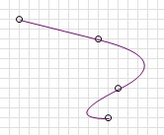 |  | 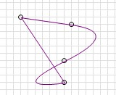

Quick Reference - Compound Types
 | Compound Type | Path (Series) | Closed Form
Straight Line +  Rectangle | 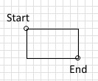 | 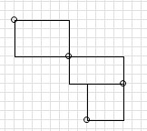 | 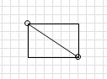
Ellipse + Circle | 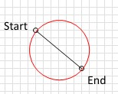 | No Series.  Individual Circles form their own complete Path. | 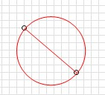

Quick Reference - Mouse & Keyboard Shortcuts
Mouse
Right Click on Work Area to add a nub
Right Click on a nub to delete that nub (note: you cannot delete the first nub in a Path)

Left Click + Hold a nub or handle to drag it to a new location
Left Click in Path Mode on the end or corner of any Line or Curve to select it.
Left Click + Shift Key in Line Mode - click and drag a nub to move entire Line.
Left Click + Shift Key in Path Mode - click and drag on clear space to move entire Path.
Left Click + Alt Key in 2X View pans the entire work area.
Left Click + Ctrl hides the control nubs and points to better view a Line or Curve.

Keyboard
Ctrl + L | Line
Ctrl + R | Rectangle
Ctrl + I | Circle
Ctrl + B | Cubic Bézier
Ctrl + Shift + B Smooth Cubic Bézier
Ctrl + Q Quadratic Bézier
Ctrl + Shift + Q Smooth Quadratic Bézier
Ctrl + E | Ellipse
Ctrl + S | Snap to Grid
Ctrl + 1 | Loop Line
Ctrl + 2 | Close Path
Ctrl + 3 | Link Lines
Enter | Apply Edit
Esc | Clear Edit

