ASSIGNMENT
DATA ANALYSIS AND VISUALISATION NDTA 631
WHEN CREDIT GETS MORE EXPENSIVE IN SOUTH AFRICA,
DOES FARMING ACTIVITY IN THE REGION LOOK DIFFERENT?
Research Report & Demonstration
Name & Surname | Student Number
Reneilwe Morajane | 202112110
Leah Marumo Machaka | 202464717
Amogelang Maine | 202409912
Mhlengie Prince Ngwenya | 202401141
Miranda Nkonwana | 202438359
MK Khosa | 202401364

Contents
1. Introduction 11
The datasets 11
2. Data Preparation 12
2.1 AgriConnect Indicators 12
2.2 Interest Margin to Gross Income 12
2.3 Why the Cleaning Matters 13
2.4 Methods used 13
3. Numerical Analysis Using NumPy 14
3.1 Agricultural Matrix 14
3.2 South Africa Interest Margin 14
3.3 Agricultural Relationships 15
4. Visualization and Interpretation 15
4.1 Market Participation Across Countries 15
4.2 Fertilizer Use Compared with Market Participation 16
4.3 Supporting agricultural visuals 17
5. Database Integration 17
5.2 Import and Query 18
6. Python Integration of the Datasets 19
6.1 Conditional formatting applied (in Excel) 19
6.2 Charts built (in Excel) 19
7. Demo and Conclusion 20
7.1 Main Findings 20
Conclusion: Does the MAIN QUESTION Hold? 21
References and Supporting Evidence 21
Data Sources Used 21
Software / Analytical Tools 21

1. Introduction
South Africa plays an important role in the regional economy, including agriculture, trade and finance. Changes in financial conditions can affect the cost of borrowing for businesses and households. This makes it useful to ask whether changes in South Africa's borrowing-cost environment occur alongside changes in farming activity across the wider Sub-Saharan African region.
This report investigates a simple question: when South Africa's Interest Margin to Gross Income is higher, does agricultural activity in the surrounding region look weaker in the same year? Farming activity is represented mainly by inorganic fertilizer use and agricultural market participation.

The datasets
Dataset | Role in the story | Key information
AgriConnect Indicators | Regional farming activity | Fertilizer use; market participation; production and input indicators
Interest Margin to Gross Income (Core FSI) | South African financial context | Annual South Africa series, 2008–2024
The datasets are connected through year.The analysis uses annual regional agricultural information alongside South Africa's annual interest-margin series.
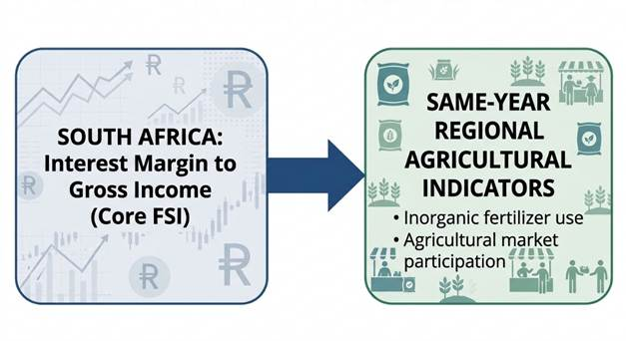
Figure 1: Main Analysis

2. Data Preparation
The first stage was to load, inspect, and clean both datasets. Python and Pandas were used to load the CSV files, inspect their structure, select relevant fields, filter observations, handle missing values, and remove duplicates. NumPy was also imported, but its main analytical use appears in the separate numerical-analysis section, where it performs array and statistical calculations.

2.1 AgriConnect Indicators
Seven agricultural indicators were selected, including market participation, average sold production, inorganic fertilizer use, improved seed use, irrigation, median cultivated area, and median agricultural production value. Non-informative label columns containing 'Not applicable' were removed.

2.2 Interest Margin to Gross Income
The financial dataset was reduced to the fields required for the analysis: country, frequency, financial sector, period, and observation value. South Africa was identified using country code ZAF. The annual series was then used for the main trend and year-based comparison.
Cleaning check | AgriConnect | Interest Margin
Observations after cleaning | 157 | 15,737
Missing values | 0 | 0
Duplicate rows | 0 | 0
South Africa subset | Not available in AgriConnect | ZAF

2.3 Why the Cleaning Matters
Cleaning makes the later comparisons more reliable. Missing values and duplicate rows could distort averages, trends, and correlations. The final datasets were therefore checked before being used in the analysis.

2.4 Methods used
The main goal of data understanding is to gain general insights about the data, which covers the number of rows and columns, values in the data, datatypes, and Missing values in the dataset. Particular methods were used to perform all necessary preparation and analysis.
- shape – shape will display the number of observations(rows) and features(columns) in the dataset
- head() will display the top 5 observations of the dataset
- tail() will display the last 5 observations of the dataset
- info() shows the variables that have missing values.
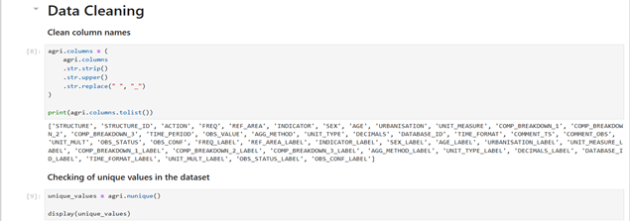
Figure 2: Data preparation evidence

3. Numerical Analysis Using NumPy
NumPy was used directly for the numerical analysis required for the datasets. This included array reshaping and integrity checks, least-squares trend calculations, percentage changes, z-score standardisation, composite-score calculations, and pairwise correlation analysis.

3.1 Agricultural Matrix
The AgriConnect data was pivoted into a country-by-indicator matrix after excluding the continental 'Overall' aggregate. The resulting matrix contained 34 peer countries and 7 indicators. The matrix was flattened into a 1-dimensional array of 238 values and reshaped back to 34 × 7; np.allclose confirmed that the reshape preserved the data structure, including missing-value positions.
Calculation | Result
Country × indicator matrix | 34 × 7
Flattened array | 238 values
Reshaped array | 34 × 7; structure preserved

3.2 South Africa Interest Margin
The annual South African series rises overall, although it fluctuates from year to year. From 2008 to 2024, the mean was 52.71, the standard deviation was 3.33 percentage points, the linear trend slope was 0.5925 percentage points per year, and R-squared was 0.8073. The series increased by 7.84 percentage points overall, from 50.29 in 2008 to 58.13 in 2024. The largest relative increase was 8.29% in 2013, while the largest decrease was 4.12% in 2009.
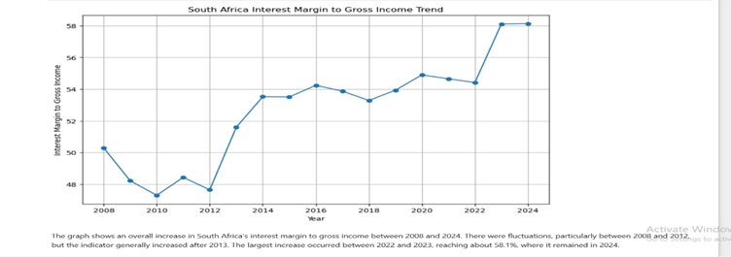
Figure 4: South Africa interest margin trend.

3.3 Agricultural Relationships
The notebook standardized the agricultural indicators using NaN-safe means and standard deviations and calculated an Agricultural Market Integration Index (AMII). The three highest AMII scores were Mozambique (0.753), Somalia (0.700) and The Gambia (0.523), while the three lowest were Comoros (−0.624), Niger (−0.733) and the Central African Republic (−1.086). The pairwise correlation matrix also showed a correlation of 0.684 between production value and market participation and 0.544 between improved seed use and fertilizer use.

4. Visualization and Interpretation
The charts were designed to answer the research question visually. Each chart focuses on one part of the story.

4.1 Market Participation Across Countries
Market participation varies substantially across the countries in the AgriConnect data. Guinea-Bissau and Côte d'Ivoire are among the countries with higher observed market participation, while other countries record lower levels.
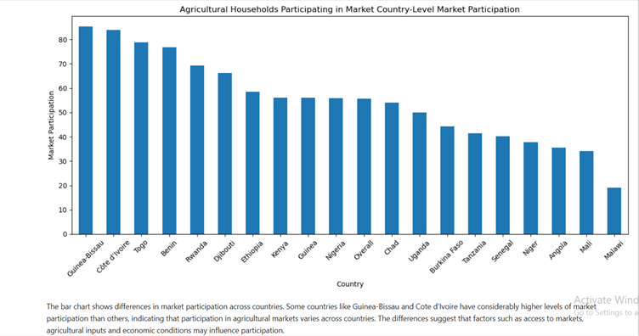
Figure 5: BAR GRAPH showing Market participation by country

4.2 Fertilizer Use Compared with Market Participation
The notebook matched fertilizer-use observations with market-participation observations by country and year and fitted a regression line. The relationship is weak and slightly negative: the slope is −0.1258, correlation is −0.1632, R-squared is 0.0266 and the p-value is 0.4919.
An R-squared of 0.0266 means fertilizer adoption explains very little of the variation in market participation in these matched observations. The p-value of 0.4919 also indicates the notebook provides no strong statistical evidence of a linear relationship between these two agricultural indicators.
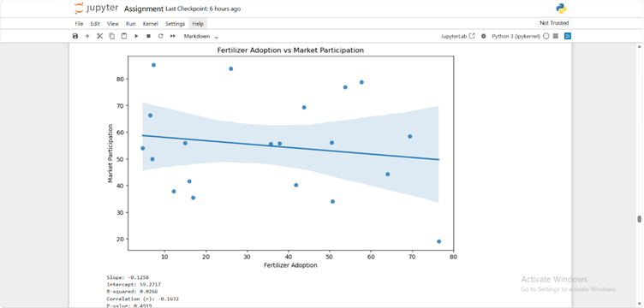
Figure 6 : SCATTER PLOT showing Fertilizer vs market participation

4.3 Supporting agricultural visuals
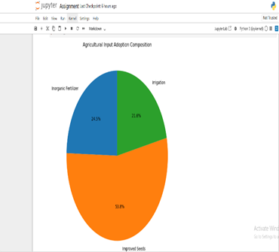 | 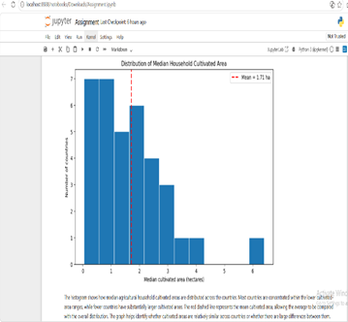
Figure 7: PIE CHART Agricultural input adoption Figure 8: HISTOGRAM

5. Database Integration
The database stage shows that the cleaned information could be stored, queried, updated, deleted, and loaded back into Pandas. The notebook used SQLite through Python's sqlite3 library, providing a working database component for the project.
5.1 Database Structure
A SQLite database file named worldbank_data.db was created with two main tables: interest_margin and agri_indicators. The first stores country, year, quarter and interest-margin values. The second stores country, indicator code, indicator name, year and agricultural values.
Table | Purpose | Important fields
interest_margin | South Africa and other financial observations | Country, year, quarter, interest margin value
agri_indicators | Agricultural indicators | Country, indicator code/name, year, agricultural value

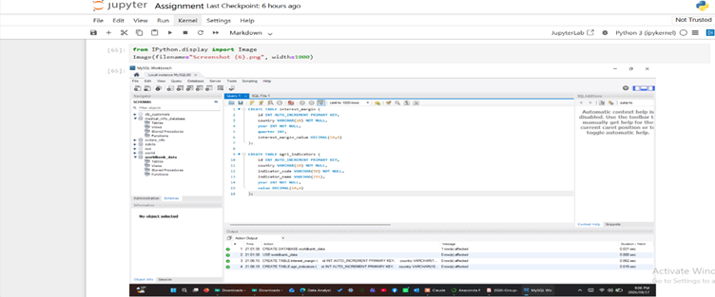
Figure 9: Database schema

5.2 Import and Query
The cleaned datasets were prepared as DataFrames and loaded into the two SQLite tables: 15,737 rows into interest_margin and 157 rows into agri_indicators. The notebook then demonstrated parameterised SELECT queries for South Africa, a safe update operation and a safe delete operation. Finally, both tables were loaded back into Pandas and exported to CSV.
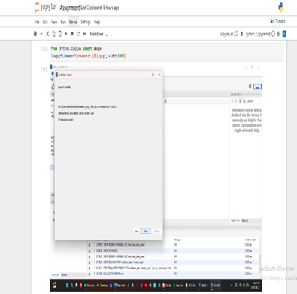 | 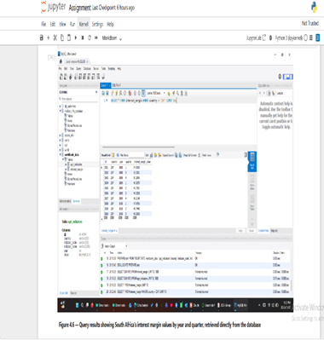
Figure 10: Successful data import Figure 11: South Africa query

6. Python Integration of the Datasets
This section of question 5 in the assignment is responsible for cleaning and transforming data, applying conditional formatting, creating charts, and summarising findings, done in Excel rather than with matplotlib/seaborn as in Part 3. It reuses the same South Africa Interest Margin to Gross Income series cleaned in Part 1 and analysed in Part 3, but performs an independent clean and transform pass and writes the result into an Excel workbook (Q5_Excel_Analysis.xlsx) using the companion script excel_analysis.py in this same folder.

6.1 Conditional formatting applied (in Excel)
- Colour scale (green to yellow to red) on Interest_Margin_Pct, to flag low vs high values at a glance
- Red / blue highlight on YoY_Change_pct. Red means the margin rose that year, blue means it fell
- Red highlight on rows where Margin_Band is "High" (54% and above)

6.2 Charts built (in Excel)
- Trend chart: area filled line, 2008 to 2024, with callouts on the start (2008), low (2010), and high (2024) points
- Year over year change bar chart: red/blue bars matching the same rising/falling logic, with value labels
- Pie chart: share of the 17 years spent in each Margin_Band (Low, Medium, High)

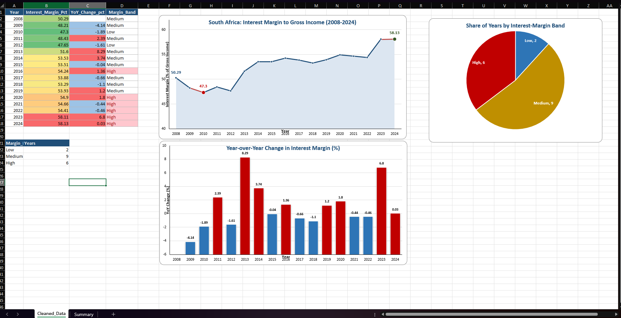Figure 12: Q5_Excel_Analysis.xlsx workbook

7. Demo and Conclusion

7.1 Main Findings
• Data preparation produced clean working datasets: 157 AgriConnect observations and 15,737 Interest Margin observations, with no remaining missing values or duplicate rows after cleaning.
• South Africa's Interest Margin to Gross Income increased overall from 50.29 in 2008 to 58.13 in 2024. The linear trend slope was 0.5925 percentage points per year and R-squared was 0.8073.
• Agricultural indicators vary considerably across the covered countries. The notebook's fertilizer-versus-market-participation regression shows only a weak relationship.
• The fertilizer/market-participation relationship had r = −0.1632 and R-squared = 0.0266, so fertilizer adoption alone is not a strong predictor of market participation.
• The datasets can be connected through year, but AgriConnect has uneven survey coverage. Only 14 of the 17 South African annual years have at least one AgriConnect indicator available in the merged table, which limits the strength of the comparison.

Conclusion: Does the MAIN QUESTION Hold?
The question asks whether years with a higher South African interest margin also show weaker farming activity in the surrounding Sub-Saharan African region. The analysis provides a clear framework for testing this idea.
The strongest supported conclusion is that South Africa's interest margin increased over the study period, while regional agricultural indicators varied across countries and survey years.
In simple terms: the datasets tell one connected story about financial conditions in South Africa and agricultural activity in the wider region, but they do not show a strong enough statistical link to conclude that more expensive credit directly leads to weaker farming activity.

Figure 11 End-to-end demo evidence

References and Supporting Evidence

Data Sources Used
World Bank Data360 : AgriConnect Indicators dataset. Used for the agricultural indicators analysed in this report.
World Bank Data360 :Interest Margin to Gross Income (Core FSI) dataset. Used for the South Africa financial-sector time series.

Software / Analytical Tools
Tool | Use in the project
Python | Main analysis and workflow
Pandas | Data loading, cleaning, reshaping and DataFrame operations
NumPy | Numerical calculations, arrays, standardisation, trend and correlation calculations
Matplotlib / Seaborn | Charts and visualisation
SQLite / Python database tools | Data storage, queries, updates and deletion tests

