MzansiConnect
Smart Municipal Service Reporting and Analytics System
Technical and Academic Documentation
Version 1.0 | 2026 | Windows 11 (x64), Node.js, PostgreSQL 16, Android

Abstract
MzansiConnect is an integrated municipal service-reporting platform that connects citizens to local-government service delivery. The system comprises four presentation applications - a React citizen web portal, an Android citizen client, a staff operations dashboard, and an administrative analytics dashboard - that all read from and write to a single PostgreSQL-backed Node.js API. This document describes the purpose, architecture, and interface of each application, presents captured screenshots of the working system, and documents the database layer that acts as the authoritative source of truth. The report serves both as a technical reference and as an academic record of the implemented system.
Keywords: service delivery, e-government, PostgreSQL, REST API, Android, React, database normalisation, multi-factor authentication.

1. Introduction

1.1 Background
South African municipalities frequently receive service-delivery complaints through unstructured channels such as telephone calls, paper forms, and social media, which makes prioritisation, tracking, and reporting difficult. MzansiConnect addresses this by providing one structured pipeline: a citizen submits a report with a category, municipality, description, and location; the report is committed to PostgreSQL; and it then appears immediately in municipality-scoped staff queues and administrative analytics.

1.2 Objectives
1. Provide a single, validated intake channel for municipal service reports.
2. Store every report as an authoritative database row with an SLA deadline.
3. Give staff a municipality-scoped queue with controlled status transitions.
4. Provide administrators with database-backed analytics and workforce management.
5. Secure staff and administrative access using password plus one-time MFA codes.

1.3 Scope
The system delivers four applications and one shared API against one PostgreSQL database. Sample analytics and sample outage rows were deliberately removed so that all dashboards reflect real committed data only.

2. System Architecture

2.1 Component Overview
Component | Technology | Role
Citizen Portal | Vite + React (TypeScript) | Citizen web intake and tracking
Android Client | Kotlin, Jetpack Compose, Room | Native citizen mobile intake and tracking
Staff Dashboard | Static HTML/CSS/JS | Municipality-scoped operations queue
Admin Dashboard | Static HTML/CSS/JS | Workforce management and analytics
API | Node.js, pg | Validation, persistence, auth, realtime events
Database | PostgreSQL 16 | Single source of truth

2.2 Data Flow
A citizen submission calls POST /api/reports. The API validates the category and municipality against PostgreSQL reference tables, commits the row (including the 48-hour default sla_due_at), then broadcasts a server-sent event on GET /api/events. Staff and administrative clients react by reloading GET /api/dashboard; the Android client refreshes its Room mirror only after the API confirms. Room is a replaceable display cache, never the system of record.

2.3 Authentication
Dashboard login is a two-step process. POST /api/auth/login verifies the password and dispatches a one-time code through Resend (email) or Twilio (SMS). POST /api/auth/verify-mfa validates the hashed, ten-minute, five-attempt code and issues a Bearer token. Provider credentials remain server-side; the web and Android clients never hold provider secrets.

3. Citizen Portal (Web)
The citizen web portal is a Vite/React single-page application served on http://localhost:5173. It loads its category and municipality choices from GET /api/options, submits reports, and renders each citizen's own reports by stable external reference. Interface features include a hero landing section, a guided report form with GPS reverse-geocoding, a load-shedding banner, a community feed, a citizen assistant, and a gamified leaderboard.
[ INSERT SCREENSHOT HERE - Figure 3.1: Citizen portal landing and service-report entry ]

4. Android Citizen Application
The Android client (MzansiConnect/) is a native Kotlin/Compose application that posts to POST /api/reports and mirrors confirmed rows into a local Room database. It identifies the citizen through a stable app_users.external_ref. The following figures were captured from the running application in an Android emulator using http://10.0.2.2:8787/ as the API base URL.
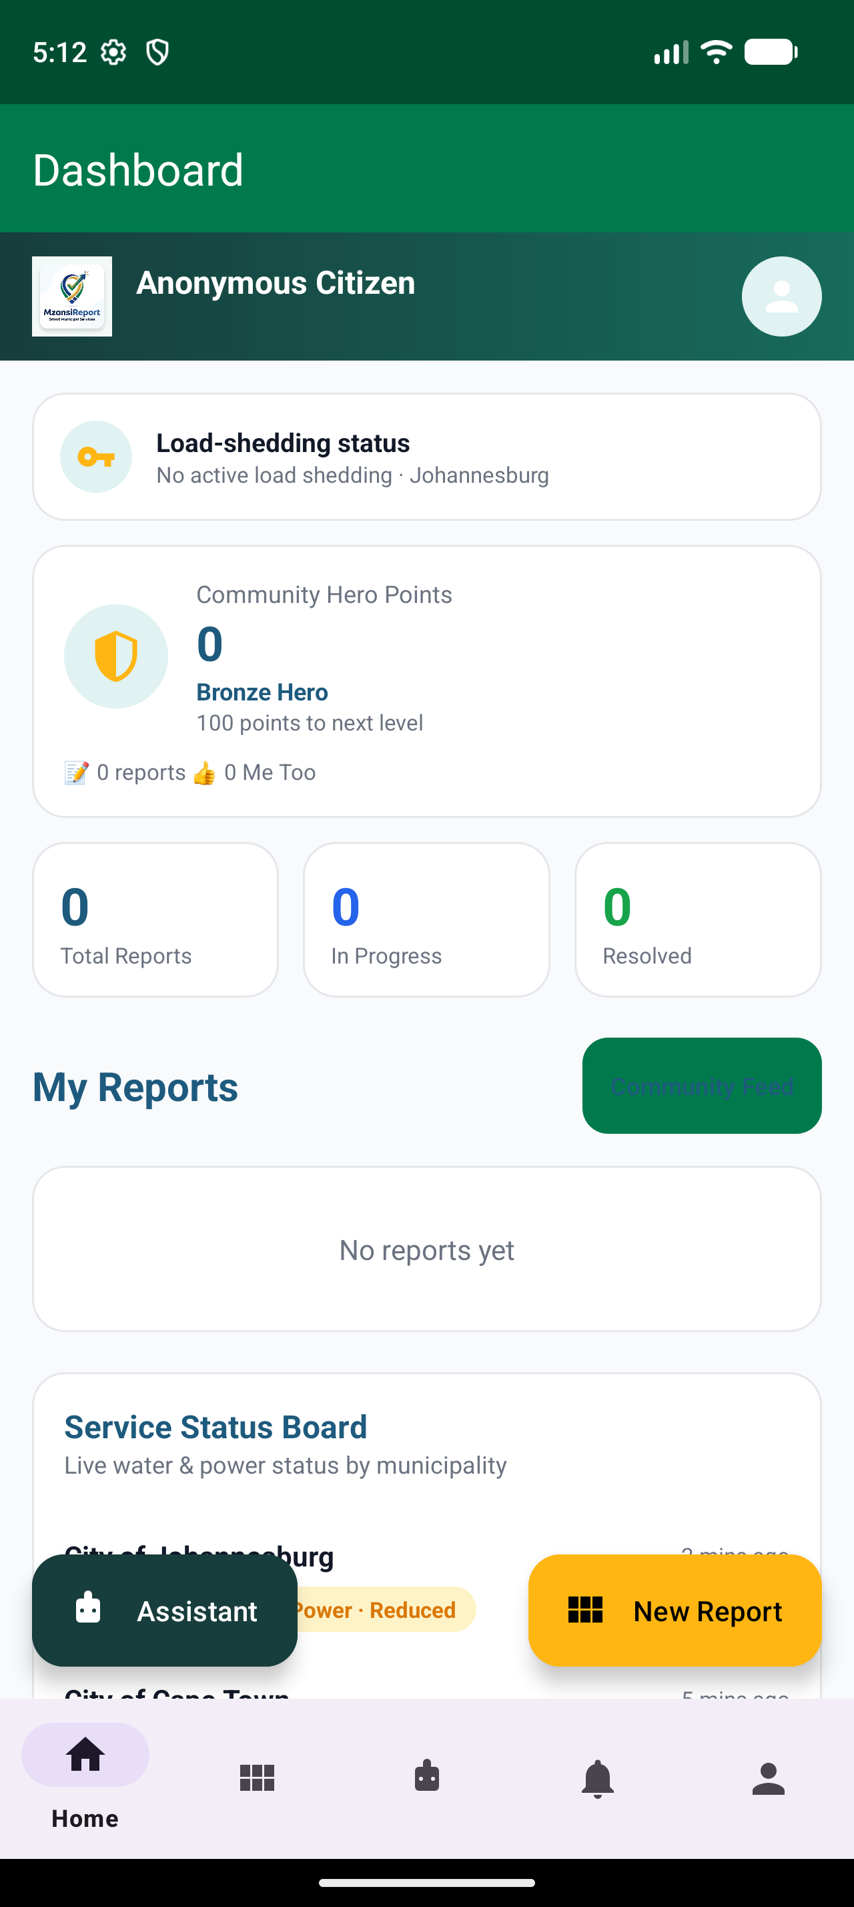  Figure 4.1 - Application launch and splash | 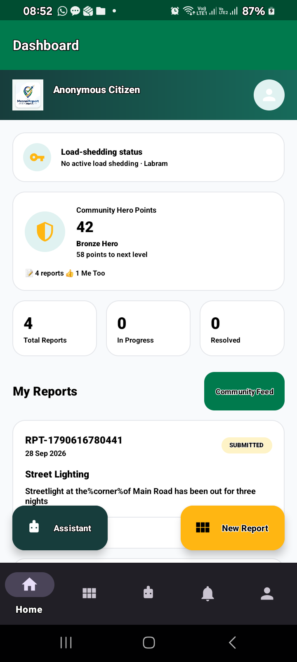  Figure 4.2 - Citizen home and navigation | 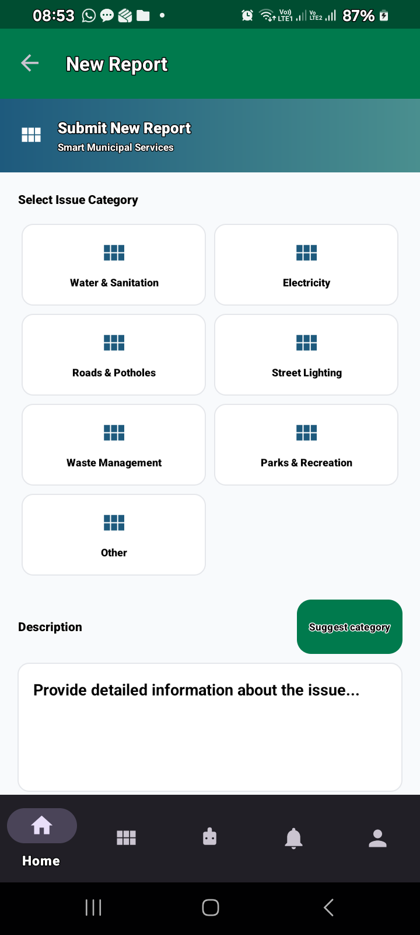  Figure 4.3 - Service report form | 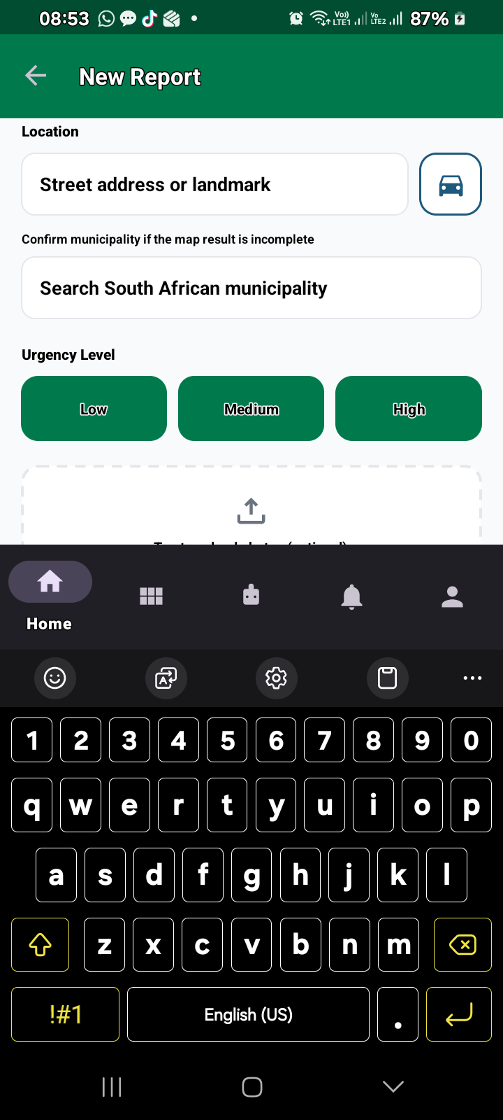  Figure 4.4 - Category and municipality selection
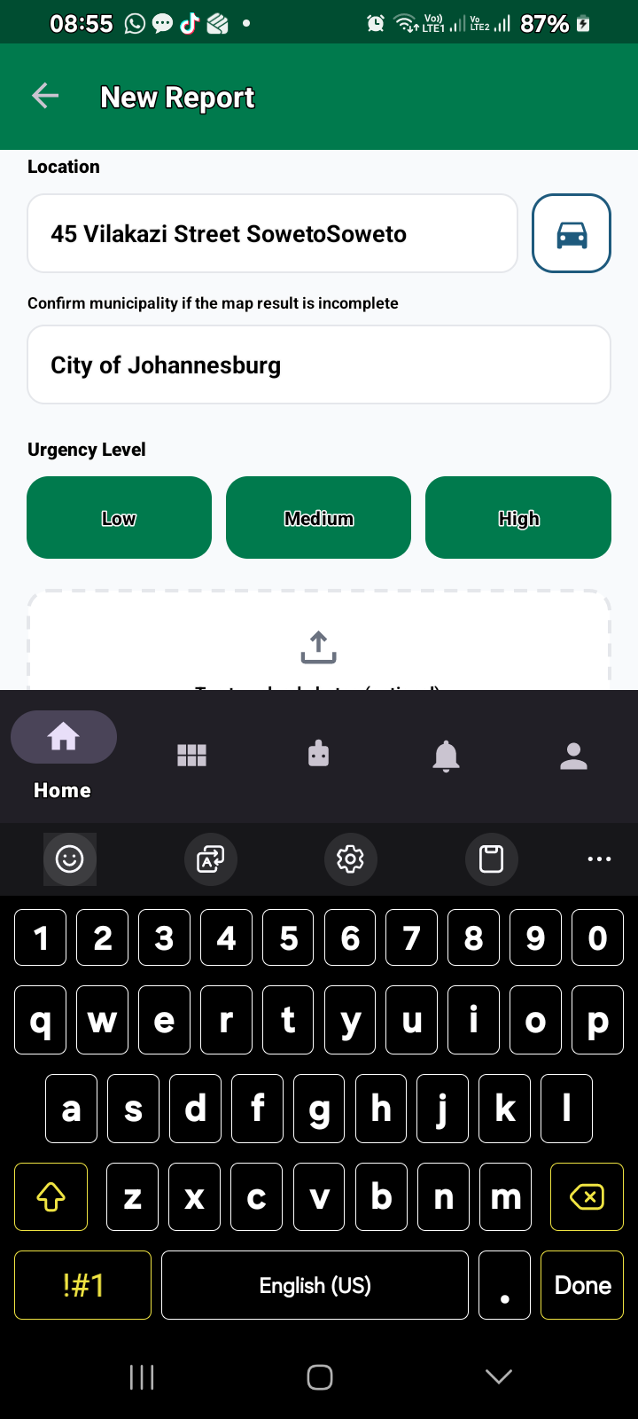  Figure 4.5 - Report submission confirmation | 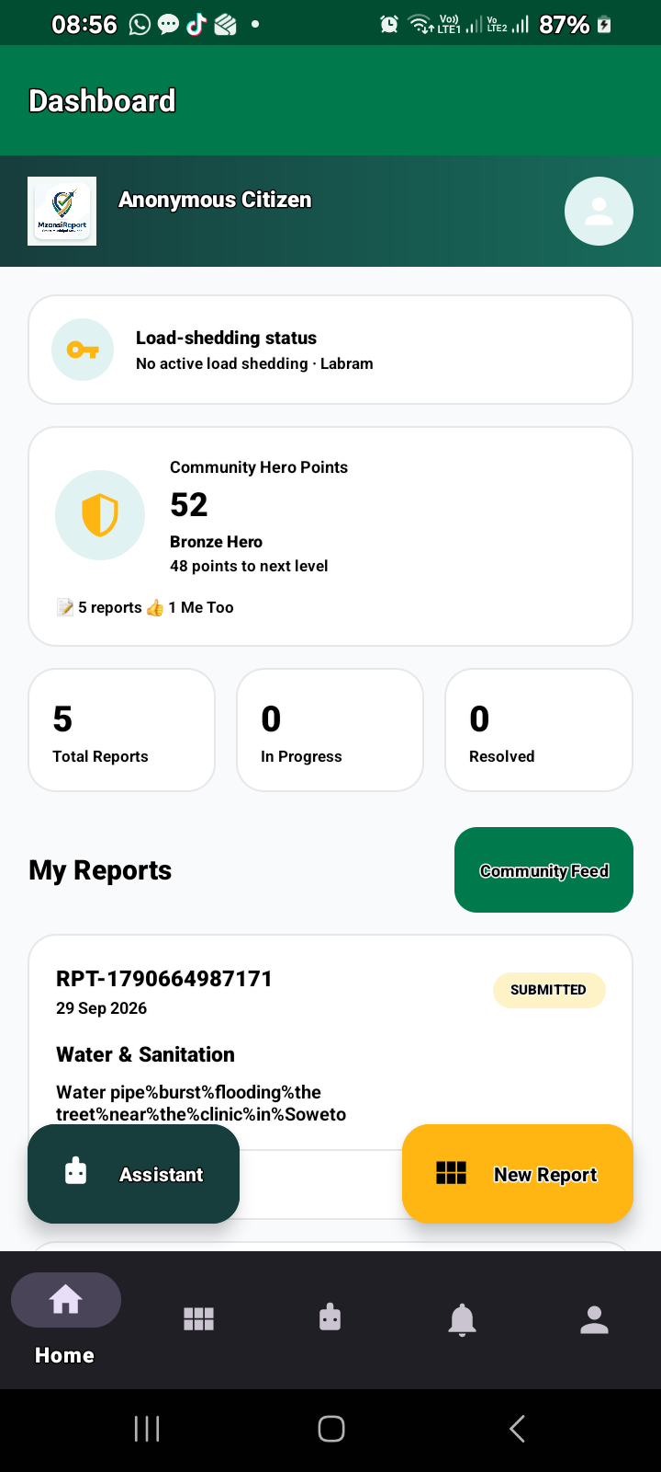  Figure 4.6 - Report list and status tracking | 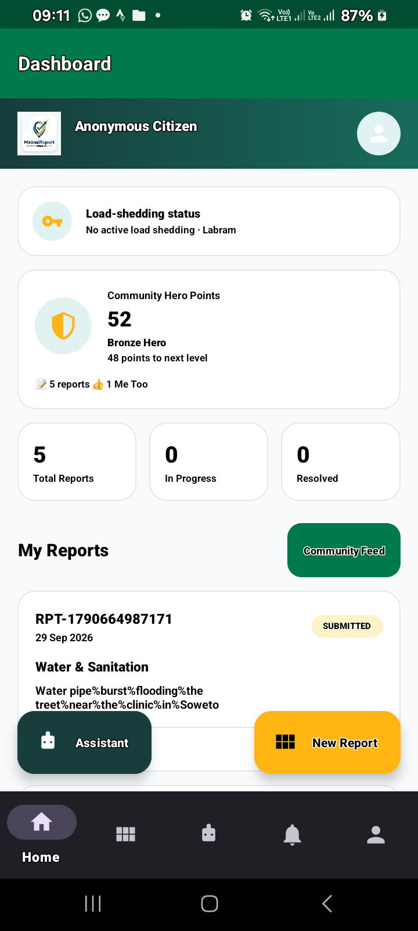  Figure 4.7 - Report detail with SLA countdown

5. Staff Operations Dashboard
The staff dashboard is a static client served at http://localhost:8080/Staff%20Dashboard/. After MFA login it presents a municipality-scoped Service queue (Open work). Each job card shows the public reference, category, urgency, description, location, citizen chip, and current status, with a status selector supporting the transitions Submitted -> Under review -> Assigned -> In progress -> Resolved -> Closed. A search box filters the queue by reference, category, or location, and a live-status indicator reflects the server-sent event connection. A load-shedding panel queries the backend's EskomSePush integration.
[ INSERT SCREENSHOT HERE - Figure 5.1: Staff sign-in screen ]
[ INSERT SCREENSHOT HERE - Figure 5.2: Staff service queue with status controls ]

6. Admin Dashboard
The admin dashboard is served at http://localhost:8080/Admin%20Dashboard/ and is protected by the same password-plus-MFA flow with the admin role. It presents a Municipal pulse header with API-monitoring health, an overview statistic grid, a load-shedding panel, a Workforce panel (active employees and open assignments), and a Recent demand panel (highest-priority reports first). It also provides the Add staff member form that calls POST /api/staff, hashing the password with PostgreSQL crypt() and recording municipality, department, and an optional SMS number. Administrative analytics are drawn from GET /api/admin/analytics, which aggregates category, status, monthly, and municipality counts from service_reports.
[ INSERT SCREENSHOT HERE - Figure 6.1: Admin sign-in screen ]
[ INSERT SCREENSHOT HERE - Figure 6.2: Admin municipal pulse, workforce, and demand panels ]

7. Database Layer (PostgreSQL)

7.1 Schema
The schema (backend/schema.sql) defines enumerated types user_role, report_status, and urgency_level, and the tables app_users, service_categories, service_reports, report_assignments, report_status_events, audit_events, and auth_mfa_challenges. Queue, citizen, assignment, workforce, and MFA indexes support the dashboard access patterns, and a touch_updated_at() trigger maintains updated_at on update.

7.2 Municipal (Data Normalisation) Migration
Staff accounts are created through an administrative free-text Municipality field, so the same municipality may be stored in several textual forms (sol plaatje municipality, Sol Plaatje Local Municipality, City of Johannesburg, Johannesburg). Without normalisation, a staff member can sign in and see an empty queue. Migration 003_normalise_municipality.sql introduces the normalise_municipality(value) function, declared IMMUTABLE, which lower-cases, trims, collapses whitespace, strips an optional City of/Municipality of prefix, and strips an optional trailing Local/Metropolitan/District Municipality or Municipality suffix. It mirrors normaliseMunicipality() in the API so that application and database comparisons agree, and it is paired with the functional index reports_municipality_norm_idx so municipality-scoped queries remain fast.
[ INSERT SCREENSHOT HERE - Figure 7.1: PostgreSQL normalise_municipality applied to stored reports ]

7.3 Reference Data
Service categories are seeded in service_categories, and the municipality directory is populated by the explicit importer (npm run import:municipalities), which aborts unless it reads exactly 8 metropolitan, 44 district, and 205 local municipalities - it never publishes a partial list. Optional report photos (migration 006) are stored in report_photos and served only to the submitting citizen or to municipality-scoped staff/admin accounts.
[ INSERT SCREENSHOT HERE - Figure 7.2: Municipality reference table in PostgreSQL ]
[ INSERT SCREENSHOT HERE - Figure 7.3: Service reports with normalised municipality values ]

8. Evaluation and Discussion
The architecture centralises authority in PostgreSQL, which removes the divergence that arises when multiple clients hold their own state. Key strengths are: validated, structured intake; a single SLA-authoritative deadline; role-scoped tokens enforced by the API; and analytics computed only from real rows. The principal operational dependency is the MFA provider: seeded example.gov.za addresses are placeholders and cannot receive codes, so production access requires real Resend/Twilio credentials and reachable contacts. For production the system requires HTTPS, a managed secret store, database backups, rate limiting, and an established identity provider.

9. Conclusion
MzansiConnect demonstrates a coherent multi-client service-delivery platform in which a React web portal, a native Android client, a staff operations dashboard, and an administrative analytics dashboard share one PostgreSQL system of record. The documented migrations - in particular the municipality normalisation function - illustrate how application-level and database-level agreement on data semantics is essential to correct, non-empty staff queues and reliable analytics.

Appendix A - API Endpoints
Method | Path | Access | Purpose
GET | /health | Public | API and PostgreSQL health
GET | /api/options | Public | Categories and municipalities
POST | /api/auth/login | Public | Check password and send MFA code
POST | /api/auth/verify-mfa | Public | Verify code and issue token
GET | /api/dashboard | Staff/admin | Report queue and workforce summary
GET | /api/admin/analytics | Admin | Report aggregates from PostgreSQL
POST | /api/reports | Citizen | Commit a report and broadcast update
GET | /api/reports?externalRef=.. | Citizen | Read a citizen's reports
PATCH | /api/reports/:id/status | Staff/admin | Update status and audit trail
GET | /api/events | All roles | Server-sent live updates

Appendix B - Migration Order
1. schema.sql 2. 002_external_ref.sql 3. 003_normalise_municipality.sql 4. 004_mfa_challenges.sql 5. 005_service_categories.sql 6. 006_municipalities_and_photos.sql 7. npm run import:municipalities 8. seed.sql

