CHAROTAR UNIVERSITY OF SCIENCE AND TECHNOLOGY (CHARUSAT)
Chandubhai S. Patel Institute of Technology (CSPIT)
Department of Computer Science & Engineering
ITUE203 – Web Development Frameworks

PRACTICAL 13

AJAX Event CRUD with the JavaScript Fetch API and a PHP JSON API
PHP 8 · MySQLi · MySQL (MariaDB) · JavaScript Fetch API · JSON
Student Name | Shreyas
Roll Number | 25CS023
Student ID | 25CS023
Email | 25cs023@charusat.edu.in
Course | ITUE203 – Web Development Frameworks
Programme | B.Tech Computer Science & Engineering
Semester / Academic Year | 3 / 2026-27
Date of Submission
Faculty Signature

1. Problem Definition and Objectives
In a classic PHP application every action submits a form and reloads the whole page. An event list that is edited often feels slow that way and loses the user's position and search. The aim of this practical is to manage events asynchronously: the browser sends small requests with the JavaScript Fetch API to a PHP endpoint that answers in JSON, and the page updates only the affected part – the page is never reloaded.
- List events from MySQL, add, edit/update and delete events with Fetch requests to api.php – without reloading the page.
- Return valid JSON for every request, handle GET (read) and POST (change) correctly and answer other methods with an error.
- Validate all input on the server before any database operation; use MySQLi prepared statements; output data safely.
- Handle errors centrally in JSON and show loading, success and error states in the page.
- Intermediate extension: an AJAX search with debounce (request sent only after the user stops typing).
Starting point: the Practical-13 folder contained an older version built with PDO on the shared student_db database (students and a role-based menu). It was backed up and replaced by the event application described here, which uses MySQLi and its own database studenthub_prac13. The five required file names were kept.

2. Tools and Technologies
Tool | Use in this practical
PHP 8.2.12 (XAMPP), MySQLi | JSON API (api.php), database connection (db.php), prepared statements
MariaDB 10.4.32 (XAMPP) | Database studenthub_prac13; schema.sql exported with mysqldump
HTML5, CSS3 | index.html (table, form, dialog), style.css
JavaScript (ES2020) – Fetch API | script.js: fetch(), async/await, JSON, AbortController, debounce
Microsoft Edge + DevTools | Running the page; Network panel evidence; headless Edge (Playwright) for the browser test
Python 3 | tests/test_app.py – automated API tests (standard library only)

3. Required Source Files
File | Purpose
db.php | MySQLi connection to studenthub_prac13; settings from defaults, config.local.php or P13_* variables; errors logged, never shown
api.php | JSON API: list/get (GET), create/update/delete (POST); validation; prepared statements; central JSON error handling
index.html | Front end: event table, add/edit form, search box, category filter, loading indicator, messages, delete dialog
script.js | Fetch API: apiRequest() wrapper, table rendering with textContent, debounced search, loading/success/error states
schema.sql | Importable schema of studenthub_prac13 with 12 fictional events (mysqldump export)

Helper files: style.css, favicon.svg, router.php (rules for PHP's built-in server), start-server.bat, .htaccess, config.example.php, .gitignore.

4. Database Schema
studenthub_prac13 contains one InnoDB table, events. CHECK constraints repeat the most important rules inside MySQL (category list, capacity 1–5000, title at least 3 characters); indexes support sorting by date and searching.
Column | Type | Rules
event_id | INT UNSIGNED AUTO_INCREMENT | Primary key
title | VARCHAR(120) | 3–120 characters; index
description | VARCHAR(1000) | 10–1000 characters
category | VARCHAR(30) | Cultural, Hackathon, Seminar, Sports, Technical, Workshop; index
event_date / start_time | DATE / TIME | valid date 2000–2100, time HH:MM; composite index
venue | VARCHAR(120) | 2–120 characters
capacity | SMALLINT UNSIGNED | 1–5000
status | ENUM('open','closed') | default open
created_at / updated_at | DATETIME | updated_at changes on every UPDATE

schema.sql (lines 43–62) – events table (12 fictional seed events: 9 open, 3 closed)
43 CREATE TABLE `events` (
44 `event_id` int(10) unsigned NOT NULL AUTO_INCREMENT,
45 `title` varchar(120) NOT NULL,
46 `description` varchar(1000) NOT NULL,
47 `category` varchar(30) NOT NULL,
48 `event_date` date NOT NULL,
49 `start_time` time NOT NULL,
50 `venue` varchar(120) NOT NULL,
51 `capacity` smallint(5) unsigned NOT NULL,
52 `status` enum('open','closed') NOT NULL DEFAULT 'open',
53 `created_at` datetime NOT NULL DEFAULT current_timestamp(),
54 `updated_at` datetime NOT NULL DEFAULT current_timestamp() ON UPDATE current_timestamp(),
55 PRIMARY KEY (`event_id`),
56 KEY `idx_events_date` (`event_date`,`start_time`),
57 KEY `idx_events_category` (`category`),
58 KEY `idx_events_title` (`title`),
59 CONSTRAINT `chk_events_category` CHECK (`category` in ('Cultural','Hackathon','Seminar','Sports','Technical','Workshop')),
60 CONSTRAINT `chk_events_capacity` CHECK (`capacity` between 1 and 5000),
61 CONSTRAINT `chk_events_title` CHECK (char_length(`title`) >= 3)
62 ) ENGINE=InnoDB AUTO_INCREMENT=13 DEFAULT CHARSET=utf8mb4 COLLATE=utf8mb4_unicode_ci;

4.1 Running the application
- Start MySQL in the XAMPP Control Panel.
- Import: phpMyAdmin → Import → schema.sql, or C:\xampp\mysql\bin\mysql.exe -u root < schema.sql in the Practical-13 folder.
- Start: start-server.bat, or C:\xampp\php\php.exe -S 127.0.0.1:8613 router.php in the Practical-13 folder.
- Open http://127.0.0.1:8613/index.html in Microsoft Edge; F12 → Network → Fetch/XHR shows every request to api.php.

5. AJAX CRUD Implementation

5.1 PHP JSON API (api.php)
api.php reads action from the query string. list and get require GET; create, update and delete require POST with a JSON body (Content-Type: application/json and the header X-Requested-With: fetch). Every answer leaves through one function, respond(), which sets the status code and JSON headers. Expected problems are thrown as ApiError (400, 404, 405, 415, 422); anything else is caught by the central exception handler, written to the PHP error log and answered with a general 500 message – no SQL or connection details reach the browser.
api.php (lines 29–52) – single JSON exit point and central error handling
29 // The single exit point: sends the status code, JSON headers and the JSON body
30 function respond(int $status, array $body): never
31 {
32 http_response_code($status);
33 header('Content-Type: application/json; charset=utf-8');
34 header('Cache-Control: no-store');
35 header('X-Content-Type-Options: nosniff');
36 echo json_encode($body, JSON_UNESCAPED_UNICODE | JSON_UNESCAPED_SLASHES | JSON_HEX_TAG | JSON_HEX_AMP | JSON_HEX_APOS | JSON_HEX_QUOT);
37 exit;
38 }
39
40 // Centralized error handling: expected problems are ApiError, everything else is logged and answered with 500
41 set_exception_handler(function (Throwable $e): void {
42 if ($e instanceof ApiError) {
43 $body = ['ok' => false, 'error' => $e->getMessage()];
44 if ($e->fields) {
45 $body['errors'] = $e->fields;
46 }
47 respond($e->getCode(), $body);
48 }
49 error_log('Practical 13 API error: ' . get_class($e) . ' [' . $e->getCode() . '] ' . $e->getMessage());
50 respond(500, ['ok' => false, 'error' => 'The server could not complete the request. Please try again later.']);
51 });
52 set_error_handler(function (int $severity, string $message, string $file, int $line): bool {

validate_event() checks every field before any INSERT or UPDATE and returns all problems at once (HTTP 422 with an errors object, one message per field). The queries use MySQLi prepared statements; the search escapes the user's % and _ so they are searched literally.
api.php (lines 188–215) – list with search and category filter (prepared statement)
188 case 'list':
189 require_method('GET');
190 $q = is_string($_GET['q'] ?? null) ? mb_substr(trim($_GET['q']), 0, 100) : '';
191 $category = is_string($_GET['category'] ?? null) && in_array($_GET['category'], CATEGORIES, true) ? $_GET['category'] : '';
192 $sql = 'SELECT ' . EVENT_COLUMNS . ' FROM events WHERE 1 = 1';
193 $types = '';
194 $params = [];
195 if ($q !== '') {
196 $like = '%' . addcslashes($q, '\\%_') . '%'; // the user's % and _ are searched literally
197 $sql .= ' AND (title LIKE ? OR venue LIKE ? OR category LIKE ? OR description LIKE ?)';
198 $types .= 'ssss';
199 array_push($params, $like, $like, $like, $like);
200 }
201 if ($category !== '') {
202 $sql .= ' AND category = ?';
203 $types .= 's';
204 $params[] = $category;
205 }
206 $stmt = $db->prepare($sql . ' ORDER BY event_date, start_time, event_id');
207 if ($types !== '') {
208 $stmt->bind_param($types, ...$params);
209 }
210 $stmt->execute();
211 $events = array_map('format_event', $stmt->get_result()->fetch_all(MYSQLI_ASSOC));
212 $total = $db->prepare('SELECT COUNT(*) FROM events');
213 $total->execute();
214 respond(200, ['ok' => true, 'count' => count($events), 'total' => (int) $total->get_result()->fetch_row()[0],
215 'query' => $q, 'category' => $category, 'categories' => CATEGORIES, 'events' => $events]);

api.php (lines 229–238) – update: id check, 404, validation, prepared UPDATE
229 case 'update':
230 require_method('POST');
231 $body = json_body();
232 $id = event_id($body['event_id'] ?? null);
233 find_event($db, $id); // 404 if it no longer exists
234 $e = validate_event($body);
235 $stmt = $db->prepare('UPDATE events SET title = ?, description = ?, category = ?, event_date = ?, start_time = ?, venue = ?, capacity = ?, status = ? WHERE event_id = ?');
236 $stmt->bind_param('ssssssisi', $e['title'], $e['description'], $e['category'], $e['event_date'], $e['start_time'], $e['venue'], $e['capacity'], $e['status'], $id);
237 $stmt->execute();
238 respond(200, ['ok' => true, 'message' => 'Event “' . $e['title'] . '” was updated.', 'event' => find_event($db, $id)]);

5.2 Fetch API front end (script.js)
All requests go through apiRequest(). It builds the URL, sends JSON for POST requests, parses the JSON answer and turns any non-OK answer into a JavaScript error that carries the server's message and the per-field errors.
script.js (lines 14–43) – the Fetch wrapper
14 async function apiRequest(action, { method = 'GET', params = {}, body = null, signal } = {}) {
15 const url = new URL(API, window.location.href);
16 url.searchParams.set('action', action);
17 Object.entries(params).forEach(([k, v]) => { if (v !== '' && v != null) url.searchParams.set(k, v); });
18 const options = { method, signal, headers: { Accept: 'application/json' } };
19 if (body !== null) {
20 options.headers['Content-Type'] = 'application/json';
21 options.headers['X-Requested-With'] = 'fetch';
22 options.body = JSON.stringify(body);
23 }
24 let response;
25 try {
26 response = await fetch(url, options);
27 } catch (err) {
28 if (err.name === 'AbortError') throw err;
29 throw new Error('The server could not be reached. Check that the PHP server is running.');
30 }
31 let data;
32 try {
33 data = await response.json();
34 } catch {
35 throw new Error(`The server sent an invalid response (HTTP ${response.status}).`);
36 }
37 if (!response.ok || !data.ok) {
38 const error = new Error(data.error || `Request failed (HTTP ${response.status}).`);
39 error.fields = data.errors || {};
40 error.status = response.status;
41 throw error;
42 }
43 return data;

After a successful create or update the form closes, a green message appears and the list is re-read with a GET request, the changed row highlighted; after a delete the row is removed. Data is always inserted with textContent (never innerHTML), so HTML in a title is shown as text. While a request runs, a loading indicator is shown and the table is dimmed; errors appear as a red message and next to the fields.
script.js (lines 190–215) – add/update without reloading the page
190 async function saveEvent(event) {
191 event.preventDefault();
192 clearFieldErrors();
193 const data = Object.fromEntries(new FormData($('event-form')).entries());
194 const isEdit = data.event_id !== '';
195 const errors = clientErrors(data);
196 if (Object.keys(errors).length) {
197 showFieldErrors(errors);
198 showMessage('Please correct the highlighted fields.', 'error');
199 return;
200 }
201 if (!isEdit) delete data.event_id;
202 const button = $('save-btn');
203 button.disabled = true;
204 setLoading(true, isEdit ? 'Saving changes…' : 'Adding event…');
205 try {
206 const result = await apiRequest(isEdit ? 'update' : 'create', { method: 'POST', body: data });
207 closeForm();
208 showMessage(result.message, 'success');
209 await loadEvents(result.event.event_id);
210 } catch (err) {
211 showFieldErrors(err.fields || {});
212 showMessage(err.message, 'error');
213 } finally {
214 button.disabled = false;
215 setLoading(false);

5.3 AJAX search with debounce
The search box sends no request per key press. Each key press restarts a 350 ms timer; only when the user pauses is the request sent. A still-running older search is cancelled with an AbortController, so results never arrive in the wrong order. In the browser test, typing “lab” key by key produced exactly one request (q=lab).
script.js (lines 134–137) – debounce
134 // Debounce: wait until the user stops typing for 350 ms before sending the search request
135 function onSearchInput() {
136 clearTimeout(searchTimer);
137 searchTimer = setTimeout(() => loadEvents(), 350);

6. Fetch API Request and Response Examples
The following exchanges were recorded from the running API (the same requests that script.js sends):
GET api.php?action=list&q=robotics
{"ok":true,"count":1,"total":12,"query":"robotics","category":"","categories":["Cultural","Hackathon","Seminar","Sports","Technical","Workshop"],"events":[{"event_id":6,"title":"Robotics Expo","description":"Line-following robots, drones and robotic arms built by student teams.","category":"Technical","event_date":"2027-01-09","start_time":"11:00","venue":"Exhibition Hall","capacity":400,"status":"open","created_at":"2026-07-06 10:00:00","updated_at":"2026-07-06 10:00:00"}]}
[HTTP 200]

POST api.php?action=create
{"ok":true,"message":"Event “Hack Night 2027” was added.","event":{"event_id":13,"title":"Hack Night 2027","description":"An overnight mini-hackathon with the Fetch API.","category":"Hackathon","event_date":"2027-03-06","start_time":"19:00","venue":"Innovation Lab, Block A","capacity":80,"status":"open","created_at":"2026-10-30 20:14:38","updated_at":"2026-10-30 20:14:38"}}
[HTTP 200]

POST api.php?action=update
{"ok":true,"message":"Event “Hack Night 2027” was updated.","event":{"event_id":13,"title":"Hack Night 2027","description":"An overnight mini-hackathon with the Fetch API.","category":"Hackathon","event_date":"2027-03-06","start_time":"20:00","venue":"Innovation Lab, Block A","capacity":90,"status":"open","created_at":"2026-10-30 20:14:38","updated_at":"2026-10-30 20:14:38"}}
[HTTP 200]

POST api.php?action=delete
{"ok":true,"message":"Event “Hack Night 2027” was deleted.","deleted_id":13}
[HTTP 200]

POST api.php?action=create (invalid)
{"ok":false,"error":"Please correct the highlighted fields.","errors":{"title":"Title must be 3–120 characters.","event_date":"Enter a valid date (YYYY-MM-DD).","capacity":"Capacity must be a whole number from 1 to 5000."}}
[HTTP 422]

The browser sends the POST requests with Content-Type: application/json, X-Requested-With: fetch and the event as a JSON string in the body (JSON.stringify).

7. Validation and Security
- Input validation on the server for every field before any database operation (422 with field messages); a lighter check in the browser for quick feedback.
- SQL injection: MySQLi prepared statements with bind_param() for every query; no query() call in the code.
- Safe output: JSON encoded with JSON_HEX_TAG|AMP|APOS|QUOT; the page uses textContent; Content-Security-Policy in index.html.
- Correct methods: reading only with GET, changing only with POST (405 with an Allow header otherwise); POST needs a JSON body and the X-Requested-With header, which a cross-site HTML form cannot send.
- Central JSON error handling: one exception handler; database and PHP errors are logged, the client receives a general message.
- Private files: schema.sql, README.md, config files, tests and screenshots answer HTTP 403; credentials belong in the git-ignored config.local.php.

8. Output Screenshots
All screenshots are genuine captures of the running application in Microsoft Edge with the fictional demo data. Figures 1–9 were taken during the browser test (headless Edge); the loading state was produced with real network throttling (2.5 s latency via the DevTools protocol). Figures 10–12 show the real Edge DevTools connected to the app (with a live screencast of the page on the left): the Network panel lists the genuine fetch requests from script.js to api.php, and each request's real JSON response was opened with DevTools' Open in Sources panel.
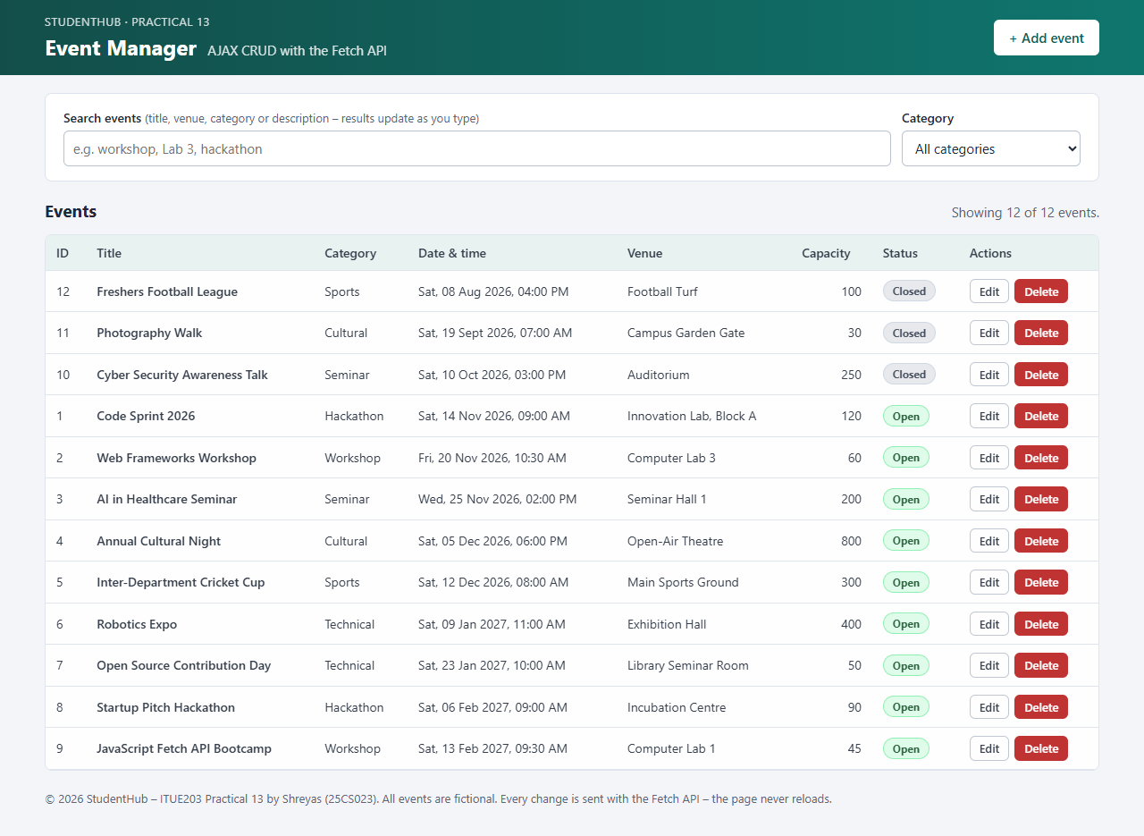
Figure 1: Event list loaded with fetch(GET api.php?action=list) – 12 events (event-list.png)
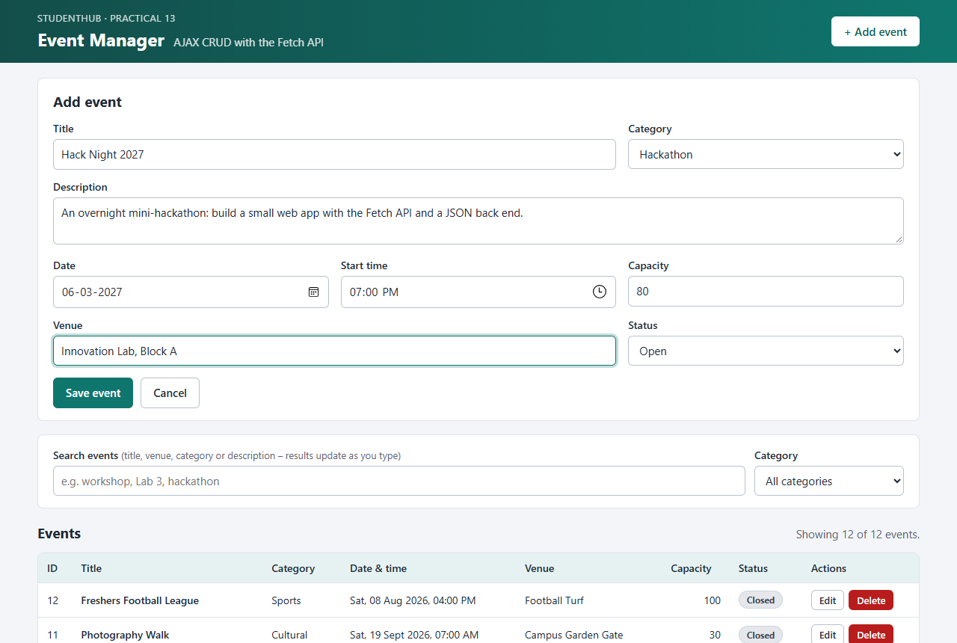
Figure 2: Add event form filled in (Hack Night 2027) (add-event-form.png)
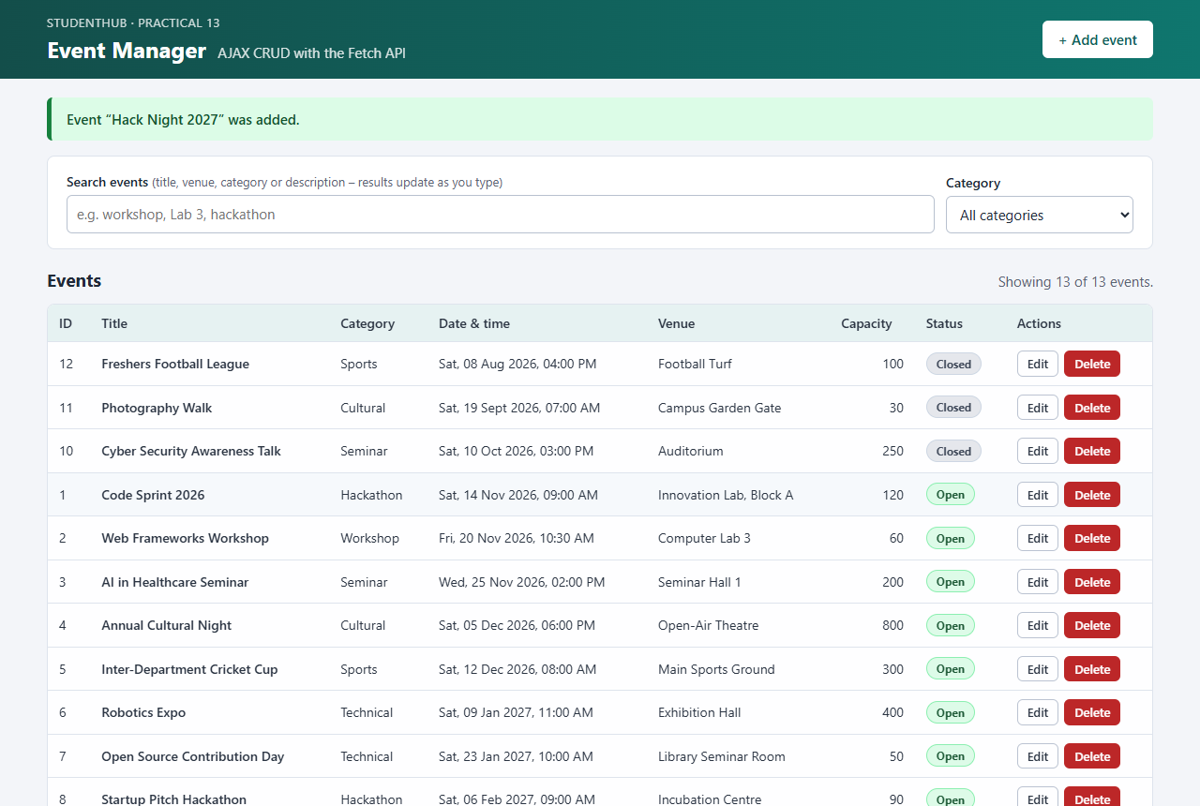
Figure 3: Event added without reloading – success message and new row highlighted (successful-add.png)
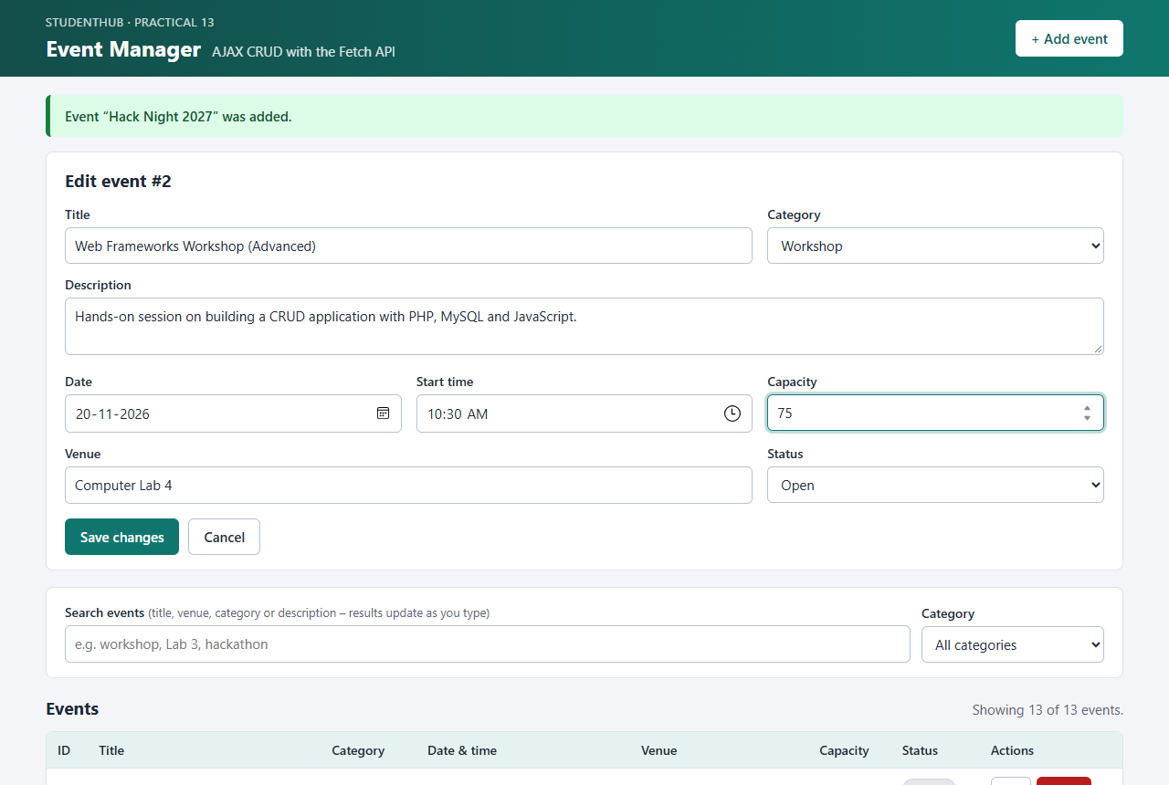
Figure 4: Edit form for “Web Frameworks Workshop” with new title, venue and capacity (edit-event-form.png)
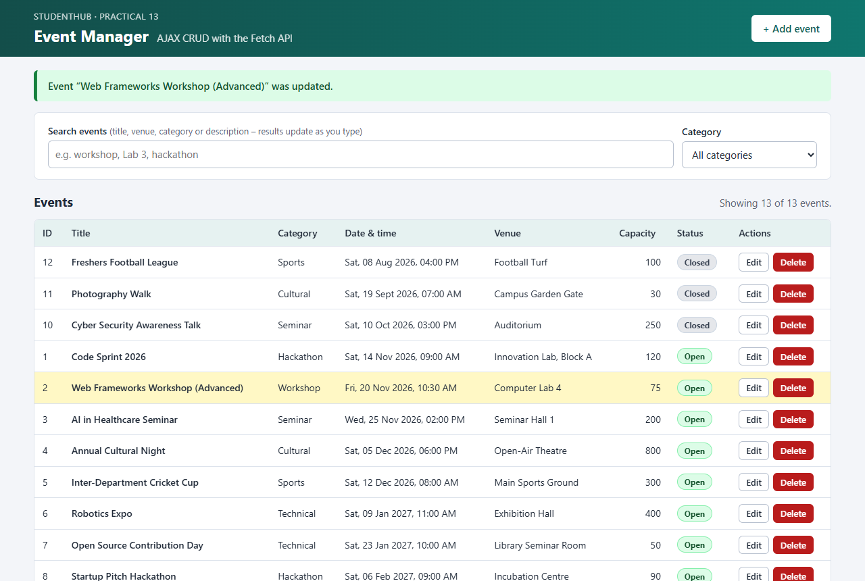
Figure 5: Event updated without reloading – message and changed row highlighted (successful-update.png)
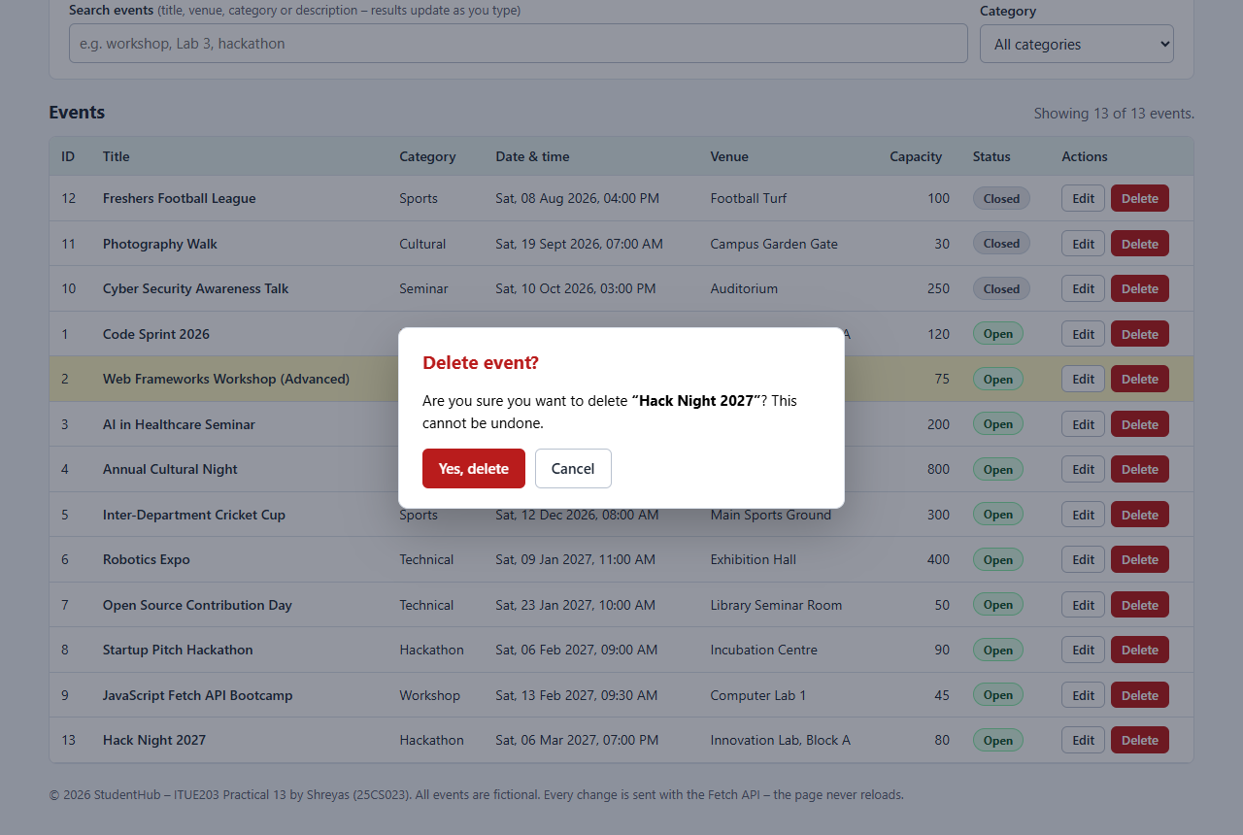
Figure 6: Confirmation dialog before deleting “Hack Night 2027” (delete-confirmation.png)
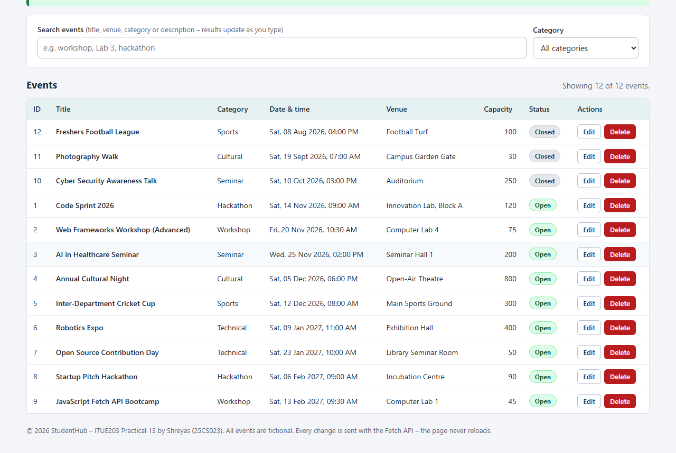
Figure 7: Event deleted without reloading – row removed, 12 events again (successful-delete.png)
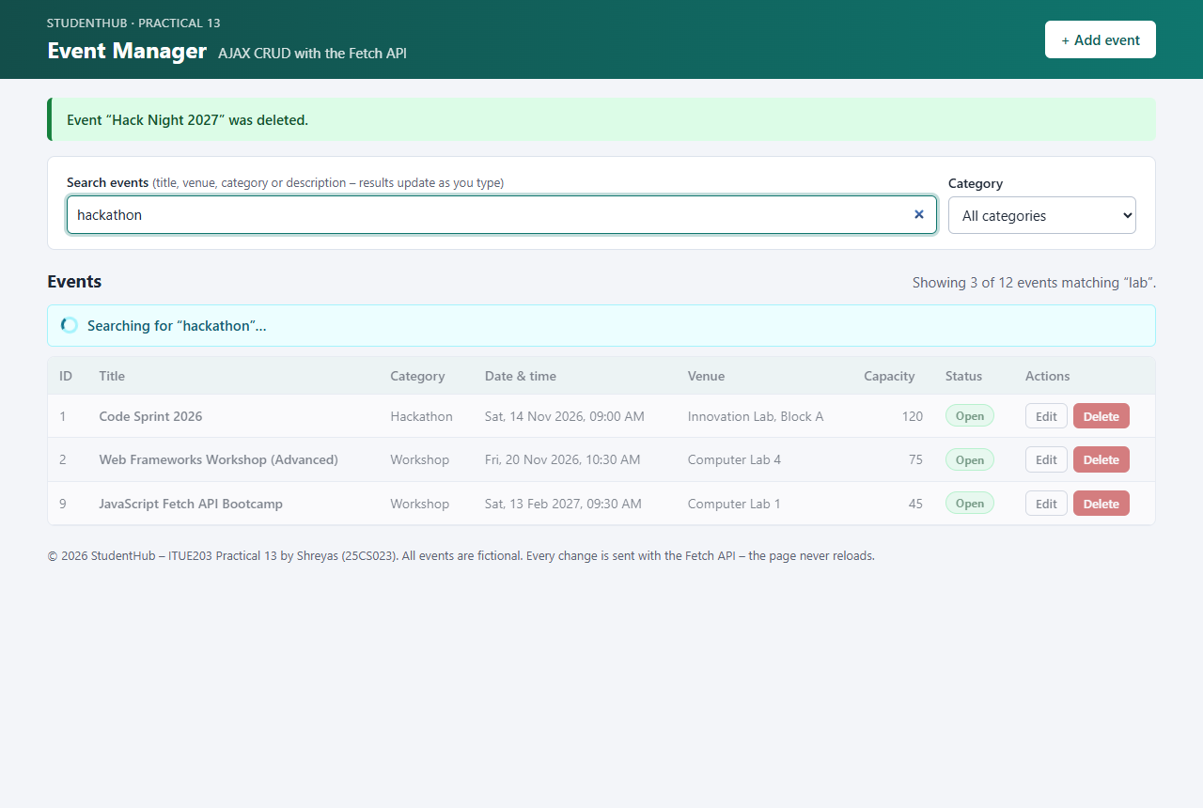
Figure 8: Loading state – “Searching for ‘hackathon’…” while the throttled request runs (loading-state.png)
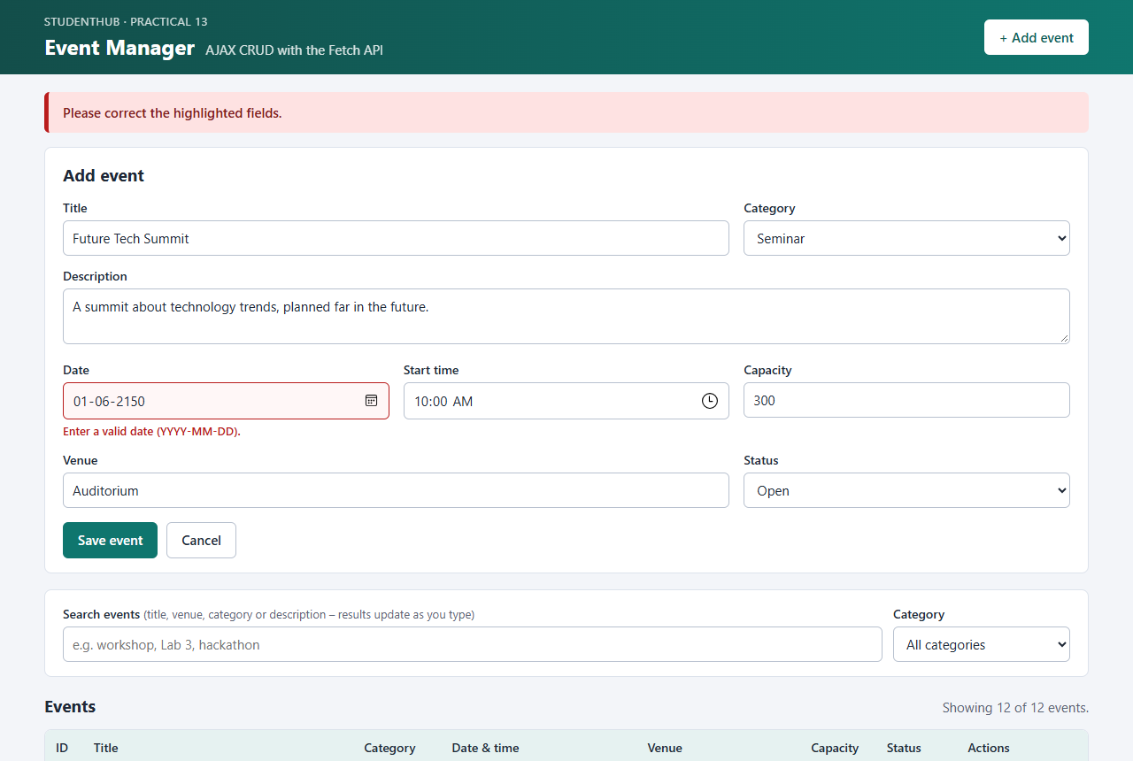
Figure 9: Error state – the API rejects a date after 2100 (HTTP 422) with a field message (error-state.png)
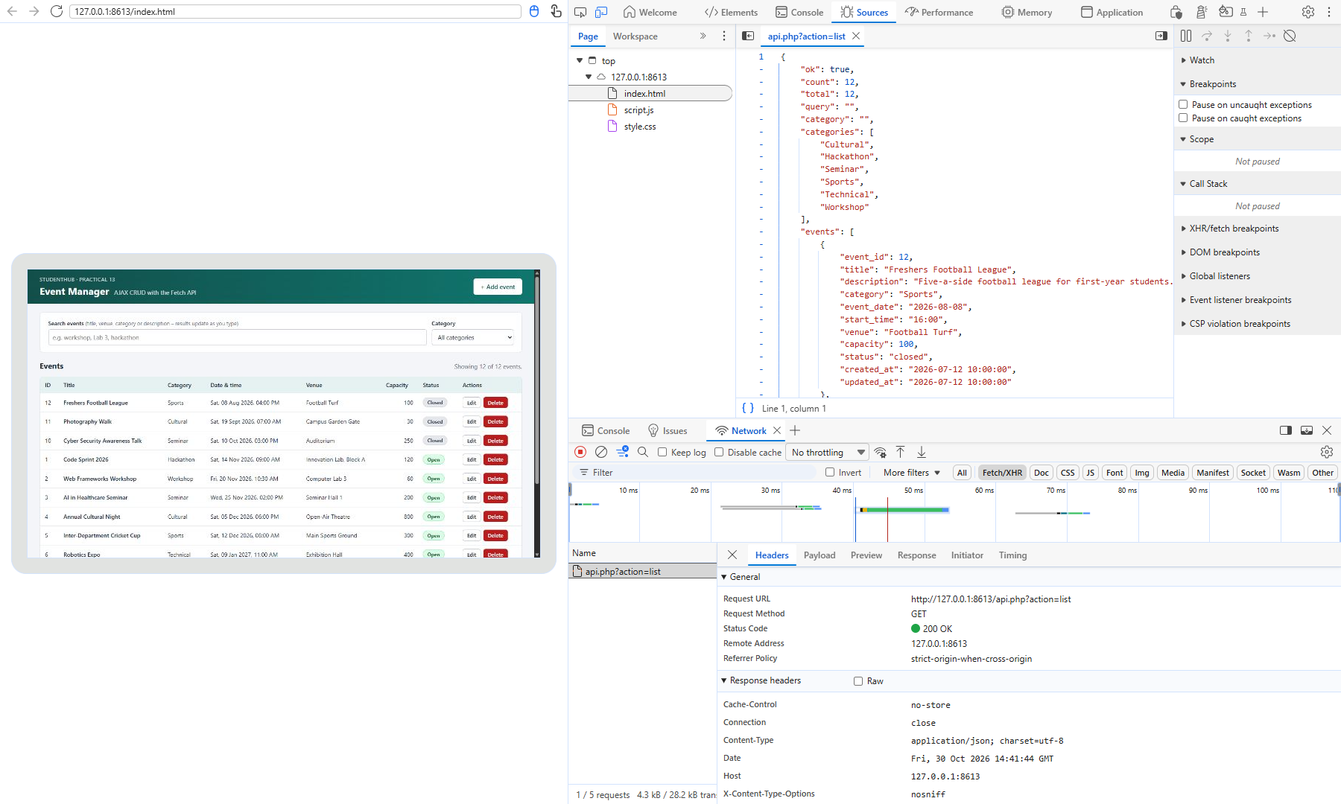
Figure 10: Network: GET api.php?action=list – 200 OK, application/json, JSON response (network-get-json.png)
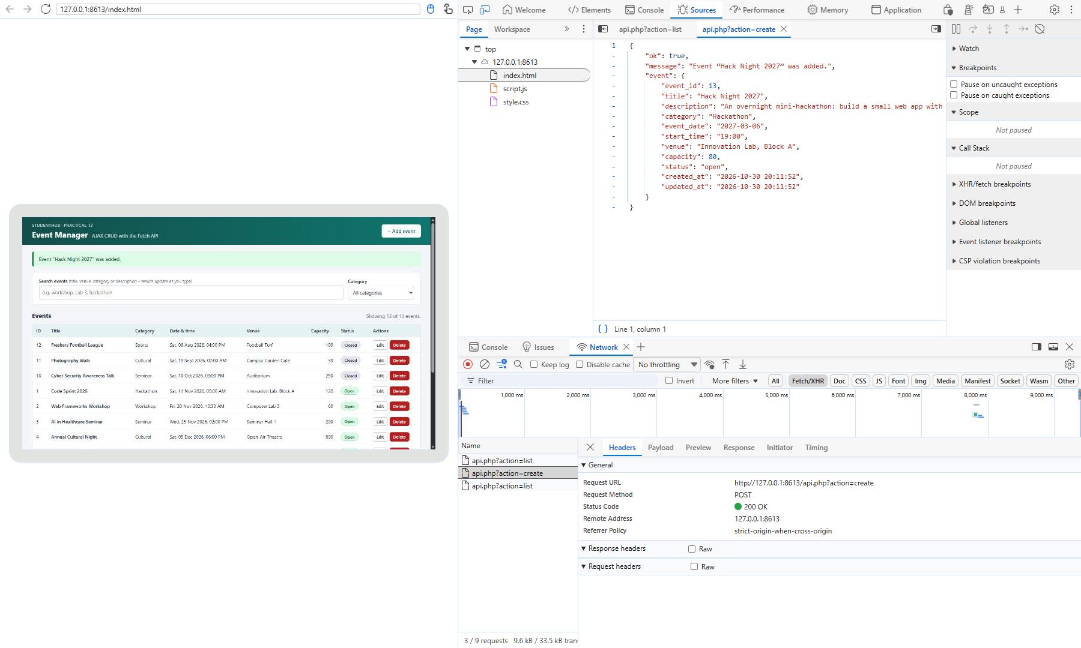
Figure 11: Network: POST api.php?action=create – 200 OK and the JSON response with the new event (network-post-add.png)
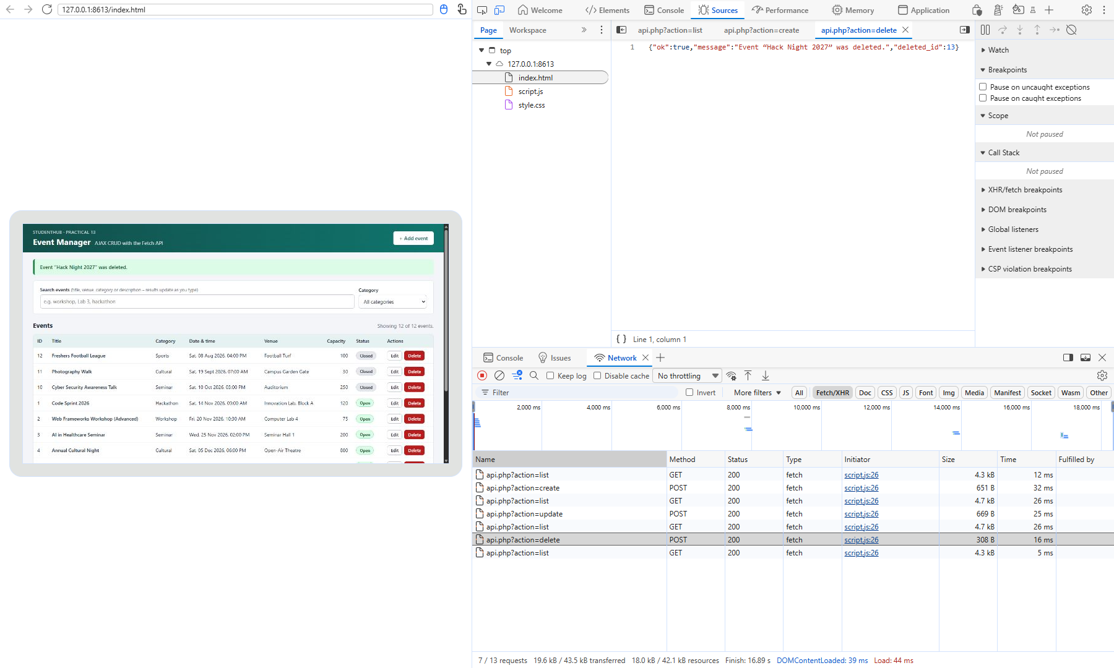
Figure 12: Network: list, create, update and delete fetch requests (Method, Status 200) and the delete JSON response (network-crud-operations.png)

9. Test Cases and Results
tests/test_app.py (Python standard library) imports schema.sql into the disposable database studenthub_prac13_test, starts two PHP servers (normal; MySQL unreachable) and checks the source files and every API action, including validation, wrong methods and bodies, SQL injection, XSS and the central error handling. tests/browser_screenshots.py checks the page in Microsoft Edge: Fetch requests, no page reload, confirmation, debounce, loading and error states.
Result: 89 of 89 automated API checks passed, 0 failed; 13 of 13 browser checks passed. php -l found no syntax errors in the 4 PHP files.
ID | Test case | Expected result | Result
TC01 | Required files | all five exist in Practical-13/ | Pass
TC02 | Database import | 12 events (9 open, 3 closed), InnoDB, indexes, CHECK constraints enforced | Pass
TC03 | List events (API) | 200, application/json, {"ok":true,"count":12,…}, numeric ids, sorted by date | Pass
TC04 | List events (page) | table filled by a fetch GET request, 12 rows | Pass
TC05 | Search by title / venue / category | matching events only, case-insensitive | Pass
TC06 | Search edge cases | 0 results; wildcards searched literally | Pass
TC07 | Category filter | only Sports; combined filter; unknown value ignored | Pass
TC08 | Debounced AJAX search | only one request (q=lab) after typing stops; results updated | Pass
TC09 | Get one event | 200 with event; 404; 400 JSON errors | Pass
TC10 | Add event (API) | 200 {"ok":true,"message":"…was added.","event":{…}}, row stored, title spaces cleaned | Pass
TC11 | Add event without reload (page) | POST create, success message, new row highlighted, page not reloaded | Pass
TC12 | Required fields | 422 with errors for all 8 fields | Pass
TC13 | Invalid values | 422 with the field error; nothing stored | Pass
TC14 | Update event (API) | 200, row changed, saved event returned | Pass
TC15 | Update without reload (page) | POST update, row shows new values, page not reloaded | Pass
TC16 | Update errors | 422 (row unchanged); 404; 400 | Pass
TC17 | Delete confirmation | dialog “Are you sure you want to delete …?” | Pass
TC18 | Delete without reload | POST delete, 200 {"ok":true,…,"deleted_id":…}, row removed, page not reloaded | Pass
TC19 | Delete errors | 404 “not found”; 400 | Pass
TC20 | Loading state | “Searching for …” indicator visible, hidden after the response | Pass
TC21 | Error state | HTTP 422 shown as message and field error “Enter a valid date” | Pass
TC22 | Wrong method | 405 JSON with Allow: POST / Allow: GET | Pass
TC23 | Wrong body | 415; 400; 400; 400; 400; 400 – all JSON | Pass
TC24 | SQL injection | 0 results; stored literally, table intact | Pass
TC25 | XSS | stored as text; JSON escapes < as <; page shows it as text, no element created, no alert | Pass
TC26 | Central JSON error handling | 500 {"ok":false,"error":"The server could not complete…"}, no SQL details; real error in PHP log | Pass
TC27 | Protected files | 403 | Pass
TC28 | Network evidence | fetch requests to api.php, 200 OK, JSON responses (screenshots 10–12) | Pass

10. Problems Encountered and Fixes
- JSON body type: the first test run showed that a JSON array ([1,2,3]) was accepted as a request body. The API now checks that the body is a JSON object before using it.
- Test timing: in the browser test the “added” message was still visible when the update finished, so the first wait returned too early; the test now waits for the “was updated” text.
- Network screenshots: capturing a visible Edge window would have used the real desktop while it was in use, so the DevTools front end served by Edge was opened in a headless browser instead – still the genuine Edge DevTools, recording genuine requests. Because a selected request hides the Status column, the response was opened in the Sources panel while the Network panel shows the status.

11. Conclusion
The event manager lists, adds, updates and deletes events entirely with the Fetch API: the page never reloads, api.php answers every request in JSON with a correct status code, GET and POST are separated, and all input is validated before a prepared statement touches the database. Loading, success and error states keep the user informed, and the debounced search sends one request per pause instead of one per key press. The Edge Network panel confirms the fetch requests and their JSON responses; 89 automated API checks and 13 browser checks passed.

12. References
- MDN – Using the Fetch API: https://developer.mozilla.org/en-US/docs/Web/API/Fetch_API/Using_Fetch
- MDN – AbortController: https://developer.mozilla.org/en-US/docs/Web/API/AbortController
- PHP Manual – json_encode: https://www.php.net/manual/en/function.json-encode.php
- PHP Manual – MySQLi prepared statements: https://www.php.net/manual/en/mysqli.quickstart.prepared-statements.php
- Microsoft Learn – Inspect network activity (Edge DevTools): https://learn.microsoft.com/microsoft-edge/devtools-guide-chromium/network/
- OWASP – REST Security Cheat Sheet: https://cheatsheetseries.owasp.org/cheatsheets/REST_Security_Cheat_Sheet.html
- Project repository: https://github.com/TheEmperor08/StudentHub-ITUE203-25CS023 (folder Practical-13)

