CHAROTAR UNIVERSITY OF SCIENCE AND TECHNOLOGY (CHARUSAT)
Chandubhai S. Patel Institute of Technology (CSPIT)
Department of Computer Science & Engineering
ITUE203 – Web Development Frameworks
PRACTICAL 1

Initiation & Planning of the StudentHub Portal
Student Name | Shreyas
Roll Number | 25CS023
Email | 25cs023@charusat.edu.in
Programme | B.Tech Computer Science & Engineering
Semester / Academic Year | 3 / 2026-27
Date of Submission
Faculty Signature

1. Aim
To initiate the development of the StudentHub portal by analysing project requirements, identifying user roles and modules, designing the sitemap and low-fidelity wireframes, organising the project folder structure, and preparing the README file and GitHub repository for future development.

2. Problem Statement
Initiate the semester-long StudentHub portal by identifying the problem scope, user roles, key modules, navigation flow and a minimum of 10 pages. Create a sitemap, a low-fidelity wireframe, the project folder structure, a README file and a GitHub repository.

3. Requirement Analysis

3.1 Problem Scope
Students of the CSE department need a single place to see their timetable, enrolled subjects, attendance, results, assignments and campus notices, while administrators need a secure way to manage student records, events and user accounts. StudentHub is a web portal built with PHP, MySQL, HTML, CSS and JavaScript that provides these modules with role-based access.

3.2 Functional Requirements
- Public portal: home page with announcements, image slider, FAQ and guidelines; contact/inquiry page.
- Accounts: student self-registration and login with hashed passwords; logout.
- Role-based access: students are taken to the student dashboard, administrators to the Admin Console; other users opening the Admin Console see an access-denied (403) page.
- Student modules: dashboard, profile with password change, courses, attendance, assignments, results, achievements, notices, directory.
- Administration: manage student records (add, search, filter, delete, CSV export), publish events with posters, view user accounts and the security audit log.

3.3 Non-Functional Requirements
- Usability: consistent navigation and layout designed for desktop and mobile screens, with light and dark themes.
- Accessibility: semantic HTML structure, labelled form fields and visible keyboard focus.
- Security: bcrypt password hashing, prepared statements for queries that use input, server-side role checks and escaped output.
- Maintainability: shared stylesheet and a reusable sidebar include across pages.

4. User Roles
Role | Responsibilities | Status
Visitor | View the home page, register, log in, send an inquiry. | Implemented
Student | View dashboard, timetable, attendance, results, assignments, events; manage profile and password. | Implemented
Faculty | Manage courses, upload assignments, update attendance, check results. | Planned – not implemented in the main application
Admin | Manage student records, events and user accounts; export CSV; review the audit log. | Implemented

5. Key Modules
Module | Pages | Purpose
Public portal | index.php, contact.php | Landing page and department contact
Authentication | login.php, register.php, logout.php | Accounts, sessions and role-based redirect
Student dashboard | dashboard.php | Summary cards, timetable, upcoming events
Profile | profile.php | Student details and password change
Academics | courses.php, attendance.php, assignments.php, results.php, achievements.php | Subjects, attendance, assignment status, results, achievements
Campus | notifications.php, directory.php | Notices and student directory
Administration | admin_dashboard.php (5 tabs) | Students, events, users and audit log
Access control | 403.php | Shown when a non-admin opens the Admin Console

6. Page Inventory
The portal has 15 screens plus a logout action, which satisfies the requirement of at least 10 pages.
# | Page | File | Access
1 | Home Portal | index.php | Public
2 | Login | login.php | Public
3 | Register | register.php | Public
4 | Contact Us | contact.php | Public
5 | Student Dashboard | dashboard.php | Student
6 | My Profile | profile.php | Student
7 | Courses | courses.php | Student
8 | Attendance | attendance.php | Student
9 | Assignments | assignments.php | Student
10 | Results | results.php | Student
11 | Achievements | achievements.php | Student
12 | Notices | notifications.php | Student
13 | Directory | directory.php | Student
14 | Admin Console | admin_dashboard.php | Admin
15 | Access Denied | 403.php | Non-admin users
16 | Logout (action) | logout.php | Logged-in users

7. Sitemap & Navigation Flow
Figure 1 shows the sitemap of StudentHub. It was drawn from the pages and links that exist in the application.
- A visitor starts at the Home Portal and can open Login, Register or Contact Us.
- Login verifies the password and checks the role: students go to the Student Dashboard, administrators to the Admin Console.
- After registering, a new student is signed in automatically and taken to the dashboard.
- Inside the student area a sidebar groups the pages into Overview, Academics, Campus and Account.
- The Admin Console has five tabs: Overview, Students, Events, Users and Audit Logs.
- A non-admin who opens the Admin Console is shown the Access Denied (403) page.
- Logout ends the session and returns to the login page.

8. Low-Fidelity Wireframes
Greyscale low-fidelity wireframes were prepared for the key screens. They show layout and content hierarchy only; they are design drawings, not screenshots of the application.
- Figure 2 – Student dashboard (desktop): sidebar, welcome header, summary cards, weekly timetable and upcoming events.
- Figure 3 – Home page and login (desktop): public landing page and the split login layout.
- Figure 4 – Mobile: dashboard, open navigation drawer and login on a phone-sized screen.

Figure 1 – Sitemap & Navigation Flow
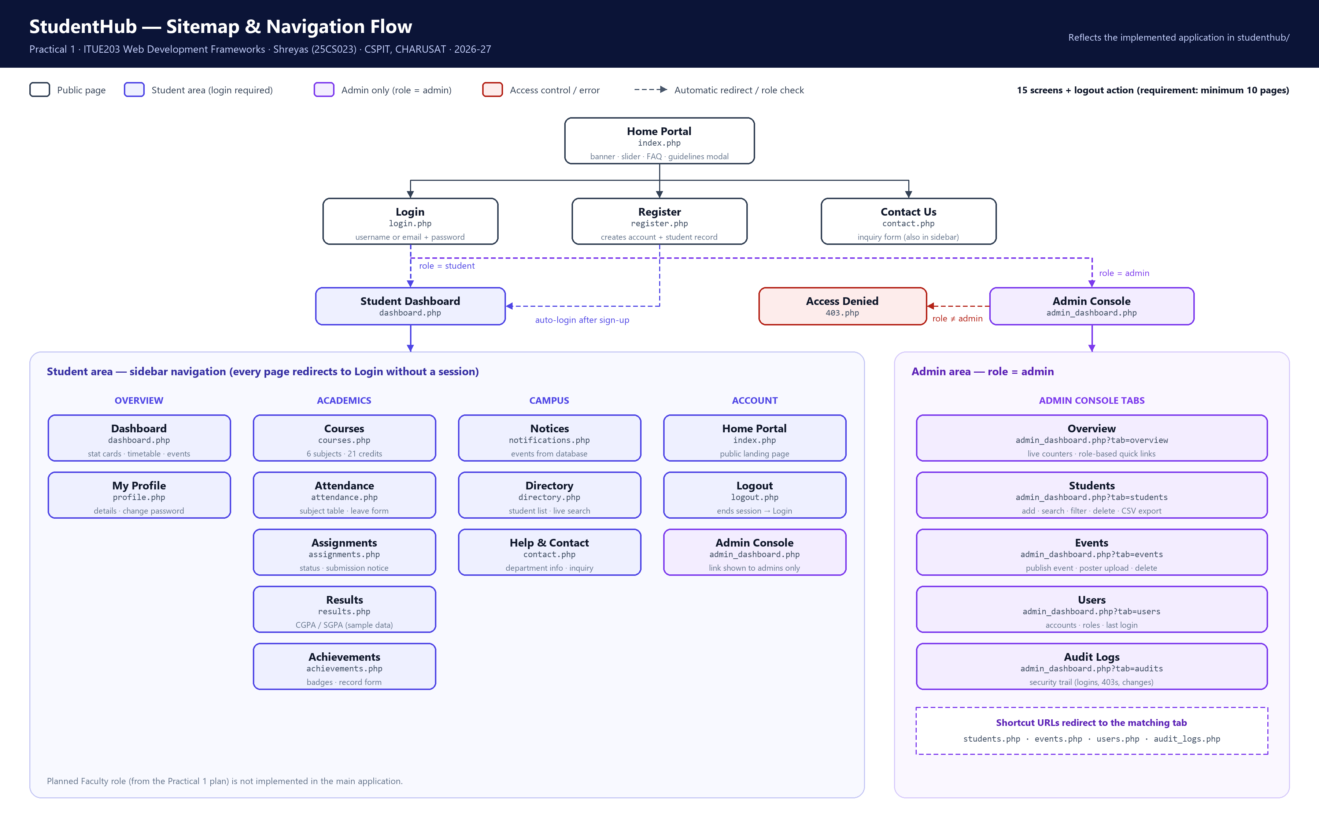
Figure 1: Sitemap and navigation flow of StudentHub

Figure 2 – Wireframe: Student Dashboard (desktop)
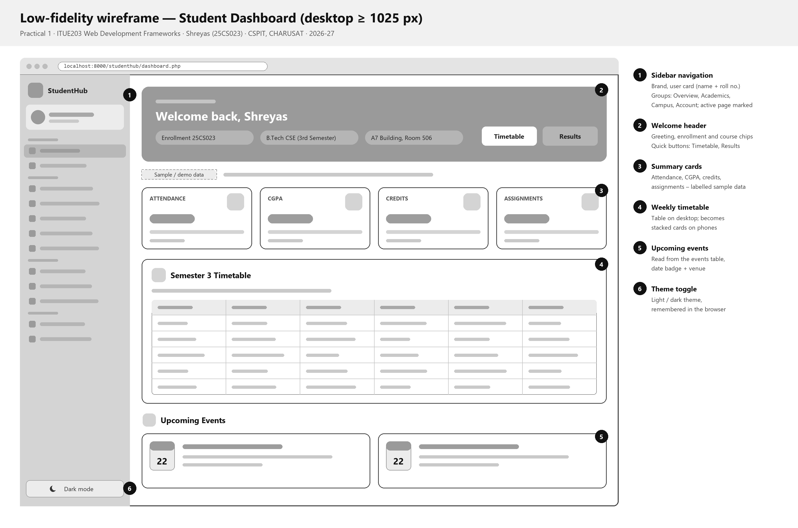
Figure 2: Low-fidelity wireframe of the student dashboard (desktop)

Figure 3 – Wireframes: Home Page and Login (desktop)
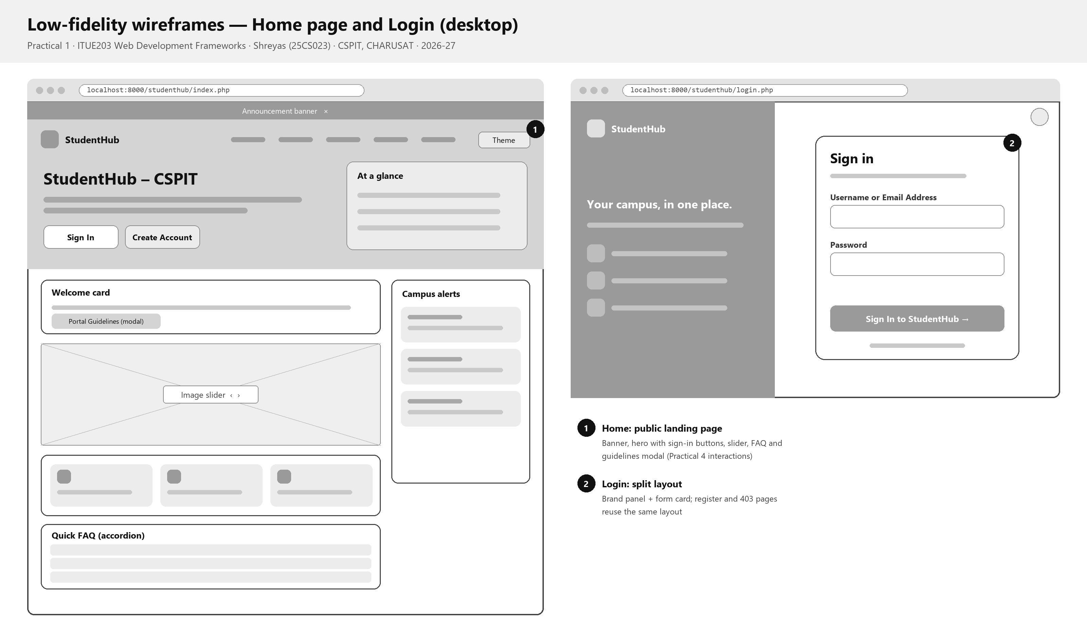
Figure 3: Low-fidelity wireframes of the home page and login (desktop)

Figure 4 – Wireframes: Mobile Screens
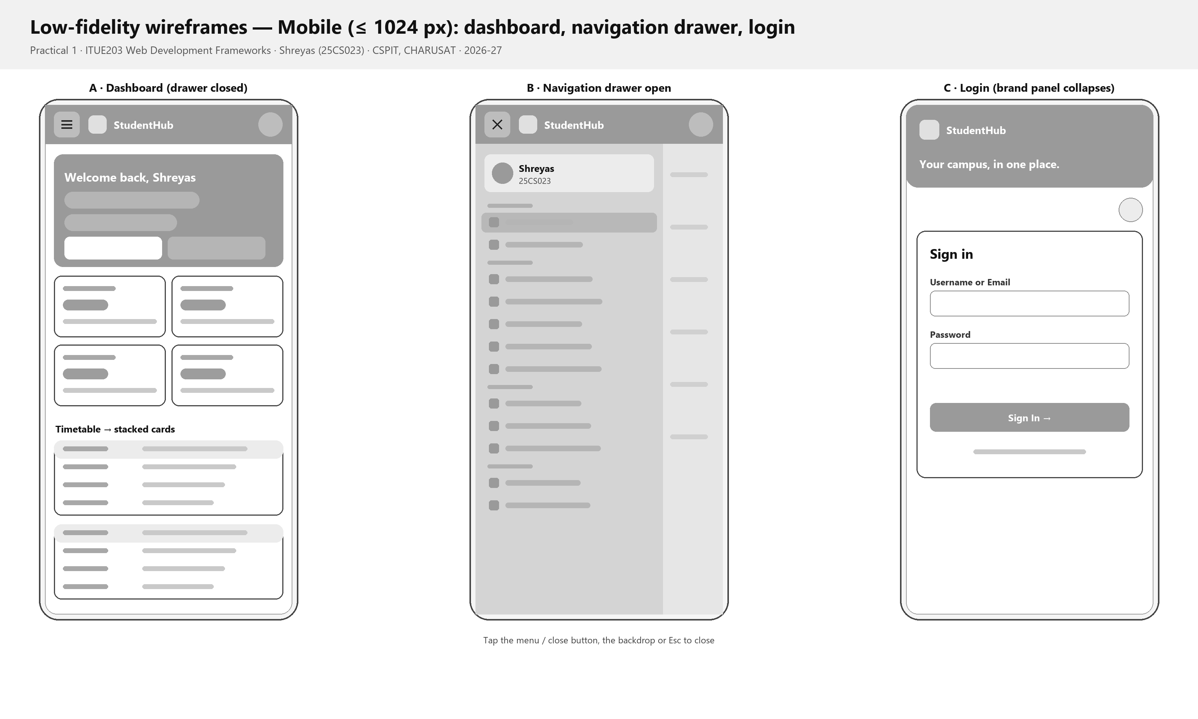
Figure 4: Low-fidelity wireframes of the mobile dashboard, navigation drawer and login

9. Project Folder Structure
StudentHub/
├── studenthub/ Main application (PHP + MySQL)
├── Practical-1/ Planning: sitemap, wireframes, README
├── Practical-2 … 15/ Practical-wise deliverables
├── database/ Safe demo SQL for the main database
├── tools/ Command-line helper to create demo accounts
├── README.md
└── TEST_REPORT.md

Practical-1/
├── README.md
├── sitemap.svg / sitemap.png
├── wireframe-1-dashboard-desktop.svg / .png
├── wireframe-2-home-login-desktop.svg / .png
├── wireframe-3-mobile.svg / .png
├── PRAC_1_Sitemap_25CS023.pdf (sitemap, 1 page)
├── PRAC_1_Wireframes_25CS023.pdf (wireframes, 3 pages)
├── PRAC_1_ITUE203_25CS023.docx (this report)
├── screenshots/ (GitHub repository screenshot)
└── source/build_diagrams.py, export_pdfs.py

10. README File
The repository contains a root README.md that describes the project, its features, local setup and the status of each practical. Practical-1/README.md records the objective, problem statement, user roles, sitemap, wireframes and folder structure of this practical.

11. Source Code Evidence
The excerpts below are copied unchanged from the StudentHub application in the repository (studenthub/ folder; Practical-15 holds an identical copy). Line numbers match the files; only the common leading indentation is removed. They show how the planned page structure and navigation flow are implemented.
File | Lines | Shows
studenthub/index.php | 18–27 | Document structure and metadata of the home page
studenthub/index.php | 36–65 | Header, brand, theme toggle, hamburger button and main navigation
studenthub/sidebar.php | 8–32 | Navigation map of the signed-in area and the skip link
studenthub/sidebar.php | 67–78 | Loop that renders the menu and the admin-only link

11.1 Home page: document structure and metadata
18 <!DOCTYPE html>
19 <html lang="en">
20 <head>
21 <meta charset="UTF-8">
22 <meta name="viewport" content="width=device-width, initial-scale=1.0">
23 <title>StudentHub - CSPIT Charusat Portal</title>
24 <link rel="stylesheet" href="assets/css/home.css?v=1">
25 <script src="assets/js/theme.js"></script>
26 </head>
27 <body>

- Document type and language: <!DOCTYPE html> selects standards mode; lang="en" tells browsers and screen readers the page language.
- Metadata: UTF-8 character set, a viewport tag for correct scaling on phones, and a descriptive page title.
- Stylesheet and script: home.css styles the public page (it imports the shared design tokens, web font and Bootstrap Icons); theme.js applies the saved light/dark theme before the page is drawn.

11.2 Home page: header and navigation
36 <header class="site-header">
37 <div class="topnav">
38 <a class="site-brand" href="index.php">
39 <span class="brand-mark" aria-hidden="true"><i class="bi bi-mortarboard-fill"></i></span>
40 <span><strong>StudentHub</strong><small>CSPIT · CHARUSAT</small></span>
41 </a>
42 <button class="theme-toggle" id="theme-toggle-btn" type="button"><i class="bi bi-moon-stars" aria-hidden="true"></i> Dark</button>
43 <button class="hamburger" id="hamburger-menu" type="button" aria-label="Toggle navigation menu"><i class="bi bi-list" aria-hidden="true"></i></button>
44
45 <!-- Navigation (collapses behind the hamburger on phones – Practical 4) -->
46 <nav class="hero-nav" aria-label="Main navigation">
47 <ul id="nav-links">
48 <li><a href="index.php" class="active" aria-current="page">Home</a></li>
49 <?php if ($is_logged_in): ?>
50 <li><a href="dashboard.php">Dashboard</a></li>
51 <li><a href="profile.php">My Profile</a></li>
52 <li><a href="courses.php">Courses</a></li>
53 <li><a href="attendance.php">Attendance</a></li>
54 <?php if ($user_role === "admin"): ?>
55 <li><a href="admin_dashboard.php" class="nav-admin"><i class="bi bi-shield-lock" aria-hidden="true"></i> Admin Console</a></li>
56 <?php endif; ?>
57 <li><a href="logout.php">Logout</a></li>
58 <?php else: ?>
59 <li><a href="login.php">Login</a></li>
60 <li><a href="register.php">Register</a></li>
61 <li><a href="dashboard.php">Dashboard</a></li>
62 <li><a href="contact.php">Contact Us</a></li>
63 <?php endif; ?>
64 </ul>
65 </nav>

- Semantic landmarks: <header> holds the site brand and a <nav> labelled "Main navigation" for assistive technology; icons are hidden from screen readers with aria-hidden.
- Navigation flow: visitors see Home, Login, Register, Dashboard and Contact Us; signed-in users see Dashboard, My Profile, Courses, Attendance and Logout, and admins also get the Admin Console link. The PHP session decides which list is printed.
- Responsive menu: on narrow screens the list collapses behind the hamburger button (#hamburger-menu), which script.js toggles.

11.3 Signed-in area: navigation map and skip link
8 // Grouped navigation: [file, icon, label, pages that mark it active]
9 $nav_groups = [
10 "Overview" => [
11 ["dashboard.php", "bi-grid-1x2", "Dashboard", ["dashboard.php", "student_dashboard.php"]],
12 ["profile.php", "bi-person-circle", "My Profile", ["profile.php"]],
13 ],
14 "Academics" => [
15 ["courses.php", "bi-journal-bookmark", "Courses", ["courses.php"]],
16 ["attendance.php", "bi-calendar-check", "Attendance", ["attendance.php"]],
17 ["assignments.php", "bi-pencil-square", "Assignments", ["assignments.php"]],
18 ["results.php", "bi-bar-chart-line", "Results", ["results.php"]],
19 ["achievements.php", "bi-award", "Achievements", ["achievements.php"]],
20 ],
21 "Campus" => [
22 ["notifications.php", "bi-megaphone", "Notices", ["notifications.php"]],
23 ["directory.php", "bi-people", "Directory", ["directory.php"]],
24 ["contact.php", "bi-life-preserver", "Help & Contact", ["contact.php"]],
25 ],
26 "Account" => [
27 ["index.php", "bi-house", "Home Portal", ["index.php"]],
28 ["logout.php", "bi-box-arrow-right", "Logout", []],
29 ],
30 ];
31 ?>
32 <a class="skip-link" href="#main-content">Skip to main content</a>

67 <?php foreach ($nav_groups as $group => $links): ?>
68 <p class="nav-group-label"><?= $group ?></p>
69 <ul>
70 <?php foreach ($links as [$href, $icon, $label, $active_pages]): ?>
71 <?php $is_active = in_array($current_page, $active_pages, true); ?>
72 <li><a href="<?= $href ?>"<?= $is_active ? ' class="active" aria-current="page"' : '' ?>><i class="bi <?= $icon ?>" aria-hidden="true"></i><span><?= $label ?></span></a></li>
73 <?php endforeach; ?>
74 <?php if ($group === "Account" && $is_admin): ?>
75 <li><a href="admin_dashboard.php" class="nav-admin"><i class="bi bi-shield-lock" aria-hidden="true"></i><span>Admin Console</span></a></li>
76 <?php endif; ?>
77 </ul>
78 <?php endforeach; ?>

- Single navigation map: $nav_groups lists every signed-in page under Overview, Academics, Campus and Account – the same grouping as the sitemap in Figure 1.
- Rendering: the loop prints each group, marks the current page with class="active" and aria-current="page", and adds the Admin Console link only when the session role is admin.
- Accessibility: the skip link jumps to <main id="main-content"> on every signed-in page. The public home page (index.php) does not include a skip link.
- Reuse: each signed-in page includes sidebar.php, so the menu is defined once.

11.4 Screenshots from VS Code
Screenshot placeholder: VS Code – studenthub/index.php, lines 18–65
Insert a screenshot of the file open in VS Code.

Screenshot placeholder: VS Code – studenthub/sidebar.php, lines 8–32
Insert a screenshot of the file open in VS Code.

12. GitHub Repository
The StudentHub source code, the practical folders (Practical-1 to Practical-15) and their documentation are kept in the student's own GitHub repository.
Repository URL: https://github.com/TheEmperor08/StudentHub-ITUE203-25CS023
PLACEHOLDER – GitHub repository screenshot (genuine screenshot required)
Insert a screenshot of the repository page showing the uploaded project; save the same image as Practical-1/screenshots/github-repository.png.

13. Tools & Technologies
Area | Used in StudentHub
Front end | HTML5, CSS3 (Grid, Flexbox), JavaScript, Bootstrap 5 (admin console), Bootstrap Icons
Back end | PHP 8.2
Database | MySQL / MariaDB
Local server | XAMPP / PHP built-in server (php -S)
Diagrams | Python script generating SVG and PNG (Practical-1/source/build_diagrams.py)
Version control | Git and GitHub (TheEmperor08/StudentHub-ITUE203-25CS023)

14. Submission Deliverables
The deliverables required for Practical 1 and where each one is provided:
# | Deliverable | Provided as
1 | Complete StudentHub project folder | The whole repository: studenthub/ (main application), Practical-1 to Practical-15, database/, tools/, README.md
2 | GitHub repository screenshot | Section 12 of this report  Practical-1/screenshots/github-repository.png
3 | GitHub repository link | https://github.com/TheEmperor08/StudentHub-ITUE203-25CS023
4 | Sitemap PDF | Practical-1/PRAC_1_Sitemap_25CS023.pdf  1 page, A4 landscape (Figure 1)
5 | Low-fidelity wireframe PDF | Practical-1/PRAC_1_Wireframes_25CS023.pdf  3 pages, A4 landscape: student dashboard (desktop), home page and login (desktop), mobile screens (Figures 2–4)

15. Conclusion
In this practical the StudentHub portal was planned: the problem scope and requirements were analysed, the user roles and modules were identified, and a page inventory of 15 screens was prepared. A sitemap and low-fidelity wireframes for desktop and mobile were created, and the project folder structure and README were organised. A GitHub repository was set up under the student's own account to hold the project.

