CHAROTAR UNIVERSITY OF SCIENCE AND TECHNOLOGY (CHARUSAT)
Chandubhai S. Patel Institute of Technology (CSPIT)
Department of Computer Science & Engineering
ITUE203 – Web Development Frameworks
PRACTICAL 2

Semantic HTML5 Pages with Accessibility-Ready Structure
Student Name | Shreyas
Roll Number | 25CS023
Student ID | 25CS023
Email | 25cs023@charusat.edu.in
Course | ITUE203 – Web Development Frameworks
Programme | B.Tech Computer Science & Engineering
Semester / Academic Year | 3 / 2026-27
Date of Submission
Faculty Signature

1. Aim and Objectives
To develop static HTML5 skeletons for the StudentHub portal pages using semantic elements and an accessibility-ready page structure.
- Build at least 10 linked static pages for StudentHub. This practical provides 17: the 11 pages named in the problem definition and 6 additional student-area pages.
- Use semantic HTML5 elements – header, nav, main, section, article, aside and footer – to describe the meaning of each part of a page.
- Make every page accessible: one h1 with ordered sub-headings, labelled form controls, descriptive image alt text, a skip-to-content link, a breadcrumb and aria-current on the current page.
- Keep the structure identical on all pages so that navigation is predictable.
- Record the browser output of every page and check the structure with a repeatable script.

2. Problem Definition
Official problem definition: “Develop static HTML5 skeletons for at least 10 StudentHub pages such as Home, About, Register, Login, Dashboard, Events, Profile, Contact, Admin, FAQ, and Feedback. Use semantic tags and accessibility-friendly structure.”
A student portal is used every day by many students, including people who navigate with a keyboard or a screen reader. If every page is built differently, users have to relearn the layout on each page, and assistive technology cannot tell the menu from the content. Designing the pages first as clean semantic skeletons gives StudentHub a consistent structure – the same header, navigation, main area and footer everywhere – on which styling (Practical 3) and interactivity can be added later without rewriting the markup.
The practical list asks three key questions; the answers for this implementation are:
Key question | Answer in this practical
Are semantic tags such as header, nav, main, section, article, aside and footer used properly? | Yes. Every page has one header, a main navigation and a breadcrumb (both nav), exactly one main and a footer. Content is grouped in section, article and aside elements (Section 4).
Are form labels, headings, image alt text and navigation links accessible? | Every form control has a label, every page has one h1 with no skipped levels, the logo has descriptive alt text, and the current page is marked with aria-current (Sections 4 and 7).
Is the page structure consistent across all pages? | Yes. All 17 pages share the same skeleton and the same main navigation; this was checked by the local script in Section 7.

3. Requirements and Tools

3.1 Requirements
- Pages: at least 10 static pages, including Home, About, Register, Login, Dashboard, Events, Profile, Contact, Admin, FAQ and Feedback.
- Semantics: semantic HTML5 elements instead of generic containers; correct heading hierarchy.
- Accessibility: labelled forms, image alt text, accessible navigation links.
- Linking: every page reachable from every other page through local links.
- Extensions from the practical list: breadcrumb navigation (intermediate) and a skip-to-content link with keyboard-friendly navigation (advanced). Both are implemented.
- Scope: HTML only – no CSS, JavaScript or server code in this practical.

3.2 Tools
Tool | Use in this practical
HTML5 | Markup of all 17 pages
Visual Studio Code | Source code editor; used for the VS Code source screenshots (Section 5.6)
Microsoft Edge 156.0.4314.50 | Viewing the pages; headless mode used to capture the browser screenshots in Section 6
Python 3.12.0 | Runs Practical-2/source/check_pages.py, the local structure, link and accessibility checker (standard library only)
Git | Version control of the StudentHub repository
Operating system | Windows 11

4. Page Structure and Implementation

4.1 Common page skeleton
Every page is built from the same skeleton, in this order:
Element | Purpose
<a href="#main-content"> | Skip-to-content link. It is the first link on the page, so a keyboard user can jump past the header and menu with one Tab and Enter.
<header> | Site banner: the StudentHub logo (a link to Home) and the site name.
<nav aria-label="Main navigation"> | Links to all 17 pages in three groups: Public pages, Student area and Administration. The current page is marked with aria-current="page" and shown in bold.
<nav aria-label="Breadcrumb"> | Shows the position of the page, e.g. Home > Dashboard > Attendance. The last item carries aria-current="page"; the > separators are hidden from screen readers with aria-hidden.
<main id="main-content"> | The unique main content of the page, starting with its single h1. Content is grouped in section, article and aside elements with h2 and h3 headings.
<footer> | Links to Contact, FAQ and Feedback, and the copyright line.

4.2 Accessibility features
- Headings: each page has exactly one h1 (the page title); h2 starts each section and h3 is used inside sections and articles. No level is skipped.
- Forms and labels: every input, select and textarea has a label linked with for/id or wraps the control. Related fields are grouped with fieldset and legend; radio groups (gender, rating) have their own legend. autocomplete values (name, email, username, current-password, new-password) are set on login, register and profile fields.
- Honest static forms: Practical 2 has no server, so every submit button is disabled and each form states that nothing is sent or saved. The Clear (reset) buttons and the details/summary sections work without JavaScript.
- Images: the only image is the StudentHub logo, with the alt text “StudentHub logo – go to the Home page”, because the image is a link.
- Navigation: the two nav elements have different aria-label values so screen readers can tell them apart; the current page has aria-current="page".
- Tables: data tables have a caption and th headers with scope="col" or scope="row". border="1" keeps them readable without CSS (an obsolete but permitted HTML attribute).
- Keyboard: only native links, buttons, form controls and details elements are used; there is no tabindex and no click-only element.
- Language and metadata: lang="en", UTF-8 charset, a viewport meta tag, a description and a unique title on every page.

4.3 Required pages
# | Page | File | Content and main elements
1 | Home | index.html | Welcome text; three article blocks for portal sections; guidelines; Quick FAQ with details/summary; aside with sample campus alerts
2 | About | about.html | Purpose of StudentHub; user roles in a description list (dl); list of modules linking every page; note about this practical
3 | Register | register.html | Registration form with three fieldsets (personal, academic, account), a gender radio group with legend and a terms checkbox
4 | Login | login.html | Sign-in form (role, enrollment number or email, password); “Forgot your password?” in details/summary; link to Register
5 | Dashboard | dashboard.html | Academic summary table with meter and progress elements; weekly timetable table; aside with an event alert
6 | Events | events.html | Two event articles with time elements for the dates; how events are published
7 | Profile | profile.html | Personal details in a dl; contact-details form; change-password form inside details/summary
8 | Contact | contact.html | Department address in an address element; inquiry form
9 | Admin | admin.html | In-page navigation to five sections; overview (dl); tables of students, events, users and an audit log; add-student and publish-event forms
10 | FAQ | faq.html | Four sections of questions, each answer in details/summary
11 | Feedback | feedback.html | Feedback form: page select, rating radio group with legend, comments

4.4 Additional pages
# | Page | File | Content and main elements
12 | Courses | courses.html | Subjects table with a tfoot total; syllabus outline in details/summary
13 | Attendance | attendance.html | Subject-wise attendance table with meter elements; leave application form
14 | Assignments | assignments.html | Assignment status table; submission form with a file input
15 | Results | results.html | Semester-wise SGPA/CGPA table; Semester 2 grade summary table
16 | Notices | notifications.html | Three notice articles with posting dates
17 | Directory | directory.html | Search form; student directory table

4.5 Content and limitations
- Content marked “Sample data” is for demonstration only. Figures such as attendance, CGPA and the timetable are placeholders, not actual academic records.
- The Admin and Directory pages contain only fictional entries (for example “Sample Student 1”, “DEMO-001”, “sample.admin”). No real student data, accounts or passwords appear in the pages.
- The Admin Console is reachable from the menu because a static page cannot check a login; access control belongs to the server-side application.
- The pages are intentionally unstyled. Layout and visual design are the subject of Practical 3.

5. Source Code Evidence
The excerpts below are copied unchanged from the files in Practical-2/. Line numbers match the files; only the common leading indentation of each excerpt is removed.
File | Lines | Shows
Practical-2/index.html | 1–19 | Document head, skip link, header and the start of the main navigation
Practical-2/index.html | 47–64 | Breadcrumb, main element, h1, section and article
Practical-2/index.html | 98–112 | aside and footer
Practical-2/register.html | 59–79, 116–127 | Form with fieldset, legend and labels; disabled submit button
Practical-2/admin.html | 53–66, 80–98 | In-page navigation, section and an accessible data table

5.1 index.html – head, skip link and header
1 <!DOCTYPE html>
2 <html lang="en">
3 <head>
4 <meta charset="UTF-8">
5 <meta name="viewport" content="width=device-width, initial-scale=1.0">
6 <meta name="description" content="StudentHub home page: student portal for CSE students of CSPIT, CHARUSAT.">
7 <title>Home – StudentHub</title>
8 </head>
9 <body>
10 <a href="#main-content">Skip to main content</a>
11
12 <header>
13 <a href="index.html"><img src="images/studenthub-logo.svg" alt="StudentHub logo – go to the Home page" width="48" height="48"></a>
14 <p><strong>StudentHub</strong> – Student portal for Computer Science &amp; Engineering, CSPIT, CHARUSAT</p>
15 <nav aria-label="Main navigation">
16 <ul>
17 <li>Public pages
18 <ul>
19 <li><a href="index.html" aria-current="page"><strong>Home</strong></a></li>

- Document setup: <!DOCTYPE html>, lang="en", UTF-8, viewport, description and a page-specific title.
- Skip link: the first element in the body, pointing to #main-content.
- Header and navigation: the logo link has descriptive alt text and fixed width and height; the main nav is a nested list, and the current page has aria-current="page".

5.2 index.html – breadcrumb, main and articles
47 </nav>
48 <nav aria-label="Breadcrumb">
49 <p>You are here: <span aria-current="page">Home</span></p>
50 </nav>
51 </header>
52
53 <main id="main-content">
54 <h1>Welcome to StudentHub</h1>
55 <p>Your portal for Computer Science &amp; Engineering (CSE) at CSPIT, A7 Building, CHARUSAT. Access your timetable, Semester 3 subjects, attendance records and exam results.</p>
56 <p><a href="login.html">Login</a> | <a href="register.html">Register as a new student</a></p>
57
58 <section>
59 <h2>Portal sections</h2>
60 <article>
61 <h3>Semester 3 subjects and timetable</h3>
62 <p>Check your enrolled CSE subjects, including FDSA, WDF, OOP, FCN and Discrete Mathematics.</p>
63 <p><a href="courses.html">View courses</a> | <a href="dashboard.html">View timetable on the dashboard</a></p>
64 </article>

- Breadcrumb: a second nav with its own aria-label; on the Home page it contains only the current page.
- Main content: main has id="main-content" (the skip-link target) and starts with the page’s only h1.
- Grouping: a section with an h2 contains independent article blocks, each with an h3.

5.3 index.html – aside and footer
98 <aside aria-labelledby="alerts-heading">
99 <h2 id="alerts-heading">Latest campus alerts</h2>
100 <p><mark>Sample data:</mark> example notices for this static page.</p>
101 <ul>
102 <li><time datetime="2026-08-22">22 August 2026</time>: Odoo Hackathon at L.D. College of Engineering.</li>
103 <li><time datetime="2026-08-15">15 August 2026</time>: Independence Day celebration at CHARUSAT Campus.</li>
104 </ul>
105 <p><a href="notifications.html">See all notices</a></p>
106 </aside>
107 </main>
108
109 <footer>
110 <p><a href="contact.html">Contact</a> | <a href="faq.html">FAQ</a> | <a href="feedback.html">Feedback</a></p>
111 <p>&copy; <time datetime="2026">2026</time> StudentHub – ITUE203 Practical 2, static HTML5 skeleton by Shreyas (25CS023). Content marked “Sample data” is for demonstration only.</p>
112 </footer>

- Complementary content: the aside is labelled by its own h2 through aria-labelledby; dates use the time element with a machine-readable datetime.
- Footer: repeated on every page with links to Contact, FAQ and Feedback.

5.4 register.html – accessible form
59 <form>
60 <fieldset>
61 <legend>Personal details</legend>
62 <p>
63 <label for="reg-name">Full name *</label><br>
64 <input type="text" id="reg-name" name="name" autocomplete="name" required>
65 </p>
66 <p>
67 <label for="reg-email">College email address *</label><br>
68 <input type="email" id="reg-email" name="email" autocomplete="email" required>
69 </p>
70 <p>
71 <label for="reg-mobile">Mobile number *</label><br>
72 <input type="tel" id="reg-mobile" name="mobile" autocomplete="tel" maxlength="10" required>
73 </p>
74 <fieldset>
75 <legend>Gender *</legend>
76 <label><input type="radio" name="gender" value="male" required> Male</label>
77 <label><input type="radio" name="gender" value="female"> Female</label>
78 <label><input type="radio" name="gender" value="other"> Other</label>
79 </fieldset>

116 <p>
117 <input type="checkbox" id="reg-terms" name="terms" required>
118 <label for="reg-terms">I agree to the terms and conditions and the privacy policy. *</label>
119 </p>
120 </fieldset>
121
122 <p><strong>Note:</strong> This is a static form skeleton. Practical 2 has no server, so the “Register account” button is disabled and nothing is sent or saved.</p>
123 <p>
124 <button type="submit" disabled>Register account</button>
125 <button type="reset">Clear</button>
126 </p>
127 </form>

- Labels: each label’s for attribute matches the id of its input; the radio buttons are wrapped in their labels.
- Grouping: fieldset and legend group related fields; the gender radio group is a nested fieldset with its own legend.
- Input types and hints: type="email", type="tel" and type="password", required, maxlength, minlength and autocomplete help browsers and assistive technology.
- No pretend backend: the submit button is disabled and the note above it says that nothing is sent or saved. The form has no action attribute.

5.5 admin.html – in-page navigation and data table
53 <main id="main-content">
54 <h1>Admin Console</h1>
55 <p><mark>Sample data:</mark> every record on this page is a fictional demonstration entry. It contains no real student data, accounts or passwords.</p>
56 <p>In the full application only administrators can open this page. This static skeleton has no login check.</p>
57
58 <nav aria-label="Admin sections">
59 <ul>
60 <li><a href="#overview">Overview</a></li>
61 <li><a href="#students">Students</a></li>
62 <li><a href="#events">Events</a></li>
63 <li><a href="#users">Users</a></li>
64 <li><a href="#audit-log">Audit log</a></li>
65 </ul>
66 </nav>

80 <section id="students">
81 <h2>Students</h2>
82 <table border="1">
83 <caption>Student records (sample entries)</caption>
84 <thead>
85 <tr>
86 <th scope="col">Enrollment</th>
87 <th scope="col">Name</th>
88 <th scope="col">Course</th>
89 <th scope="col">Year</th>
90 </tr>
91 </thead>
92 <tbody>
93 <tr>
94 <th scope="row">DEMO-001</th>
95 <td>Sample Student 1</td>
96 <td>B.Tech CSE</td>
97 <td>2nd year</td>
98 </tr>

- Sample data notice: the page states at the top that every record is fictional.
- In-page navigation: a third nav, labelled “Admin sections”, links to the ids of the five sections.
- Accessible table: the caption names the table; column headers use scope="col" and the first cell of each row is a th with scope="row".

5.6 Screenshots from VS Code
PLACEHOLDER – VS Code screenshot: Practical-2/index.html (head, skip link, header, navigation)
Insert a genuine screenshot of the file open in VS Code.

PLACEHOLDER – VS Code screenshot: Practical-2/register.html (form, fieldset, legend, labels)
Insert a genuine screenshot of the file open in VS Code.

PLACEHOLDER – VS Code screenshot: Practical-2/admin.html (sections and table)
Insert a genuine screenshot of the file open in VS Code.

6. Browser Output
The screenshots below are the actual pages rendered by Microsoft Edge 156 in headless mode at a width of 1280 pixels. Each shows the full page from the skip link to the footer; only the blank space below the footer was trimmed. The pages are unstyled because Practical 2 uses no CSS. The original image files are in Practical-2/screenshots/browser/.

6.1 Home – index.html
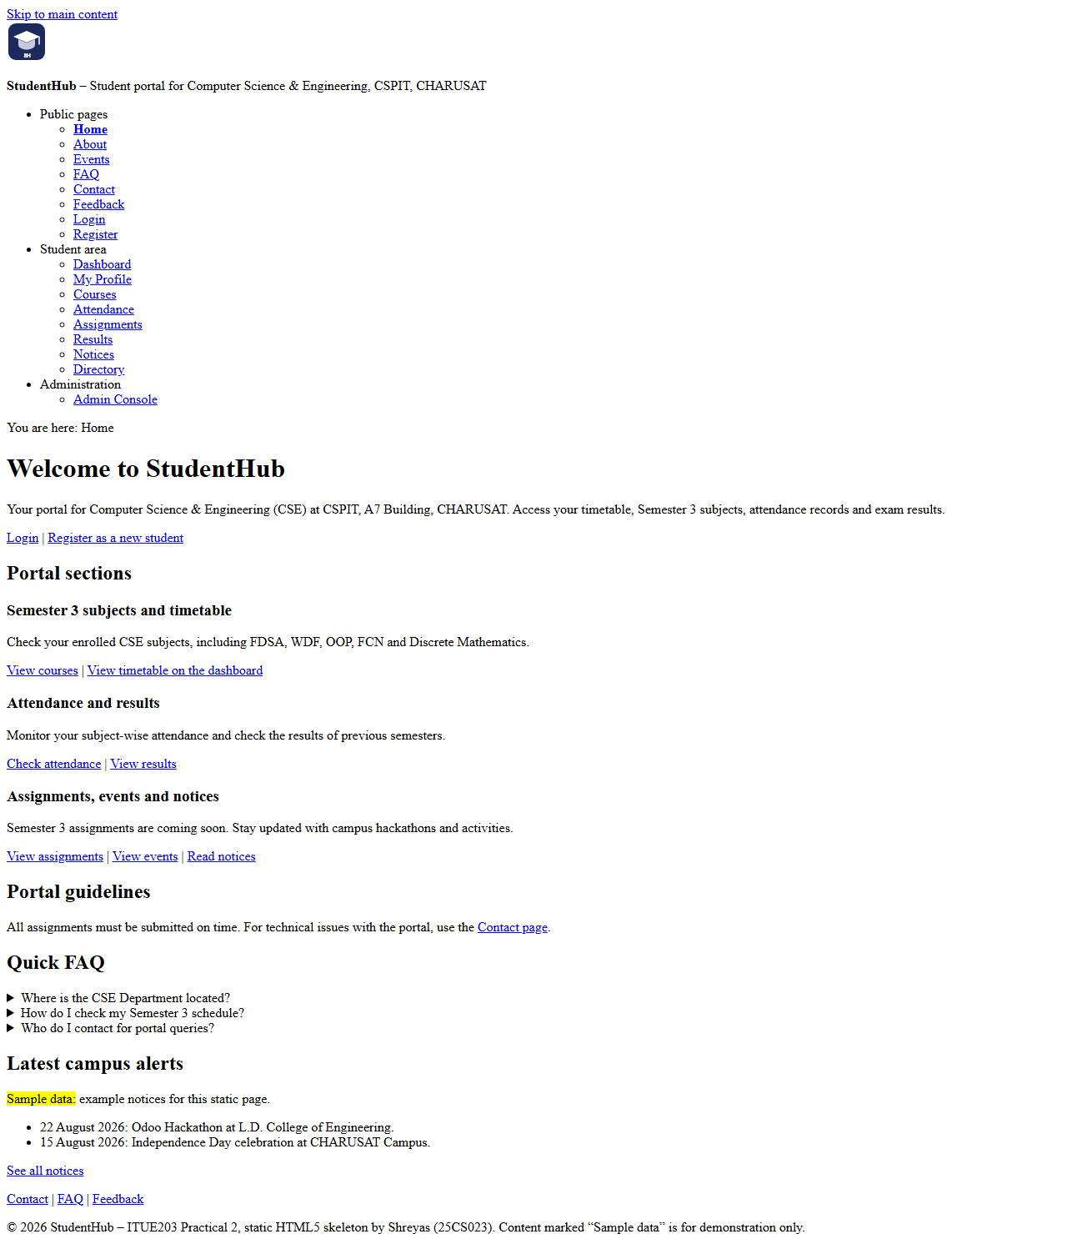
Figure 1: Home page (index.html) in Microsoft Edge

6.2 About – about.html
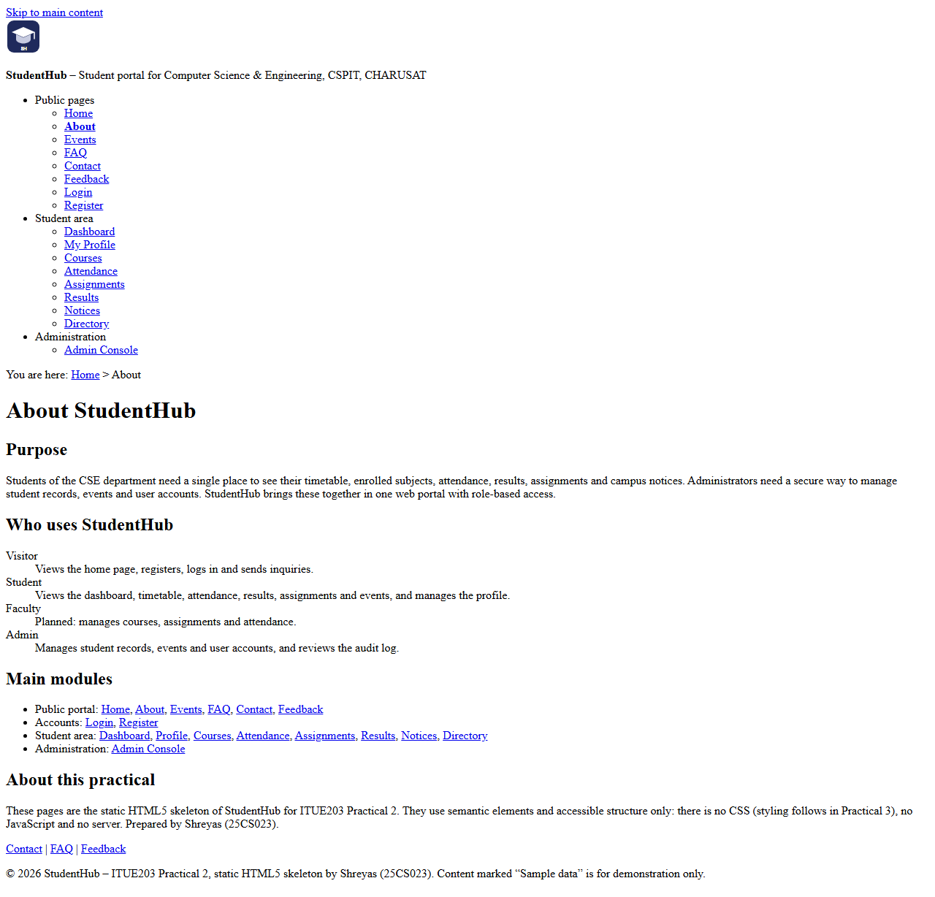
Figure 2: About page (about.html) in Microsoft Edge

6.3 Register – register.html
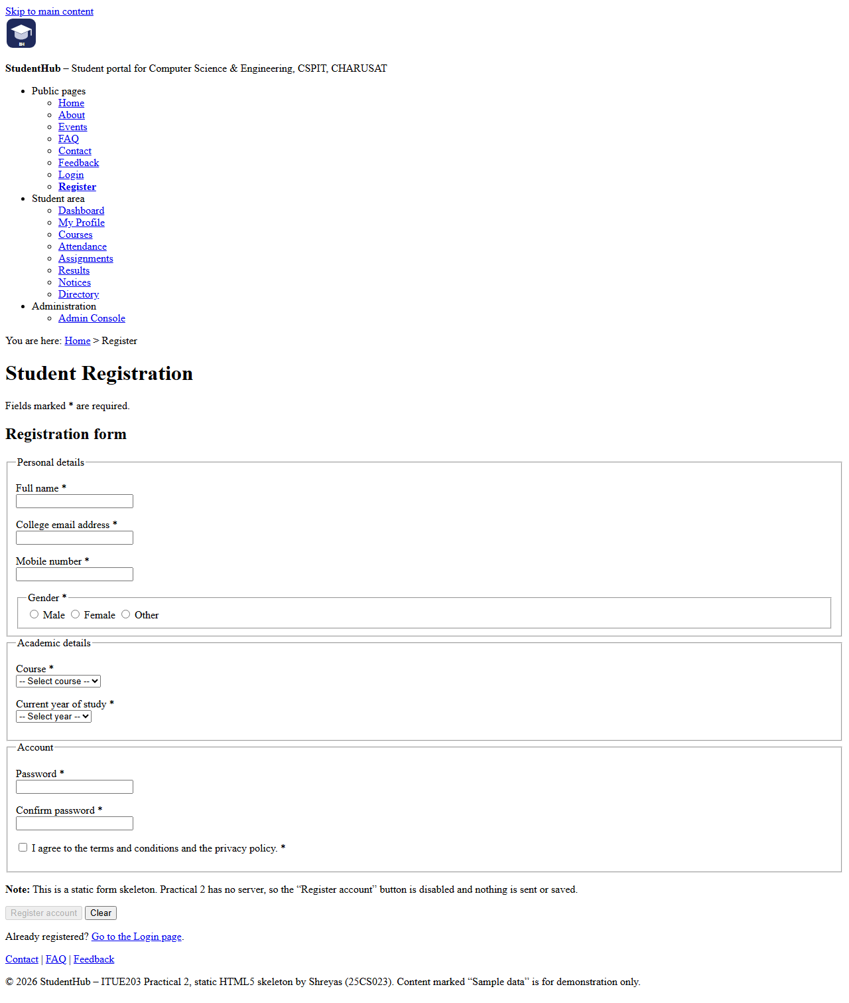
Figure 3: Register page (register.html) in Microsoft Edge

6.4 Login – login.html
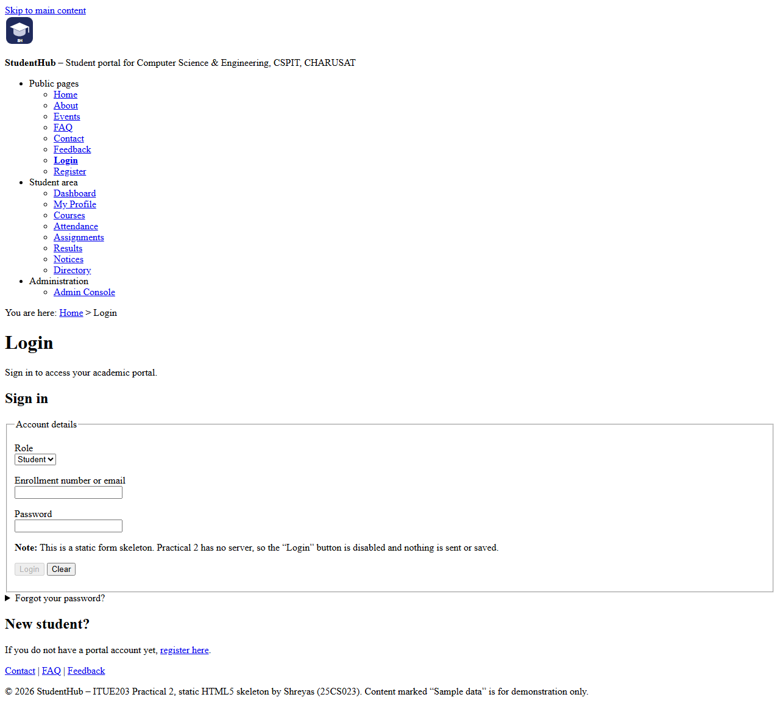
Figure 4: Login page (login.html) in Microsoft Edge

6.5 Dashboard – dashboard.html
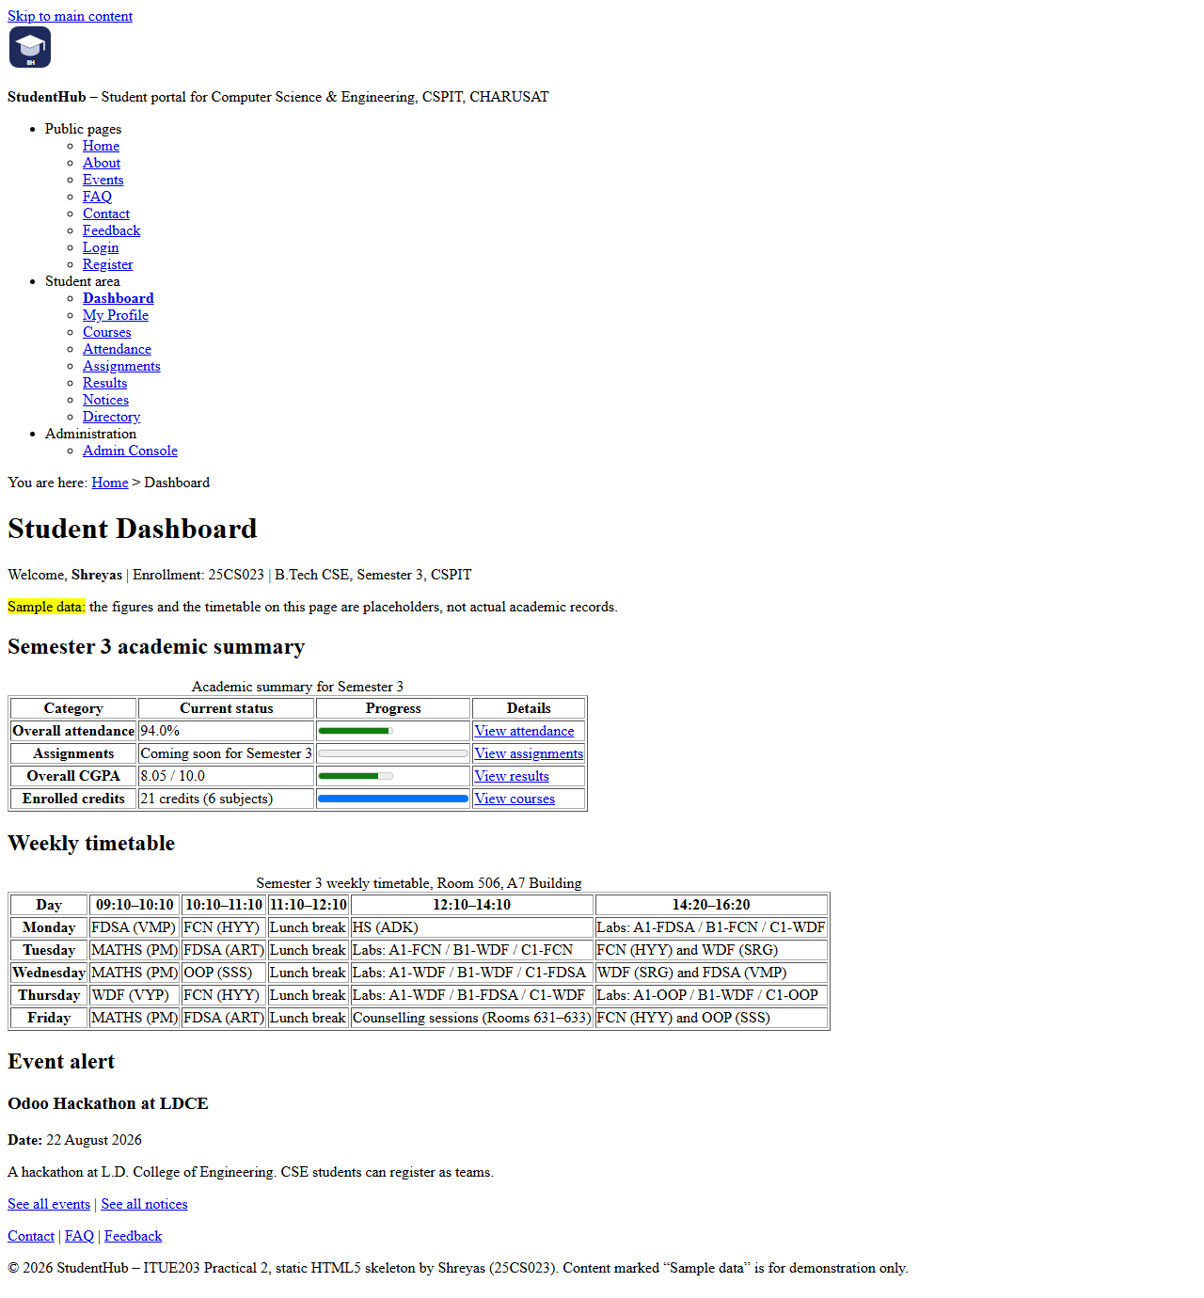
Figure 5: Dashboard page (dashboard.html) in Microsoft Edge

6.6 Events – events.html
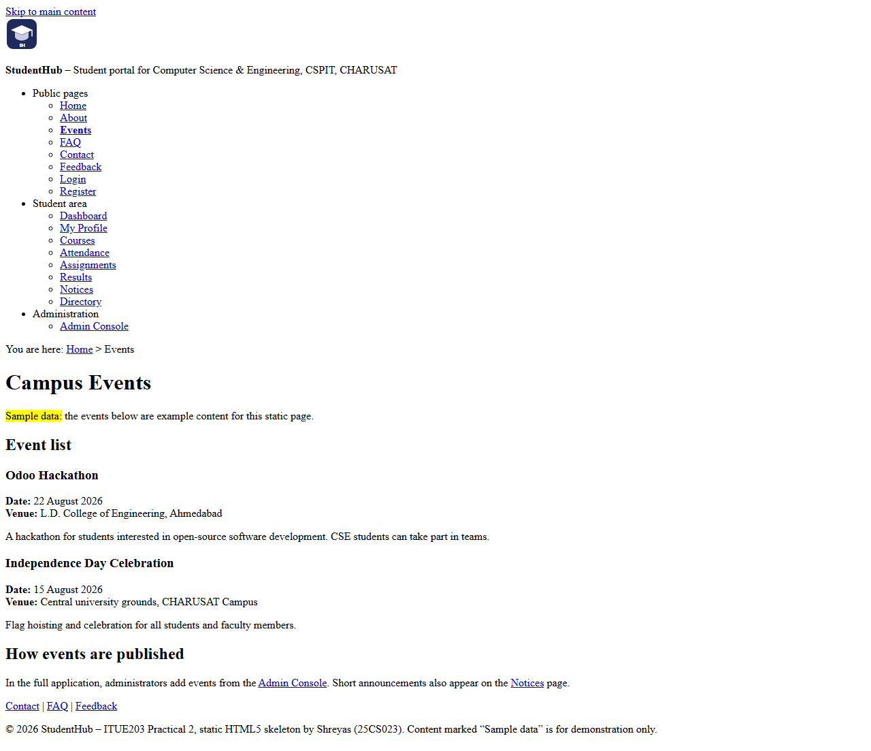
Figure 6: Events page (events.html) in Microsoft Edge

6.7 Profile – profile.html
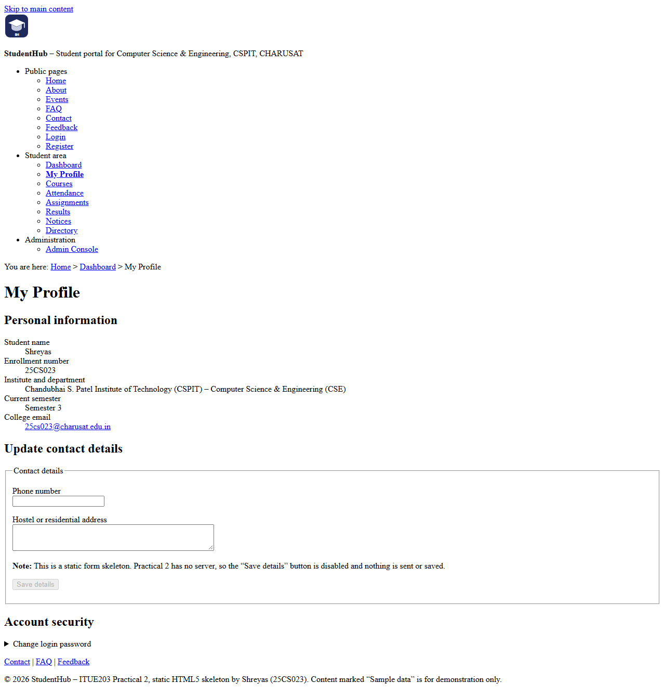
Figure 7: Profile page (profile.html) in Microsoft Edge

6.8 Contact – contact.html
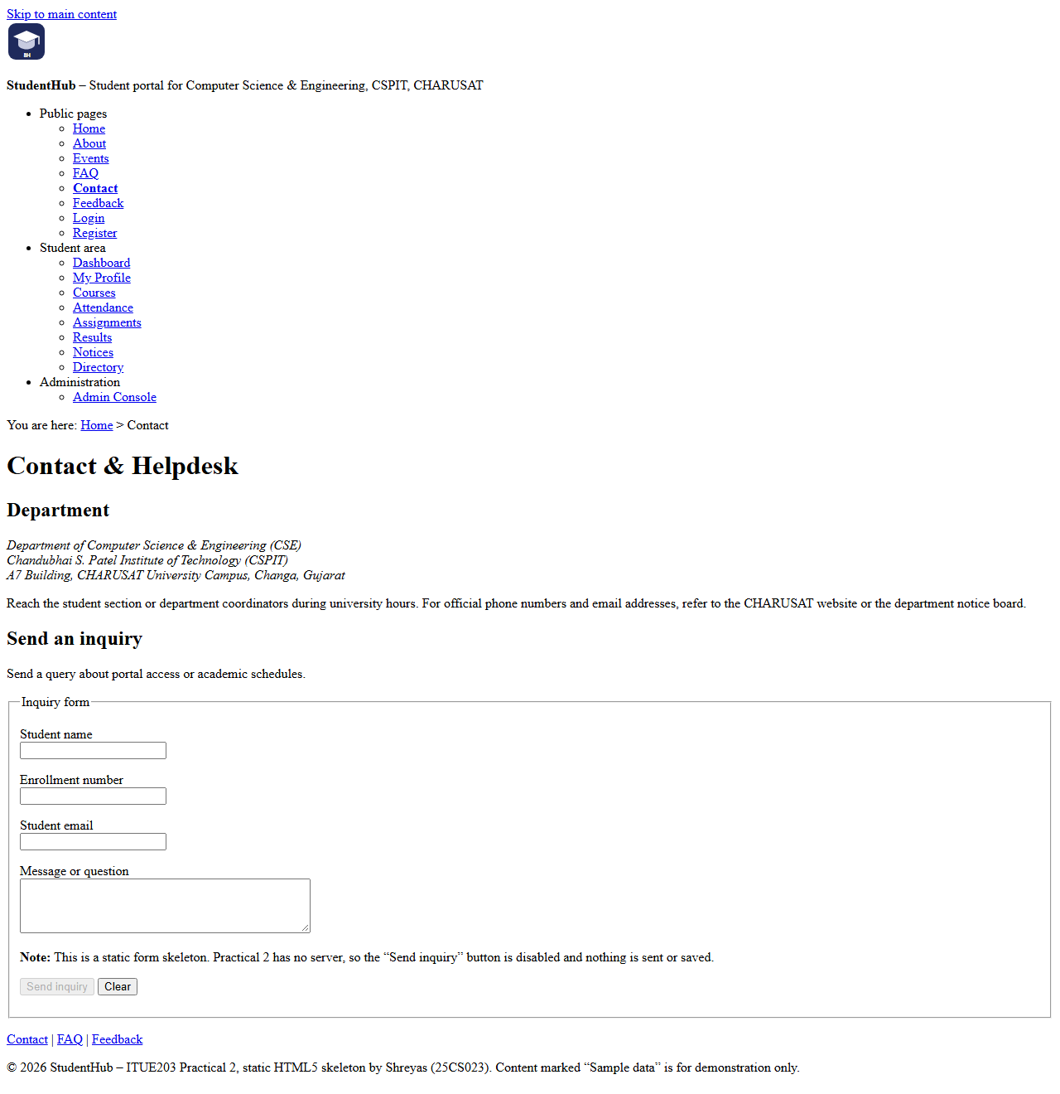
Figure 8: Contact page (contact.html) in Microsoft Edge

6.9 Admin – admin.html
The Admin Console is longer than one page, so its screenshot (09-admin.png) is shown in two parts, split at a blank line between the Students and Events sections.
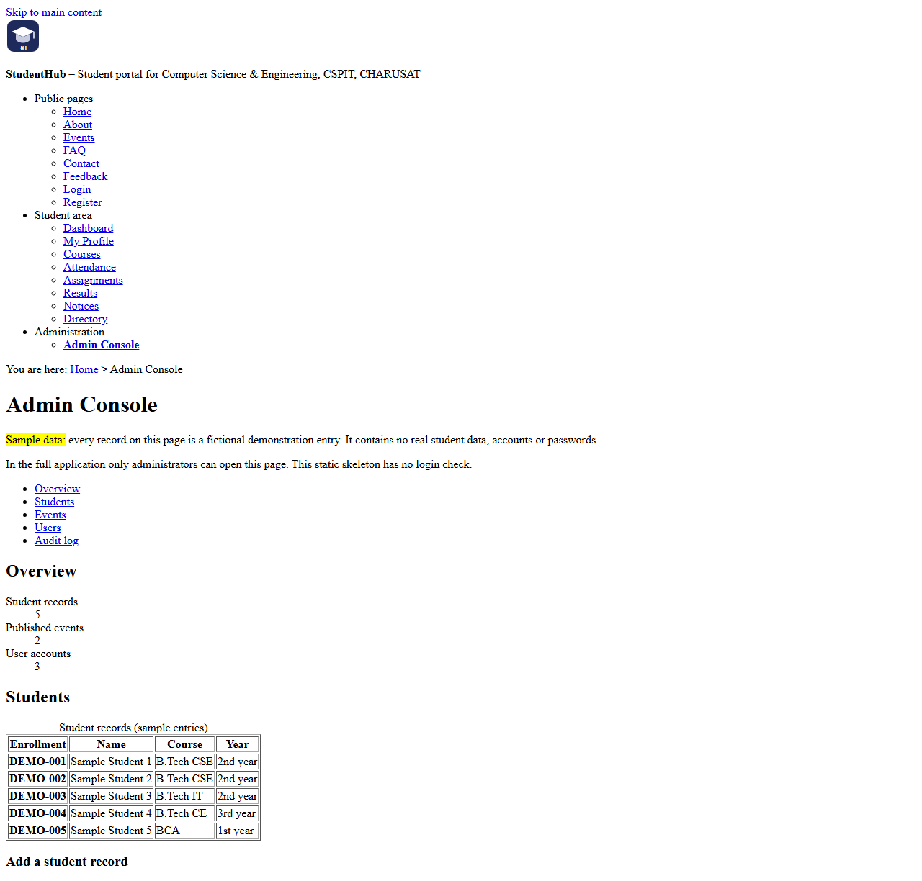
Figure 9a: Admin page (admin.html), part 1 of 2 – header, overview and students
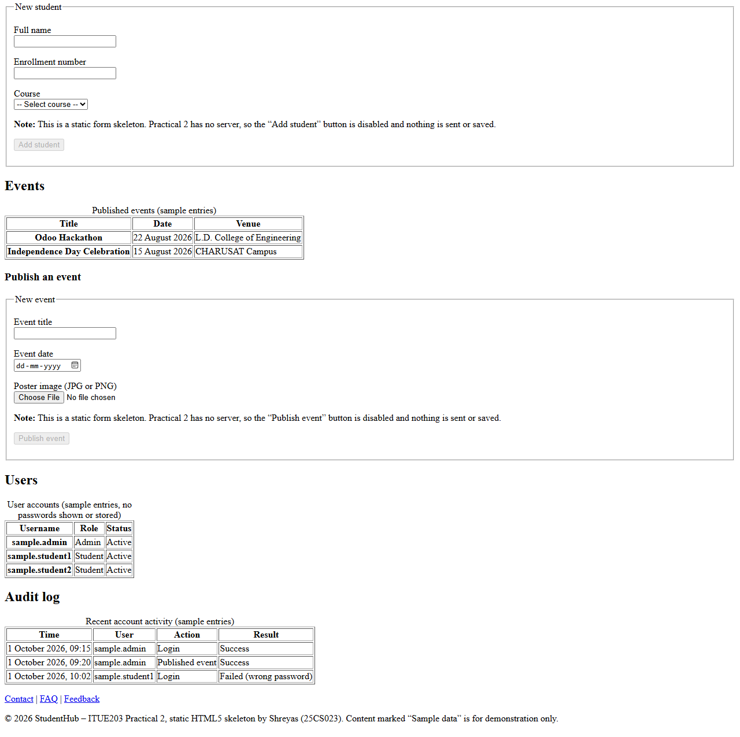
Figure 9b: Admin page (admin.html), part 2 of 2 – events, users and audit log

6.10 FAQ – faq.html
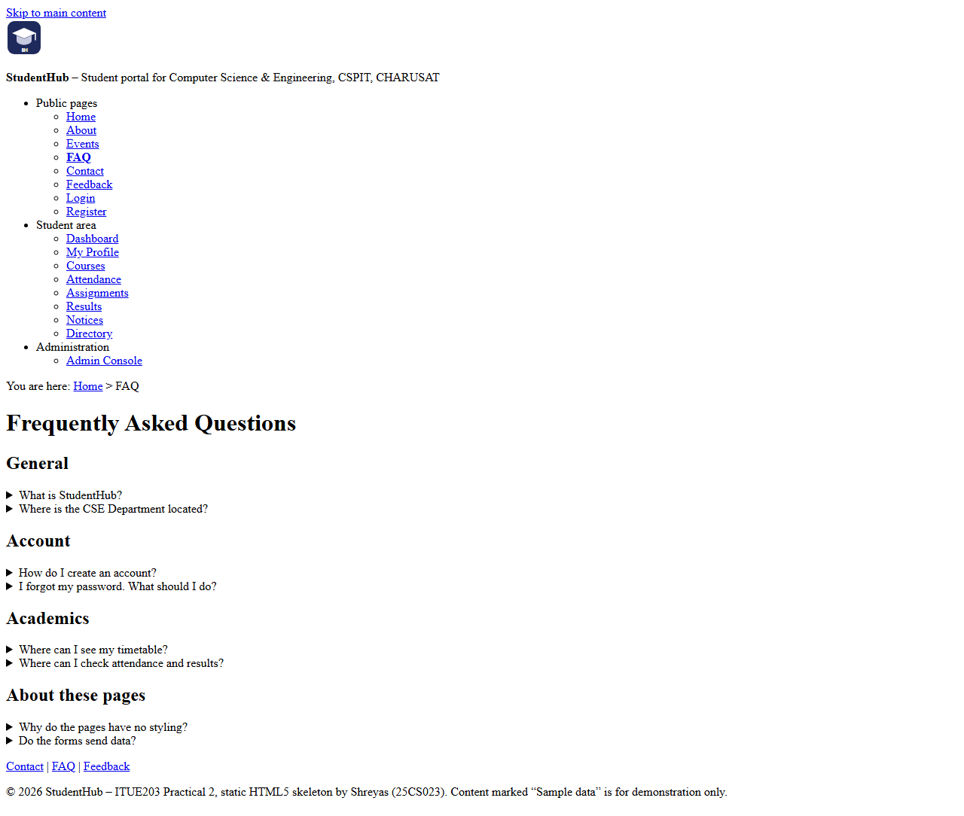
Figure 10: FAQ page (faq.html) in Microsoft Edge

6.11 Feedback – feedback.html
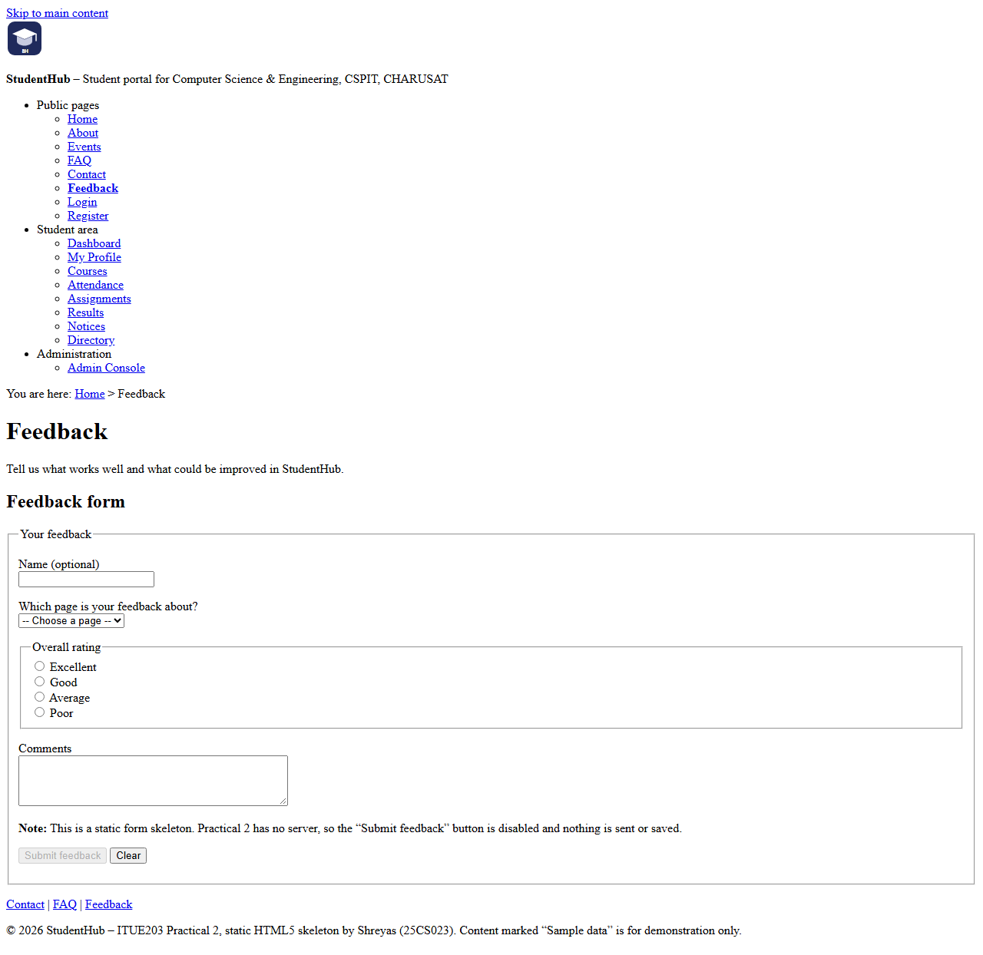
Figure 11: Feedback page (feedback.html) in Microsoft Edge

7. Testing and Accessibility Checklist

7.1 Local checker: source/check_pages.py
The pages were checked with Practical-2/source/check_pages.py, a script written for this practical using only the Python standard library. It is a local checker, not the official W3C Markup Validation Service: it tests the rules listed below, tag nesting and duplicate ids, but not every rule of the HTML specification.
Command used:
python Practical-2/source/check_pages.py Practical-2

Result: all 17 pages passed and the script printed “ALL CHECKS PASSED”. The counts below are taken from the script’s output; “links checked” counts every link on the page, including the shared navigation:
Page | Links checked | Form controls | Result
index.html | 36 | 0 | Passed
about.html | 40 | 0 | Passed
events.html | 25 | 0 | Passed
faq.html | 29 | 0 | Passed
contact.html | 23 | 4 | Passed
feedback.html | 23 | 7 | Passed
login.html | 25 | 3 | Passed
register.html | 24 | 11 | Passed
dashboard.html | 29 | 0 | Passed
profile.html | 25 | 4 | Passed
courses.html | 24 | 0 | Passed
attendance.html | 24 | 3 | Passed
assignments.html | 24 | 2 | Passed
results.html | 24 | 0 | Passed
notifications.html | 26 | 0 | Passed
directory.html | 25 | 2 | Passed
admin.html | 28 | 6 | Passed

As a control test, the same script was run on the earlier version of the Practical-2 folder (before this practical’s changes). It reported 212 problems across the 17 expected files, including the five pages that did not exist yet; other examples were missing main navigation and skip links, table headers without scope, and obsolete table attributes. This shows that the script does detect the faults it is meant to find.

7.2 Accessibility checklist
# | Check | Result | How it was checked
1 | DOCTYPE, lang="en", UTF-8 charset, viewport meta and a unique title on every page | Pass | check_pages.py
2 | Semantic landmarks: header, nav, exactly one main and footer; content in section, article or aside | Pass | check_pages.py
3 | Exactly one h1 per page; no skipped heading levels | Pass | check_pages.py
4 | Skip-to-content link is the first link and targets main#main-content | Pass | check_pages.py, screenshots
5 | Main navigation lists all 17 pages; current page marked with aria-current="page" | Pass | check_pages.py, screenshots
6 | Breadcrumb navigation with aria-current="page" | Pass | check_pages.py, screenshots
7 | Every form control has a label; radio groups use fieldset and legend | Pass | check_pages.py
8 | Every image has descriptive alt text | Pass | check_pages.py
9 | Data tables have a caption and th elements with scope | Pass | check_pages.py
10 | All local and in-page links resolve; no href="#" placeholders; no external links | Pass | check_pages.py
11 | Keyboard friendly: native elements only, no tabindex, no click-only controls | Pass | Source review
12 | No non-working controls: submit buttons disabled with an explanation | Pass | check_pages.py, screenshots
13 | No inline styles, style or script elements, or obsolete layout attributes | Pass | check_pages.py
14 | Pages render correctly in a browser | Pass | All 17 screenshots opened and inspected

7.3 Not tested
- Official W3C validation: the pages were not submitted to the W3C Markup Validation Service.
- Colour contrast: not measured. The pages use the browser’s default colours because there is no CSS.
- Screen-reader behaviour: not tested with a screen reader.
- Keyboard use in the browser: not tested by hand; item 11 is based on reviewing the source.
- Other browsers and devices: only Microsoft Edge on Windows 11 was used; phones and other browsers were not tested.

8. Results and Conclusion
Seventeen static HTML5 pages were developed for StudentHub: the eleven pages required by the problem definition (Home, About, Register, Login, Dashboard, Events, Profile, Contact, Admin, FAQ and Feedback) and six additional student-area pages. All pages share one semantic skeleton with a skip-to-content link, a header, a main navigation that marks the current page, a breadcrumb, a single main element and a footer, so the structure is consistent across the portal. Forms use labels, fieldsets and legends, the logo image has descriptive alt text, and every page is reachable from every other page.
The local checker passed all 17 pages, and the browser screenshots of all pages were captured and inspected. The breadcrumb (intermediate extension) and the skip-to-content link with keyboard-friendly markup (advanced extension) from the practical list are included.
Remaining limitations: the forms do not send data because there is no server in this practical; the pages contain sample data only; and official W3C validation, colour contrast, screen-reader testing and manual keyboard testing were not carried out. Styling with CSS Grid, Flexbox and a framework follows in Practical 3.

9. References
- ITUE203 Web Development Frameworks – Practical List 2026-27, Practical 2: “Semantic HTML5 Pages with Accessibility-Ready Structure”, CSPIT, CHARUSAT.
- StudentHub repository: https://github.com/TheEmperor08/StudentHub-ITUE203-25CS023 (this practical’s changes are uploaded separately).
- Practical-2/README.md – page list and accessibility checklist; Practical-2/source/check_pages.py – local checker.
- WHATWG, HTML Living Standard – https://html.spec.whatwg.org/
- W3C Markup Validation Service – https://validator.w3.org/ (recommended for official validation; not used in this report).
- Tools: Microsoft Edge 156.0.4314.50, Python 3.12.0, Visual Studio Code, Git.

Appendix A. Additional Pages
Browser output of the six additional pages. To keep this appendix compact, each image is cropped below the shared header and navigation (identical on every page, see Figure 1), so it starts at the breadcrumb. The full screenshots are 12-courses.png to 17-directory.png in Practical-2/screenshots/browser/.
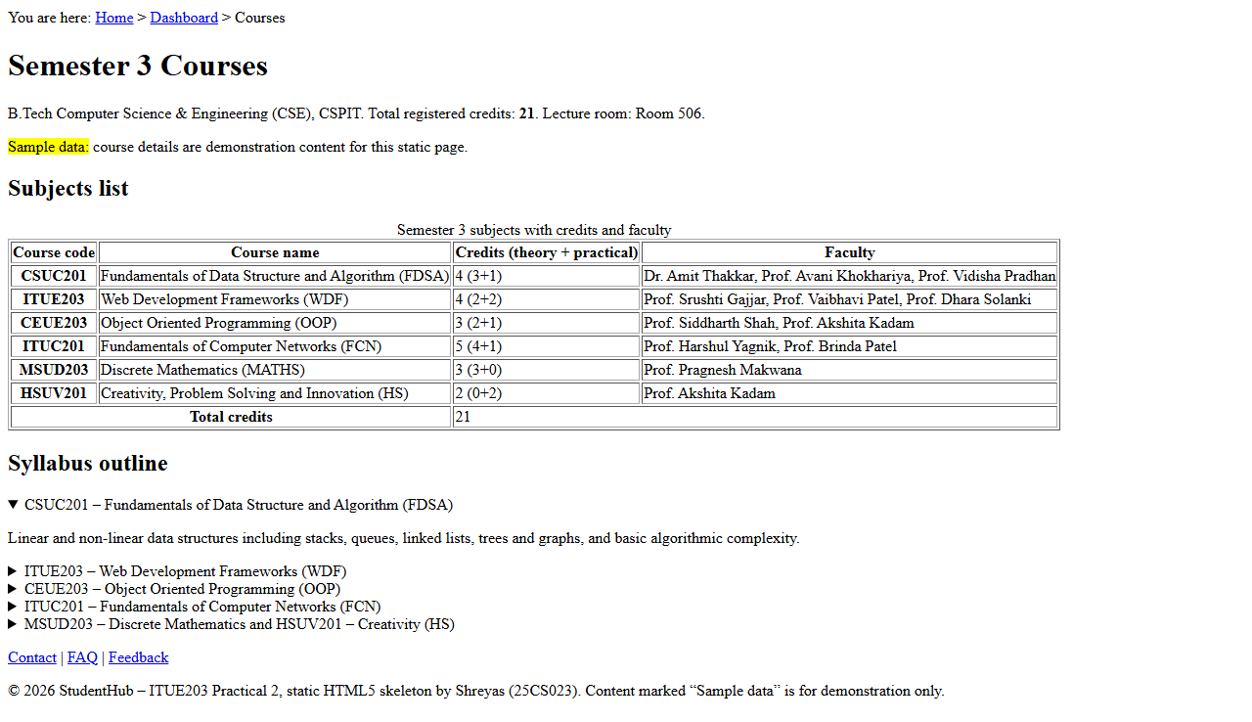
Figure A1: Courses page (courses.html), below the shared header
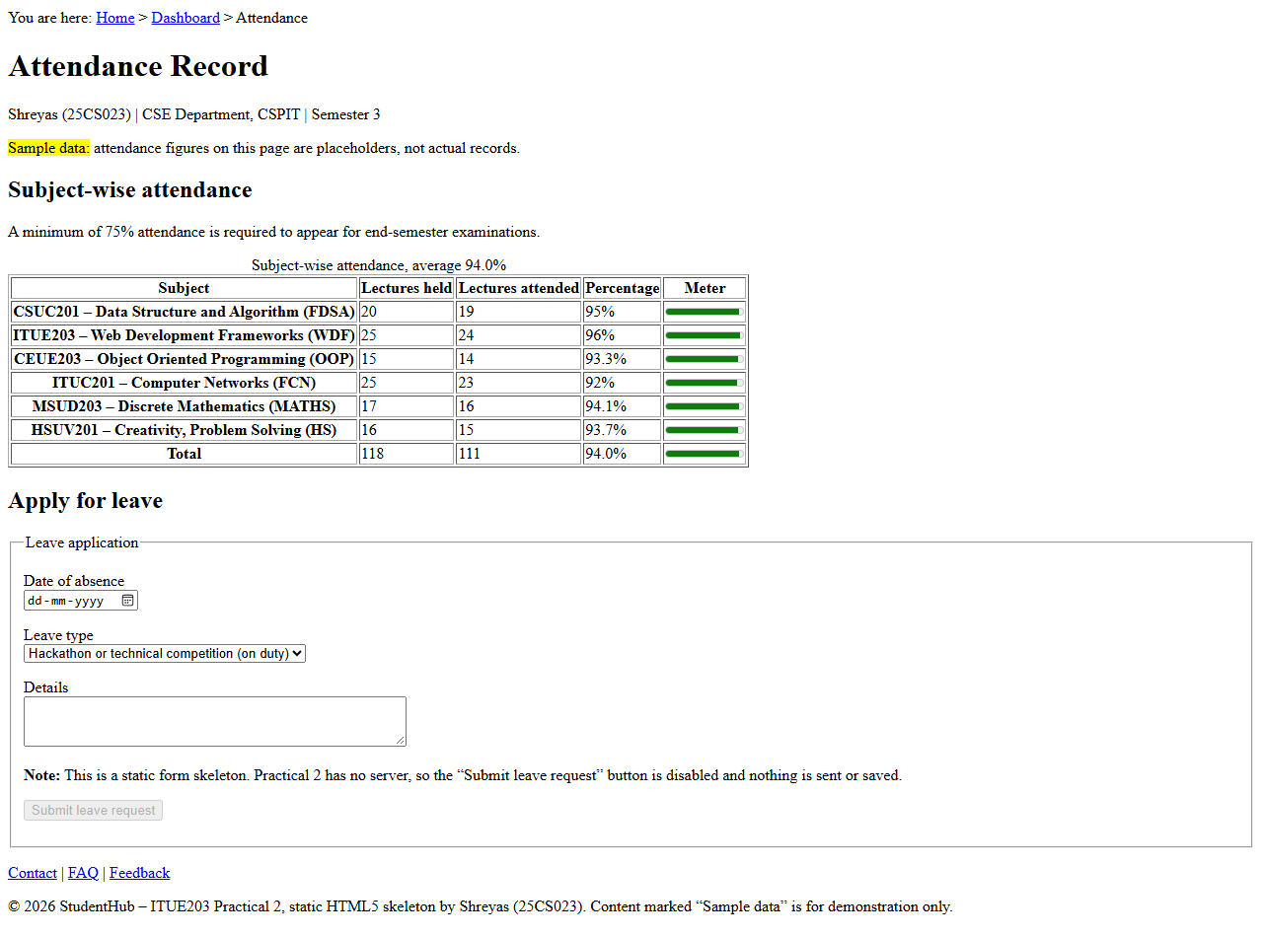
Figure A2: Attendance page (attendance.html), below the shared header
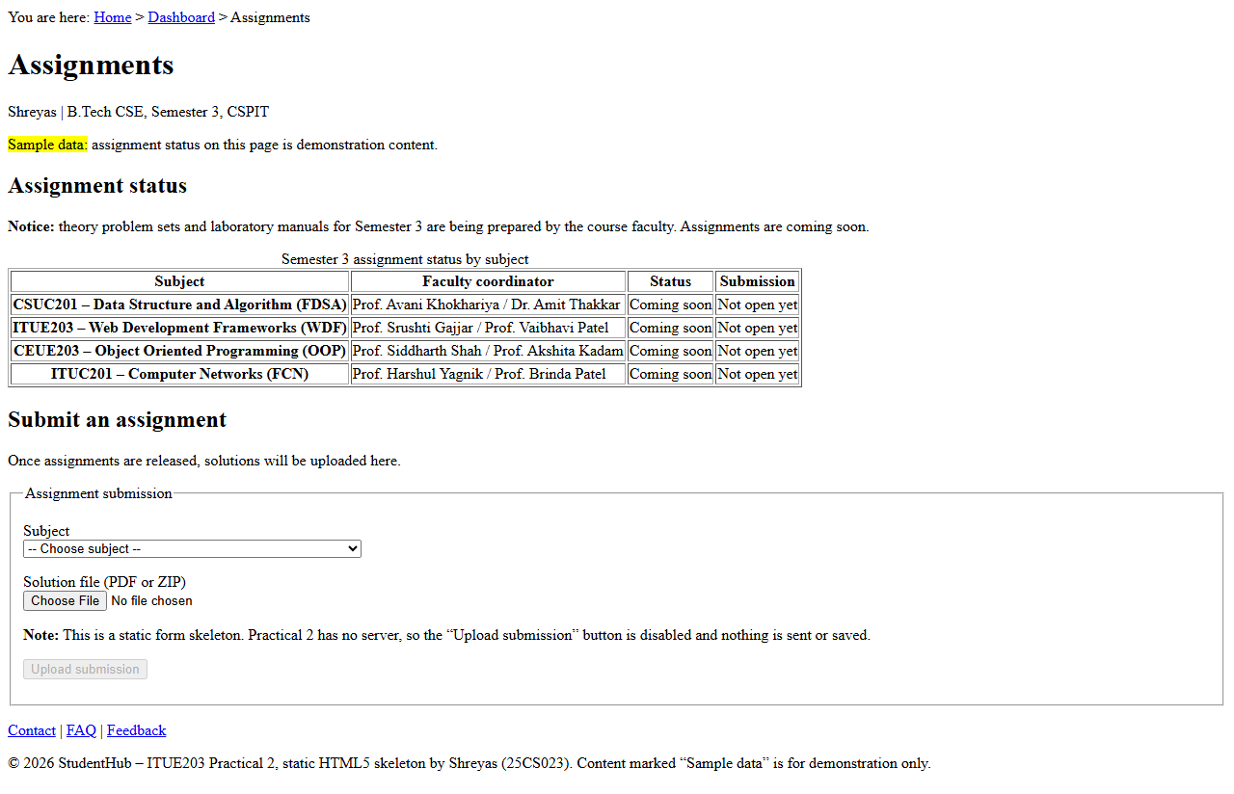
Figure A3: Assignments page (assignments.html), below the shared header
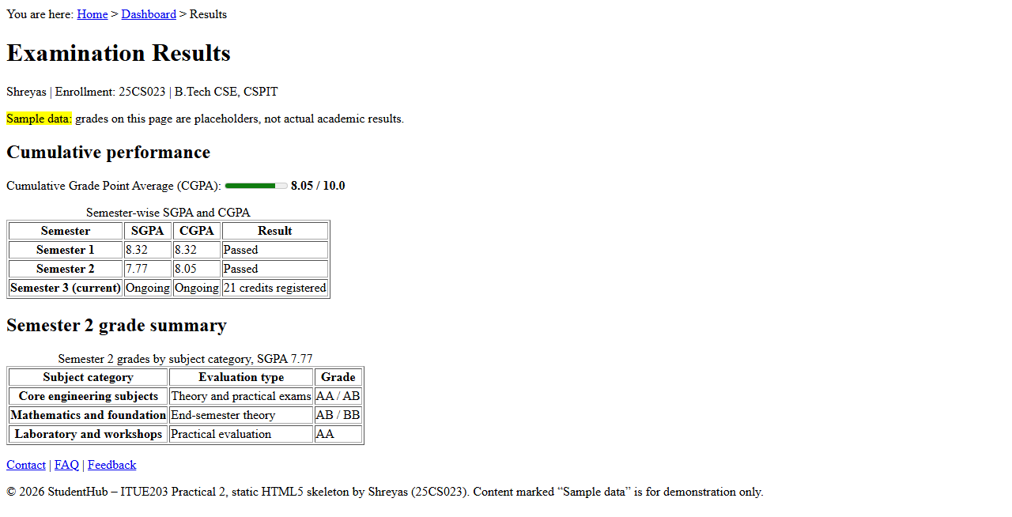
Figure A4: Results page (results.html), below the shared header
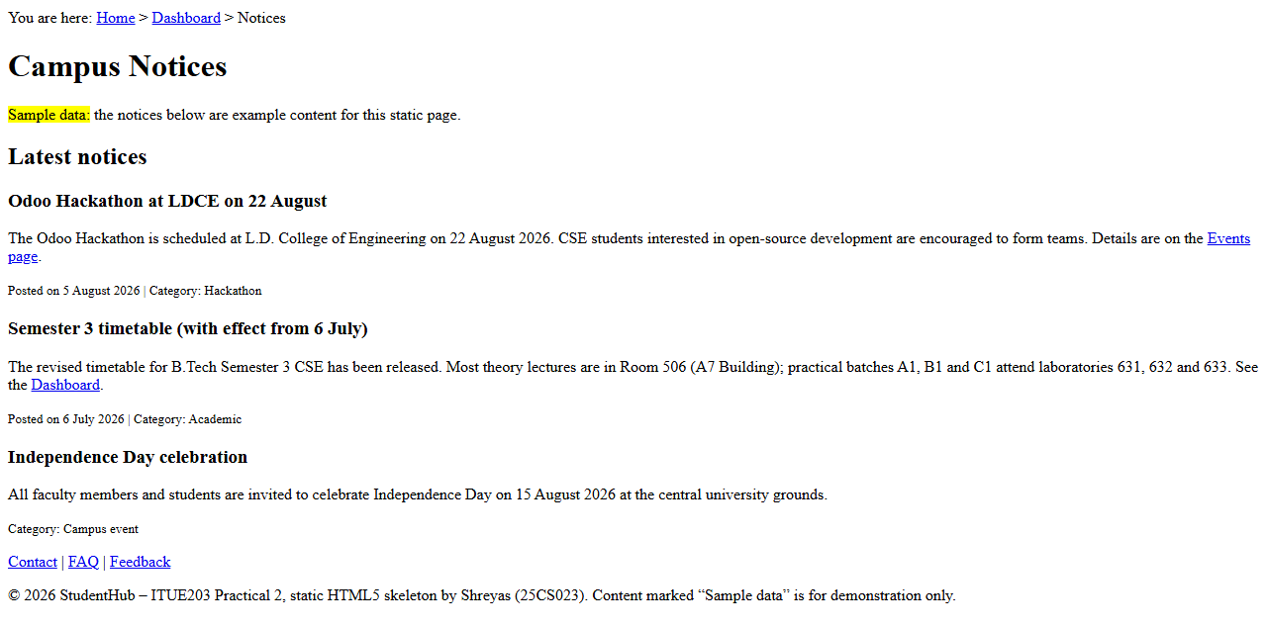
Figure A5: Notices page (notifications.html), below the shared header
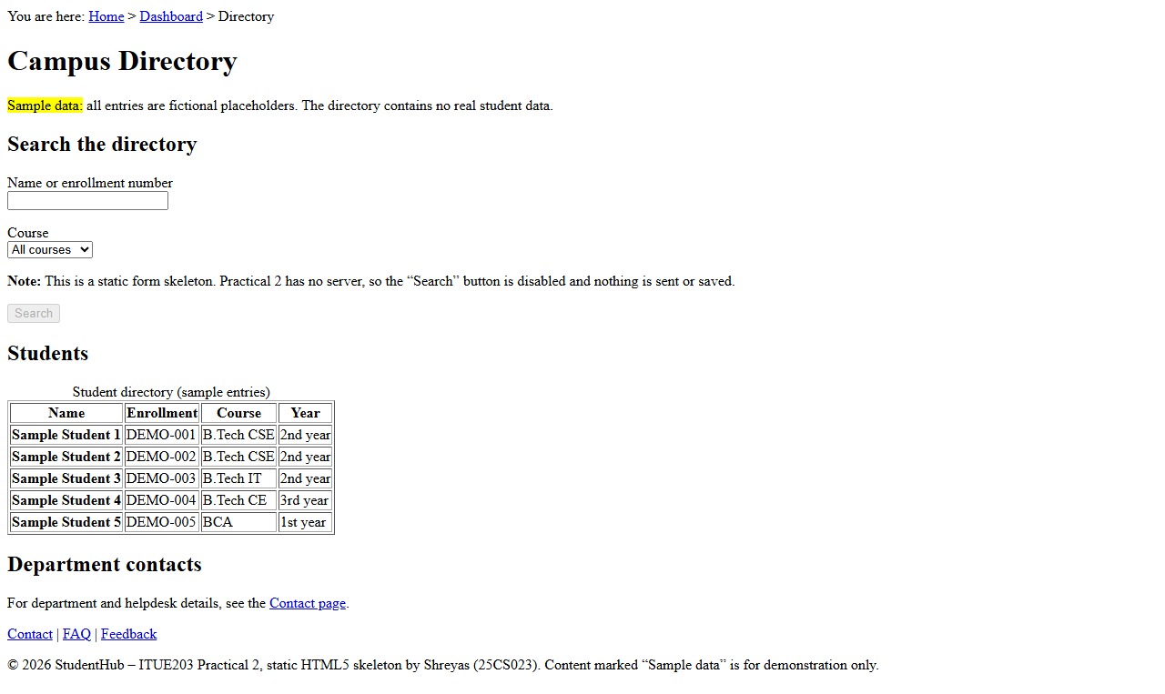
Figure A6: Directory page (directory.html), below the shared header

