CHAROTAR UNIVERSITY OF SCIENCE AND TECHNOLOGY (CHARUSAT)
Chandubhai S. Patel Institute of Technology (CSPIT)
Department of Computer Science & Engineering
ITUE203 – Web Development Frameworks
PRACTICAL 3

Responsive UI Design using CSS Grid, Flexbox and Bootstrap
Student Name | Shreyas
Roll Number | 25CS023
Email | 25cs023@charusat.edu.in
Course | ITUE203 – Web Development Frameworks
Programme | B.Tech Computer Science & Engineering
Semester / Academic Year | 3 / 2026-27
Date of Submission
Faculty Signature

1. Aim and Objectives
To design responsive, mobile-first layouts for the StudentHub portal using CSS Flexbox, CSS Grid and the Bootstrap 5.3 framework.
- Build the Home and About pages with Flexbox: wrapping navigation, a flexible hero section and rows of cards.
- Build the Dashboard and Events pages with CSS Grid: named grid areas for the page layout and automatic card grids.
- Build the Registration (and Login) page with Bootstrap 5.3 components, grid classes and accessible form controls.
- Make every page adapt to mobile (375px), tablet (768px) and desktop (1280px) widths, starting from the mobile layout.
- Keep the StudentHub look, readable text and sufficient colour contrast, with no unnecessary inline CSS.

2. Problem Definition
Official problem definition: “Design responsive layouts for Home, About, Registration, Dashboard, and Events pages using CSS Grid and Flexbox. Optional to use CSS framework such as Bootstrap or Tailwind. Ensure mobile-first responsiveness.”
Students open StudentHub on phones, tablets and laptops. A layout designed only for a wide screen becomes cramped or scrolls sideways on a phone. The pages therefore start from a single-column mobile layout and add columns as the screen grows. Each technique is used where it fits best: Flexbox for one-directional rows of items, Grid for two-dimensional page layouts, and Bootstrap for ready-made, tested responsive components.
The practical list asks four key questions; the answers for this implementation are:
Key question | Answer in this practical
How does the layout adapt for mobile, tablet and desktop screens? | One column on phones; from 768px cards sit two per row, the hero and form fields go side by side and the full menu appears; from 1024px grid areas place the timetable beside the event alert and cards fill one row (Section 7).
Which layout technique is used and why? | Flexbox for the navigation, hero and card rows (items in one direction that wrap); CSS Grid for the Dashboard and Events page layouts and card grids (rows and columns together); Bootstrap for the Registration and Login forms and the collapsing navbar (tested components).
Are typography, spacing, colours and contrast readable? | System font at 16px with 1.6 line height and consistent 16–24px spacing. All 27 text and control colour pairs meet WCAG 2.1 contrast minimums (Section 9).
Is the framework used consistently without unnecessary inline CSS? | Yes. No page has a style attribute or style element (checked by script). Bootstrap is customised in one stylesheet through its own CSS variables.

3. Tools and Technologies
Tool | Use in this practical
HTML5 | Semantic structure of the six pages
CSS3 | Flexbox, CSS Grid, custom properties and min-width media queries (assets/css/)
Bootstrap 5.3.3 | Navbar, grid and form components on Registration and Login; stored locally in vendor/bootstrap-5.3.3/ (MIT licence)
Microsoft Edge 156.0.4314.50 | Viewing the pages; headless mode for the screenshots and the in-browser layout checks
Python 3.12.0 | source/check_pages.py and source/contrast_check.py (standard library only)
Git | Version control of the StudentHub repository
Operating system | Windows 11

4. CSS Flexbox Implementation – Home and About
Files: index.html, about.html, assets/css/flex.css and the shared header and footer rules in assets/css/base.css.
- Navigation: the header and menu are flex containers with flex-wrap: wrap, so on a phone the six links wrap onto two lines and on a tablet they sit beside the logo.
- Hero section (Home): flex-direction: column on phones; from 768px it becomes a row with the text taking flex: 2 and the campus alerts panel flex: 1.
- Card rows: .card-row wraps its cards: flex-basis 100% on phones (1 per row), calc(50% − gap) on tablets (2 per row) and 0 on desktops (all in one row: 3 portal cards on Home, 4 role cards on About). Each card is itself a column flex container, so the links line up at the bottom.
- About page: .split places Purpose and About this practical side by side from 768px; the page list is a wrapping row of “chips”.
5 .hero {
6 display: flex;
7 flex-direction: column;
8 gap: 24px;
9 margin-bottom: 32px;
10 padding: 28px 20px;
11 border-radius: var(--radius);
12 background: linear-gradient(135deg, var(--indigo) 0%, var(--violet) 100%);
13 color: var(--on-navy);
14 }
15
16 .hero h1,
17 .hero h2 {
18 color: var(--on-navy);
19 }
20
21 .hero__actions {
22 display: flex;
23 flex-wrap: wrap;
24 gap: 12px;
25 }

59 .card-row {
60 display: flex;
61 flex-wrap: wrap;
62 gap: var(--gap);
63 margin: 0 0 32px;
64 padding: 0;
65 list-style: none;
66 }
67
68 .card-row > * {
69 display: flex;
70 flex: 1 1 100%;
71 flex-direction: column;
72 }

117 @media (min-width: 768px) {
118 .hero {
119 flex-direction: row;
120 align-items: center;
121 padding: 40px;
122 }
123

37 <section class="hero" aria-labelledby="hero-title">
38 <div class="hero__text">
39 <h1 id="hero-title">Welcome to StudentHub</h1>
40 <p>Your portal for Computer Science &amp; Engineering at CSPIT, CHARUSAT. Check your timetable, Semester 3 subjects, attendance and campus events in one place.</p>
41 <div class="hero__actions">
42 <a class="button" href="login.html">Login</a>
43 <a class="button button--ghost" href="register.html">Register as a new student</a>
44 </div>
45 </div>
46 <aside class="hero__panel" aria-labelledby="alerts-title">

5. CSS Grid Implementation – Dashboard and Events
Files: dashboard.html, events.html and assets/css/grid.css.
- Page layout with named areas: .dashboard uses grid-template-areas: one column (welcome, stats, timetable, alert) on phones; from 1024px two columns (3fr 1fr) place the timetable beside the event alert. .events does the same with the event list (2fr) and the information panel (1fr).
- Automatic card grids: .stat-grid uses repeat(auto-fit, minmax(150px, 1fr)): 2 summary cards per row on a phone and 4 on tablet and desktop. .event-grid uses repeat(auto-fill, minmax(260px, 1fr)): 1 event card per row on a phone, 2 on tablet and desktop.
- Wide table: the timetable keeps a minimum width of 640px and scrolls inside its own labelled region on phones, so the page itself never scrolls sideways.
6 .dashboard {
7 display: grid;
8 grid-template-columns: 1fr;
9 grid-template-areas:
10 "welcome"
11 "stats"
12 "timetable"
13 "alert";
14 gap: 20px;
15 }

27 .stat-grid {
28 display: grid;
29 grid-template-columns: repeat(auto-fit, minmax(150px, 1fr));
30 gap: var(--gap);
31 margin: 0;
32 padding: 0;
33 list-style: none;
34 }

107 .event-grid {
108 display: grid;
109 grid-template-columns: repeat(auto-fill, minmax(260px, 1fr));
110 gap: var(--gap);
111 margin: 0;
112 padding: 0;
113 list-style: none;
114 }

138 @media (min-width: 1024px) {
139 .dashboard {
140 grid-template-columns: 3fr 1fr;
141 grid-template-areas:
142 "welcome welcome"
143 "stats stats"
144 "timetable alert";
145 }
146
147 .events {
148 grid-template-columns: 2fr 1fr;
149 grid-template-areas: "list info";
150 }
151 }

37 <main id="main-content" class="container dashboard">
38 <section class="dashboard__welcome card" aria-labelledby="dashboard-title">
39 <h1 id="dashboard-title">Student Dashboard</h1>
40 <p>Welcome, <strong>Shreyas</strong> | Enrollment: 25CS023 | B.Tech CSE, Semester 3, CSPIT</p>
41 <p><span class="sample-note">Sample data</span> The figures and the timetable on this page are placeholders, not actual academic records.</p>
42 </section>
43
44 <section class="dashboard__stats" aria-labelledby="summary-title">
45 <h2 id="summary-title">Semester 3 summary</h2>
46 <ul class="stat-grid">

6. Bootstrap Implementation – Registration and Login
Files: register.html, login.html, assets/css/bootstrap-custom.css and the local framework files vendor/bootstrap-5.3.3/css/bootstrap.min.css and vendor/bootstrap-5.3.3/js/bootstrap.bundle.min.js. Both framework files were compared with the SHA-384 integrity hashes published for Bootstrap 5.3.3 and match.
- Navbar: navbar-expand-md with a collapse menu: below 768px the links are hidden behind the ☰ toggle button (which needs bootstrap.bundle.min.js); from 768px they show in a row.
- Grid: the form uses row g-3 and col-12 col-md-6, so fields are one per row on phones and two per row from 768px; the content column widens with col-lg-10 / col-xl-8 (Registration) and col-sm-10 col-md-7 col-lg-5 (Login).
- Components: card, form-label, form-control, form-select, form-check (inline radios and checkbox), btn and breadcrumb; fieldset and legend group the fields.
- Branding: bootstrap-custom.css sets Bootstrap’s own CSS variables (for example --bs-primary and --bs-btn-bg) to the StudentHub colours and darkens the form-control borders for contrast.
- Static form: the submit button is disabled and a note states that nothing is sent or saved; there is no backend in this practical.
15 <nav class="navbar navbar-expand-md sh-navbar" data-bs-theme="dark" aria-label="Main navigation">
16 <div class="container">
17 <a class="navbar-brand d-flex align-items-center gap-2 fw-bold" href="index.html"><img src="assets/images/studenthub-logo.svg" alt="" width="36" height="36"> StudentHub</a>
18 <button class="navbar-toggler" type="button" data-bs-toggle="collapse" data-bs-target="#main-nav" aria-controls="main-nav" aria-expanded="false" aria-label="Toggle navigation">
19 <span class="navbar-toggler-icon"></span>
20 </button>
21 <div class="collapse navbar-collapse" id="main-nav">
22 <ul class="navbar-nav ms-auto gap-md-1">

52 <div class="row g-3">
53 <div class="col-12 col-md-6">
54 <label for="reg-name" class="form-label">Full name *</label>
55 <input type="text" class="form-control" id="reg-name" name="name" autocomplete="name" required>
56 </div>
57 <div class="col-12 col-md-6">
58 <label for="reg-email" class="form-label">College email address *</label>
59 <input type="email" class="form-control" id="reg-email" name="email" autocomplete="email" required>
60 </div>

153 <script src="vendor/bootstrap-5.3.3/js/bootstrap.bundle.min.js"></script>

7. Responsive Design: Mobile, Tablet and Desktop
The stylesheets are mobile-first: rules outside media queries describe the phone layout, and only min-width queries add the larger layouts. The pages contain the viewport meta tag, images scale with max-width: 100%, and no page scrolls horizontally at any of the three widths (Section 9).
Width | Flexbox pages | Grid pages | Bootstrap pages
Mobile, below 768px (tested at 375px) | Menu wraps to two lines; hero and cards stacked, 1 per row | One column; 2 summary cards per row; 1 event card per row; timetable scrolls in its box | Menu behind the ☰ button; one field per row
Tablet, 768px and wider (tested at 768px) | Hero text and alerts side by side; 2 cards per row | 4 summary cards per row; 2 event cards per row | Full menu in the navbar; two fields per row
Desktop, 1024px and wider (tested at 1280px) | All cards of a row on one line (3 or 4) | Two-column grid areas: timetable + event alert, event list + information panel | Wider centred form column

8. Browser Output
All screenshots are real full-page renders of the pages by Microsoft Edge 156 in headless mode. Edge’s headless window cannot be narrower than about 500px, so each page was loaded in a frame of exactly 375, 768 or 1280 CSS pixels and the page’s media queries respond to that width. The images are scaled to fit the page; the full-resolution files are in Practical-3/screenshots/mobile/, tablet/ and desktop/.

8.1 Mobile – 375px
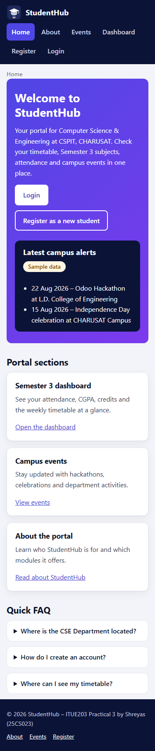  Figure 1: Home (Flexbox), 375px | 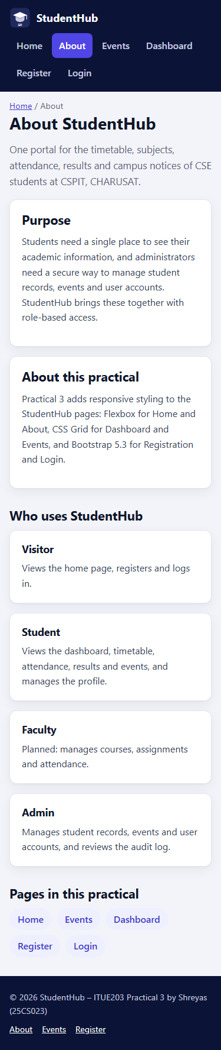  Figure 2: About (Flexbox), 375px | 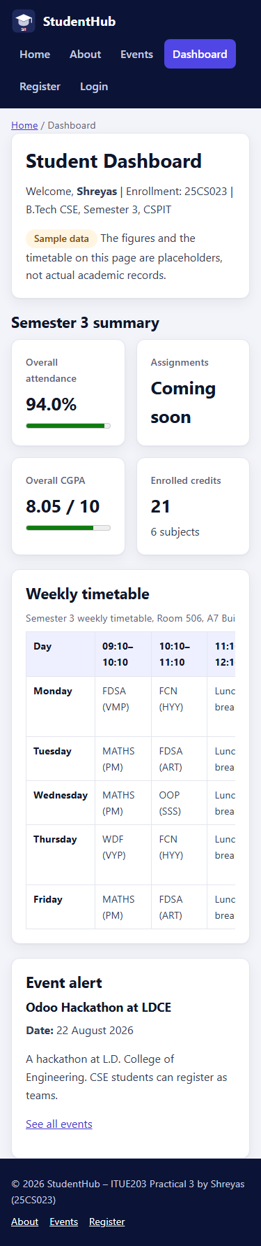  Figure 3: Dashboard (CSS Grid), 375px

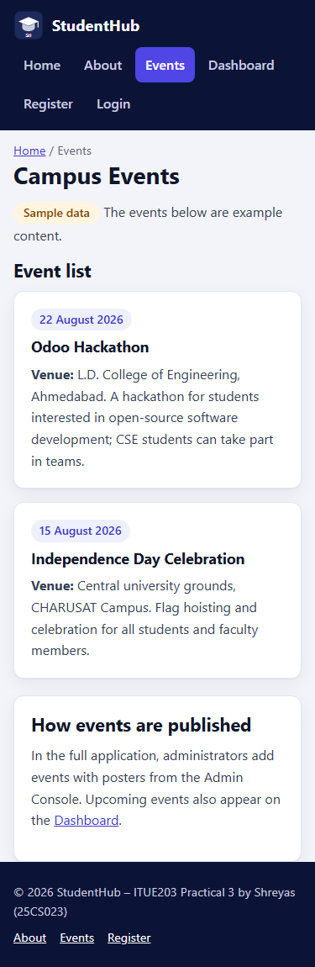  Figure 4: Events (CSS Grid), 375px | 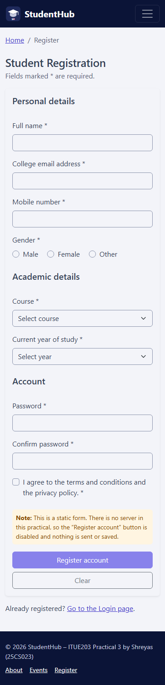  Figure 5: Registration (Bootstrap), 375px | 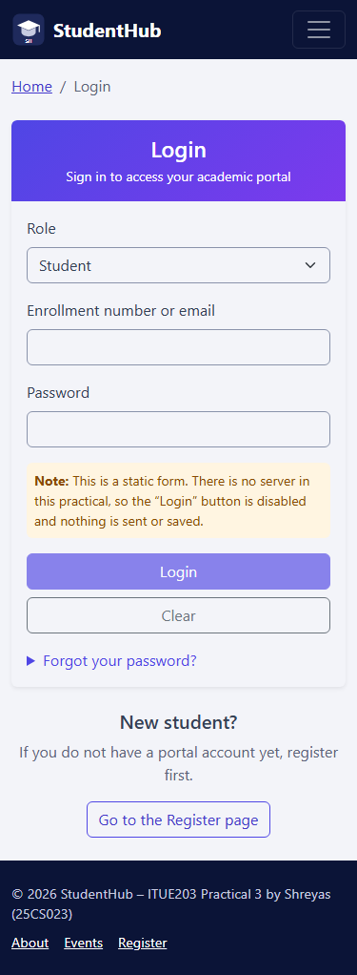  Figure 6: Login (Bootstrap), 375px

8.2 Tablet – 768px
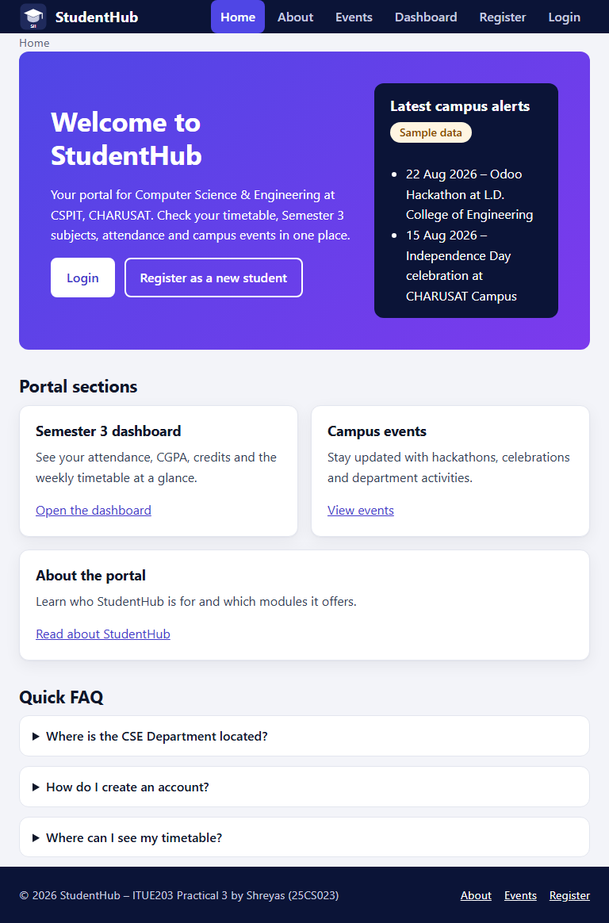  Figure 7: Home (Flexbox), 768px | 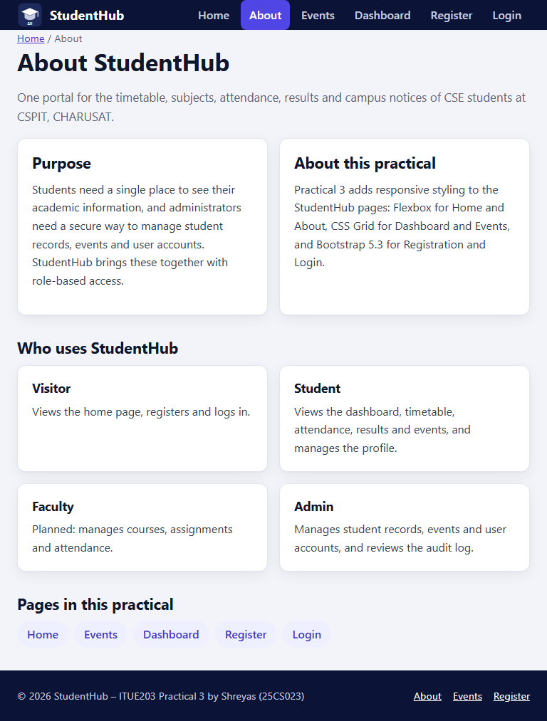  Figure 8: About (Flexbox), 768px

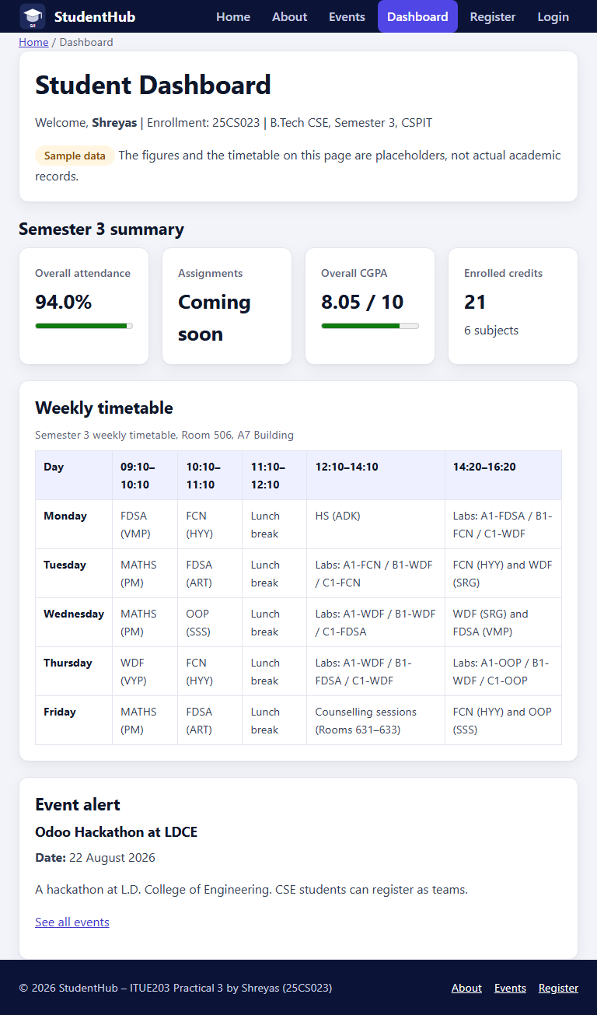  Figure 9: Dashboard (CSS Grid), 768px | 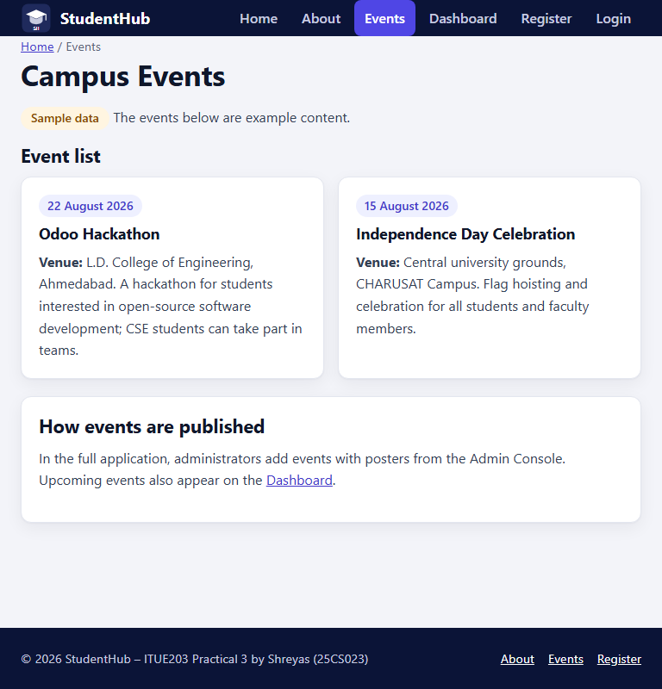  Figure 10: Events (CSS Grid), 768px

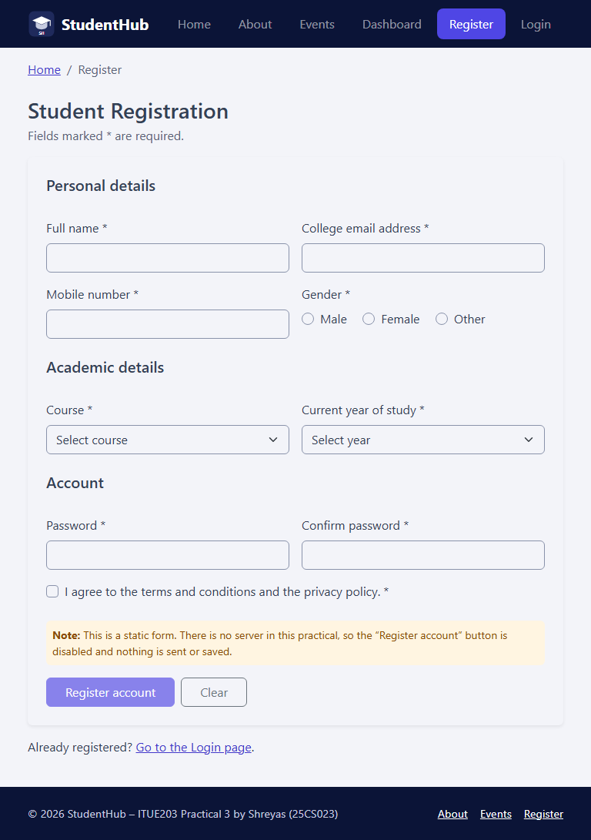  Figure 11: Registration (Bootstrap), 768px | 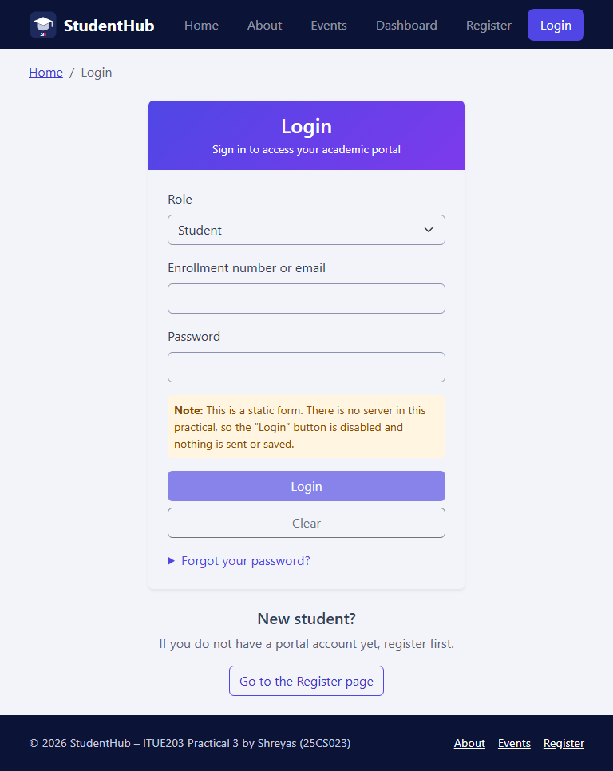  Figure 12: Login (Bootstrap), 768px

8.3 Desktop – 1280px
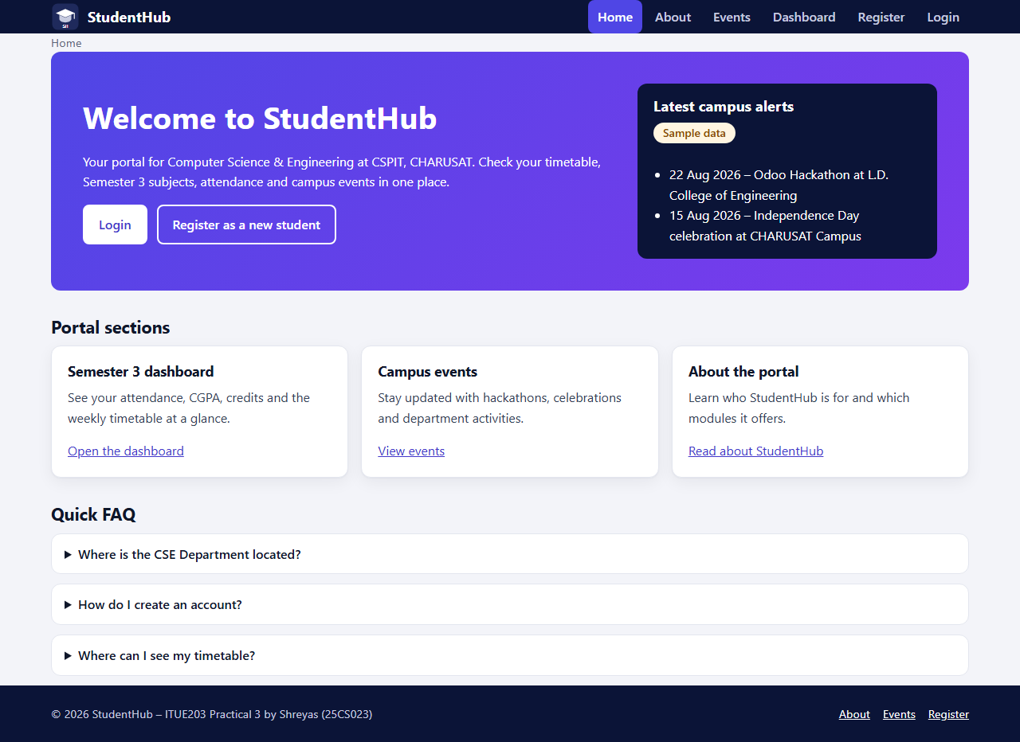
Figure 13: Home (Flexbox), 1280px
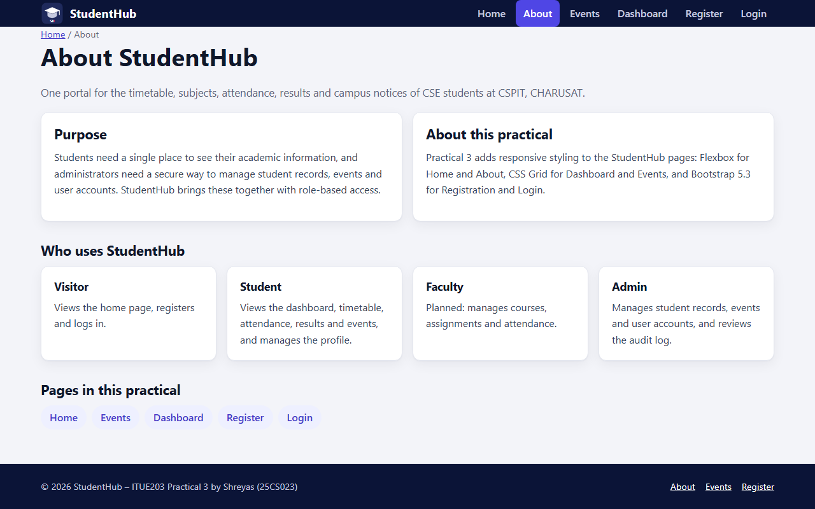
Figure 14: About (Flexbox), 1280px
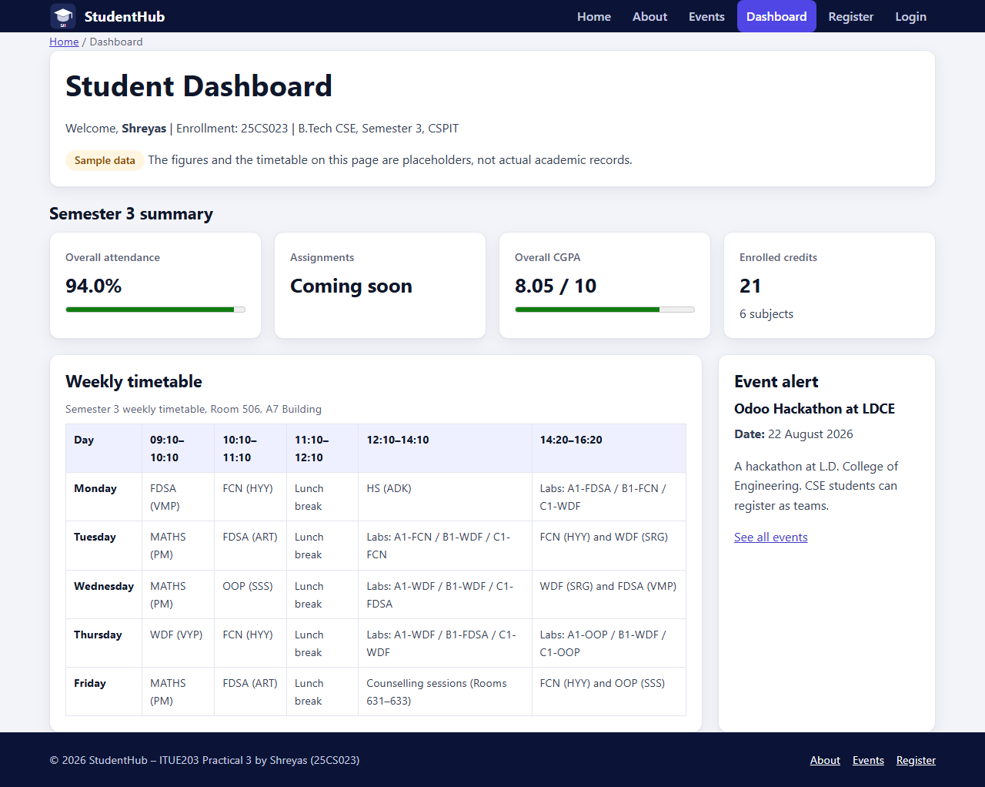
Figure 15: Dashboard (CSS Grid), 1280px
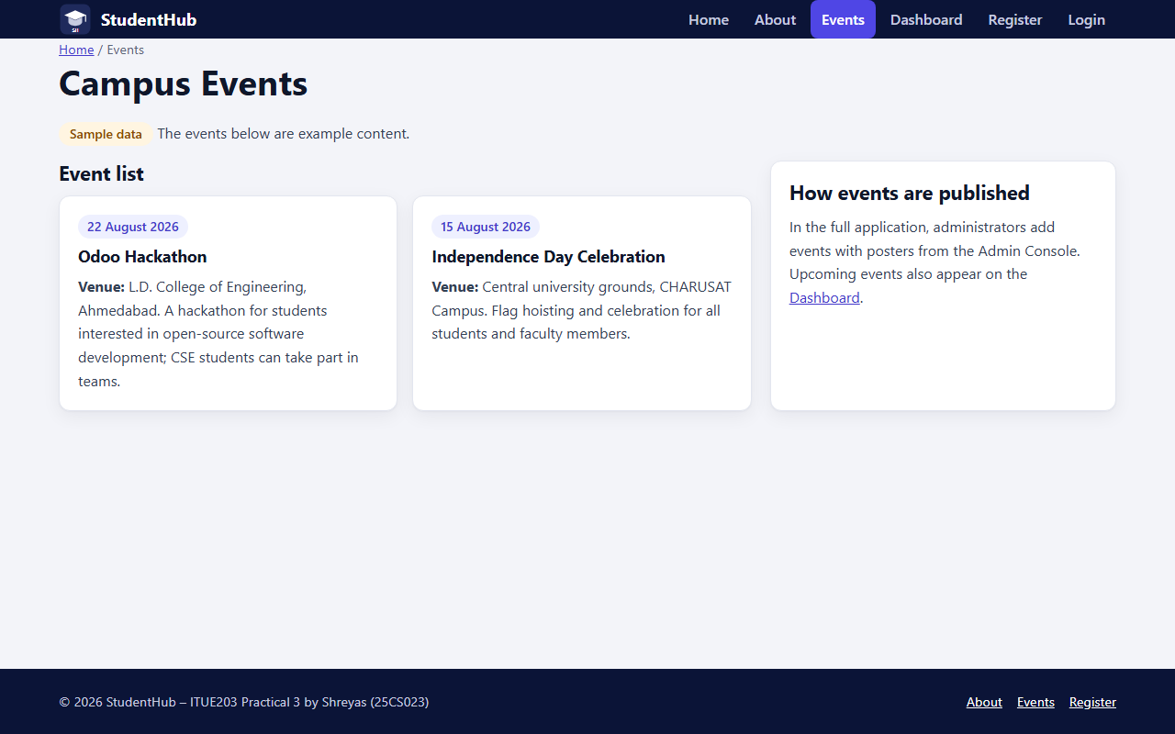
Figure 16: Events (CSS Grid), 1280px
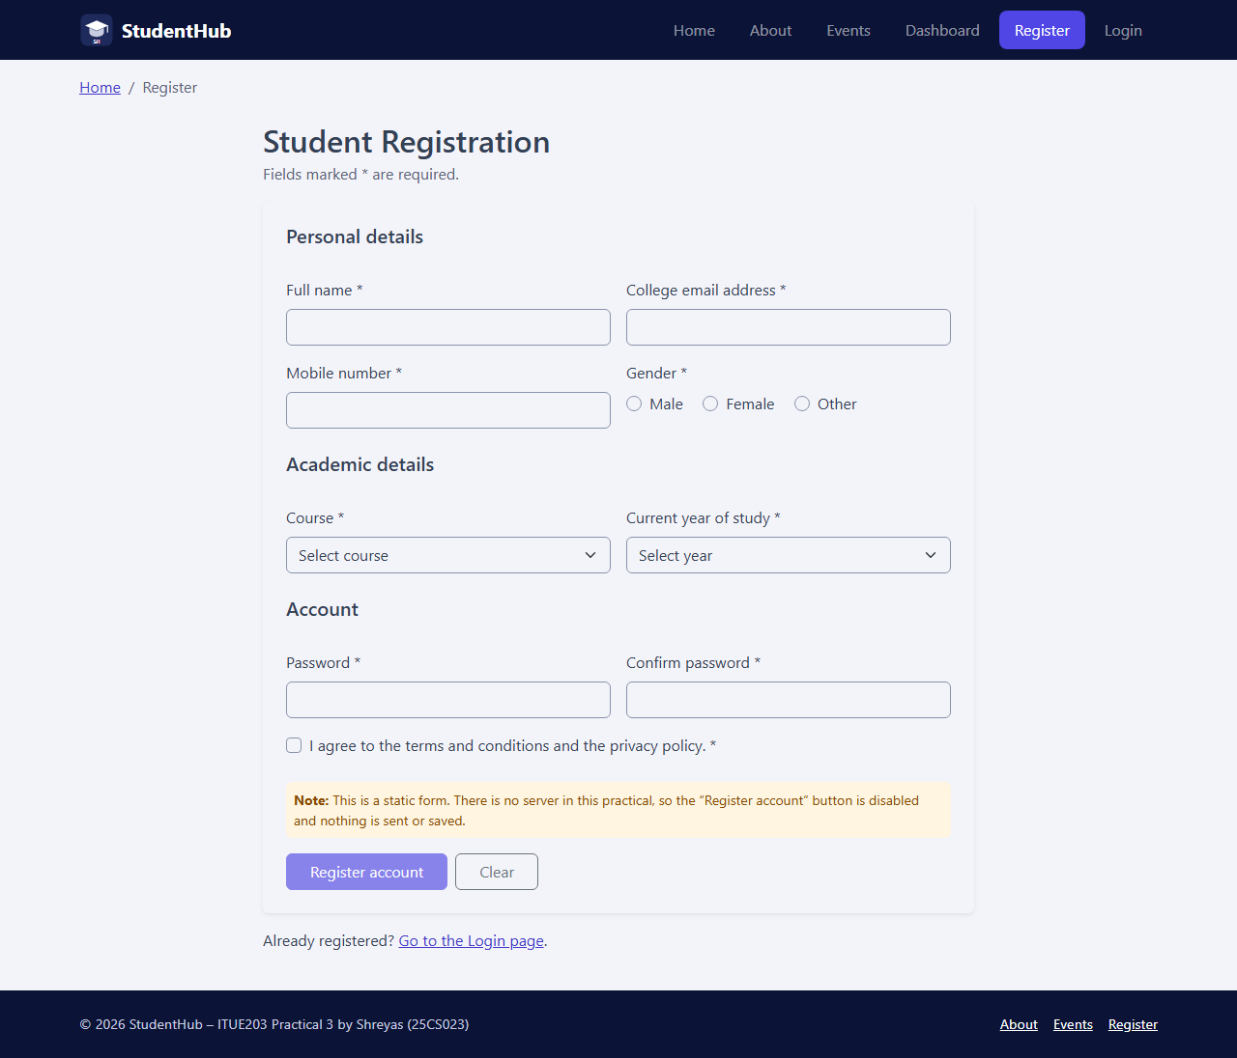
Figure 17: Registration (Bootstrap), 1280px
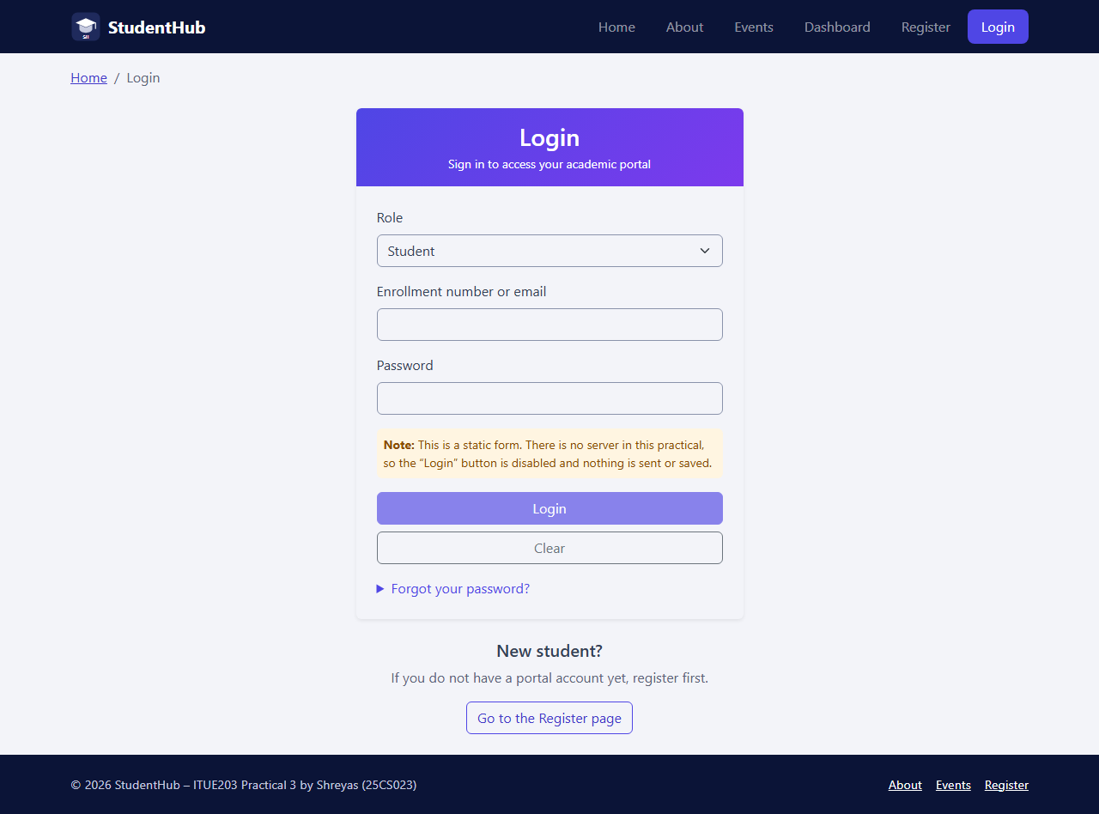
Figure 18: Login (Bootstrap), 1280px

9. Testing and Accessibility Checks
Only the tests listed here were carried out; the results are those reported by the tools.
Test | How | Result
Structure, links and accessibility basics: doctype, lang, title, landmarks, one h1, heading order, skip link, labels, image alt, table caption and th scope, aria-current in navigation and breadcrumb, local links, no inline styles or external URLs | source/check_pages.py (local script, not the W3C validator) | All 6 pages pass
CSS organisation: no @import, external URLs or !important; only min-width media queries; Grid and Flexbox features present; Bootstrap file hashes | source/check_pages.py | Pass
The checker detects faults | 5 faults planted in a copy: inline style, missing label, external link, max-width query, !important | All 5 reported
Grid, Flexbox and Bootstrap really applied at each width: computed display, column counts, flex direction, cards per row, Bootstrap CSS and JS loaded, menu button only below 768px | getComputedStyle() inside Edge at 375, 768 and 1280px | 57 of 57 pass
Horizontal overflow | Page scrollWidth compared with the viewport width in Edge | None (18 of 18 renders)
Colour contrast (WCAG 2.1: 4.5:1 for text, 3:1 for control borders and the focus outline) | source/contrast_check.py | 27 of 27 pairs pass
Screenshots | All 18 page screenshots and 6 source-code images opened and inspected | Readable and correctly rendered

The contrast check found one real problem, which was fixed: Bootstrap’s default form-control border (#dee2e6) has only 1.3:1 contrast on white, so bootstrap-custom.css sets #8a93ab (3.07:1).
Not tested: real phones and tablets, browsers other than Microsoft Edge, screen readers, manual keyboard use, opening the Bootstrap menu by hand, and the official W3C Markup Validation Service.

10. Results and Conclusion
Six responsive StudentHub pages were built: Home and About with Flexbox, Dashboard and Events with CSS Grid, and Registration and Login with Bootstrap 5.3. The five pages required by the problem definition are all present and connected by the same navigation. The layouts are mobile-first and were verified in Microsoft Edge at 375, 768 and 1280px: the Grid and Flexbox properties and the Bootstrap components are active at each width, no page scrolls sideways, and all checked colour pairs meet the WCAG 2.1 contrast minimums. The pages open directly from the folder without a server, internet connection or build step.
Limitations: the forms are static (no backend in this practical) and the dashboard figures are sample data. The intermediate extension (Contact and Feedback pages) and the advanced extension (jQuery components) were not implemented. Testing was limited to Microsoft Edge on Windows, as listed in Section 9.

11. References
- ITUE203 Web Development Frameworks – Practical List 2026-27, Practical 3: “Responsive UI Design using CSS Grid, Flexbox, and Bootstrap/Tailwind”, CSPIT, CHARUSAT.
- Bootstrap 5.3 documentation – https://getbootstrap.com/docs/5.3/
- W3C, Web Content Accessibility Guidelines (WCAG) 2.1 – https://www.w3.org/TR/WCAG21/
- StudentHub repository: https://github.com/TheEmperor08/StudentHub-ITUE203-25CS023 (this practical’s changes are uploaded separately).
- Practical-3/README.md; Practical-3/source/check_pages.py and contrast_check.py.

