CHAROTAR UNIVERSITY OF SCIENCE AND TECHNOLOGY (CHARUSAT)
Chandubhai S. Patel Institute of Technology (CSPIT)
Department of Computer Science & Engineering
ITUE203 – Web Development Frameworks
PRACTICAL 8

MySQL Schema Design, ER Model, PDO Connectivity and Prepared Statements
Student Name | Shreyas
Roll Number | 25CS023
Student ID | 25CS023
Email | 25cs023@charusat.edu.in
Course | ITUE203 – Web Development Frameworks
Programme | B.Tech Computer Science & Engineering
Semester / Academic Year | 3 / 2026-27
Date of Submission
Faculty Signature

1. Aim and Objectives
To design a normalised MySQL database for StudentHub with the tables students, events and registrations, import it with phpMyAdmin, and connect to it securely from PHP using PDO and prepared statements.
- Model the data with an ER diagram and normalise the tables to Third Normal Form (3NF).
- Define correct primary keys, foreign keys, unique keys, indexes, CHECK constraints and data types.
- Write an SQL dump with fictional seed data that imports in phpMyAdmin without manual steps.
- Create db.php: a PDO connection with exception mode, UTF-8, native prepared statements and error handling that never shows credentials or database errors in the browser.
- Create test_connection.php that proves the connection and reads all three tables with prepared statements.
- Advanced extension: add stored procedures; intermediate extension: PDO with prepared statements.
- Test every part and record only results that were actually executed.

2. Problem Definition
Official problem definition: “Design the database for StudentHub with students, events and registrations. Create PHP database connection using MYSQL statements.”
StudentHub lets students register for college events. Until now the practicals stored data in static pages and JSON files. A real portal needs a database in which one student can register for many events and one event can have many students, without storing the same student or event details again and again. The database must refuse invalid data (for example a registration for a student who does not exist), and the PHP code must connect to it in a way that is safe against SQL injection and does not reveal the server's settings when something goes wrong.
Answers to the key questions of the practical:
Key question | Answer in this practical
Is the schema normalised properly? | Yes. All three tables are in 3NF: every column holds one value, every key is a single column, and no non-key column depends on another non-key column. The many-to-many relationship is resolved by registrations (Section 4.3).
Are primary keys and foreign keys correctly defined? | Each table has an AUTO_INCREMENT primary key; registrations.student_id and registrations.event_id are foreign keys with ON DELETE/ON UPDATE CASCADE. The tests confirmed that invalid references are rejected with MySQL error 1452 (Section 9).
Is the database connection handled securely? | Yes. PDO in exception mode with native prepared statements; no password in the repository; the real error is written to the PHP error log while the page shows only a general message (Sections 6–8).

3. Requirements and Tools
Item | Version / use
XAMPP | Windows package used for PHP, MariaDB, Apache and phpMyAdmin
PHP | 8.2.12 (XAMPP) with the pdo_mysql extension; built-in server on 127.0.0.1:8608
Database server | MariaDB 10.4.32 (XAMPP's MySQL), port 3306
phpMyAdmin | 5.2.1 – import of schema.sql and inspection of the tables
Browser | Microsoft Edge 156 – all screenshots
Testing | PHP CLI (tests/test_db.php) and Python 3.12 standard library (tests/test_page.py)
Operating system | Windows 11

Project folder: Practical-8 in the StudentHub repository. The practical uses its own database, studenthub_prac8, so the main StudentHub database and the earlier practical8_db are not changed.

4. Database Design

4.1 Tables
Table | Columns | Purpose
students | student_id (PK), student_code, full_name, email, branch, semester, created_at | One row per student
events | event_id (PK), title, event_date, venue, category, capacity, created_at | One row per event
registrations | registration_id (PK), student_id (FK), event_id (FK), registered_at, status | One row per student-event registration; resolves the many-to-many relationship

4.2 ER Diagram
A student makes zero or more registrations, and an event has zero or more registrations; each registration belongs to exactly one student and exactly one event. The diagram was drawn as SVG (docs/er-diagram.svg) and rendered to PNG with Microsoft Edge.
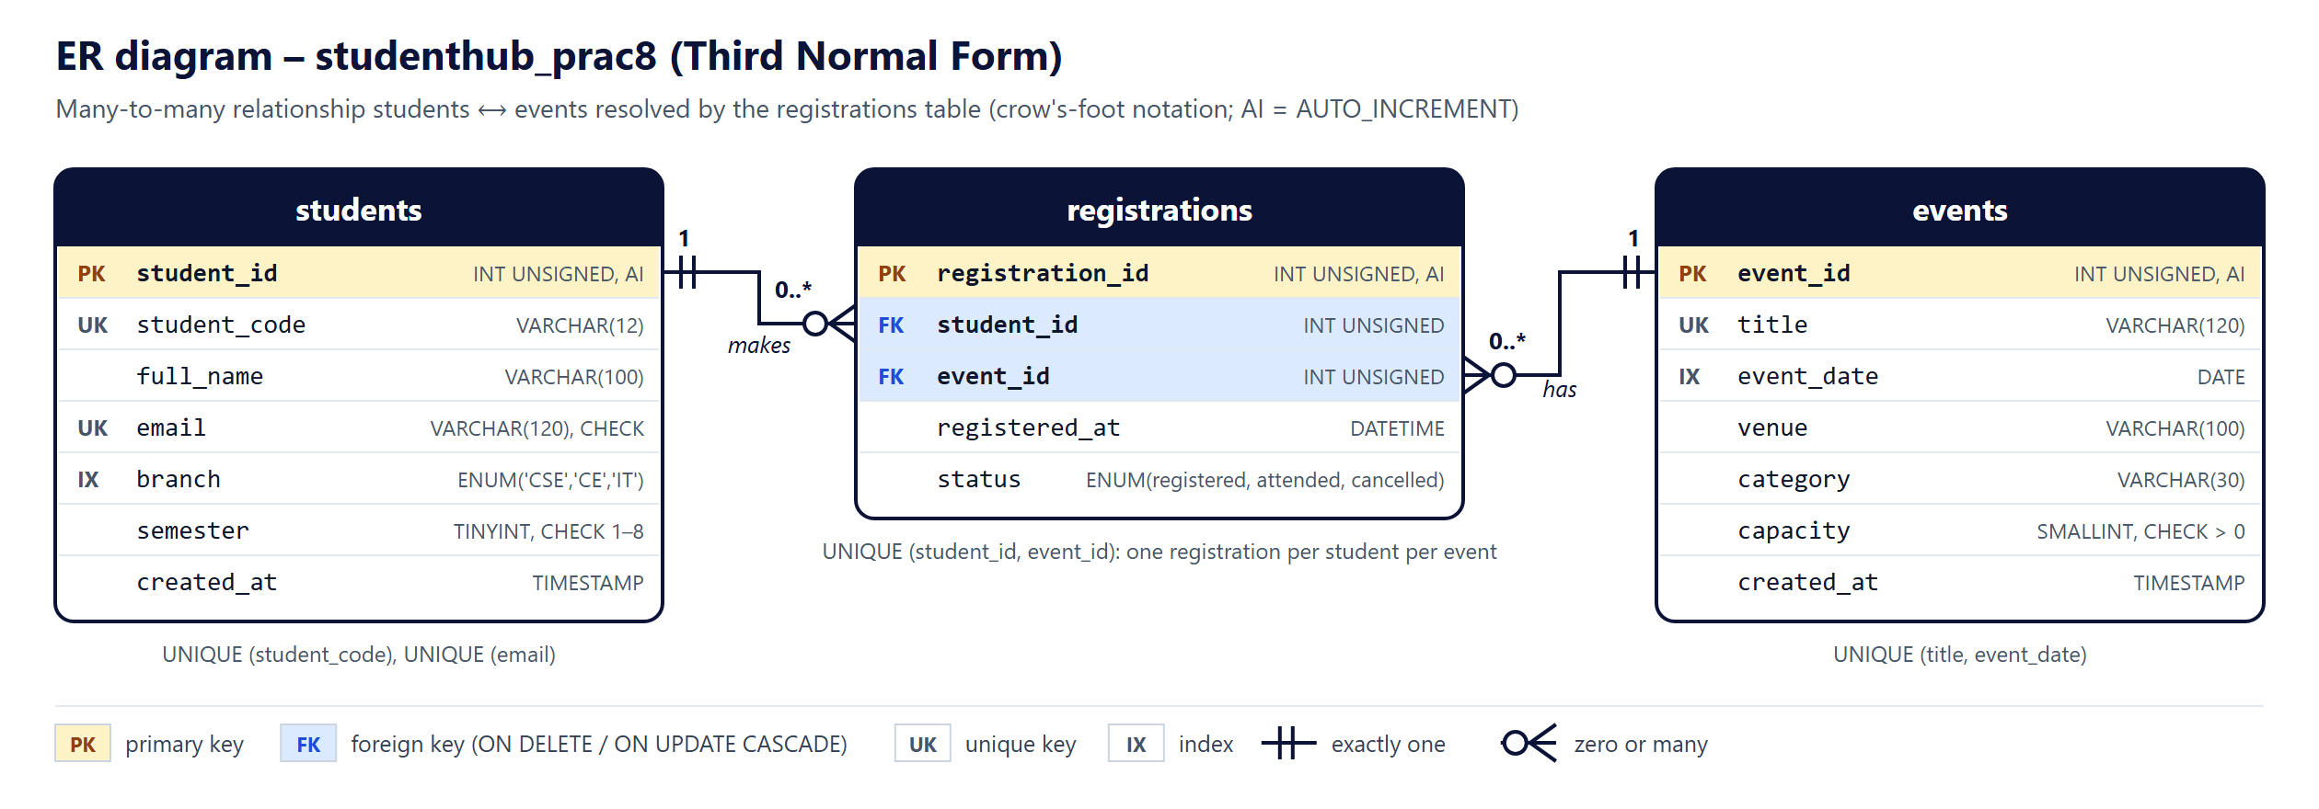
Figure 1: ER diagram of studenthub_prac8 (crow's-foot notation)

4.3 Normalisation to Third Normal Form
A first idea is often a single table such as the one below, where each row repeats the student and the event:
student_code | full_name | branch | event_title | event_date | venue | capacity | status
DEMO-S001 | Aarohi Menon | CSE | Inter-college Hackathon | 2026-08-22 | Lab 1 | 4 | registered
DEMO-S001 | Aarohi Menon | CSE | Web Development Bootcamp | 2026-08-30 | Lab 3 | 30 | attended
DEMO-S002 | Eshan Kapoor | IT | Inter-college Hackathon | 2026-08-22 | Lab 1 | 4 | registered

This design has update, insert and delete anomalies: changing a venue means changing every registration of that event, an event without registrations cannot be stored, and deleting the last registration of a student deletes the student. The schema was therefore normalised step by step:
Normal form | How the schema meets it
1NF | Every column holds one atomic value (no lists such as “events: 1, 3, 5”), there are no repeating groups, and every table has a primary key.
2NF | Every primary key is a single surrogate column (student_id, event_id, registration_id), so no column can depend on only part of a key.
3NF | No non-key column depends on another non-key column. Student details depend only on student_id and are stored only in students; event details depend only on event_id and are stored only in events. registrations stores just the two foreign keys and the facts about that registration (registered_at, status).

student_code and email are also unique, so they are candidate keys; making them UNIQUE keeps the design in 3NF (and in Boyce-Codd Normal Form) because every determinant is a key.

4.4 Keys, Constraints and Indexes
Element | Definition and reason
Primary keys | INT UNSIGNED AUTO_INCREMENT in every table – short, never changes, independent of names or codes.
Foreign keys | registrations.student_id → students.student_id and registrations.event_id → events.event_id, both ON DELETE CASCADE and ON UPDATE CASCADE: a registration cannot point to a missing student or event, and deleting a student also deletes that student's registrations.
Unique keys | students.student_code, students.email, events(title, event_date), registrations(student_id, event_id) – the last one stops a student registering twice for the same event.
CHECK constraints | semester BETWEEN 1 AND 8; email LIKE '%_@_%._%'; capacity > 0.
ENUM types | branch ('CSE', 'CE', 'IT') and status ('registered', 'attended', 'cancelled') allow only known values.
Indexes | students.branch (filter by branch), events.event_date (sorting by date), registrations.event_id (event rosters). MySQL indexes the foreign key student_id through the unique key (student_id, event_id).
Engine / character set | InnoDB (needed for foreign keys and transactions); utf8mb4 with utf8mb4_unicode_ci, so every name and symbol is stored correctly.

4.5 SQL Excerpts (schema.sql)
Database creation and safe re-import (child tables are dropped before parent tables):
15 SET NAMES utf8mb4;
16 SET time_zone = '+05:30';
17
18 CREATE DATABASE IF NOT EXISTS studenthub_prac8
19 CHARACTER SET utf8mb4 COLLATE utf8mb4_unicode_ci;
20 USE studenthub_prac8;
21
22 -- Drop in child-to-parent order so the foreign keys never block a re-import
23 DROP PROCEDURE IF EXISTS register_student_for_event;
24 DROP PROCEDURE IF EXISTS get_event_roster;
25 DROP TABLE IF EXISTS registrations;
26 DROP TABLE IF EXISTS events;
27 DROP TABLE IF EXISTS students;

The students table:
32 CREATE TABLE students (
33 student_id INT UNSIGNED NOT NULL AUTO_INCREMENT,
34 student_code VARCHAR(12) NOT NULL,
35 full_name VARCHAR(100) NOT NULL,
36 email VARCHAR(120) NOT NULL,
37 branch ENUM('CSE', 'CE', 'IT') NOT NULL,
38 semester TINYINT UNSIGNED NOT NULL,
39 created_at TIMESTAMP NOT NULL DEFAULT CURRENT_TIMESTAMP,
40 PRIMARY KEY (student_id),
41 CONSTRAINT uq_students_code UNIQUE (student_code),
42 CONSTRAINT uq_students_email UNIQUE (email),
43 CONSTRAINT chk_students_semester CHECK (semester BETWEEN 1 AND 8),
44 CONSTRAINT chk_students_email CHECK (email LIKE '%_@_%._%'),
45 INDEX idx_students_branch (branch)
46 ) ENGINE = InnoDB DEFAULT CHARSET = utf8mb4 COLLATE = utf8mb4_unicode_ci;

The registrations table with both foreign keys:
69 CREATE TABLE registrations (
70 registration_id INT UNSIGNED NOT NULL AUTO_INCREMENT,
71 student_id INT UNSIGNED NOT NULL,
72 event_id INT UNSIGNED NOT NULL,
73 registered_at DATETIME NOT NULL DEFAULT CURRENT_TIMESTAMP,
74 status ENUM('registered', 'attended', 'cancelled') NOT NULL DEFAULT 'registered',
75 PRIMARY KEY (registration_id),
76 CONSTRAINT uq_registrations_student_event UNIQUE (student_id, event_id),
77 INDEX idx_registrations_event (event_id),
78 CONSTRAINT fk_registrations_student FOREIGN KEY (student_id)
79 REFERENCES students (student_id) ON DELETE CASCADE ON UPDATE CASCADE,
80 CONSTRAINT fk_registrations_event FOREIGN KEY (event_id)
81 REFERENCES events (event_id) ON DELETE CASCADE ON UPDATE CASCADE
82 ) ENGINE = InnoDB DEFAULT CHARSET = utf8mb4 COLLATE = utf8mb4_unicode_ci;

4.6 Fictional Seed Data
All sample data is invented: names, DEMO-S codes and example.com addresses do not belong to real students. It contains 8 students, 5 events and 12 registrations. The Inter-college Hackathon has a capacity of 4 and is already full, to demonstrate the capacity check; registration 7 is cancelled and registrations 5 and 6 are marked attended.
Event ID | Title | Date | Capacity | Registrations
1 | Inter-college Hackathon | 2026-08-22 | 4 | 4 (full)
2 | Web Development Bootcamp | 2026-08-30 | 30 | 3 (2 attended, 1 cancelled)
3 | AI and Machine Learning Seminar | 2026-09-15 | 100 | 3
4 | Robotics Expo | 2026-09-25 | 50 | 1
5 | Annual Sports Week | 2026-11-01 | 200 | 1

4.7 Stored Procedures (Advanced Extension)
register_student_for_event locks the event row, refuses an unknown or full event with SIGNAL SQLSTATE '45000', and otherwise inserts the registration and returns its ID. get_event_roster(event_id) returns the students registered for one event and is called from test_connection.php.
124 CREATE PROCEDURE register_student_for_event(IN p_student_id INT UNSIGNED, IN p_event_id INT UNSIGNED)
125 BEGIN
126 DECLARE v_capacity SMALLINT UNSIGNED DEFAULT NULL;
127 DECLARE v_taken INT DEFAULT 0;
128
129 SELECT capacity INTO v_capacity FROM events WHERE event_id = p_event_id FOR UPDATE;
130 IF v_capacity IS NULL THEN
131 SIGNAL SQLSTATE '45000' SET MESSAGE_TEXT = 'Event not found';
132 END IF;
133
134 SELECT COUNT(*) INTO v_taken FROM registrations
135 WHERE event_id = p_event_id AND status <> 'cancelled';
136 IF v_taken >= v_capacity THEN
137 SIGNAL SQLSTATE '45000' SET MESSAGE_TEXT = 'Event is full';
138 END IF;
139
140 INSERT INTO registrations (student_id, event_id) VALUES (p_student_id, p_event_id);
141 SELECT LAST_INSERT_ID() AS registration_id;
142 END$$

5. Importing the Database with phpMyAdmin
- Start Apache and MySQL in the XAMPP Control Panel and open http://localhost/phpmyadmin.
- Open the Import tab, click Choose File and select Practical-8\schema.sql; keep the format SQL and click Import.
- phpMyAdmin reports “Import has been successfully finished, 17 queries executed.” The database studenthub_prac8 and its three tables appear in the left panel.
The import was carried out in Microsoft Edge: the file was chosen in phpMyAdmin's real file field and the Import button was pressed (automated through Edge's DevTools protocol so that it could be repeated). Figure 2 shows the database's Import tab with schema.sql selected and Figure 3 shows the result. The note #1007 “database exists” is expected on a re-import because of CREATE DATABASE IF NOT EXISTS.
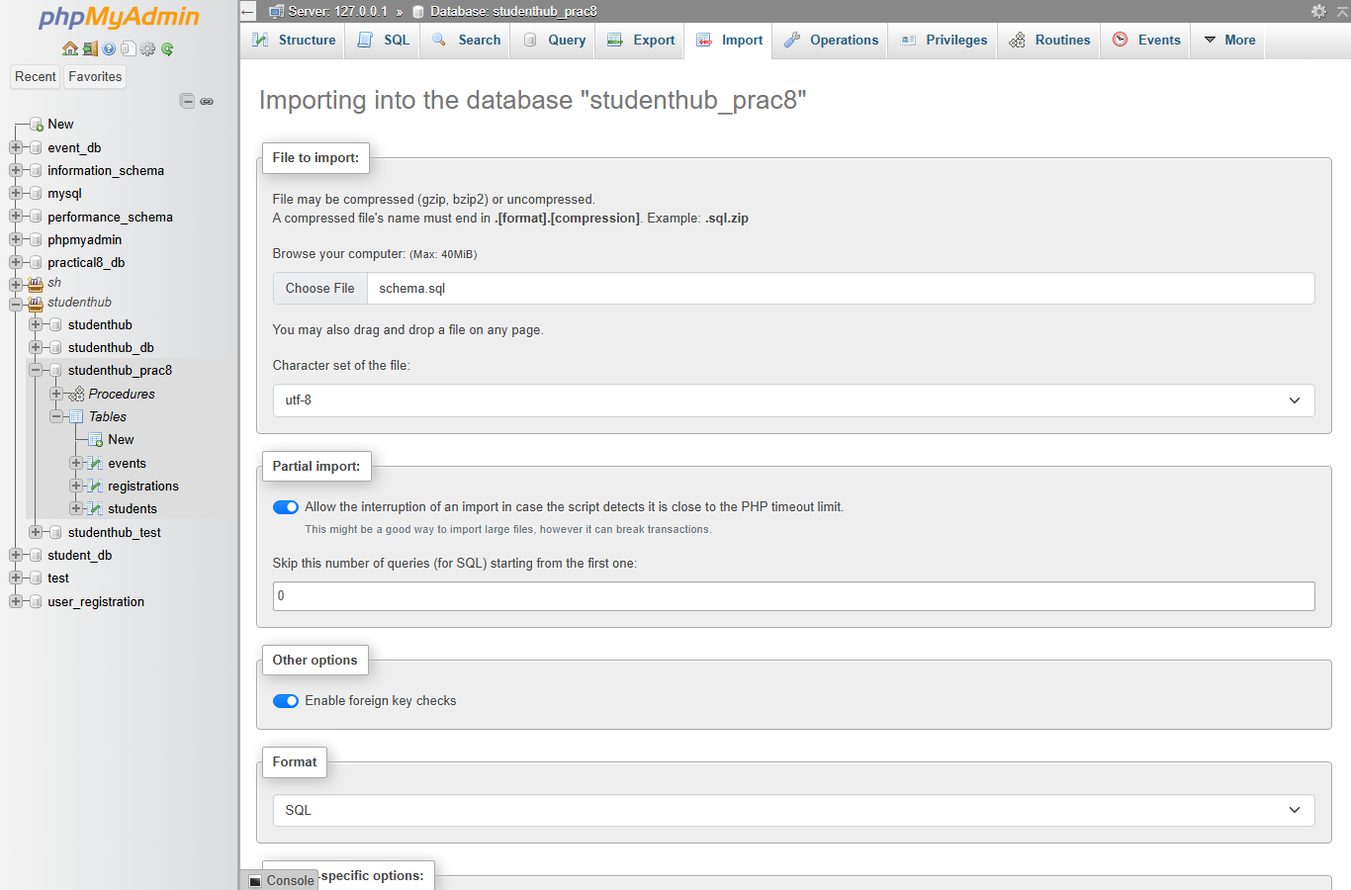
Figure 2: phpMyAdmin Import tab of studenthub_prac8 with schema.sql chosen
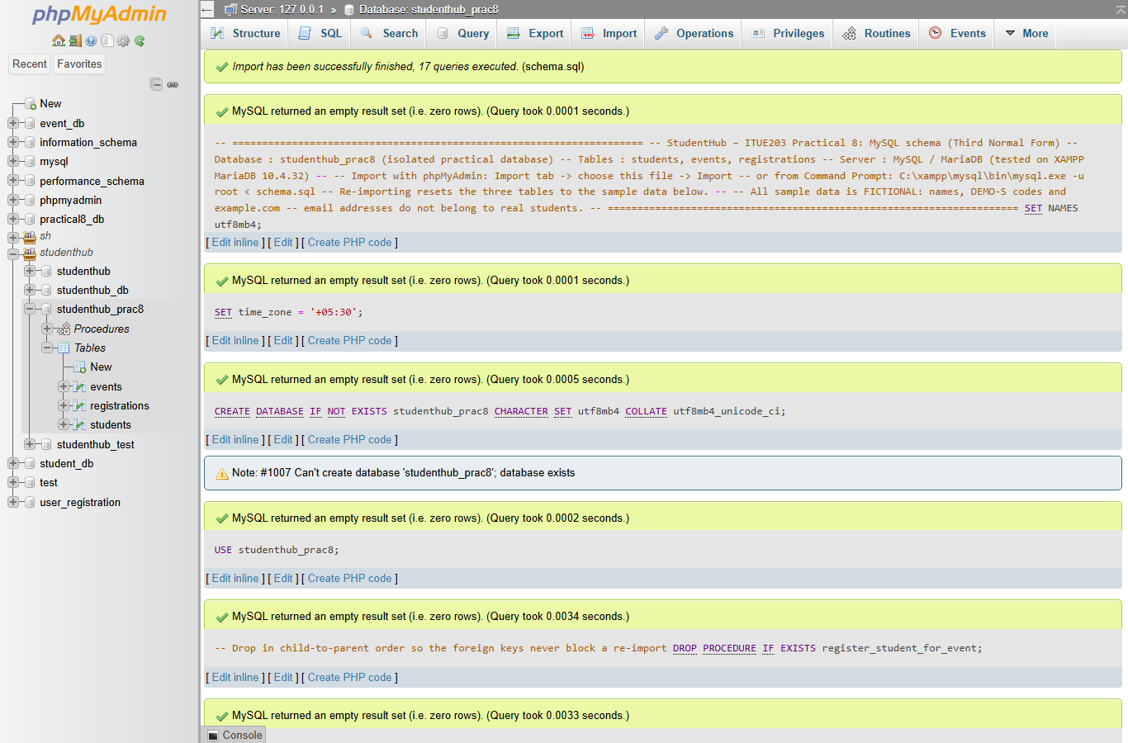
Figure 3: Import result – “Import has been successfully finished, 17 queries executed. (schema.sql)”
Observation: when the same file is imported from the server-level Import tab (no database selected), phpMyAdmin 5.2.1 additionally shows “Error: #1046 No database selected” after the SET, USE and procedure statements. Each statement itself succeeded, the database check afterwards found all tables, rows and procedures, and the same file imported with the MySQL command-line client (--show-warnings) or from the database's Import tab shows no such message. The messages therefore come from phpMyAdmin's own extra queries, not from schema.sql; this is explained in the README. The first import also showed warning #1280 because the primary keys had been given names that MySQL ignores; the names were removed and the warning no longer appears.
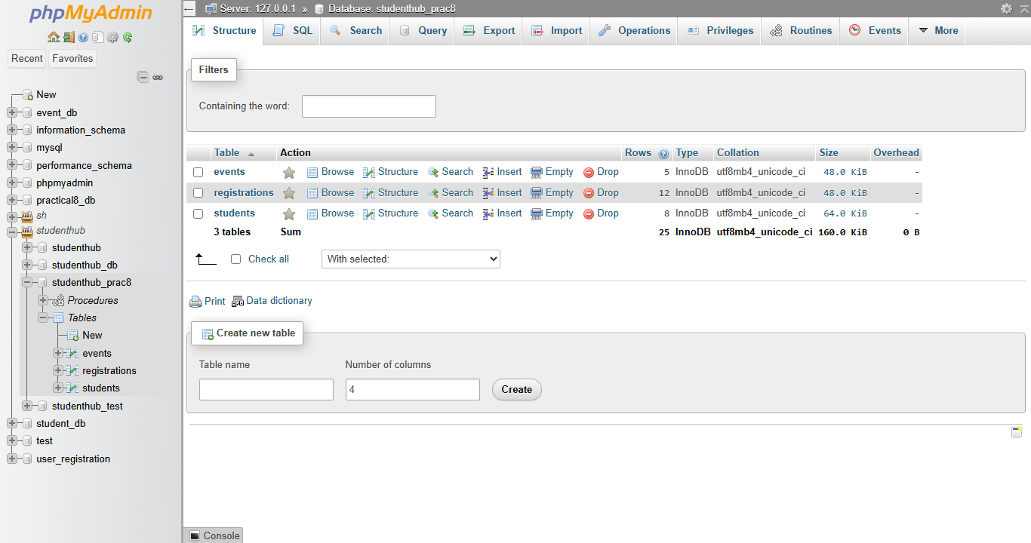
Figure 4: phpMyAdmin – the three InnoDB tables of studenthub_prac8 (events 5, registrations 12, students 8 rows)
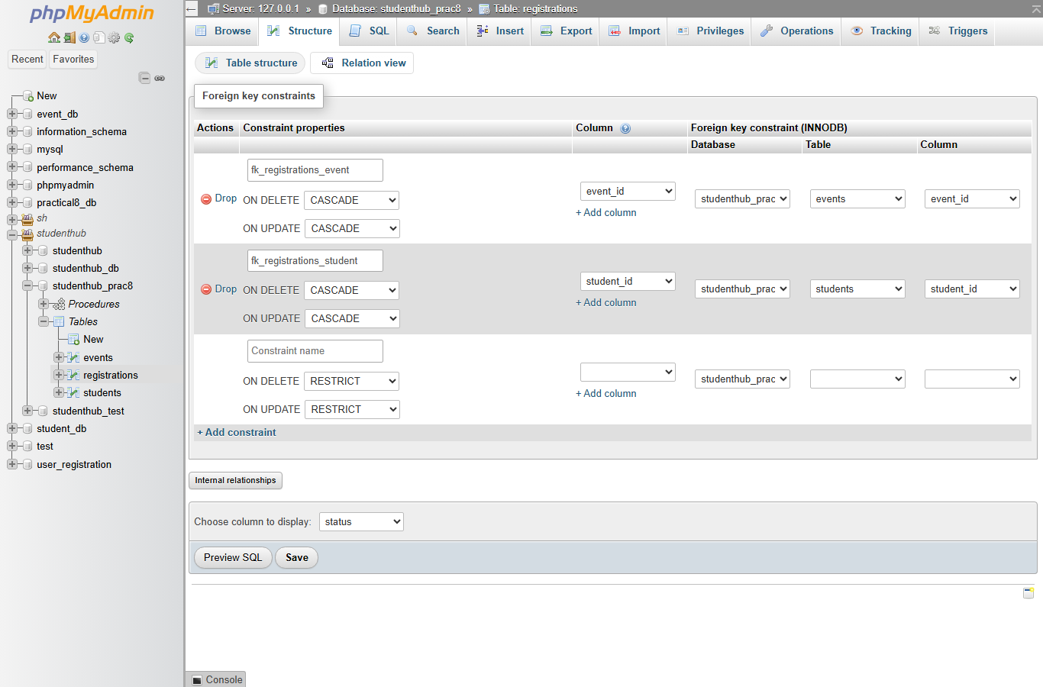
Figure 5: phpMyAdmin relation view of registrations – both foreign keys with ON DELETE / ON UPDATE CASCADE

6. Secure PDO Connection (db.php)
db.php contains only the connection. get_db() creates one PDO object, configures it and returns the same object to every caller:
28 // Returns one shared PDO connection. On failure the real error goes to the PHP error log and the caller
29 // receives a RuntimeException with a general message that contains no host, user or password.
30 function get_db(): PDO
31 {
32 static $pdo = null;
33 if ($pdo instanceof PDO) {
34 return $pdo;
35 }
36 $config = db_config();
37 $dsn = sprintf('mysql:host=%s;port=%d;dbname=%s;charset=utf8mb4', $config['host'], (int) $config['port'], $config['name']);
38 try {
39 $pdo = new PDO($dsn, (string) $config['user'], (string) $config['pass'], [
40 PDO::ATTR_ERRMODE => PDO::ERRMODE_EXCEPTION, // every SQL error throws a PDOException
41 PDO::ATTR_DEFAULT_FETCH_MODE => PDO::FETCH_ASSOC,
42 PDO::ATTR_EMULATE_PREPARES => false, // real server-side prepared statements
43 PDO::ATTR_STRINGIFY_FETCHES => false,
44 // XAMPP's my.ini is not strict, so invalid values (e.g. branch 'XYZ') would be silently changed;
45 // strict mode for this connection makes MySQL reject them with an error instead
46 PDO::MYSQL_ATTR_INIT_COMMAND => "SET SESSION sql_mode = 'STRICT_ALL_TABLES,ERROR_FOR_DIVISION_BY_ZERO,NO_ZERO_IN_DATE,NO_ZERO_DATE,NO_ENGINE_SUBSTITUTION'",
47 ]);
48 } catch (PDOException $exception) {
49 error_log('Practical 8 database connection failed: ' . $exception->getMessage());
50 throw new RuntimeException('The database connection could not be established.');
51 }
52 return $pdo;
53 }

Requirement | How db.php meets it
Isolated database | dbname=studenthub_prac8 in the DSN; the main StudentHub database is never used.
try / catch | new PDO(...) runs inside try; a PDOException is caught, logged with error_log() and replaced by a RuntimeException with a general message.
Exception mode | PDO::ATTR_ERRMODE => PDO::ERRMODE_EXCEPTION, so every failed query throws instead of failing silently.
UTF-8 | charset=utf8mb4 in the DSN; the tables also use utf8mb4_unicode_ci.
Prepared statements | PDO::ATTR_EMULATE_PREPARES => false: statements are prepared by MySQL itself and the values are sent separately.
Strict SQL mode | XAMPP's my.ini is not strict, so MySQL would silently change an invalid ENUM value to ''. The connection sets strict mode with PDO::MYSQL_ATTR_INIT_COMMAND, so such values are rejected (found by the tests).
No secrets in the repository | Only XAMPP's default local settings (root, empty password) are in the code. A different password goes in config.local.php, which is ignored by Git; config.example.php is the template.
Errors never shown | display_errors is turned off; the browser sees only a general message. Opening db.php directly returns 403.

7. Prepared Statements
A prepared statement sends the SQL text and the values to MySQL separately. MySQL compiles the SQL with placeholders (:branch or ?) first, and the value is then used only as data. Even a value such as CSE' OR '1'='1 can therefore never change the meaning of the query – it is simply compared with the branch column and matches nothing. All queries in test_connection.php use prepare() and execute(); the LIMIT value is bound as an integer with bindValue(..., PDO::PARAM_INT).
57 // Records of the three tables (LIMIT bound as an integer parameter)
58 $limit = 50;
59 $stmt = $pdo->prepare('SELECT student_id, student_code, full_name, email, branch, semester FROM students ORDER BY student_id LIMIT :limit');
60 $stmt->bindValue(':limit', $limit, PDO::PARAM_INT);
61 $stmt->execute();
62 $students = $stmt->fetchAll();

80 // A prepared statement with a value from the address (?branch=CE); the value is sent separately from the SQL
81 $stmt = $pdo->prepare('SELECT student_code, full_name, semester FROM students WHERE branch = :branch ORDER BY full_name');
82 $stmt->execute([':branch' => $branch]);
83 $byBranch = $stmt->fetchAll();
84
85 // Stored procedure (advanced extension) called through a prepared statement
86 $stmt = $pdo->prepare('CALL get_event_roster(:event_id)');
87 $stmt->execute([':event_id' => 1]);
88 $roster = $stmt->fetchAll();
89 $stmt->closeCursor();

The branch value from the address (?branch=CE) is also checked against the list CSE, CE, IT before it is used, and table names (which cannot be bound as parameters) come only from a fixed list in the code. Every value printed in the page is escaped with htmlspecialchars().
90 } catch (PDOException $exception) { // a query failed (PDOException must come first: it extends RuntimeException)
91 error_log('Practical 8 query failed: ' . $exception->getMessage());
92 $errorTitle = 'Database query failed';
93 $error = $exception->getCode() === '42S02'
94 ? 'Connected, but the tables were not found. Import schema.sql in phpMyAdmin and reload this page.'
95 : 'Connected, but a database query failed. The details were written to the PHP error log.';
96 } catch (RuntimeException $exception) { // get_db() could not connect (already logged in db.php)
97 $errorTitle = 'Database connection failed';
98 $error = 'Could not connect to the studenthub_prac8 database. Check that MySQL is running in the XAMPP Control Panel and that schema.sql has been imported in phpMyAdmin.';
99 }
100 if ($error !== null) {
101 http_response_code(500);
102 }

PDOException is caught first because it is a subclass of RuntimeException; the tests found that the original order reported every query error as a connection error.

8. Output – Connection Test Page
test_connection.php was served by XAMPP's PHP (php -S 127.0.0.1:8608 router.php) and opened in Microsoft Edge. It shows the connection status, the server version and character set, the three table names with engine, row count and keys, all records of students, events and registrations (joined with names and titles), a prepared statement with a parameter and the stored-procedure roster.
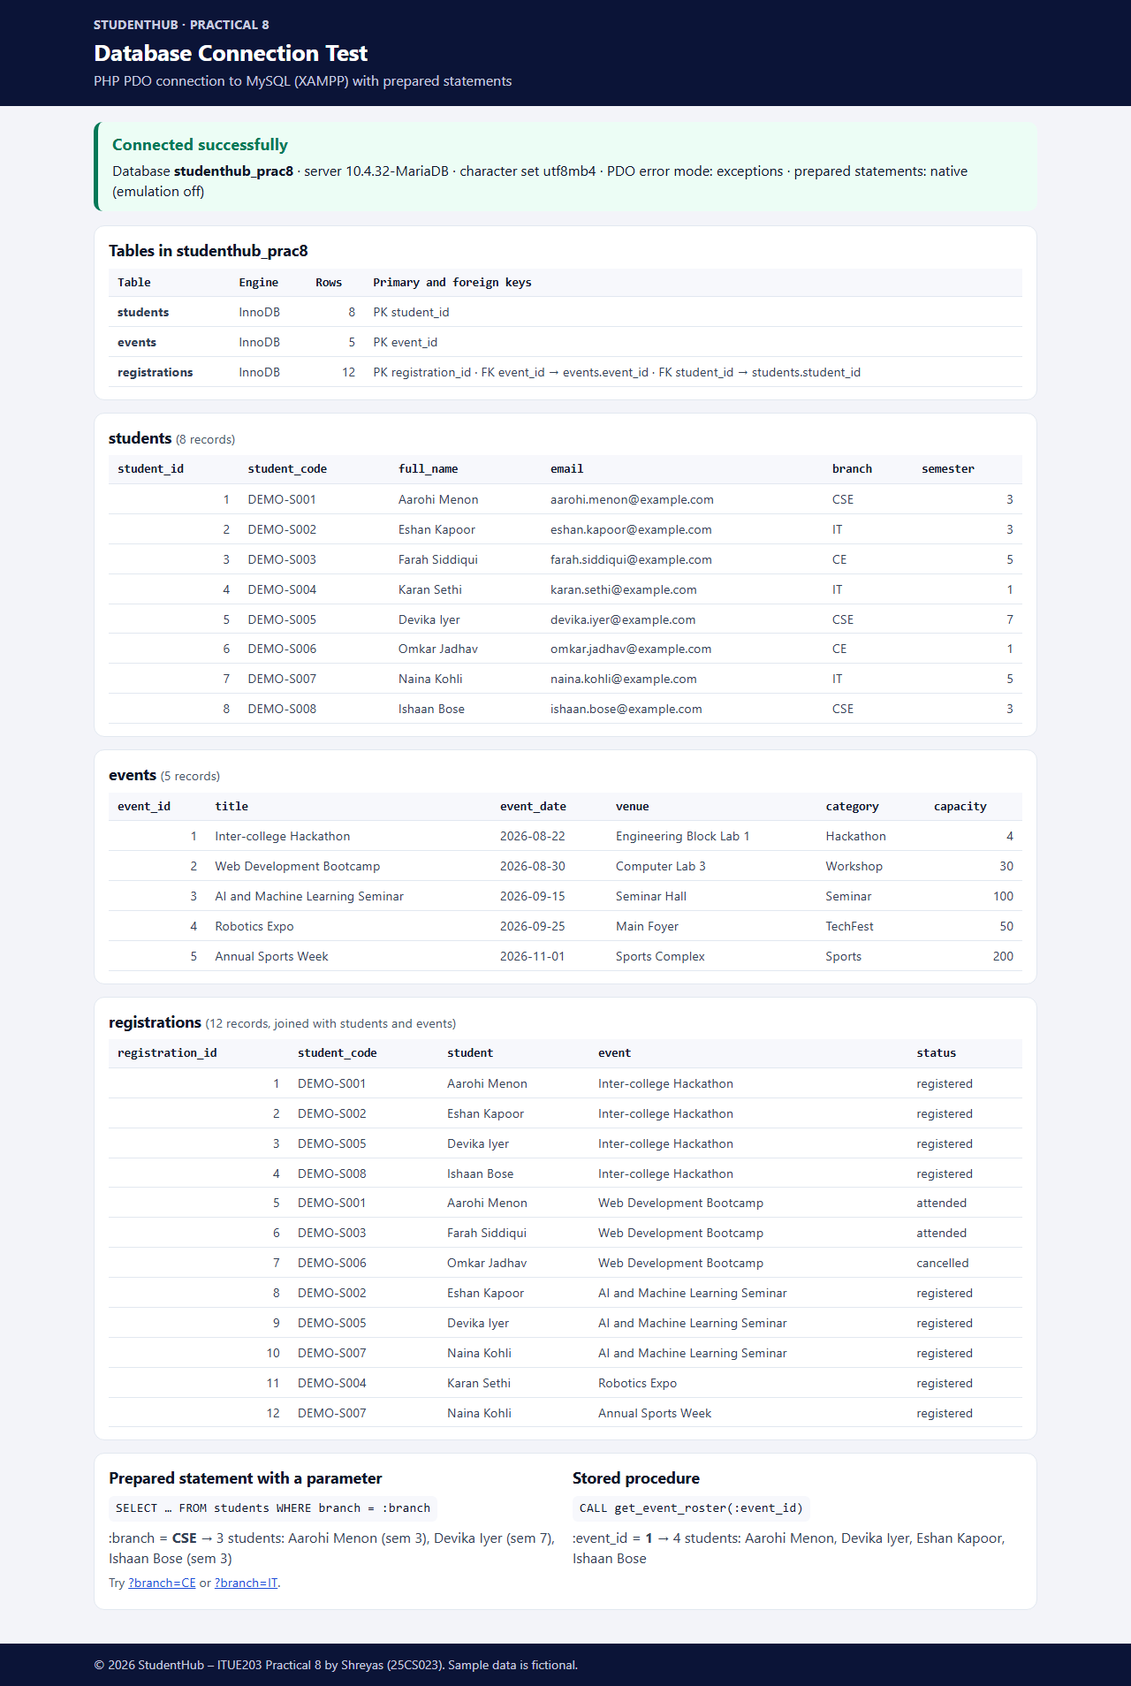
Figure 6: test_connection.php connected to studenthub_prac8 (screenshots/database-connection.png)
To test error handling, the same page was started with a wrong database password (environment variable P8_DB_PASS). The page answers with HTTP 500 and a general message only; the real error “SQLSTATE[HY000] [1045] Access denied for user …” was written to the PHP error log and does not appear in the page.
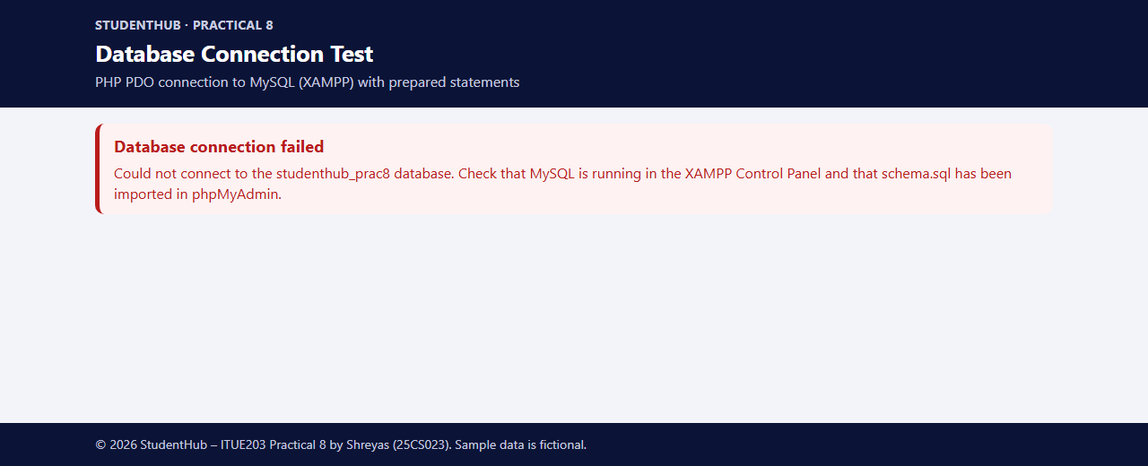
Figure 7: the same page with a wrong password – general message, no user name, host or SQLSTATE

9. Testing and Results
All tests below were executed on the final version (PHP 8.2.12, MariaDB 10.4.32, Windows 11). tests/test_db.php checks the database through db.php; tests/test_page.py runs php -l, test_db.php, the page tests on a PHP server and four error scenarios on separate servers. Every data change is made inside a transaction that is rolled back, and the database was re-imported with phpMyAdmin afterwards.
Test suite | Checks | Result
tests/test_db.php (PHP CLI) | 44 | 44 passed, 0 failed
tests/test_page.py (Python, includes php -l and test_db.php) | 44 | 44 passed, 0 failed

# | Area | Test | Actual result
1 | SQL import | schema.sql imported through phpMyAdmin (server and database Import tab) | “Import has been successfully finished, 17 queries executed”
2 | php -l | config.example.php, db.php, router.php, test_connection.php, tests/test_db.php | No syntax errors
3 | Tables | exactly events, registrations, students; InnoDB; utf8mb4_unicode_ci; no NULL columns; data types | Pass
4 | Keys | 3 primary keys; 2 foreign keys with CASCADE; 4 unique keys; 3 indexes; 3 CHECK constraints | Pass
5 | Seed data | 8 / 5 / 12 rows; DEMO-S codes and example.com only; no orphan rows; no event over capacity | Pass
6 | PDO settings | studenthub_prac8; exception mode; emulation off; FETCH_ASSOC; utf8mb4; strict mode | Pass
7 | Prepared statements | branch CSE/IT/CE → 3/3/2; injection text → 0 rows; positional ? placeholders; PARAM_INT; O'Neil stored correctly | Pass
8 | Foreign keys | registration for student 999 or event 999 | Rejected, error 1452
9 | Unique keys | same student twice for one event; duplicate email | Rejected, error 1062
10 | CHECK / ENUM | semester 9; email 'abc'; capacity 0; branch 'XYZ' | Rejected, errors 4025 / 1265
11 | Cascade | delete student 1; change event_id 5 → 50 | Registrations removed / updated
12 | Procedures | roster of event 1; register into full event; unknown event; free place | 4 rows; “Event is full”; “Event not found”; new ID
13 | Page output | 200; connection status; table names, row counts and keys; all records; JOIN; ?branch=IT and ?branch=CE | Pass
14 | Invalid input | ?branch=CSE' OR '1'='1 and ?branch[]=IT | Not accepted – falls back to CSE
15 | Error handling | wrong database, wrong password, MySQL not reachable, tables missing | HTTP 500, general message, real error in the log
16 | No leaks | page searched for root, SQLSTATE, Access denied, host, port, password | None found
17 | Protected files | db.php, config.*.php, tests/, .gitignore, .htaccess, router.php, start-server.bat | 403

Problems found by the tests and fixed
- Invalid ENUM value accepted: XAMPP's MariaDB runs without strict mode, so branch 'XYZ' was stored as an empty string. Fixed by setting strict SQL mode for every PDO connection in db.php.
- Wrong error message: PDOException extends RuntimeException, so a missing table was reported as “could not connect” and the query error was not logged. Fixed by catching PDOException first.
- Import warning #1280: MySQL ignores names given to primary keys and warned about them; the names were removed from schema.sql.
- Test-script problems (not application bugs): pdo_mysql reports the emulation setting as int(0) rather than false, and the Windows console could not print the → character; both were corrected in the test scripts.
Not tested: XAMPP Apache (the page was served by XAMPP's PHP built-in server), MySQL 8 (only MariaDB 10.4.32), and browsers other than Microsoft Edge.

10. Conclusion
The StudentHub database was designed with an ER model and normalised to Third Normal Form: students and events are stored once, and registrations links them with two foreign keys. Primary, foreign and unique keys, CHECK constraints and indexes make the database refuse invalid data, which the tests confirmed with the expected MySQL errors. schema.sql imports in phpMyAdmin in one step and contains only fictional data. db.php connects with PDO in exception mode, UTF-8 and native prepared statements, keeps the password out of the repository and shows only a general message when the connection fails. test_connection.php reads all three tables with prepared statements and stored procedures. Testing also showed why tests matter: they found a non-strict server setting and a wrong catch order that would otherwise have gone unnoticed.

11. References
- PHP Manual – PDO: https://www.php.net/manual/en/book.pdo.php
- PHP Manual – Prepared statements and stored procedures: https://www.php.net/manual/en/pdo.prepared-statements.php
- PHP Manual – PDO_MYSQL DSN: https://www.php.net/manual/en/ref.pdo-mysql.connection.php
- MariaDB Knowledge Base – CONSTRAINT (CHECK and FOREIGN KEY): https://mariadb.com/kb/en/constraint/
- MariaDB Knowledge Base – SQL_MODE: https://mariadb.com/kb/en/sql-mode/
- phpMyAdmin documentation – Import and export: https://docs.phpmyadmin.net/en/latest/import_export.html
- OWASP – SQL Injection Prevention Cheat Sheet: https://cheatsheetseries.owasp.org/cheatsheets/SQL_Injection_Prevention_Cheat_Sheet.html
- Project repository: https://github.com/TheEmperor08/StudentHub-ITUE203-25CS023 (folder Practical-8)

