CHAROTAR UNIVERSITY OF SCIENCE AND TECHNOLOGY (CHARUSAT)
Chandubhai S. Patel Institute of Technology (CSPIT)
Department of Computer Science & Engineering
ITUE203 – Web Development Frameworks

PRACTICAL 11

Student Management in the Admin Console – CRUD, Search, Filters, Soft Delete and CSV Export
PHP 8 · MySQLi prepared statements · MariaDB (studenthub_db) · Bootstrap 5 Admin Console
Corrected submission – implemented in the integrated StudentHub portal (studenthub/)
Student Name | Shreyas
Roll Number | 25CS023
Student ID | 25CS023
Email | 25cs023@charusat.edu.in
Course | ITUE203 – Web Development Frameworks
Programme | B.Tech Computer Science & Engineering
Semester / Academic Year | 3 / 2026-27
Date of Submission
Faculty Signature

Corrected report. This report replaces the original Practical 11 report (Practical-11/PRAC_11_ITUE203_25CS023.docx, kept unchanged in the repository). The original report describes a standalone application in Practical-11/ with its own database studenthub_prac11 and no login. This corrected version describes the same requirements as they are now implemented in the Student Records tab of the Admin Console of the integrated portal (database studenthub_db, one login), including the later fix that a deactivated student can no longer sign in. All screenshots in this report were taken from the canonical integrated application studenthub/ with Microsoft Edge on disposable test databases with fictional records; all test results are copied from the saved test outputs of the repository.

1. Aim and Objectives
To implement complete student management with PHP, MySQL and MySQLi that performs all record operations safely and keeps every record, even after a student is removed from the active list – as part of the one integrated StudentHub portal, working on the same student records that self-registration, the profile pages and the event registrations use.
- Display the student records of the portal database in a paginated table (10 per page) with a clear Active / Inactive status and whether the record is linked to a login account.
- Add and update students with server-side validation, a unique enrollment number and e-mail address, and clear messages.
- Search by name, e-mail and enrollment number, and filter by course, semester and status – all combinable.
- Soft delete a student only after an explicit confirmation: the status changes from Active to Inactive and the row stays in MySQL together with its account link and event registrations; a Reactivate button restores it.
- Export the filtered records to a CSV file that opens correctly in Microsoft Excel and is protected against formula injection.
- Use MySQLi prepared statements for every query with values, a CSRF token on every POST, output escaping, administrator-only access and an audit-log entry for every change.
- Integration requirement: a student account whose linked record is deactivated can no longer sign in, and an open session of that student ends at its next request.

2. Problem Definition
An institute's student list changes constantly: students join, change course or semester, and leave. Staff must be able to find a student quickly and export the list for spreadsheet work. At the same time a record must never be lost by a wrong click, so removing a student must be reversible – a soft delete that only marks the student inactive. Every input comes from the browser and is therefore untrusted: it has to be validated on the server, sent to MySQL only through prepared statements, and escaped whenever it is shown again.
Inside the integrated portal there is an additional requirement. The table studenthub_db.students already holds the records created by self-registration (Practical 9, linked to the login account through students.user_id) and is referenced by registrations (Practical 8 foundation) with ON DELETE CASCADE. A separate Practical 11 database would create a second, diverging student list, and a hard delete would silently remove a student's event-registration history. Student management therefore had to be built on the existing table: enrollment numbers keep the existing YYPPnnn scheme (e.g. 25CS011), the existing status values Active / Inactive are reused, and no student row is ever deleted by the portal.

3. Tools and Technologies
Tool | Use in this practical
PHP 8.2.12 (XAMPP) | Admin Console page, validation, sessions, CSV generation
MySQLi (exception mode) | Every query with values as a prepared statement (prepare / bind_param / execute)
MariaDB 10.4.32 (XAMPP) | Shared portal database studenthub_db; migration 002 (unique enrollment numbers)
Bootstrap 5.3.2 + Bootstrap Icons | Layout of the Admin Console (loaded from the jsDelivr CDN)
HTML5 forms (novalidate) | Form fields and messages; the server alone decides whether input is valid
Python 3 | tests/test_students.py (HTTP tests) and database/tests/test_002_unique_enrollment_no.py on disposable databases
Microsoft Edge (headless) + Playwright | tests/browser_students.py and tests/browser_inactive_login.py – browser checks and the screenshots
Git / GitHub | Commits 0ac2f5d (integration) and 6420efc (sign-in fix), pushed to the project repository

4. Place in the Integrated Portal
Practical 11 is no longer a separate application. It is the Student Records (CRUD) tab of the Admin Console (studenthub/admin_dashboard.php?tab=students), which an administrator reaches after signing in at the portal's single login page. The logic lives in one include file; the console page only calls it.
File / route | Role in Practical 11
admin_dashboard.php?tab=students | List with search, filters and pagination; view=add, view=edit&id=N and view=deactivate&id=N only show the forms (GET never changes data)
admin_dashboard.php (POST) | action=add_student, update_student, deactivate_student, reactivate_student – CSRF token and permission students.manage required
admin_dashboard.php?tab=students&export=csv | CSV download of the records matching the current search and filters (read-only)
includes/student_management.php | Filters, list, validation, duplicate checks, save, soft delete / reactivation, CSV export
includes/registration.php | Course list REGISTRATION_COURSES and next_enrollment_number(), shared with self-registration
includes/auth.php, login.php | Login, session, require_permission(), CSRF; account_is_deactivated() / account_block_reason()
includes/event_registration.php, directory.php | Inactive students cannot register for events and are not listed in the student directory
audit_logger.php | log_audit(): CREATE_STUDENT, UPDATE_STUDENT, DEACTIVATE_STUDENT, REACTIVATE_STUDENT, EXPORT_CSV
database/migrations/002_unique_enrollment_no.sql | UNIQUE index on students.enrollment_no (with .down.sql rollback)

Shared services. The tab uses the portal's one authentication system (session cookie STUDENTHUBSESSID, HttpOnly, SameSite=Strict), the one CSRF token of the session, the common HTTP 403 page and the common audit log (shown in the console's Security Audit Trail tab). The permissions are listed explicitly in includes/auth.php: admin.console and students.manage belong to the role admin only, so students and editors receive HTTP 403 for the tab, the forms, the export and every POST action, and each refusal is logged as ACCESS_DENIED.

5. Database Design and Relationships
Practical 11 uses the portal table students (InnoDB, utf8mb4_unicode_ci). Its structure, as created by database/studenthub_demo.sql, is:
Column | Type | Notes
id | INT(11) AUTO_INCREMENT | Primary key (record ID)
user_id | INT(11) NULL | Link to the login account; UNIQUE uq_students_user_id, FK fk_students_user → users.id ON DELETE SET NULL
enrollment_no | VARCHAR(20) NULL | UNIQUE uq_students_enrollment_no (migration 002); NULL allowed for legacy rows
name | VARCHAR(100) NOT NULL | Full name
email | VARCHAR(100) NOT NULL | UNIQUE key email
course | VARCHAR(50) NOT NULL | Course name; existing names are kept
gender | VARCHAR(10) NOT NULL | Male / Female / Other for new records
semester | INT(11) DEFAULT 3 | CHECK chk_students_semester: NULL or 1–8
status | VARCHAR(20) DEFAULT 'Active' | Active / Inactive – the soft-delete flag
created_at | TIMESTAMP | Default CURRENT_TIMESTAMP

5.1 Relationships
Relationship | Rule | Effect for student management
users 1 : 0..1 students | students.user_id UNIQUE, ON DELETE SET NULL | A record can be linked to one login account; the Admin Console never changes the link
students 1 : n registrations | fk_registrations_student ON DELETE CASCADE | Deleting a student would erase registrations – the portal therefore never deletes students (soft delete)
events 1 : n registrations | fk_registrations_event ON DELETE CASCADE; UNIQUE (student_id, event_id) | A student registers at most once per event
users 1 : n audit_logs | audit_logs.user_id ON DELETE SET NULL | Every change made in the tab is logged with the administrator's account

5.2 Migration 002 – unique enrollment numbers
Because the console now adds and edits records, two records must never share an enrollment number. The application checks it, and migration 002 makes the database enforce it as well (also for simultaneous requests). The script first checks its preconditions and changes nothing if one fails: migration 001 is recorded, the column exists and no number is used twice (the column collation is case-insensitive, so 25cs011 and 25CS011 count as the same number). It then adds the index, verifies it and records version 002 in schema_migrations. It is idempotent; 002_unique_enrollment_no.down.sql drops only the index and the 002 row. According to database/README.md it was applied to the live database on 31 Oct 2026 after a verified backup (9 records, no duplicates).
database/migrations/002_unique_enrollment_no.sql (lines 40–51) – duplicate precondition and the UNIQUE index
40 -- the column collation is case-insensitive, so "25cs001" and "25CS001" count as the same number
41 IF EXISTS (SELECT 1 FROM students WHERE enrollment_no IS NOT NULL GROUP BY enrollment_no HAVING COUNT(*) > 1) THEN
42 SIGNAL SQLSTATE '45000' SET MESSAGE_TEXT = 'Migration 002: some enrollment numbers are used by more than one student. Correct them first (see database/README.md).';
43 END IF;
44 END //
45
46 DELIMITER ;
47
48 -- ---------------------------------------------------------------------------------------------------------------------
49 -- 1. The unique index
50 -- ---------------------------------------------------------------------------------------------------------------------
51 ALTER TABLE students ADD UNIQUE KEY IF NOT EXISTS uq_students_enrollment_no (enrollment_no);

Soft delete in the schema. No column was added for the soft delete. Deactivating a student sets the existing status column to Inactive; the row, its user_id link and its registrations stay. The time of the deactivation is recorded in the audit log (DEACTIVATE_STUDENT), not in a column of students.

6. Implementation

6.1 Search, filters and pagination
student_filters() reads the query string and accepts a course, semester or status only if it is one of the known values (unknown values are ignored, never used in SQL). student_filter_sql() builds one WHERE clause with ? parameter markers that is shared by the table, the page count and the CSV export. The search text is matched against name, e-mail and enrollment number; % and _ typed by the user are escaped with addcslashes() so they are searched literally. The list is ordered newest first and shows 10 records per page; page links keep the filters.
studenthub/includes/student_management.php (lines 72–98) – one parameterised WHERE clause for list, count and export
72 function student_filter_sql(array $filters): array
73 {
74 $where = [];
75 $types = '';
76 $params = [];
77 if ($filters['q'] !== '') {
78 $like = '%' . addcslashes($filters['q'], '\\%_') . '%';
79 $where[] = '(name LIKE ? OR email LIKE ? OR enrollment_no LIKE ?)';
80 $types .= 'sss';
81 array_push($params, $like, $like, $like);
82 }
83 if ($filters['course'] !== '') {
84 $where[] = 'course = ?';
85 $types .= 's';
86 $params[] = $filters['course'];
87 }
88 if ($filters['semester'] !== '') {
89 $where[] = 'semester = ?';
90 $types .= 'i';
91 $params[] = (int) $filters['semester'];
92 }
93 if ($filters['status'] === 'Inactive') {
94 $where[] = "TRIM(status) = 'Inactive'";
95 } elseif ($filters['status'] === 'Active') {
96 $where[] = "COALESCE(TRIM(status), '') <> 'Inactive'";
97 }
98 return [$where ? ' WHERE ' . implode(' AND ', $where) : '', $types, $params];

6.2 Add and edit with server-side validation
validate_student_record() checks every field: the enrollment number must match ^[0-9]{2}[A-Z]{2}[0-9]{3}$ (stored in upper case), the name 2–100 letters (spaces, apostrophes, dots and hyphens allowed, spaces collapsed), a valid e-mail of at most 100 characters (stored in lower case), a course from the list, a semester 1–8 and the gender Male, Female or Other; a field sent as an array is refused. When a record is edited, an unchanged legacy value (an old number format, course or gender, or no semester) is kept as it is. check_student_record() then adds the duplicate checks, so a duplicate number is reported together with all other errors in one answer (HTTP 422, the typed values shown again HTML-escaped).
studenthub/includes/student_management.php (lines 254–283) – validation plus duplicate checks (all problems at once)
254 function check_student_record(mysqli $db, array $input, array $courses, ?array $existing, int $id): array
255 {
256 [$clean, $errors] = validate_student_record($input, $courses, $existing);
257 $conflicts = student_conflicts($db, isset($errors['enrollment_no']) ? null : $clean['enrollment_no'],
258 isset($errors['email']) ? null : $clean['email'], $id);
259 return [$clean, $errors + $conflicts];
260 }
261
262 // Other records that already use this enrollment number or e-mail (any status – inactive records keep theirs)
263 function student_conflicts(mysqli $db, ?string $enrollment, ?string $email, int $except_id): array
264 {
265 $errors = [];
266 if ($enrollment !== null) {
267 $stmt = $db->prepare('SELECT 1 FROM students WHERE enrollment_no = ? AND id <> ? LIMIT 1');
268 $stmt->bind_param('si', $enrollment, $except_id);
269 $stmt->execute();
270 if ($stmt->get_result()->num_rows > 0) {
271 $errors['enrollment_no'] = 'This enrollment number is already used by another student.';
272 }
273 }
274 if ($email !== null) {
275 $stmt = $db->prepare('SELECT 1 FROM students WHERE LOWER(TRIM(email)) = ? AND id <> ? LIMIT 1');
276 $lower = strtolower(trim($email));
277 $stmt->bind_param('si', $lower, $except_id);
278 $stmt->execute();
279 if ($stmt->get_result()->num_rows > 0) {
280 $errors['email'] = 'Another student record already uses this email address.';
281 }
282 }
283 return $errors;

save_student_record() writes the record in a transaction. If the enrollment number was left empty on the add form, the next free number of the existing scheme is assigned: two digits of the admission year (derived from the semester and the academic year) plus the course code from REGISTRATION_COURSES (IT, CS, DS, WD) and a three-digit counter, computed by next_enrollment_number(), which locks the matching rows with SELECT … FOR UPDATE until the commit. The duplicate checks run again inside the transaction, and a duplicate saved by someone else at the same moment is caught by the UNIQUE keys (MySQL error 1062) and turned into a field message. Only the form fields are written: user_id, status, created_at and the registrations are never touched, and no login account is created.
studenthub/includes/student_management.php (lines 288–321) – add / update in one transaction
288 function save_student_record(mysqli $db, array $clean, ?int $id = null): array
289 {
290 $db->begin_transaction();
291 try {
292 $enrollment = $clean['enrollment_no'];
293 if ($id === null && $enrollment === null) {
294 $prefix = sprintf('%02d', student_admission_year($clean['semester']) % 100) . REGISTRATION_COURSES[$clean['course']];
295 $enrollment = next_enrollment_number($db, $prefix); // locks the prefix range until commit
296 }
297 $errors = student_conflicts($db, $enrollment, $clean['email'], $id ?? 0);
298 if ($errors) {
299 $db->rollback();
300 return ['errors' => $errors];
301 }
302 if ($id === null) {
303 $stmt = $db->prepare("INSERT INTO students (enrollment_no, name, email, course, semester, gender, status) VALUES (?, ?, ?, ?, ?, ?, 'Active')");
304 $stmt->bind_param('ssssis', $enrollment, $clean['name'], $clean['email'], $clean['course'], $clean['semester'], $clean['gender']);
305 $stmt->execute();
306 $id = (int) $stmt->insert_id;
307 } else {
308 $stmt = $db->prepare('UPDATE students SET enrollment_no = ?, name = ?, email = ?, course = ?, semester = ?, gender = ? WHERE id = ?');
309 $stmt->bind_param('ssssisi', $enrollment, $clean['name'], $clean['email'], $clean['course'], $clean['semester'], $clean['gender'], $id);
310 $stmt->execute();
311 }
312 $db->commit();
313 return ['id' => $id, 'enrollment_no' => $enrollment];
314 } catch (mysqli_sql_exception $e) {
315 $db->rollback();
316 if ($e->getCode() === 1062) { // the same number or e-mail was saved by someone else meanwhile
317 return ['errors' => str_contains($e->getMessage(), 'uq_students_enrollment_no')
318 ? ['enrollment_no' => 'This enrollment number is already used by another student.']
319 : ['email' => 'Another student record already uses this email address.']];
320 }
321 throw $e;

6.3 Soft delete and reactivation
The Deactivate button only opens admin_dashboard.php?tab=students&view=deactivate&id=N, a confirmation panel that shows the record, the number of its event registrations and the consequences. Only the button Yes, deactivate student sends a POST with the CSRF token. set_student_status() changes nothing but the status; the condition in the WHERE clause makes a second attempt harmless ("already inactive" / "already active").
studenthub/includes/student_management.php (lines 327–343) – status-only soft delete and the CSV cell guard
327 function set_student_status(mysqli $db, int $id, bool $active): bool
328 {
329 $stmt = $db->prepare($active
330 ? "UPDATE students SET status = 'Active' WHERE id = ? AND TRIM(status) = 'Inactive'"
331 : "UPDATE students SET status = 'Inactive' WHERE id = ? AND COALESCE(TRIM(status), '') <> 'Inactive'");
332 $stmt->bind_param('i', $id);
333 $stmt->execute();
334 return $stmt->affected_rows === 1;
335 }
336
337 // ---------------------------------------------------------------- CSV export
338 // A cell starting with = + - @, tab or carriage return gets a leading apostrophe, so a spreadsheet shows it as text
339 // instead of running it as a formula.
340 function csv_safe_cell($value): string
341 {
342 $text = (string) $value;
343 return $text !== '' && strpbrk($text[0], "=+-@\t\r") !== false ? "'" . $text : $text;

The POST handler of the console checks the CSRF token first, then the permission, loads the record and calls the functions above; every successful change is written to the audit log and answered with a redirect (Post/Redirect/Get) and a one-time success message.
studenthub/admin_dashboard.php (lines 68–106) – POST handler of the Student Records tab
68 if ($_SERVER["REQUEST_METHOD"] === "POST") {
69 require_valid_csrf();
70 $action = $_POST["action"] ?? "";
71
72 // Student records (Practical 11): add, edit, soft delete and reactivation – admins only (students.manage)
73 if (in_array($action, ["add_student", "update_student", "deactivate_student", "reactivate_student"], true)) {
74 require_permission("students.manage");
75 $current_tab = "students";
76 $target_id = student_id_from($_POST["id"] ?? "");
77 $record = $target_id > 0 ? find_student_record($conn, $target_id) : null;
78 if ($action !== "add_student" && $record === null) {
79 flash("error", "That student record was not found."); redirect("admin_dashboard.php?tab=students");
80 }
81 if ($action === "add_student" || $action === "update_student") {
82 $existing = $action === "update_student" ? $record : null;
83 [$clean, $errors] = check_student_record($conn, $_POST, $student_courses, $existing, $existing ? $target_id : 0);
84 $result = $errors ? ["errors" => $errors] : save_student_record($conn, $clean, $existing ? $target_id : null);
85 if (isset($result["errors"])) {
86 http_response_code(422);
87 $student_form = ["mode" => $existing ? "edit" : "add", "id" => $target_id, "record" => $existing, "errors" => $result["errors"],
88 "values" => array_map(fn ($field) => is_string($_POST[$field] ?? null) ? $_POST[$field] : "", array_combine(STUDENT_FIELDS, STUDENT_FIELDS))];
89 } else {
90 $number = $result["enrollment_no"] ?? "no enrollment number";
91 log_audit($conn, $current_user["id"], $current_user["username"], $existing ? "UPDATE_STUDENT" : "CREATE_STUDENT",
92 ($existing ? "Updated" : "Added") . " student record ID {$result["id"]} ($number)", "SUCCESS");
93 flash("success", $existing ? "Student “{$clean["name"]}” ($number) was updated."
94 : "Student “{$clean["name"]}” was added with enrollment number $number.");
95 redirect("admin_dashboard.php?tab=students");
96 }
97 } else {
98 $activate = $action === "reactivate_student";
99 $label = "“{$record["name"]}” (" . ($record["enrollment_no"] ?: "no enrollment number") . ")";
100 if (set_student_status($conn, $target_id, $activate)) {
101 log_audit($conn, $current_user["id"], $current_user["username"], $activate ? "REACTIVATE_STUDENT" : "DEACTIVATE_STUDENT",
102 ($activate ? "Reactivated" : "Deactivated (soft delete)") . " student record ID $target_id (" . ($record["enrollment_no"] ?: "no enrollment number") . ")", "SUCCESS");
103 flash("success", $activate ? "Student $label was reactivated."
104 : "Student $label was deactivated. The record, its account link and its event registrations are kept; a linked student account can no longer sign in.");
105 } else {
106 flash("error", "Student $label is already " . ($activate ? "active." : "inactive."));

6.4 CSV export
The Export CSV button carries the current search and filters (it reads Export CSV (filtered) when a filter is active). The export calls student_list() without a limit, so every matching record of every page is written, inactive ones included. The file studenthub_students_<date>_<time>.csv is UTF-8 with a byte-order mark, comma separated, with CRLF line endings, so Excel opens it directly. It contains only record fields – the account column says only Linked or None; no password hash, role, token or session data is exported. Every cell passes csv_safe_cell() (shown in 6.3): a value starting with =, +, -, @, tab or carriage return gets a leading apostrophe so that a spreadsheet shows it as text instead of running it as a formula. Each export is audit-logged (EXPORT_CSV with the number of records).
studenthub/includes/student_management.php (lines 348–362) – CSV download
348 function send_students_csv(array $students): void
349 {
350 header('Content-Type: text/csv; charset=utf-8');
351 header('Content-Disposition: attachment; filename="studenthub_students_' . date('Ymd_His') . '.csv"');
352 $out = fopen('php://output', 'w');
353 fwrite($out, "\xEF\xBB\xBF");
354 fputcsv($out, ['Record ID', 'Enrollment No', 'Name', 'Email', 'Course', 'Semester', 'Status', 'Login Account', 'Created At'],
355 ',', '"', '', "\r\n");
356 foreach ($students as $s) {
357 fputcsv($out, array_map('csv_safe_cell', [
358 $s['id'], $s['enrollment_no'] ?? '', $s['name'], $s['email'], $s['course'], $s['semester'] ?? '',
359 student_is_active($s) ? 'Active' : 'Inactive', $s['user_id'] !== null ? 'Linked' : 'None', $s['created_at'] ?? '',
360 ]), ',', '"', '', "\r\n");
361 }
362 fclose($out);

6.5 Deactivated students cannot sign in (fix, commit 6420efc)
After the first integration step a deactivated student could still sign in (listed as a limitation in TEST_REPORT §7). The fix in includes/auth.php and login.php treats a student account whose linked record is Inactive as blocked. account_block_reason() also covers accounts disabled by an administrator (users.status, added later with Practical 14). The account and its record are re-read on every request, so an open session ends at the next request: the session data is deleted on the server, the visitor gets a new empty session ID and SESSION_REVOKED is logged. Admin and editor accounts, even if linked to an inactive record, and student accounts without a linked record are not affected.
studenthub/includes/auth.php (lines 185–224) – block rule and per-request re-check
185 // A student account whose linked student record (students.user_id) was deactivated in the Admin Console (Practical 11
186 // soft delete) may neither sign in nor keep a session. Admin and editor accounts and student accounts without a linked
187 // record are not affected. "Inactive" is matched like everywhere else in the portal (trimmed, any letter case).
188 function account_is_deactivated(string $role, ?string $student_status): bool
189 {
190 return $role === 'student' && $student_status !== null && strcasecmp(trim($student_status), 'Inactive') === 0;
191 }
192
193 // Why an account may not sign in or keep a session (null = allowed): an account disabled by an administrator (users.status,
194 // Practical 14, any role) or a student account whose linked student record is inactive (Practical 11)
195 function account_block_reason(array $row): ?string
196 {
197 if (($row['account_status'] ?? 'active') === 'disabled') {
198 return 'the account is disabled';
199 }
200 return account_is_deactivated((string) $row['role'], $row['student_status'] ?? null) ? 'the linked student record is inactive' : null;
201 }
202
203 // Re-reads the account on every request: a deleted account loses access at once, a role change applies immediately and a
204 // disabled account or deactivated student is signed out. Returns [user or null, reason ('account_unavailable' or
205 // 'access_disabled'), detail for the audit log].
206 function refresh_user_from_database(array $user): array
207 {
208 global $conn;
209 $stmt = $conn->prepare('SELECT u.id, u.username, u.email, u.role, u.status AS account_status, s.status AS student_status
210 FROM users u LEFT JOIN students s ON s.user_id = u.id WHERE u.id = ?');
211 $stmt->bind_param('i', $user['id']);
212 $stmt->execute();
213 $row = $stmt->get_result()->fetch_assoc();
214 $stmt->close();
215 if (!$row || !in_array($row['role'], STUDENTHUB_ROLES, true)) {
216 return [null, 'account_unavailable', ''];
217 }
218 if (($block = account_block_reason($row)) !== null) {
219 return [null, 'access_disabled', $block];
220 }
221 $_SESSION['username'] = $row['username'];
222 $_SESSION['email'] = $row['email'];
223 $_SESSION['role'] = $row['role'];
224 return [['id' => (int) $row['id'], 'username' => $row['username'], 'email' => $row['email'], 'role' => $row['role']], '', ''];

At sign-in the block is checked only after password_verify() succeeded. The answer is HTTP 403 with one generic message ("Your access to StudentHub is currently disabled. Please contact the administrator."), no session is started and LOGIN_DENIED is logged; a wrong password still gets the normal "Invalid username/email or password." (HTTP 401), so the status of a record is never revealed to someone who does not know the password.
studenthub/login.php (lines 38–69) – sign-in refused after password verification
38 // An unknown account is checked against a dummy hash, so both failures take about the same time
39 $hash = $account["password"] ?? '$2y$10$cL5pLAsT9eF311SYAHI/9OCtAW62Xl1zkDZ3VA2wDn4DbvPI3.YlC';
40 $verified = password_verify($password, $hash);
41 // Correct password, but the account is disabled or its linked student record is deactivated: no session is started
42 // (generic message; the status is only revealed to someone who knows the password)
43 $block = $account !== null && $verified ? account_block_reason($account) : null;
44 $denied = $block !== null;
45 if ($denied) {
46 log_audit($conn, (int) $account["id"], $account["username"], "LOGIN_DENIED", "Sign-in refused: $block.", "SECURITY_BLOCK");
47 } elseif ($account !== null && $verified && in_array($account["role"], STUDENTHUB_ROLES, true)) {
48 login_user($account);
49 $up = $conn->prepare("UPDATE users SET last_login = NOW() WHERE id = ?");
50 $up->bind_param("i", $account["id"]);
51 $up->execute();
52 $up->close();
53 log_audit($conn, (int) $account["id"], $account["username"], "USER_LOGIN", "User logged in with role=" . $account["role"], "SUCCESS");
54 if ($account["role"] === "admin") {
55 flash("success", "Welcome, " . $account["username"] . ". You are signed in as administrator.");
56 redirect("admin_dashboard.php");
57 }
58 flash("success", "Welcome back, " . $account["username"] . ".");
59 redirect("dashboard.php");
60 }
61 if ($denied) {
62 $error = LOGIN_STATUS["access_disabled"][1];
63 } else {
64 $error = "Invalid username/email or password.";
65 log_audit($conn, null, mb_substr($entered, 0, 100), "LOGIN_FAILED",
66 $account === null ? "Sign-in attempt for an unknown account." : "Wrong password.", "FAILED");
67 }
68 }
69 http_response_code($denied ? 403 : 401);

7. Validation and Security
- Server-side validation: every field is checked by validate_student_record(); the form has novalidate, so the browser never decides. Invalid input is answered with HTTP 422, a message under each field and the general alert "Please correct the highlighted fields. Nothing was saved."
- Duplicates: checked before saving (all errors at once), again inside the transaction, and finally by the UNIQUE keys on enrollment_no and email – also in another letter case and with extra spaces.
- SQL injection: all queries with values are prepared statements; filter values are accepted only from fixed lists; the page number and record IDs are matched against strict patterns; LIKE wildcards are escaped.
- XSS: every value is printed through e() = htmlspecialchars(…, ENT_QUOTES | ENT_SUBSTITUTE, 'UTF-8').
- CSRF: every POST form carries the session's 64-character token, compared with hash_equals(); a missing, wrong or modified token (or another session's token) is refused with HTTP 403 "Security check failed" and logged as CSRF_REJECTED. GET requests – even with action parameters and the token – change nothing.
- Authorisation: require_permission('students.manage') on the export and on every action; students, editors and visitors are refused on the server, not only hidden in the menu.
- CSV export: formula-injection guard, RFC 4180 quoting by fputcsv(), no account or session data.
- Records are never lost: the code contains no DELETE FROM students; deactivation is reversible.
- Headers: signed-in pages send X-Frame-Options: DENY, X-Content-Type-Options: nosniff, Referrer-Policy: same-origin and Cache-Control: no-store.
- Deactivated students: refused at sign-in after password verification and signed out at the next request (section 6.5).

8. Output Screenshots
All screenshots are genuine full-page captures from Microsoft Edge (headless, driven by Playwright, window 1280 px wide) of the integrated portal running on PHP's built-in server with a disposable database built from database/studenthub_demo.sql plus fictional students added by the test. Figures 1–11 were produced by tests/browser_students.py (screenshots 01–13), Figures 12–15 by tests/browser_inactive_login.py (screenshots 14–17). Two further captures of the folder are not reproduced here: 02-add-student-form.png (the empty add form, the same form as in Figure 2) and 08-student-updated.png (the list after saving the edit of Figure 6). The Admin Console gained further tabs in later integration steps (for example Inquiries, Practical 7), which are therefore not visible in these screenshots.
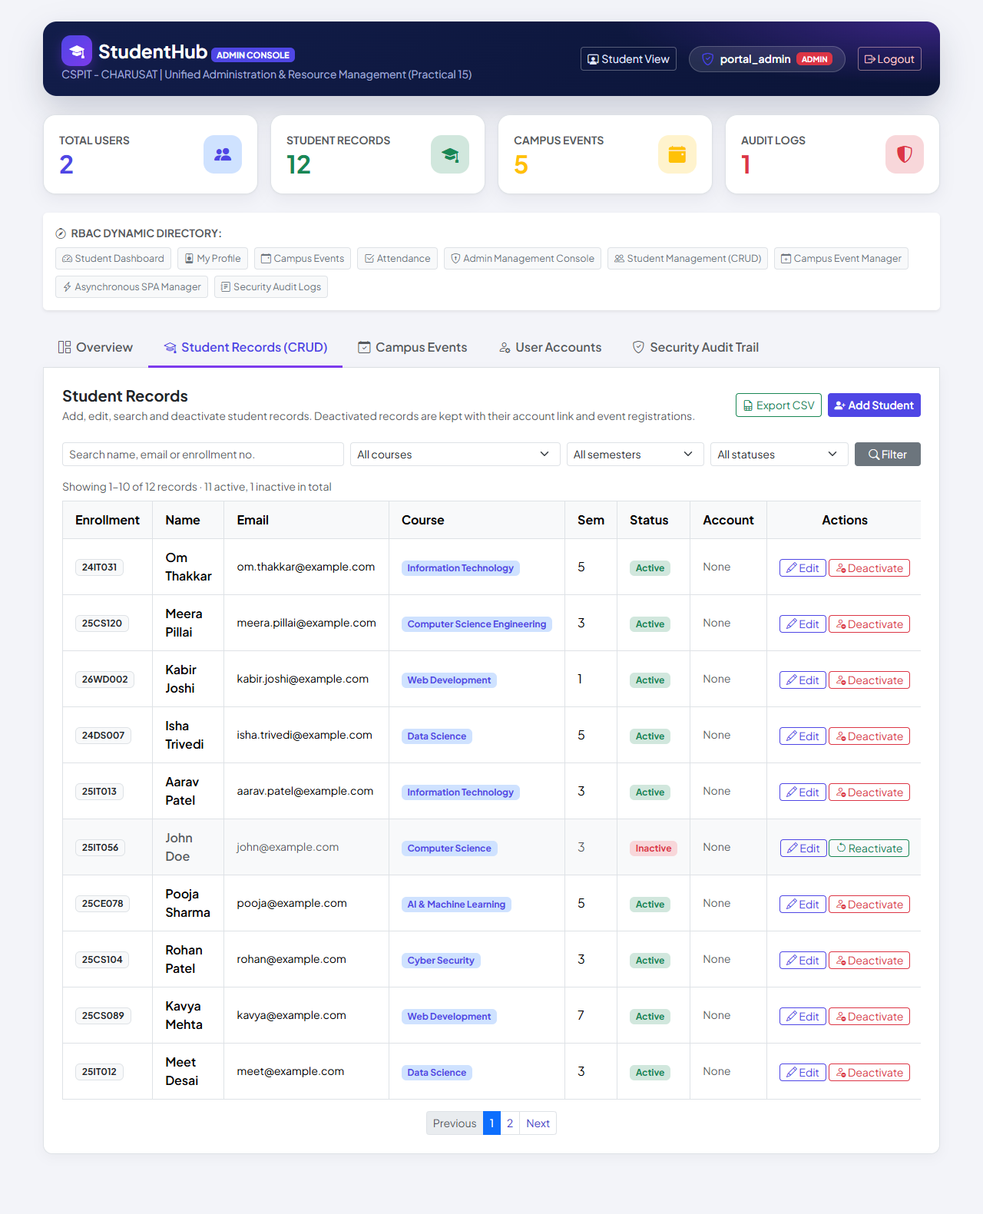
Figure 1: Student Records tab of the Admin Console (administrator portal_admin): 10 of 12 records on page 1 with enrollment number, name, e-mail, course, semester, status and account columns; John Doe (25IT056) is Inactive with a greyed row and a Reactivate button; summary "11 active, 1 inactive in total" and pagination (01-student-list.png)
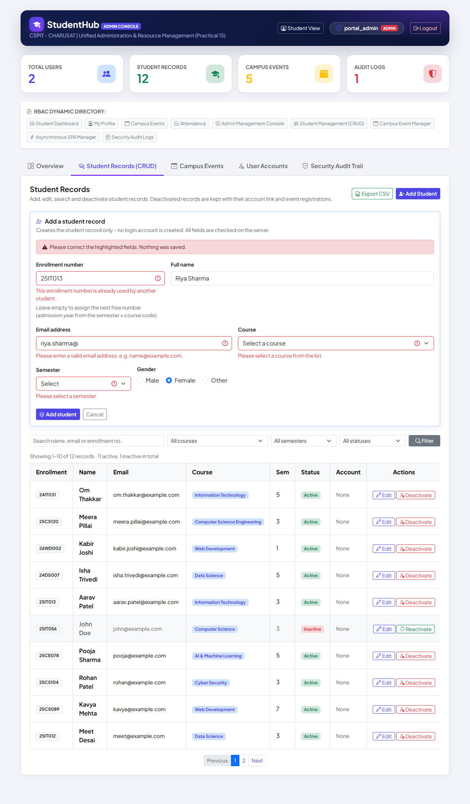
Figure 2: Server-side validation of the add form: the enrollment number 25IT013 is already used by another student, the e-mail "riya.sharma@" is invalid, no course and no semester were selected; the typed name Riya Sharma is kept and nothing was saved (03-validation-error.png)
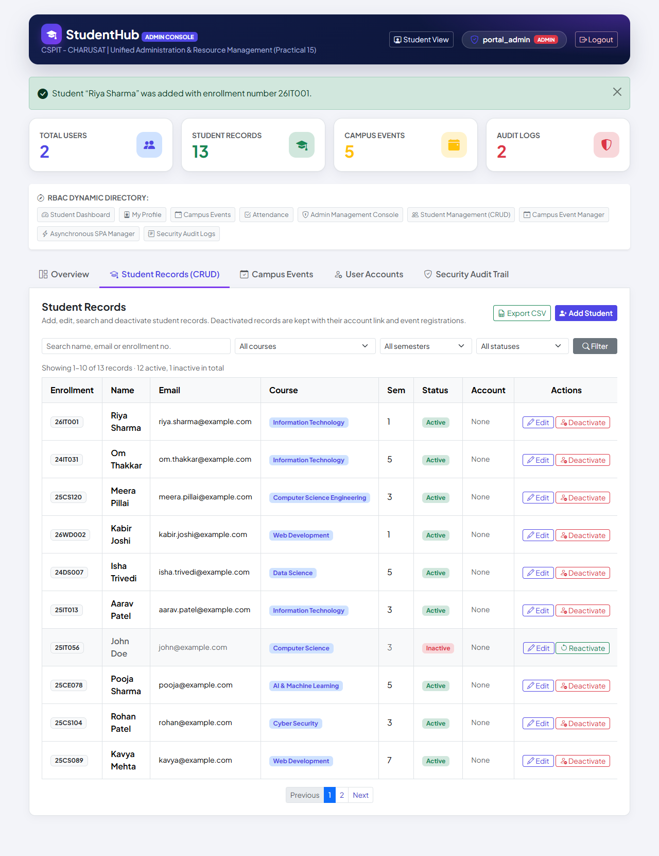
Figure 3: After a valid submission with an empty enrollment number: "Student “Riya Sharma” was added with enrollment number 26IT001." – the number was assigned automatically and the new record is first in the list (13 records) (04-student-created.png)
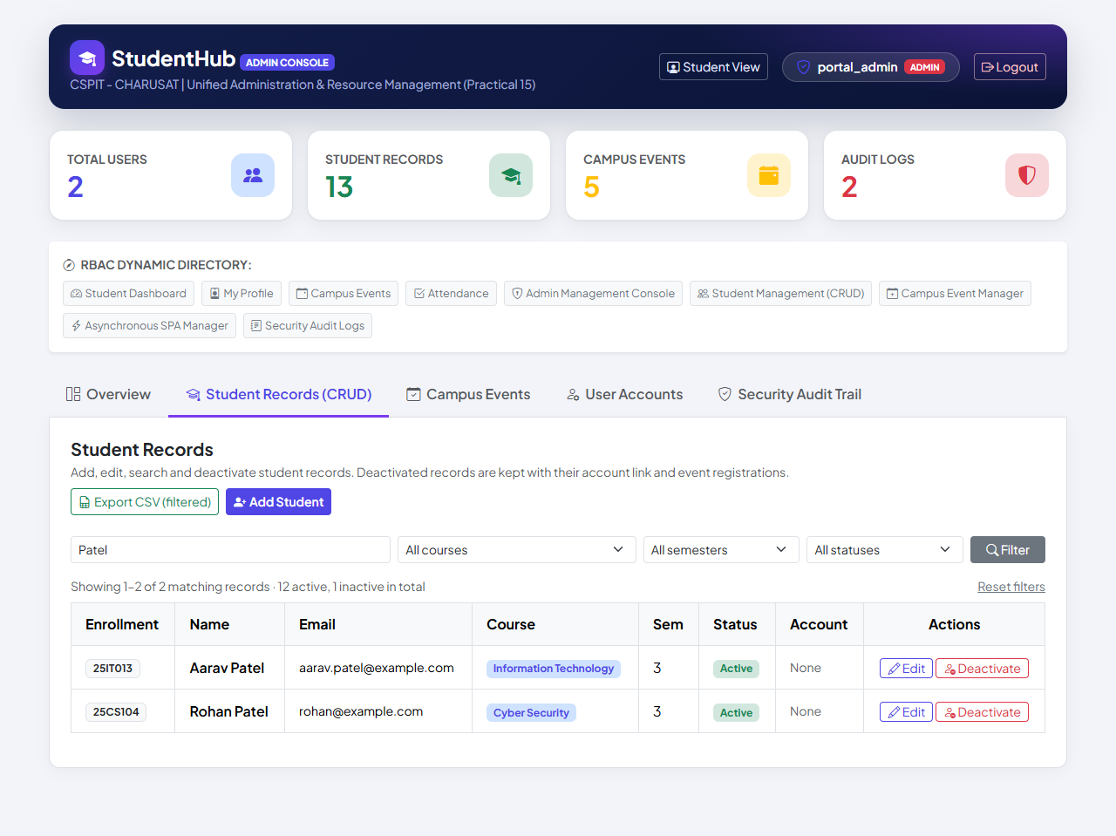
Figure 4: Search "Patel": 2 matching records (Aarav Patel, Rohan Patel); the export button now reads "Export CSV (filtered)" and a "Reset filters" link is shown (05-search-results.png)
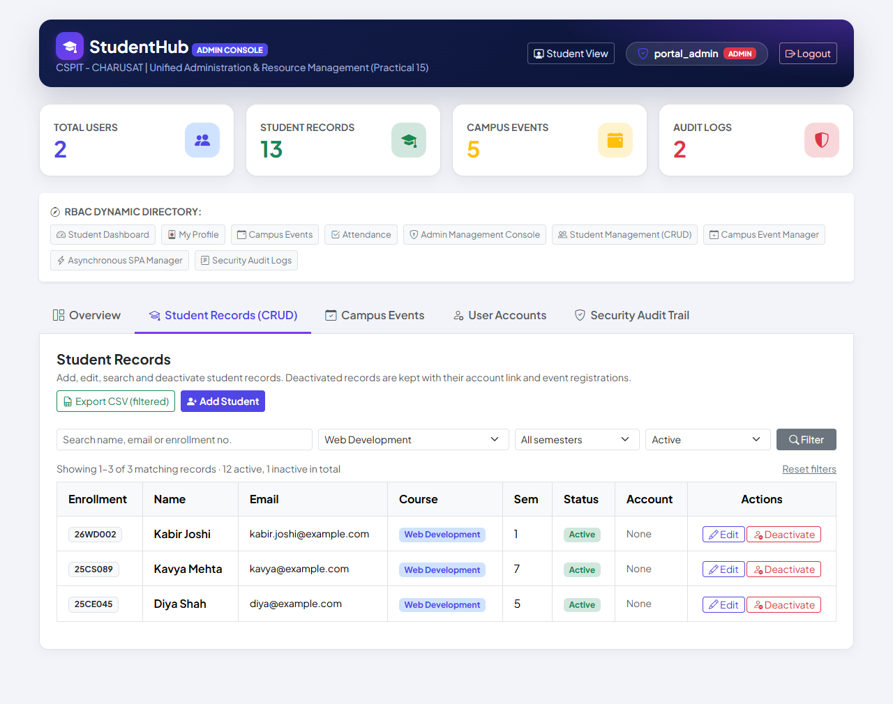
Figure 5: Combined filters course "Web Development" + status "Active": the 3 matching records (Kabir Joshi, Kavya Mehta, Diya Shah); the selected filters stay in the form (06-filtered-records.png)
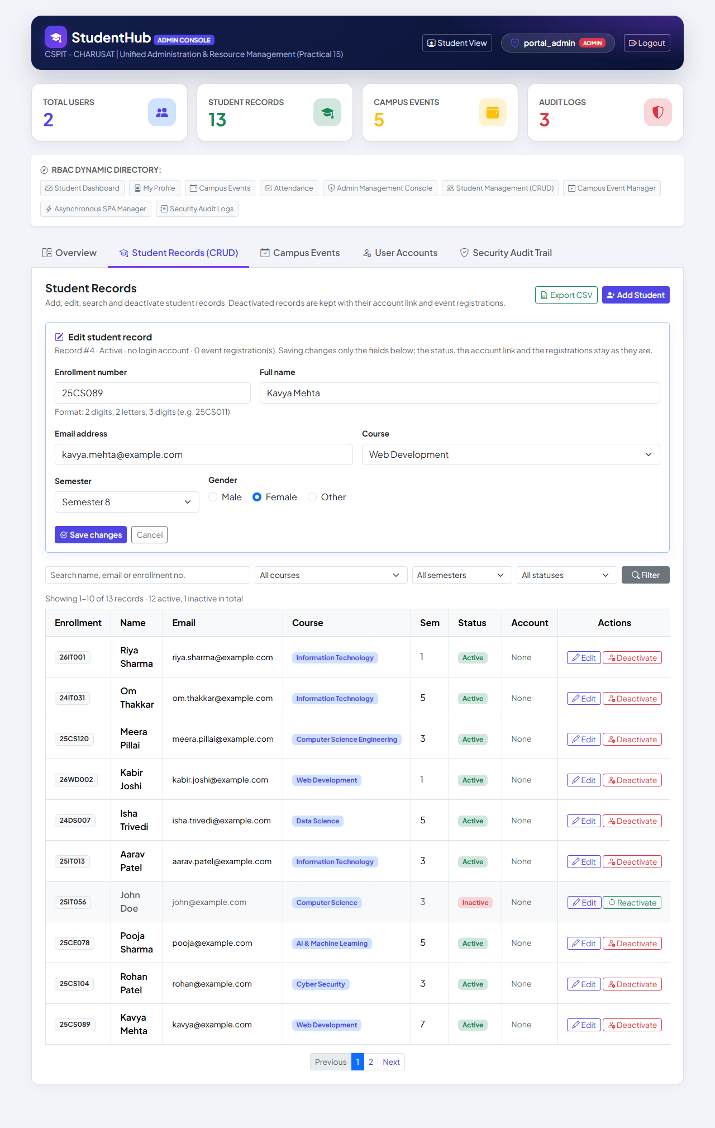
Figure 6: Edit form for Kavya Mehta filled from the database: "Record #4 · Active · no login account · 0 event registration(s)"; the e-mail is being changed to kavya.mehta@example.com and the semester to 8 (07-edit-student.png)
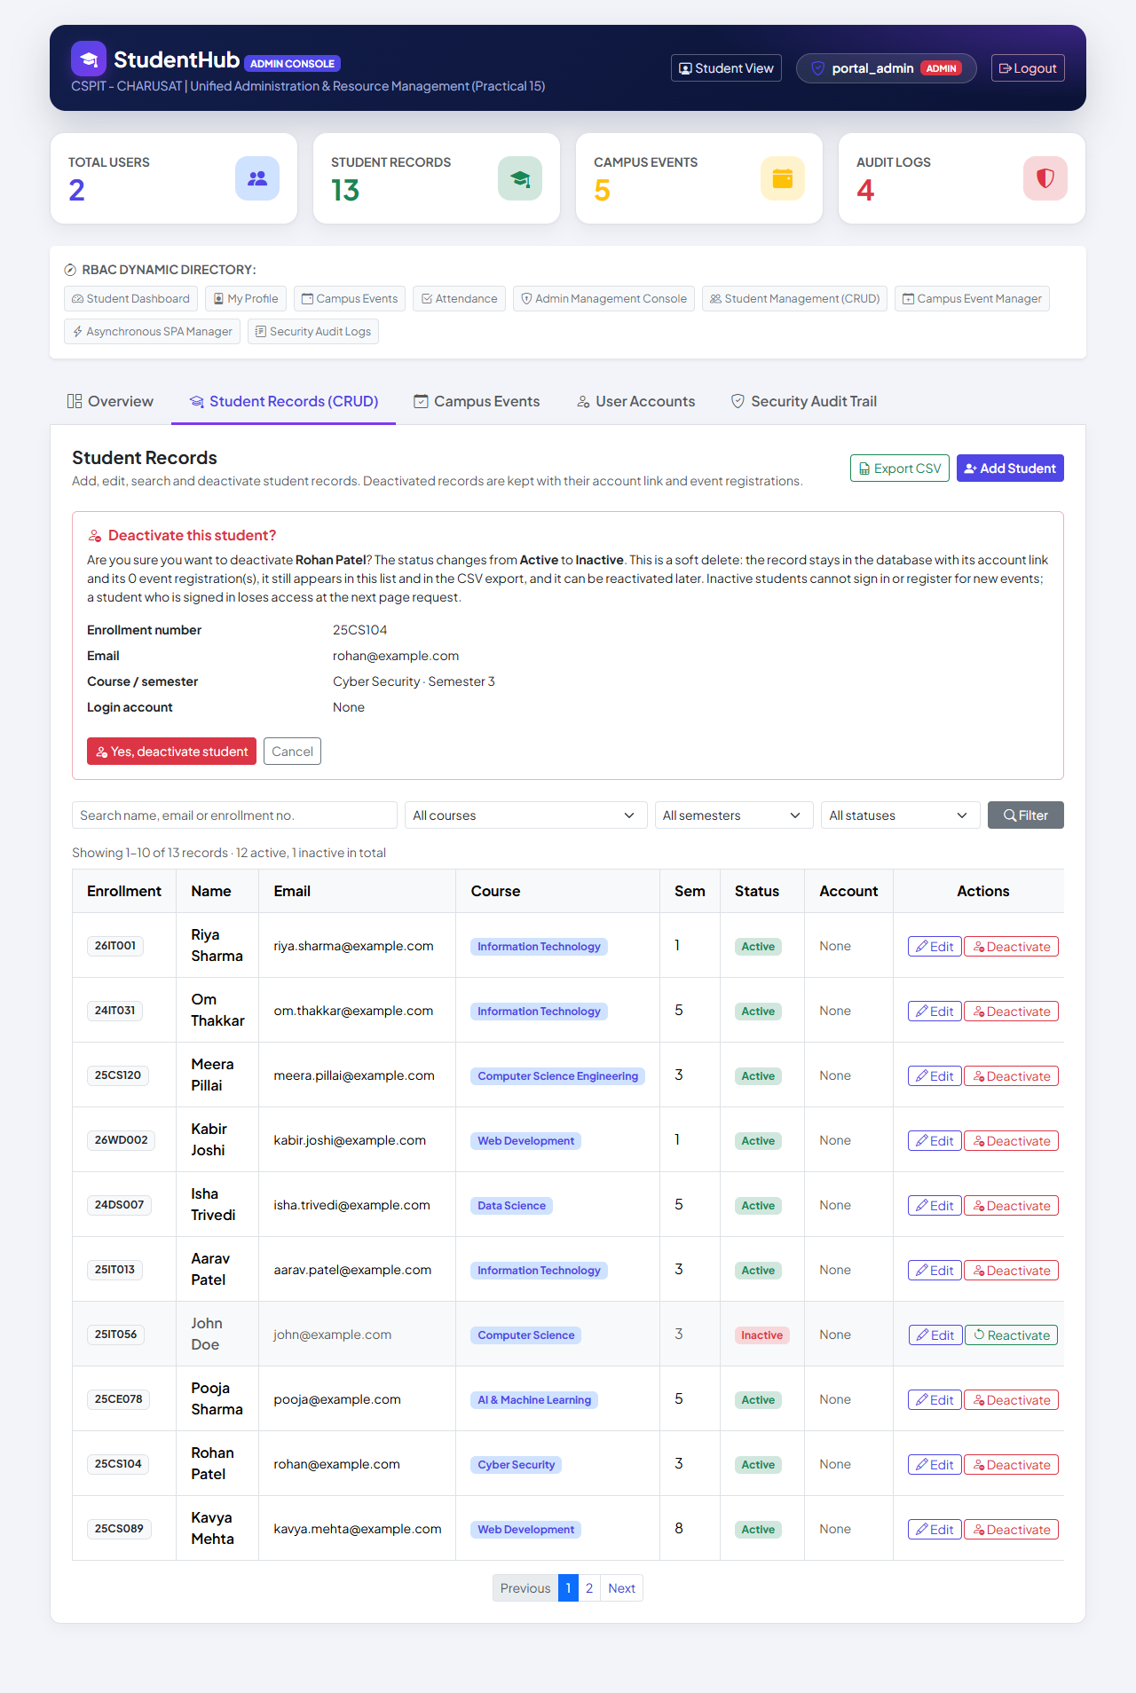
Figure 7: Confirmation before the soft delete of Rohan Patel (25CS104): the panel explains that the record, its account link and its registrations are kept, that it stays in the list and the CSV export, and that inactive students cannot sign in or register; nothing has changed yet (09-deactivate-confirmation.png)
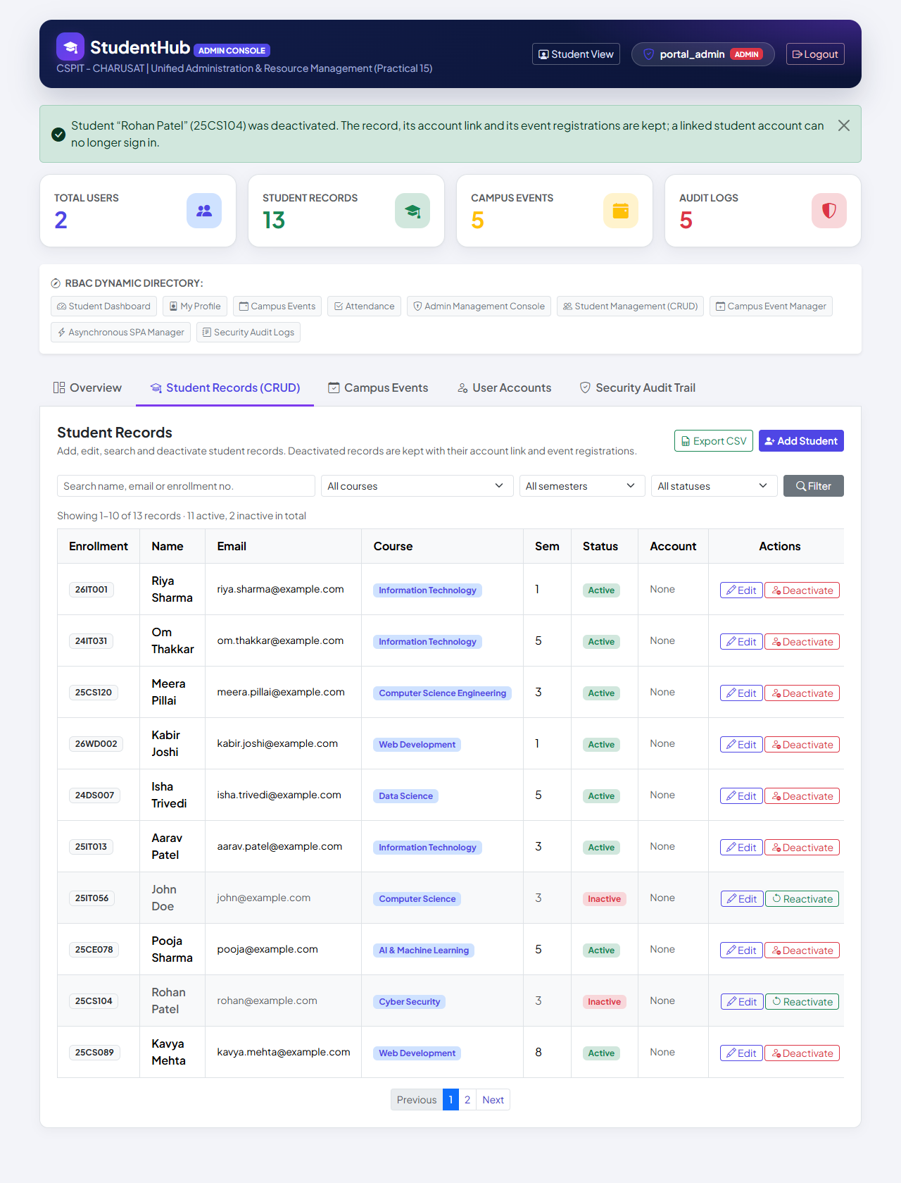
Figure 8: After the confirmed deactivation: "Student “Rohan Patel” (25CS104) was deactivated. The record, its account link and its event registrations are kept; a linked student account can no longer sign in." – the row is still listed, greyed, with an Inactive badge and a Reactivate button (11 active, 2 inactive, still 13 records) (10-student-inactive.png)
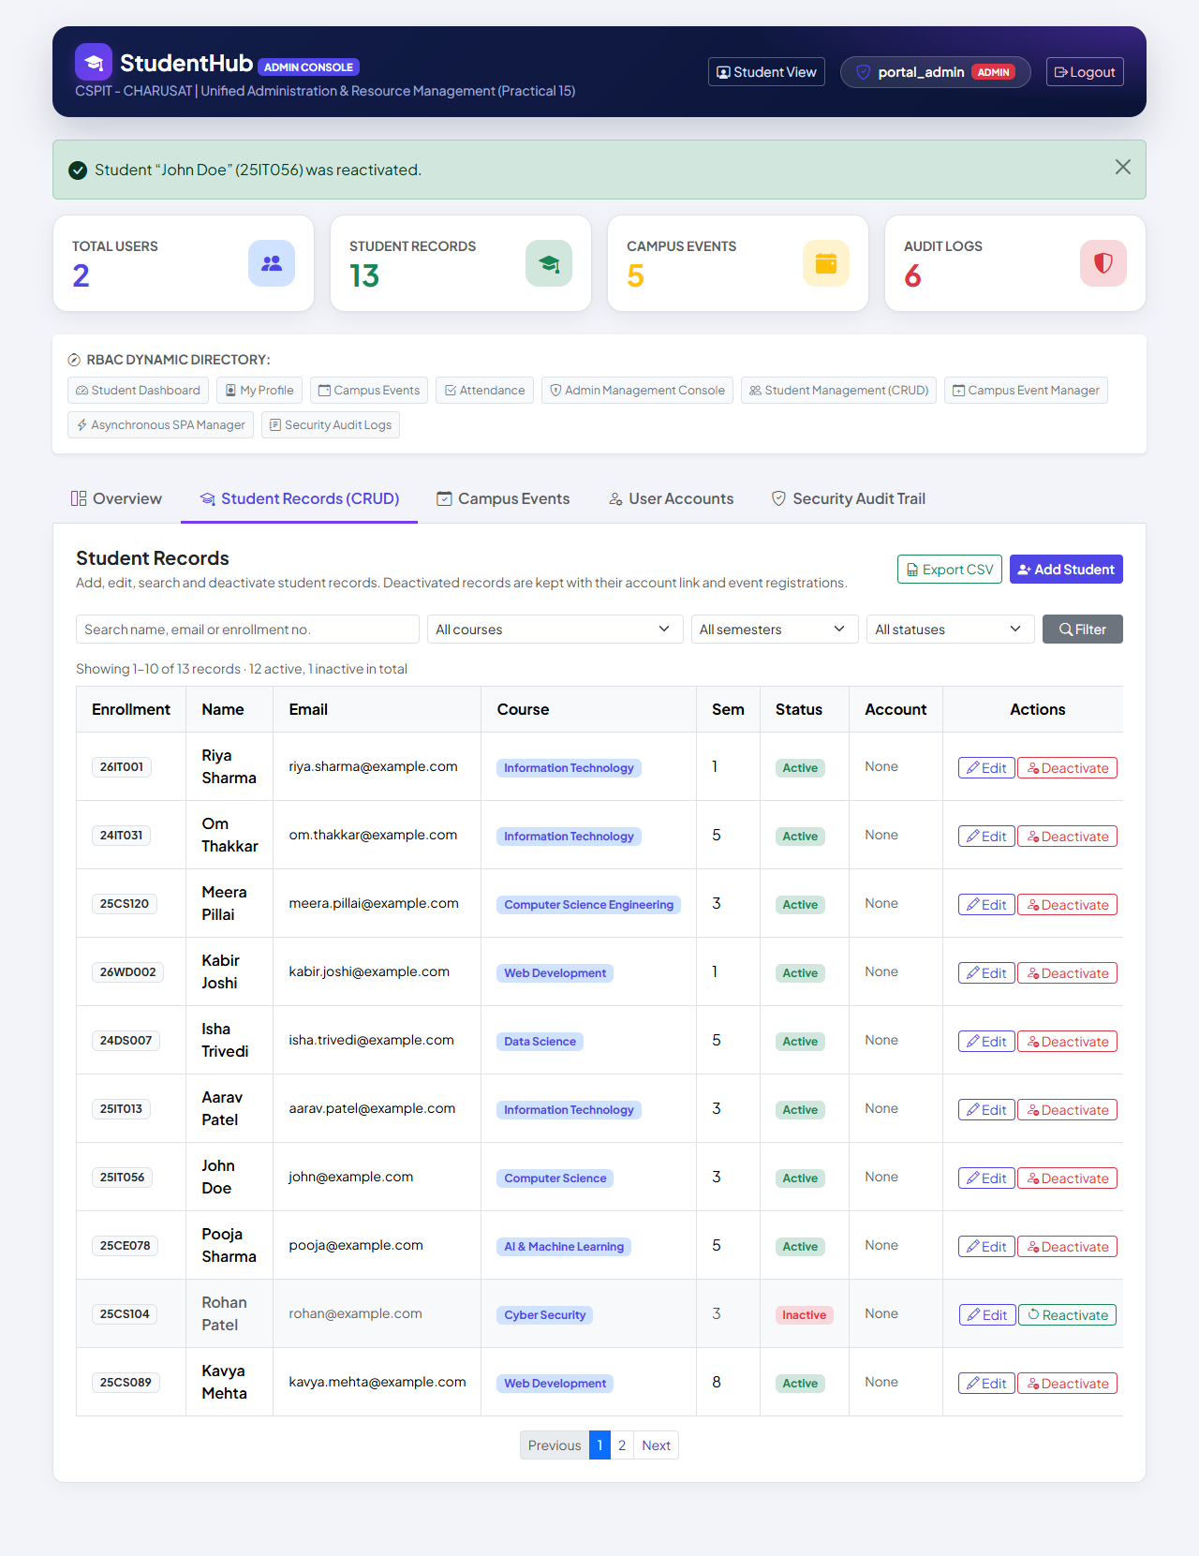
Figure 9: Reactivation: "Student “John Doe” (25IT056) was reactivated." – John Doe is Active again (12 active, 1 inactive) (11-student-reactivated.png)
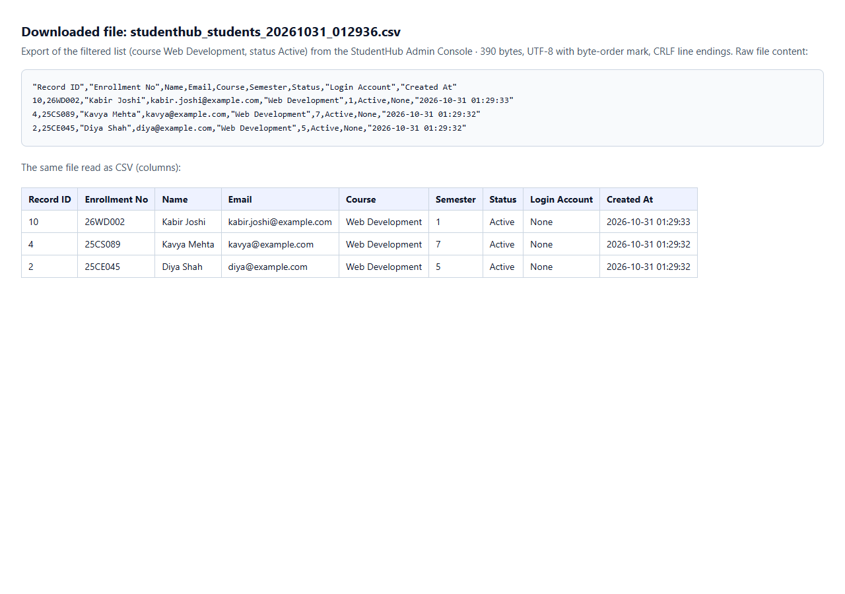
Figure 10: The CSV file downloaded by the Export button of Figure 5's filtered view (course Web Development, status Active): studenthub_students_20261031_012936.csv, 390 bytes, UTF-8 with byte-order mark, CRLF line endings. A headless browser has no download bar, so the test saved the download (also kept as 12-csv-export-web-development-active.csv) and displayed its exact content as text and, parsed as CSV, as a table in the browser; Excel was not used (12-csv-export.png)
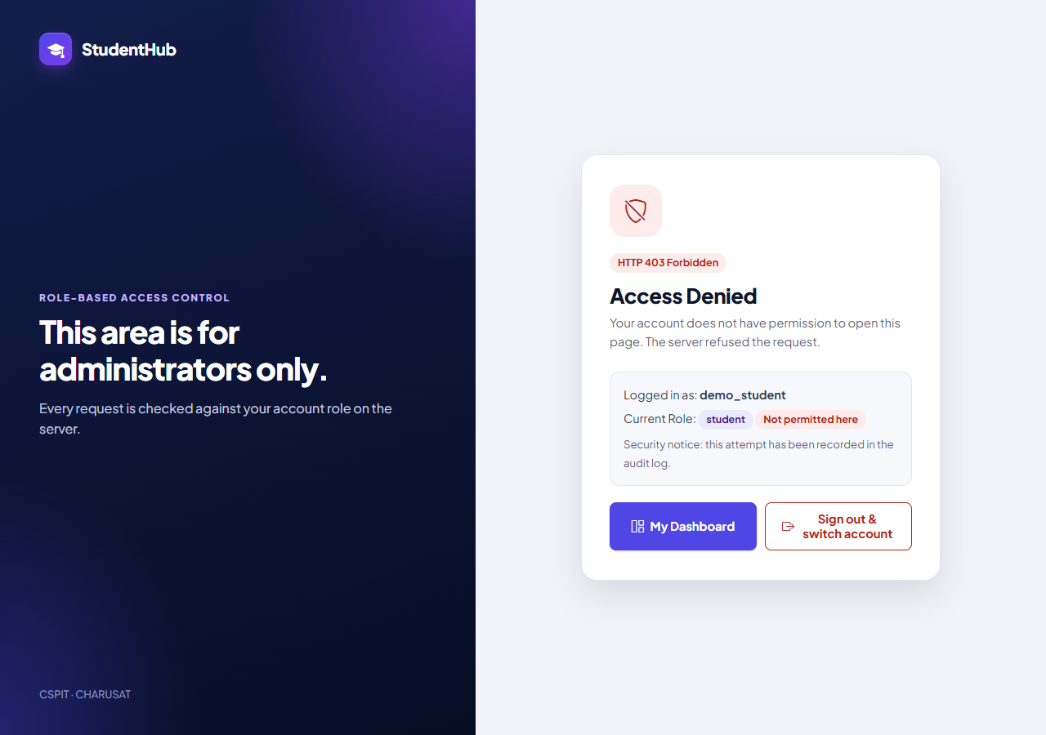
Figure 11: A signed-in student (demo_student) opening the Student Records tab: HTTP 403 "Access Denied" page, role student "Not permitted here", no student data shown; the attempt is recorded in the audit log (13-student-access-denied.png)
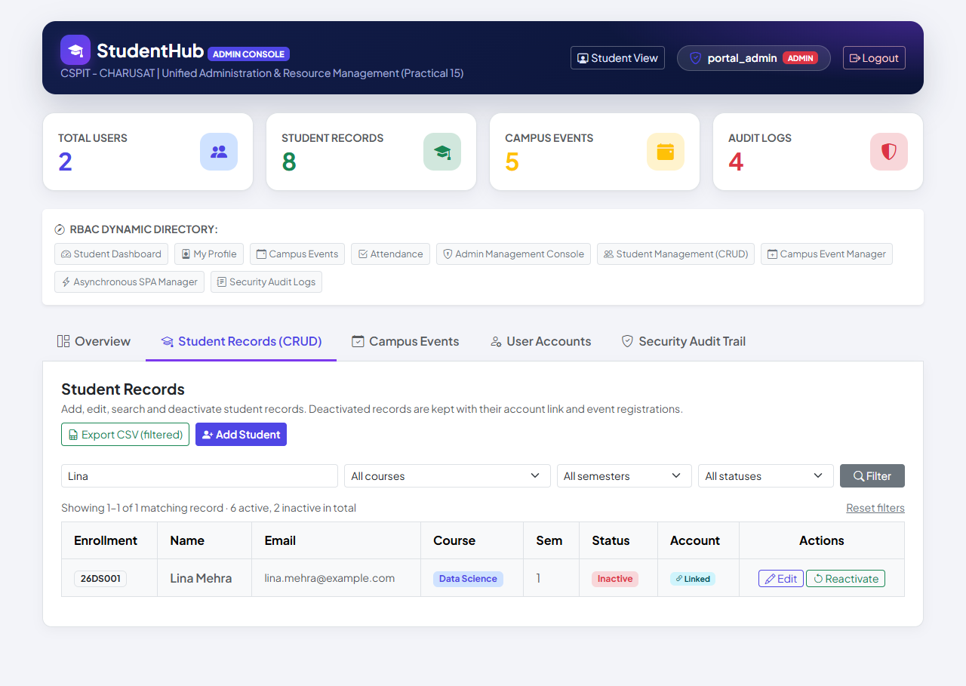
Figure 12: Sign-in fix: Lina Mehra registered herself (record 26DS001, account column "Linked") and the administrator has deactivated the record – status Inactive, Reactivate button (14-admin-deactivated-linked-student.png)
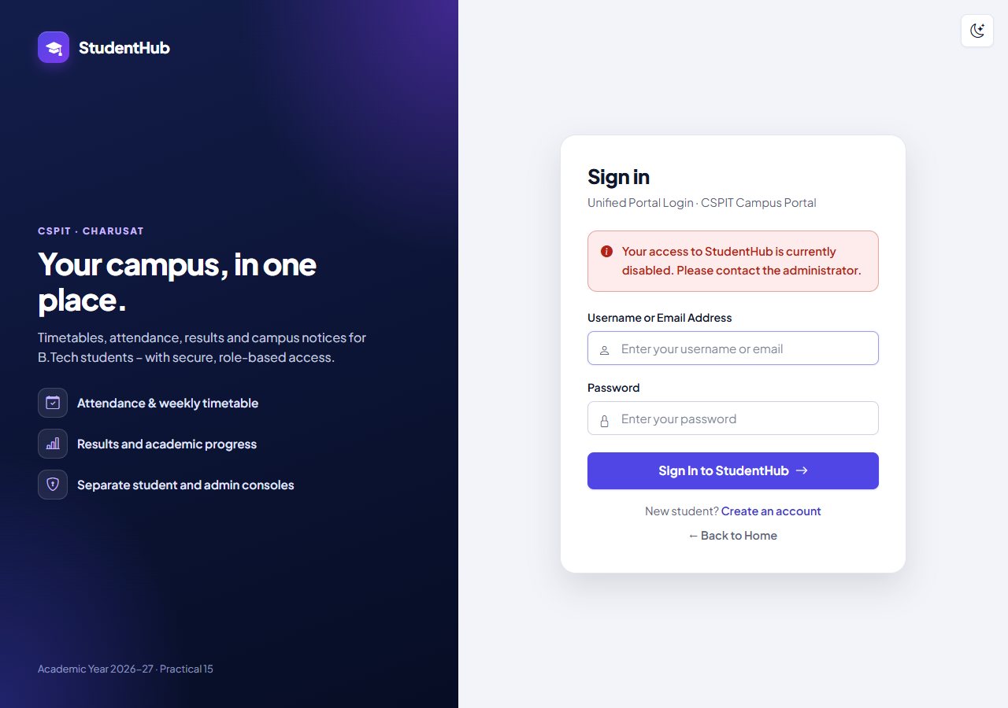
Figure 13: The student's already open session: her next page request leads to the sign-in page with the generic message "Your access to StudentHub is currently disabled. Please contact the administrator." (15-session-ended-after-deactivation.png)
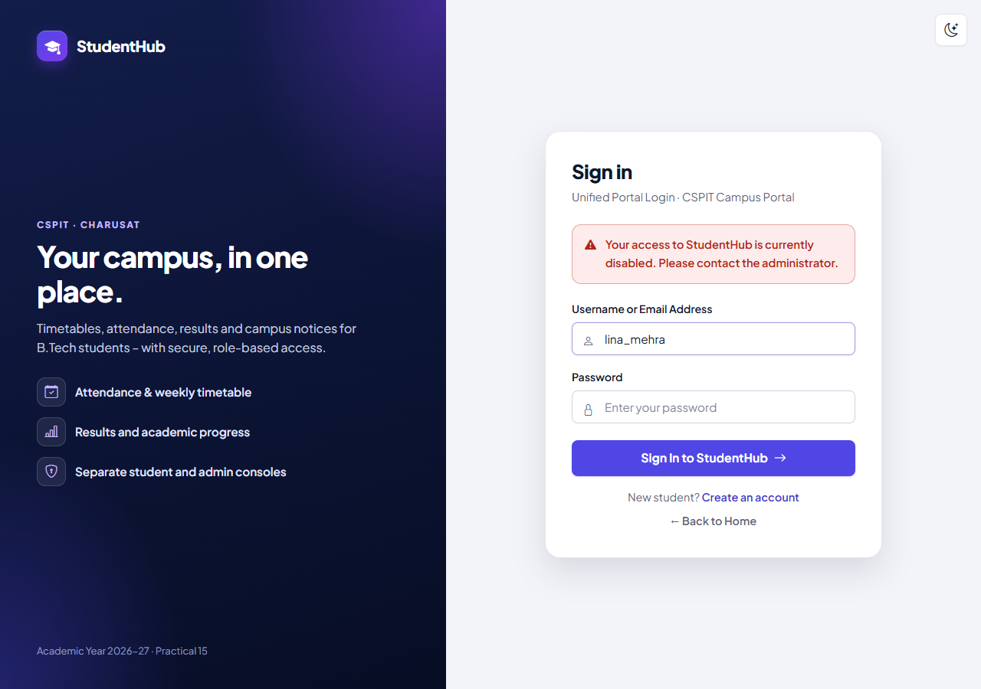
Figure 14: Signing in again as lina_mehra with the correct password is refused with the same generic message (no record details); no session is started (16-inactive-login-denied.png)
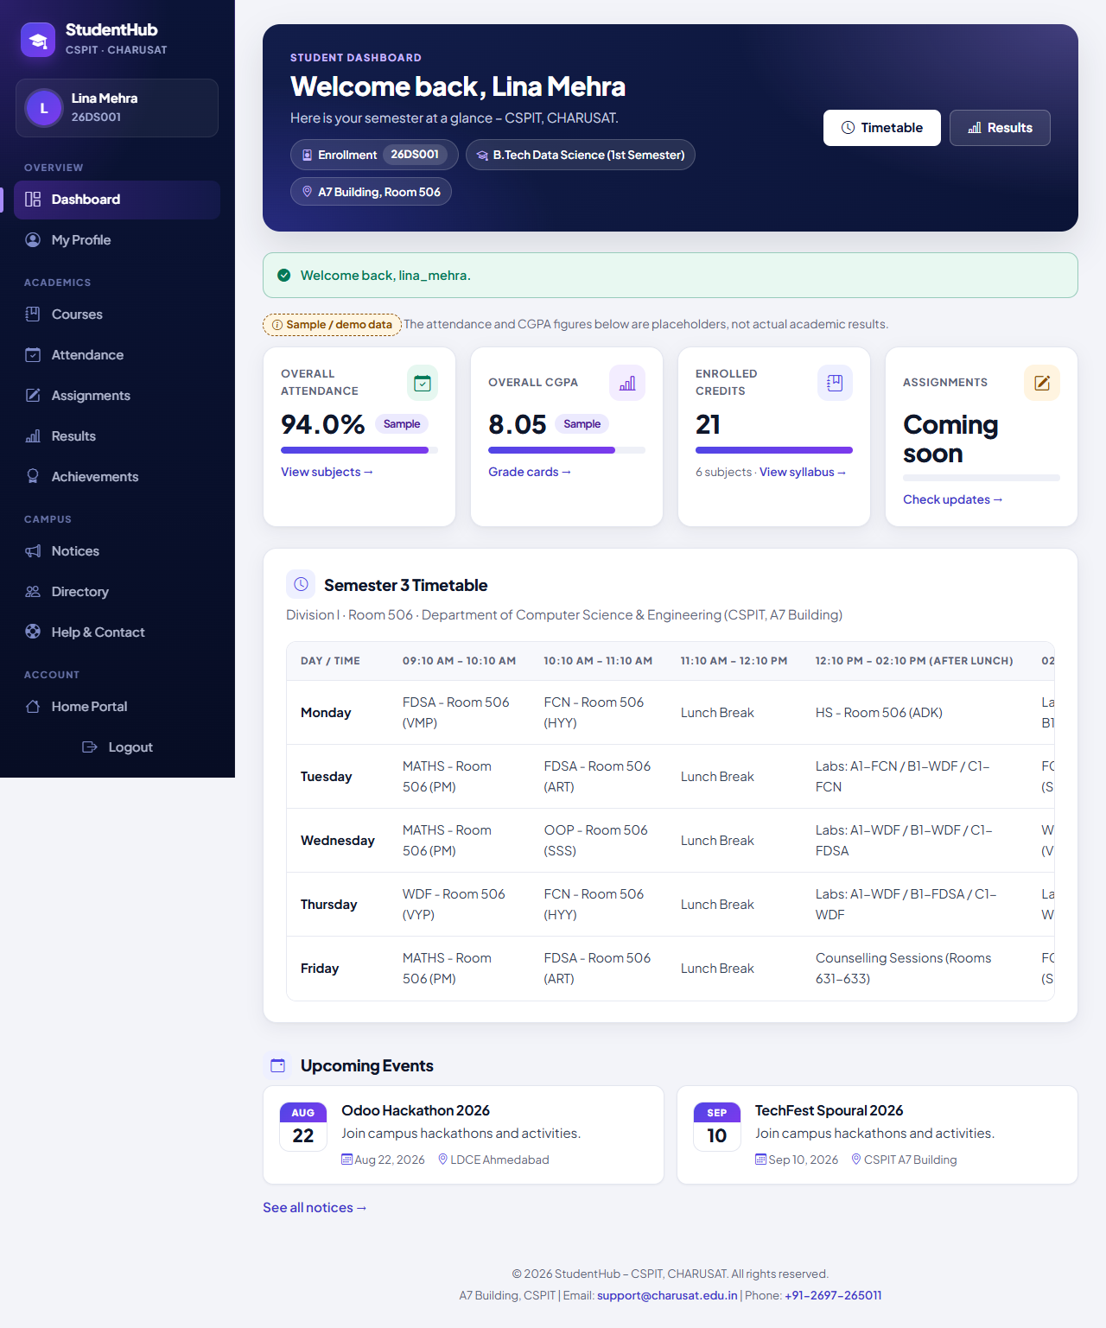
Figure 15: After the administrator reactivated the record the student signs in normally: dashboard with "Welcome back, Lina Mehra", enrollment 26DS001 and the message "Welcome back, lina_mehra." (17-login-after-reactivation.png)

9. Testing and Results
All tests were executed on 31 October 2026 on Windows 11 with PHP 8.2.12 (XAMPP), MariaDB 10.4.32 and PHP's built-in server, against disposable databases (built from database/studenthub_demo.sql or from a restored copy of the real database, dropped afterwards). The live studenthub_db received only migration 002, after a verified backup, and its users, password hashes, students, events, registrations and menu items were verified unchanged afterwards. The numbers below are copied from the saved outputs and from TEST_REPORT.md §7–§8.
Suite | Result | Output
tests/test_students.py – HTTP tests of the Student Records tab (demo data) | 170 / 170 passed | tests/test_students_output.txt
The same with --source-dump (restored copy of the real database) | 170 / 170 passed | not committed (contains real records)
tests/browser_students.py – Microsoft Edge + screenshots 01–13 | 16 / 16 passed | tests/browser_students_output.txt
tests/browser_inactive_login.py – Edge: register, deactivate, session ended, sign-in refused, reactivate | 13 / 13 passed | tests/browser_inactive_login_output.txt
database/tests/test_002_unique_enrollment_no.py – fixture / real dump | 22 / 22 and 22 / 22 passed | database/tests/test_002_output.txt
test_002 … --verify-live – live database after migration 002 (read-only) | 4 / 4 passed | database/tests/test_002_verify_live_output.txt
Regression: tests/test_auth.py (Practicals 9/10) / tests/browser_auth.py | 132 / 132 / 14 / 14 passed | tests/test_auth_output.txt, tests/browser_auth_output.txt

Regression of the Practical 8 migration test (database/tests/test_001_practical8_foundation.py): TEST_REPORT §7–§8 record 87 / 87 (fixture) and 24 / 24 (--verify-live) for this step. The saved file database/tests/test_001_output.txt now holds a later re-run (88 / 88).

9.1 Checks per area (tests/test_students.py)
Area | Checks | Examples of what is verified
Static checks | 5 | php -l on all PHP files of studenthub/ and tools/; no DELETE FROM students; prepared statements; students.manage on the server
Database (migration 002) | 4 | UNIQUE index present, 002 recorded, duplicate refused also in another letter case, several NULLs allowed
Student listing (admin) | 7 | newest first, columns, summary 6 active / 1 inactive, Inactive marking, CSRF token in every form, empty state
Add student | 11 | entered and automatic numbers (26IT102, 25DS001), normalisation, no login account created, CREATE_STUDENT
Invalid student details | 14 | empty / digits / HTML / one-letter name, invalid or too long e-mail, unknown course or gender, SQL in the number, array field
Duplicates | 5 | same number, lower case, with spaces; e-mail in other case; duplicate reported together with other errors
Invalid semester values | 9 | 0, 9, 12, -1, 3.5, abc, 1 OR 1=1, empty – all refused, nothing stored
Edit student | 14 | values saved; link, status, number, creation time and registrations unchanged; legacy record editable; unknown IDs
Search and filters | 14 | name, e-mail, number prefix, course, semester, status and combinations; % and _ literal
SQL injection attempts | 9 | four injection strings in the search; injected course, semester, status and page values ignored
Pagination | 5 | 24 records → 3 pages of 10; last page; page past the end; filters kept
Soft delete and reactivation | 21 | confirmation page, GET / token-less requests change nothing, record and registrations kept, student_inactive, reactivation
Inactive records elsewhere | 2 | hidden from the student directory, listed again after reactivation
CSV export | 14 | BOM, CRLF, header, all 27 records incl. inactive, formula injection, 9 columns, filtered export of all pages, file-name time zone
Access control | 7 | students, editors and visitors refused for tab, forms, export and POST actions
CSRF and GET requests | 4 | missing, wrong, modified and another admin's token refused and logged
Deactivated students cannot sign in | 22 | session ended (new ID, SESSION_REVOKED), old cookie useless, sign-in 403 + LOGIN_DENIED, editors/admins unaffected, reactivation
Server log / clean-up | 3 | no PHP warnings; disposable database removed; live database untouched
Total | 170

9.2 Browser checks (Microsoft Edge)
tests/browser_students.py (16 checks) clicked through the tab as a user would: list and pagination, Inactive badge, add form, server-side validation messages, successful add with the assigned number, search Patel, combined filters, the CSV download (file name pattern, BOM, header, only the filtered rows), edit and save, deactivation with confirmation, reactivation, HTTP 403 for a student, no JavaScript errors and no PHP warnings. tests/browser_inactive_login.py (13 checks) registered a new student, deactivated the linked record in a second browser context, and verified that the student's open session ended, that a new sign-in was refused with the generic message, and that sign-in worked again after reactivation while the administrator's session was never affected. Both outputs report one known, pre-existing 404 for /favicon.ico (the portal has no favicon).

10. Problems Found and Fixed During Integration
- Time zone of dates: XAMPP's PHP used the Europe/Berlin time zone from php.ini while MariaDB uses the system's India time, so between midnight and about 04:30 the portal's dates (form defaults, academic year for enrollment numbers, CSV file name) were one day behind. studenthub/db.php now sets Asia/Kolkata (override: STUDENTHUB_TIMEZONE); a test checks that the export file name matches the database clock.
- Deactivated students could still sign in: found after the first integration commit (0ac2f5d) and listed as a limitation; fixed in commit 6420efc (section 6.5) with 22 new HTTP checks and the Edge test browser_inactive_login.py. The confirmation panel and the success message now say that a linked student account can no longer sign in, and screenshots 01–13 were regenerated with the new wording.
- All problems reported at once: field validation needs no database, the duplicate checks do. check_student_record() runs both and merges the results, so a duplicate enrollment number is reported together with the other errors (Figure 2) instead of only after the other errors have been corrected.
- CSV evidence in a headless browser: a headless Edge has no download bar, so the test saved the downloaded file and showed its bytes as text and as a table (Figure 10) instead of a screenshot of Excel.

11. Differences from the Original Standalone Practical and Limitations
Aspect | Original report (Practical-11/) | Integrated portal (studenthub/)
Database | Own database studenthub_prac11, table students (student_id, full_name, …, status ENUM('active','inactive'), deleted_at) | Shared studenthub_db.students – the same rows used by self-registration, profiles and event registrations
Access | Standalone application without a login | Admin Console behind the portal login; students.manage (administrators only)
CSRF | One-time form tokens | One CSRF token per session on every POST, checked with hash_equals()
Search / filters | Name, e-mail and course; course and status filter | Name, e-mail and enrollment number; course, semester and status filters
Soft delete | status inactive + deleted_at time | status Inactive; time in the audit log; Reactivate button
Enrollment numbers | – | YYPPnnn scheme, automatic next number, UNIQUE index (migration 002)
Sign-in effect | – | A linked student account cannot sign in while its record is Inactive
CSV file | students_YYYYMMDD_HHMMSS.csv, 9 columns incl. Deactivated At | studenthub_students_YYYYMMDD_HHMMSS.csv, 9 columns (Record ID … Login Account, Created At)
Tests | 106 / 106 automated, 13 / 13 browser | 170 / 170 automated, 16 / 16 + 13 / 13 browser, migration tests

Limitations (TEST_REPORT §7): there is no interface to link an added record to an existing login account (links are created only by self-registration); the soft-delete time is recorded in the audit log, not in a column of students; the add form offers automatic enrollment numbers only for the four registration courses (Information Technology, Computer Science Engineering, Data Science, Web Development) – other courses need a typed number; the Admin Console still loads Bootstrap from a CDN; the browser reports one 404 for /favicon.ico.

12. Conclusion
Student management now works on the portal's own student records instead of a separate database. Administrators list, search and filter the records, add and edit them with full server-side validation and unique enrollment numbers, soft-delete them only after a confirmation and reactivate them, and export exactly the filtered records to a CSV file protected against formula injection. Deactivation never destroys data – the record, its account link and its event registrations stay – and a deactivated student can neither sign in nor keep an open session. Prepared statements, output escaping, a CSRF token on every POST, server-side permission checks and audit logging protect the tab. 170 automated checks, 16 + 13 browser checks and the migration tests passed.

13. References
- Project repository: https://github.com/TheEmperor08/StudentHub-ITUE203-25CS023 – studenthub/ (portal), database/ (schema and migration 002), tests/, evidence/practical-11-integration/, TEST_REPORT.md §7–§8; commits 0ac2f5d, 6420efc
- PHP Manual – MySQLi prepared statements: https://www.php.net/manual/en/mysqli.quickstart.prepared-statements.php
- PHP Manual – htmlspecialchars: https://www.php.net/manual/en/function.htmlspecialchars.php
- PHP Manual – fputcsv: https://www.php.net/manual/en/function.fputcsv.php
- PHP Manual – hash_equals: https://www.php.net/manual/en/function.hash-equals.php
- PHP Manual – password_verify: https://www.php.net/manual/en/function.password-verify.php
- OWASP – CSV Injection: https://owasp.org/www-community/attacks/CSV_Injection
- OWASP – Cross-Site Request Forgery Prevention Cheat Sheet: https://cheatsheetseries.owasp.org/cheatsheets/Cross-Site_Request_Forgery_Prevention_Cheat_Sheet.html
- OWASP – SQL Injection Prevention Cheat Sheet: https://cheatsheetseries.owasp.org/cheatsheets/SQL_Injection_Prevention_Cheat_Sheet.html

