CHAROTAR UNIVERSITY OF SCIENCE AND TECHNOLOGY (CHARUSAT)
Chandubhai S. Patel Institute of Technology (CSPIT)
Department of Computer Science & Engineering
ITUE203 – Web Development Frameworks

PRACTICAL 13

Event Finder – AJAX Event CRUD with the Fetch API and a PHP JSON API
PHP 8 · MySQLi · MariaDB (studenthub_db) · JavaScript Fetch API · JSON
Corrected submission – implemented in the integrated StudentHub portal (studenthub/)
Student Name | Shreyas
Roll Number | 25CS023
Student ID | 25CS023
Email | 25cs023@charusat.edu.in
Course | ITUE203 – Web Development Frameworks
Programme | B.Tech Computer Science & Engineering
Semester / Academic Year | 3 / 2026-27
Date of Submission
Faculty Signature

Corrected report. This report replaces the original Practical 13 report (Practical-13/PRAC_13_ITUE203_25CS023.docx, kept unchanged in the repository). The original report describes a standalone application in Practical-13/ (index.html, script.js, api.php) with its own database studenthub_prac13. This corrected version describes the Event Finder of the integrated portal: api/events.php uses the portal's database connection, login session, roles and CSRF token and the same event and registration rules as the Admin Console (Practical 12); no schema change was needed. All screenshots in this report were taken from the canonical integrated application studenthub/ with Microsoft Edge on disposable test databases with fictional records; all test results are copied from the saved test outputs of the repository.

1. Aim and Objectives
To manage campus events asynchronously inside the integrated portal: the browser sends small requests with the JavaScript Fetch API to a PHP endpoint that answers in JSON, and the page updates only the affected part – it is never reloaded.
- List events from the portal database and – for administrators – add, edit/update and delete events with Fetch requests to api/events.php, without reloading the page.
- Return valid JSON for every request with a fitting status code, handle GET (read) and POST (change) correctly and answer other methods with 405.
- Validate all input on the server before any database operation (the same validate_event() as the Admin Console), use MySQLi prepared statements and output data safely.
- Handle errors centrally in JSON and show loading, success, empty and error states in the page.
- Intermediate extension: an AJAX search with debounce (request sent 300 ms after the last key press) combined with category, registration-status and date filters.
- Integration: respect the portal login and roles – students with a linked student record register for events and cancel through the same API; POST requests carry the session's CSRF token.

2. Problem Definition
In a classic PHP application every action submits a form and reloads the whole page. An event list that is searched and edited often feels slow that way and loses the user's position and search. A Fetch-based page avoids this, but moves the attack surface to a JSON endpoint that any script can call directly. The endpoint therefore has to make every decision itself: who is signed in, which role may do what, whether the request really comes from the portal page (CSRF), whether the body is valid JSON and whether the event data is valid.
In the standalone version the API had its own database studenthub_prac13 and its own event table and protected POST requests with the header X-Requested-With: fetch. In the portal the same events are also managed in the Admin Console (Practical 12) and registered for on the Campus Events page, so the API must use the same tables, the same validation and registration rules, the portal session and roles – and it must answer a missing session with JSON HTTP 401 instead of the HTML redirect to the login page that normal portal pages use.

3. Tools and Technologies
Tool | Use in this practical
PHP 8.2.12 (XAMPP), MySQLi | JSON API api/events.php, prepared statements, central JSON error handling
MariaDB 10.4.32 (XAMPP) | Shared database studenthub_db (tables events, event_categories, registrations, students)
JavaScript (ES2020) – Fetch API | fetch(), async/await, AbortController, URLSearchParams, FormData, JSON
HTML5 <dialog>, CSS3 | events_live.php (filters, result list, modal create/edit dialog), styles in assets/css/global.css
Microsoft Edge (headless) + Playwright | tests/browser_api.py – browser checks, request and navigation counting, screenshots
Python 3 | tests/test_api.py – HTTP tests of every API action on disposable databases
Git / GitHub | Commit a9d4e22, pushed to the project repository

4. Place in the Integrated Portal and Source Files
The Event Finder is a normal portal page (sidebar group Campus → Event Finder) that every signed-in user can open. The five required files of the original practical map to these portal files:
Original file | Portal file | Purpose
db.php | studenthub/db.php | The portal's MySQLi connection; with STUDENTHUB_API defined it answers its own failures (HTTP 503) as JSON
api.php | studenthub/api/events.php | JSON API: list, get (GET); create, update, delete, register, cancel (POST)
index.html | studenthub/events_live.php | Event Finder page: CSRF meta tag, filters, result list, loading indicator, messages, create/edit dialog for administrators
script.js | studenthub/assets/js/events-live.js | Fetch front end: api() wrapper, rendering with textContent, debounced search, dialog, register / cancel
schema.sql | database/studenthub_demo.sql + migrations | No schema change for Practical 13; the tables of Practicals 8, 11 and 12 are used

The API reuses the portal's own code instead of duplicating it: includes/auth.php (session, role_can(), csrf_is_valid()), includes/event_management.php (filters, validate_event(), save_event(), delete_event(), delete_poster_file()), includes/event_registration.php (register_student_for_event(), cancel_event_registration()) and audit_logger.php. What each role can do:
Role | Event Finder page | API actions allowed
admin | New event button, Edit and Delete on every card | list, get, create, update, delete (events.manage); register / cancel → 403
student with a linked record | Register / Cancel registration | list, get, register, cancel; create / update / delete → 403 (ACCESS_DENIED logged)
editor | View and search only | list, get
not signed in | Redirect to the login page | every action → 401 JSON, never a redirect

5. Database Schema
Practical 13 needed no schema change (TEST_REPORT §10). The API reads and writes the tables described in the Practical 12 report: events (with status, capacity and the unique poster from migrations 001 and 003), event_categories (allowed categories for the filter and the validation), registrations (each student's own registration state; UNIQUE student + event) and students (the record linked to the signed-in account through students.user_id). The seats taken and the number of registrations are counted by sub-queries in the same SELECT. api_event() turns a row into JSON with exactly these fields – internal columns and file names are never sent:
JSON field | Meaning
id, title, category, location, description | Event data; <, >, & and quotes are sent as \u escapes, and the page inserts the values with textContent
event_date, event_time, when | Date YYYY-MM-DD, time HH:MM or null, and a display label such as "18 Nov 2026, 10:00"
capacity, seats_taken, seats_left | Capacity null = no limit; seats_left null when there is no limit
status, is_past | open / closed; whether the date has passed
poster_url | poster.php?event=N when a stored poster exists, otherwise null
registrations_total, my_registration | All registrations of the event; the signed-in student's own state (registered / attended / cancelled / null)

6. AJAX CRUD Implementation

6.1 PHP JSON API (api/events.php)
api/events.php reads action from the query string. list and get require GET; create, update, delete, register and cancel require POST with a JSON body. Every answer leaves through one function, api_respond(), which sets the status code, Content-Type: application/json, Cache-Control: no-store and nosniff, and encodes the body with JSON_HEX_TAG | JSON_HEX_AMP | JSON_HEX_APOS | JSON_HEX_QUOT, so <, >, & and quotes never appear literally in the JSON text. Expected problems are thrown as ApiError with a status code; anything else is caught by the central exception handler, written to the PHP error log and answered with a general 500 message – no SQL or connection details reach the browser. PHP warnings are turned into exceptions, so they take the same path.
studenthub/api/events.php (lines 31–48) – single JSON exit point and central error handling
31 // The single exit point: status code, JSON headers and the JSON body
32 function api_respond(int $status, array $body): void
33 {
34 http_response_code($status);
35 header('Content-Type: application/json; charset=utf-8');
36 header('Cache-Control: no-store');
37 header('X-Content-Type-Options: nosniff');
38 echo json_encode($body, JSON_UNESCAPED_UNICODE | JSON_UNESCAPED_SLASHES | JSON_HEX_TAG | JSON_HEX_AMP | JSON_HEX_APOS | JSON_HEX_QUOT);
39 exit;
40 }
41
42 // Central error handling: expected problems are ApiError; anything else is logged and answered with a general 500
43 set_exception_handler(function (Throwable $e): void {
44 if ($e instanceof ApiError) {
45 api_respond($e->getCode(), ['ok' => false, 'error' => $e->getMessage()] + ($e->fields ? ['errors' => $e->fields] : []));
46 }
47 error_log('StudentHub API error: ' . get_class($e) . ' [' . $e->getCode() . '] ' . $e->getMessage() . ' in ' . $e->getFile() . ':' . $e->getLine());
48 api_respond(500, ['ok' => false, 'error' => 'The server could not complete the request. Please try again later.']);

For every POST, json_body() checks – in this order – the content type (415 unless application/json), the CSRF token in the X-CSRF-Token header (403, logged as CSRF_REJECTED), the size of the body (400 above 20,000 bytes) and that the body is a JSON object (400 for malformed JSON or a JSON array). A cross-site HTML form can send neither application/json nor a custom header, and it cannot know the session's token.
studenthub/api/events.php (lines 62–82) – request checks for POST
62 // POST: JSON body, CSRF header; returns the decoded object
63 function json_body(array $user): array
64 {
65 global $conn;
66 $type = strtolower(trim(explode(';', (string) ($_SERVER['CONTENT_TYPE'] ?? ''))[0]));
67 if ($type !== 'application/json') {
68 throw new ApiError(415, 'Send the request body as JSON (Content-Type: application/json).');
69 }
70 if (!csrf_is_valid($_SERVER['HTTP_X_CSRF_TOKEN'] ?? null)) {
71 log_audit($conn, $user['id'], $user['username'], 'CSRF_REJECTED', 'API POST ' . ($_GET['action'] ?? '') . ' without a valid token', 'SECURITY_BLOCK');
72 throw new ApiError(403, 'Security check failed. Reload the page and try again.');
73 }
74 $raw = file_get_contents('php://input');
75 if (strlen((string) $raw) > 20000) {
76 throw new ApiError(400, 'The request body is too large.');
77 }
78 $data = json_decode((string) $raw, true);
79 if (!is_array($data) || array_is_list($data) && $data !== []) {
80 throw new ApiError(400, 'The request body must be a JSON object.');
81 }
82 return $data;

6.2 Session, roles and JSON 401
Normal portal pages call require_login(), which redirects to the login page. A redirect would be useless for fetch(), so the API starts the same secure session and calls validate_session() directly: without a valid session (never signed in, timed out, or a deactivated student) it answers HTTP 401 in JSON. Then portal.view is required, and each action checks its own permission (events.manage for create / update / delete; a linked student record for register / cancel).
studenthub/api/events.php (lines 133–147) – authentication without redirects
133 // ---------------------------------------------------------------- authentication (no redirects: JSON 401)
134 start_secure_session();
135 send_security_headers(true);
136 [$user, $reason] = validate_session();
137 if ($user === null) {
138 throw new ApiError(401, match ($reason) {
139 'timeout' => 'Your session ended because you were inactive. Please sign in again.',
140 'access_disabled' => 'Your access to StudentHub is currently disabled. Please contact the administrator.',
141 default => 'Please sign in to use StudentHub.',
142 });
143 }
144 require_api_permission($user, 'portal.view');
145 $categories = event_categories($conn);
146 $student = $user['role'] === 'student' ? linked_student($conn, $user['id']) : null;
147 $action = is_string($_GET['action'] ?? null) ? $_GET['action'] : '';

list passes the query parameters to the same event_filters() as the Admin Console (unknown values are ignored), returns at most 100 events and adds the role flags can_manage and can_register that the page uses to decide which buttons to show – the server still checks every action. create and update validate the JSON body with validate_event() and save it with save_event(), so every rule of Practical 12 applies here too, including the capacity that cannot drop below the seats taken. delete uses delete_event() and answers 409 for an event with registrations. register / cancel call the registration transaction and map its reasons to status codes (unknown event 404, inactive student 403, duplicate / full / closed / past / not registered 409).
studenthub/api/events.php (lines 168–185) – create and update with the shared validation
168 case 'create':
169 case 'update':
170 require_method('POST');
171 require_api_permission($user, 'events.manage');
172 $body = json_body($user);
173 $existing = null;
174 if ($action === 'update' && ($existing = ($id = body_id($body, 'id')) > 0 ? find_event($conn, $id) : null) === null) {
175 throw new ApiError(404, 'That event was not found.');
176 }
177 [$clean, $errors] = validate_event(event_input($body), $categories, $existing);
178 $saved = $errors ? ['errors' => $errors] : save_event($conn, $clean, $existing ? (int) $existing['id'] : null);
179 if (isset($saved['errors'])) {
180 throw new ApiError(422, 'Please correct the highlighted fields.', $saved['errors']);
181 }
182 log_audit($conn, $user['id'], $user['username'], $existing ? 'UPDATE_EVENT' : 'CREATE_EVENT',
183 ($existing ? 'Updated' : 'Created') . " event ID {$saved['id']} ({$clean['title']}) via the events API", 'SUCCESS');
184 api_respond($existing ? 200 : 201, ['ok' => true, 'event' => api_event(find_event($conn, $saved['id']), null),
185 'message' => $existing ? "Event “{$clean['title']}” was updated." : "Event “{$clean['title']}” was published."]);

6.3 Fetch API front end (events-live.js)
All requests go through api(). It builds the URL with URLSearchParams, sends JSON with the CSRF token (read from the page's <meta name="csrf-token">) for POST requests, parses the JSON answer and turns a network failure or a non-JSON answer into an error object, so the caller always receives {status, data}.
studenthub/assets/js/events-live.js (lines 45–69) – the Fetch wrapper
45 // One API call. Returns {status, data}; network failures and non-JSON answers become an error object.
46 async function api(action, { method = 'GET', params = {}, body = null, signal } = {}) {
47 const url = API + '?' + new URLSearchParams({ action, ...params });
48 const headers = { Accept: 'application/json' };
49 if (body !== null) {
50 headers['Content-Type'] = 'application/json';
51 headers['X-CSRF-Token'] = token;
52 }
53 let response;
54 try {
55 response = await fetch(url, { method, headers, body: body === null ? undefined : JSON.stringify(body), credentials: 'same-origin', signal });
56 } catch (error) {
57 if (error.name === 'AbortError') throw error;
58 return { status: 0, data: { ok: false, error: 'The server could not be reached. Check your connection and try again.' } };
59 }
60 let data;
61 try {
62 data = await response.json();
63 } catch {
64 data = { ok: false, error: 'The server sent an unexpected answer (HTTP ' + response.status + ').' };
65 }
66 if (response.status === 401) {
67 data.error = (data.error || 'Please sign in again.') + ' Reload the page to sign in.';
68 }
69 return { status: response.status, data };

load() reads the filter form, shows the loading indicator, marks the list aria-busy and cancels a still running older request with an AbortController, so results never arrive in the wrong order. The cards are built with document.createElement() and every value from the server is inserted with textContent – never innerHTML – so HTML in a title is shown as text. An empty result shows "No events found…", a failure an error box with a Try again button.
studenthub/assets/js/events-live.js (lines 73–93) – list request with loading state and cancellation
73 async function load() {
74 if (controller) controller.abort();
75 const current = controller = new AbortController();
76 const params = Object.fromEntries(new FormData(filters));
77 results.setAttribute('aria-busy', 'true');
78 loading.hidden = false;
79 try {
80 const { status, data } = await api('list', { params, signal: current.signal });
81 if (!data.ok) {
82 renderError(data.error || 'The events could not be loaded (HTTP ' + status + ').');
83 return;
84 }
85 events = data.events;
86 render();
87 summary.textContent = data.count === 0 ? 'No events match your search.' : data.count + (data.count === 1 ? ' event found.' : ' events found.');
88 } catch (error) {
89 if (error.name !== 'AbortError') renderError('The events could not be loaded.');
90 } finally {
91 if (current === controller) { // a newer search has not replaced this one
92 results.setAttribute('aria-busy', 'false');
93 loading.hidden = true;

6.4 Create and update without reloading the page
The administrator's dialog (<dialog> opened with showModal()) is filled from the event's JSON for editing. save() sends the form values as JSON; on HTTP 422 it writes each message from errors under its field and marks the field aria-invalid; on success it closes the dialog, shows the server's message and reloads only the list. Delete asks for confirmation and then sends {"id": N}; register and cancel send {"event_id": N} and refresh the list afterwards, so a conflict (for example a seat taken by someone else) is shown and the card is corrected at once.
studenthub/assets/js/events-live.js (lines 187–215) – create / update and field errors
187 async function save(event) {
188 event.preventDefault();
189 clearErrors();
190 const values = Object.fromEntries(new FormData(form));
191 const id = values.id;
192 delete values.id;
193 const action = id ? 'update' : 'create';
194 if (id) values.id = Number(id);
195 const button = document.getElementById('event-save');
196 button.disabled = true;
197 const { status, data } = await api(action, { method: 'POST', body: values });
198 button.disabled = false;
199 if (status === 422 && data.errors) {
200 for (const [field, text] of Object.entries(data.errors)) {
201 const target = document.getElementById('f-' + field + '-error');
202 if (target) target.textContent = text;
203 if (form.elements[field]) form.elements[field].setAttribute('aria-invalid', 'true');
204 }
205 const first = form.querySelector('[aria-invalid="true"]');
206 if (first) first.focus();
207 return;
208 }
209 if (!data.ok) {
210 dialog.close();
211 showMessage('error', data.error);
212 return;
213 }
214 dialog.close();
215 showMessage('success', data.message);

6.5 AJAX search with debounce
The search box sends no request per key press. Each key press restarts a 300 ms timer; only when the user pauses is the request sent. The category, registration-status and date selects send a request at once when they change. In the Edge test, typing "workshop" quickly produced exactly one API request.
studenthub/assets/js/events-live.js (lines 227–232) – debounce wiring
227 filters.addEventListener('submit', (e) => { e.preventDefault(); load(); });
228 filters.elements.q.addEventListener('input', () => { // debounce: one request 300 ms after the last key press
229 clearTimeout(timer);
230 timer = setTimeout(load, 300);
231 });
232 for (const name of ['category', 'status', 'when']) filters.elements[name].addEventListener('change', load);

7. Request and Response Examples
The page sends every POST as fetch(url, {method: 'POST', headers: {Accept: 'application/json', 'Content-Type': 'application/json', 'X-CSRF-Token': token}, body: JSON.stringify(values), credentials: 'same-origin'}). The following exchanges happened in the Edge test. The status codes are taken from tests/browser_api_output.txt (for list and update, which that output does not state, from the same actions in tests/test_api_output.txt); the messages are the ones the page displayed from the JSON (visible in the figures of section 9).
Request | Status | Answer shown by the page
GET api/events.php?action=list&q=&category=&status=&when=upcoming | 200 | "5 events found." and the cards (Figure 2)
POST ?action=create – location empty, capacity 0 | 422 | Field messages under Location and Capacity (Figure 5)
POST ?action=create – valid event | 201 | "Event “Hackathon Kick-off” was published." (Figure 6)
POST ?action=update – {"id": …, …} | 200 | Card shows the new location and capacity (Figures 7–8)
POST ?action=register – {"event_id": …} (student) | 201 | "You are registered for “Git & GitHub Workshop”." (Figure 8)
POST ?action=register – event already full | 409 | "The event is full." (Figure 9)
POST ?action=delete – event with a registration | 409 | "This event has 1 registration(s) and cannot be deleted, …" (Figure 10)
GET ?action=list without a session | 401 | {"ok":false,"error":"Please sign in to use StudentHub."} (Figure 12)

Two responses were opened directly in Edge and are reproduced verbatim from the screenshots. The list response (Figure 11, GET api/events.php?action=list&when=upcoming&category=Workshop as administrator) begins with
{"ok":true,"count":3,"events":[{"id":4,"title":"Robotics \u0026 Automation Exhibition","category":"Workshop","event_date":"2026-11-10","event_time":null,"when":"10 Nov 2026","location":"CSPIT Foyer","description":"","capacity":null,"seats_taken":0,"seats_left":null,"status":"open","is_past":false,"poster_url":null,"registrations_total":0,"my_registration":null}, …
and ends with "filters":{"q":"","category":"Workshop","status":"","when":"upcoming"},"can_manage":true,"can_register":false}. The & of the title is sent as \u0026 because of JSON_HEX_AMP. A visitor without a session receives {"ok":false,"error":"Please sign in to use StudentHub."} with HTTP 401 (Figure 12). All status codes of the API, from the source code:
Status | When
200 / 201 | list, get, update, delete, cancel / create, register succeeded ({"ok": true, …})
400 | Unknown action, malformed JSON, a JSON array, a body over 20,000 bytes
401 | No valid session (not signed in, timed out, deactivated student)
403 | Missing or wrong X-CSRF-Token; the role lacks the permission; unlinked account or administrator registering; inactive student
404 | Unknown or malformed event ID
405 | Wrong method, with an Allow header
409 | Duplicate, full, closed or past event, nothing to cancel, delete of an event with registrations
415 | POST without Content-Type: application/json
422 | Validation failed – {"ok": false, "error": …, "errors": {field: message}}
500 / 503 | Unexpected server error / database unavailable – general message only, details in the server log

8. Validation and Security
- Server-side validation of every field with the portal's validate_event() before any INSERT or UPDATE (422 with one message per field); the dialog's HTML attributes are only a convenience.
- SQL injection: MySQLi prepared statements in the shared include files; the API has no own connection and no ->query() call (static test); filter values only from fixed lists; % and _ searched literally.
- Safe output: JSON encoded with the JSON_HEX_* flags; the page inserts data only with textContent; posters only as poster.php URLs.
- CSRF: POST requires application/json and the session's token in X-CSRF-Token (compared with hash_equals()); failures are audit-logged.
- Correct methods: reading only with GET, changing only with POST; 405 with an Allow header otherwise.
- Authentication and roles: JSON 401 without a session; events.manage for create / update / delete; only a linked student account can register; ACCESS_DENIED logged for refused roles. The page's buttons follow can_manage / can_register, but the server checks every request.
- Integrity: the registration transaction of Practical 12 (row lock, capacity, duplicates) – 6 simultaneous API registrations for 3 seats gave exactly three 201 and three 409.
- Central error handling: one exception handler; database and PHP errors are logged, the client receives a general message; an unreachable database gives HTTP 503 in JSON.

9. Output Screenshots
All screenshots are genuine full-page captures from Microsoft Edge (headless, driven by Playwright, window 1280 px wide) taken by tests/browser_api.py while the portal ran on PHP's built-in server with a disposable database built from database/studenthub_demo.sql plus four fictional events and two fictional students added by the test. The test counted page navigations: create, update and delete happened without a page reload. Captures 05 (the filled dialog before saving) and 09 (the card after the update, also visible in Figures 8–10) are not reproduced. In the full-page captures of the modal dialog (Figures 5 and 7) the darkened backdrop covers only the 900-pixel-high browser window, not the whole capture.
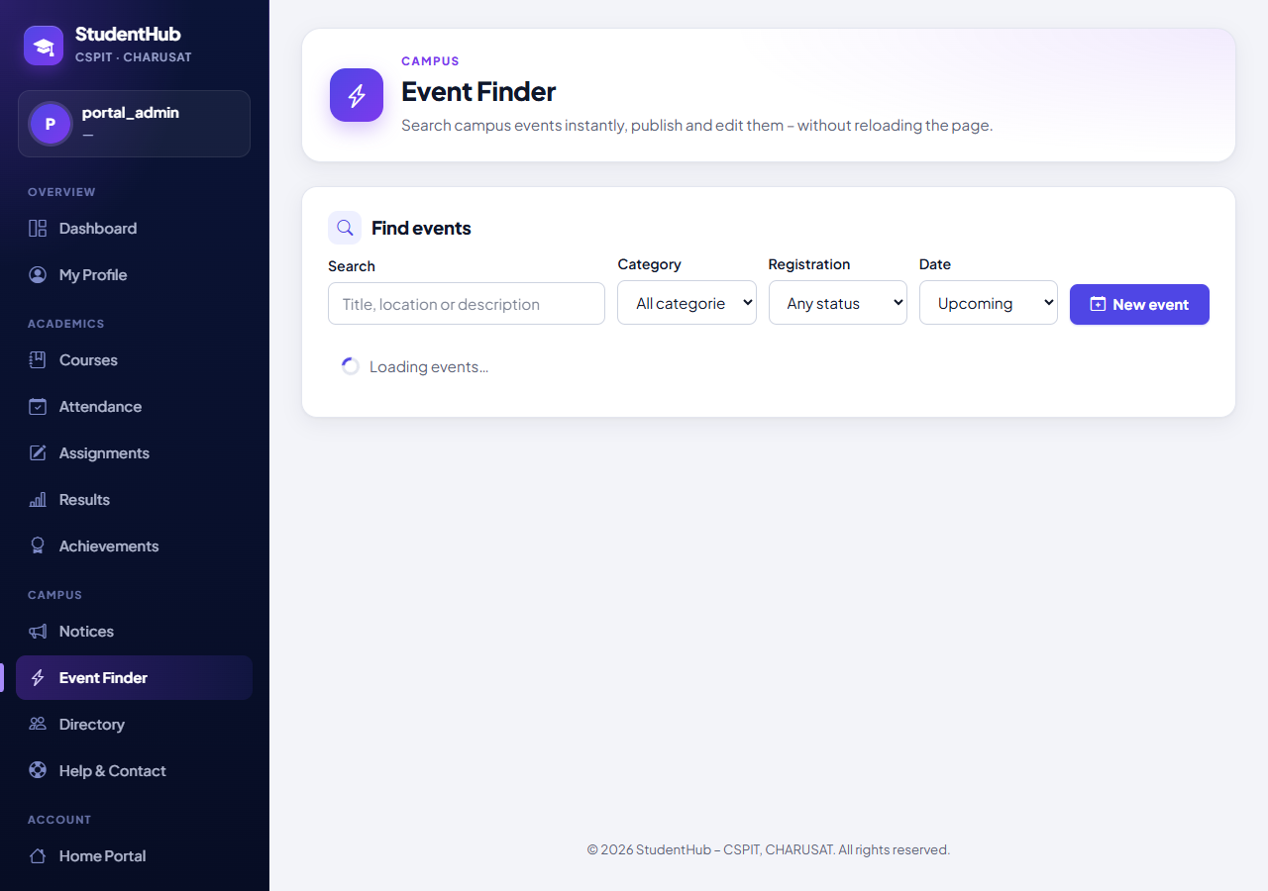
Figure 1: Loading state of the Event Finder (administrator portal_admin): "Loading events…" with a spinner below the filters while the first list request runs. For this screenshot the test held the API answer back for 1.5 s in its own network layer (a Playwright route); the answer itself was the real one (01-loading-state.png)
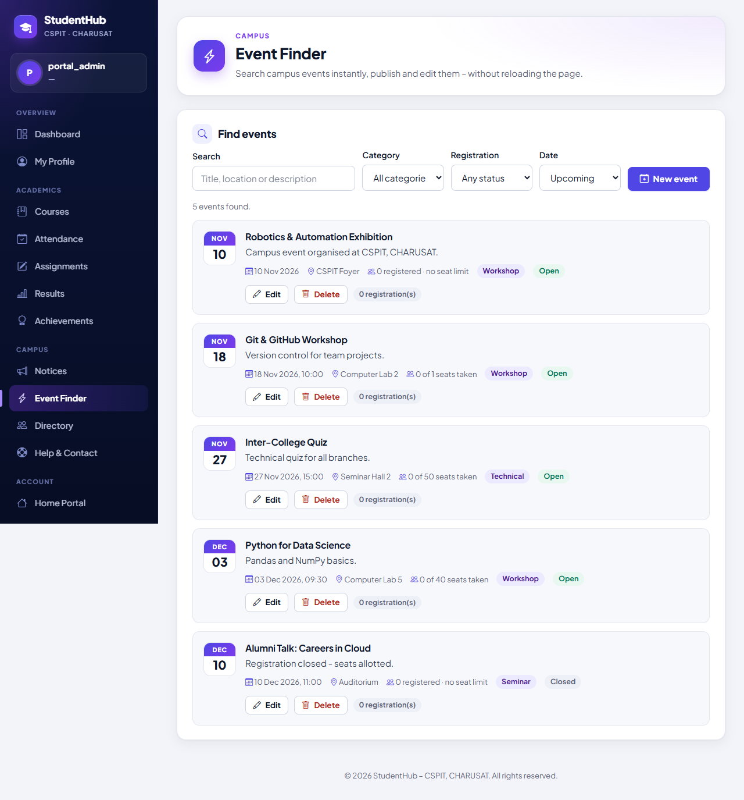
Figure 2: Upcoming events loaded from the JSON API, soonest first: "5 events found." – each card shows date, location, seats, category and Open / Closed badge and, for the administrator, Edit, Delete and the number of registrations (02-event-list.png)
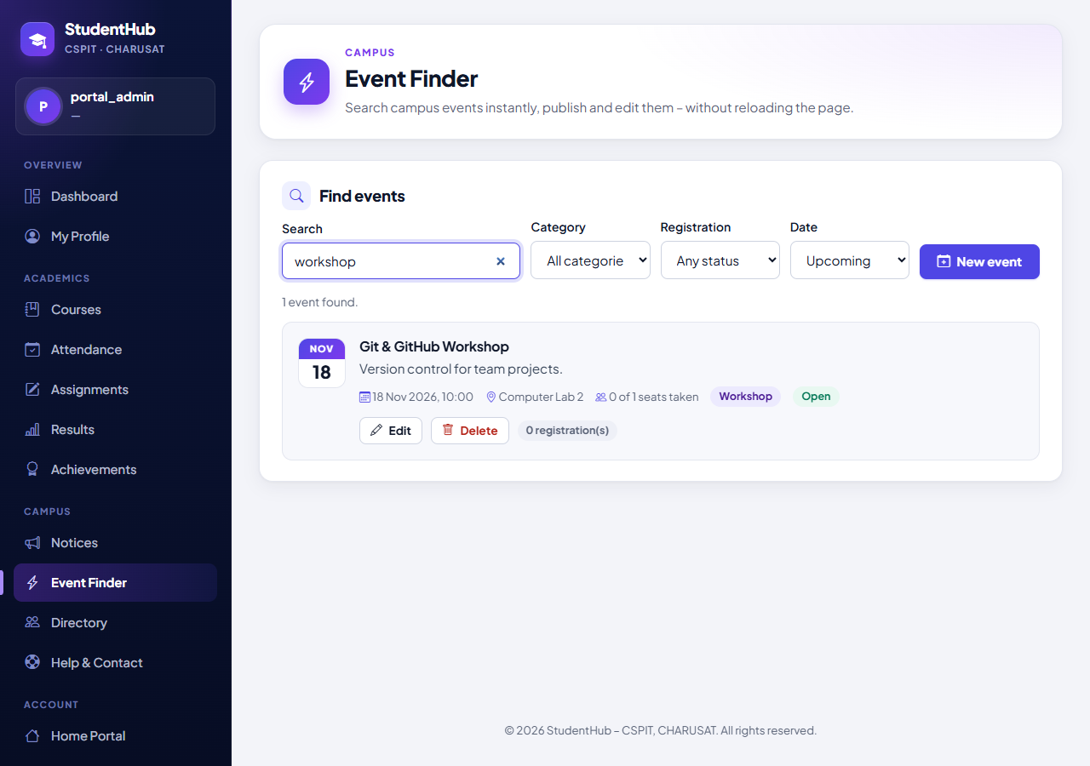
Figure 3: Debounced live search: typing "workshop" sent a single API request (counted by the test); "1 event found." – Git & GitHub Workshop (03-live-search.png)
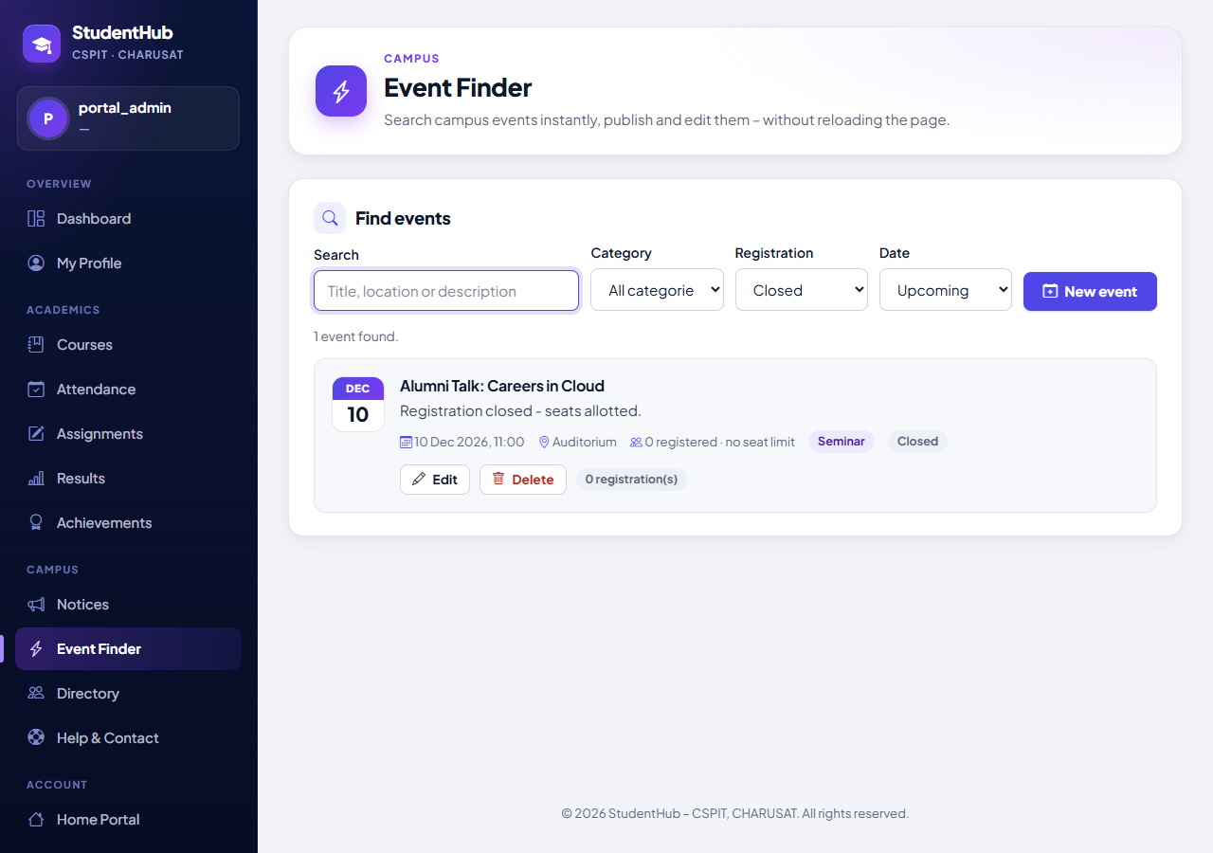
Figure 4: Registration filter "Closed" applied through the API: "1 event found." – Alumni Talk: Careers in Cloud (04-filters.png)
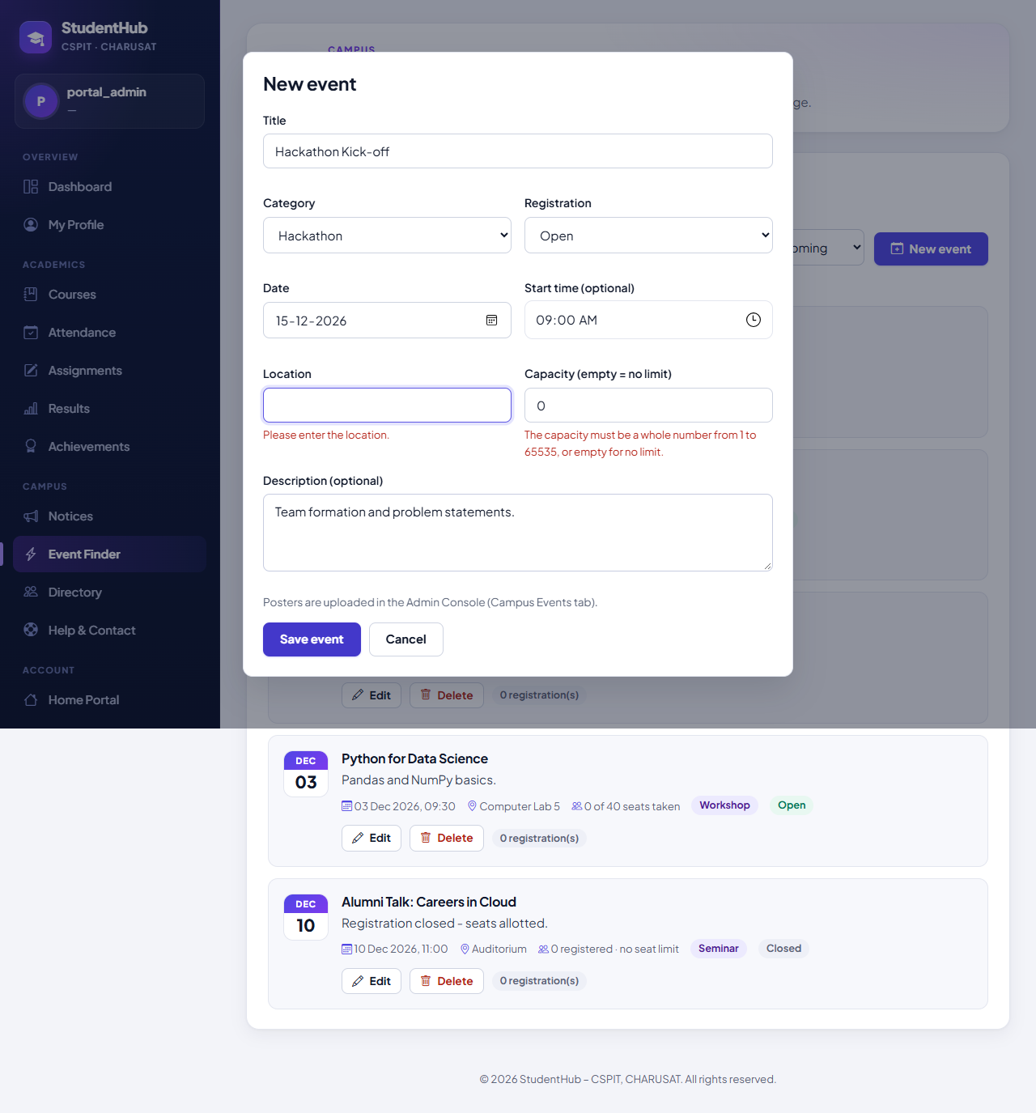
Figure 5: New-event dialog after Save with an empty location and capacity 0: the API answered HTTP 422 and the page shows "Please enter the location." and "The capacity must be a whole number from 1 to 65535, or empty for no limit." under the fields; nothing was stored (06-validation-error.png)
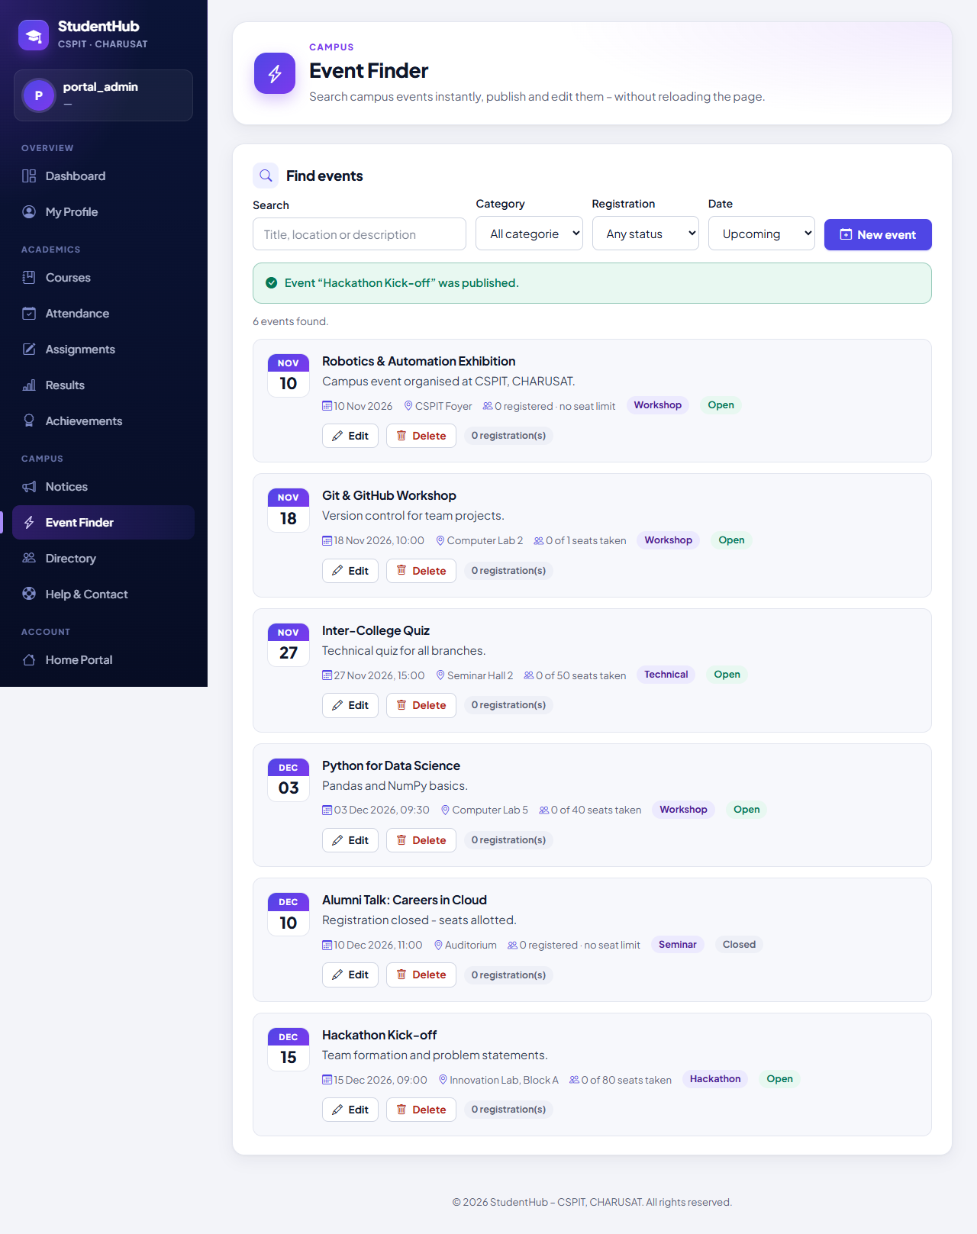
Figure 6: Create via fetch (HTTP 201) without a page reload: "Event “Hackathon Kick-off” was published." – 6 events found; the new event (15 Dec 2026, 09:00, Innovation Lab, Block A, 0 of 80 seats taken) is in the list (07-event-created.png)
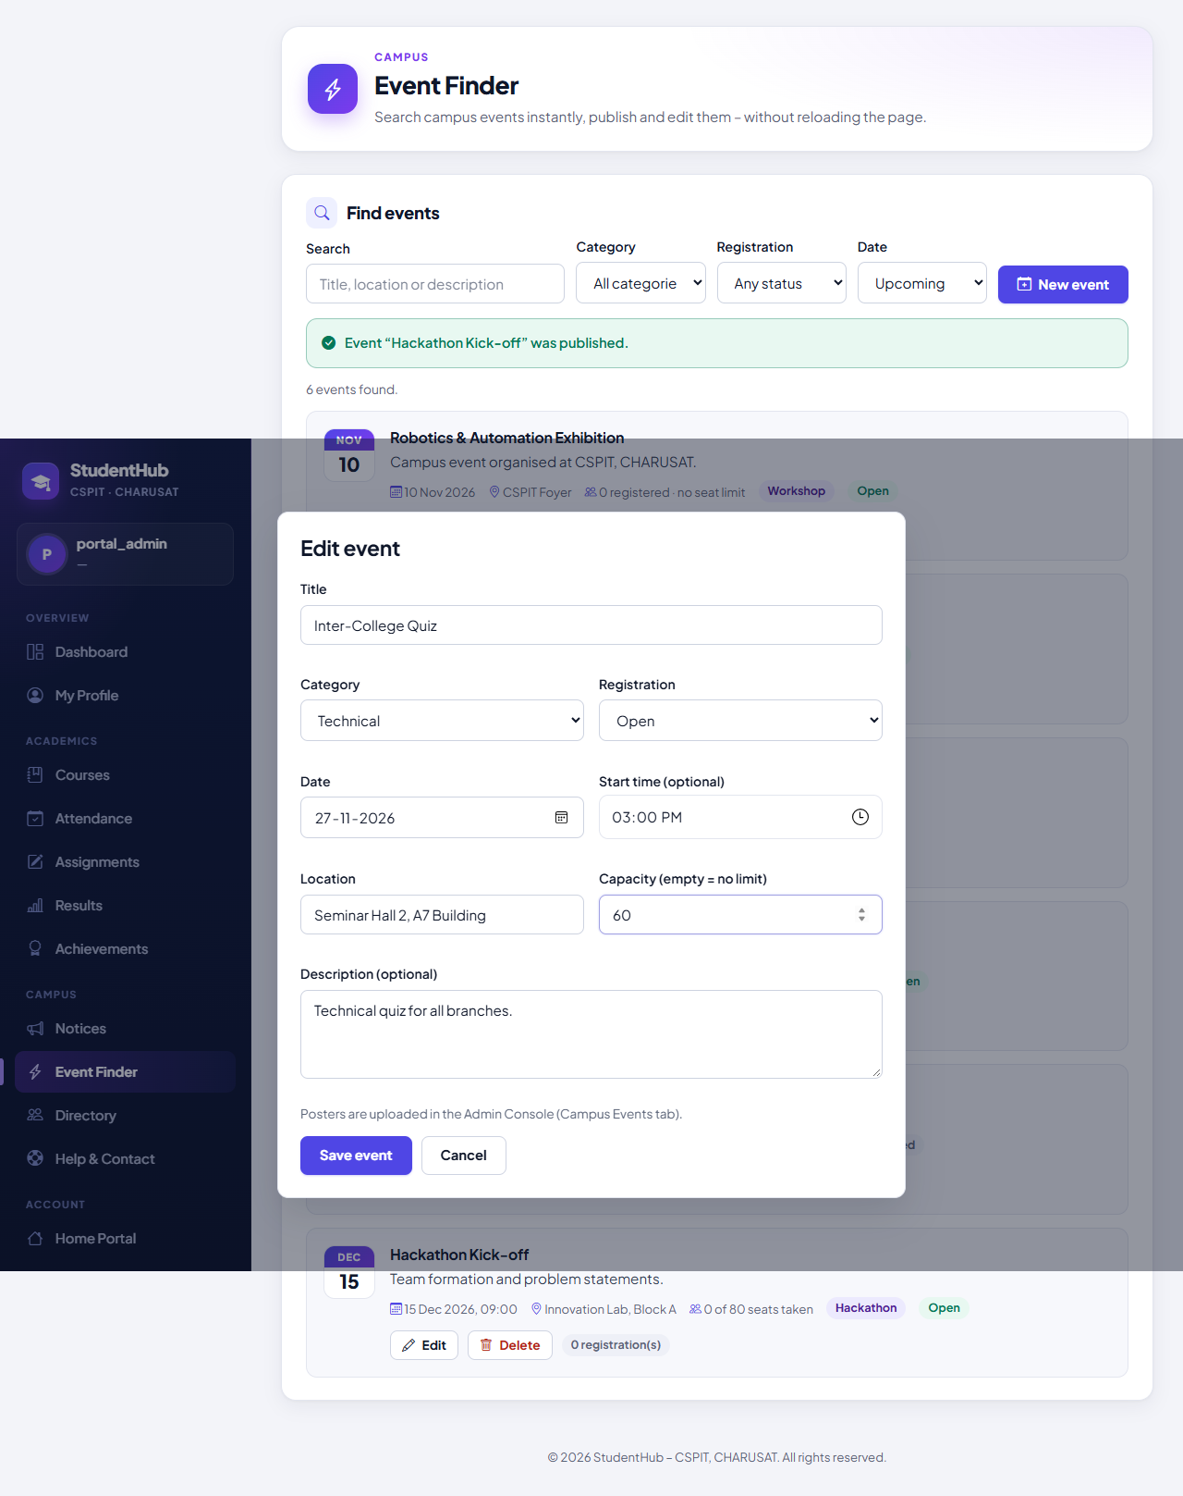
Figure 7: Edit dialog for "Inter-College Quiz" filled from the JSON data: location changed to "Seminar Hall 2, A7 Building" and capacity to 60 before saving (08-edit-event.png)
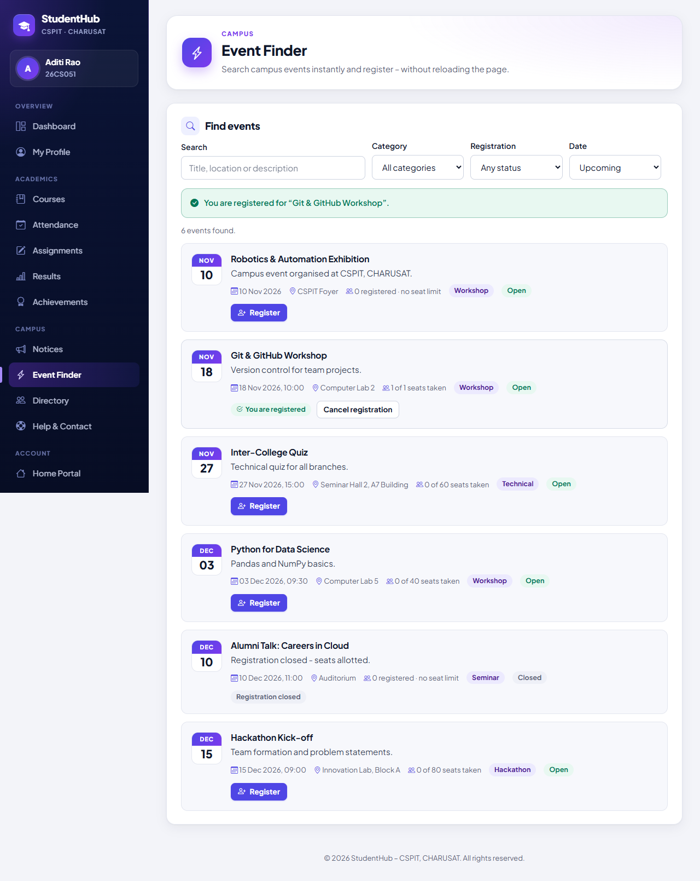
Figure 8: The student Aditi Rao (26CS051) registers via fetch (HTTP 201): "You are registered for “Git & GitHub Workshop”." – the card shows "You are registered", Cancel registration and 1 of 1 seats taken; the updated Inter-College Quiz shows Seminar Hall 2, A7 Building and 0 of 60 seats taken (10-student-registered.png)
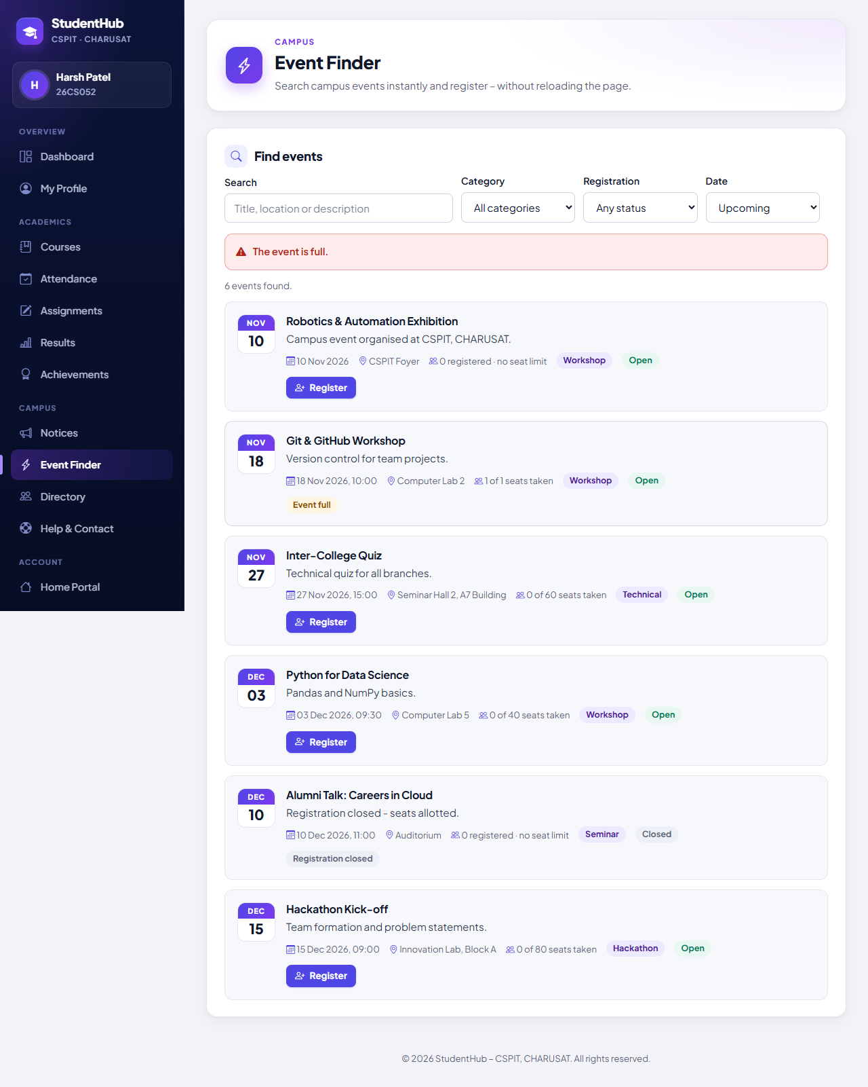
Figure 9: The student Harsh Patel (26CS052) clicks the Register button that was still shown on his page after the last seat had been taken: the API answers 409 and the page shows "The event is full."; the refreshed list now shows "Event full" (1 of 1 seats taken) (11-registration-conflict.png)
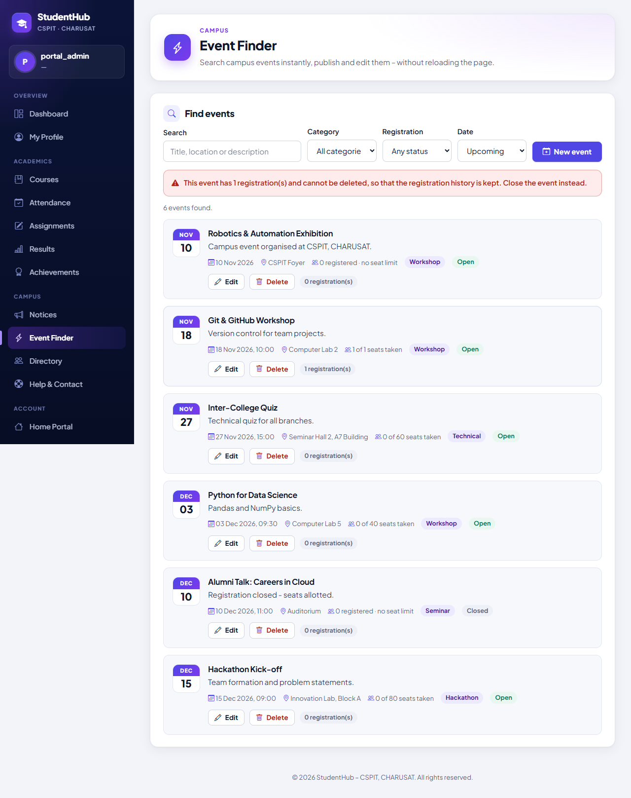
Figure 10: The administrator deletes "Git & GitHub Workshop", which has 1 registration: the API answers 409 – "This event has 1 registration(s) and cannot be deleted, so that the registration history is kept. Close the event instead." – and the event stays in the list (12-delete-conflict.png)
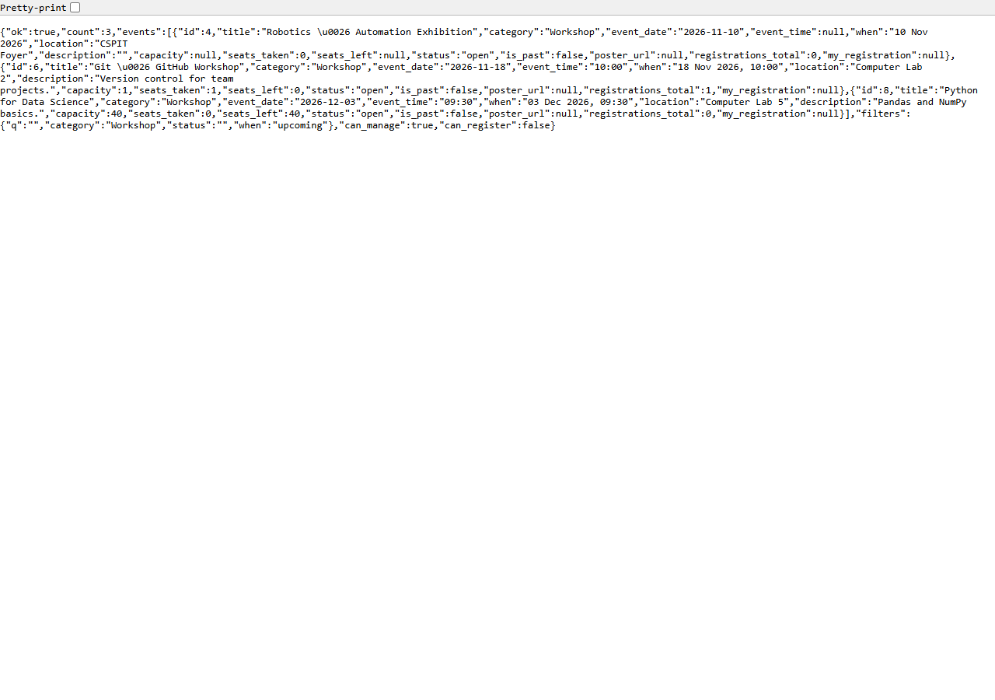
Figure 11: Raw JSON of api/events.php?action=list&when=upcoming&category=Workshop opened in Edge as the administrator: {"ok":true,"count":3,…} with exactly the documented event fields, "&" encoded as \u0026, the active filters and can_manage true / can_register false (13-api-json-response.png)
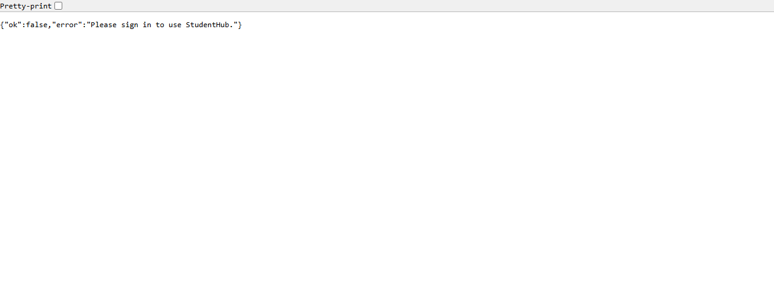
Figure 12: A visitor without a session calling api/events.php?action=list: HTTP 401 with the JSON body {"ok":false,"error":"Please sign in to use StudentHub."} – no redirect to the login page (14-api-unauthorised.png)

10. Testing and Results
All tests were executed on 31 October 2026 on Windows 11 with PHP 8.2.12 (XAMPP), MariaDB 10.4.32 and PHP's built-in server, against disposable databases; a second test server was pointed at a database that does not exist to check the HTTP 503 answer. The numbers are copied from the saved outputs and from TEST_REPORT.md §10.
Suite | Result | Output
tests/test_api.py – HTTP tests of api/events.php and events_live.php | 72 / 72 passed | tests/test_api_output.txt
tests/browser_api.py – Microsoft Edge + screenshots | 16 / 16 passed | tests/browser_api_output.txt
Regression: test_events 94 / 94, test_students 170 / 170, test_auth 132 / 132, test_001 88 / 88 | all passed | outputs in tests/ and database/tests/
Regression in Edge: browser_events 16 / 16, browser_students 16 / 16, browser_inactive_login 13 / 13, browser_auth 14 / 14 | all passed | outputs in tests/

10.1 Checks per area (tests/test_api.py)
Area | Checks | Examples of what is verified
Static checks | 4 | php -l; portal connection and helpers only, no ->query(); textContent only and X-CSRF-Token; 300 ms debounce
Authentication | 2 | not signed in: list and create → 401 JSON, no redirect, nothing stored
GET list / get | 19 | response shape and exact event fields, role flags, filters and combinations, % _ and SQL strings as text, HTML in a title escaped as \u003C, 404 for unknown / malformed IDs
Methods, content type, CSRF, format | 6 | 405 with Allow, 400 unknown action, 403 for a missing / wrong / modified token (logged), 415 for a form-encoded POST, 400 for malformed JSON, an array, a body over 20 kB
Create / update / delete | 13 | create 201 + CREATE_EVENT, eight invalid bodies → 422 with errors, update 200 / 404 / 422
Register / cancel and conflicts | 17 | register 201, duplicate / full / closed / past 409, unknown 404, cancel 200 / 409, unlinked account and admin 403, 6 parallel registrations for 3 seats, delete 409 / 200 / 404
Roles | 3 | students and editors 403 for create / update / delete (ACCESS_DENIED); a deactivated student loses API access (401)
Event Finder page | 5 | student, admin, editor and visitor views of events_live.php; no PHP warnings
Database unavailable / clean-up | 3 | HTTP 503 JSON with a general message only; disposable database removed; live database untouched
Total | 72

The Edge test (16 checks) verified the loading state and its disappearance, the list from the API, the debounced search (one request), the filters, the 422 field messages, create / update / delete via fetch without a page reload, a student registration (201), the 409 for a stale Register button with the list refreshed to Event full, the 409 for deleting an event with a registration, the raw JSON response, the 401 for a visitor, no JavaScript errors other than the intended 401 / 409 / 422 responses and no PHP warnings or API errors (apart from the known 404 for /favicon.ico).

11. Problems Found and Fixed During Integration
- Loading indicator stayed visible (fixed): the browser test found that the page's display: flex rules for .live-loading and .live-message overrode the hidden attribute, so "Loading events…" stayed on screen after the list had loaded. An explicit rule now hides both elements while they carry hidden:
studenthub/assets/css/global.css (lines 458–459) – the fix for the hidden attribute
458 .live-loading { display: flex; align-items: center; gap: 10px; padding: 14px; color: var(--text-muted); }
459 .live-loading[hidden], .live-message[hidden] { display: none; } /* display: flex must not override the hidden attribute */

- Redirect versus JSON: the portal's require_login() redirects to the login page, which fetch() cannot use. The API calls validate_session() itself and answers 401 JSON (section 6.2); with STUDENTHUB_API defined, db.php also answers an unreachable database with HTTP 503 JSON instead of an HTML page.
- Stale buttons: a Register button can be outdated when someone else takes the last seat. The server refuses the request (409) and the page refreshes the list after every register / cancel, so the card shows Event full at once (Figure 9).
- Evidence of the loading state: the real API answers within milliseconds, so the test delayed the answer in its own network layer for screenshot 01; the response itself was not changed.

12. Differences from the Original Standalone Practical and Limitations
Aspect | Original report (Practical-13/) | Integrated portal (studenthub/)
Database | Own studenthub_prac13 with its own events table (title 3–120, description 10–1000, venue, capacity 1–5000) | Portal studenthub_db.events, shared with the Admin Console and the Campus Events page; no schema change
Files | api.php, index.html, script.js, db.php, schema.sql | api/events.php, events_live.php, assets/js/events-live.js, portal db.php
Request protection | JSON body and X-Requested-With: fetch | Portal session, application/json and the session's token in X-CSRF-Token
Access | – | Roles: administrators manage, students register / cancel, editors read; 401 JSON without a session
Validation | Own validate_event() in api.php | The portal's validate_event(), the same rules as the Admin Console
Debounce | 350 ms + AbortController | 300 ms + AbortController
Registration | – | register / cancel with the Practical 12 transaction (409 conflicts)
Delete | Any event | Refused (409) for events with registrations
Network evidence | Edge DevTools Network panel screenshots | Raw JSON opened in Edge (Figures 11–12); the test counts API requests and page navigations. No DevTools screenshots were taken for the integrated version
Tests | 89 / 89 API, 13 / 13 browser | 72 / 72 API, 16 / 16 browser

Limitations (TEST_REPORT §10): posters are uploaded only in the Admin Console (the API handles JSON, not files); the Event Finder lists at most 100 events per request. The page needs JavaScript – without it a <noscript> note points to the Campus Events page, which works without JavaScript.

13. Conclusion
The Event Finder lists, searches, adds, updates and deletes events entirely with the Fetch API: the page never reloads, api/events.php answers every request in JSON with a fitting status code, GET and POST are separated, and all input is validated by the same rules as in the Admin Console before a prepared statement touches the database. Integrated into the portal, the API uses the portal session, roles and CSRF token, lets students register and cancel through the same overbooking-safe transaction, and answers without a session with JSON 401 instead of a redirect. Loading, success, empty and error states keep the user informed, and the debounced search sends one request per pause instead of one per key press. 72 automated API checks and 16 browser checks passed.

14. References
- Project repository: https://github.com/TheEmperor08/StudentHub-ITUE203-25CS023 – studenthub/api/events.php, studenthub/events_live.php, studenthub/assets/js/events-live.js, tests/, evidence/practical-13-integration/, TEST_REPORT.md §10; commit a9d4e22
- MDN – Using the Fetch API: https://developer.mozilla.org/en-US/docs/Web/API/Fetch_API/Using_Fetch
- MDN – AbortController: https://developer.mozilla.org/en-US/docs/Web/API/AbortController
- MDN – The HTML dialog element: https://developer.mozilla.org/en-US/docs/Web/HTML/Element/dialog
- MDN – Node.textContent: https://developer.mozilla.org/en-US/docs/Web/API/Node/textContent
- PHP Manual – json_encode: https://www.php.net/manual/en/function.json-encode.php
- PHP Manual – MySQLi prepared statements: https://www.php.net/manual/en/mysqli.quickstart.prepared-statements.php
- OWASP – REST Security Cheat Sheet: https://cheatsheetseries.owasp.org/cheatsheets/REST_Security_Cheat_Sheet.html

