CHAROTAR UNIVERSITY OF SCIENCE AND TECHNOLOGY (CHARUSAT)
Chandubhai S. Patel Institute of Technology (CSPIT)
Department of Computer Science & Engineering
ITUE203 – Web Development Frameworks

PRACTICAL 14

Admin Dashboard with Role-Based Access, Live Statistics and Audit Logging
PHP 8 · MySQLi prepared statements · MariaDB · Bootstrap 5 · role-based access control · audit log
Report – implemented in the integrated StudentHub portal (studenthub/)
Student Name | Shreyas
Roll Number | 25CS023
Student ID | 25CS023
Email | 25cs023@charusat.edu.in
Course | ITUE203 – Web Development Frameworks
Programme | B.Tech Computer Science & Engineering
Semester / Academic Year | 3 / 2026-27
Date of Submission
Faculty Signature

New report. No Word or PDF report existed for Practical 14: the repository only contained Practical-14/README.md, which describes a standalone dashboard on the user_registration database of Practicals 9 and 10. This report describes Practical 14 as it is implemented in the canonical integrated portal studenthub/ (commit 05927b3, database studenthub_db): the Admin Console overview with live statistics, role-based navigation from the menu_items table, account status (disable / enable), one consistent HTTP 403 page and the filtered audit log. All screenshots were taken from studenthub/ with Microsoft Edge (headless, Playwright) on disposable test databases with fictional records; all test results are copied from the saved test outputs of the repository.

1. Problem Definition and Objectives
Topic (from Practical-14/README.md): Admin Dashboard with Role-Based Access, Statistics & Audit Logging. The practical status table of the root README.md lists it as “Admin dashboard, audit logging, 403”.
The first version was a standalone folder Practical-14/ (Bootstrap 5 + PHP/MySQLi on the user_registration database; compared with the integrated version in Section 3). Its navigation hub was not filtered by role, its schema.sql inserted six sample audit rows (four of their actions are never written by the code) and re-importing it erased the recorded audit log; no screenshots or report were made for it.
The task of the integration was to give the one portal studenthub/ – which already had the logins, student records and events of Practicals 8–13 – a real administrator dashboard on its own database. Objectives:
- Show live statistics of studenthub_db, counted on every page load: students (active / inactive), events (upcoming / open), registrations (active / cancelled / attended), accounts (per role and disabled) and the audit log (entries and security blocks in the last 7 days).
- Show the latest event registrations (student and event), the newest accounts and the most recent activity.
- Build the navigation from menu_items with a role hierarchy student < editor < admin, so that an editor never sees an administrator link; hide links to pages that do not exist and escape every value read from the database.
- Give every request by a signed-in student or editor to any Admin Console tab or action the same HTTP 403 page and an audit entry.
- Let administrators disable and enable accounts: a disabled account cannot sign in and loses its open sessions; the own account and the last active administrator are protected.
- Offer the audit log with filters by action, status and user.
- Record automated HTTP and browser tests and genuine Microsoft Edge screenshots.

2. Tools and Technologies
Tool / technology | Use in this practical
PHP 8.2.12 (XAMPP), MySQLi | Admin Console, statistics, account status and audit queries – every query with user input is a prepared statement; mysqli runs in exception mode
MariaDB 10.4.32 | The portal database studenthub_db; migration 004 adds users.status, the role check chk_users_role and the roles of menu_items
Bootstrap 5.3.2 and Bootstrap Icons 1.11.1 (CDN) + assets/css/bootstrap-theme.css | Layout of the Admin Console (cards, tabs, tables, badges)
Python 3 test scripts | tests/test_dashboard.py (HTTP against PHP's built-in server on Windows 11), database/tests/test_004_admin_dashboard.py (migration)
Playwright + Microsoft Edge (headless) | tests/browser_dashboard.py – browser checks and the screenshots

3. Source Files
File | Role in Practical 14
studenthub/admin_dashboard.php | Admin Console: five statistics cards, navigation box for the role, tabs Overview, Student Records, Campus Events, User Accounts, Inquiries, Security Audit Trail; POST handlers for disable / enable / delete of accounts
studenthub/includes/dashboard.php | dashboard_stats(), latest_registrations(), newest_accounts(), active_admin_count(), find_account(), set_account_status(), audit_actions(), audit_filters(), audit_list()
studenthub/includes/navigation.php | ROLE_RANK, portal_page_exists(), menu_for_role()
studenthub/sidebar.php | Grouped sidebar of every portal page; adds a Shortcuts group from the menu_items rows of the user's role that the fixed groups do not contain
studenthub/includes/auth.php | STUDENTHUB_PERMISSIONS, require_permission(), account_block_reason(), refresh_user_from_database(), validate_session()
studenthub/login.php | Refuses a disabled account after the password check (LOGIN_DENIED)
studenthub/403.php | The one shared “Access Denied” page (HTTP 403)
studenthub/audit_logger.php | log_audit() – prepared INSERT into audit_logs
database/migrations/004_admin_dashboard.sql / .down.sql | Migration 004 and its rollback
database/tests/test_004_admin_dashboard.py | Tests of migration 004 + read-only live check

The standalone Practical-14/ folder is kept unchanged as historical evidence. The table compares it with the integrated version:
Aspect | Standalone Practical-14/ (README) | Integrated studenthub/
Database | user_registration (shared with Practicals 9 and 10) | studenthub_db, the one database of the portal
Statistics | Row counts of users, students, events, audit_logs | Five counters with breakdowns, counted on every page load
Recent data | Five most recent accounts | Latest event registrations, newest accounts, recent activity
Navigation | Every menu_items row shown to the admin | Rows up to the own role; missing pages hidden; values escaped; sidebar Shortcuts
Access control | Only role = admin may open dashboard.php | Permission checked for the console and for every action; same 403 page and ACCESS_DENIED entry
Account status | – | users.status active / disabled; own account and last active admin protected
Audit log | Six newest rows, plus sample rows from schema.sql | Newest 100 matching entries with action / status / user filters; only real entries

4. Database
Practical 14 uses the existing tables of studenthub_db and changes them only through migration 004 (database/migrations/004_admin_dashboard.sql). Its preconditions (migration 003 recorded, every account has the role admin, editor or student) run first, so nothing is altered if one fails. It then converts the menu role user (not a portal role) to student, points links to old standalone pages or missing anchors at the integrated pages, adds users.status (every existing account stays active) and the role check, verifies the result and records the row 004 in schema_migrations. The row linking to the non-existent faculty.php is kept – the portal hides links to missing pages. The script is idempotent; the rollback removes users.status and the check and maps student back to user.
database/migrations/004_admin_dashboard.sql (lines 40–55) – the schema changes of migration 004
40 -- 1. menu_items.min_role: 'user' -> 'student' (widen, convert, narrow)
41 ALTER TABLE menu_items MODIFY min_role ENUM('user', 'student', 'editor', 'admin') NOT NULL DEFAULT 'student';
42 UPDATE menu_items SET min_role = 'student' WHERE min_role = 'user';
43 ALTER TABLE menu_items MODIFY min_role ENUM('student', 'editor', 'admin') NOT NULL DEFAULT 'student';
44
45 -- 2. links to old standalone pages or missing anchors -> the integrated pages
46 UPDATE menu_items SET link = 'profile.php' WHERE link = 'student_dashboard.php' AND title LIKE 'My Profile%';
47 UPDATE menu_items SET link = 'dashboard.php' WHERE link = 'student_dashboard.php' AND title = 'Student Dashboard';
48 UPDATE menu_items SET link = 'notifications.php' WHERE link = 'student_dashboard.php#events';
49 UPDATE menu_items SET link = 'attendance.php' WHERE link = 'student_dashboard.php#attendance';
50 UPDATE menu_items SET link = 'events_live.php', title = 'Event Finder (Fetch API)', min_role = 'student', icon = 'bi-lightning-charge'
51 WHERE link = '../Practical-13/index.html';
52
53 -- 3. account status and a role check
54 ALTER TABLE users ADD COLUMN IF NOT EXISTS status ENUM('active', 'disabled') NOT NULL DEFAULT 'active' AFTER role;
55 ALTER TABLE users ADD CONSTRAINT IF NOT EXISTS chk_users_role CHECK (role IN ('admin', 'editor', 'student'));

The counters read students (status, user_id), events (event_date, status), registrations (status), users (role, status) and audit_logs (status, created_at). The relationships are unchanged from migration 001: one account is linked to at most one student record (students.user_id, ON DELETE SET NULL); students and events have many registrations (ON DELETE CASCADE); audit entries point at their account (ON DELETE SET NULL, so deleting an account keeps its entries and username). The menu rows of a new installation (database/studenthub_demo.sql) are:
id | title | link | min_role | Seen by
1 | Student Dashboard | dashboard.php | student | all roles
2 | My Profile | profile.php | student | all roles
3 | Campus Events | notifications.php | student | all roles
5 | Attendance | attendance.php | editor | editor, admin
6 | Admin Management Console | admin_dashboard.php | admin | admin
7 | Student Management (CRUD) | admin_dashboard.php?tab=students | admin | admin
8 | Campus Event Manager | admin_dashboard.php?tab=events | admin | admin
9 | Event Finder (Fetch API) | events_live.php | student | all roles
10 | Security Audit Logs | admin_dashboard.php?tab=audits | admin | admin

Rows 1, 2, 3, 5 and 9 point at pages that the fixed sidebar groups already contain, so only an administrator gets a Shortcuts group (rows 6, 7, 8 and 10). The demo data has no faculty.php row (id 4); the live database keeps it and the portal does not show it.

4.1 Running the application
Create studenthub_db from database/studenthub_demo.sql (it already contains migrations 001–005; an existing database receives the missing migrations in order after a mysqldump backup), create the first administrator with php tools\create_demo_user.php --db=studenthub_db --username=admin01 --email=admin01@example.com --role=admin (the password is prompted; --role=editor / --role=student for further accounts) and run php -S localhost:8000 -t studenthub. An administrator lands on the Admin Console after signing in; students and editors land on the dashboard.

5. Implementation

5.1 Live statistics and latest data
dashboard_stats() counts everything with one aggregate query per table group; conditional SUM() expressions give the breakdowns, and COALESCE turns the sum of an empty table into 0. The Admin Console calls it on every page load, so the cards always show the current state of the database. Each card links to the matching tab.
studenthub/includes/dashboard.php (lines 9–22) – the five counters
9 function dashboard_stats(mysqli $db): array
10 {
11 $one = fn (string $sql): array => $db->query($sql)->fetch_assoc();
12 $students = $one("SELECT COUNT(*) AS total, COALESCE(SUM(TRIM(status) = 'Inactive'), 0) AS inactive, COALESCE(SUM(user_id IS NOT NULL), 0) AS linked FROM students");
13 $events = $one("SELECT COUNT(*) AS total, COALESCE(SUM(event_date >= CURDATE()), 0) AS upcoming,
14 COALESCE(SUM(event_date >= CURDATE() AND status = 'open'), 0) AS open_upcoming FROM events");
15 $registrations = $one("SELECT COUNT(*) AS total, COALESCE(SUM(status = 'registered'), 0) AS registered, COALESCE(SUM(status = 'attended'), 0) AS attended,
16 COALESCE(SUM(status = 'cancelled'), 0) AS cancelled FROM registrations");
17 $users = $one("SELECT COUNT(*) AS total, COALESCE(SUM(role = 'admin'), 0) AS admins, COALESCE(SUM(role = 'editor'), 0) AS editors,
18 COALESCE(SUM(role = 'student'), 0) AS students, COALESCE(SUM(status = 'disabled'), 0) AS disabled FROM users");
19 $audit = $one("SELECT COUNT(*) AS total, COALESCE(SUM(status = 'SECURITY_BLOCK' AND created_at >= NOW() - INTERVAL 7 DAY), 0) AS blocked_week FROM audit_logs");
20 $int = fn (array $row): array => array_map('intval', $row);
21 return ['students' => $int($students) + ['active' => (int) $students['total'] - (int) $students['inactive']], 'events' => $int($events),
22 'registrations' => $int($registrations), 'users' => $int($users), 'audit' => $int($audit)];

latest_registrations() joins registrations, students and events (newest first, LIMIT ? bound as an integer), newest_accounts() lists the five latest accounts with role and status, and the Recent system activity table is audit_list() without filters, limited to six rows. The Overview tab also shows the applied migrations (schema_migrations) and how many student records are linked to an account.

5.2 Role-based navigation
Every menu_items row has a minimum role. menu_for_role() compares the rank of the user's role with the rank of the row and keeps the row only if portal_page_exists() confirms that the link is a page of this portal (a plain name.php, optionally with ?query or #part, that exists as a file). Links such as faculty.php or ../Practical-13/index.html can therefore never appear.
studenthub/includes/navigation.php (lines 7–26) – role hierarchy and menu filter
7 const ROLE_RANK = ['student' => 1, 'editor' => 2, 'admin' => 3];
8
9 // True if the link points to an existing page of this portal ("page.php", "page.php?tab=x", "page.php#part")
10 function portal_page_exists(string $link): bool
11 {
12 $page = preg_split('/[?#]/', $link, 2)[0];
13 return preg_match('/^[A-Za-z0-9_\-]+\.php$/', $page) === 1 && is_file(dirname(__DIR__) . DIRECTORY_SEPARATOR . $page);
14 }
15
16 // The menu rows this role may see, in table order: [['title', 'link', 'icon', 'min_role'], ...]
17 function menu_for_role(mysqli $db, string $role): array
18 {
19 $rank = ROLE_RANK[$role] ?? 0;
20 $items = [];
21 foreach ($db->query('SELECT title, link, icon, min_role FROM menu_items ORDER BY id')->fetch_all(MYSQLI_ASSOC) as $item) {
22 if ($rank >= (ROLE_RANK[$item['min_role']] ?? PHP_INT_MAX) && portal_page_exists($item['link'])) {
23 $items[] = $item;
24 }
25 }
26 return $items;

sidebar.php (lines 32–47) calls menu_for_role() for the signed-in role, keeps the rows whose link is not already in its fixed groups and inserts them as a Shortcuts group after Campus; every value is printed with the escaping helper e() (htmlspecialchars with ENT_QUOTES). The console's navigation box lists the same rows. The links are only a convenience: every page behind them checks the permission again on the server.

5.3 One consistent access check and 403 page
Permissions are listed explicitly per role. The Admin Console starts with require_permission("admin.console"), and each action asks for its own permission again (students.manage, events.manage, users.manage, inquiries.manage). An editor holds only portal.view, so an editor is treated exactly like a student here.
studenthub/includes/auth.php (lines 20–28) – permissions per role
20 const STUDENTHUB_PERMISSIONS = [
21 'portal.view' => ['admin', 'editor', 'student'], // dashboard, profile, academic and campus pages
22 'admin.console' => ['admin'], // Admin Console (admin_dashboard.php)
23 'students.manage' => ['admin'],
24 'events.manage' => ['admin'],
25 'users.manage' => ['admin'],
26 'audit.view' => ['admin'],
27 'inquiries.manage' => ['admin'], // stored Help & Contact inquiries (Practical 7)
28 ];

studenthub/includes/auth.php (lines 272–282) – audit entry and the shared 403 page
272 function require_permission(string $permission): array
273 {
274 $user = require_login();
275 if (!role_can($user['role'], $permission)) {
276 global $conn;
277 log_audit($conn, $user['id'], $user['username'], 'ACCESS_DENIED',
278 "Role '{$user['role']}' lacks permission '$permission' for " . basename($_SERVER['SCRIPT_NAME'] ?? ''), 'SECURITY_BLOCK');
279 include dirname(__DIR__) . '/403.php';
280 exit;
281 }
282 return $user;

require_permission() first runs require_login() (signed in, not idle longer than the timeout, account re-read from the database). A missing permission writes ACCESS_DENIED with the status SECURITY_BLOCK and the reason (“Role 'editor' lacks permission 'admin.console' for admin_dashboard.php”), then includes 403.php, which sends HTTP 403 and shows the signed-in user, the role and the notice that the attempt was recorded.

5.4 Account status: disable and enable
The User Accounts tab shows every account with role, status, last login and registration time. For every account except the administrator's own (marked Current session) it offers Disable / Enable and Delete as POST forms with the CSRF token; the console checks the token for every POST before any action runs (require_valid_csrf()).
studenthub/includes/dashboard.php (lines 61–81) – rules for disabling an account
61 function set_account_status(mysqli $db, int $id, string $status, int $current_user_id): ?string
62 {
63 $account = find_account($db, $id);
64 if ($account === null) {
65 return 'That account was not found.';
66 }
67 if ($status === 'disabled') {
68 if ($id === $current_user_id) {
69 return 'You cannot disable your own account.';
70 }
71 if ($account['role'] === 'admin' && $account['status'] === 'active' && active_admin_count($db) <= 1) {
72 return 'The last active administrator cannot be disabled.';
73 }
74 }
75 if ($account['status'] === $status) {
76 return "The account “{$account['username']}” is already $status.";
77 }
78 $stmt = $db->prepare('UPDATE users SET status = ? WHERE id = ?');
79 $stmt->bind_param('si', $status, $id);
80 $stmt->execute();
81 return null;

The POST handler in admin_dashboard.php (lines 180–212) requires users.manage, calls set_account_status(), writes USER_DISABLED or USER_ENABLED with the account's id, name and role, and redirects to the User Accounts tab with a message (“Account “neha_editor” was disabled. It can no longer sign in and its open sessions end.”). Deleting applies the same protections and writes DELETE_USER.
The status takes effect everywhere because the portal re-reads the account on every request. account_block_reason() returns a reason for a disabled account (any role) or for a student account whose linked record is inactive (Practical 11):
studenthub/includes/auth.php (lines 195–200) – why an account may not sign in or keep a session
195 function account_block_reason(array $row): ?string
196 {
197 if (($row['account_status'] ?? 'active') === 'disabled') {
198 return 'the account is disabled';
199 }
200 return account_is_deactivated((string) $row['role'], $row['student_status'] ?? null) ? 'the linked student record is inactive' : null;

- Open session: validate_session() calls refresh_user_from_database(); for a blocked account it writes SESSION_REVOKED (“Session ended: the account is disabled.”), deletes the session data, issues a new empty session ID and redirects to login.php?status=access_disabled.
- New sign-in: login.php checks the status only after password_verify() succeeded. A disabled account gets HTTP 403, no session, a LOGIN_DENIED entry and the generic message “Your access to StudentHub is currently disabled. Please contact the administrator.”; a wrong password still gets the normal “Invalid username/email or password.”, so the status is never revealed to someone without the password.
- Protection: an administrator cannot disable or delete the own account; the last active administrator cannot be disabled or deleted (a defence in depth – see Section 10).

5.5 Audit log and filters
audit_filters() reads its own query parameters (audit_action, audit_status, audit_user). Action and status are accepted only if they are in the list of existing actions or in AUDIT_STATUSES; anything else is ignored. The user filter is at most 50 characters and is bound into a LIKE with % and _ escaped, so SQL or wildcards in it are plain text. audit_list() builds the WHERE clause only from these three values, binds them as parameters and returns the newest 100 matching entries (ORDER BY id DESC LIMIT ?).
studenthub/includes/dashboard.php (lines 91–100) – whitelisted audit filters
91 function audit_filters(array $query, array $actions): array
92 {
93 $text = fn (string $key): string => is_string($query[$key] ?? null) && mb_check_encoding($query[$key], 'UTF-8') ? trim($query[$key]) : '';
94 $action = $text('audit_action');
95 $status = $text('audit_status');
96 return [
97 'action' => in_array($action, $actions, true) ? $action : '',
98 'status' => in_array($status, AUDIT_STATUSES, true) ? $status : '',
99 'user' => mb_substr($text('audit_user'), 0, 50),
100 ];

Security-relevant entries written by the portal code (status in brackets):
Action | Written when | Status | Source
USER_LOGIN | successful sign-in | SUCCESS | login.php
LOGIN_FAILED | wrong password or unknown account | FAILED | login.php
LOGIN_DENIED | correct password, but the account is disabled or the student record inactive | SECURITY_BLOCK | login.php
SESSION_REVOKED | open session of a blocked account ends | SECURITY_BLOCK | includes/auth.php
SESSION_TIMEOUT | session ended after inactivity | INFO | includes/auth.php
ACCESS_DENIED | missing permission (HTTP 403) | SECURITY_BLOCK | includes/auth.php
CSRF_REJECTED | POST without a valid token | SECURITY_BLOCK | includes/auth.php, logout.php, api/events.php
USER_DISABLED / USER_ENABLED | account status changed | SUCCESS | admin_dashboard.php
DELETE_USER | account deleted (username and role in the details) | SUCCESS | admin_dashboard.php
USER_LOGOUT | sign-out by POST | SUCCESS | logout.php

Other entries record student, event, inquiry and export actions of the other practicals (for example CREATE_STUDENT, UPLOAD_REJECTED, EVENT_REGISTER, EXPORT_CSV). The portal has no function to edit or delete audit entries; deleting an account only clears the link (user_id becomes NULL) and keeps the username.

6. Validation and Security
- Server-side authorisation: the console, every tab and every POST action check a permission on the server; hiding a link is never the only protection. CSRF: account actions are POST forms with the session token; a GET request with action=disable_user and a POST without a token change nothing (tested).
- Prepared statements and escaping: every query with user input binds its parameters and filter values are whitelisted or bound as text; names, e-mail addresses, menu values and audit details are printed with htmlspecialchars() / e(), the statistics are cast to integers.
- Sessions and database rules: a disabled account loses its session at the next request and sees only one generic message after a correct password; chk_users_role refuses an invalid role and the ENUM of users.status refuses (or does not store) an invalid status – both tested in the migration suite.
- Audit trail: denied access, refused sign-ins, revoked sessions, CSRF rejections and account changes are recorded with user, IP address, user agent and status.

7. Output Screenshots
Taken by tests/browser_dashboard.py in Microsoft Edge (1280 px wide, full page) on a disposable database with fictional accounts (portal_admin, neha_editor, riya_shah, kunal_desai). The screenshots were made when migration 004 was the latest one, so the console does not yet show the Inquiries tab added later with migration 005.
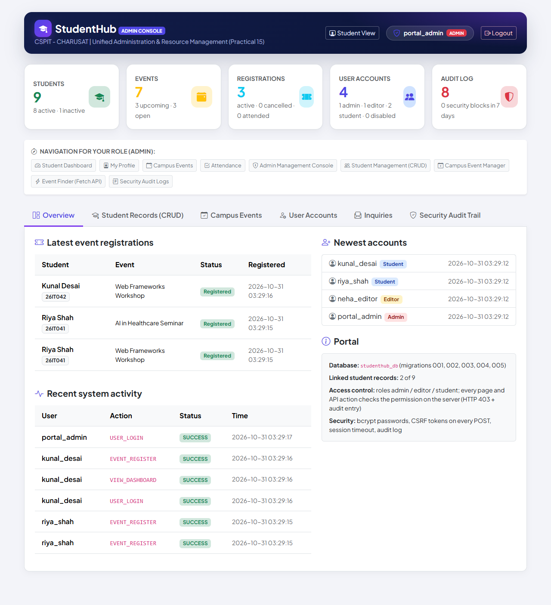
Figure 1: Admin Console overview: five live counters, navigation for the admin role, latest event registrations, newest accounts and recent activity (01-admin-dashboard.png)
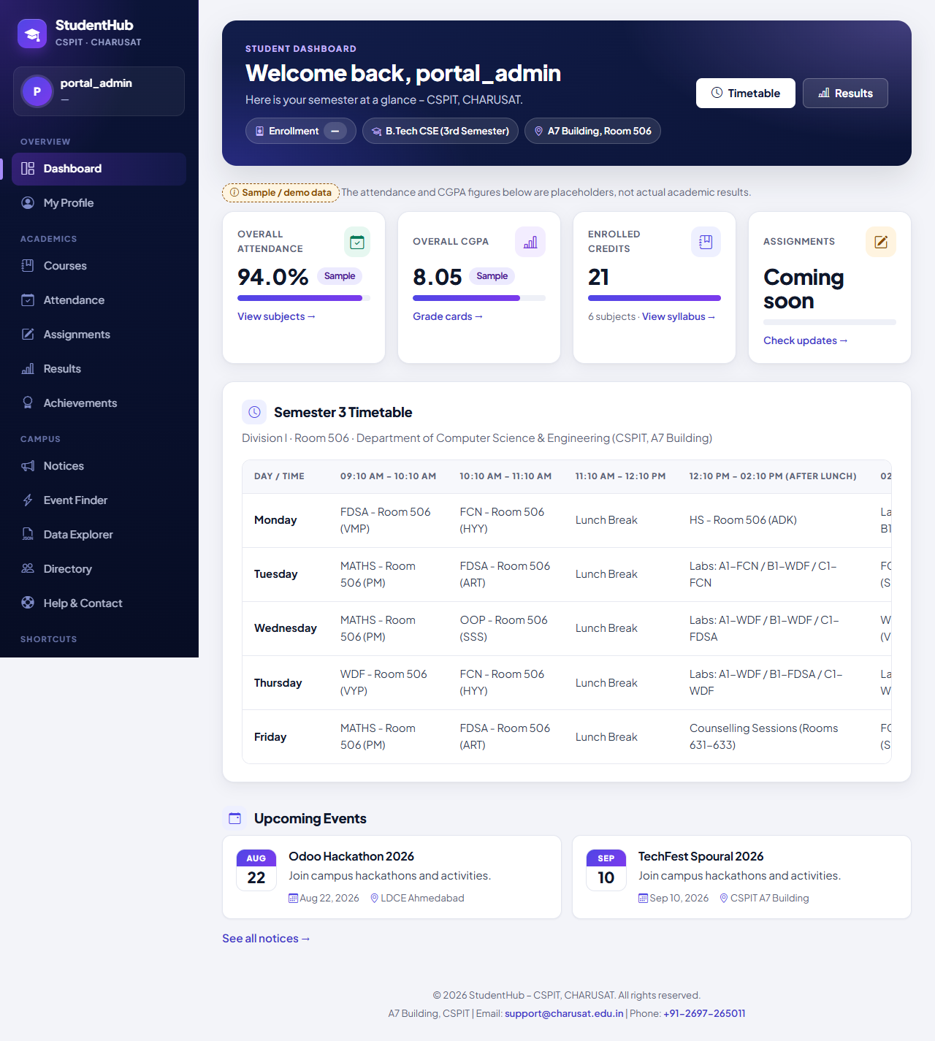
Figure 2: Administrator's sidebar with the Shortcuts group taken from menu_items (Admin Management Console) (02-admin-navigation.png)
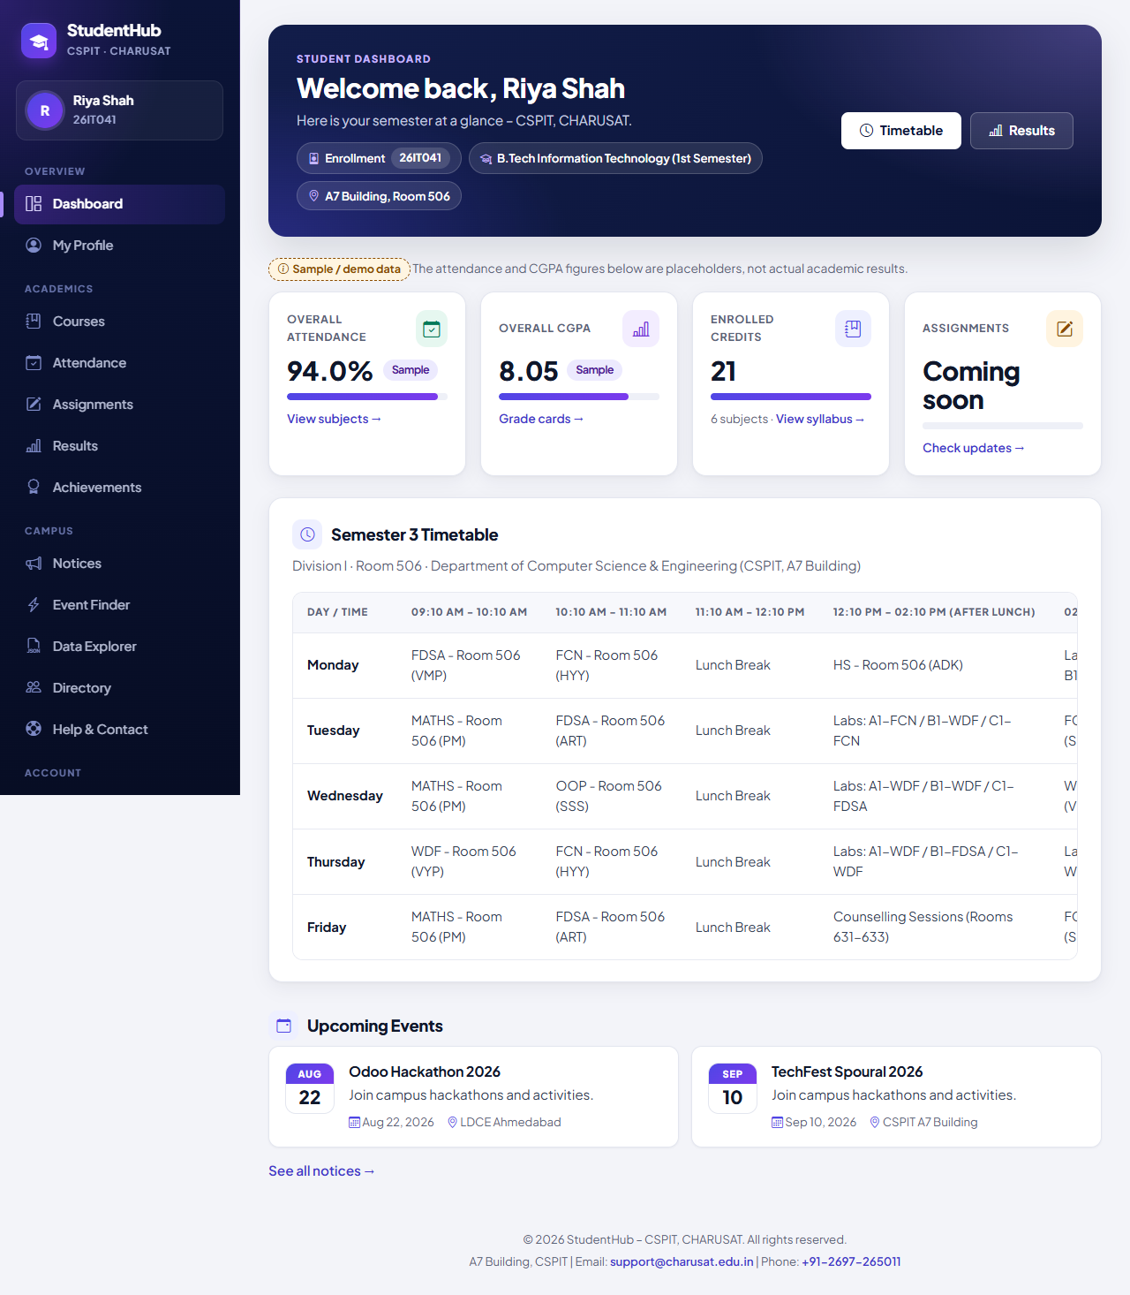
Figure 3: Student's sidebar: the same fixed groups, no Shortcuts and no administrator link (03-student-navigation.png)
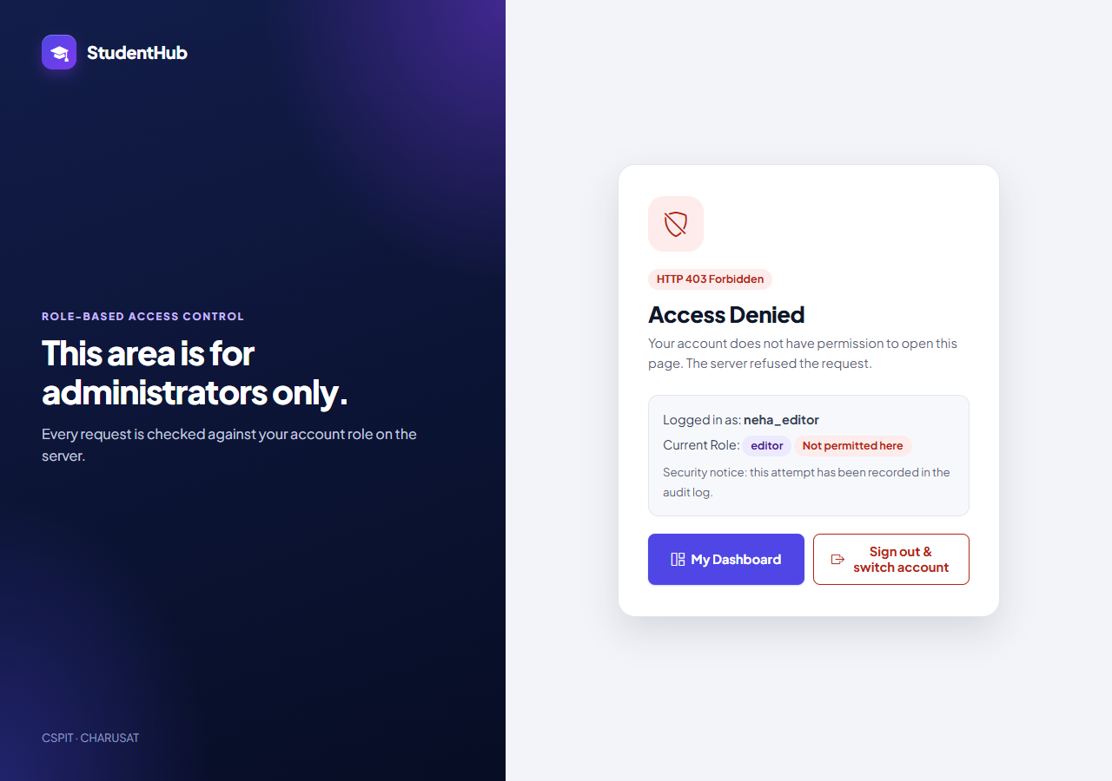
Figure 4: Editor opening the Admin Console: the shared HTTP 403 “Access Denied” page with user and role (04-editor-access-denied.png)
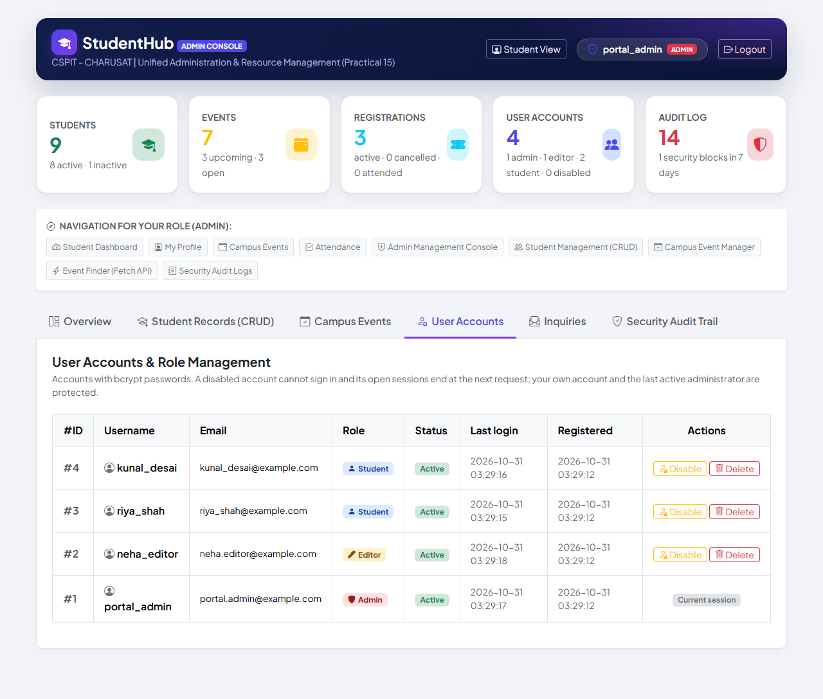
Figure 5: User Accounts tab: role and status badges; Disable and Delete for other accounts, “Current session” for the own one (05-user-accounts.png)
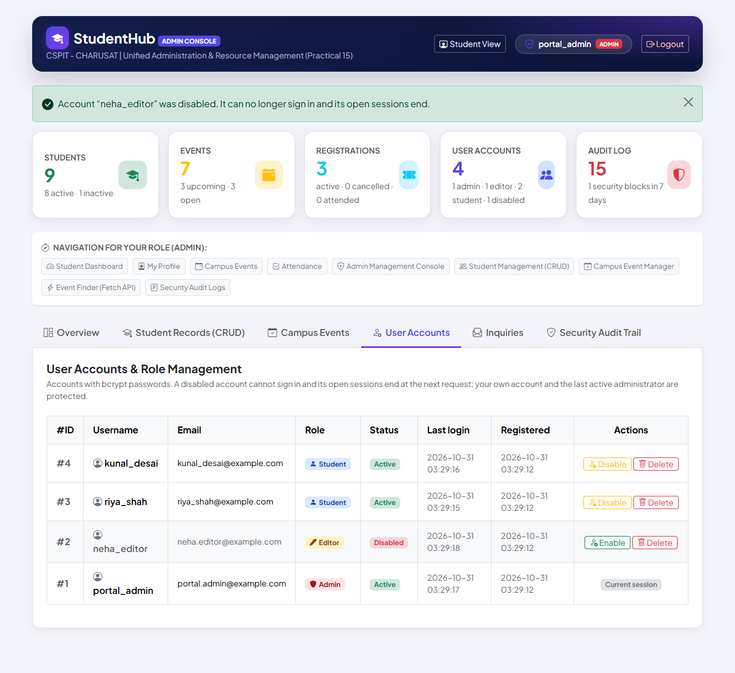
Figure 6: The editor account disabled: confirmation message, status Disabled, counter “1 disabled”, Enable button (06-account-disabled.png)
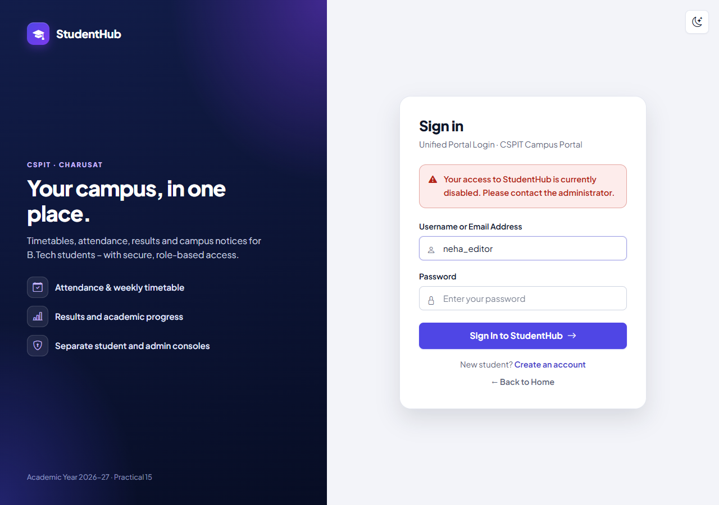
Figure 7: The disabled editor signing in with the correct password: generic refusal message (07-disabled-login-denied.png)
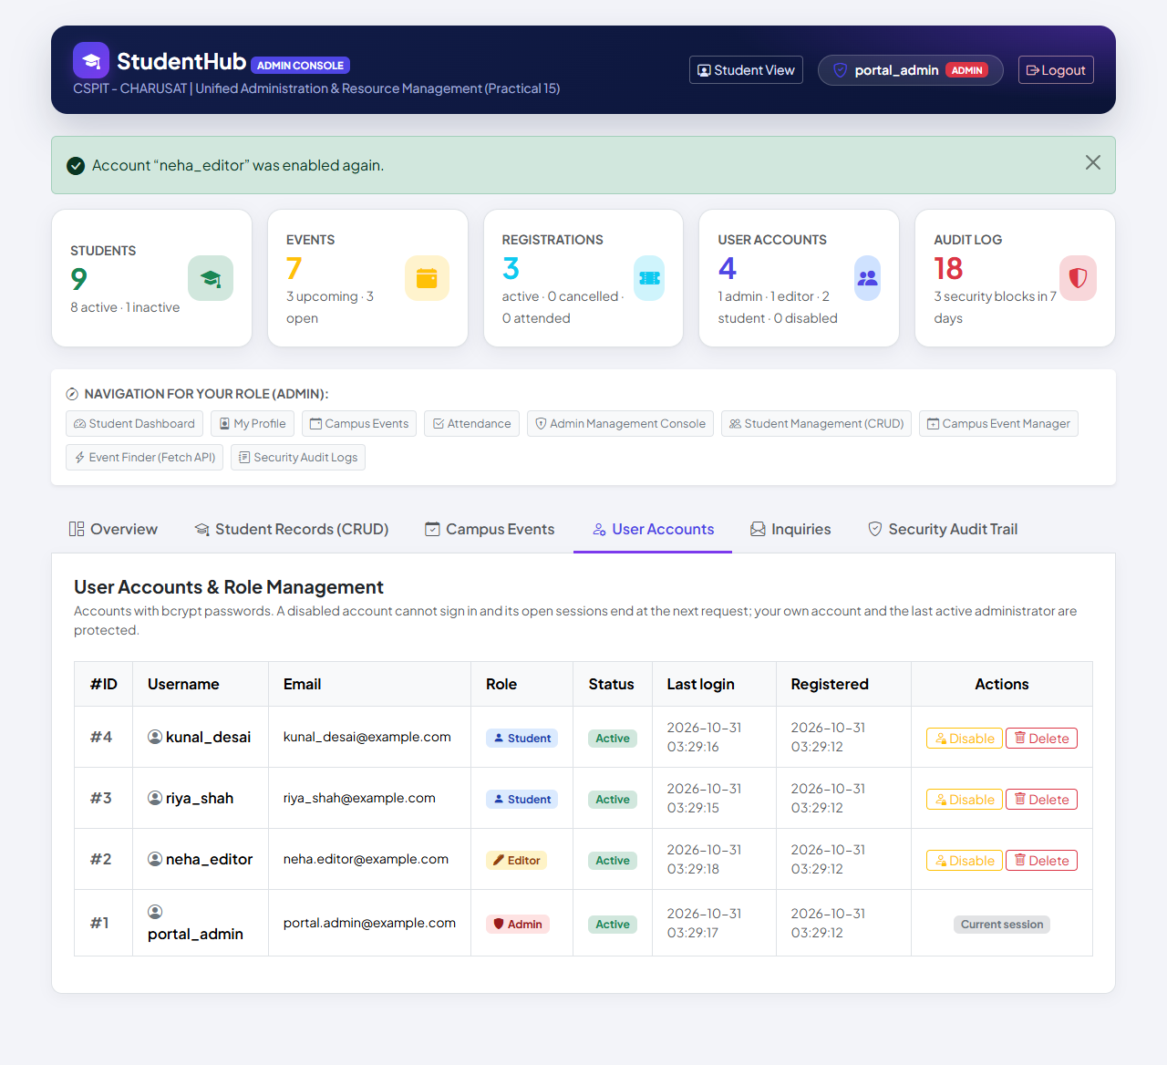
Figure 8: The account enabled again: status Active, counter back to “0 disabled” (08-account-enabled.png)
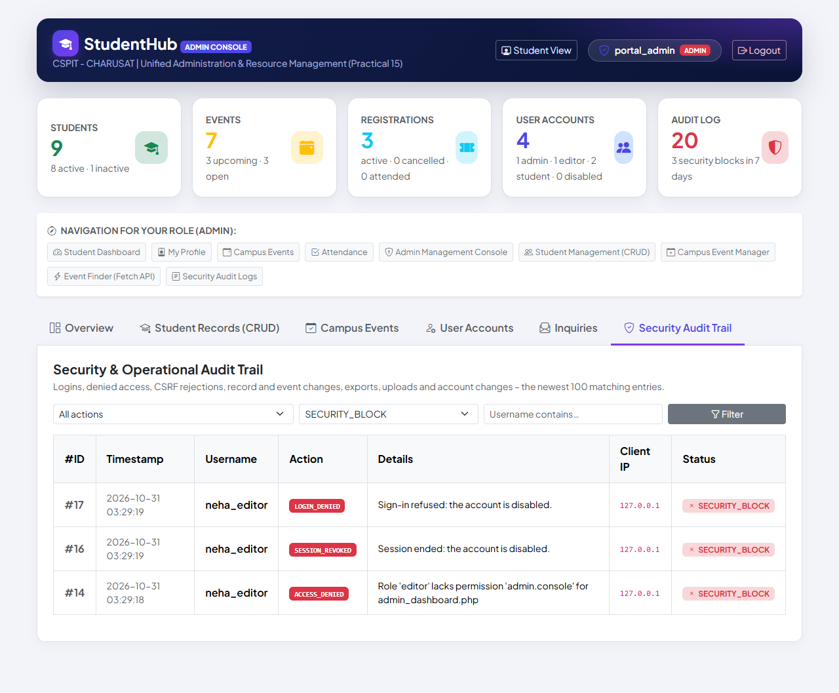
Figure 9: Audit log filtered to SECURITY_BLOCK: LOGIN_DENIED (#17), SESSION_REVOKED (#16) and ACCESS_DENIED (#14) with their details (09-audit-log-security.png)
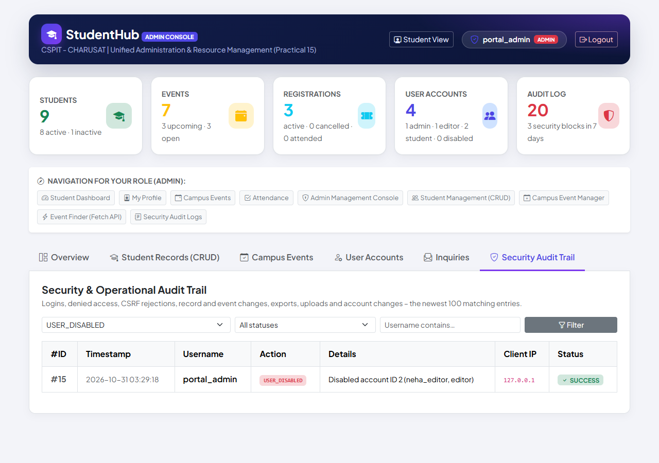
Figure 10: Audit log filtered to the action USER_DISABLED: the account change with the administrator's name (10-audit-log-account-change.png)

8. Test Cases and Results
Executed on 31 October 2026 with PHP 8.2.12 (XAMPP), MariaDB 10.4.32 and Windows 11; browser tests in Microsoft Edge (headless, Playwright). Every write test used a disposable database (the HTTP suite builds it from database/studenthub_demo.sql); the live studenthub_db received migration 004 only after a fresh verified backup, and its accounts (including password hashes), students, events, registrations and categories were verified unchanged.
Suite | Result | Output file
tests/test_dashboard.py – HTTP tests | 36 / 36 passed | tests/test_dashboard_output.txt
tests/browser_dashboard.py – Microsoft Edge + screenshots | 15 / 15 passed | tests/browser_dashboard_output.txt
database/tests/test_004_admin_dashboard.py – fixture / real dump | 18 / 18 and 18 / 18 passed | database/tests/test_004_output.txt
test_004_admin_dashboard.py --verify-live – live database (read-only) | 5 / 5 passed | database/tests/test_004_verify_live_output.txt
Live checks of migrations 001–003 after 004 | 24 / 24, 4 / 4, 5 / 5 | database/tests/*_verify_live_output.txt

tests/test_dashboard.py – 36 checks by group:
Group | Checks | What is verified (expected result = actual result in every case)
Live statistics | 5 | Five counters equal the database; accounts split by role with disabled ones counted; newest 3 registrations (student + event, newest first); five newest accounts; recent activity (up to 6)
Role-based navigation | 6 | Student and editor sidebars have no admin links; admin gets Shortcuts from menu_items; never faculty.php or ../Practical-13; HTML in a menu title or icon escaped; the console's navigation box lists exactly the admin's rows
Access-denied page | 4 | Student and editor: every console tab gives the same HTTP 403 page, each attempt logged; a POST to disable an account gives 403 and changes nothing
Account status | 13 | POST forms with tokens (none for the own account); GET and token-less POST change nothing; disable → 303, USER_DISABLED; open session ends (SESSION_REVOKED); sign-in refused (403, LOGIN_DENIED); wrong password gets the normal message; disabling twice; own account protected; disabled student refused; enable → USER_ENABLED and sign-in works; unknown id; deleting another account is logged with the username
Audit filters | 6 | Action, status, user and combined filters return exactly the matching entries (newest first); unknown values ignored, SQL in the user filter is text; no PHP warnings in the server log
Clean-up | 2 | Disposable database removed; live studenthub_db not touched

tests/browser_dashboard.py – 15 checks in Microsoft Edge:
# | Browser check | Result
1 | Three registrations made by two students on the Campus Events page | PASS
2 | Dashboard: live counters equal the database | PASS
3 | Latest registrations show the students and events just registered | PASS
4–6 | Admin sidebar has Shortcuts to the console tabs; student and editor sidebars have no admin links | PASS
7 | Editor opening the Admin Console → HTTP 403 “Access Denied” (same page as for students) | PASS
8–11 | Admin disables the editor; the editor's open session ends; sign-in refused; after Enable the editor signs in | PASS
12–13 | Audit log filtered to SECURITY_BLOCK and to the action USER_DISABLED shows the expected entries | PASS
14–15 | No JavaScript errors (only the intended 403 responses); no PHP warnings in the server log | PASS

The browser run also reported the known 404 for /favicon.ico (the portal has no favicon) as information.
Migration 004 (18 checks): only the intended structural changes; menu rows converted and every other row, account (incl. password hashes), student, event, registration, category and audit entry unchanged; invalid role and status refused; idempotent; rollback, re-apply and the precondition stop work; a fresh install equals an upgraded database.
Regression (TEST_REPORT §11): test_api 72 / 72, test_events 94 / 94, test_students 170 / 170, test_auth 132 / 132, migrations 001–003 88 / 88, 22 / 22, 27 / 27 and five Edge suites (75 checks) – all passed. In the final complete run of Practical 15 (tests/run_all_output.txt) the Practical 14 suites passed again (36, 18 and 15, none failed).

9. Problems Encountered and Fixes
Problem | Fix
menu_items.min_role used the value user, which is not a portal role, and several rows linked to standalone pages (../Practical-13/index.html) or to anchors that do not exist | Migration 004 converts user to student, restricts the column to the three roles and points those links at the integrated pages
The live database contains a menu link to the non-existent faculty.php | The row is kept (no data is deleted); portal_page_exists() hides every link to a missing page
The sidebar printed its link values without escaping – harmless while they were fixed in the code, but now they come from menu_items | Every title, link and icon is printed with e(); a test inserts HTML into a menu row and checks that it is escaped
Disabling an account must also end the sessions that are already open | The account is re-read on every request; account_block_reason() now also covers users.status, so the session ends at the next request (SESSION_REVOKED)
The refusal must not reveal the account status to someone without the password | The status is checked only after password_verify(); a wrong password always gets the normal message

10. Known Limitations
- There is no form to edit menu_items; rows are changed in the database or by migrations.
- The “last active administrator” protection is a defence in depth: it cannot be reached through the interface, because an administrator cannot disable or delete the own account.
- The Admin Console loads Bootstrap from a CDN; the portal has no favicon (one 404 per browser session).
- audit_logs is an ordinary table: anyone with direct database access could change it. The portal itself offers no way to edit or delete entries.
- There is no limit on repeated sign-in attempts (a project-wide limitation, see TEST_REPORT.md).

11. Conclusion
Practical 14 is now part of the one StudentHub portal instead of a separate dashboard on another database. The Admin Console counts students, events, registrations, accounts and audit entries live from studenthub_db, lists the latest registrations, accounts and activity, and builds the navigation from menu_items according to the role hierarchy student < editor < admin. Every request by a signed-in student or editor to the console ends on the same HTTP 403 page with an audit entry, administrators can disable and re-enable accounts with immediate effect on open sessions and sign-ins, and the audit log can be filtered by action, status and user. The behaviour is verified by 36 HTTP checks, 15 Microsoft Edge checks and 18 + 18 + 5 migration checks, all passed, and documented with ten genuine screenshots.

12. References
- PHP Manual – MySQLi prepared statements: https://www.php.net/manual/en/mysqli.quickstart.prepared-statements.php
- PHP Manual – password_verify: https://www.php.net/manual/en/function.password-verify.php
- PHP Manual – htmlspecialchars: https://www.php.net/manual/en/function.htmlspecialchars.php
- OWASP – Authorization Cheat Sheet: https://cheatsheetseries.owasp.org/cheatsheets/Authorization_Cheat_Sheet.html
- OWASP – Logging Cheat Sheet: https://cheatsheetseries.owasp.org/cheatsheets/Logging_Cheat_Sheet.html
- OWASP – Cross-Site Request Forgery Prevention Cheat Sheet: https://cheatsheetseries.owasp.org/cheatsheets/Cross-Site_Request_Forgery_Prevention_Cheat_Sheet.html
- Bootstrap 5.3 documentation: https://getbootstrap.com/docs/5.3/
- Playwright for Python: https://playwright.dev/python/
- Project files: TEST_REPORT.md (section 11), database/README.md (migration 004), README.md (Admin dashboard, Local Setup), Practical-14/README.md (standalone version)
- Project repository: https://github.com/TheEmperor08/StudentHub-ITUE203-25CS023 (folder studenthub/, commit 05927b3)

