CHAROTAR UNIVERSITY OF SCIENCE AND TECHNOLOGY (CHARUSAT)
Chandubhai S. Patel Institute of Technology (CSPIT)
Department of Computer Science & Engineering
ITUE203 – Web Development Frameworks

PRACTICAL 15

StudentHub – Final Integrated Campus Portal
PHP 8 · MariaDB · HTML5 / CSS3 / JavaScript · Fetch API · sessions, RBAC and CSRF · Python + Playwright tests
Report – implemented in the integrated StudentHub portal (studenthub/)
Student Name | Shreyas
Roll Number | 25CS023
Student ID | 25CS023
Email | 25cs023@charusat.edu.in
Course | ITUE203 – Web Development Frameworks
Programme | B.Tech Computer Science & Engineering
Semester / Academic Year | 3 / 2026-27
Date of Submission
Faculty Signature

New report. No Word or PDF report existed for Practical 15. Practical 15 is the final integrated portal: Practicals 5–14 were integrated step by step into the one canonical application studenthub/ (one application, one database studenthub_db, one login), and Practical-15/ is now a verified byte-for-byte snapshot of it (Practical-15/README.md, Practical-15/SNAPSHOT.md, tools/sync_practical15.py). This report covers the architecture, the database (migrations 001–005), where each practical lives in the portal, installation, configuration and deployment, the snapshot process, the complete test run and the end-to-end scenario. All screenshots were taken from the canonical application studenthub/ with Microsoft Edge (headless, Playwright) on disposable test databases with fictional records; all test results are copied from the saved test outputs of the repository. The commit that records the snapshot is not named here – see the repository history.

1. Problem Definition and Objectives
Topic (root README.md, practical status table): Integrated portal (copy of studenthub/); title of Practical-15/README.md: StudentHub – Final Integrated Campus Portal.
Practicals 1–14 were first built as standalone applications in Practical-N/ folders, several of them with their own database. Practicals 5–14 were then integrated one by one into the portal studenthub/. Until this step, Practical-15/ was an older, independently kept copy of the portal with its own schema.sql (TEST_REPORT §6 noted that it was “still the older copy of the portal”). Practical 15 closes the project:
- One application (studenthub/), one database (studenthub_db) and one login for every feature of Practicals 5–14.
- Practical-15/ becomes an exact, verified snapshot of studenthub/ instead of a separately maintained copy.
- Installation, configuration, account creation and deployment are documented (README.md, DEPLOYMENT.md).
- Every test suite runs on disposable databases in one complete run, and one continuous Microsoft Edge scenario walks through the critical workflows with screenshots.
- The remaining limitations are stated openly.

2. Tools and Technologies
Tool / technology | Use in the final portal
PHP 8.2.12 (XAMPP) with mysqli, fileinfo, mbstring | All pages, the JSON API and the business rules (README requirement: PHP 8.1+)
MariaDB 10.4.32 | The database studenthub_db (README: MariaDB 10.4+ or MySQL 8)
HTML5, CSS3, JavaScript | Semantic pages, the design system assets/css/global.css, Fetch API front ends (events-live.js, data.js), real-time validation (register-validation.js)
Bootstrap 5.3.2, Bootstrap Icons 1.11.1 (CDN) | Layout of the Admin Console
Python 3, Playwright, Microsoft Edge (headless) | tests/run_all.py, the HTTP suites and the Edge suites
phpMyAdmin | Database screenshots of Practical 8 (tests/browser_database_evidence.py)
Git / GitHub | Version history; tools/sync_practical15.py copies the files tracked by Git
Windows 11, PHP built-in server | Test environment of 31 October 2026

3. Integrated Architecture
Every page of the portal lives in studenthub/ and loads the same two foundations: db.php opens one MySQLi connection to the database named by the environment (default studenthub_db; there is no fallback database – if it is unreachable the portal answers HTTP 503 with a general message and logs the reason on the server), and includes/auth.php provides the one session, permission and CSRF system:
studenthub/includes/auth.php (lines 2–12) – the single authentication and authorisation layer
2 // StudentHub – the one authentication and authorisation system of the portal (Practicals 9 and 10 integrated).
3 //
4 // start_secure_session() session cookie STUDENTHUBSESSID: HttpOnly, SameSite=Strict, Secure on HTTPS, strict mode
5 // require_login() logged in, not idle longer than the timeout, account still exists (re-read every request)
6 // require_permission($p) require_login() + role check; otherwise HTTP 403 page and an audit-log entry
7 // optional_user() for public pages: the user if a valid session exists, else null (never redirects)
8 // csrf_field() / require_valid_csrf() token for every state-changing POST form
9 // login_user() / end_session() session ID regeneration at login, complete removal at logout
10 //
11 // Session keys (unchanged from the existing portal): user_id, username, email, role, plus last_activity and csrf_token.
12 // Roles stay exactly admin, editor and student; permissions are listed explicitly below.

Layer | Files | Responsibility
Pages and front end | *.php pages, sidebar.php, assets/css/, assets/js/ | HTML5 pages, forms, the grouped sidebar, Fetch API front ends
Access control | includes/auth.php, 403.php | Session cookie STUDENTHUBSESSID, 30-minute inactivity timeout, roles admin / editor / student with explicit permissions, CSRF tokens, security headers, the shared HTTP 403 page
Business rules | includes/registration.php, student_management.php, event_management.php, event_registration.php, dashboard.php, navigation.php, inquiries.php; api/events.php | Validation, transactions, capacity rule, soft delete, statistics – used by the pages and by the JSON API alike
Data and audit | db.php, audit_logger.php → studenthub_db | One connection; one audit log for security and data events
Files | poster.php, uploads/ | Event posters, stored under random names and delivered only to signed-in users

3.1 Folder and file map
Path | Content
studenthub/ | The canonical application (56 files tracked by Git)
Practical-15/ | Verified snapshot of studenthub/ plus its own README.md and SNAPSHOT.md
Practical-1/ … Practical-14/ | The original standalone versions, kept as historical evidence
database/ | studenthub_demo.sql (new installation), migrations/001–005 with rollbacks, migration tests
tests/ | HTTP and Microsoft Edge suites, run_all.py, saved outputs
tools/ | create_demo_user.php (accounts), sync_practical15.py (snapshot)
evidence/ | Genuine screenshots of every integration step
README.md, TEST_REPORT.md, DEPLOYMENT.md, index.php | Documentation; the root index.php redirects to the portal

The 56 application files (the list with SHA-256 hashes is Practical-15/SNAPSHOT.md):
Group | Files
Public and account pages | index.php (home portal), login.php, register.php, logout.php, contact.php, 403.php
Student pages | dashboard.php (student_dashboard.php has identical content), profile.php, courses.php, attendance.php, assignments.php, results.php, achievements.php, notifications.php (Campus Events), events_live.php (Event Finder), data_explorer.php, directory.php
Administration | admin_dashboard.php; students.php, events.php, users.php, audit_logs.php redirect to its tabs
API and files | api/events.php, poster.php, uploads/.htaccess, uploads/.gitkeep
Shared PHP | db.php, audit_logger.php, sidebar.php, student_profile.php, includes/auth.php, registration.php, student_management.php, event_management.php, event_registration.php, navigation.php, dashboard.php, inquiries.php
Front end | assets/css/ (tokens, global, home, auth, bootstrap-theme), assets/js/ (nav, theme, script, auth, register-validation, data, events-live), data/ (students, events, faqs JSON)
Older pages | insert.php (answers HTTP 410 “Feature unavailable”), test_connection.php (Practical 8 array demo)

4. Database
All modules share studenthub_db (InnoDB, utf8mb4_unicode_ci, signed INT(11) keys). A new installation imports database/studenthub_demo.sql, which already contains migrations 001–005, fictional demo rows and no accounts or password hashes. An existing database is backed up with mysqldump and receives the missing migrations in order; schema_migrations records which ones are applied. Every migration checks its preconditions first, is idempotent and has a .down.sql rollback (database/README.md).
Migration | Practical | Changes | Tests (complete run; live)
001 | 8 | students.user_id (UNIQUE, FK ON DELETE SET NULL), semester check, events.event_time / capacity (+ check), table registrations (CASCADE FKs, UNIQUE student + event, status), fk_audit_logs_user | 88; live 24 / 24
002 | 11 | UNIQUE students.enrollment_no | 22; live 4 / 4
003 | 12 | event_categories + fk_events_category, events.status, events.updated_at, UNIQUE events.poster | 27; live 5 / 5
004 | 14 | menu_items.min_role student / editor / admin + integrated links, users.status, chk_users_role | 18; live 5 / 5
005 | 7 | Table inquiries (FK to users ON DELETE SET NULL, topic ENUM, message CHECK 10–2000 characters, status new / resolved) | 14; live 4 / 4

Relationship | Rule
users 1 : 0..1 students (students.user_id UNIQUE) | ON DELETE SET NULL – the record stays, only the link goes
students 1 : n registrations | ON DELETE CASCADE (the portal never deletes students – soft delete only)
events 1 : n registrations, UNIQUE (student_id, event_id) | ON DELETE CASCADE (the portal refuses to delete an event with registrations)
event_categories 1 : n events | ON UPDATE CASCADE, ON DELETE RESTRICT
users 1 : n audit_logs; users 1 : n inquiries | ON DELETE SET NULL – entries and inquiries are kept
menu_items, schema_migrations | No relationships

The capacity rule is enforced in PHP by register_student_for_event() (includes/event_registration.php): in one transaction it locks the event row with SELECT … FOR UPDATE, counts the registrations that are not cancelled and inserts (or reactivates) a registration only if a seat is free. Six simultaneous requests for three seats give exactly three registrations (README); the JSON API uses the same function.
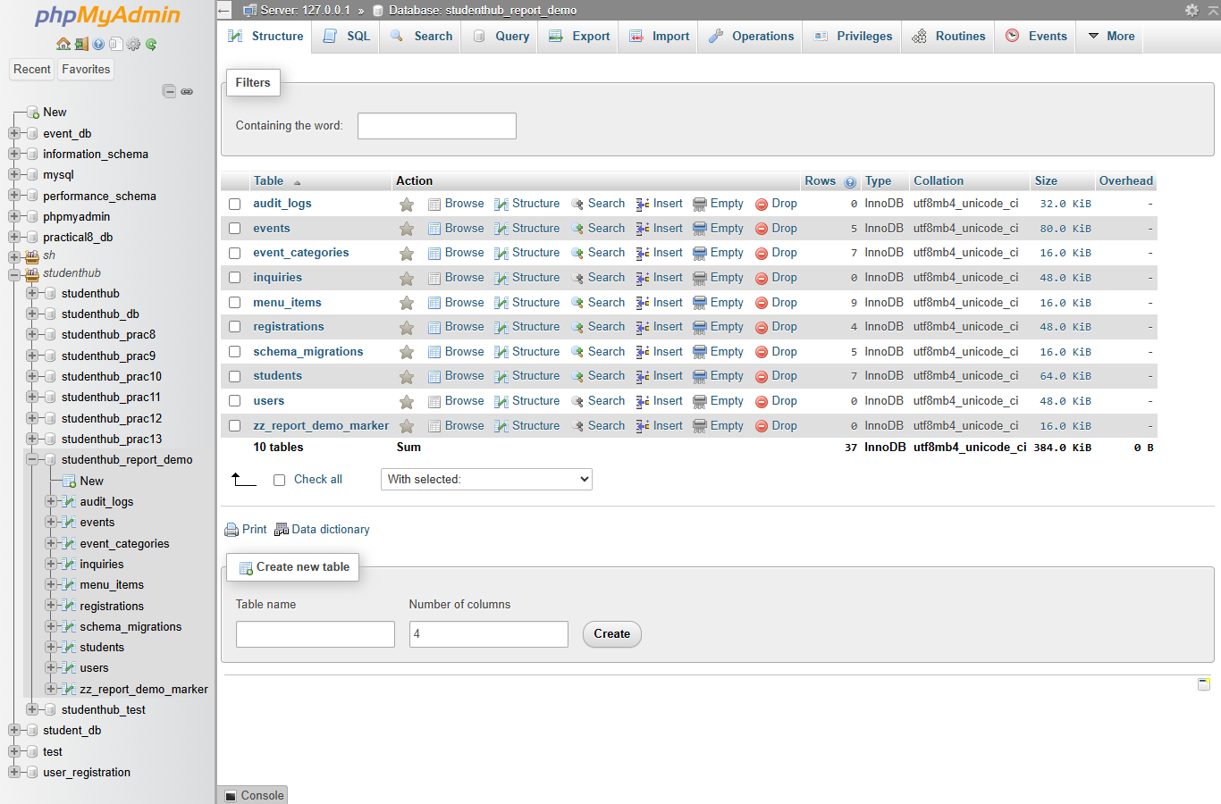
Figure 1: phpMyAdmin: the portal tables of a disposable copy built from studenthub_demo.sql (zz_report_demo_marker is the test's marker table) (01-database-tables.png)

5. How Each Practical Lives in the Portal
P | Feature in the portal | Files / route | Verified by (checks) | Commit
1 | Planning: roles, sitemap, structure | documents in Practical-1/ (nothing to integrate) | audit (TEST_REPORT §12) | –
2 | Semantic HTML5 pages | all portal pages (header / nav / main / section / footer) | audit (TEST_REPORT §12) | –
3 | Grid / Flexbox / responsive layout | assets/css/global.css, mobile drawer | audit (TEST_REPORT §12) | –
4 | DOM: FAQ, modal, slider, banner, hamburger, theme | index.php, assets/js/script.js, theme.js | audit (TEST_REPORT §12) | –
5 | Real-time regex validation, strength meter | register.php, assets/js/register-validation.js | test_forms 41 (P5–7), Edge 15 | 938e74f
6 | Campus Data Explorer (Fetch, search, filter, sort, pages) | data_explorer.php, assets/js/data.js, data/*.json | as P5 | 938e74f
7 | Stored Help & Contact inquiries | contact.php, includes/inquiries.php, ?tab=inquiries, migration 005 | as P5; migration 005: 14 | 938e74f
8 | Database foundation, capacity rule in a transaction | migration 001, includes/event_registration.php | test_001 88 | 37b35e6
9 | Secure self-registration (account + record in one transaction) | register.php, includes/registration.php | test_auth 132, Edge 14 | 8011d39
10 | Login, sessions, timeout, POST logout, CSRF, roles | login.php, logout.php, includes/auth.php | as P9 | 8011d39
11 | Student management, soft delete, CSV; inactive students cannot sign in | ?tab=students, includes/student_management.php, migration 002 | test_students 170, migration 002: 22, Edge 16 + 13 | 0ac2f5d, fix 6420efc
12 | Events with secure poster upload, registration, capacity, cancellation | ?tab=events, includes/event_management.php, poster.php, notifications.php, migration 003 | test_events 94, migration 003: 27, Edge 16 | ba11795
13 | Event Finder (Fetch API) + JSON API | events_live.php, assets/js/events-live.js, api/events.php | test_api 72, Edge 16 | a9d4e22
14 | Admin dashboard, role-based navigation, account status, audit filters | admin_dashboard.php, includes/dashboard.php, navigation.php, sidebar.php, migration 004 | test_dashboard 36, migration 004: 18, Edge 15 | 05927b3
15 | Final snapshot and end-to-end test | Practical-15/, tools/sync_practical15.py, tests/browser_e2e.py | snapshot 5, Edge end-to-end 17 | see the repository history

The Admin Console routes are admin_dashboard.php?tab=…. Not carried into the portal: the canvas CAPTCHA of Practical 5 (a client-side CAPTCHA gives no real protection on a live form; the standalone Practical-5/ keeps it). Practicals 11–14 are shown in the end-to-end scenario (Section 9); three practicals that the scenario does not touch are shown here:
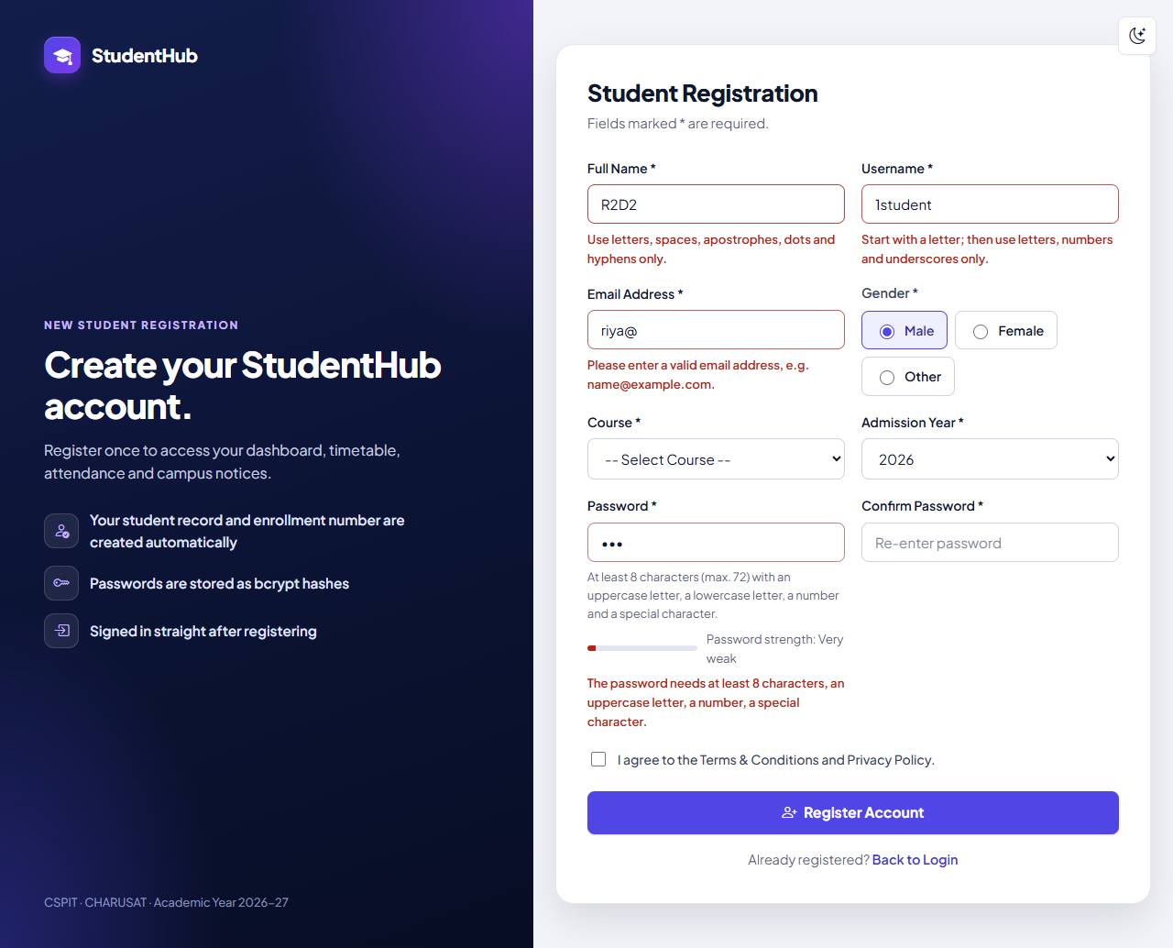
Figure 2: Practical 5 in the portal: messages and the strength meter appear while typing on register.php (01-register-live-validation.png)
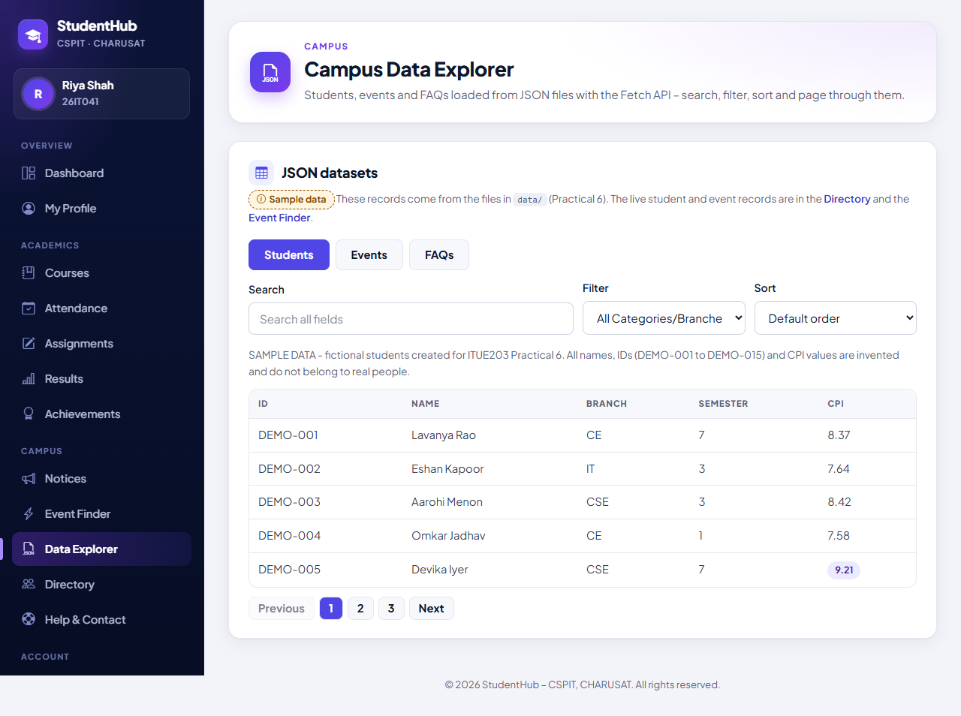
Figure 3: Practical 6 in the portal: the Campus Data Explorer renders data/students.json with search, filter, sort and pages (05-data-explorer-students.png)
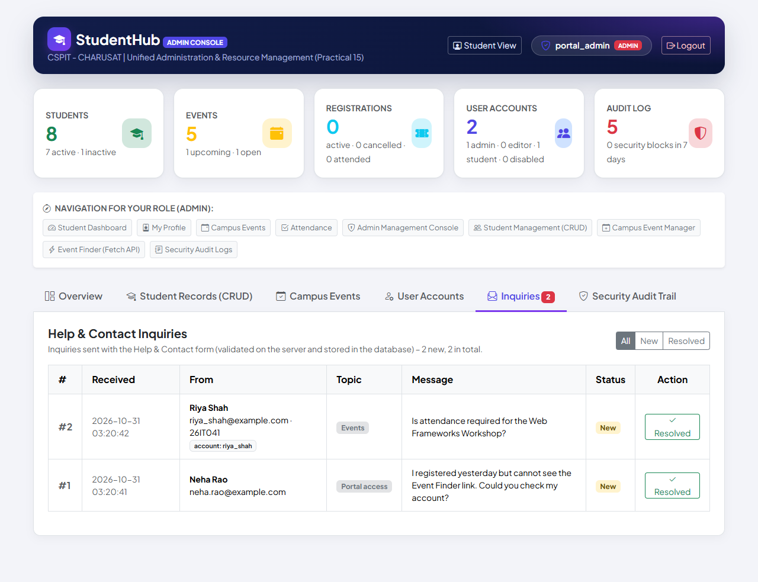
Figure 4: Practical 7 in the portal: stored inquiries in the Admin Console (Inquiries tab, new-count badge) (10-admin-inquiries.png)

6. Installation, Configuration, Accounts and Deployment

6.1 Local setup (Windows + XAMPP)
- Requirements: XAMPP with PHP 8.1+ (tested 8.2.12) and MariaDB 10.4+ / MySQL 8 (tested 10.4.32); Python 3 only for the tests, Playwright + Microsoft Edge only for the browser tests. Start MySQL in the XAMPP Control Panel.
- Create the database: mysql -u root -e "CREATE DATABASE IF NOT EXISTS studenthub_db CHARACTER SET utf8mb4 COLLATE utf8mb4_unicode_ci", then mysql -u root studenthub_db < database\studenthub_demo.sql. An existing database: back it up and apply only the missing migrations (SELECT * FROM schema_migrations shows what is applied).
- Create the first administrator: php tools\create_demo_user.php --db=studenthub_db --username=admin01 --email=admin01@example.com --role=admin – the password is prompted and stored only as a bcrypt hash.
- Run php -S localhost:8000 -t studenthub and open http://localhost:8000/ (or serve the repository root; its index.php redirects to studenthub/). The snapshot runs the same way: php -S localhost:8015 -t Practical-15.

6.2 Configuration and accounts
Environment variable | Default | Meaning
DB_HOST, DB_USER, DB_PASS, DB_NAME | localhost, root, (empty), studenthub_db | Database connection – there is no fallback database
STUDENTHUB_SESSION_TIMEOUT | 1800 | Inactivity timeout in seconds
STUDENTHUB_TIMEZONE | Asia/Kolkata | Time zone for dates (should match the database server)
STUDENTHUB_UPLOAD_DIR | studenthub/uploads | Folder for event posters (must not be reachable over HTTP)

No account and no password is stored in the repository. Administrators and editors are created with tools/create_demo_user.php (--role=admin, --role=editor, --role=student). Students normally register themselves at register.php, which creates the account (role always student) and its linked student record with the next enrollment number in one transaction. Administrators can disable, enable and delete accounts in the Admin Console; the own account and the last active administrator are protected.

6.3 Deployment on Apache (DEPLOYMENT.md)
- PHP 8.1+ with mysqli, fileinfo, mbstring; AllowOverride All so that studenthub/uploads/.htaccess denies HTTP access to the poster folder and switches PHP off there; HTTPS (the session cookie becomes Secure automatically).
- studenthub/ is the document root; database/, tests/, tools/, Practical-* and evidence/ must not be served. The web server user may write only to the poster folder (ideally outside the document root via STUDENTHUB_UPLOAD_DIR). display_errors = Off, log_errors = On.
- A dedicated database user with only SELECT, INSERT, UPDATE, DELETE on studenthub_db; schema and migrations are run with an administrative account; connection settings as SetEnv variables, never in a file inside the document root.
- Operation: regular mysqldump --single-transaction backups outside the web root (they contain password hashes), review of the audit log and the PHP error log, and before an update: back up, apply new migrations, run python tests/run_all.py against a copy, then deploy.
These steps were written for the project but were not carried out on a real public server; the application was tested with PHP's built-in server.

7. The Practical 15 Snapshot
Practical-15/ is not maintained by hand. python tools/sync_practical15.py copies every file tracked by Git in studenthub/ (git ls-files) byte for byte, removes application files that no longer exist in studenthub/ – the stale files of the old copy, such as its own schema.sql, were removed this way and remain in the Git history – and writes Practical-15/SNAPSHOT.md with the SHA-256 hash of every file and the base commit. Uploaded posters are never copied; README.md and SNAPSHOT.md are the only files of the folder that are not application files. python tools/sync_practical15.py --check only verifies and exits with code 1 if anything differs:
tools/sync_practical15.py (lines 26–39) – byte comparison and detection of extra files
26 def differences(files):
27 problems = []
28 for rel in files:
29 a, b = SRC / rel, DST / rel
30 if not b.is_file():
31 problems.append(f"missing in Practical-15: {rel}")
32 elif a.read_bytes() != b.read_bytes():
33 problems.append(f"differs: {rel}")
34 wanted = set(files) | OWN
35 for p in DST.rglob("*"):
36 rel = p.relative_to(DST).as_posix()
37 if p.is_file() and rel not in wanted and not (rel.startswith("uploads/") and rel not in ("uploads/.htaccess", "uploads/.gitkeep")):
38 problems.append(f"extra file in Practical-15: {rel}")
39 return problems

The manifest lists 56 files and records as base commit 938e74f (the Practicals 5–7 integration); the copied files may include changes committed together with the manifest. tests/test_snapshot.py checks the snapshot in five steps:
# | Check in tests/test_snapshot_output.txt | Result
1 | tools/sync_practical15.py --check: Practical-15/ is byte-for-byte identical to studenthub/ and SNAPSHOT.md matches | PASS
2 | SNAPSHOT.md lists all 56 tracked application files | PASS
3 | The snapshot folder has no separate database or configuration of its own (no schema.sql, no config files) | PASS
4 | tests/test_auth.py against Practical-15/: 132 passed, 0 failed | PASS
5 | tests/test_api.py against Practical-15/: 72 passed, 0 failed | PASS

8. Security Summary
Area | Control in the portal | Verified by
Passwords | password_hash() (bcrypt); policy 8–72 characters with upper- and lower-case letter, digit and special character; no passwords or hashes in the repository | test_auth
Sign-in | One generic message; unknown accounts are checked against a dummy hash; session ID regenerated at login | test_auth, Edge
Sessions | Cookie STUDENTHUBSESSID (HttpOnly, SameSite=Strict, Secure on HTTPS, strict mode); 30-minute timeout; account re-read on every request; logout only by POST | test_auth
Access control | Explicit permissions per role; HTTP 403 page + ACCESS_DENIED; the API answers 401 / 403 in JSON | test_dashboard, test_api, end-to-end 4 and 17
Blocked accounts | Disabled accounts and student accounts with an inactive record cannot sign in; open sessions end (SESSION_REVOKED) | test_students, test_dashboard, end-to-end 6/7
CSRF | Token on every POST form; X-CSRF-Token header for the API; refusals logged as CSRF_REJECTED | test_auth and the module suites, end-to-end 17
SQL injection | Prepared statements for user input; % and _ escaped in searches | test_students, test_events, test_api, test_dashboard
Cross-site scripting | htmlspecialchars() / e() on output; textContent in JavaScript; HTML escaped in JSON | test_students, test_events, test_api, test_forms, test_dashboard
File uploads | JPEG / PNG / WebP up to 2 MB; content type must match; real image; no embedded PHP; random 32-hex name; uploads/.htaccess; poster.php with nosniff and a sandbox CSP for signed-in users | test_events, end-to-end 8/9
Data rules | Capacity in a locking transaction; duplicates refused; soft delete of students; events with registrations cannot be deleted | test_events, test_api, test_students, end-to-end 10–12
Headers and errors | X-Frame-Options: DENY, nosniff, Referrer-Policy, no-store on private pages; errors only in the server log; HTTP 503 without details | test_auth
Audit and export | One filterable audit log; CSV cells starting with =, +, -, @, tab or CR are prefixed with an apostrophe | test_dashboard, test_students, end-to-end 16

9. End-to-End Scenario
tests/browser_e2e.py drives one continuous scenario in Microsoft Edge (1280 × 900 window, full-page screenshots) on the disposable database studenthub_p11_test and a temporary poster folder; the live database is never used. Five browser contexts play a new student (Ishaan Mehta), the administrator (portal_admin), an editor (neha_editor), a second student (Kunal Desai) and a visitor. Result: 17 / 17 passed (tests/browser_e2e_output.txt).
Check | Workflow and assertion | Figure
1 | Registration: account + linked student record with the next enrollment number, signed in | 5
2 | Logout (POST) and login with the e-mail address | 6
3 | The profile shows the student's own record | 7
4 | Editor and student opening the Admin Console → HTTP 403 “Access Denied” | 8
5 | Admin adds a student (automatic enrollment number) and edits the semester | 9
6/7 | Deactivation: the signed-in student loses access; a new sign-in is refused with the generic message | 10
6 | Reactivation restores sign-in | 11
8/9 | A PHP file disguised as .jpg is refused; a real JPEG poster is stored under a random name; the event is edited | 12, 13
10/11 | Registration succeeds; a second attempt → “already registered”; another student on a stale page → “The event is full.” | 14, 15
12 | Cancellation keeps the row as cancelled and frees the seat | 16
13 | Event Finder: debounced search and registration through the JSON API without a page reload | 17
14 | Student search + status filter | 18
15 | Dashboard counters equal the database | 19
16 | Audit log: denied access, refused sign-in, revoked session and rejected upload are recorded | 20
17 | A forged form without the CSRF token → “Security check failed” (403), nothing changed; the API answers 401 to a visitor | 21
– | No JavaScript errors (only the intended 401 / 403 / 422 responses); no PHP warnings or errors in the server log | –

The run also reported the known 404 for /favicon.ico as information (the portal has no favicon).
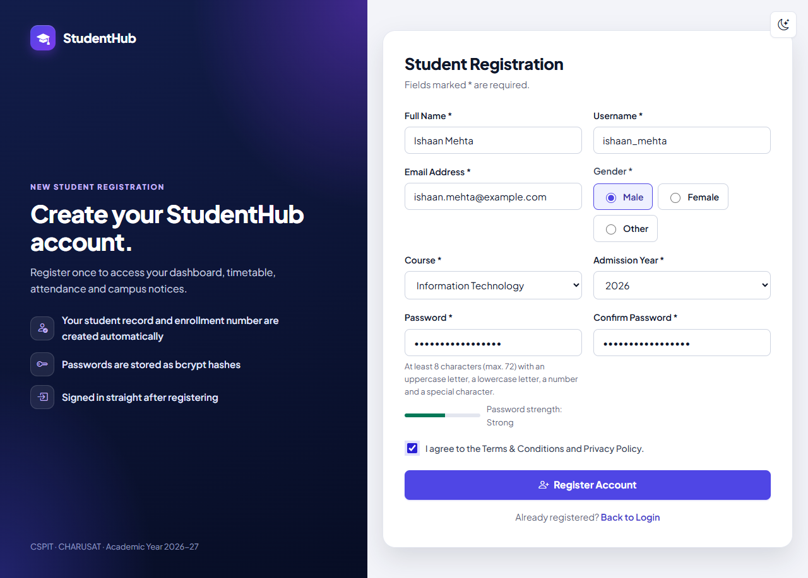
Figure 5: Step 1 – the registration form filled in for Ishaan Mehta (password strength “Strong”) (01-registration.png)
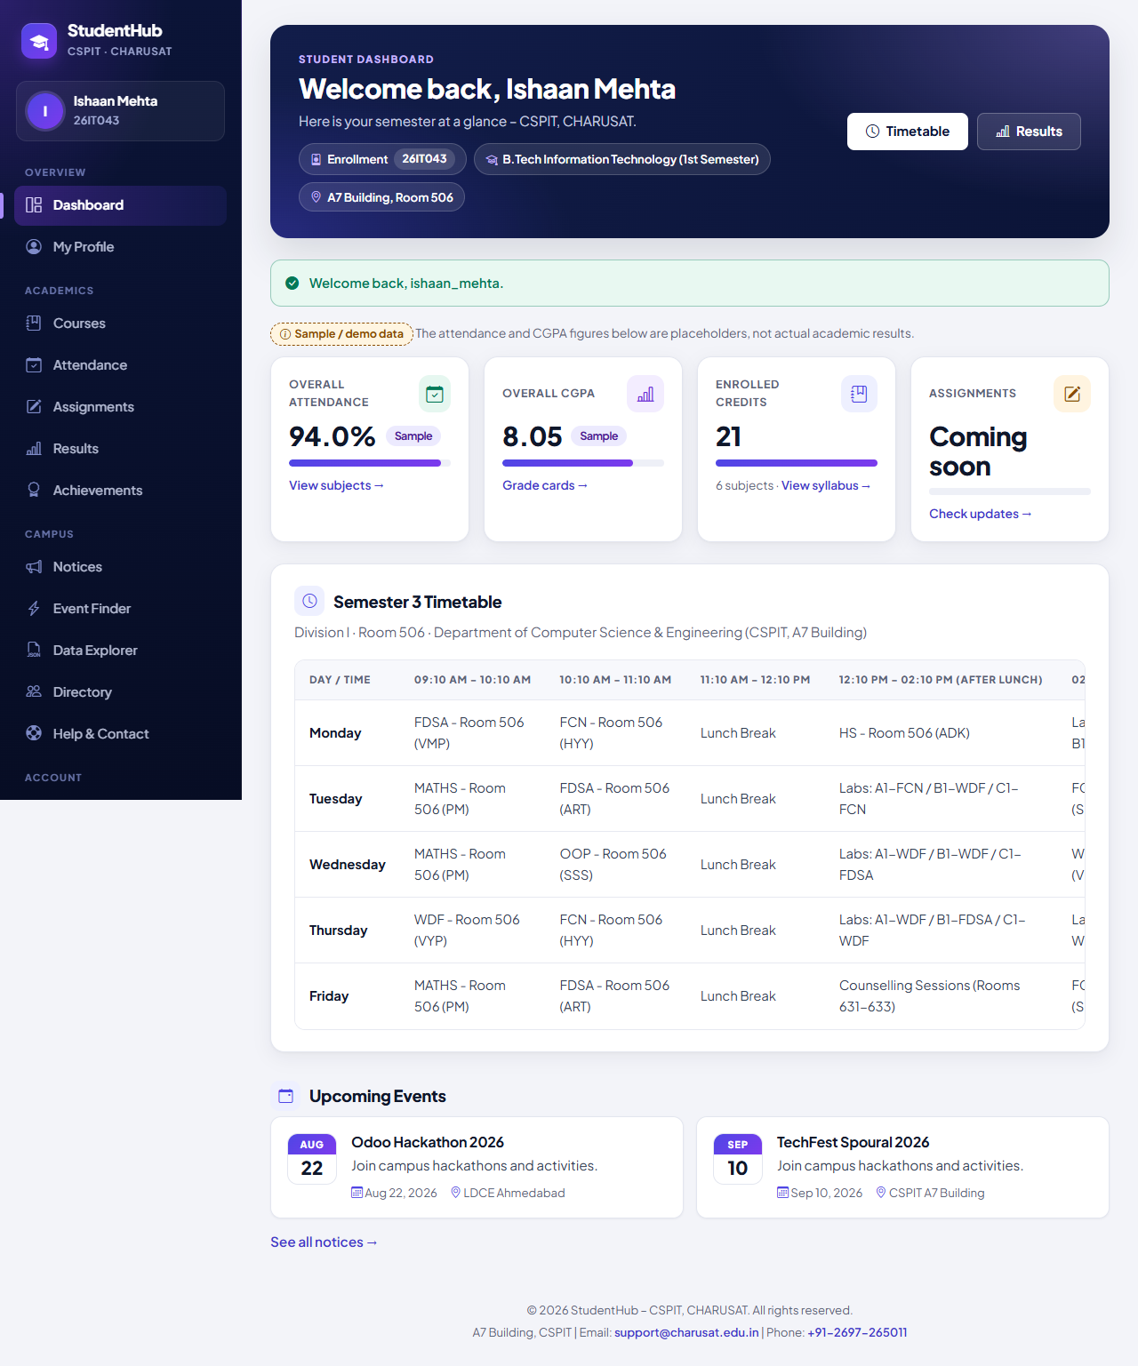
Figure 6: Step 2 – signed in again with the e-mail address: dashboard with enrollment number 26IT043 (02-login-dashboard.png)
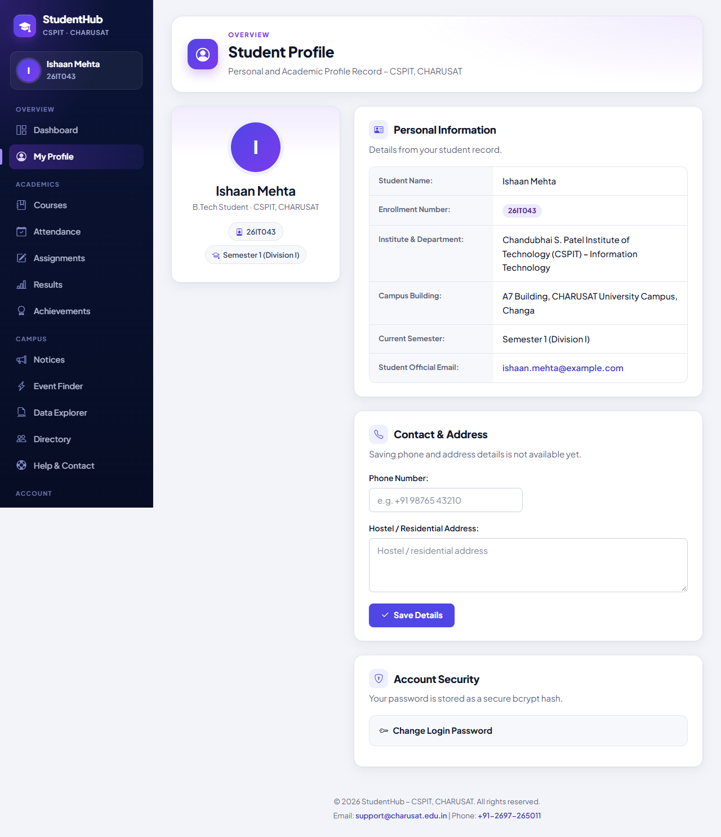
Figure 7: Step 3 – the profile shows the student's own record (03-student-profile.png)
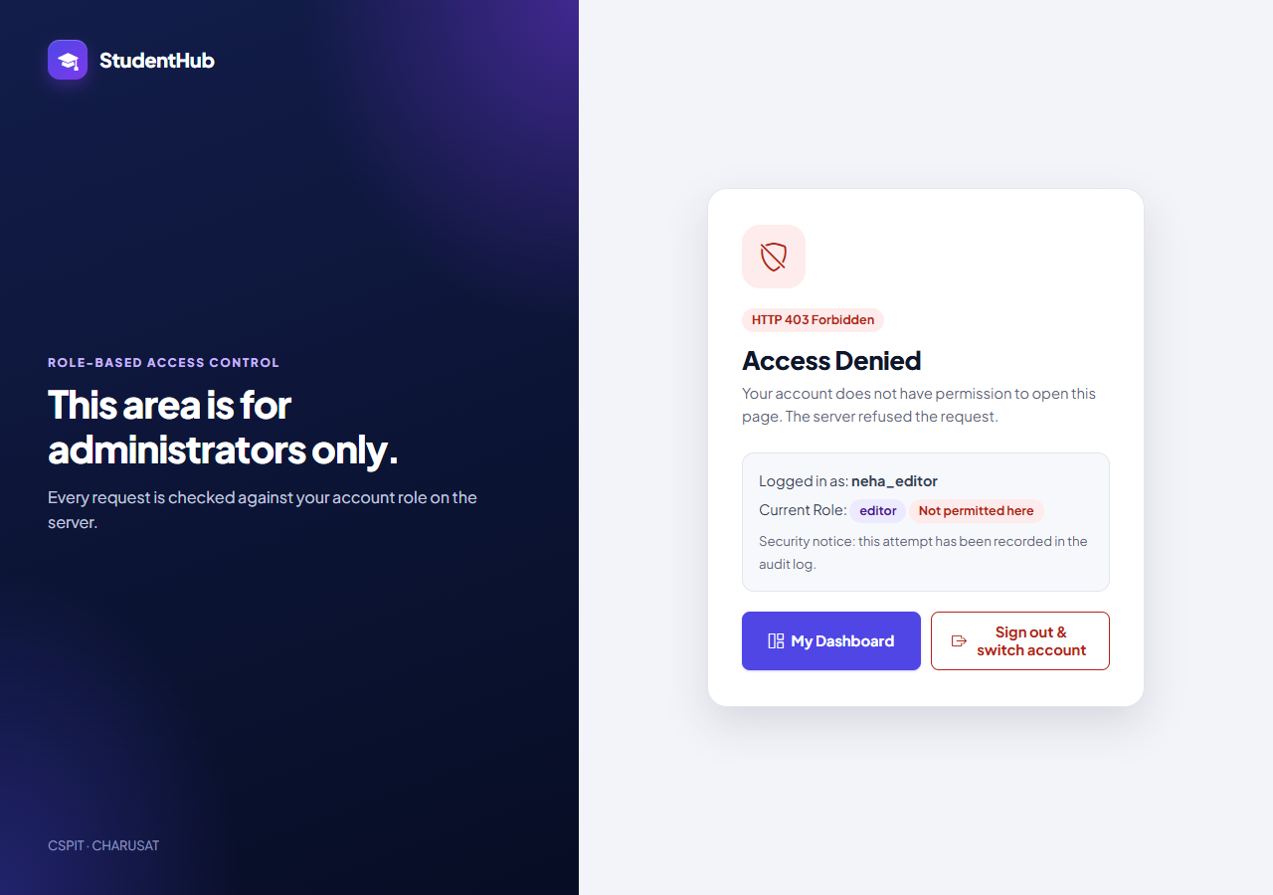
Figure 8: Step 4 – the editor opening the Admin Console gets the HTTP 403 page (04-editor-access-denied.png)
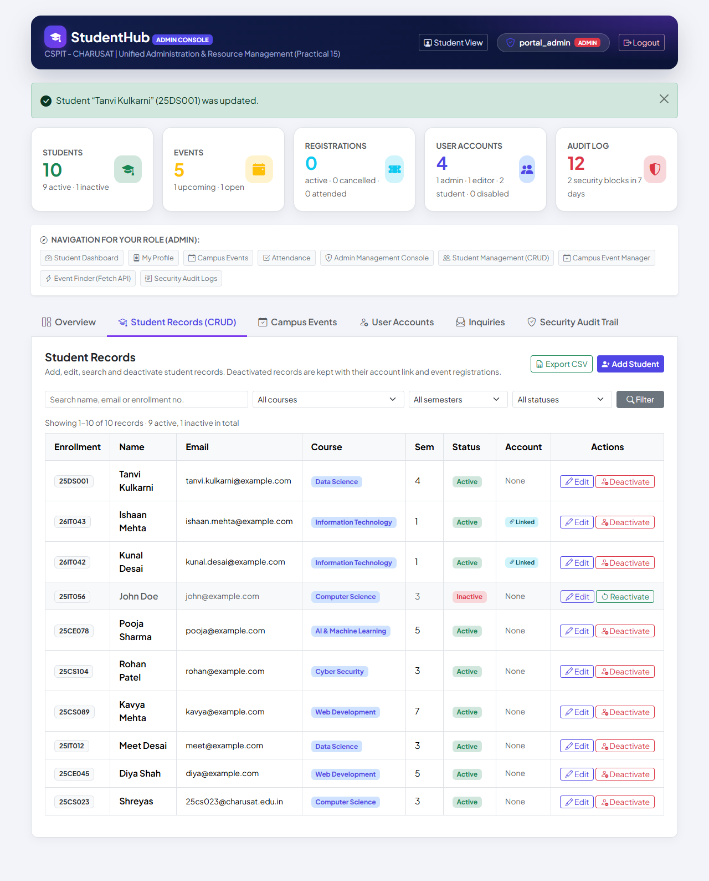
Figure 9: Step 5 – student “Tanvi Kulkarni” added with the automatic number 25DS001 and updated (semester 4) (05-student-created-edited.png)
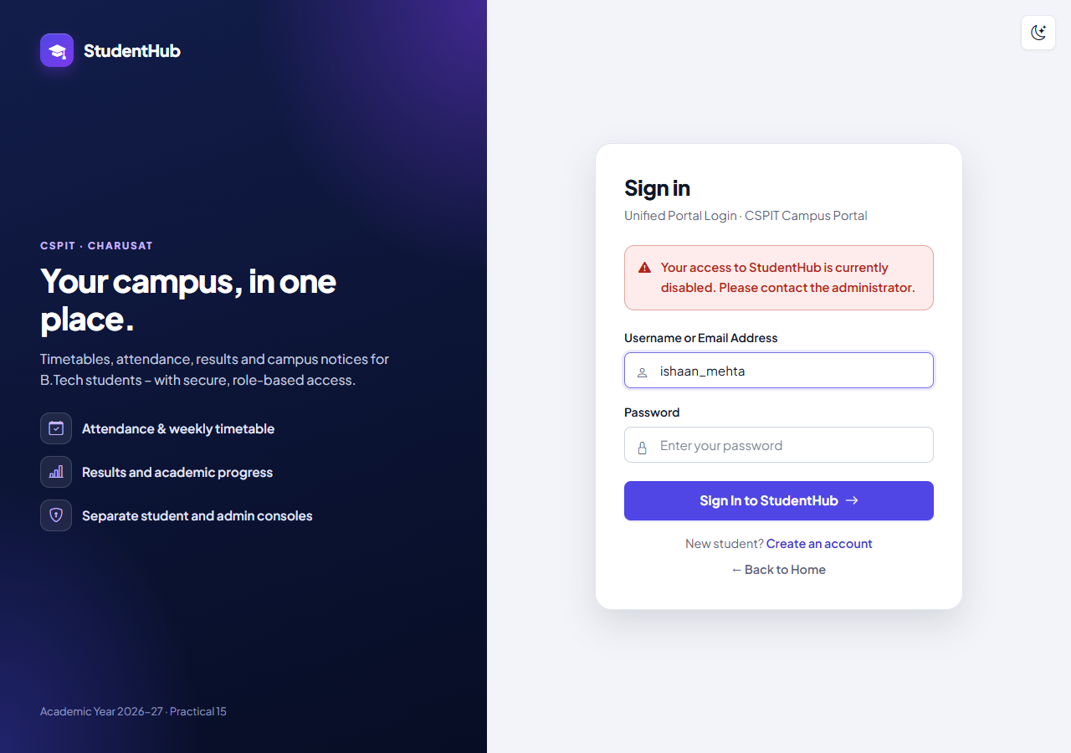
Figure 10: Steps 6/7 – after deactivation the student's sign-in is refused with the generic message (06-inactive-login-denied.png)
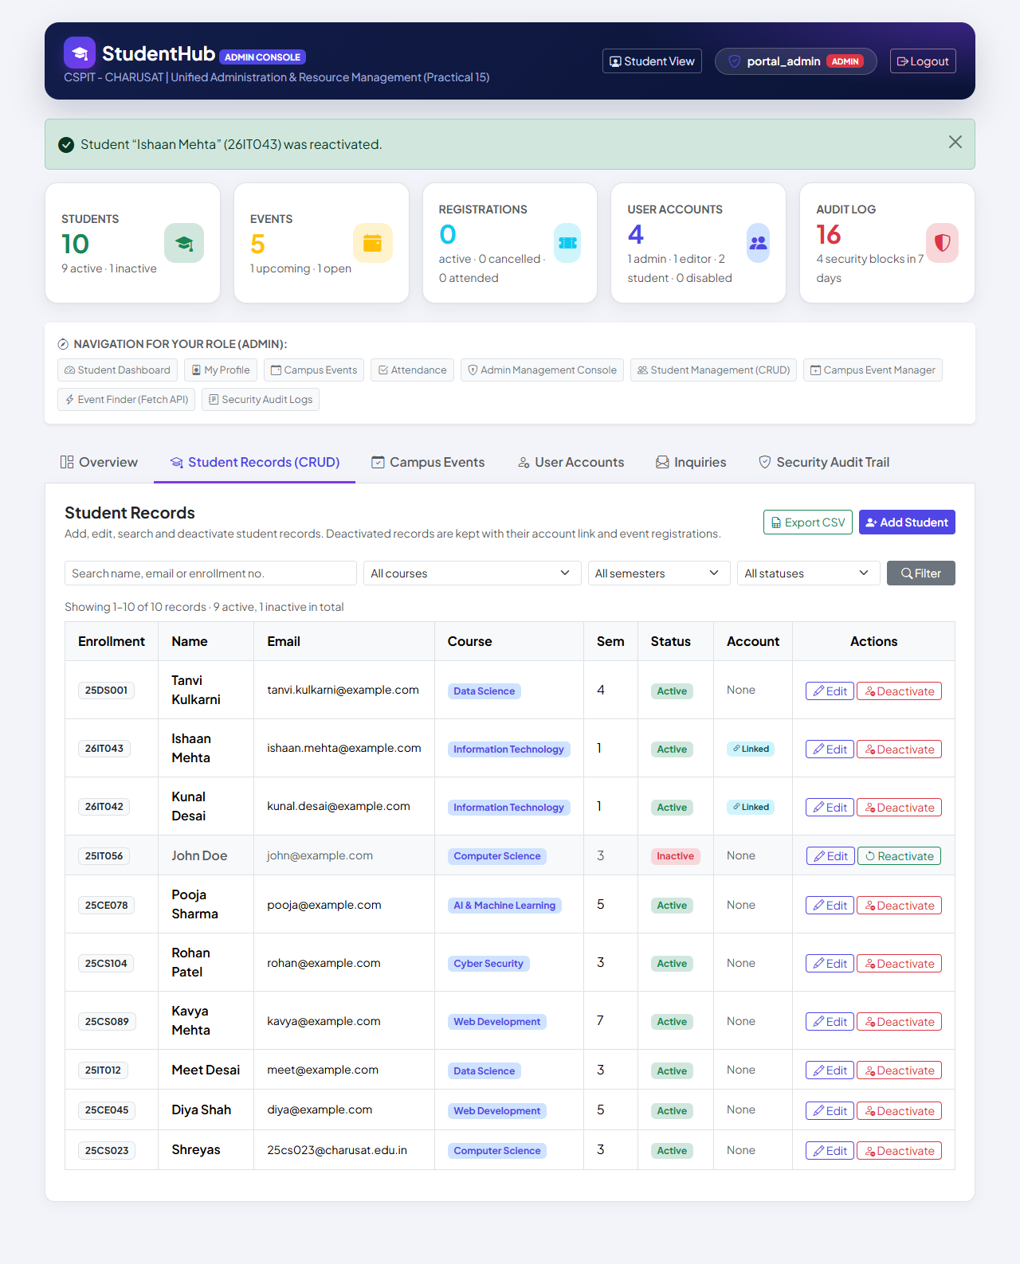
Figure 11: Step 6 – the record reactivated; sign-in works again (07-student-reactivated.png)
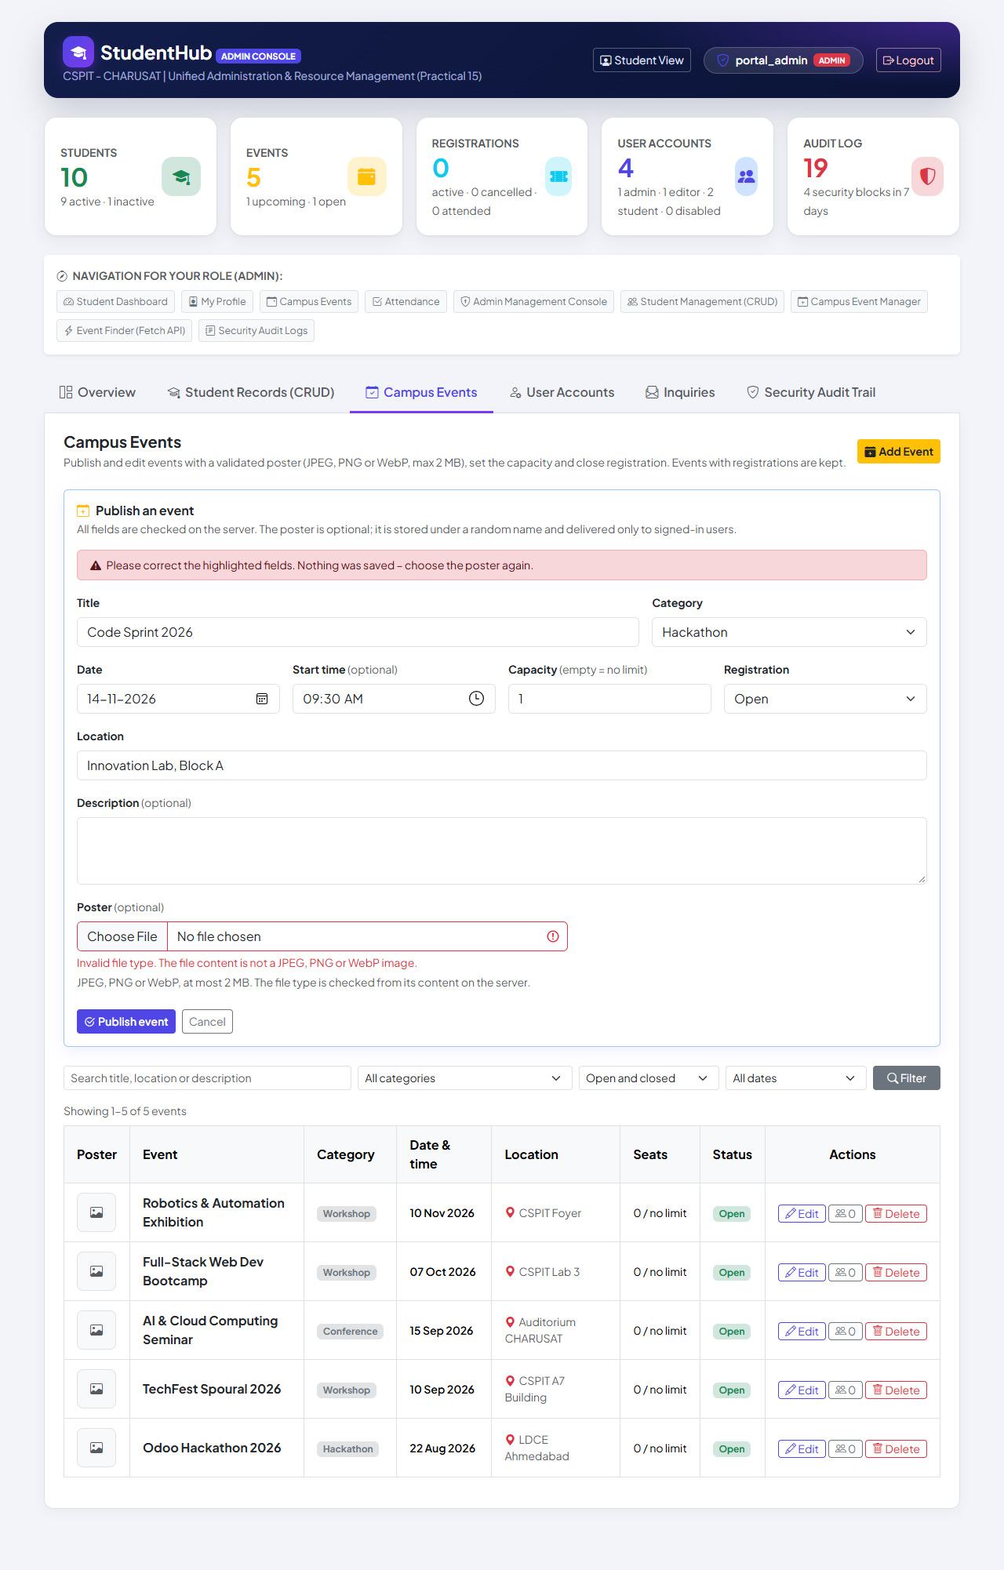
Figure 12: Step 8 – a PHP file named .jpg is refused: “The file content is not a JPEG, PNG or WebP image.”, nothing saved (08-poster-rejected.png)
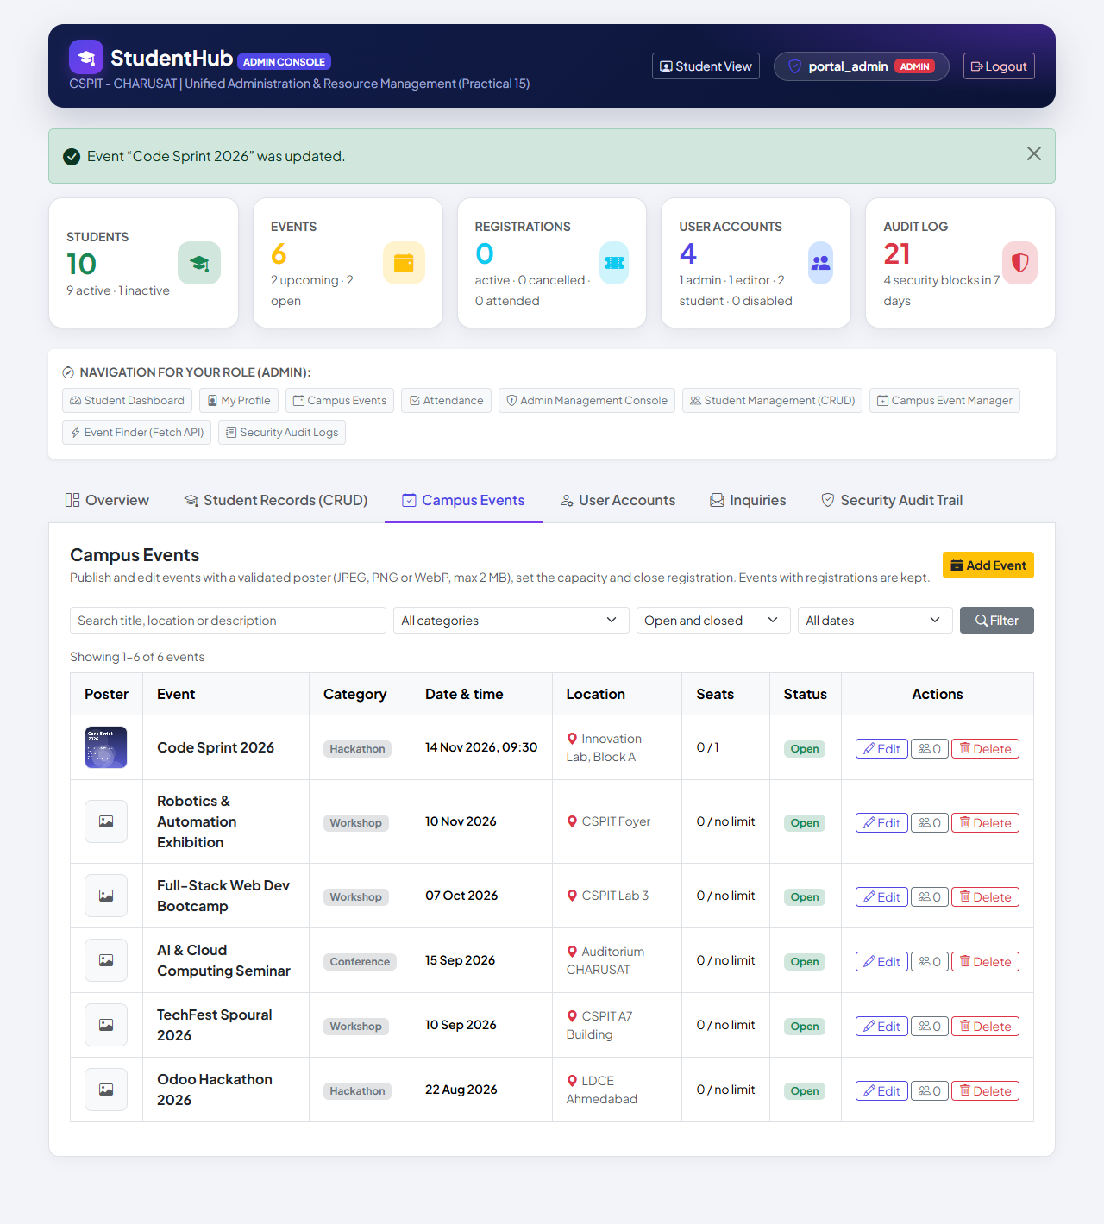
Figure 13: Step 9 – event “Code Sprint 2026” (capacity 1) with its stored poster, after editing (09-event-with-poster.png)
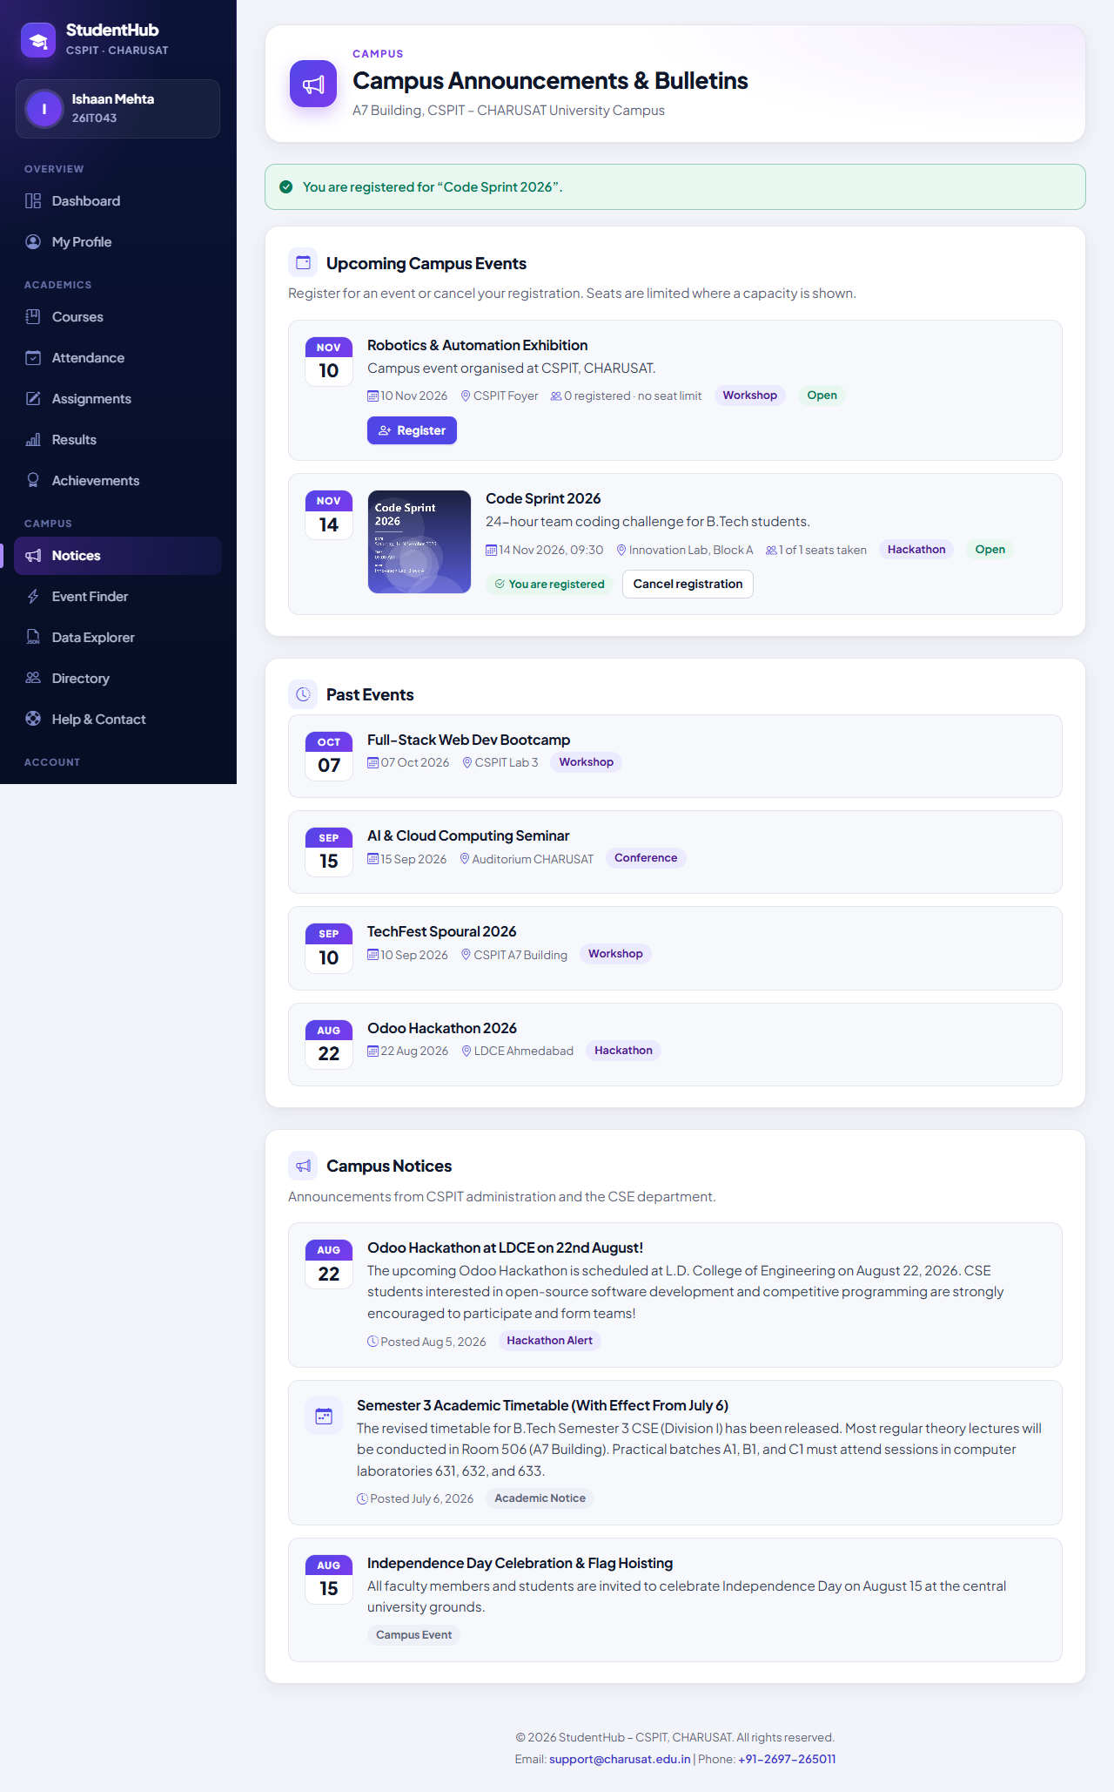
Figure 14: Step 10 – the student is registered for “Code Sprint 2026” (1 of 1 seats taken) (10-event-registration.png)
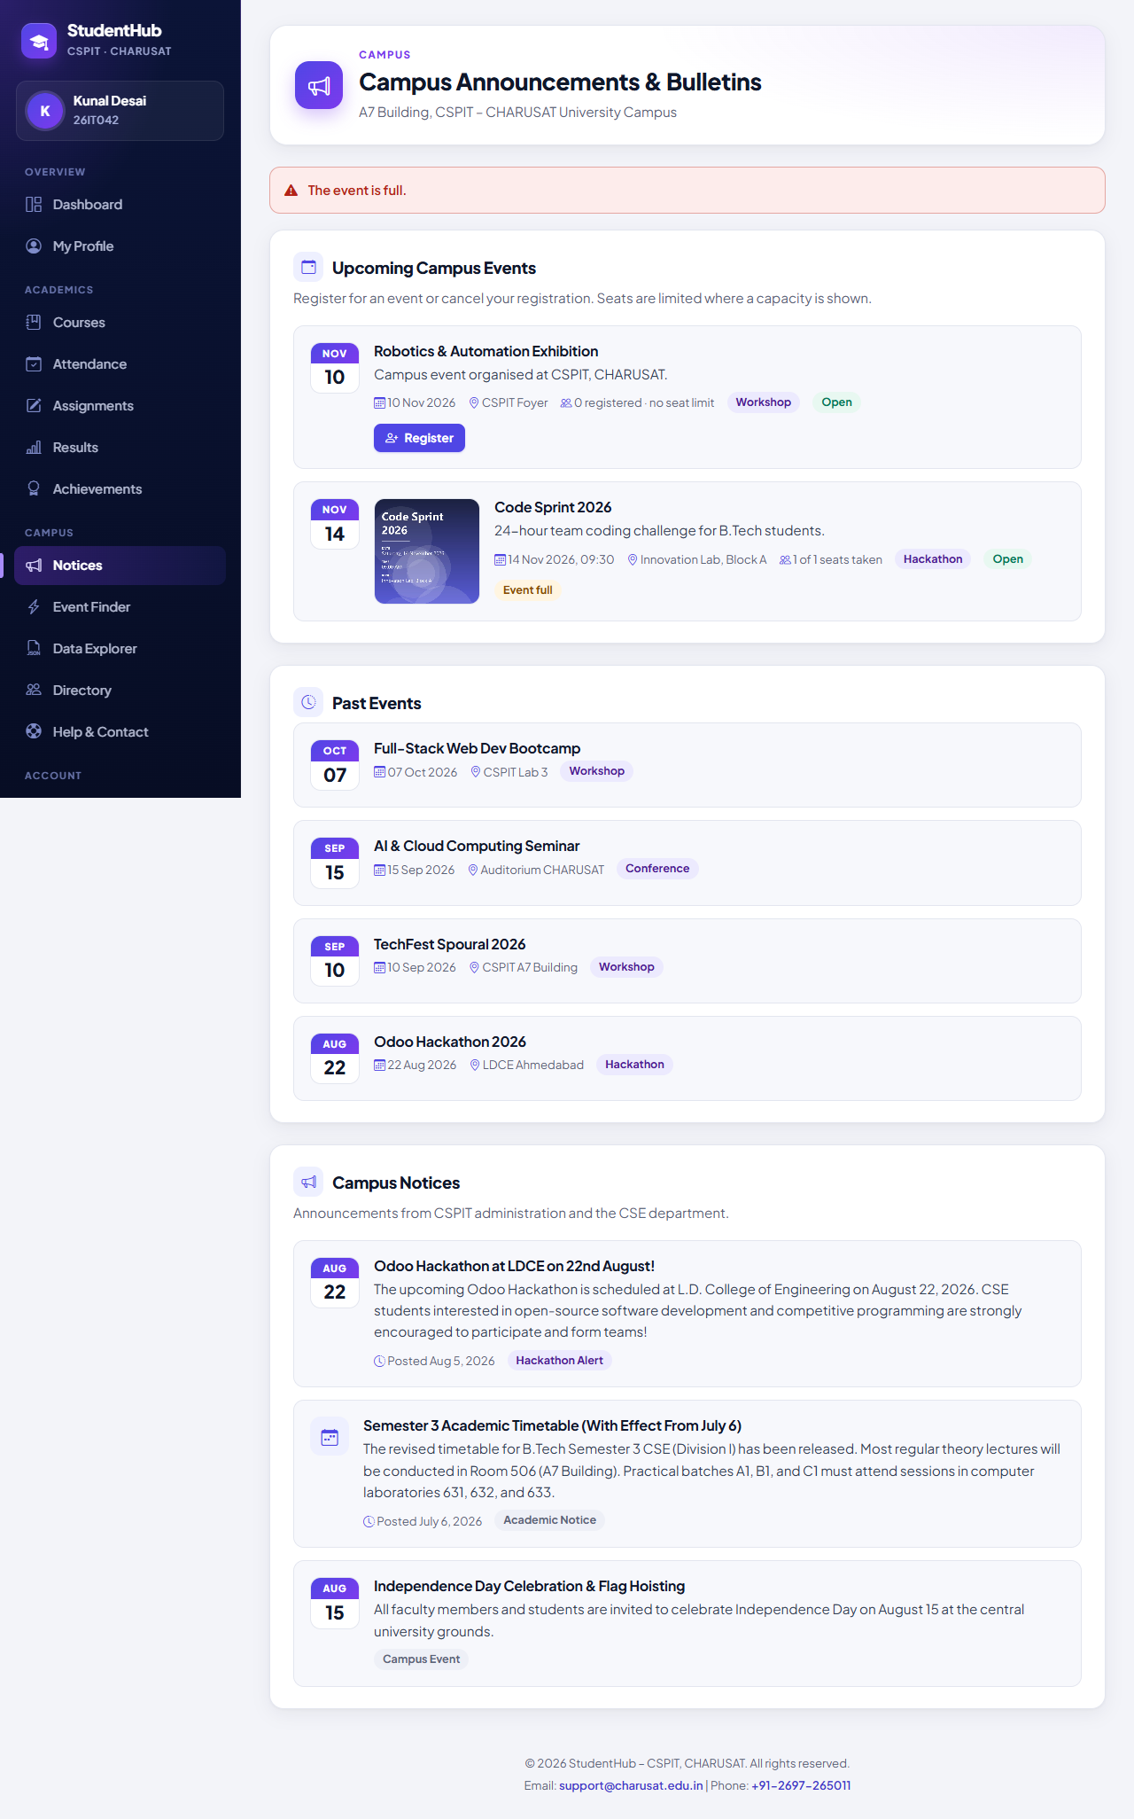
Figure 15: Step 11 – the second student gets “The event is full.” (11-event-full.png)
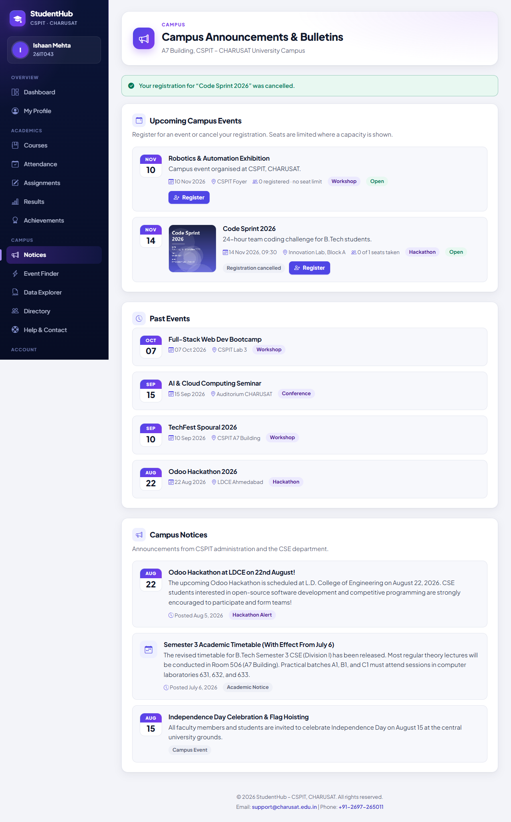
Figure 16: Step 12 – the registration is cancelled; the row is kept and the seat is free again (12-registration-cancelled.png)
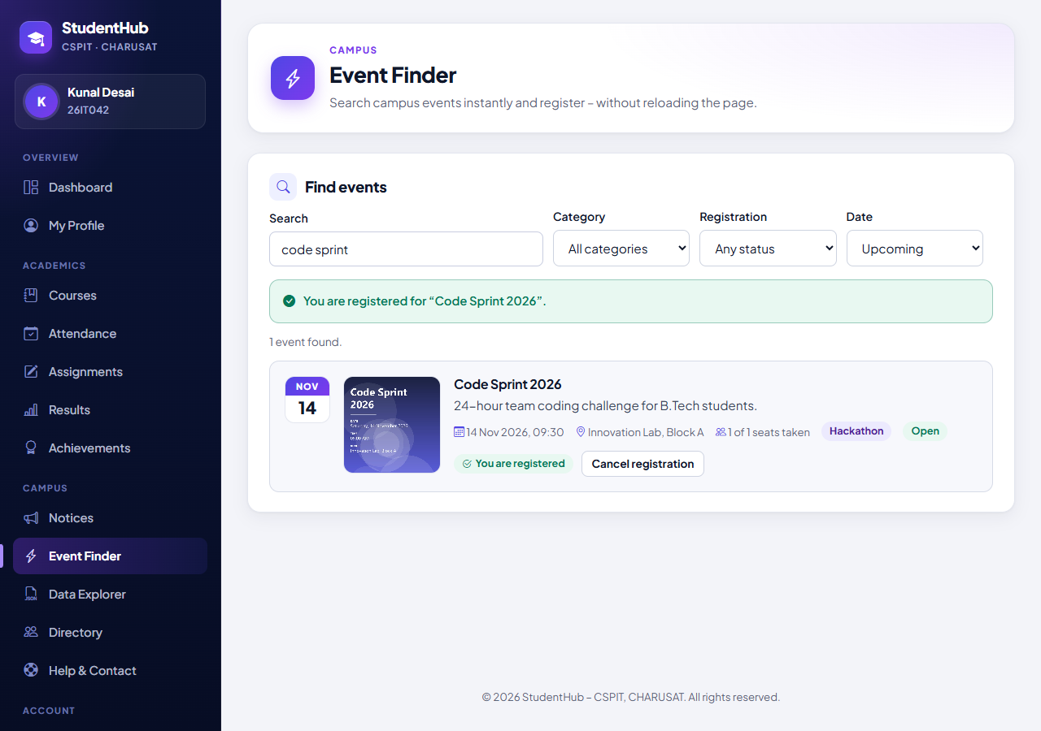
Figure 17: Step 13 – Event Finder: search “code sprint” and registration through the JSON API without a reload (13-fetch-api-registration.png)
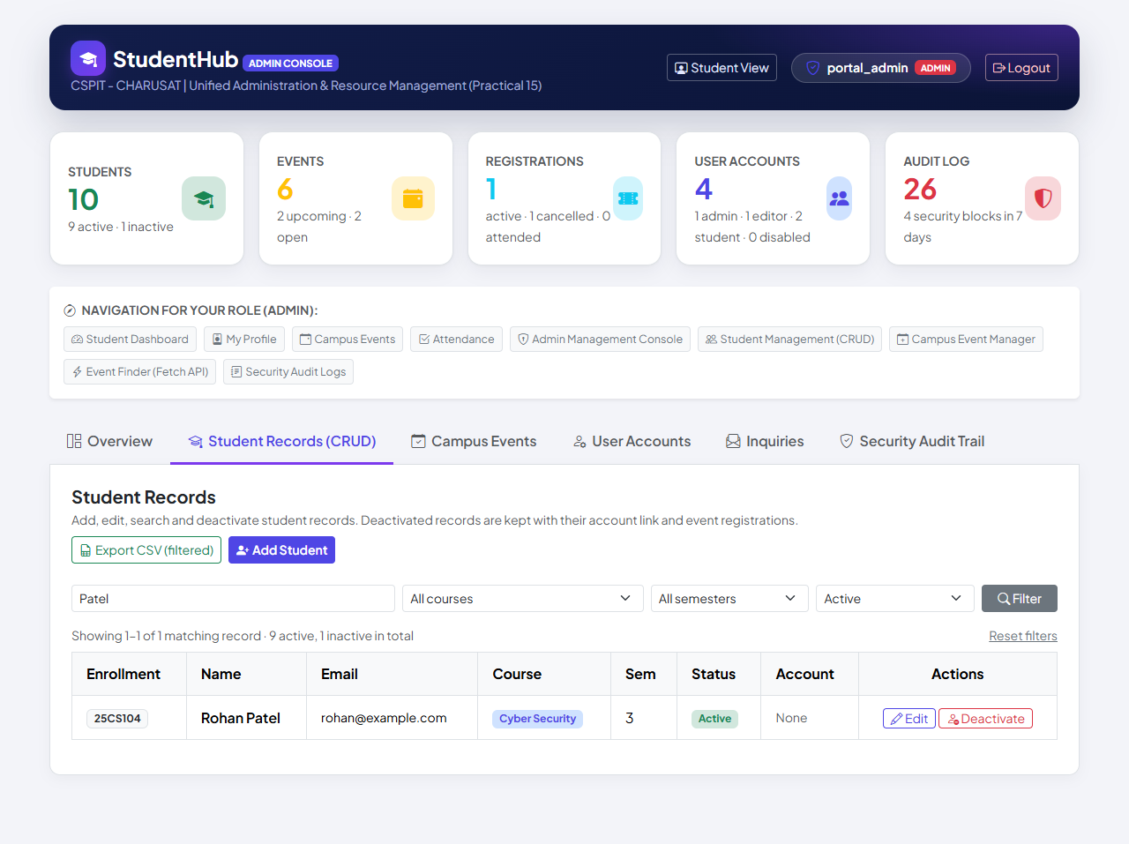
Figure 18: Step 14 – student search “Patel” combined with the status filter Active (14-search-filters.png)
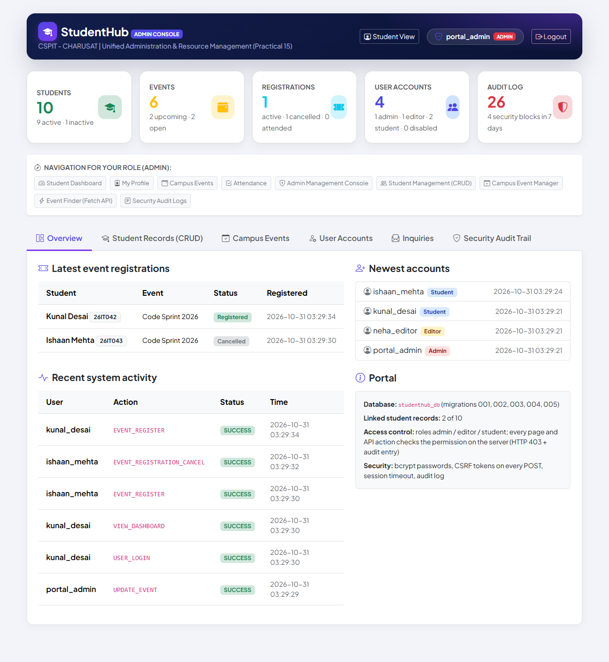
Figure 19: Step 15 – dashboard counters and the latest registrations (registered and cancelled) (15-dashboard-statistics.png)
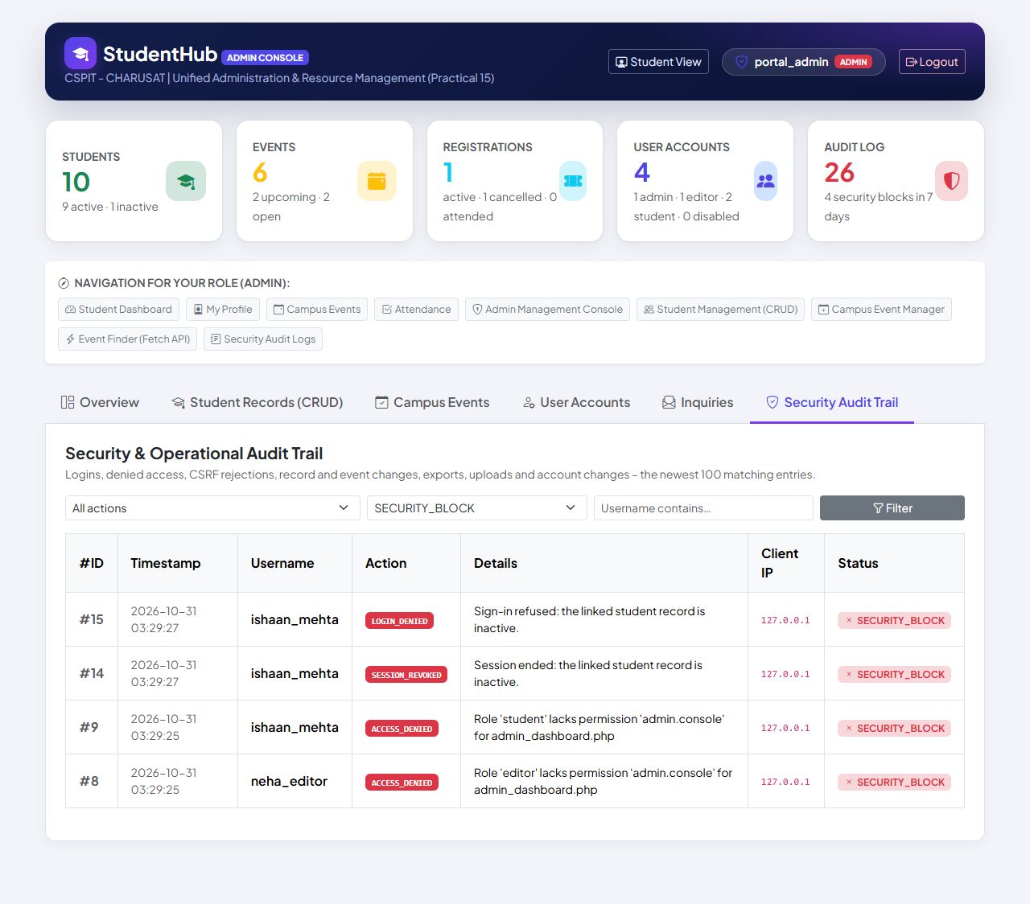
Figure 20: Step 16 – audit log filtered to SECURITY_BLOCK: refused sign-in, revoked session and two denied console accesses (the rejected upload has the status FAILED and is checked in the database) (16-audit-log.png)
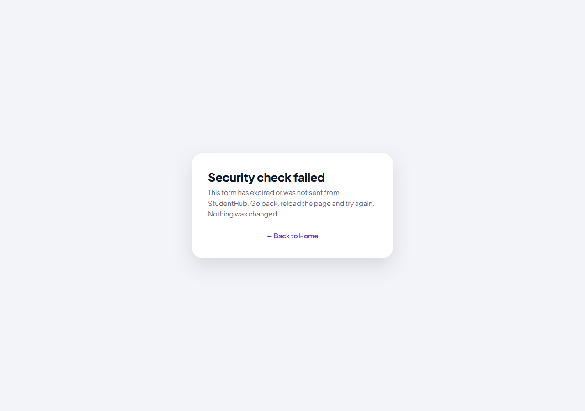
Figure 21: Step 17 – a forged form without the CSRF token: “Security check failed”, nothing was changed (17-csrf-rejected.png)

10. Test Cases and Results
Complete run on 31 October 2026 – python tests/run_all.py --browser <python with Playwright> – with PHP 8.2.12 (XAMPP), MariaDB 10.4.32, Windows 11 and Microsoft Edge (headless, Playwright). Every suite uses its own disposable database (and a temporary poster folder); the live studenthub_db is only read. Output: tests/run_all_output.txt.
Suite | Passed | Failed | Time
Practical 8 – migration 001 and portal | 88 | 0 | 13 s
Practical 11 – migration 002 | 22 | 0 | 7 s
Practical 12 – migration 003 | 27 | 0 | 6 s
Practical 14 – migration 004 | 18 | 0 | 5 s
Practical 7 – migration 005 | 14 | 0 | 4 s
Practicals 9/10 – registration, login, sessions, RBAC | 132 | 0 | 22 s
Practical 11 – student management | 170 | 0 | 16 s
Practical 12 – events, posters, registration | 94 | 0 | 14 s
Practical 13 – JSON API, Event Finder | 72 | 0 | 10 s
Practical 14 – admin dashboard | 36 | 0 | 7 s
Practicals 5–7 – validation, Data Explorer, inquiries | 41 | 0 | 5 s
Practical 15 – snapshot (incl. 132 + 72 checks against the snapshot) | 5 | 0 | 33 s
Edge – registration, login, RBAC | 14 | 0 | 5 s
Edge – student management | 16 | 0 | 7 s
Edge – inactive student login | 13 | 0 | 6 s
Edge – event management | 16 | 0 | 11 s
Edge – Event Finder (Fetch API) | 16 | 0 | 13 s
Edge – admin dashboard | 15 | 0 | 9 s
Edge – Practicals 5–7 | 15 | 0 | 7 s
Edge – end-to-end (Practical 15) | 17 | 0 | 13 s
Total (20 suites) | 841 | 0

12 database and HTTP suites contribute 719 checks and 8 Microsoft Edge suites 122 checks. run_all.py reads each suite's own last summary line and counts a suite that exits with an error as failed.
Live database: migrations 001–005 were applied to the working studenthub_db, each after a verified backup; the read-only live checks pass (001 24 / 24, 002 4 / 4, 003 5 / 5, 004 5 / 5, 005 4 / 4). Database evidence for Practical 8: tests/browser_database_evidence.py 6 / 6 (phpMyAdmin screenshots of a disposable copy).

11. Problems Encountered and Fixes
Problem | Fix
Practical-15/ was an older, independently kept copy of the portal (with its own schema.sql) that no longer matched studenthub/ | Replaced by the generated snapshot; the old copy stays in the Git history; tests/test_snapshot.py detects any difference
The first complete run showed one failure in the Event Finder browser test: the check for “Event full” ran before the list refresh after the API's 409 answer had finished (a timing race in the test; it had passed in every earlier run) | The test now waits for the refreshed card; the second complete run passed completely
Summary of the complete run | run_all.py was corrected to read each suite's own last summary line (TEST_REPORT §13)
Earlier integration steps (TEST_REPORT §7–§12): PHP used XAMPP's Europe/Berlin time zone; deactivated students could still sign in; the Event Finder's loading indicator stayed visible (display: flex overrode hidden); sidebar links from menu_items were not escaped; data.js inserted values unescaped and had an artificial 800 ms delay | Fixed in their steps (Asia/Kolkata, sign-in and session check, CSS fix, escaping, delay removed) – the complete run confirms all of them together

12. Known Limitations
- No limit on repeated sign-in attempts; no e-mail (password reset, answers to inquiries).
- Posters are uploaded only in the Admin Console (the JSON API handles no files); menu_items has no editing form.
- The Admin Console loads Bootstrap from a CDN; the portal has no favicon (one 404 per browser session).
- The canvas CAPTCHA of Practical 5 was not carried into the portal.
- Academic figures on the student pages (CGPA, SGPA, attendance, timetable) are sample data, labelled “Sample / demo data”.
- The standalone Practical-1/ … Practical-14/ folders are historical and not updated.
- The deployment steps of DEPLOYMENT.md were not carried out on a public server.

13. Conclusion
StudentHub is now one application with one database and one login: the validation of Practical 5, the Data Explorer of Practical 6, the inquiries of Practical 7, the database foundation of Practical 8, the registration, login and sessions of Practicals 9 and 10, the student management of Practical 11, the events and posters of Practical 12, the Fetch API of Practical 13 and the admin dashboard of Practical 14 all run in studenthub/ on studenthub_db through migrations 001–005. Practical-15/ is a generated, hash-verified snapshot of exactly this application. The complete run passed all 841 checks of 20 suites, the snapshot itself passed the authentication and API suites, and the end-to-end scenario carried students, an editor and the administrator through 17 critical workflows in Microsoft Edge with genuine screenshots. The remaining limitations are listed above.

14. References
- PHP Manual – MySQLi prepared statements: https://www.php.net/manual/en/mysqli.quickstart.prepared-statements.php
- PHP Manual – password_hash: https://www.php.net/manual/en/function.password-hash.php
- MDN – Using the Fetch API: https://developer.mozilla.org/en-US/docs/Web/API/Fetch_API/Using_Fetch
- OWASP – Session Management Cheat Sheet: https://cheatsheetseries.owasp.org/cheatsheets/Session_Management_Cheat_Sheet.html
- OWASP – File Upload Cheat Sheet: https://cheatsheetseries.owasp.org/cheatsheets/File_Upload_Cheat_Sheet.html
- MariaDB Knowledge Base – SELECT … FOR UPDATE: https://mariadb.com/kb/en/for-update/
- Apache HTTP Server – .htaccess files: https://httpd.apache.org/docs/2.4/howto/htaccess.html
- Playwright for Python: https://playwright.dev/python/
- Project files: README.md, DEPLOYMENT.md, TEST_REPORT.md (section 13), database/README.md, Practical-15/README.md, Practical-15/SNAPSHOT.md
- Project repository: https://github.com/TheEmperor08/StudentHub-ITUE203-25CS023

