CHAROTAR UNIVERSITY OF SCIENCE AND TECHNOLOGY (CHARUSAT)
Chandubhai S. Patel Institute of Technology (CSPIT)
Department of Computer Science & Engineering
ITUE203 – Web Development Frameworks

PRACTICAL 6

Rendering External JSON Data using Fetch API, Search and Filter
JavaScript (ES6+) · Fetch API · JSON · HTML5 · CSS3 · PHP 8 (page and access control)
Corrected submission – implemented in the integrated StudentHub portal (studenthub/)
Student Name | Shreyas
Roll Number | 25CS023
Student ID | 25CS023
Email | 25cs023@charusat.edu.in
Course | ITUE203 – Web Development Frameworks
Programme | B.Tech Computer Science & Engineering
Semester / Academic Year | 3 / 2026-27
Date of Submission
Faculty Signature

Corrected report. This report replaces the original Practical 6 report (Practical-6/PRAC_6_ITUE203_25CS023.docx, kept unchanged in the repository). The original report described the standalone page Practical-6/directory.html (five ES modules, served by Python's http.server). This version describes the Campus Data Explorer of the portal – studenthub/data_explorer.php with studenthub/assets/js/data.js – which reads the same anonymised Practical 6 datasets (copied into studenthub/data/) but is simpler than the standalone page; every difference is listed in Section 10. All screenshots in this report were taken from the canonical integrated application studenthub/ with Microsoft Edge on disposable test databases with fictional records; all test results are copied from the saved test outputs of the repository.

1. Aim and Objectives
To display students, events and FAQs from external JSON files inside the StudentHub portal using the JavaScript Fetch API, with dynamic rendering, search, filtering, sorting and pagination, and with clear loading and error states.
- Load three JSON datasets (students, events, FAQs – Practical 6's sample data, 15 records each) with fetch() and render them as tables.
- Implement search, filter, sort and pagination with JavaScript array methods (filter, some, includes, sort, slice, forEach) and a Set for the filter options.
- Show a loading message while a file is being fetched and an error message with the reason when loading fails.
- Show each file's own “SAMPLE DATA” description, so the user always sees that the records are invented.
- Escape every value from the JSON files before it is inserted into the page.
- Make the page a normal part of the portal: portal layout and sidebar link, available to signed-in users only.
The advanced extension of the standalone version (a localStorage cache of the last response) and its ES-module structure were not carried over; see Section 10.

2. Problem Definition
Official problem definition: “Display event lists, student profiles, notices, or FAQs from external JSON files using Fetch API. Implement dynamic rendering, search, filter, sorting, and pagination.”
Practical 6 was first built as the standalone page Practical-6/directory.html. In the integrated portal the audit in TEST_REPORT.md (section 12) found that “assets/js/data.js and data/*.json existed but no page used them”. The integration therefore added the Campus Data Explorer page data_explorer.php; at the same time data.js was changed to escape every value, and the artificial 800 ms delay it contained was removed. After the report review the portal's earlier JSON files were replaced by Practical 6's own anonymised sample datasets (DEMO-001 … DEMO-015), and data.js was extended to read their format and to show each file's description above the table (TEST_REPORT.md section 13).
The practical list asks four key questions; the answers for the integrated implementation are:
Key question | Answer in the integrated portal
How is JSON fetched, parsed, and rendered? | fetchData() calls fetch() with the template literal data/${type}.json, checks response.ok, parses the body with response.json(), keeps the records list in currentData and shows the file's description with showNote(). renderTable() builds the table head from the keys of the first record and one row per record, with every value escaped by esc().
Which array methods are used for search, filter, sort, and pagination? | filter() with Object.values(item).some() and includes() for the search, filter() with equality on branch (students) or category (events and FAQs) for the filter, sort() with localeCompare() for the A–Z / Z–A order, slice() for the 5 rows of the current page, and forEach() with a Set to build the filter options.
How are loading and error states handled? | showLoading() shows “⏳ Fetching Data from JSON...” in #status-container (an aria-live="polite" region); showError() shows “Error loading data:” followed by the reason, with role="alert"; when nothing matches, “No records found.” is shown.
How is modularity maintained in JavaScript files? | All behaviour is in one file, data.js, inside a DOMContentLoaded handler, split into functions with one task each (fetchData, populateFilterOptions, applyFilters, renderTable, renderPagination, showNote, showLoading, showError). The PHP page contains only the empty containers. Unlike the standalone version, it is not split into ES modules.

3. Tools and Technologies
Tool / technology | Use in this practical
HTML5 + PHP 8.2.12 (XAMPP) | studenthub/data_explorer.php: page structure, access check, sidebar
CSS3 | studenthub/assets/css/global.css: tabs, toolbar, status messages and table of the Data Explorer
JavaScript (ES6+) | studenthub/assets/js/data.js: Fetch API, async/await, array methods, template literals
JSON | studenthub/data/students.json, events.json, faqs.json – Practical 6's sample datasets, 15 records each
Python 3 (standard library) | tests/test_forms.py: HTTP tests against the PHP built-in server
Playwright + Microsoft Edge (headless) | tests/browser_forms.py: browser checks and the screenshots in Section 8
Git / GitHub | Version control; the integration is commit 938e74f of the StudentHub repository, the later switch to the Practical 6 datasets is described in TEST_REPORT.md section 13
Operating system | Windows 11

4. Place in the Integrated StudentHub Portal
The Data Explorer is a normal portal page in the Campus group of the sidebar (“Data Explorer”, sidebar.php line 23), next to Notices, the Event Finder, the Directory and Help & Contact. It uses the portal's layout, theme and session.
File / route | Role
studenthub/data_explorer.php (route data_explorer.php) | The page: header, “Sample data” note, three dataset buttons, search / filter / sort controls and the containers for status, table and pagination. Requires the permission portal.view.
studenthub/assets/js/data.js | The Practical 6 script (loaded with defer).
studenthub/data/students.json, events.json, faqs.json | The external JSON datasets – byte-for-byte copies of Practical-6/data/*.json.
studenthub/assets/css/global.css | Styles under the comment “Campus Data Explorer (Practical 6)”.
studenthub/sidebar.php | The sidebar link.
tests/test_forms.py, tests/browser_forms.py | Tests of the integration (Section 9).

Access is controlled by the portal's integrated login (Practicals 9 and 10): require_permission("portal.view") admits the roles admin, editor and student and sends a visitor who is not signed in to the login page.
studenthub/data_explorer.php (lines 2–7) – purpose of the page and access check
2 // StudentHub – Campus Data Explorer (Practical 6 integrated): the sample JSON datasets in data/ (students, events, FAQs) are
3 // loaded with the Fetch API by assets/js/data.js and shown with search, filter, sorting and pagination. The live portal
4 // records are in the Directory (students) and the Event Finder (events); these files demonstrate client-side rendering.
5 require_once "db.php";
6 require_once __DIR__ . "/includes/auth.php";
7 $current_user = require_permission("portal.view");

The note on the page states that the records are sample data and points to the pages with the live database records: the Directory (students) and the Event Finder (events_live.php, Practical 13), which also uses fetch() but reads the database through the portal's JSON API api/events.php. The Data Explorer complements it by demonstrating client-side rendering of static JSON files.

5. Implementation

5.1 The page and its containers
The three buttons carry the dataset name in data-type. The page itself contains no data: the table, the dataset description, the status messages and the page buttons are produced by data.js. Without JavaScript the noscript message “The Data Explorer needs JavaScript.” is shown.
studenthub/data_explorer.php (lines 37–41) – the three dataset buttons
37 <div class="explorer-tabs" role="group" aria-label="Dataset">
38 <button type="button" class="tab-btn active" data-type="students">Students</button>
39 <button type="button" class="tab-btn" data-type="events">Events</button>
40 <button type="button" class="tab-btn" data-type="faqs">FAQs</button>
41 </div>

Between the buttons and the containers (lines 42–47) is the toolbar with three labelled controls: a search box (type="search", id searchInput, with autocomplete switched off), the filter select #filterSelect (first option “All Categories/Branches”) and the sort select #sortSelect with the options Default order, Name A–Z and Name Z–A. Then follow the containers:
studenthub/data_explorer.php (lines 48–51) – status, table and pagination containers and the noscript message
48 <div id="status-container" aria-live="polite"></div>
49 <div id="data-table-container"></div>
50 <div id="pagination-container" class="pagination-bar"></div>
51 <noscript><p class="alert-error">The Data Explorer needs JavaScript.</p></noscript>

5.2 JSON datasets
The three files are identical copies of the datasets of the standalone Practical-6/data/ folder. Each is a JSON object that labels itself as sample data: dataset (its name), sampleData: true, description (a sentence beginning “SAMPLE DATA - …”) and records, a list of 15 objects. The student file, for example, describes itself as “SAMPLE DATA - fictional students created for ITUE203 Practical 6. All names, IDs (DEMO-001 to DEMO-015) and CPI values are invented and do not belong to real people.”
File | Records | Fields | Filter | Sorted by
students.json | 15 | id (DEMO-001 … DEMO-015), name, branch, semester, cpi | branch (CE, CSE, IT) | name
events.json | 15 | id, title, date (yyyy-mm-dd), venue, category | category (Cultural, Hackathon, Seminar, Social, Sports, TechFest, Workshop) | title
faqs.json | 15 | id, category, question, answer | category (Academics, Attendance, Campus, Exams, Fees, Hostel, Portal) | question

5.3 Fetching and parsing the JSON (Fetch API)
fetchData() is an async function: it shows the loading state, awaits the response, treats any status outside 200–299 as an error (response.ok) and parses the JSON. It then takes the records list (a plain array would be accepted as it is), shows the file's description with showNote(), and builds the filter options from the data with a Set, so each branch or category appears once. Any exception – a failed request, a bad status or invalid JSON – is caught and shown as an error message. The same function is called when the page loads (students) and whenever a dataset button is clicked; a click also clears the search and resets the sort order.
studenthub/assets/js/data.js (lines 41–76) – fetchData() and populateFilterOptions()
41 async function fetchData(type) {
42 showLoading();
43 try {
44 const response = await fetch(`data/${type}.json`);
45 if (!response.ok) throw new Error('Failed to fetch data');
46
47 const data = await response.json();
48 // Practical 6 format: {dataset, sampleData, description, records: [...]} (a plain array is accepted too)
49 currentData = Array.isArray(data) ? data : (data.records || []);
50 showNote(Array.isArray(data) ? '' : (data.description || ''));
51
52 populateFilterOptions(type);
53 applyFilters();
54 } catch (error) {
55 showError(`Error loading data: ${error.message}`);
56 }
57 }
58
59 // Populate Filter Dropdown dynamically based on data type
60 function populateFilterOptions(type) {
61 filterSelect.innerHTML = '<option value="all">All Categories/Branches</option>';
62 let options = new Set();
63
64 currentData.forEach(item => {
65 if (type === 'students') options.add(item.branch);
66 if (type === 'events' || type === 'faqs') options.add(item.category);
67 });
68
69 options.forEach(opt => {
70 if (opt) {
71 filterSelect.innerHTML += `<option value="${esc(opt)}">${esc(opt)}</option>`;
72 }
73 });
74 }
75
76 // Filter, Search, and Sort Logic

5.4 Search, filter and sorting
applyFilters() runs on every key press in the search box and on every change of the filter or sort select. It never changes currentData; it builds filteredData from it and always returns to page 1.
- Search: case-insensitive (toLowerCase()), matched against every value of a record – including the ID, numbers such as the semester, and for FAQs the answer text.
- Filter: equality on branch (students) or category (events and FAQs).
- Sort: “Name A–Z” / “Name Z–A” compare the name, title or question field with localeCompare(); “Default order” keeps the order of the file.
studenthub/assets/js/data.js (lines 77–112) – search, filter and sort
77 function applyFilters() {
78 const searchTerm = searchInput.value.toLowerCase();
79 const filterVal = filterSelect.value;
80 const sortVal = sortSelect.value;
81
82 filteredData = currentData.filter(item => {
83 // Search logic (check values of object)
84 const matchesSearch = Object.values(item).some(val =>
85 String(val).toLowerCase().includes(searchTerm)
86 );
87
88 // Filter logic
89 let matchesFilter = true;
90 if (filterVal !== 'all') {
91 if (currentType === 'students') matchesFilter = item.branch === filterVal;
92 if (currentType === 'events' || currentType === 'faqs') matchesFilter = item.category === filterVal;
93 }
94
95 return matchesSearch && matchesFilter;
96 });
97
98 // Sorting logic
99 if (sortVal !== 'default') {
100 filteredData.sort((a, b) => {
101 let valA = a.name || a.title || a.question || a.q;
102 let valB = b.name || b.title || b.question || b.q;
103 valA = String(valA).toLowerCase();
104 valB = String(valB).toLowerCase();
105
106 if (sortVal === 'name_asc') return valA.localeCompare(valB);
107 if (sortVal === 'name_desc') return valB.localeCompare(valA);
108 });
109 }
110
111 currentPage = 1; // Reset to first page
112 renderTable();

5.5 Dynamic rendering
renderTable() computes the number of pages, takes the 5 records of the current page with slice(), and builds the table: one <th scope="col"> per key of the first record (upper-cased) and one row per record. Each value passes through esc() before it is placed in the HTML string; a CPI of 9 or more is additionally wrapped in <mark>.
studenthub/assets/js/data.js (lines 116–155) – renderTable()
116 function renderTable() {
117 statusContainer.innerHTML = '';
118
119 if (filteredData.length === 0) {
120 tableContainer.innerHTML = '<p style="padding:20px; text-align:center;">No records found.</p>';
121 paginationContainer.innerHTML = '';
122 return;
123 }
124
125 // Pagination calculations
126 const totalPages = Math.ceil(filteredData.length / itemsPerPage);
127 const startIndex = (currentPage - 1) * itemsPerPage;
128 const paginatedData = filteredData.slice(startIndex, startIndex + itemsPerPage);
129
130 // Generate Table HTML
131 let html = '<div class="table-wrap"><table class="data-table"><thead><tr>';
132
133 // Dynamic Headers
134 const keys = Object.keys(paginatedData[0]);
135 keys.forEach(key => {
136 html += `<th scope="col">${esc(key.toUpperCase())}</th>`;
137 });
138 html += '</tr></thead><tbody>';
139
140 // Dynamic Rows
141 paginatedData.forEach(item => {
142 html += '<tr>';
143 keys.forEach(key => {
144 let val = esc(item[key]);
145 // Styling specific columns
146 if (key === 'cpi' && item[key] >= 9) val = `<mark>${val}</mark>`;
147 html += `<td>${val}</td>`;
148 });
149 html += '</tr>';
150 });
151
152 html += '</tbody></table></div>';
153 tableContainer.innerHTML = html;
154
155 renderPagination(totalPages);

5.6 Pagination
renderPagination() creates Previous, one button per page and Next; Previous is disabled on the first page and Next on the last; the current page button gets the class active. When all results fit on one page, no page buttons are shown.
studenthub/assets/js/data.js (lines 159–189) – renderPagination()
159 function renderPagination(totalPages) {
160 if (totalPages <= 1) {
161 paginationContainer.innerHTML = '';
162 return;
163 }
164
165 let html = `<button id="prevBtn" ${currentPage === 1 ? 'disabled' : ''}>Previous</button>`;
166
167 for (let i = 1; i <= totalPages; i++) {
168 html += `<button class="page-btn ${currentPage === i ? 'active' : ''}" data-page="${i}">${i}</button>`;
169 }
170
171 html += `<button id="nextBtn" ${currentPage === totalPages ? 'disabled' : ''}>Next</button>`;
172 paginationContainer.innerHTML = html;
173
174 // Pagination Events
175 document.getElementById('prevBtn')?.addEventListener('click', () => {
176 if (currentPage > 1) { currentPage--; renderTable(); }
177 });
178 document.getElementById('nextBtn')?.addEventListener('click', () => {
179 if (currentPage < totalPages) { currentPage++; renderTable(); }
180 });
181 document.querySelectorAll('.page-btn').forEach(btn => {
182 btn.addEventListener('click', (e) => {
183 currentPage = parseInt(e.target.getAttribute('data-page'));
184 renderTable();
185 });
186 });
187 }
188
189 // The dataset's own description (e.g. "SAMPLE DATA - fictional students ..."), inserted as text

5.7 Dataset description, loading and error states
showNote() creates a <p id="dataset-note"> above the table once and writes the file's description into it with textContent, so the text can never be interpreted as HTML; the paragraph is hidden when a file has no description. The loading message is placed in #status-container, which is an aria-live="polite" region, and the table and page buttons are cleared while a file is loading. The error message is escaped, because it contains the text of the caught exception.
studenthub/assets/js/data.js (lines 189–212) – showNote(), showLoading() and showError()
189 // The dataset's own description (e.g. "SAMPLE DATA - fictional students ..."), inserted as text
190 function showNote(text) {
191 let note = document.getElementById('dataset-note');
192 if (!note) {
193 note = document.createElement('p');
194 note.id = 'dataset-note';
195 note.className = 'section-note';
196 tableContainer.before(note);
197 }
198 note.textContent = text;
199 note.hidden = !text;
200 }
201
202 // UI States
203 function showLoading() {
204 tableContainer.innerHTML = '';
205 paginationContainer.innerHTML = '';
206 statusContainer.innerHTML = '<div class="loading">⏳ Fetching Data from JSON...</div>';
207 }
208
209 function showError(msg) {
210 tableContainer.innerHTML = '';
211 paginationContainer.innerHTML = '';
212 statusContainer.innerHTML = `<div class="error-message" role="alert">⚠️ ${esc(msg)}</div>`;

6. Database and Relationships
Practical 6 uses no database table. The Data Explorer reads three static JSON files with fetch(); nothing is written and nothing is stored in the browser. The only server-side rule is the access check of data_explorer.php: require_permission("portal.view") uses the signed-in session (the role comes from users.role).
The live student and event records of the portal remain in the students and events tables of studenthub_db and are shown on the Directory and the Event Finder pages. The JSON files contain only invented sample records and are not connected to those tables, which is why the page labels them as sample data and links to the live pages.

7. Validation and Security
- Escaping: esc() replaces &, <, >, " and ' with HTML entities. It is applied to every table value, every column heading, every filter option and the error text, so text in a JSON file can never run as HTML; the dataset description is inserted with textContent. The escaping was added during the integration (TEST_REPORT.md section 12: “data.js now escapes every value”).
- Response checks: a status outside 200–299 and invalid JSON both end in the error message instead of a broken page.
- Fixed URLs: the dataset name in the request comes from the data-type attribute of the three buttons in the page, not from free user input.
- Access: the page requires sign-in. The JSON files themselves are static files that the server delivers without a session – the HTTP test fetched them without signing in – so they must never contain private data; they contain only the invented sample records described in Section 5.2.
studenthub/assets/js/data.js (lines 4–10) – the esc() function and the state of the explorer
4 document.addEventListener('DOMContentLoaded', () => {
5 const esc = (value) => String(value).replace(/[&<>"']/g, (c) => ({ '&': '&amp;', '<': '&lt;', '>': '&gt;', '"': '&quot;', "'": '&#39;' }[c]));
6 let currentData = [];
7 let filteredData = [];
8 let currentType = 'students';
9 let currentPage = 1;
10 const itemsPerPage = 5;

8. Output Screenshots
All screenshots are genuine full-page captures of studenthub/data_explorer.php in Microsoft Edge (headless, driven by Playwright, viewport 1280 × 900 px), made by tests/browser_forms.py on 31 October 2026 against the PHP built-in server and a disposable database, after the switch to the Practical 6 datasets. The signed-in user “Riya Shah” (26IT041) is a fictional test account created by the test. For the loading screenshot the test holds the request for data/students.json in its own network layer until the screenshot has been taken and then releases it, so the response is the real file; this capture replaces an earlier one that had been saved only after the data had loaded (TEST_REPORT.md section 13).
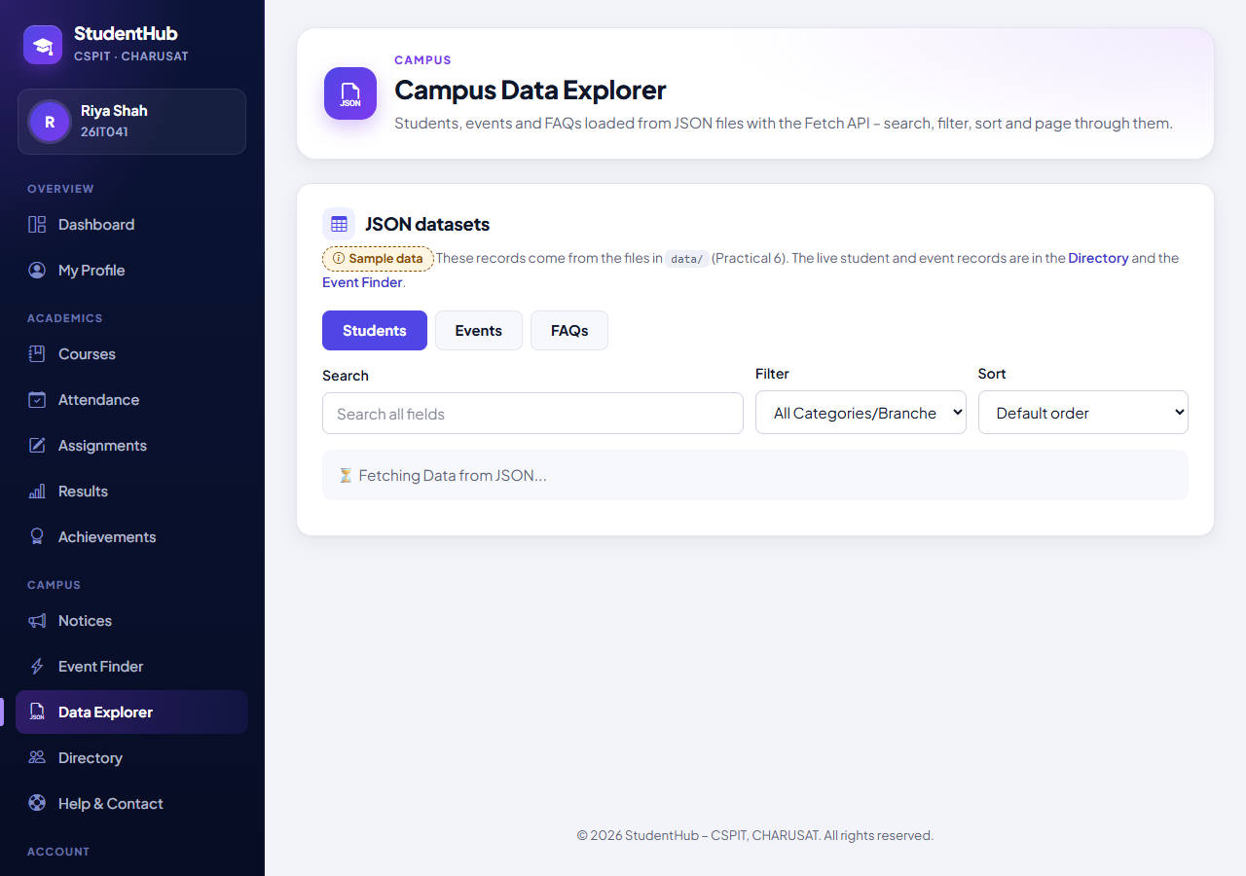
Figure 1: Loading state: while the request for data/students.json is still pending, the status area shows “⏳ Fetching Data from JSON...” below the controls; no table, description or page buttons are shown yet. (04-data-explorer-loading.png)
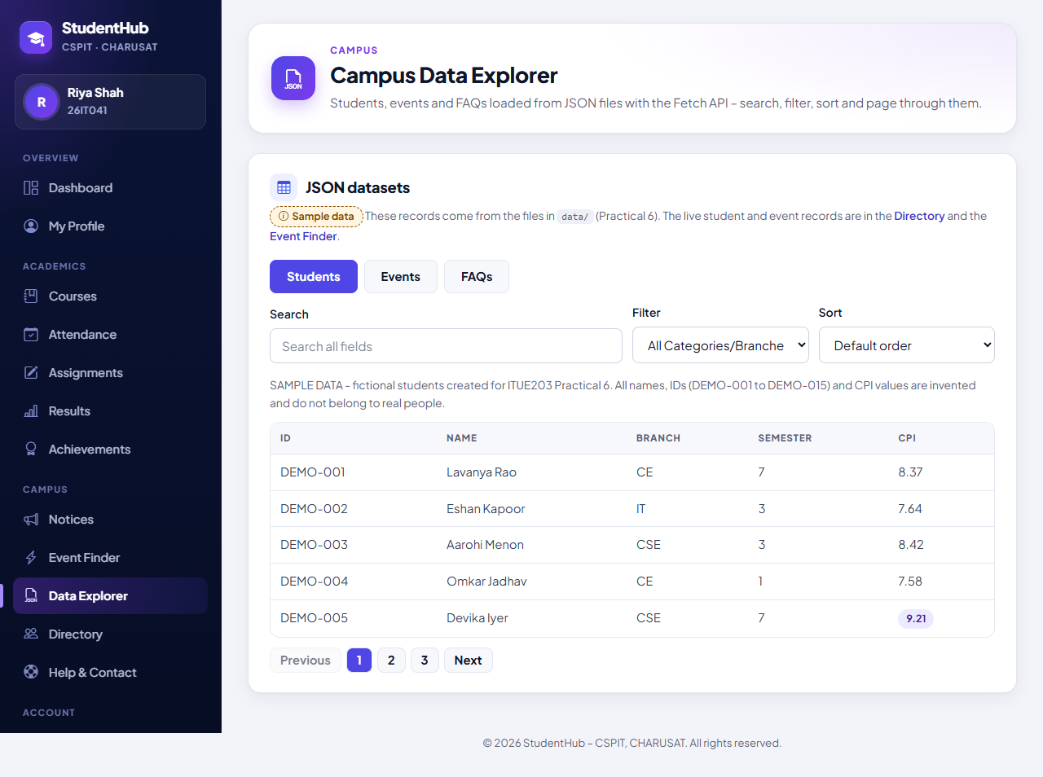
Figure 2: Students dataset loaded: the file's own description (“SAMPLE DATA - fictional students created for ITUE203 Practical 6. All names, IDs (DEMO-001 to DEMO-015) and CPI values are invented …”) above the table; page 1 of 3 with DEMO-001 to DEMO-005, columns taken from the JSON keys (ID, NAME, BRANCH, SEMESTER, CPI), and the CPI 9.21 highlighted with <mark>. (05-data-explorer-students.png)
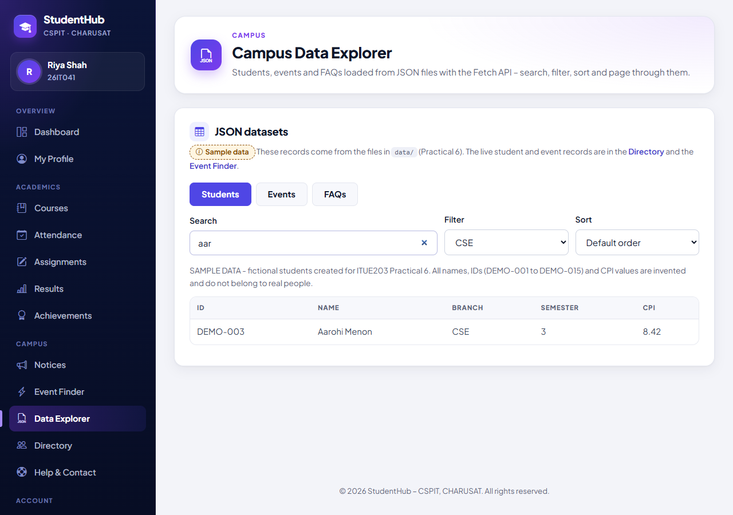
Figure 3: Search “aar” (a term the test derives from the data) combined with the branch filter CSE: exactly one record remains, DEMO-003 Aarohi Menon (CSE, semester 3, CPI 8.42); no page buttons are shown because the result fits on one page. (06-data-explorer-search-filter.png)
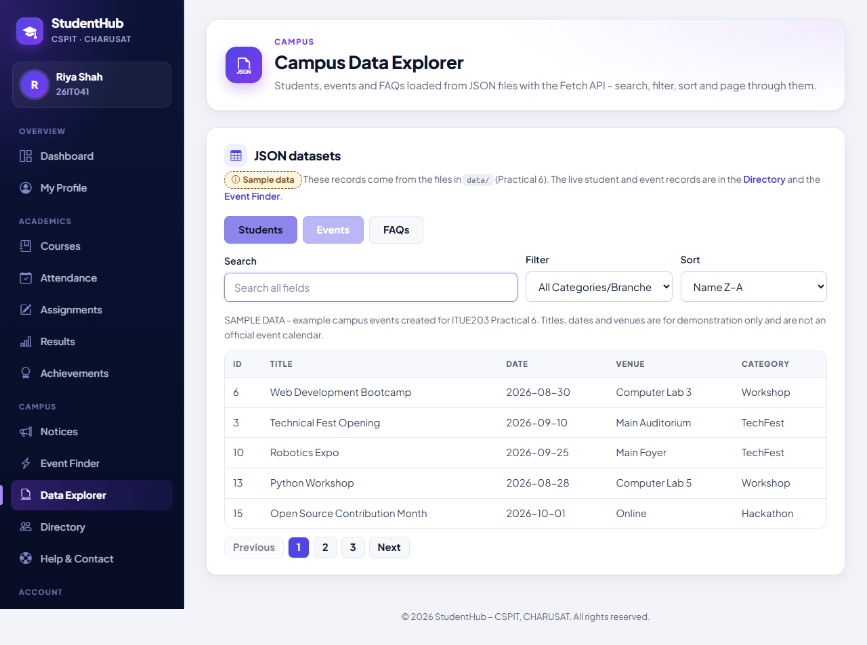
Figure 4: Events dataset (ID, TITLE, DATE, VENUE, CATEGORY) with its own SAMPLE DATA description, sorted “Name Z–A” by title: Web Development Bootcamp, Technical Fest Opening, Robotics Expo, Python Workshop, Open Source Contribution Month on page 1 of 3. (07-data-explorer-events-sorted.png)

9. Testing and Results
Environment of the recorded runs (31 October 2026): Windows 11, PHP 8.2.12 (XAMPP) built-in server on 127.0.0.1, MariaDB 10.4.32 for the disposable test database, Microsoft Edge in headless mode through Playwright. The complete run of all suites after these changes (tests/run_all_output.txt) passed 841 checks with 0 failures.
Suite | Scope | Result | Output file
tests/test_forms.py | HTTP tests of Practicals 5, 6 and 7 in the portal; 6 checks concern Practical 6 | 41 / 41 passed | tests/test_forms_output.txt
tests/browser_forms.py | Microsoft Edge checks and screenshots of Practicals 5–7; 5 checks concern Practical 6, two more cover the whole run (no JavaScript errors, no PHP warnings) | 15 / 15 passed | tests/browser_forms_output.txt

Practical 6 checks, copied from the saved outputs:
- data_explorer.php (signed in) has the tabs, search, filter, sort, status, table and pagination containers and loads data.js – PASS
- not signed in: redirected to the login page – PASS
- the sidebar links to the Data Explorer – PASS
- data/students.json, events.json and faqs.json are Practical 6's sample datasets (sampleData, description, 15 records each) – PASS
- the student dataset uses invented DEMO-001 … DEMO-015 ids (no real enrollment numbers) – PASS
- data.js fetches the JSON, handles errors, escapes every value and paginates (5 per page) – PASS
- Edge: Data Explorer: loading state while students.json is fetched (no table yet) – PASS
- Edge: the dataset's own 'SAMPLE DATA' description is shown above the table – PASS
- Edge: students rendered from JSON: 5 rows per page with pagination – PASS
- Edge: search 'aar' + branch filter CSE -> exactly the 1 matching CSE student(s) – PASS
- Edge: events tab sorted Z–A – PASS
- Edge (whole run): no JavaScript errors; no PHP warnings or errors in the server log – PASS
Note on the method: the sixth HTTP check searches the source of data.js for fetch, the use of data.records, response.ok, the catch block, the escaping of each value and the page size, and confirms that the old 800 ms delay is gone; the behaviour is checked in Edge.

9.1 Not tested
- The error state was not produced in a browser; it is covered only by the source check above, so there is no screenshot of an error message.
- The FAQs dataset (and its category filter) was checked over HTTP but not opened in Edge.
- Keyboard-only use, screen readers, browsers other than Edge and narrow (mobile) widths.

10. Differences from the Original Standalone Practical and Limitations
Aspect | Standalone Practical-6 (original report) | Integrated portal
Page and server | directory.html, Python http.server on port 8606, no login | data_explorer.php in the portal; sign-in required
Code structure | five ES modules (config, api, filters, render, main) | one script, data.js, with separate functions
Data | objects labelled as sample data with a records list; fictional DEMO-001… IDs | the same three files (byte-identical copies); the description is shown above the table
Search | listed fields only, spaces trimmed, matches highlighted with <mark> | all values of a record, not trimmed, no highlighting
Filter | branch, event category, FAQ category | the same: branch, event category, FAQ category
Sorting | several fields in both directions, aria-sort | one text field (name / title / question), A–Z or Z–A
Pagination | 5, 10 or 15 rows; aria-current | fixed 5 rows per page
Loading / errors | spinner, aria-busy, 8-second time-out, Retry button, error simulation panel | text message; error with the reason; no Retry button and no time-out
Cache (advanced) | last response kept in localStorage | none
Fast switching | request number + AbortController guard | no guard against a slow, older response
Tests | 29 static, 22 contrast and 93 Edge checks | 6 HTTP and 5 Edge checks within the 41 / 41 and 15 / 15 suites

10.1 Limitations
- JavaScript required: without JavaScript the page shows only the notice “The Data Explorer needs JavaScript.”
- Sample data: the JSON files are static sample files, not the portal's live records, and they are not kept in step with the database.
- Public files: the JSON files can be downloaded without signing in, although the page itself requires it; they contain only invented data.
- No retry or cache: after a failed request the user must click the dataset button again or reload the page.
- Accessibility: the dataset buttons are plain buttons in a role="group" (not the ARIA tabs pattern of the standalone version), and the sorted column is not marked with aria-sort.

11. Conclusion
The StudentHub portal now contains the Campus Data Explorer, studenthub/data_explorer.php, which loads Practical 6's anonymised students, events and FAQs datasets with the Fetch API and renders them as tables with search, filter, A–Z / Z–A sorting and pagination of 5 rows, all built with array methods. Each file's own “SAMPLE DATA” description is shown above the table, loading and error states are shown in a live region, every value from the files is HTML-escaped, and the page is reachable from the sidebar for signed-in users only.
The integrated version is deliberately simpler than the standalone one: the localStorage cache, the ES-module structure, the time-out and Retry button and the extra accessibility features remain in Practical-6/. The integration passed the HTTP suite (41 / 41) and the Edge suite (15 / 15), and the screenshots show the loading state, the loaded data with its description, a combined search and filter, and a sorted events list.

12. References
- ITUE203 Web Development Frameworks – Practical List 2026-27, Practical 6: “Rendering External JSON Data using Fetch API, Search and Filter”, CSPIT, CHARUSAT.
- StudentHub repository: https://github.com/TheEmperor08/StudentHub-ITUE203-25CS023 – folders studenthub/ (portal), Practical-6/ (original standalone version and its datasets), tests/, evidence/practical-05-07-integration/; TEST_REPORT.md sections 12 and 13.
- MDN – Using the Fetch API: https://developer.mozilla.org/en-US/docs/Web/API/Fetch_API/Using_Fetch
- MDN – Response.ok: https://developer.mozilla.org/en-US/docs/Web/API/Response/ok
- MDN – Array.prototype.filter(): https://developer.mozilla.org/en-US/docs/Web/JavaScript/Reference/Global_Objects/Array/filter
- MDN – String.prototype.localeCompare(): https://developer.mozilla.org/en-US/docs/Web/JavaScript/Reference/Global_Objects/String/localeCompare
- MDN – Node.textContent: https://developer.mozilla.org/en-US/docs/Web/API/Node/textContent
- MDN – ARIA live regions: https://developer.mozilla.org/en-US/docs/Web/Accessibility/ARIA/ARIA_Live_Regions

