CHAROTAR UNIVERSITY OF SCIENCE AND TECHNOLOGY (CHARUSAT)
Chandubhai S. Patel Institute of Technology (CSPIT)
Department of Computer Science & Engineering
ITUE203 – Web Development Frameworks

PRACTICAL 7

PHP Form Processing with Server-Side Validation and Stored Inquiries
PHP 8 · MySQLi prepared statements · MariaDB 10.4 · HTML5 · CSS3
Corrected submission – implemented in the integrated StudentHub portal (studenthub/)
Student Name | Shreyas
Roll Number | 25CS023
Student ID | 25CS023
Email | 25cs023@charusat.edu.in
Course | ITUE203 – Web Development Frameworks
Programme | B.Tech Computer Science & Engineering
Semester / Academic Year | 3 / 2026-27
Date of Submission
Faculty Signature

Corrected report. This report replaces the original Practical 7 report (Practical-7/PRAC_7_ITUE203_25CS023.docx, kept unchanged in the repository). The original report described the standalone application in Practical-7/ (index.php and records.php, storing submissions in a JSON file protected by flock()). This version describes the same server-side form processing on the portal's Help & Contact page studenthub/contact.php: valid inquiries are stored in the database table inquiries (migration 005) instead of a file, and administrators read and resolve them in the Admin Console. All screenshots in this report were taken from the canonical integrated application studenthub/ with Microsoft Edge on disposable test databases with fictional records; all test results are copied from the saved test outputs of the repository.

1. Aim and Objectives
To process the StudentHub inquiry (Help & Contact) form with PHP: receive the data with the POST method, validate and sanitise every field on the server, store valid inquiries safely, show clear success and error messages, and let the administrators work through the stored inquiries.
- Build an accessible PHP form whose data is sent with POST and processed only on the server.
- Validate empty and invalid inputs on the server – name, e-mail address, optional enrollment number, topic and message – without relying on JavaScript or browser checks.
- Sanitise the input and escape every value when it is displayed, so submitted text can never run as HTML.
- Store valid inquiries safely, also when several are sent at the same moment (in the portal: a database table instead of a file).
- Show a clear success message with a reference number after saving, and a message next to each invalid field.
- Intermediate extension: display the stored records – here as the Inquiries tab of the Admin Console.
- Advanced extension: protect the form with a CSRF token – here the portal's session token, checked on every POST.

2. Problem Definition
Official problem definition: “Process submitted registration/contact form data using PHP. Validate and sanitize inputs on the server side and store records in CSV or JSON file format. Display success/error messages.”
Practical 7 was first built as a standalone PHP application in Practical-7/ that appended valid submissions to private/submissions.json under an exclusive flock() lock. The integrated portal already had a Help & Contact page, but according to the audit in TEST_REPORT.md (section 12) “inquiries were not stored (only an audit line when signed in)”. The integration, as recorded there, stores validated inquiries in a new table inquiries (migration 005), gives the sender a reference number, adds a honeypot field and adds an Inquiries tab to the Admin Console; the validation and storage functions are in studenthub/includes/inquiries.php.
Storage format. The practical asks for CSV or JSON file storage. Inside the portal, which already keeps all its data in studenthub_db, the inquiries are stored in a database table instead. database/README.md explains the choice: “Practical 7 kept inquiries in a JSON file protected by flock(); in the portal the database provides the same safety for simultaneous submissions (tested with 8 parallel requests).” The JSON-file version with file locking remains unchanged in Practical-7/ and is described in the original report.

The practical list asks four key questions; the answers for the integrated implementation are:
Key question | Answer in the integrated portal
Is the form submitted using POST? | Yes. The form has method="POST" and action="contact.php"; the data is processed only when $_SERVER["REQUEST_METHOD"] is POST. A GET request only displays the form.
Are inputs validated and sanitized server side? | Yes. validate_inquiry() accepts only UTF-8 strings, trims every value, collapses spaces in the name, lower-cases the e-mail and upper-cases the enrollment number, and checks the name pattern and length, the e-mail with filter_var(), the enrollment-number format, the topic list and the message length (10–2000 characters). The form has novalidate and no validation script, so every check is made by PHP.
Is file writing handled safely? | In the portal no file is written. Each inquiry is one INSERT with a prepared statement; the InnoDB table gives every row its own AUTO_INCREMENT id, so simultaneous inquiries cannot overwrite each other – 8 parallel inquiries were all stored with different numbers. The table also enforces the topic list (ENUM) and the message length (CHECK).
Are success and error responses displayed clearly? | After saving, the page redirects (HTTP 303) and shows, once, a message with the sender's name and the reference number, e.g. “Thank you, Neha Rao. Your inquiry has been received by the A7 CSE helpdesk (reference #1).” (Figure 2). Invalid input returns HTTP 422 with “Please correct the highlighted fields. Your inquiry was not sent.”, a message under each invalid field and the entered values kept.

3. Tools and Technologies
Tool / technology | Use in this practical
PHP 8.2.12 (XAMPP), MySQLi | contact.php, includes/inquiries.php, admin_dashboard.php: processing, validation, sessions; prepared statements for INSERT, SELECT and UPDATE
MariaDB 10.4.32 | Table inquiries in studenthub_db (migration database/migrations/005_inquiries.sql)
HTML5, CSS3 | Form markup with labels and ARIA attributes; global.css for field messages and the hidden honeypot field
Bootstrap 5.3.2 (CSS) | Table, badge and button styles of the Admin Console
Python 3 (standard library) | tests/test_forms.py (HTTP tests) and database/tests/test_005_inquiries.py
Playwright + Microsoft Edge (headless) | tests/browser_forms.py: browser checks and the screenshots in Section 8
Git / GitHub | Version control; the integration is commit 938e74f of the StudentHub repository
Operating system | Windows 11

4. Place in the Integrated StudentHub Portal
The form is the portal's Help & Contact page, linked in the Campus group of the sidebar and from the home page (“Contact Us”). It is public: visitors can send an inquiry without an account. For a signed-in user the name, e-mail address and enrollment number are filled in from the linked students record, and the stored inquiry is linked to the account.
File / route | Role
studenthub/contact.php (route contact.php) | Form, POST processing, messages; public (optional_user()).
studenthub/includes/inquiries.php | INQUIRY_TOPICS, validate_inquiry(), save_inquiry(), list_inquiries(), inquiry_counts(), resolve_inquiry().
studenthub/admin_dashboard.php?tab=inquiries | Admin Console Inquiries tab: list, filter, mark as resolved.
studenthub/includes/auth.php | CSRF token functions, e(), redirect() (HTTP 303), the permissions admin.console and inquiries.manage (administrators only).
database/migrations/005_inquiries.sql / .down.sql | Creates (or removes) the inquiries table.
database/studenthub_demo.sql | Fresh installation; contains the inquiries table and records migrations 001–005.

Connections to the other integrated practicals: the CSRF token and sessions come from the integrated login (Practicals 9 and 10); every stored and resolved inquiry is written to the audit log and the Inquiries tab sits in the Admin Console of Practical 14; the inquiries table references users in the shared portal database studenthub_db, into which Practicals 8–15 are integrated step by step (database/README.md).

5. Implementation

5.1 The form
All values are printed with e(). The form keeps the field names of the earlier portal form (name, id, mail, topic, msg). When a field is invalid, PHP adds aria-invalid="true" and aria-describedby and prints the message in a <span class="field-error"> below it. The last field, website, is the honeypot: it is moved off-screen by CSS, hidden from screen readers (aria-hidden="true") and skipped by the Tab key (tabindex="-1").
studenthub/contact.php (lines 91–98) – start of the inquiry form: POST, CSRF token and the first field
91 <form action="contact.php" method="POST" novalidate>
92 <?= csrf_field() ?>
93 <fieldset>
94 <legend class="sr-only">Inquiry Form</legend>
95 <p>
96 <label for="name">Your Name:</label>
97 <input type="text" id="name" name="name" maxlength="100" autocomplete="name" value="<?= e($values["name"]) ?>" required<?= inquiry_attrs($errors, "name") ?>>
98 <?= inquiry_error($errors, "name") ?>

The enrollment number, e-mail, topic and message fields follow the same pattern (lines 100–123); the topic options are generated from INQUIRY_TOPICS. The honeypot field is a single line, followed by the two buttons:
studenthub/contact.php (lines 124–127) – the honeypot field and the buttons
124 <p class="hp-field" aria-hidden="true"><label for="website">Leave this field empty</label><input type="text" id="website" name="website" tabindex="-1" autocomplete="off"></p>
125 <p>
126 <button type="submit"><i class="bi bi-send" aria-hidden="true"></i> Send Inquiry</button>
127 <button type="reset">Clear</button>

5.2 POST processing (Post/Redirect/Get)
When the request is a POST, the CSRF token is checked first (require_valid_csrf(), Section 7). The input is then validated; the submitted strings are kept for redisplay. A valid inquiry is stored, an audit entry is written, the success message is put into the session (flash()) and the browser is redirected back to contact.php with HTTP 303, so refreshing the page cannot send the inquiry again. Invalid input returns HTTP 422 and the form is shown again.
studenthub/contact.php (lines 16–28) – processing of the submitted form
16 if ($_SERVER["REQUEST_METHOD"] === "POST") {
17 require_valid_csrf();
18 [$clean, $errors] = validate_inquiry($_POST);
19 foreach (INQUIRY_FIELDS as $field) {
20 $values[$field] = is_string($_POST[$field] ?? null) ? $_POST[$field] : "";
21 }
22 if (!$errors) {
23 $inquiry_id = save_inquiry($conn, $clean, $current_user["id"] ?? null);
24 log_audit($conn, $current_user["id"] ?? null, $current_user["username"] ?? "guest", "SUBMIT_INQUIRY", "Inquiry #$inquiry_id stored (topic: {$clean["topic"]})", "SUCCESS");
25 flash("success", "Thank you, {$clean["name"]}. Your inquiry has been received by the A7 CSE helpdesk (reference #$inquiry_id).");
26 redirect("contact.php");
27 }
28 http_response_code(422);

5.3 Server-side validation and sanitising
studenthub/includes/inquiries.php (lines 11–63) – validate_inquiry()
11 function validate_inquiry(array $input): array
12 {
13 $errors = [];
14 $raw = [];
15 foreach (INQUIRY_FIELDS as $field) {
16 $value = $input[$field] ?? '';
17 if (!is_string($value) || !mb_check_encoding($value, 'UTF-8')) {
18 $errors[$field] = 'This field contains characters that are not allowed.';
19 $value = '';
20 }
21 $raw[$field] = trim($value);
22 }
23 $clean = [
24 'name' => (string) preg_replace('/\s+/u', ' ', $raw['name']),
25 'email' => strtolower($raw['mail']),
26 'enrollment_no' => $raw['id'] === '' ? null : strtoupper($raw['id']),
27 'topic' => $raw['topic'] === '' ? 'General' : $raw['topic'],
28 'message' => str_replace("\r\n", "\n", $raw['msg']),
29 ];
30 if (!isset($errors['name'])) {
31 if ($clean['name'] === '') {
32 $errors['name'] = 'Please enter your name.';
33 } elseif (mb_strlen($clean['name'], 'UTF-8') < 2 || mb_strlen($clean['name'], 'UTF-8') > 100) {
34 $errors['name'] = 'The name must be 2–100 characters long.';
35 } elseif (!preg_match("/^\\p{L}[\\p{L}\\p{M} .'-]*$/u", $clean['name'])) {
36 $errors['name'] = 'Use letters, spaces, apostrophes, dots and hyphens only.';
37 }
38 }
39 if (!isset($errors['mail'])) {
40 if ($clean['email'] === '') {
41 $errors['mail'] = 'Please enter your email address.';
42 } elseif (strlen($clean['email']) > 100 || filter_var($clean['email'], FILTER_VALIDATE_EMAIL) === false) {
43 $errors['mail'] = 'Please enter a valid email address, e.g. name@example.com.';
44 }
45 }
46 if (!isset($errors['id']) && $clean['enrollment_no'] !== null && !preg_match('/^[0-9]{2}[A-Z]{2}[0-9]{3}$/', $clean['enrollment_no'])) {
47 $errors['id'] = 'Use the enrollment number format 2 digits, 2 letters, 3 digits (e.g. 25CS023), or leave it empty.';
48 }
49 if (!isset($errors['topic']) && !in_array($clean['topic'], INQUIRY_TOPICS, true)) {
50 $errors['topic'] = 'Please choose a topic from the list.';
51 }
52 if (!isset($errors['msg'])) {
53 $length = mb_strlen($clean['message'], 'UTF-8');
54 if ($length === 0) {
55 $errors['msg'] = 'Please enter your message.';
56 } elseif ($length < 10 || $length > 2000) {
57 $errors['msg'] = 'The message must be 10–2000 characters long.';
58 }
59 }
60 if (($input['website'] ?? '') !== '') { // honeypot: invisible to people, often filled in by bots
61 $errors['msg'] = 'The inquiry could not be accepted.';
62 }
63 return [$clean, $errors];

Field | Sanitising | Rule | Message
Your Name (name) | trimmed; runs of white space become one space | required; 2–100 characters; /^\p{L}[\p{L}\p{M} .'-]*$/u | Please enter your name. / The name must be 2–100 characters long. / Use letters, spaces, apostrophes, dots and hyphens only.
Enrollment Number (id, optional) | trimmed, upper-cased; empty becomes NULL | /^[0-9]{2}[A-Z]{2}[0-9]{3}$/ | Use the enrollment number format 2 digits, 2 letters, 3 digits (e.g. 25CS023), or leave it empty.
Email (mail) | trimmed, lower-cased | required; at most 100 characters; filter_var(…, FILTER_VALIDATE_EMAIL) | Please enter your email address. / Please enter a valid email address, e.g. name@example.com.
Topic (topic) | trimmed; empty becomes General | one of General, Academics, Events, Portal access, Other | Please choose a topic from the list.
Message (msg) | trimmed; CR LF line breaks become LF | required; 10–2000 characters (mb_strlen) | Please enter your message. / The message must be 10–2000 characters long.
Every field | – | must be a string with valid UTF-8 (an array such as msg[] is refused) | This field contains characters that are not allowed.
Honeypot (website) | – | must be empty | The inquiry could not be accepted. (shown under the message)

Sanitising here means normalising the value that is stored; HTML is not removed or encoded before storage. Instead, every value is escaped at the moment it is printed (Section 7), so the stored text stays exactly what the sender wrote.

5.4 Storing and reading inquiries
save_inquiry() inserts one row with a prepared statement and returns the new id, which is shown to the sender as the reference number. user_id is the id of the signed-in account, or NULL for a visitor. list_inquiries() reads the newest inquiries (at most 100), optionally only those with the status new or resolved, and joins users to show the account name.
studenthub/includes/inquiries.php (lines 66–71) – save_inquiry() (list_inquiries() follows in lines 74–87)
66 function save_inquiry(mysqli $db, array $clean, ?int $user_id): int
67 {
68 $stmt = $db->prepare('INSERT INTO inquiries (user_id, name, email, enrollment_no, topic, message) VALUES (?, ?, ?, ?, ?, ?)');
69 $stmt->bind_param('isssss', $user_id, $clean['name'], $clean['email'], $clean['enrollment_no'], $clean['topic'], $clean['message']);
70 $stmt->execute();
71 return (int) $stmt->insert_id;

5.5 Displaying the stored records – Admin Console Inquiries tab (intermediate extension)
The Admin Console (admin_dashboard.php) is open only to administrators (admin.console). Its Inquiries tab shows a badge with the number of new inquiries, the counts of new and stored inquiries (e.g. “2 new, 2 in total”), a filter (All / New / Resolved) and a table with the columns #, Received, From, Topic, Message, Status and Action. Every value is escaped with e(); the message keeps its line breaks (white-space: pre-wrap). An open inquiry has a Resolved button – a small POST form with the CSRF token; a resolved one shows the time it was resolved. The markup is the block “INQUIRIES TAB” in admin_dashboard.php (lines 1190–1232); Figures 3 and 4 show it rendered.
Marking an inquiry as resolved is accepted only as a POST with a valid CSRF token and the permission inquiries.manage. resolve_inquiry() changes only an inquiry whose status is still new (UPDATE … WHERE id = ? AND status = 'new'), so resolving twice gives the message “That inquiry was not found or is already resolved.”
studenthub/admin_dashboard.php (lines 168–177) – the resolve action
168 // Help & Contact inquiries (Practical 7): mark as resolved – admins only (inquiries.manage)
169 if ($get_action === "resolve_inquiry") {
170 require_permission("inquiries.manage");
171 if ($target_id > 0 && resolve_inquiry($conn, $target_id)) {
172 log_audit($conn, $current_user["id"], $current_user["username"], "RESOLVE_INQUIRY", "Inquiry #$target_id marked as resolved", "SUCCESS");
173 flash("success", "Inquiry #$target_id was marked as resolved.");
174 } else {
175 flash("error", "That inquiry was not found or is already resolved.");
176 }
177 redirect("admin_dashboard.php?tab=inquiries");

6. Database and Relationships
Migration 005 adds one table to studenthub_db and changes nothing else:
database/migrations/005_inquiries.sql (lines 35–51) – the inquiries table
35 CREATE TABLE IF NOT EXISTS inquiries (
36 id INT(11) NOT NULL AUTO_INCREMENT,
37 user_id INT(11) DEFAULT NULL,
38 name VARCHAR(100) NOT NULL,
39 email VARCHAR(100) NOT NULL,
40 enrollment_no VARCHAR(20) DEFAULT NULL,
41 topic ENUM('General', 'Academics', 'Events', 'Portal access', 'Other') NOT NULL DEFAULT 'General',
42 message TEXT NOT NULL,
43 status ENUM('new', 'resolved') NOT NULL DEFAULT 'new',
44 created_at TIMESTAMP NOT NULL DEFAULT CURRENT_TIMESTAMP,
45 resolved_at DATETIME DEFAULT NULL,
46 PRIMARY KEY (id),
47 KEY idx_inquiries_status (status, created_at),
48 KEY idx_inquiries_user (user_id),
49 CONSTRAINT fk_inquiries_user FOREIGN KEY (user_id) REFERENCES users (id) ON DELETE SET NULL ON UPDATE CASCADE,
50 CONSTRAINT chk_inquiries_message CHECK (CHAR_LENGTH(message) BETWEEN 10 AND 2000)
51 ) ENGINE=InnoDB DEFAULT CHARSET=utf8mb4 COLLATE=utf8mb4_unicode_ci;

Element | Meaning
id INT AUTO_INCREMENT, primary key | The reference number shown to the sender (#1, #2, …).
user_id → users.id, fk_inquiries_user | Optional link to the signed-in account (NULL for visitors). ON DELETE SET NULL: deleting an account keeps its inquiries; ON UPDATE CASCADE.
topic ENUM | The same five values as INQUIRY_TOPICS in PHP; default General.
message TEXT + CHECK chk_inquiries_message | CHAR_LENGTH(message) BETWEEN 10 AND 2000 – the PHP rule repeated in the database.
status ENUM('new', 'resolved') | Default new; resolved_at is set when an administrator resolves the inquiry.
Indexes | idx_inquiries_status (status, created_at) for the filter, idx_inquiries_user (user_id) for the foreign key.

Relationship: users 1 : 0..n inquiries through the optional inquiries.user_id. The table is InnoDB with utf8mb4_unicode_ci, like the other portal tables.
- Preconditions: the script stops with a message if no database is selected, if migration 004 is not recorded, or if a different inquiries table already exists.
- Verification and record: after creating the table it checks that fk_inquiries_user references users with the delete rule SET NULL, and records version 005 in schema_migrations.
- Rollback: 005_inquiries.down.sql drops the table – and with it every stored inquiry – and removes the 005 record.
- Live database: according to database/README.md, migration 005 was applied to the live database on 31 Oct 2026 after a verified backup; the read-only check --verify-live passed 4 / 4.
- Why PHP validation still matters: the database README notes that XAMPP runs MariaDB without strict mode, so values that break no CHECK (for example a too-long text) would be silently adjusted; PHP therefore checks every length first.

7. Validation and Security

7.1 CSRF token (advanced extension)
The portal creates one random token per session (bin2hex(random_bytes(32)), renewed at login), puts it into every POST form with csrf_field() and compares it with hash_equals(). A POST without a valid token is stopped with HTTP 403 and written to the audit log as CSRF_REJECTED with the status SECURITY_BLOCK; nothing is stored.
studenthub/includes/auth.php (lines 95–110) – CSRF token check (the token is created by csrf_token(), lines 82–88)
95 function csrf_is_valid($submitted): bool
96 {
97 $expected = $_SESSION['csrf_token'] ?? null;
98 return is_string($expected) && is_string($submitted) && $submitted !== '' && hash_equals($expected, $submitted);
99 }
100
101 // For POST handlers: a missing or wrong token stops the request (HTTP 403) and is written to the audit log
102 function require_valid_csrf(): void
103 {
104 if (csrf_is_valid($_POST['csrf_token'] ?? null)) {
105 return;
106 }
107 global $conn;
108 log_audit($conn, isset($_SESSION['user_id']) ? (int) $_SESSION['user_id'] : null, $_SESSION['username'] ?? 'guest',
109 'CSRF_REJECTED', 'POST to ' . basename($_SERVER['SCRIPT_NAME'] ?? '') . ' without a valid token', 'SECURITY_BLOCK');
110 studenthub_fail(403, 'Security check failed', 'This form has expired or was not sent from StudentHub. Go back, reload the page and try again. Nothing was changed.');

7.2 Other measures
- Escaping on output: e() is htmlspecialchars() with ENT_QUOTES | ENT_SUBSTITUTE and UTF-8. It is used for the values shown again in the form, for the success message and for every cell of the Admin Console. Tested with <b>Bold</b> as a name and a stored message containing <script>alert(1)</script>: both appear as text.
- SQL injection: all queries with user input use prepared statements; inquiry_counts() runs a fixed query without input.
- Honeypot: the hidden website field is invisible to people; a simple bot that fills every field is refused with HTTP 422 and nothing is stored.
- Type and encoding checks: arrays and invalid UTF-8 are refused in every field.
- Access control: the Admin Console requires admin.console, the resolve action inquiries.manage (both administrators only); a GET request with action=resolve_inquiry changes nothing; students and editors receive HTTP 403.
- Audit and privacy: a stored inquiry writes SUBMIT_INQUIRY (details: “Inquiry #… stored (topic: …)”) and resolving writes RESOLVE_INQUIRY. The audit entry does not contain the message text. The inquiries table stores no IP address; like every audit entry of the portal, the audit row records the IP address and browser string.
- Post/Redirect/Get: the success message is stored in the session, shown once after the 303 redirect, and a page refresh cannot repeat the submission.

7.3 Accessibility of the form
Every control has a visible label (for/id), and the fields are grouped in a fieldset with the screen-reader legend “Inquiry Form”. Invalid fields get aria-invalid="true" and aria-describedby pointing to their message; the general error box has role="alert" and the success box role="status". The honeypot is hidden from screen readers and from keyboard navigation.

8. Output Screenshots
All screenshots are genuine full-page captures in Microsoft Edge (headless, driven by Playwright, viewport 1280 px wide), made by tests/browser_forms.py on 31 October 2026 against the PHP built-in server and a disposable database. The senders “Neha Rao” (visitor) and “Riya Shah” (student account riya_shah) and the administrator portal_admin are fictional test data.
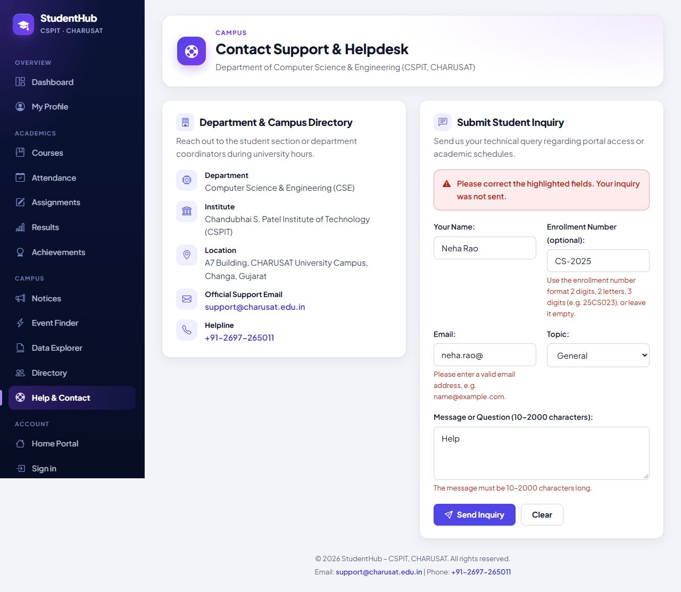
Figure 1: Server-side validation: a visitor submitted name Neha Rao, enrollment number CS-2025, e-mail neha.rao@ and the message “Help”. The page shows “Please correct the highlighted fields. Your inquiry was not sent.” and a message under the enrollment number, the e-mail and the message; all entered values are kept. The test confirmed that nothing was stored. (08-contact-validation.png)
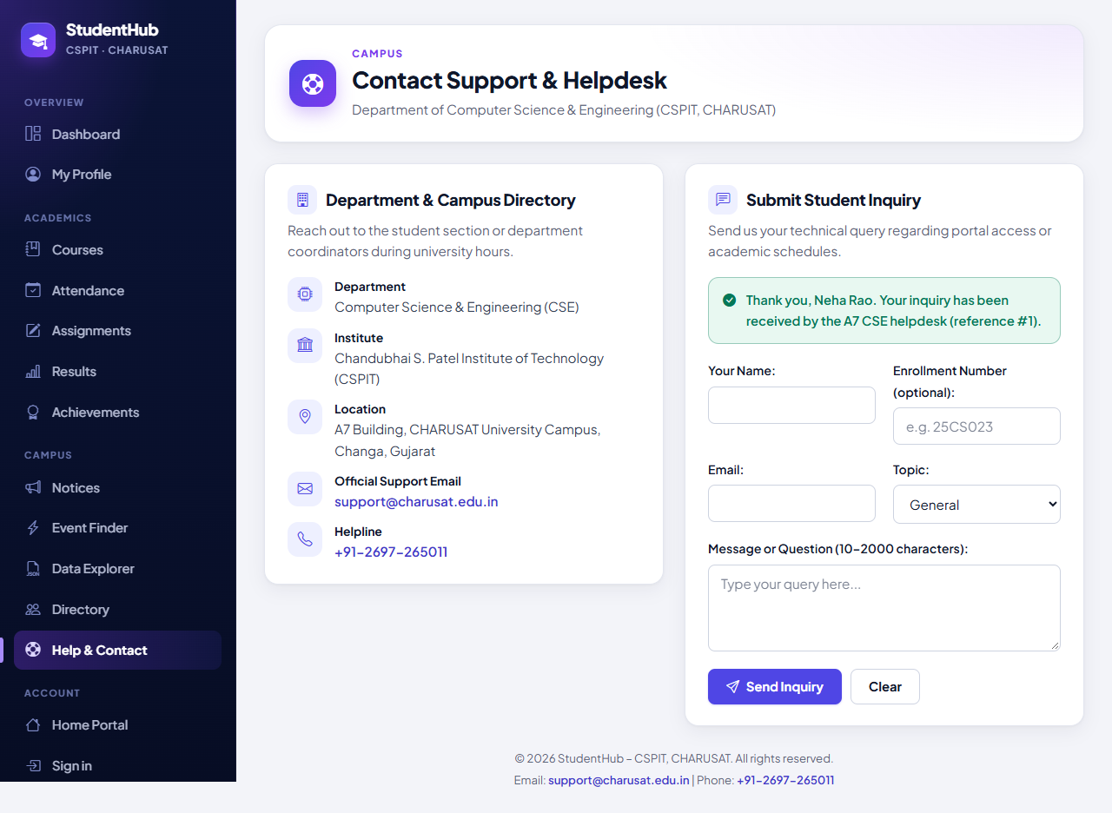
Figure 2: After correcting the e-mail, leaving the enrollment number empty, choosing the topic Portal access and writing a longer message: following the 303 redirect the page shows “Thank you, Neha Rao. Your inquiry has been received by the A7 CSE helpdesk (reference #1).” and an empty form. (09-contact-success.png)
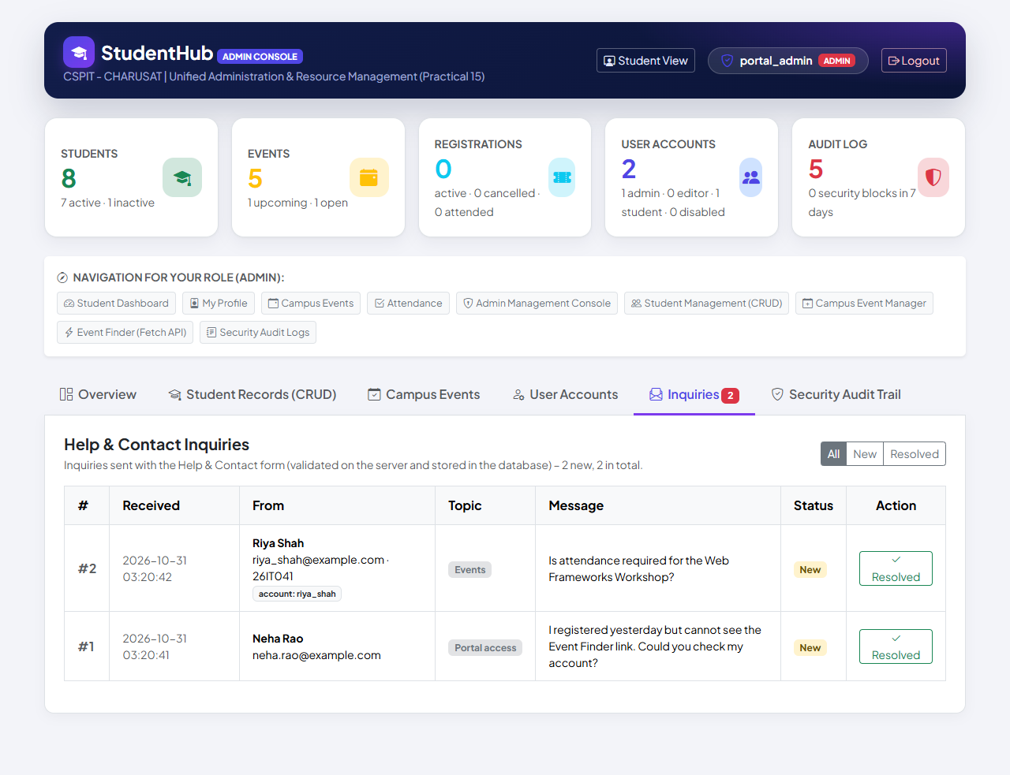
Figure 3: Admin Console, Inquiries tab (badge 2, “2 new, 2 in total”), newest first: #2 from the signed-in student Riya Shah (riya_shah@example.com · 26IT041, badge “account: riya_shah”, topic Events) and #1 from the visitor Neha Rao (topic Portal access); both have the status New and a Resolved button. (10-admin-inquiries.png)
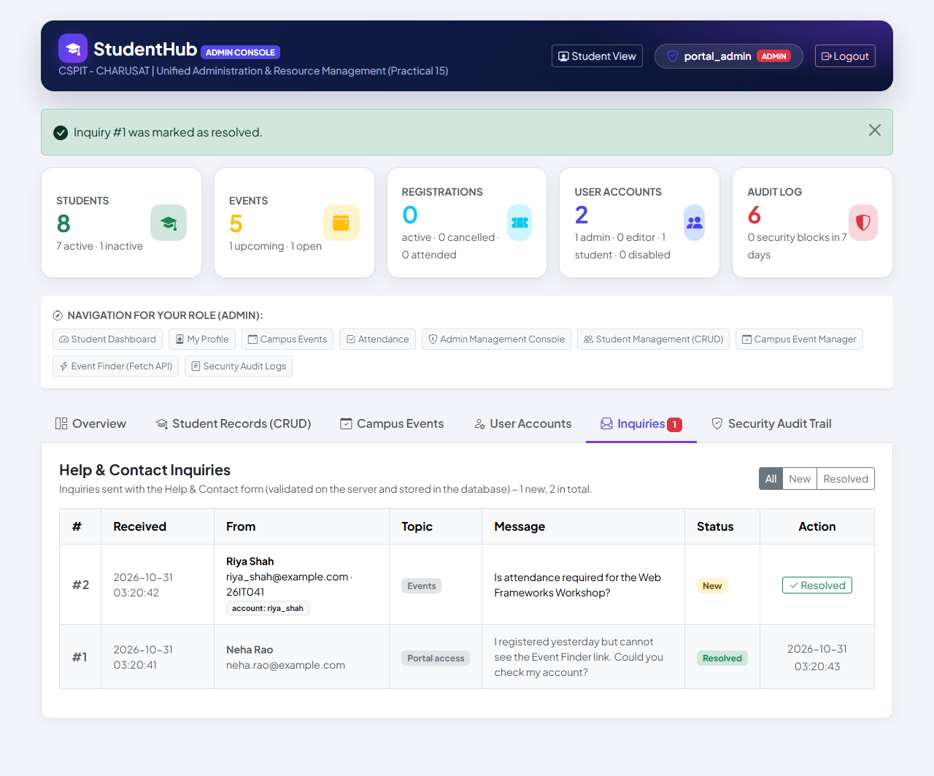
Figure 4: After clicking Resolved for #1: the message “Inquiry #1 was marked as resolved.”, the tab badge shows 1 (“1 new, 2 in total”), and row #1 shows the status Resolved with the time 2026-10-31 03:20:43 instead of the button. (11-inquiry-resolved.png)

9. Testing and Results
Environment of the recorded runs (31 October 2026): Windows 11, PHP 8.2.12 (XAMPP) built-in server on 127.0.0.1, MariaDB 10.4.32, Microsoft Edge in headless mode through Playwright. All suites work on disposable databases; test_forms.py confirms at the end that the live studenthub_db was not touched, and the migration test reads the live database only with --verify-live. The complete run of all suites (tests/run_all_output.txt) passed 841 checks with 0 failures.
Suite | Scope | Result | Output file
tests/test_forms.py | HTTP tests of Practicals 5–7; 19 checks of the contact form and 9 of the Admin Console Inquiries tab concern Practical 7 | 41 / 41 passed | tests/test_forms_output.txt
tests/browser_forms.py | Microsoft Edge checks and screenshots; 4 checks concern Practical 7, two more cover the whole run (no unexpected JavaScript errors, no PHP warnings) | 15 / 15 passed | tests/browser_forms_output.txt
database/tests/test_005_inquiries.py (fixture) | Migration 005 on a fixture with migrations 001–004 | 14 / 14 passed | database/tests/test_005_output.txt
test_005_inquiries.py --source-dump | Migration 005 on a real dump in a disposable database (result recorded in TEST_REPORT.md section 12) | 14 / 14 passed | –
test_005_inquiries.py --verify-live | Read-only comparison of the live database with the baseline upgraded with 005 | 4 / 4 passed | database/tests/test_005_verify_live_output.txt

Key checks, summarised from the saved outputs (all PASS):
- Form and storage: contact.php is public with a CSRF token, a topic list and a hidden honeypot field; a valid visitor inquiry -> 303 back to the form, stored with the e-mail in lower case, the enrollment number in upper case, status new and no account; the success message names the reference number once; SUBMIT_INQUIRY audit entry without the message text.
- Refused input (HTTP 422 with the matching message): empty name, name with digits, invalid e-mail, wrong enrollment format, unknown topic, message under 10 or over 2000 characters, field sent as an array, honeypot filled in; rejected input is shown again HTML-escaped; nothing was stored; without the CSRF token -> 403, nothing stored.
- Signed-in student and concurrency: fields prefilled from the linked record and the inquiry linked to the account (user_id); 8 simultaneous inquiries -> all 8 stored with different reference numbers.
- Admin Console: newest first with a 'new' badge count; messages HTML-escaped; CSRF token in every POST form; GET or a POST without token changes nothing (403); mark as resolved stores the time and a RESOLVE_INQUIRY entry; resolving again -> error message; filter 'Resolved' works; student and editor -> 403.
- Migration 005: only the new table changes; FK ON DELETE SET NULL; existing rows unchanged; repeatable; CHECK refuses a short message; deleting an account keeps its inquiry; rollback and re-apply; precondition stop; fresh install identical.
- Edge: the four steps of Figures 1–4 and no JavaScript errors other than the intended 422 response (the browser's automatic /favicon.ico request got 404 – a known, pre-existing item: the portal has no favicon).

9.1 Not tested
- Running the portal under Apache (all recorded runs used PHP's built-in server).
- Screen readers, a physical keyboard, browsers other than Edge and narrow (mobile) widths.
- A database failure while an inquiry is being stored.

10. Differences from the Original Standalone Practical and Limitations
Aspect | Standalone Practical-7 (original report) | Integrated portal
Application | index.php (form + processing) and records.php; PHP built-in server on port 8607 with router.php | studenthub/contact.php in the portal, plus the Admin Console tab
Fields | full name, e-mail, category (5), message 10–1000 characters | name, optional enrollment number, e-mail, topic (5), message 10–2000 characters
Storage | private/submissions.json under flock(LOCK_EX); IDs SUB-0001, SUB-0002, …; damaged files backed up | table inquiries (migration 005); ids #1, #2, …; prepared INSERT; ENUM, CHECK and foreign key
Display of stored records | records.php, a local demonstration page for everyone | Admin Console Inquiries tab, administrators only, with a filter and “mark as resolved”
CSRF | own token, renewed after every successful submission; HTTP 400 on failure | the portal's session token (renewed at login); HTTP 403 and an audit entry on failure
Bot protection | none | honeypot field website
Signed-in users | – (no login) | fields prefilled from the student record; inquiry linked to the account
Tests | 63 / 63 checks (tests/test_form.py) | 19 + 9 HTTP checks, 4 Edge checks, migration tests 14 / 14, 14 / 14, 4 / 4

10.1 Limitations
- Storage format: the inquiries are stored in a database table, not in a CSV or JSON file as the problem definition asks; the file-based version remains in Practical-7/.
- No e-mail: the portal sends no e-mail – DEPLOYMENT.md states that inquiry answers are not implemented. The helpdesk can only mark an inquiry as resolved.
- No delete or reopen: the console offers only “mark as resolved”; it lists at most the newest 100 inquiries.
- Simple bot protection: the honeypot stops only simple bots; there is no limit on the number of inquiries per sender.
- No client-side checks: the contact page has HTML5 attributes but novalidate and no validation script, so errors are shown only after the page has been sent to the server.
- Rollback: undoing migration 005 deletes every stored inquiry; export them first if they are needed.

11. Conclusion
The StudentHub Help & Contact form is now processed entirely by PHP inside the integrated portal. Data is sent with POST and a CSRF token, sanitised and validated on the server, and every valid inquiry is stored in the inquiries table of studenthub_db with a prepared statement – 8 simultaneous inquiries were all stored with distinct reference numbers. Senders see a success message with the reference number after a 303 redirect, or a general message and field-level messages with their input kept; every displayed value is escaped, and a honeypot field refuses simple bots.
Both extensions are integrated: the stored records are displayed in the Admin Console's Inquiries tab, where administrators filter them and mark them as resolved (intermediate), and CSRF protection guards both the form and the resolve action (advanced). The integration passed the HTTP suite (41 / 41), the Edge suite (15 / 15) and the migration tests (14 / 14, 14 / 14 and 4 / 4). The one deliberate deviation from the problem definition – database storage instead of a CSV/JSON file – is explained in Section 2 and Section 10.

12. References
- ITUE203 Web Development Frameworks – Practical List 2026-27, Practical 7: “PHP Form Processing with Server-Side Validation and CSV/JSON File Storage”, CSPIT, CHARUSAT.
- StudentHub repository: https://github.com/TheEmperor08/StudentHub-ITUE203-25CS023 – folders studenthub/ (portal), database/ (migration 005 and its tests), Practical-7/ (original standalone version), tests/, evidence/practical-05-07-integration/; TEST_REPORT.md section 12; database/README.md.
- PHP Manual – Dealing with forms: https://www.php.net/manual/en/tutorial.forms.php
- PHP Manual – filter_var and validate filters: https://www.php.net/manual/en/filter.filters.validate.php
- PHP Manual – htmlspecialchars: https://www.php.net/manual/en/function.htmlspecialchars.php
- PHP Manual – mysqli prepared statements: https://www.php.net/manual/en/mysqli.quickstart.prepared-statements.php
- MariaDB Knowledge Base – CONSTRAINT (CHECK and FOREIGN KEY): https://mariadb.com/kb/en/constraint/
- OWASP Cheat Sheet – Cross-Site Request Forgery Prevention: https://cheatsheetseries.owasp.org/cheatsheets/Cross-Site_Request_Forgery_Prevention_Cheat_Sheet.html

