CHAROTAR UNIVERSITY OF SCIENCE AND TECHNOLOGY (CHARUSAT)
Chandubhai S. Patel Institute of Technology (CSPIT)
Department of Computer Science & Engineering
ITUE203 – Web Development Frameworks

PRACTICAL 8

Database Design for StudentHub – Students, Events and Registrations in the Shared Portal Database
MariaDB 10.4 (studenthub_db) · migration 001 · InnoDB keys and constraints · PHP 8 MySQLi · phpMyAdmin
Corrected submission – implemented in the integrated StudentHub portal (studenthub/)
Student Name | Shreyas
Roll Number | 25CS023
Student ID | 25CS023
Email | 25cs023@charusat.edu.in
Course | ITUE203 – Web Development Frameworks
Programme | B.Tech Computer Science & Engineering
Semester / Academic Year | 3 / 2026-27
Date of Submission
Faculty Signature

Corrected report. This report replaces the original Practical 8 report (Practical-8/PRAC_8_ITUE203_25CS023.docx, kept unchanged in the repository). The original report describes a standalone database studenthub_prac8 (UNSIGNED keys, two stored procedures, a PDO test page test_connection.php). This corrected version describes the same design as it now exists in the shared portal database studenthub_db: migration 001 adds the registrations table, the student–account link, event time and capacity and the CHECK and foreign-key rules to the existing portal tables without replacing them; the capacity rule is a PHP transaction instead of a stored procedure, and the portal connects with MySQLi. All screenshots in this report were taken from the canonical integrated application studenthub/ with Microsoft Edge on disposable test databases with fictional records; all test results are copied from the saved test outputs of the repository.

1. Aim and Objectives
To design a normalised MySQL/MariaDB database for StudentHub with students, events and registrations and to connect to it securely from PHP with prepared statements – as the database of the one integrated portal (studenthub/), so that registration, login, event registration and the Admin Console all use the same records.
- Model the data with an entity–relationship view and keep the tables in Third Normal Form (3NF).
- Define primary, foreign and unique keys, CHECK constraints, indexes and suitable data types.
- Add the design to the existing portal database without changing any existing value (migration with preconditions, verification and rollback), and provide fictional demo data for new installations (no accounts, no password hashes).
- Connect from PHP without ever showing credentials or database errors, use prepared statements for every query with a value, and enforce the event capacity without overbooking, also for simultaneous requests.
- Test every part on disposable databases and record only results that were actually executed.

2. Problem Definition
Official problem definition (from the original report): “Design the database for StudentHub with students, events and registrations. Create PHP database connection using MYSQL statements.”
A student registers for many events and an event has many students, so the relationship must be resolved without repeating student or event details. The database must refuse invalid data – a registration for a missing student or event, the same student twice for one event, a semester outside 1–8, a capacity of zero – and PHP must connect safely. In the portal there was a second problem: studenthub_db already existed with its own column names (enrollment_no, name, course, location), signed INT(11) keys, the roles admin, editor and student and real accounts. A separate Practical 8 database would have created a second, diverging set of students and events, so the design had to be added to the existing tables by a migration that changes no existing value.
Key question | Answer in the integrated portal
Is the schema normalised properly? | Yes – student data only in students, event data only in events, the many-to-many relationship resolved by registrations; single surrogate keys, no transitive dependencies (Section 5.3).
Are primary and foreign keys correctly defined? | Every table has an AUTO_INCREMENT primary key; registrations has two CASCADE foreign keys and a unique (student_id, event_id) pair; the tests confirmed that invalid references are refused (Section 10).
Is the connection handled securely? | Yes – MySQLi in exception mode, utf8mb4, settings from the environment, no fallback database, a general HTTP 503 page and the real reason only in the server log (Section 7).

3. Requirements and Tools
Item | Version / use
XAMPP (Windows 11) | PHP 8.2.12 with mysqli; MariaDB 10.4.32 (database studenthub_db, InnoDB, utf8mb4_unicode_ci); phpMyAdmin
mysql command-line client | C:\xampp\mysql\bin\mysql.exe – applies the migration and the demo file (database/README.md)
phpMyAdmin | XAMPP's phpMyAdmin (http://localhost/phpmyadmin) – tables, relations, Designer view and a JOIN query (Figures 1–6)
Python 3 / Microsoft Edge + Playwright | database/tests/test_001_practical8_foundation.py, tests/run_all.py; tests/browser_database_evidence.py (screenshots)
Git / GitHub | Commit 37b35e6 – Practical 8 foundation in the portal database

4. Place in the Integrated Portal
Practical 8 is the database foundation of the portal. The files below define, document and test studenthub_db; the portal's PHP code uses it through one connection.
File | Role
database/migrations/001_practical8_foundation.sql (+ .down.sql) | Upgrades an existing studenthub_db to the Practical 8 design; schema rollback
database/studenthub_demo.sql | Current schema (migrations 001–005) with fictional demo rows for a new installation
database/README.md | Relationships, Practical 8 mapping, setup, rollback, MariaDB DDL limitations, test results
studenthub/db.php | The portal's MySQLi connection
studenthub/includes/event_registration.php | register_student_for_event() – capacity rule in one transaction (replaces the stored procedure)
database/tests/test_001_practical8_foundation.py | Migration and behaviour tests on disposable databases plus a read-only live check

database/README.md maps the original design to the portal database:
Practical 8 (studenthub_prac8) | Portal database (studenthub_db) | Note
registrations (CASCADE FKs, UNIQUE student+event, status ENUM) | registrations – same columns and rules | keys signed INT(11) like the portal's primary keys (P8: UNSIGNED)
students.semester TINYINT, CHECK 1–8 | INT(11), CHECK NULL or 1–8 | NULL allowed for legacy rows
events.capacity NOT NULL, CHECK > 0 | NULL, CHECK NULL or > 0; new event_time | existing events: NULL = no limit (nothing invented)
student_code, full_name, venue, branch | enrollment_no, name, location, course | portal names kept; course names stay free text
procedure register_student_for_event | PHP function of the same name | the same rule inside a real transaction
– | students.user_id → users.id; audit_logs.user_id → users.id | student–account link; optional audit link

5. Database Design

5.1 Tables and relationships
After migration 001 the Practical 8 part of studenthub_db consists of these tables (InnoDB, utf8mb4_unicode_ci, signed INT(11) keys). Columns added by later migrations are marked in italics.
Table | Columns | Purpose
students | id PK, user_id (FK, UNIQUE, NULL), enrollment_no, name, email (UNIQUE), course, gender, semester, status, created_at | One row per student (also without an account)
events | id PK, title, event_date, event_time, location, capacity, description, category, poster, created_at – status, updated_at (003) | One row per event
registrations | registration_id PK, student_id FK, event_id FK, registered_at, status ENUM('registered','attended','cancelled') | One row per student per event
users, audit_logs | login accounts (Practicals 9/10) and the activity log, now linked by foreign keys | Accounts and history
schema_migrations | version PK, description, applied_at | Applied migrations

Relationship | Foreign key | Cardinality | On delete / update
students → registrations | fk_registrations_student: student_id → students.id | 1 : n | CASCADE / CASCADE
events → registrations | fk_registrations_event: event_id → events.id | 1 : n | CASCADE / CASCADE
users → students | fk_students_user: students.user_id → users.id (UNIQUE) | 1 : 0..1 | SET NULL / CASCADE
users → audit_logs | fk_audit_logs_user: audit_logs.user_id → users.id | 1 : n | SET NULL / CASCADE

Instead of the hand-drawn ER diagram of the original, the ER view of the portal database was generated by phpMyAdmin's Designer from the real foreign keys (Figure 5); its automatic layout lets some boxes overlap, so the table above is the authoritative list of relationships.

5.2 Normalisation to Third Normal Form
The three-table JOIN of Figure 6 returns one row per registration. Stored as a single table, every row would repeat the event's title, date and location (values from studenthub_demo.sql and the fictional registrations of the screenshot):
enrollment_no | name | event title | event_date | location | status
25CE045 | Diya Shah | Full-Stack Web Dev Bootcamp | 2026-11-20 | CSPIT Lab 3 | registered
25IT012 | Meet Desai | Full-Stack Web Dev Bootcamp | 2026-11-20 | CSPIT Lab 3 | registered
25CE078 | Pooja Sharma | Odoo Hackathon 2026 | 2026-08-22 | LDCE Ahmedabad | attended

That design has update, insert and delete anomalies (a new location must be changed in every row; an event without registrations cannot be stored; cancelling the last registration loses the student). The portal schema avoids them:
Normal form | How the portal schema meets it
1NF | Every column holds one atomic value, there are no repeating groups and every table has a primary key.
2NF | Every primary key is a single surrogate column, so no column depends on part of a key; the natural pair (student_id, event_id) is a UNIQUE key and registered_at / status depend on the whole registration.
3NF | No non-key column depends on another non-key column: student details depend only on students.id, event details only on events.id; registrations holds only the two foreign keys and facts of the registration.

students.email, students.user_id and (migration 002) students.enrollment_no are unique, so they are candidate keys and the tables stay in 3NF. Two redundancies remain and are listed in Section 12: course names are free text, and a self-registered student's e-mail is stored in users and in students.

5.3 Keys, constraints and indexes
Element | Definition in studenthub_db
Primary keys | INT(11) AUTO_INCREMENT – signed, because a foreign-key column must have exactly the referenced type and the existing portal keys were signed.
Foreign keys | registrations → students / events with ON DELETE CASCADE; students.user_id and audit_logs.user_id → users.id with ON DELETE SET NULL (deleting an account keeps the student record and the audit history).
Unique keys | uq_registrations_student_event (student_id, event_id); uq_students_user_id; students.email; users.username, users.email; later uq_students_enrollment_no (002).
CHECK | chk_students_semester: NULL or 1–8; chk_events_capacity: NULL or > 0 (enforced by MariaDB independently of sql_mode).
Indexes | idx_registrations_event (event_id); idx_events_date (event_date, event_time); the FK student_id uses the leftmost column of the unique key (Figure 2).

5.4 Migration 001
Step 1 of the migration runs only read-only checks; if one fails, the script stops with a message and nothing is changed:
database/migrations/001_practical8_foundation.sql (lines 29–56) – preconditions (nothing changes if one fails)
29 -- 0. Preconditions (read-only)
30 -- ---------------------------------------------------------------------------------------------------------------------
31 BEGIN NOT ATOMIC
32 IF DATABASE() IS NULL THEN
33 SIGNAL SQLSTATE '45000' SET MESSAGE_TEXT = 'Migration 001: no database selected. Run: mysql -u root studenthub_db < 001_practical8_foundation.sql';
34 END IF;
35 IF (SELECT COUNT(*) FROM information_schema.TABLES
36 WHERE TABLE_SCHEMA = DATABASE() AND TABLE_NAME IN ('users', 'students', 'events', 'audit_logs') AND ENGINE = 'InnoDB') <> 4 THEN
37 SIGNAL SQLSTATE '45000' SET MESSAGE_TEXT = 'Migration 001: tables users, students, events and audit_logs (InnoDB) are required.';
38 END IF;
39 IF (SELECT COUNT(*) FROM information_schema.COLUMNS
40 WHERE TABLE_SCHEMA = DATABASE() AND COLUMN_TYPE = 'int(11)'
41 AND ((TABLE_NAME = 'users' AND COLUMN_NAME = 'id') OR (TABLE_NAME = 'students' AND COLUMN_NAME = 'id')
42 OR (TABLE_NAME = 'events' AND COLUMN_NAME = 'id') OR (TABLE_NAME = 'audit_logs' AND COLUMN_NAME = 'user_id'))) <> 4 THEN
43 SIGNAL SQLSTATE '45000' SET MESSAGE_TEXT = 'Migration 001: users.id, students.id, events.id and audit_logs.user_id must be signed INT(11).';
44 END IF;
45 IF EXISTS (SELECT 1 FROM audit_logs a LEFT JOIN users u ON u.id = a.user_id WHERE a.user_id IS NOT NULL AND u.id IS NULL) THEN
46 SIGNAL SQLSTATE '45000' SET MESSAGE_TEXT = 'Migration 001: audit_logs has user_id values of deleted accounts. Review them (see database/README.md) before migrating.';
47 END IF;
48 IF EXISTS (SELECT 1 FROM students WHERE semester IS NOT NULL AND semester NOT BETWEEN 1 AND 8) THEN
49 SIGNAL SQLSTATE '45000' SET MESSAGE_TEXT = 'Migration 001: students has semester values outside 1-8. Correct them before migrating.';
50 END IF;
51 IF EXISTS (SELECT 1 FROM information_schema.TABLES WHERE TABLE_SCHEMA = DATABASE() AND TABLE_NAME = 'registrations')
52 AND NOT EXISTS (SELECT 1 FROM information_schema.COLUMNS WHERE TABLE_SCHEMA = DATABASE() AND TABLE_NAME = 'registrations'
53 AND COLUMN_NAME = 'registration_id' AND COLUMN_TYPE = 'int(11)') THEN
54 SIGNAL SQLSTATE '45000' SET MESSAGE_TEXT = 'Migration 001: a different registrations table already exists. Rename or remove it first.';
55 END IF;
56 END //

Next, students receives the account link and Practical 8's semester rule. The linking rule is strict: a record gets a user_id only if its e-mail (trimmed, case-insensitive) belongs to exactly one account, that account has the role student, exactly one student record has that e-mail and neither side is linked yet. Everything else stays unlinked; no account is created and nothing is deleted.
database/migrations/001_practical8_foundation.sql (lines 61–87) – students.user_id, the semester CHECK and the verified e-mail linking
61 -- 1. students: link to the login account and Practical 8's semester rule
62 -- ---------------------------------------------------------------------------------------------------------------------
63 ALTER TABLE students
64 ADD COLUMN IF NOT EXISTS user_id INT(11) NULL DEFAULT NULL AFTER id,
65 ADD UNIQUE KEY IF NOT EXISTS uq_students_user_id (user_id);
66
67 ALTER TABLE students
68 ADD CONSTRAINT fk_students_user FOREIGN KEY IF NOT EXISTS (user_id) REFERENCES users (id)
69 ON DELETE SET NULL ON UPDATE CASCADE;
70
71 ALTER TABLE students
72 ADD CONSTRAINT IF NOT EXISTS chk_students_semester CHECK (semester IS NULL OR semester BETWEEN 1 AND 8);
73
74 -- Link a student record to an account only when the e-mail (trimmed, case-insensitive) belongs to exactly one account,
75 -- that account has the role 'student', exactly one student record has that e-mail, and neither side is linked yet.
76 -- Everything else (no account, ambiguous e-mail, admin/editor account) stays unlinked; no account is created.
77 UPDATE students AS s
78 JOIN (
79 SELECT MIN(st.id) AS student_id, MIN(u.id) AS user_id
80 FROM users AS u
81 JOIN students AS st ON LOWER(TRIM(st.email)) = LOWER(TRIM(u.email))
82 GROUP BY LOWER(TRIM(u.email))
83 HAVING COUNT(DISTINCT st.id) = 1 AND COUNT(DISTINCT u.id) = 1 AND MIN(u.role) = 'student'
84 ) AS verified ON verified.student_id = s.id
85 LEFT JOIN students AS already ON already.user_id = verified.user_id
86 SET s.user_id = verified.user_id
87 WHERE s.user_id IS NULL AND already.id IS NULL;

Then event time and capacity are added (NULL for every existing event), the registrations table is created with both CASCADE foreign keys, and audit_logs gets its optional foreign key:
database/migrations/001_practical8_foundation.sql (lines 90–122) – events.event_time / capacity, registrations and fk_audit_logs_user
90 -- 2. events: time and capacity (NULL for existing events - nothing is invented)
91 -- ---------------------------------------------------------------------------------------------------------------------
92 ALTER TABLE events
93 ADD COLUMN IF NOT EXISTS event_time TIME NULL DEFAULT NULL AFTER event_date,
94 ADD COLUMN IF NOT EXISTS capacity SMALLINT(5) UNSIGNED NULL DEFAULT NULL AFTER location,
95 ADD INDEX IF NOT EXISTS idx_events_date (event_date, event_time);
96
97 ALTER TABLE events
98 ADD CONSTRAINT IF NOT EXISTS chk_events_capacity CHECK (capacity IS NULL OR capacity > 0);
99
100 -- ---------------------------------------------------------------------------------------------------------------------
101 -- 3. registrations: Practical 8's many-to-many table between students and events
102 -- (capacity is enforced in PHP with a transaction that locks the event row: studenthub/includes/event_registration.php)
103 -- ---------------------------------------------------------------------------------------------------------------------
104 CREATE TABLE IF NOT EXISTS registrations (
105 registration_id INT(11) NOT NULL AUTO_INCREMENT,
106 student_id INT(11) NOT NULL,
107 event_id INT(11) NOT NULL,
108 registered_at DATETIME NOT NULL DEFAULT CURRENT_TIMESTAMP,
109 status ENUM('registered', 'attended', 'cancelled') NOT NULL DEFAULT 'registered',
110 PRIMARY KEY (registration_id),
111 UNIQUE KEY uq_registrations_student_event (student_id, event_id),
112 KEY idx_registrations_event (event_id),
113 CONSTRAINT fk_registrations_student FOREIGN KEY (student_id) REFERENCES students (id) ON DELETE CASCADE ON UPDATE CASCADE,
114 CONSTRAINT fk_registrations_event FOREIGN KEY (event_id) REFERENCES events (id) ON DELETE CASCADE ON UPDATE CASCADE
115 ) ENGINE=InnoDB DEFAULT CHARSET=utf8mb4 COLLATE=utf8mb4_unicode_ci;
116
117 -- ---------------------------------------------------------------------------------------------------------------------
118 -- 4. audit_logs: optional link to the account; anonymous entries keep user_id NULL, deleted accounts become NULL
119 -- ---------------------------------------------------------------------------------------------------------------------
120 ALTER TABLE audit_logs
121 ADD CONSTRAINT fk_audit_logs_user FOREIGN KEY IF NOT EXISTS (user_id) REFERENCES users (id)
122 ON DELETE SET NULL ON UPDATE CASCADE;

A final block verifies every foreign key (with its referenced table and delete rule, because ADD … IF NOT EXISTS compares only names), both CHECK constraints and both unique keys, and only then records version 001 in schema_migrations. Every step is idempotent. On the live database the migration linked 5 student records; 4 records have no account and 1 student account has no record (database/README.md).
Rollback and DDL limitations. The preferred way back is the mysqldump taken before migrating; 001_practical8_foundation.down.sql removes exactly what 001 added (and therefore deletes all registrations, event times/capacities and links). MariaDB commits every ALTER/CREATE TABLE immediately, so the migration is not atomic: the preconditions catch known causes first and a re-run completes an interrupted migration. XAMPP runs without strict SQL mode, so values not covered by a CHECK (for example too-long text) are still silently adjusted.

5.5 Demo data
database/studenthub_demo.sql creates the current schema (with migrations 001–005), refuses to run on a database older than 001 and can be re-run safely. It contains 7 students (the owner's record and 6 fictional example.com students, one Inactive), 5 events (capacity and time NULL), 7 event categories, 9 menu links and the 5 migration rows – but no accounts, no password hashes, no audit entries and no registrations. For the screenshots, tests/browser_database_evidence.py loaded it into the disposable database studenthub_report_demo, set event 5 to 2026-11-20 with capacity 40 and inserted four fictional registrations; the database was dropped afterwards.

6. Setting Up the Database
A new installation creates the database and imports the demo file with the mysql client (database/README.md):
- mysql.exe -u root -e "CREATE DATABASE IF NOT EXISTS studenthub_db CHARACTER SET utf8mb4 COLLATE utf8mb4_unicode_ci"
- mysql.exe -u root studenthub_db < database\studenthub_demo.sql, then create the first administrator with tools/create_demo_user.php (the password is prompted, never stored).
An existing database is backed up with mysqldump (kept outside the repository – it contains real accounts and hashes), migrated with mysql.exe -u root studenthub_db < database\migrations\001_practical8_foundation.sql and checked with test_001_practical8_foundation.py --verify-live --baseline-dump …. The original practical imported its schema.sql through phpMyAdmin's Import tab; here phpMyAdmin is used to inspect the result (Figures 1–6). The disposable database for these screenshots was loaded with the mysql client; a phpMyAdmin import was not captured again.

7. Secure Database Connection (studenthub/db.php)
Every page includes studenthub/db.php, which opens one MySQLi connection. Settings come from the environment with XAMPP defaults: DB_HOST (localhost), DB_USER (root), DB_PASS (empty), DB_NAME (studenthub_db). display_errors is off and log_errors on.
studenthub/db.php (lines 53–70) – exception mode, utf8mb4, no fallback, general error page
53 // Uncaught errors: log the details, show a general page
54 set_exception_handler(function (Throwable $e): void {
55 error_log('StudentHub error: ' . get_class($e) . ' [' . $e->getCode() . '] ' . $e->getMessage() . ' in ' . $e->getFile() . ':' . $e->getLine());
56 studenthub_fail(500, 'Something went wrong', 'The page could not be completed. Please try again later.');
57 });
58
59 mysqli_report(MYSQLI_REPORT_ERROR | MYSQLI_REPORT_STRICT); // every MySQL error throws mysqli_sql_exception
60 try {
61 $conn = new mysqli($db_host, $db_user, $db_pass, $db_name);
62 $conn->set_charset('utf8mb4');
63 } catch (mysqli_sql_exception $e) {
64 // Diagnostic for the administrator (server log only); the password is never logged
65 error_log('StudentHub: cannot connect to the configured database "' . $db_name . '" on host "' . $db_host . '" as user "'
66 . $db_user . '": [' . $e->getCode() . '] ' . $e->getMessage() . '. No fallback database is used.');
67 studenthub_fail(503, 'Service temporarily unavailable', 'StudentHub cannot reach its database right now. Please try again in a few minutes.');
68 exit;
69 }
70 unset($db_pass);

- No fallback: if the configured database is unavailable the portal answers HTTP 503 – it never falls back to an older database such as user_registration. tests/test_auth.py (132 / 132) checked this with an unknown database and a wrong password: HTTP 503 on the home, sign-in and dashboard pages, no credentials, database names, SQL or stack traces in the page, the real reason only in the server log and the password never logged.
- Exception mode: mysqli_report(MYSQLI_REPORT_ERROR | MYSQLI_REPORT_STRICT) makes every MySQL error throw; uncaught exceptions reach set_exception_handler(), are logged and answered with a general HTTP 500 page.
- Nothing leaks: studenthub_fail() prints only a general message (JSON for the API) with Cache-Control: no-store; the log line names database, host and user but never the password, and unset($db_pass) removes it after connecting.
- UTF-8 and time zone: set_charset('utf8mb4'); dates use Asia/Kolkata like MariaDB on this server.
db.php also opens a PDO handle ($pdo) "for later Fetch/AJAX modules"; no page of the portal uses it at present – all queries use the MySQLi connection $conn.

8. Prepared Statements and the Capacity Rule
A prepared statement sends the SQL with ? placeholders first and the values separately (bind_param()), so a value can never change the query; the portal's queries with request values are MySQLi prepared statements. The original stored procedure became the PHP function register_student_for_event(). It runs in one transaction, locks the event row with SELECT … FOR UPDATE so that concurrent registrations for the same event wait for each other, and counts the seats taken (registrations that are not cancelled) only after the lock is held. capacity NULL means no limit.
studenthub/includes/event_registration.php (lines 45–88) – locking, checks and the capacity count
45 function register_student_for_event(mysqli $db, int $student_id, int $event_id): int
46 {
47 $db->begin_transaction();
48 try {
49 $stmt = $db->prepare('SELECT capacity, status, event_date < CURDATE() AS is_past FROM events WHERE id = ? FOR UPDATE');
50 $stmt->bind_param('i', $event_id);
51 $stmt->execute();
52 $event = $stmt->get_result()->fetch_assoc();
53 if ($event === null) {
54 throw new EventRegistrationException(EventRegistrationException::EVENT_NOT_FOUND);
55 }
56 if ($event['status'] !== 'open') {
57 throw new EventRegistrationException(EventRegistrationException::EVENT_CLOSED);
58 }
59 if ((int) $event['is_past'] === 1) {
60 throw new EventRegistrationException(EventRegistrationException::EVENT_PAST);
61 }
62
63 $stmt = $db->prepare('SELECT status FROM students WHERE id = ? LOCK IN SHARE MODE');
64 $stmt->bind_param('i', $student_id);
65 $stmt->execute();
66 $student = $stmt->get_result()->fetch_assoc();
67 if ($student === null) {
68 throw new EventRegistrationException(EventRegistrationException::STUDENT_NOT_FOUND);
69 }
70 if (strcasecmp(trim((string) $student['status']), 'Inactive') === 0) {
71 throw new EventRegistrationException(EventRegistrationException::STUDENT_INACTIVE);
72 }
73
74 $stmt = $db->prepare('SELECT registration_id, status FROM registrations WHERE student_id = ? AND event_id = ? FOR UPDATE');
75 $stmt->bind_param('ii', $student_id, $event_id);
76 $stmt->execute();
77 $existing = $stmt->get_result()->fetch_assoc();
78 if ($existing !== null && $existing['status'] !== 'cancelled') {
79 throw new EventRegistrationException(EventRegistrationException::DUPLICATE);
80 }
81
82 if ($event['capacity'] !== null) {
83 // locking read: always counts the latest committed rows
84 $stmt = $db->prepare("SELECT COUNT(*) FROM registrations WHERE event_id = ? AND status <> 'cancelled' LOCK IN SHARE MODE");
85 $stmt->bind_param('i', $event_id);
86 $stmt->execute();
87 if ((int) $stmt->get_result()->fetch_row()[0] >= (int) $event['capacity']) {
88 throw new EventRegistrationException(EventRegistrationException::EVENT_FULL);

If a seat is free, the registration is inserted – or the student's cancelled registration is reactivated, so the unique key is never violated – and the transaction commits; a duplicate inserted meanwhile by another request is caught as MySQL error 1062 and reported as duplicate. database/README.md lists the reasons event_not_found, student_not_found, student_inactive, duplicate and event_full; the event module (Practical 12) added event_closed and event_past. A plain INSERT INTO registrations would bypass the rule, so the portal always uses this function – from the Campus Events page (notifications.php) and the JSON API (api/events.php). Reading the three tables together is a prepared JOIN, for example on the admin dashboard (Practical 14):
studenthub/includes/dashboard.php (lines 25–33) – three-table JOIN with a bound LIMIT
25 // The newest event registrations with student and event
26 function latest_registrations(mysqli $db, int $limit = 5): array
27 {
28 $stmt = $db->prepare('SELECT r.registered_at, r.status, s.name, s.enrollment_no, e.title, e.event_date
29 FROM registrations r JOIN students s ON s.id = r.student_id JOIN events e ON e.id = r.event_id
30 ORDER BY r.registered_at DESC, r.registration_id DESC LIMIT ?');
31 $stmt->bind_param('i', $limit);
32 $stmt->execute();
33 return $stmt->get_result()->fetch_all(MYSQLI_ASSOC);

9. Output
Figures 1–6 are genuine full-page captures from Microsoft Edge (headless, Playwright, window 1366 × 900) of XAMPP's phpMyAdmin, taken by tests/browser_database_evidence.py on the disposable database studenthub_report_demo (built from database/studenthub_demo.sql plus four fictional registrations). The table zz_report_demo_marker in these figures is only the safety marker of the disposable database – the script drops a database only if it contains this table; it is not part of the portal schema. The left panel also lists other local databases, among them the historical practical databases. Figures 7 and 8 show the registrations table in use by later integration steps.
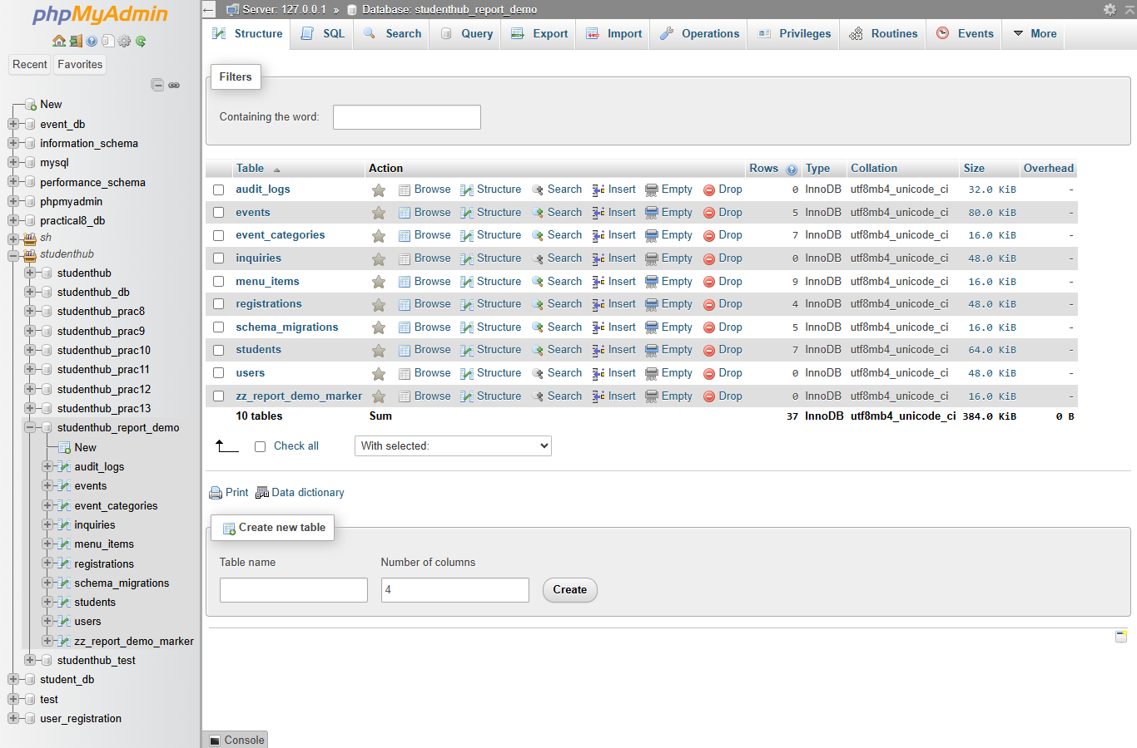
Figure 1: phpMyAdmin – the disposable database studenthub_report_demo: 10 InnoDB tables with utf8mb4_unicode_ci (events 5, event_categories 7, menu_items 9, registrations 4, schema_migrations 5, students 7, users 0, audit_logs 0, inquiries 0 rows) plus the safety marker zz_report_demo_marker (01-database-tables.png)
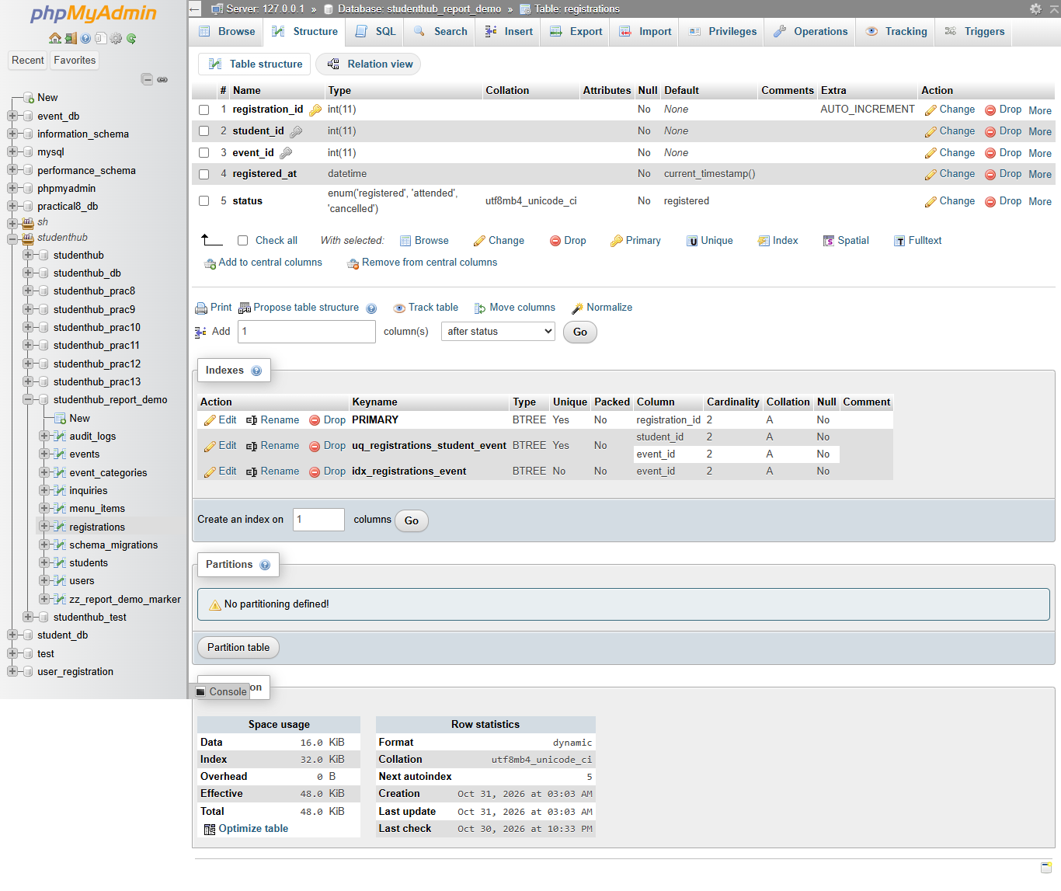
Figure 2: Structure of registrations: registration_id int(11) AUTO_INCREMENT, student_id and event_id int(11), registered_at datetime DEFAULT current_timestamp(), status enum('registered','attended','cancelled'); indexes PRIMARY, uq_registrations_student_event (student_id, event_id) and idx_registrations_event (event_id) (02-registrations-structure.png)
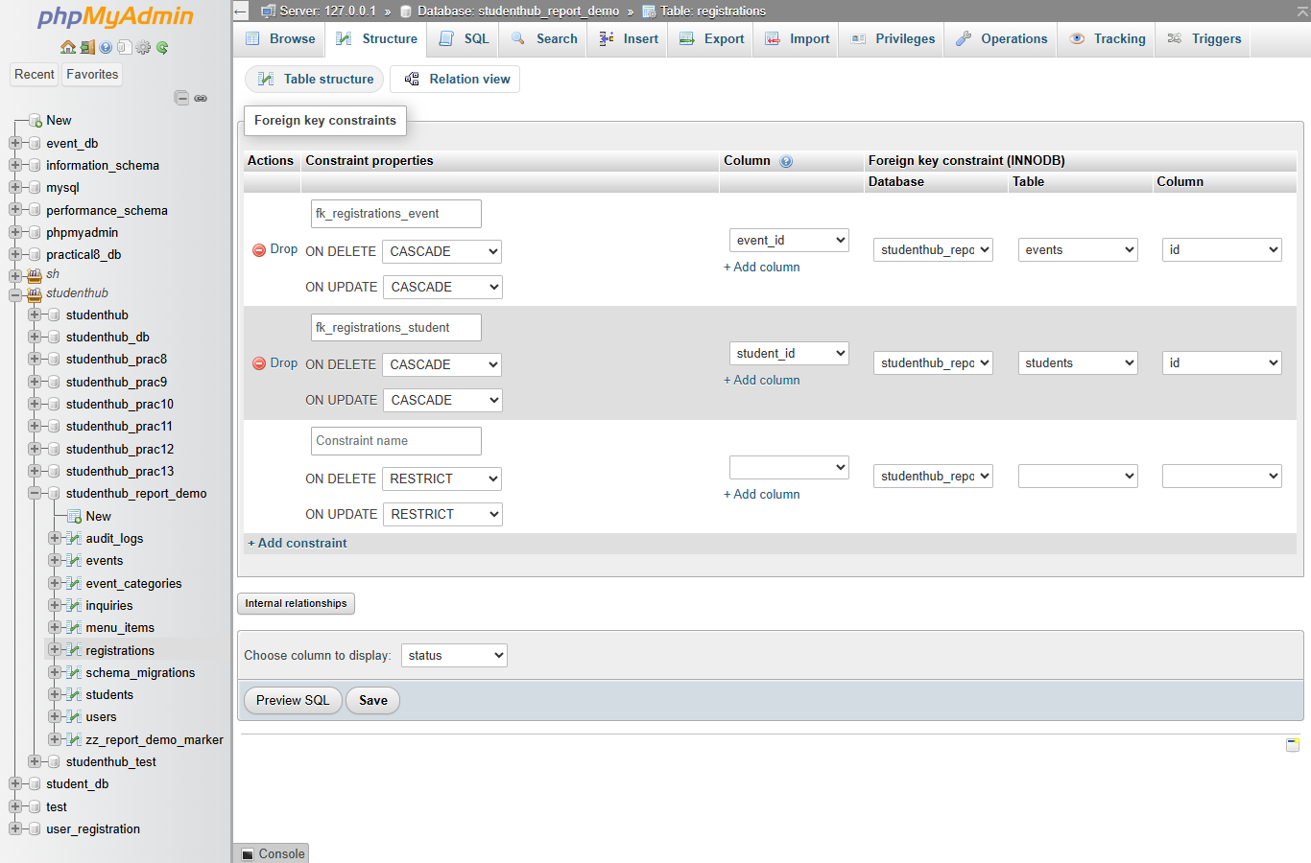
Figure 3: Relation view of registrations: fk_registrations_event (event_id → events.id) and fk_registrations_student (student_id → students.id), both ON DELETE CASCADE and ON UPDATE CASCADE (03-registrations-foreign-keys.png)
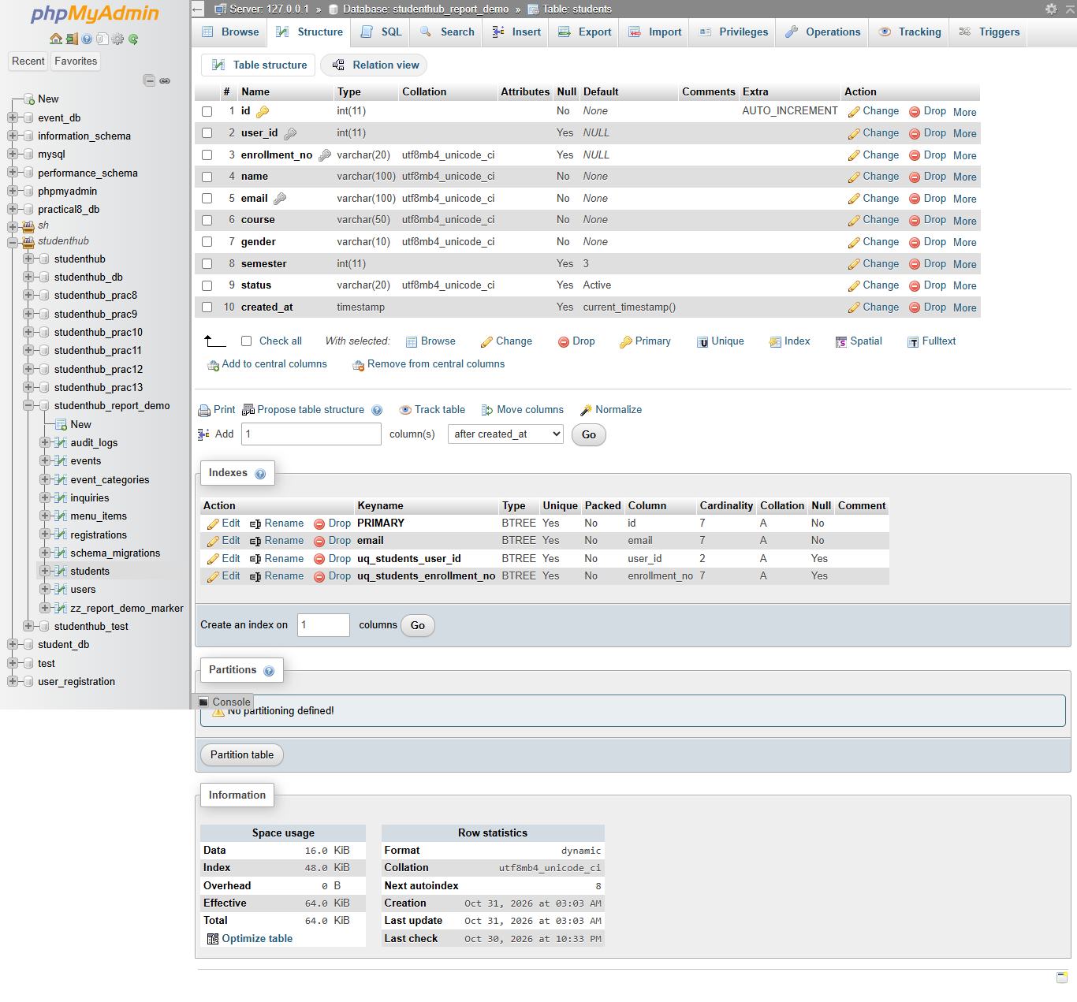
Figure 4: Structure of students after migrations 001 and 002: user_id int(11) NULL, enrollment_no varchar(20) NULL, semester int(11) DEFAULT 3, status DEFAULT Active; unique indexes PRIMARY, email, uq_students_user_id, uq_students_enrollment_no (04-students-structure.png)
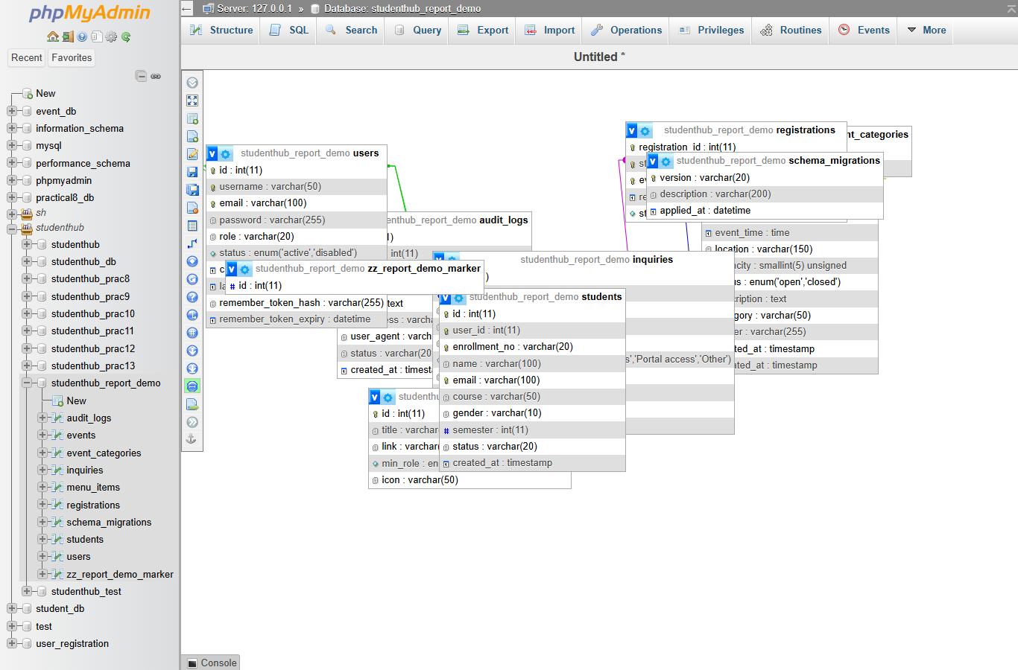
Figure 5: ER view generated by phpMyAdmin's Designer from the real foreign keys; the automatic layout lets some boxes overlap (Section 5.1 lists the relationships). The box zz_report_demo_marker is only the safety marker of the disposable database (05-er-diagram-designer.png)
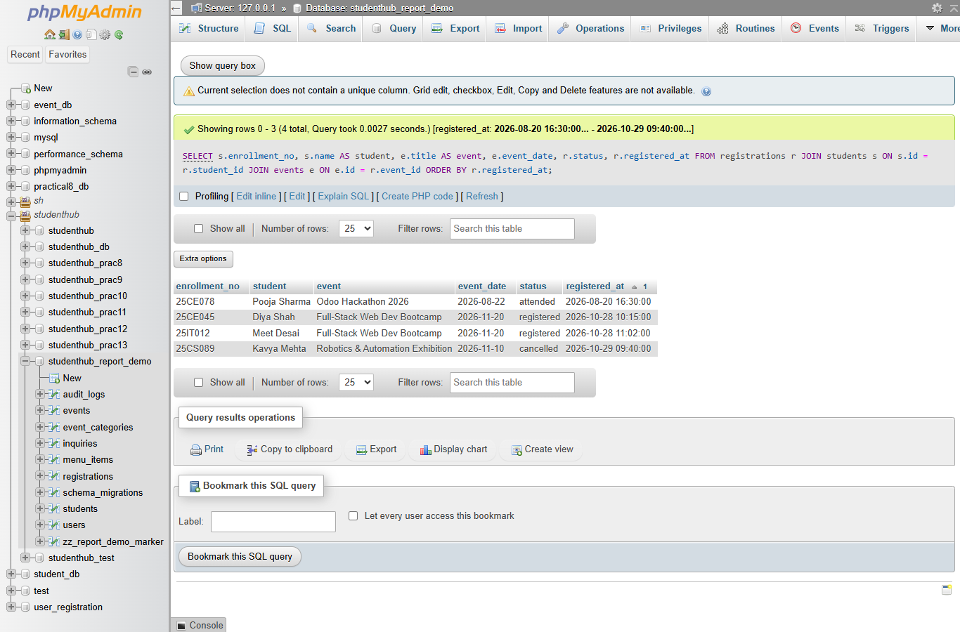
Figure 6: Three-table JOIN of registrations, students and events: the 4 fictional registrations – Pooja Sharma (25CE078) Odoo Hackathon 2026 attended; Diya Shah (25CE045) and Meet Desai (25IT012) Full-Stack Web Dev Bootcamp registered; Kavya Mehta (25CS089) Robotics & Automation Exhibition cancelled – ordered by registered_at (06-join-query-result.png)
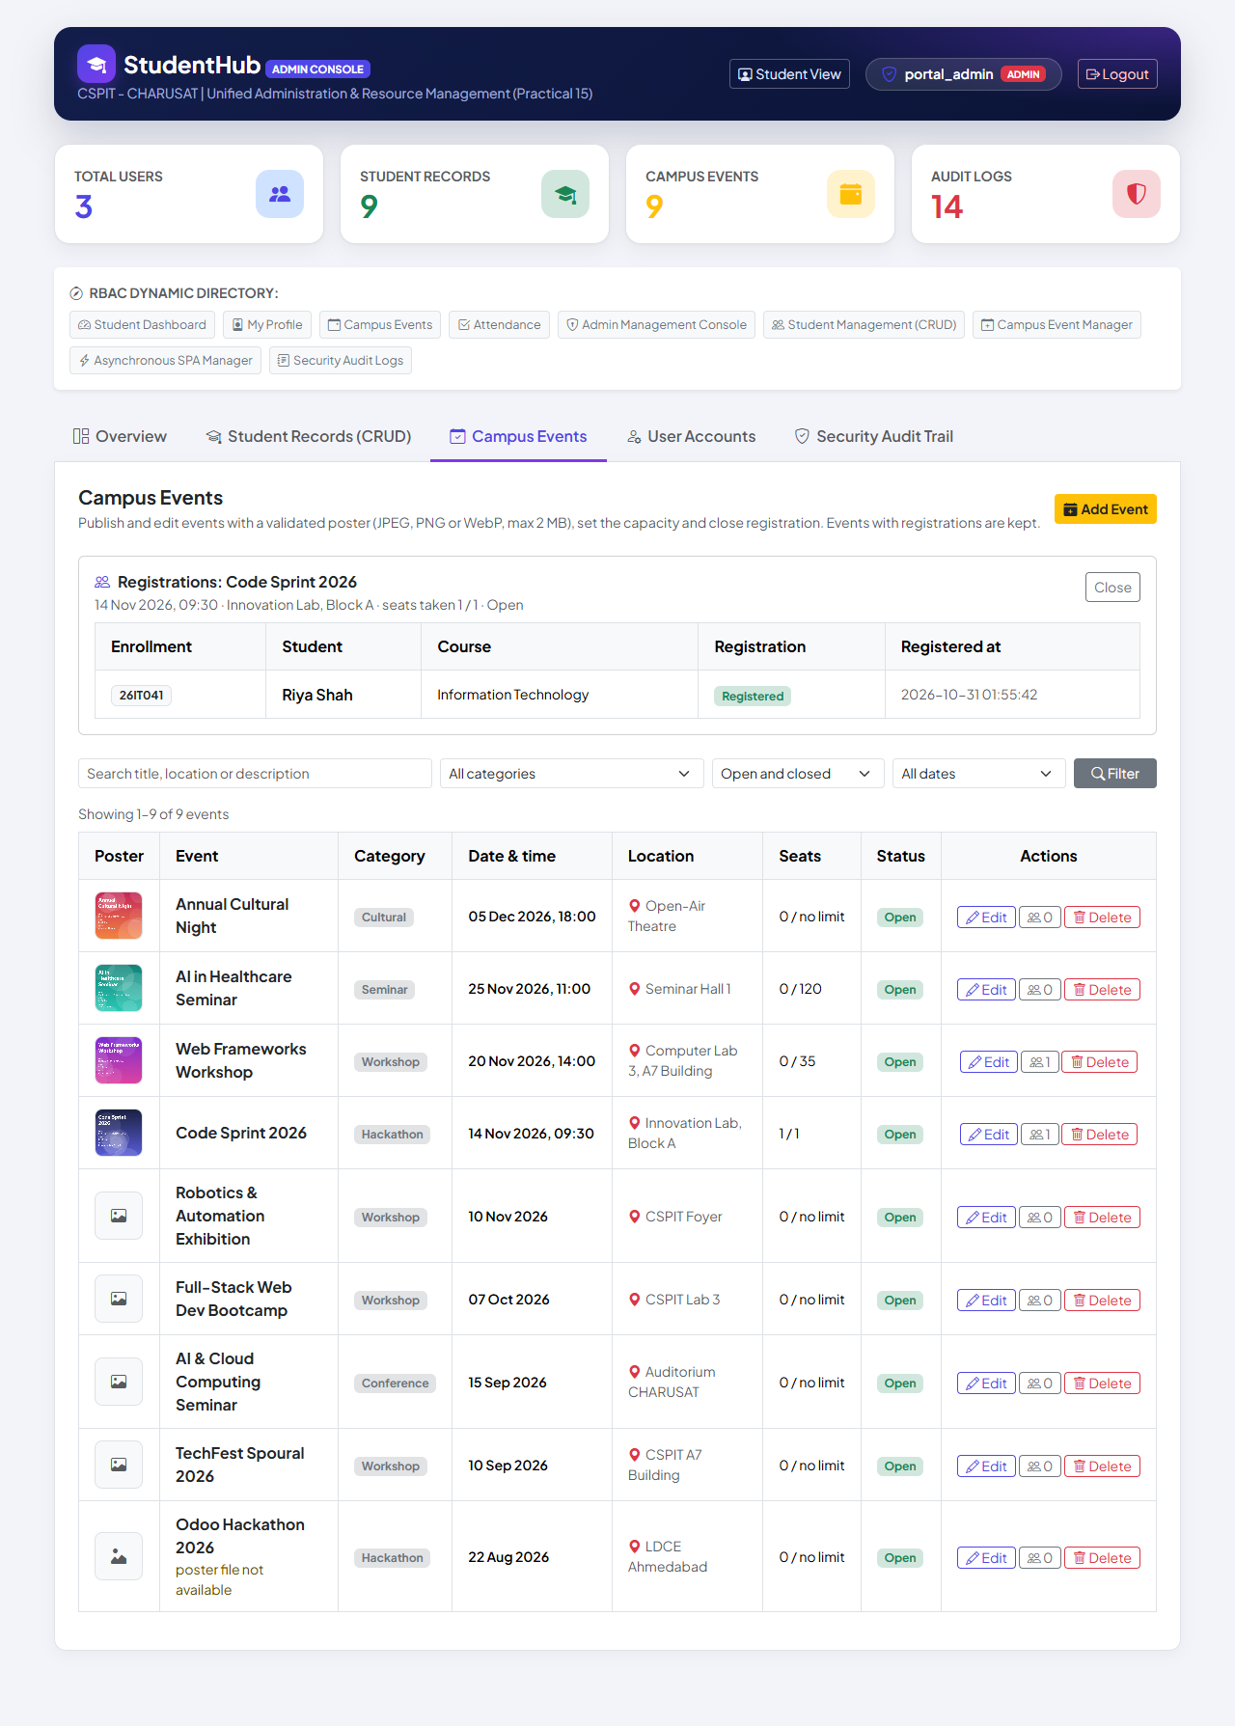
Figure 7: The registrations table in use (Practical 12, later step): Admin Console → Campus Events, registrations of Code Sprint 2026 (capacity 1, seats taken 1 / 1) – Riya Shah 26IT041, Registered; the Seats column shows seats taken / capacity and "no limit" where capacity is NULL (11-event-registrations.png)
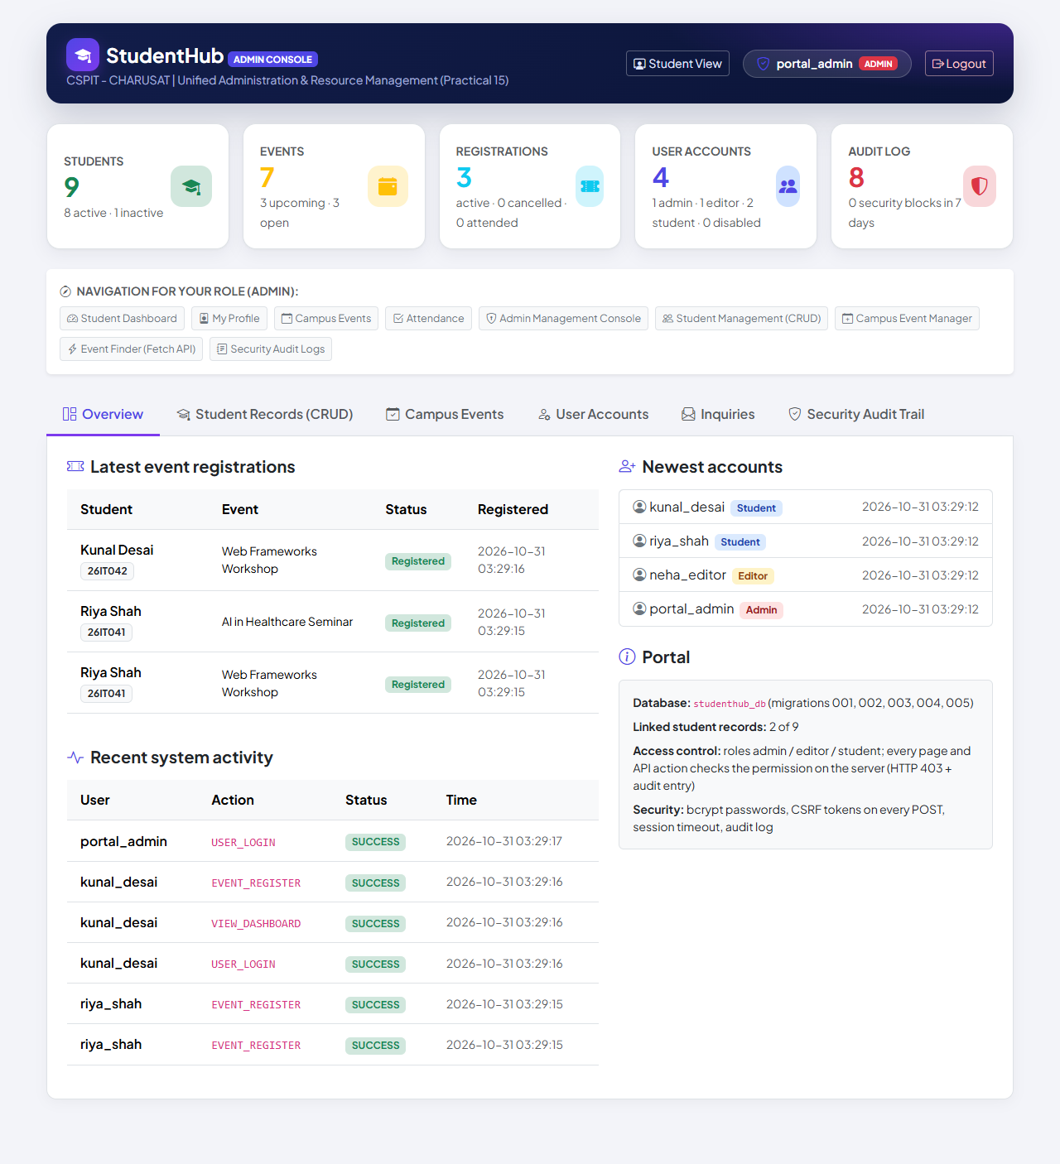
Figure 8: Admin dashboard (Practical 14, later step): Registrations counter and "Latest event registrations" from registrations JOIN students JOIN events; the Portal box names studenthub_db (migrations 001–004) and 2 of 9 student records linked to accounts (01-admin-dashboard.png)

10. Testing and Results
All tests were executed on 31 October 2026 with PHP 8.2.12 (XAMPP), MariaDB 10.4.32 and PHP's built-in server on Windows 11. The migration test creates the disposable databases studenthub_mig001_test, studenthub_mig001_pre and studenthub_mig001_fresh (each with a marker table) and drops them; the real studenthub_db is only read, by the --verify-live mode. The numbers are copied from the saved outputs.
Suite | Result | Output
database/tests/test_001_practical8_foundation.py (fixture, fictional data) | 88 / 88 passed | database/tests/test_001_output.txt
… --verify-live – live database after the migration (read-only) | 24 / 24 passed | database/tests/test_001_verify_live_output.txt
tests/browser_database_evidence.py – phpMyAdmin in Edge (Figures 1–6) | 6 / 6 passed | tests/browser_database_evidence_output.txt
tests/run_all.py – row "Practical 8 – migration 001 and portal" | 88 / 0 (whole run 841 / 0) | tests/run_all_output.txt

database/README.md and TEST_REPORT §6–§8 record earlier runs with 87 checks (fixture 87 / 87, restored real pre-migration dump 87 / 87 – not committed because it contains real records); the saved output of the latest run contains 88 checks, all passed.

Area (test_001_output.txt) | Checks | What was verified
Load + apply migration 001 | 1 + 23 | every new column, key, FK and CHECK with exact type and rule; 001 recorded once; every original value unchanged (SHA-256, incl. password hashes); nothing invented
Linking students to accounts | 3 | only unique, verified matches with a student account (2 in the fixture); no admin/editor linked
Repeated run / rollback and re-apply | 3 + 5 | second run changes nothing; rollback restores the exact structure and data, runs twice; re-apply identical
Precondition stop | 5 | deleted-account audit entry or semester outside 1–8 → stop, nothing changed; demo file refused on an old database
Capacity rule / parallel requests | 12 + 2 | duplicates refused; capacity 2 → third student event_full; cancelled seat reused; NULL = no limit; 8 simultaneous processes for 3 seats → exactly 3
CHECK constraints / foreign keys | 4 + 12 | capacity 0, semester 0 and 9 refused; missing references refused; CASCADE deletes; deleting an account keeps the record and audit entries (user_id → NULL)
Portal pages on the migrated copy | 13 | logins, Admin Console tabs and actions, student pages, 403 for a student, self-registration linked, no PHP warnings
Fresh install from studenthub_demo.sql | 5 | structure identical to an upgraded database; 001 and a re-import change nothing

Live check (24 / 24): after migration 001 was applied to the live studenthub_db (after a verified backup), --verify-live found all 19 structure checks satisfied, the structure identical to the migrated baseline, every original row and value unchanged (incl. password hashes), the links equal to the verified e-mail matches (5) and registrations empty at that time. Later uses: tests/test_events.py (94 / 94; 6 simultaneous registrations for 3 seats → exactly 3) and tests/test_api.py (72 / 72; 6 simultaneous API registrations → three 201 and three 409) exercise the same function (TEST_REPORT §9–§10).

11. Problems Found and Design Decisions
- Audit log and stale sessions: with the new foreign key on audit_logs.user_id, logging an action of an account deleted while its session was open would have failed the page; studenthub/audit_logger.php now catches MySQL error 1452 and stores the entry with user_id = NULL and the username kept (tested).
- Key types: a foreign key needs the exact referenced type, so the new keys are signed INT(11) like the portal's primary keys (Practical 8 used INT UNSIGNED); the preconditions check the types first.
- No invented or silently changed data: existing events get capacity and time NULL, legacy students without a semester stay valid, a semester outside 1–8 stops the migration, and ambiguous e-mails or admin/editor accounts are never linked.
- Non-transactional DDL: preconditions, idempotent steps, a verification block, a dump before migrating and a tested rollback replace the atomicity MariaDB cannot give. The fresh-install test was later updated to apply the newer migrations first (README).

12. Differences from the Original Practical and Limitations
Aspect | Original report (Practical-8/) | Integrated portal
Database | Own studenthub_prac8, recreated by schema.sql | Shared studenthub_db; design added by migration 001
Connection | PDO, native prepares, strict SQL mode, config.local.php | MySQLi, exception mode, environment variables, no fallback, HTTP 503; no strict mode
Business logic | Stored procedures register_student_for_event, get_event_roster | PHP transaction; rosters in the Admin Console (Practical 12)
Demo data | 8 students, 5 events, 12 registrations | 7 students, 5 events, no registrations or accounts
Evidence | test_connection.php page; 44 / 44 + 44 / 44 tests | phpMyAdmin on a disposable copy; 88 / 88, 24 / 24 live, 6 / 6 browser

- A plain INSERT INTO registrations bypasses the capacity rule – the portal must always use register_student_for_event().
- Without strict SQL mode, values not covered by a CHECK (e.g. too-long text) are silently adjusted.
- Course names are free text. A self-registered student's e-mail is stored in users and students; editing the record in the Admin Console changes only students.email.
- Registrations cannot be marked attended from the interface (TEST_REPORT §9); only MariaDB 10.4.32 was tested.

13. Conclusion
The Practical 8 design – students and events stored once and linked by registrations with two CASCADE foreign keys and a unique student–event pair – is now part of the one database of the integrated portal. Migration 001 added it to the existing tables with read-only preconditions, a strict account-linking rule, CHECK constraints, a verification block and a tested rollback, without changing any existing value. The capacity rule runs as a PHP transaction that locks the event row, so eight simultaneous requests for three seats produced exactly three registrations. The portal connects with MySQLi in exception mode and never shows database details. 88 automated checks, 24 read-only live checks and 6 browser checks passed.

14. References
- Project repository: https://github.com/TheEmperor08/StudentHub-ITUE203-25CS023 – database/, studenthub/db.php, studenthub/includes/event_registration.php, evidence/practical-08-integration/, TEST_REPORT.md; commit 37b35e6
- MariaDB Knowledge Base – CONSTRAINT (CHECK and FOREIGN KEY): https://mariadb.com/kb/en/constraint/
- MariaDB Knowledge Base – SELECT … FOR UPDATE: https://mariadb.com/kb/en/for-update/
- PHP Manual – MySQLi prepared statements: https://www.php.net/manual/en/mysqli.quickstart.prepared-statements.php
- PHP Manual – mysqli_report: https://www.php.net/manual/en/function.mysqli-report.php
- phpMyAdmin documentation: https://docs.phpmyadmin.net/en/latest/
- OWASP – SQL Injection Prevention Cheat Sheet: https://cheatsheetseries.owasp.org/cheatsheets/SQL_Injection_Prevention_Cheat_Sheet.html

